**C++ Assignment**

1. //Covers class,objects,access specifiers

C++ Program to Define a Class BOOK and accessing member function using its object

1)Define a class BOOK with the following specifications :

Private members of the class BOOK are

BOOK NO integer type

BOOKTITLE 20 characters

PRICE float (price per copy)

TOTAL_COST() A function to calculate the total cost for N number of copies where N is passed to the function as argument.

Public members of the class BOOK are

INPUT() function to read BOOK_NO. BOOKTITLE, PRICE

PURCHASE() function to ask the user to input the number of copies to be purchased. It invokes TOTAL_COST() and prints

the total cost to be paid by the user.

1. Write a C++ Program to add and subtract Complex Number Using Operator Overloading of - and + operators.

Step 1: Declare the class.

Step 2: Declare the variables and its member function.

Step 3: Using the function getvalue() to get the two numbers.

Step 4: Define the function operator +() to add two complex numbers.

Step 5: Define the function operator â€“()to subtract two complex numbers.

Step 6: Define the display function.

Step 7: Declare the class objects obj1,obj2 and result.

Step 8: Call the function getvalue using obj1 and obj2

Step 9: Calculate the value for the object result_add result_sub by calling the function operator + and operator -.

Step 10: Call the display function using obj1 and obj2 and result_add and result_sub.

1. **Mini Project:**

In this assignment, you need to create a class file for:

* A Student
* A Teacher
* A Course

The Course object should contain an array of Student objects so ensure that you create an array inside the Course object to hold Students. A Course object will also contain a single Teacher object..  For this assignment, create an array of size 3 for students.

Use this diagram as an example of how some objects relate to each other in a program that might be used to maintain class registrations.  The term UProgram is used so as not to confuse Program with a computer program.  It is meant to represent a program such as Computer Science or Liberal Arts, etc.

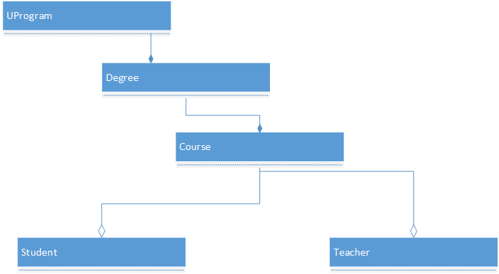

The Student and Teacher classes need to have private member variables for first and last names, age, address, city, and phone along with public accessors for these.

Each class needs to have a default constructor and one that sets the values of the member variables when the object is created.  Each class should also have a destructor.

Ensure that you are using a header (.h) and an implementation file (.cpp) for each class.

The Teacher class needs to have a method called GradeStudent() that accepts no arguments and returns nothing.  Have this method output an appropriate message to the console such as "Student graded".

Add a method to both Student and Teacher called SitInClass().  it should take no arguments and return no arguments but, to illustrate class scope, have the method output, "Sitting at front of class" for the teacher and "Sitting in main theater" for the students.

In the main() method:

1. Instantiate three Student objects called Student1, Student2, and Student3, provide values for the member variables.
2. Instantiate a Course object called Intermediate C++.
3. Add your three students to this Course object.
4. Instantiate at least one Teacher object.
5. Add that Teacher object to your Course object
6. Using cout statements where appropriate, follow these instructions:
   1. Output the name of the course
   2. Call the GradeStudent() method on the Teacher object
   3. Leave your application open and answer the Lab assessment questions

Questions

1)What line of code was necessary for you to instantiate a Student object in main()?? (Class Files)

A) import "Student.h"

B) #import "Student.h"

C) #include "Student.h"

D) #include "Student.cpp"

Ans: C

2) What is output to the console when the SitInClass() method is called on a Teacher object?(Class Scope)

|  |
| --- |
| Sitting at front of class |

Ans:

3) What would be the value of the member variables of a Student object if you instantation stud1 with the above code? ( Class Instantiation)

A) All values will be null

B) Values will be initialized to default values for the data types

C) All values will be initialized to blank spaces

D) All values will be initialized to zero

Ans: A