**WAD Ass (3a) – Nodejs API**

Creating 4 **REST APIs** using different **HTTP methods** — GET, POST, PUT, DELETE — to perform CRUD operations.

**1] POST METHOD**

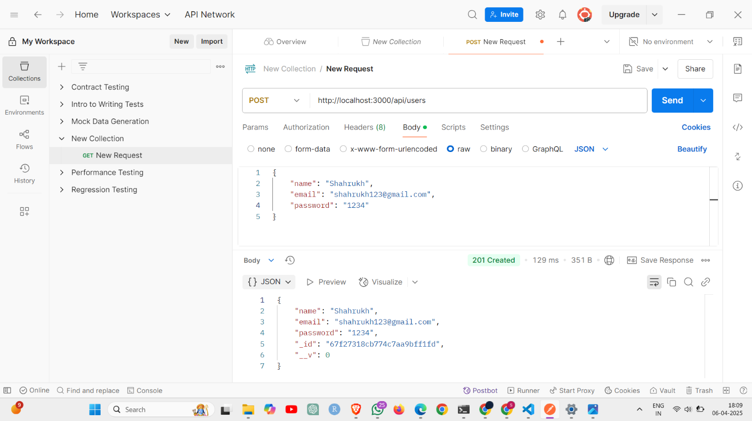

**2] MongoDB data after POST**

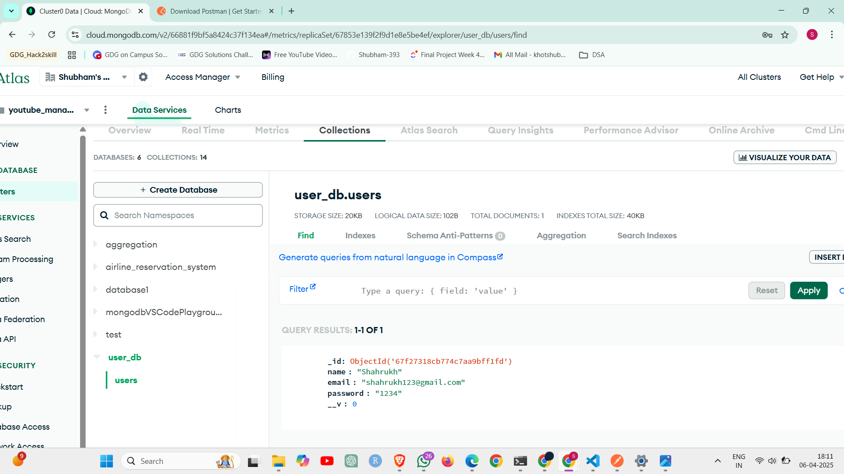

**3] GET**

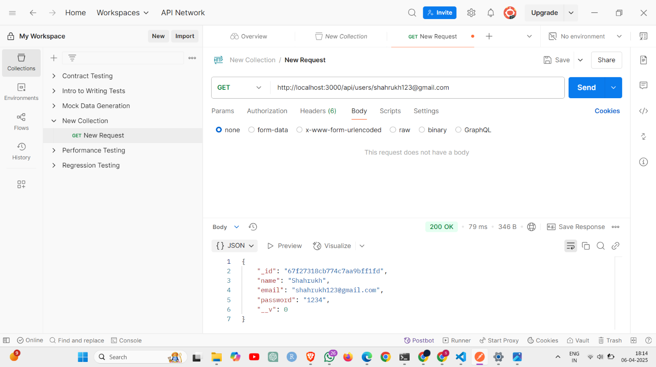

**4] PUT**

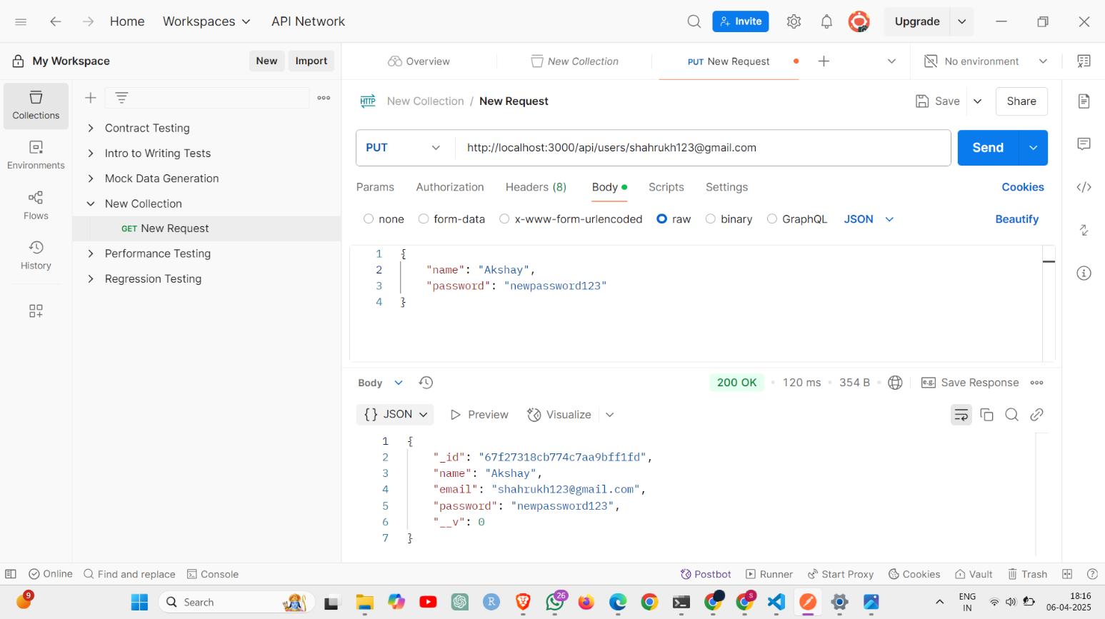

**5] MongoDB data after GET**



**6] DELET**

