

<https://github.com/Shubham-5323/Design-Thinking-Framework-Quantum-University-02-Project>

**Design Thinking framework**

**Quantum University**

**Project- 2**

**Schematic Diagram**

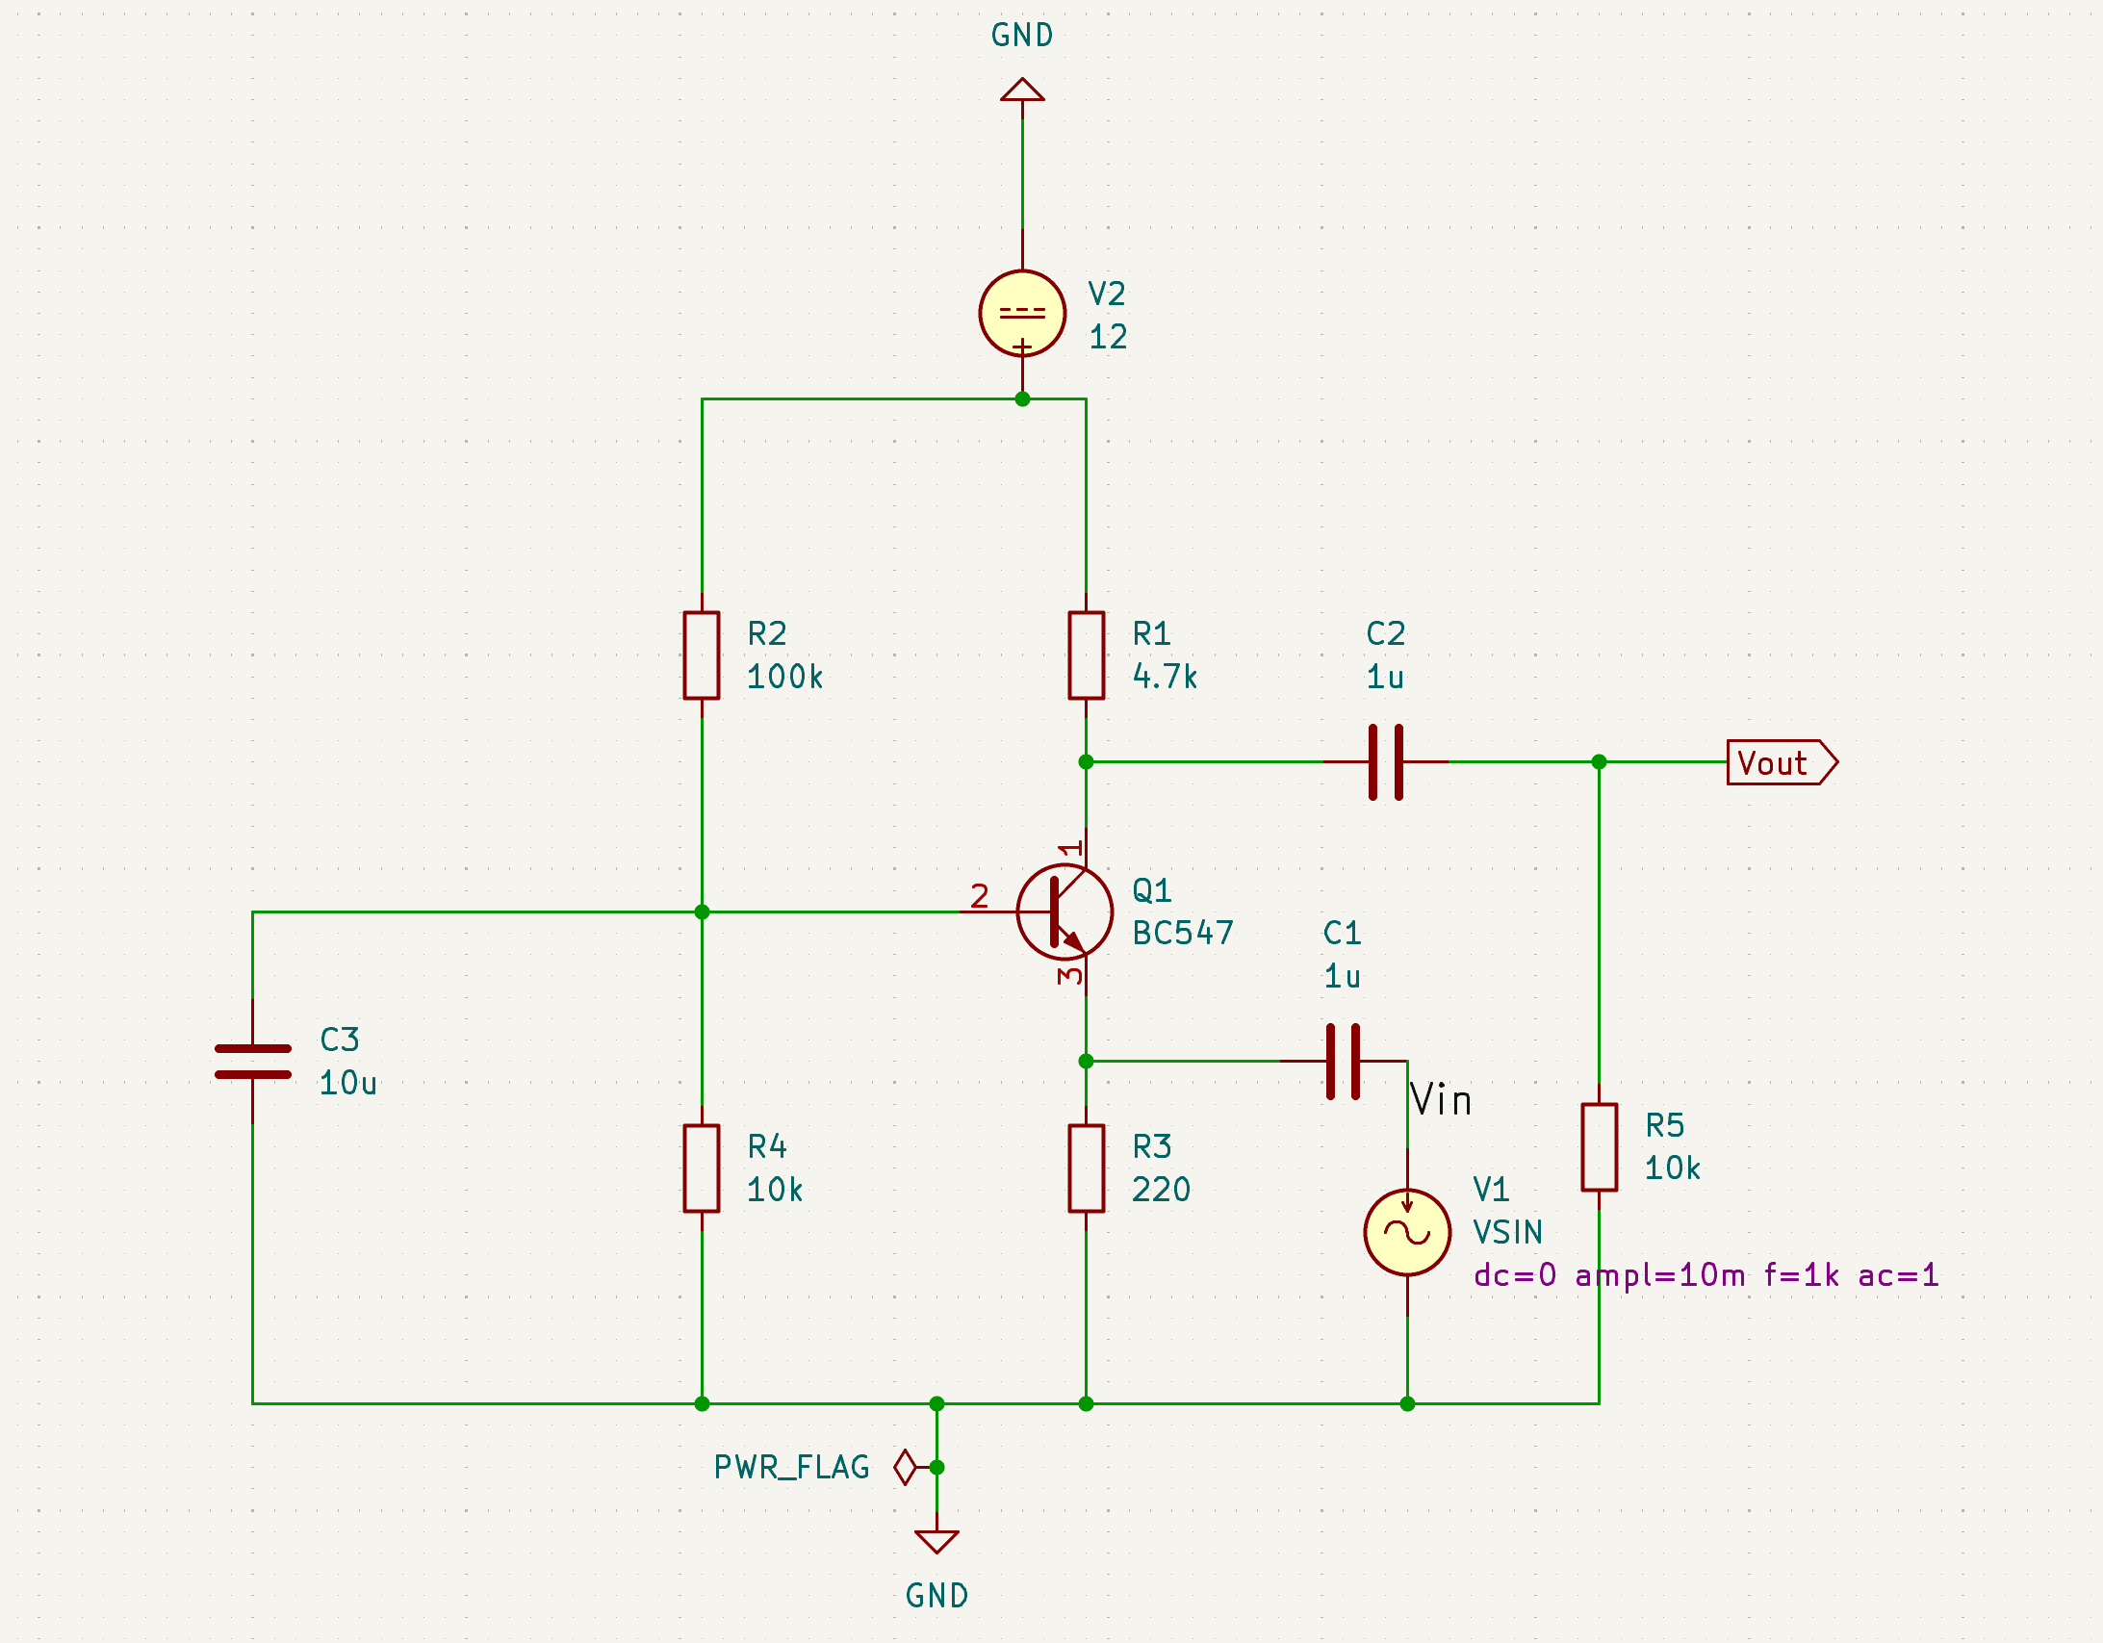

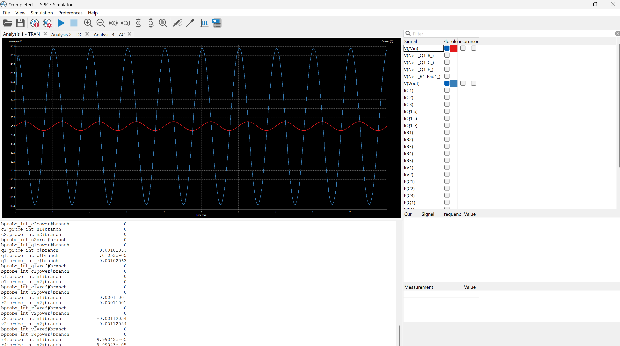

* **Transient Analysis**
* Shows how the amplifier responds to signals that change over time, like pulses or sine waves.
* Helps confirm that the circuit accurately follows the input signal without delay or distortion.
* Demonstrates real-time behaviour, useful for checking signal shape and timing.

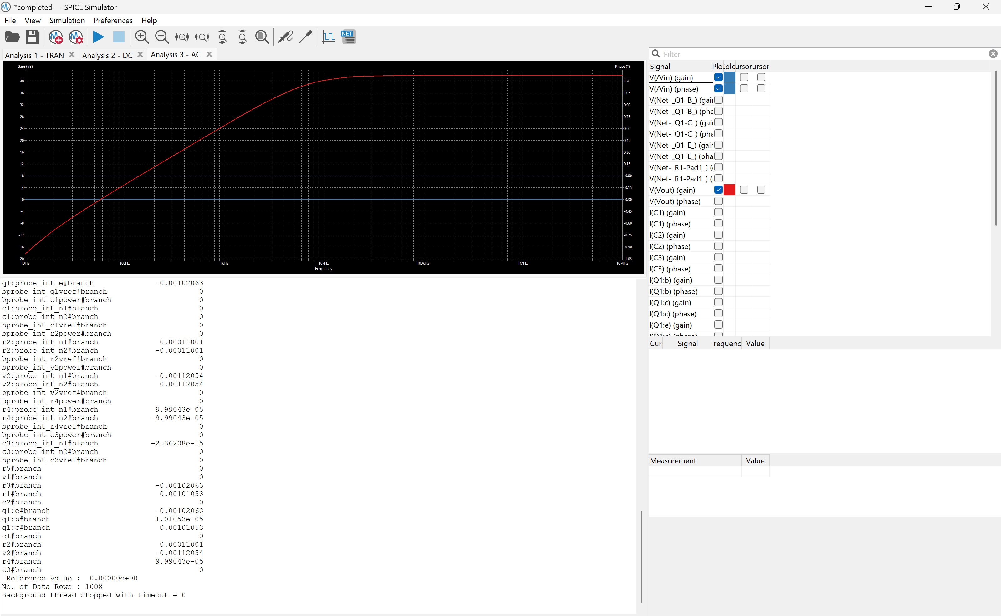

* **AC Analysis (Frequency Response)**
* Examines how the circuit responds to small input signals across a range of frequencies.
* Determines the amplifier's ability to amplify or transfer signals without loss across those frequencies.
* Confirms if the circuit behaves as a buffer or amplifier and helps identify useful frequency ranges (bandwidth)
* 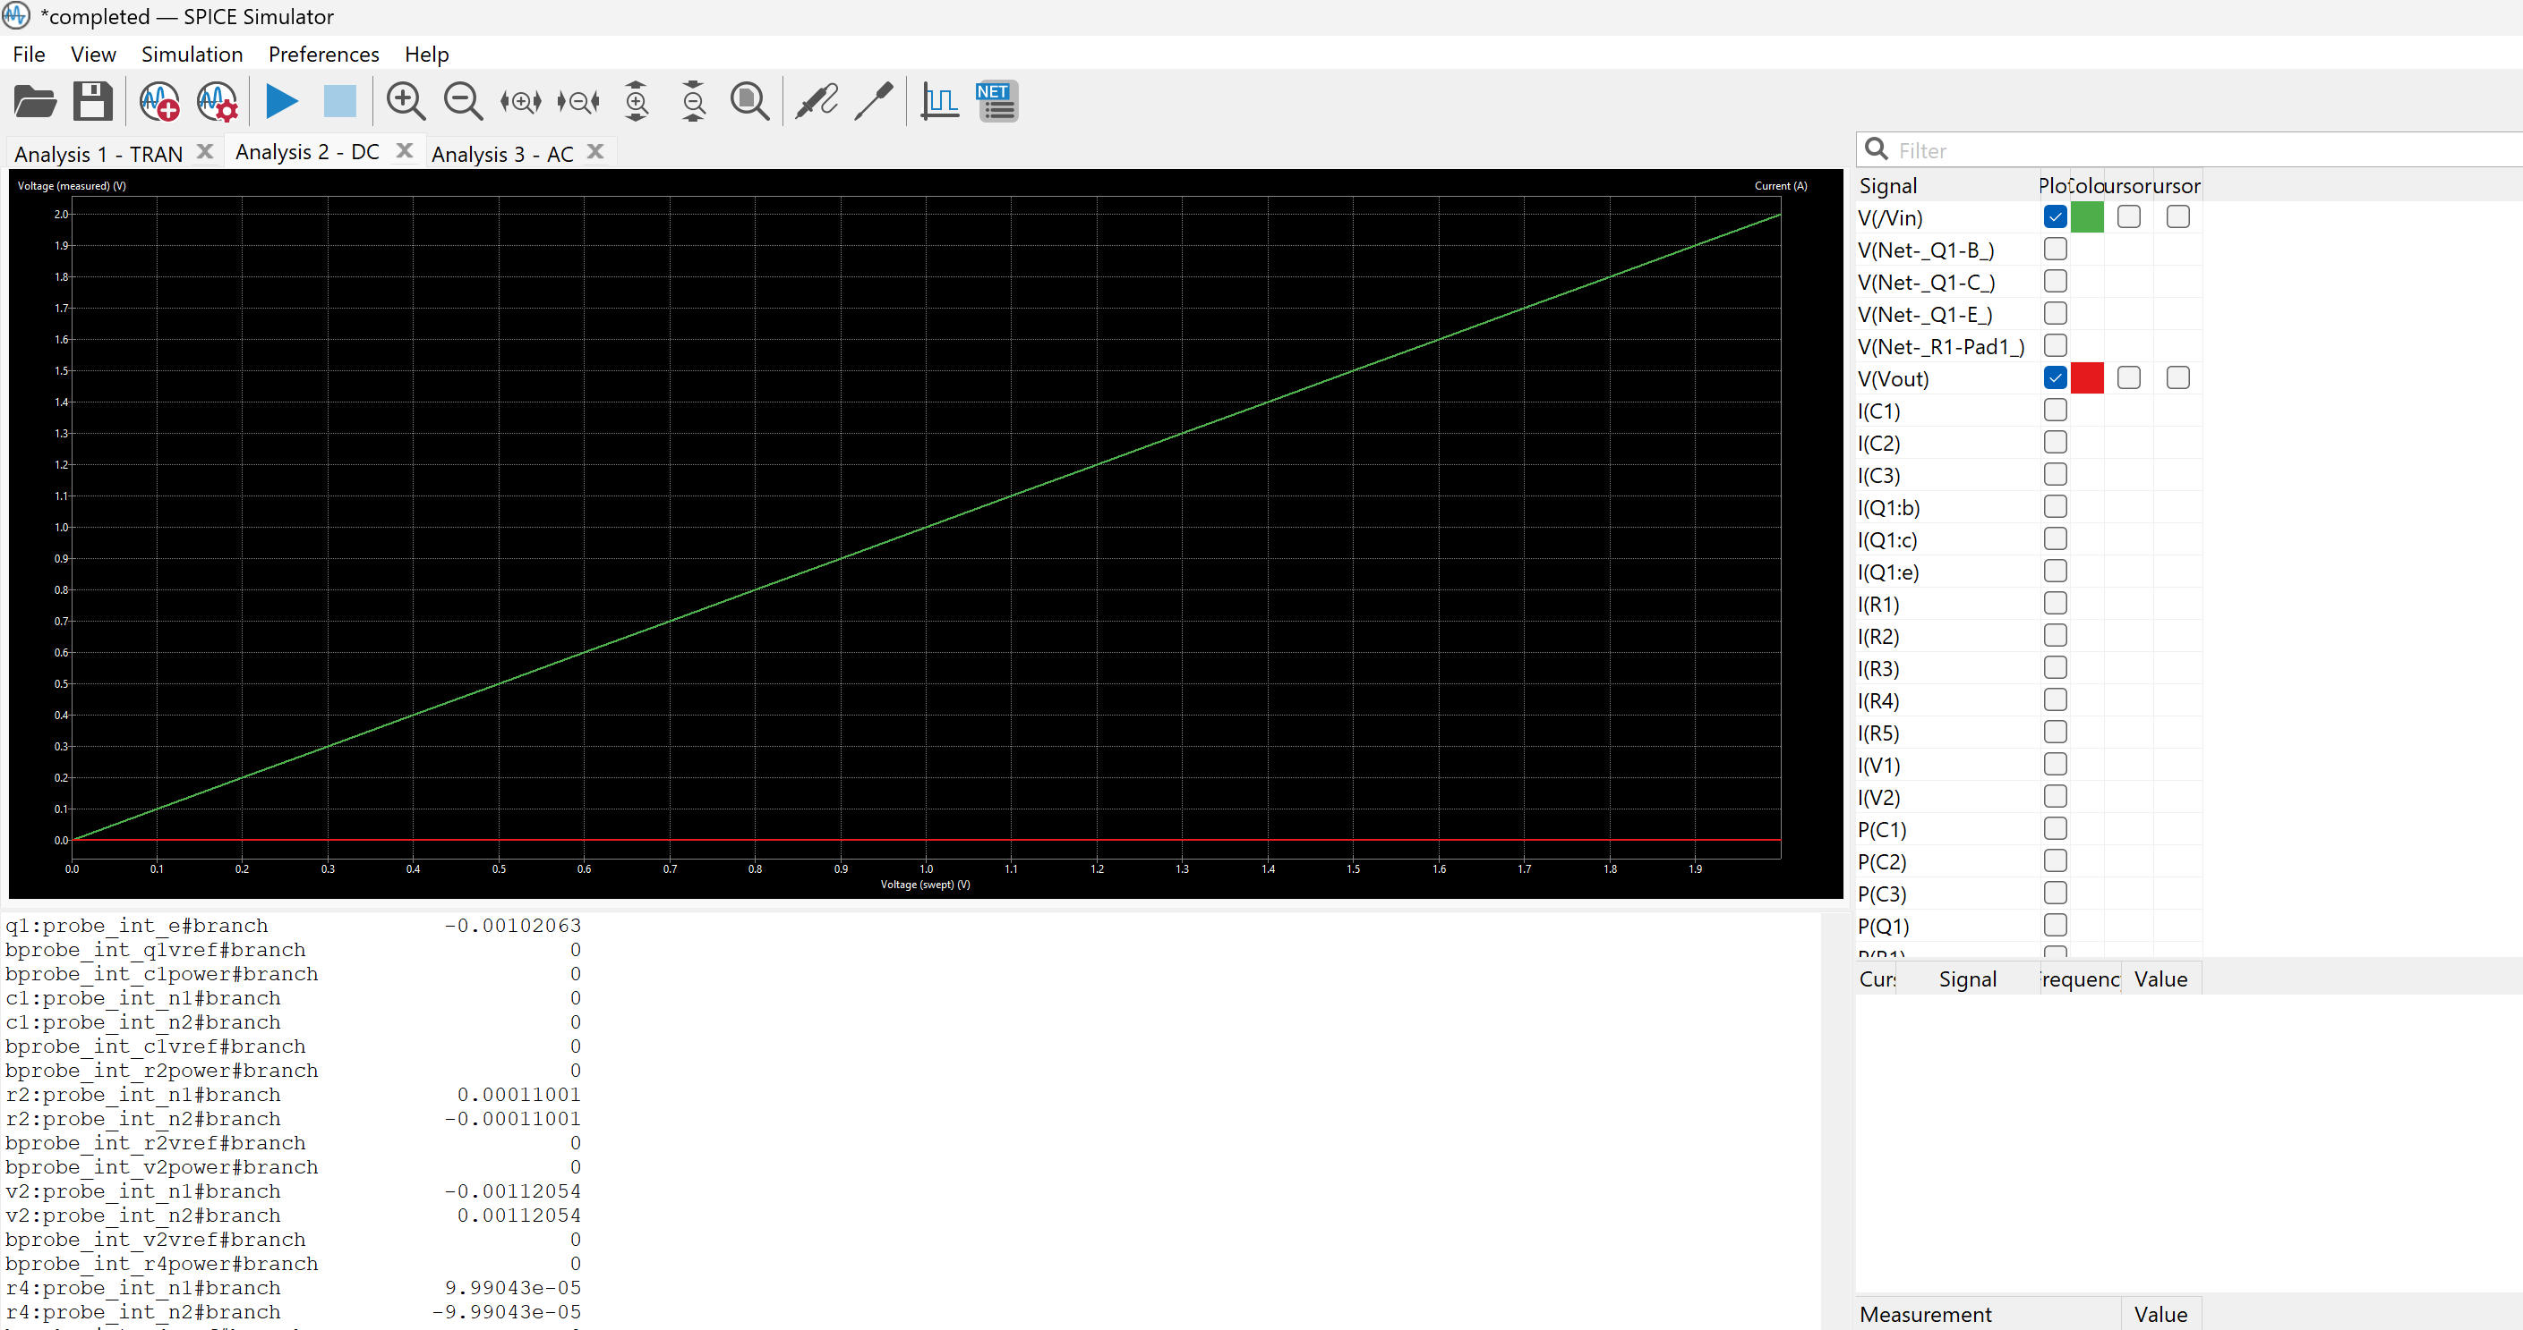**DC Sweep Analysis (Static Output Behaviour)**
* Reveals how the output current changes as the voltage across the output is varied, for different fixed input current levels.
* Shows that the output current mainly depends on the input current and is nearly unaffected by output voltage.
* Confirms the transistor acts like a current source controlled by another.

Explain the following

1. BJT is called a current controlled current source
2. CB-BJT can be used as current buffers

**(I) BJT is called a current-controlled current source (CCCS)**

* A **Bipolar Junction Transistor (BJT)** operates based on current control. The input current at the **base** controls the output current at the **collector**.
* The relationship follows **collector current (Ic) = β × base current (Ib)**, where **β** is the current gain.
* Since the base current influences the collector current proportionally, a BJT functions as a **current-controlled current source**, meaning a small input current can regulate a larger output current.

**(ii) Common-Base BJT (CB-BJT) as a Current Buffer**

* A **CB configuration** provides a **low input impedance** and **high output impedance**, making it useful for current buffering.
* It ensures that the input current is transferred almost completely to the output with minimal variation.
* The **current gain (α)** in CB mode is close to **1**, meaning the output current closely follows the input current, reinforcing its use as a **current buffer** to prevent loading effects in circuits.