3 Tier Architecture
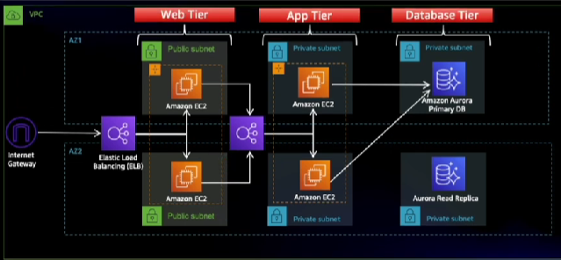

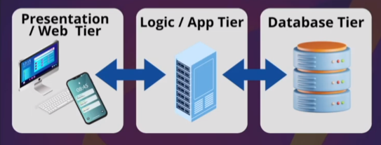
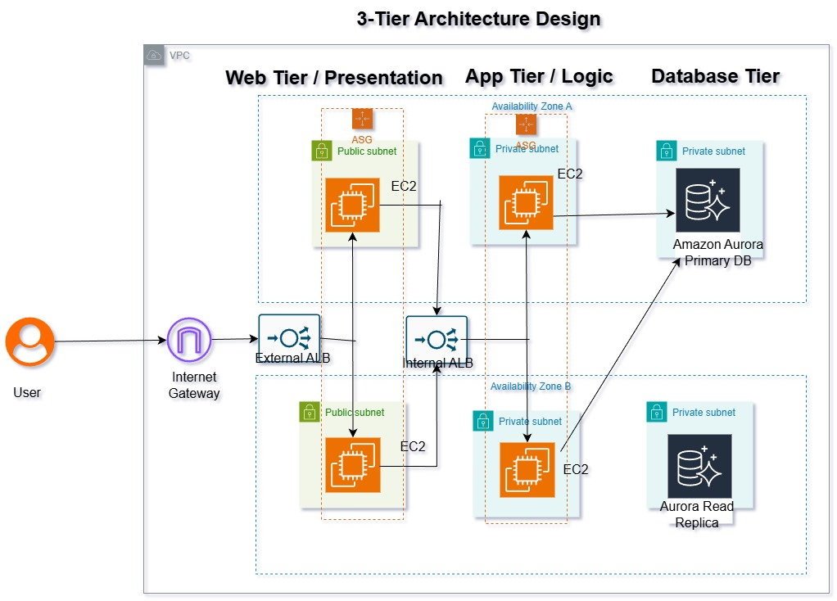

- Crate a VPC for your project
- Create an s3 bucket and upload your code, create an IAM role to attach to ec2 instance
- Create SG for resources like ( Web servers, web ALB, app servers, app internal LB, DB)
- Created an DB subnet group in RDS and Create an RDS database(MySQL)
- Create Application tier resources including Internal Load balancer
- Crete web tier resources including external load balancer
- Also create an Ato scaling group with its its AMI and Template maded
- Generate an SSL certificate and apply it to External Load Balancer and map to external load balancer

We make an Custom VPC ( 3TierProject-vpc ) as a best practice with CIDR range 193.168.1.0/24 :
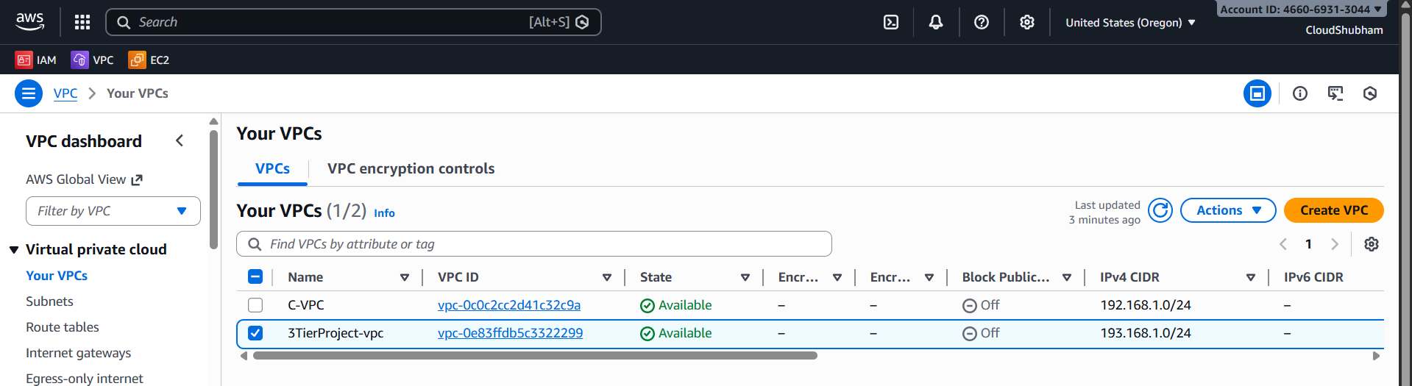

We created 6 subnets in which 2 subnets in Public and 4 Subnets in Private, and WebSubnets are placed in Public Subnets rest 4 subnets in which 2 for DbSubnet and 2 for AppSubnet in private subnets :
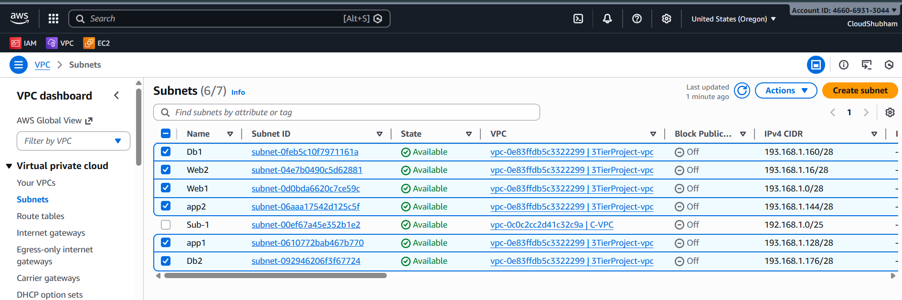

We created this subnets in 2 Availability zones for High availability :
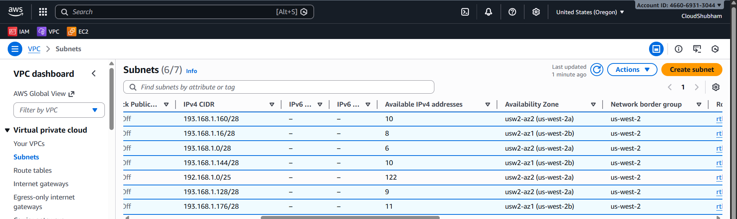

As there is a Route Table associated with subnets 1 RT for Public and 4 RT for Private subnet:…………
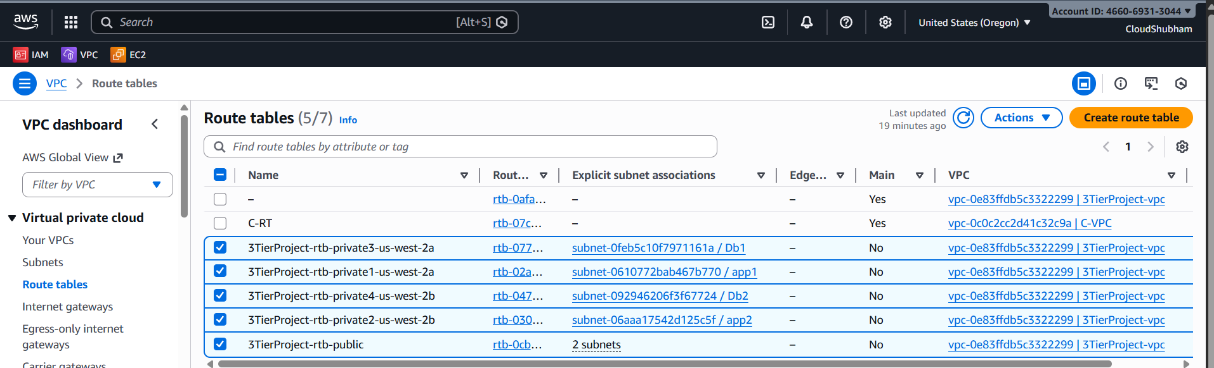

There is 1 Internet Gateway :
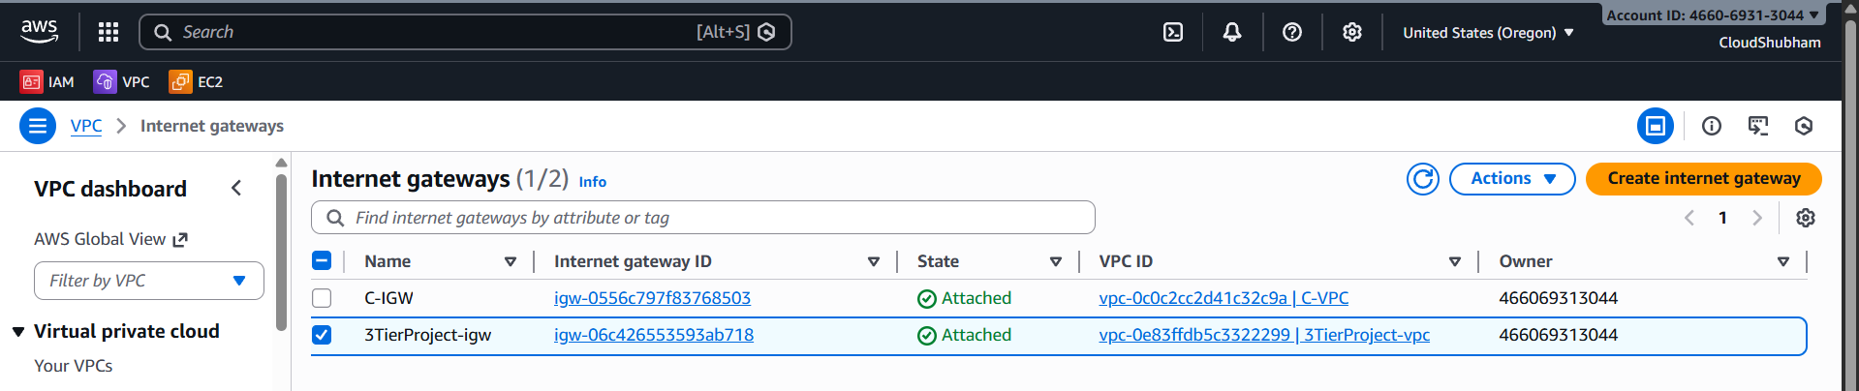
As there was 3 Elastic Ips are use for Project , 1 for NAT gateway ……………..
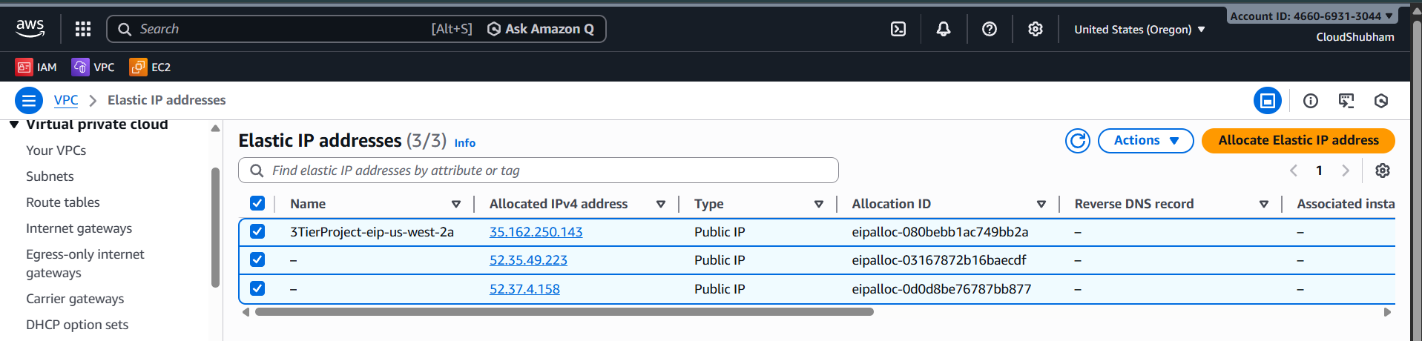

Yes, 1st Elastic IP is connected to Nat Gateway so to get connected to internet to receive new patches updates easily on Public fixed ip.
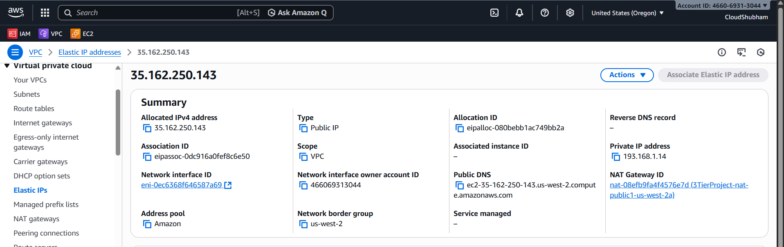

………………………………………
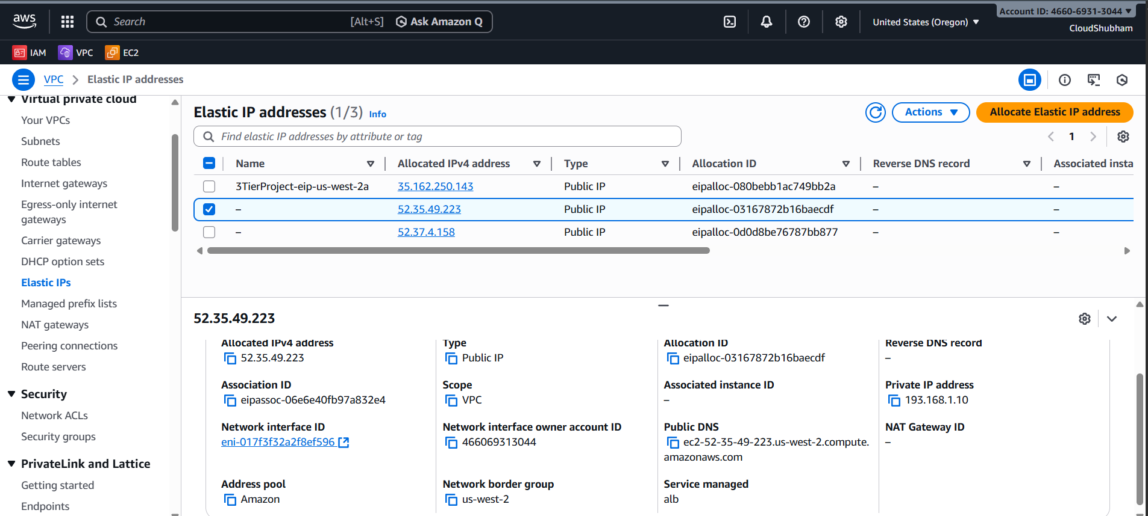
…………………………….
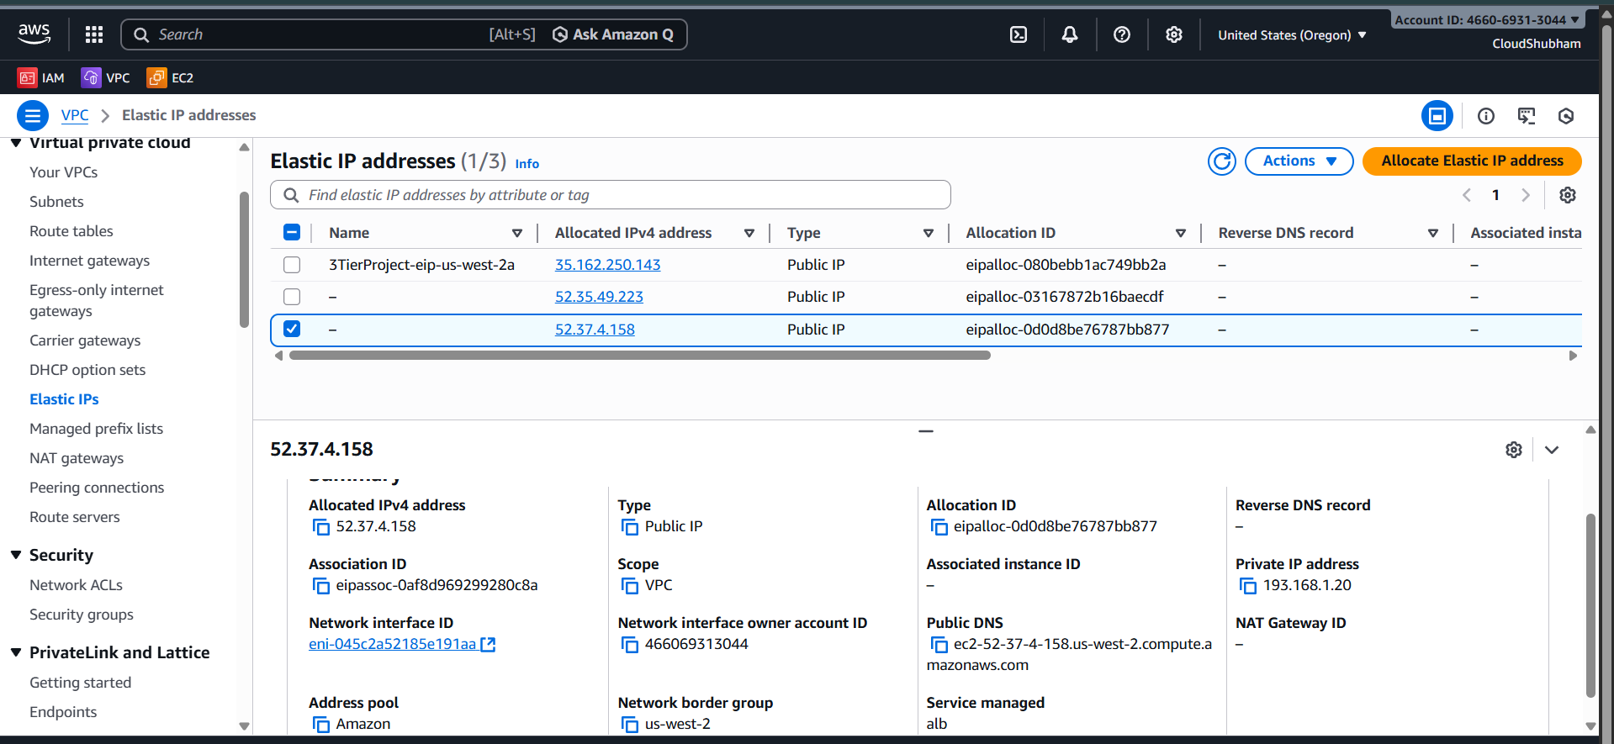

Nat gateways allows Private Subnets to securely access the internet for updates, patches or API calls.
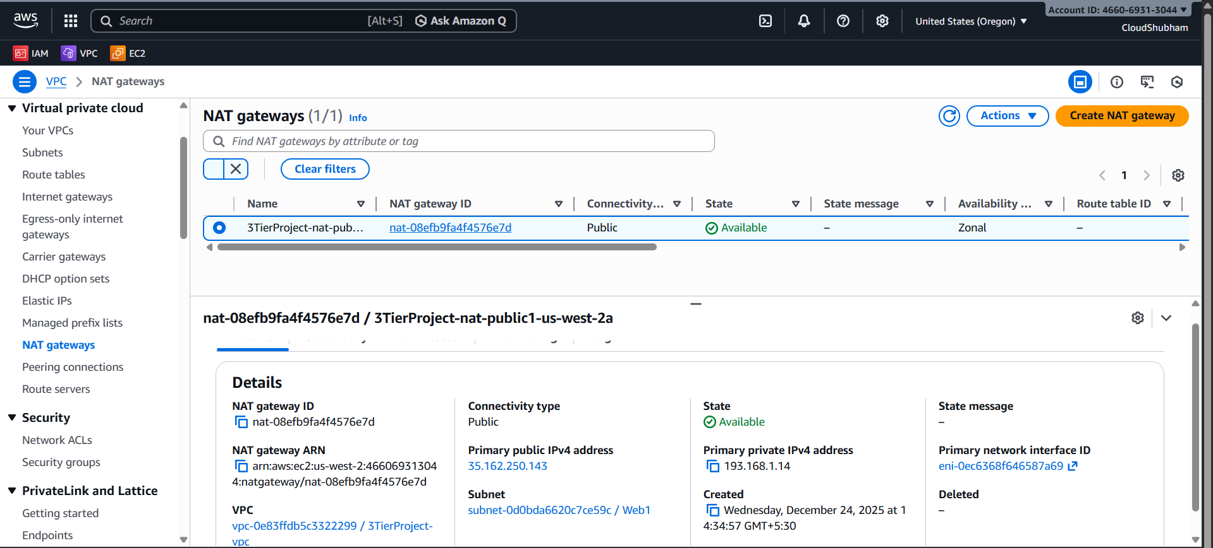
There is NACL attach which allows all Traffic IN and OUT:
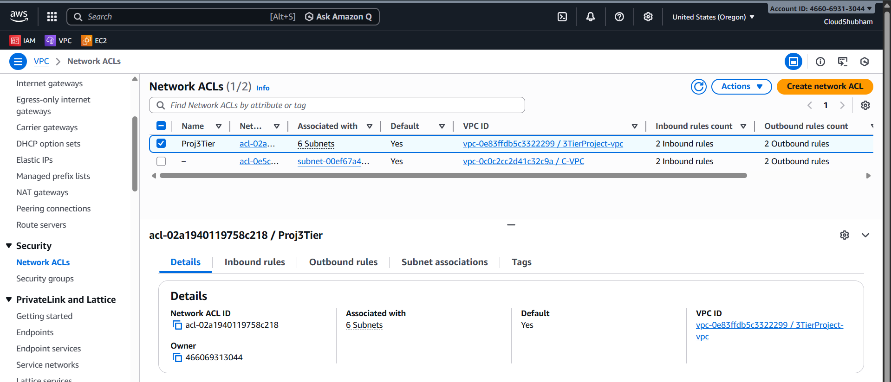
There are 5 security groups made each for Servers and Database .
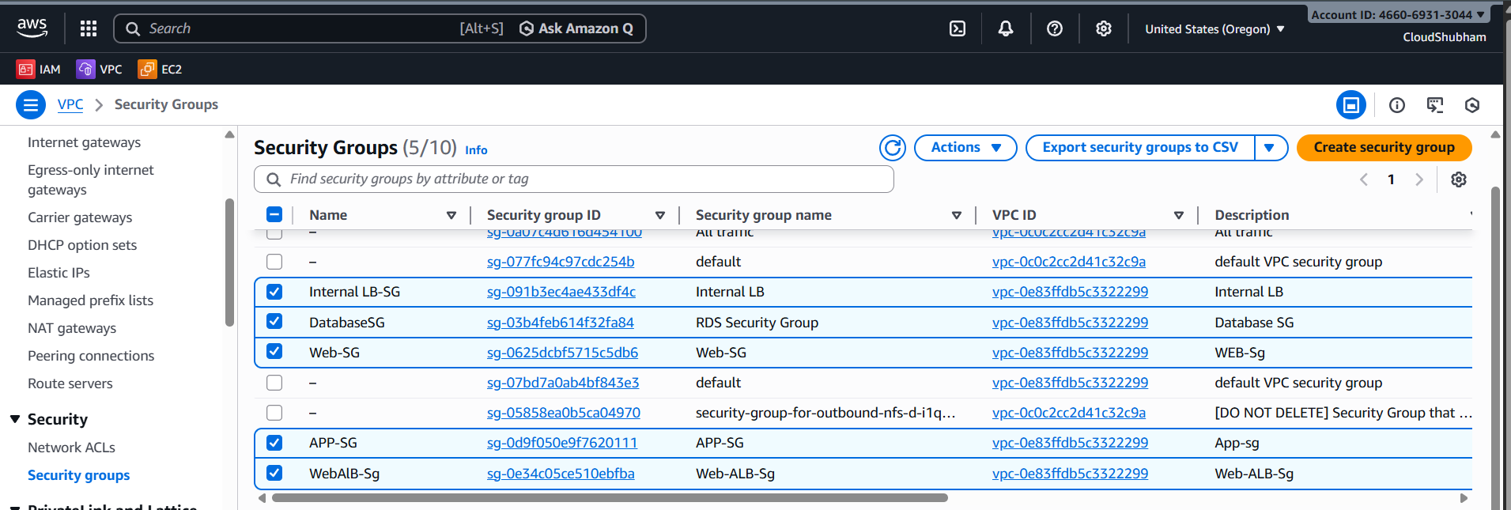

Web ALB SG should have all traffic allowed from HTTP, HTTPS and any port:
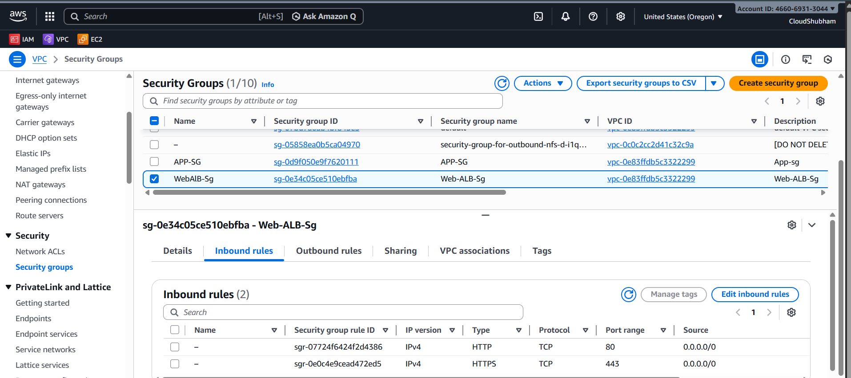

Web sg traffic is only open for the traffic coming from WebAlb-sg only and also HTTP and HTTPS
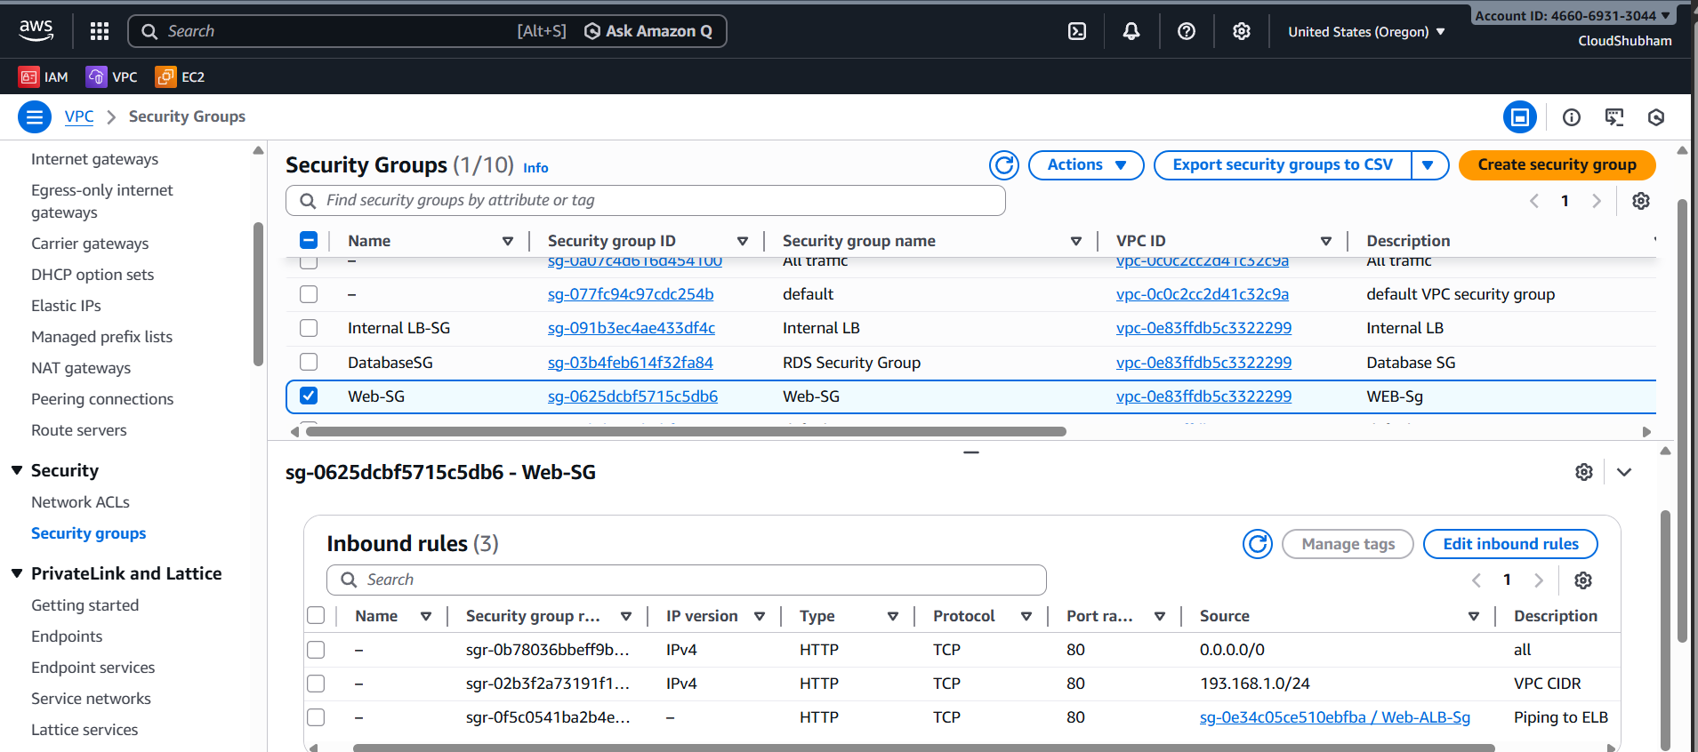

There is Internal LB which can have inbound traffic to those who are in CIDR range of subnets :
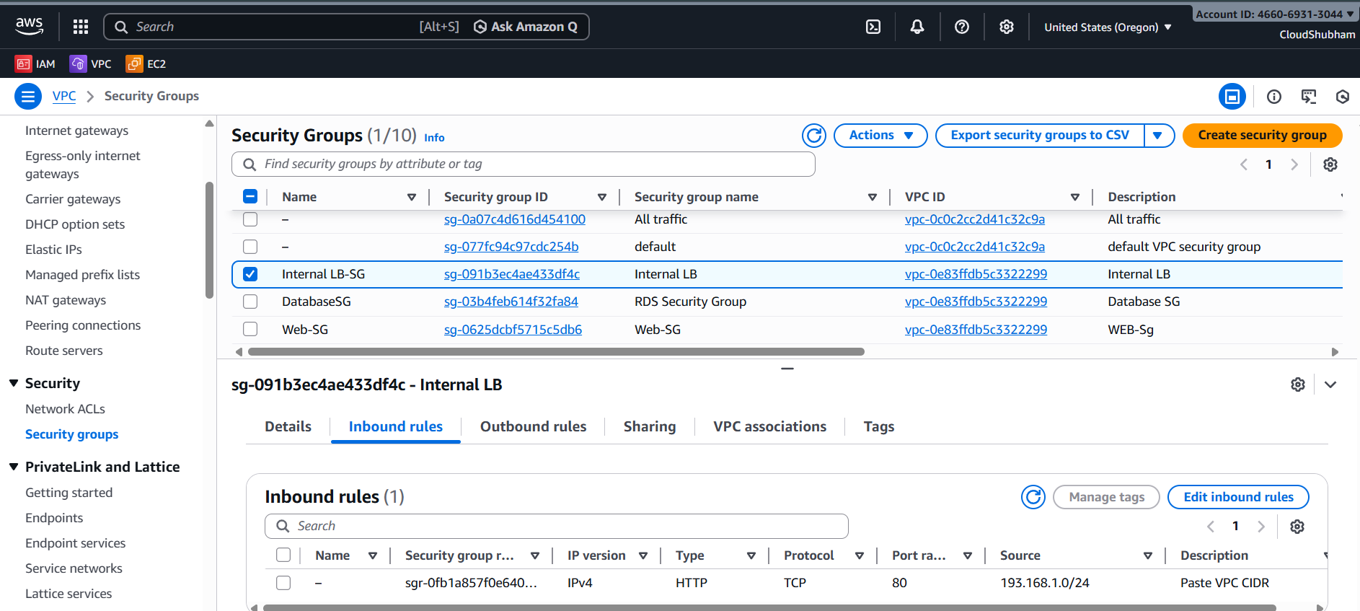

There is an App-sg which will allow only which has traffic from Internal LB and from Private VPC only :
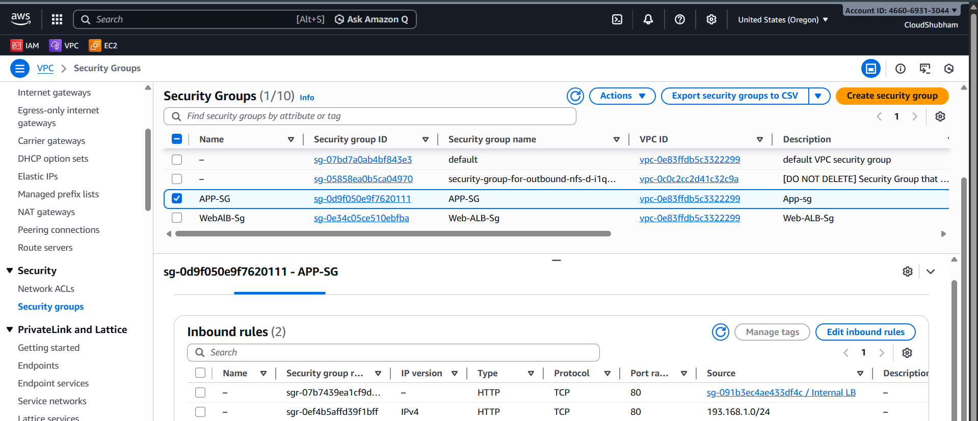

There is an DB-SG which allow inbound traffic which has Mysql/Aurora having port 3306 only :
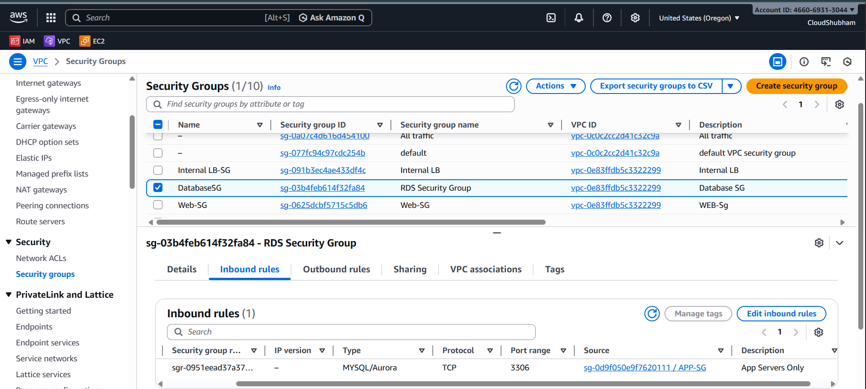

App ( Logic layer )Load Balancer will handle only internal traffic which is coming ……………

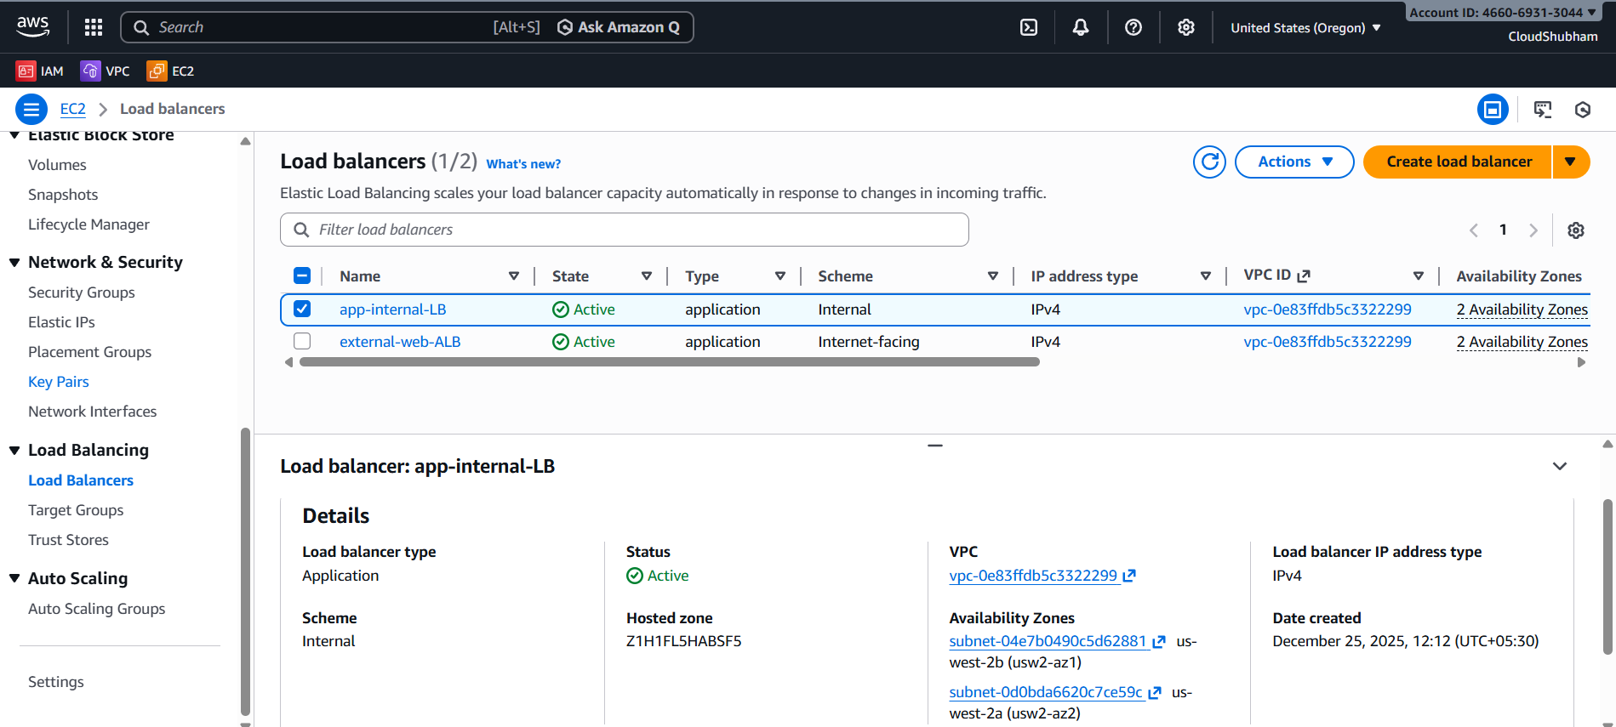

There is a target group associated with Internal LB which will handle traffic or request from Instances on Web tier working :
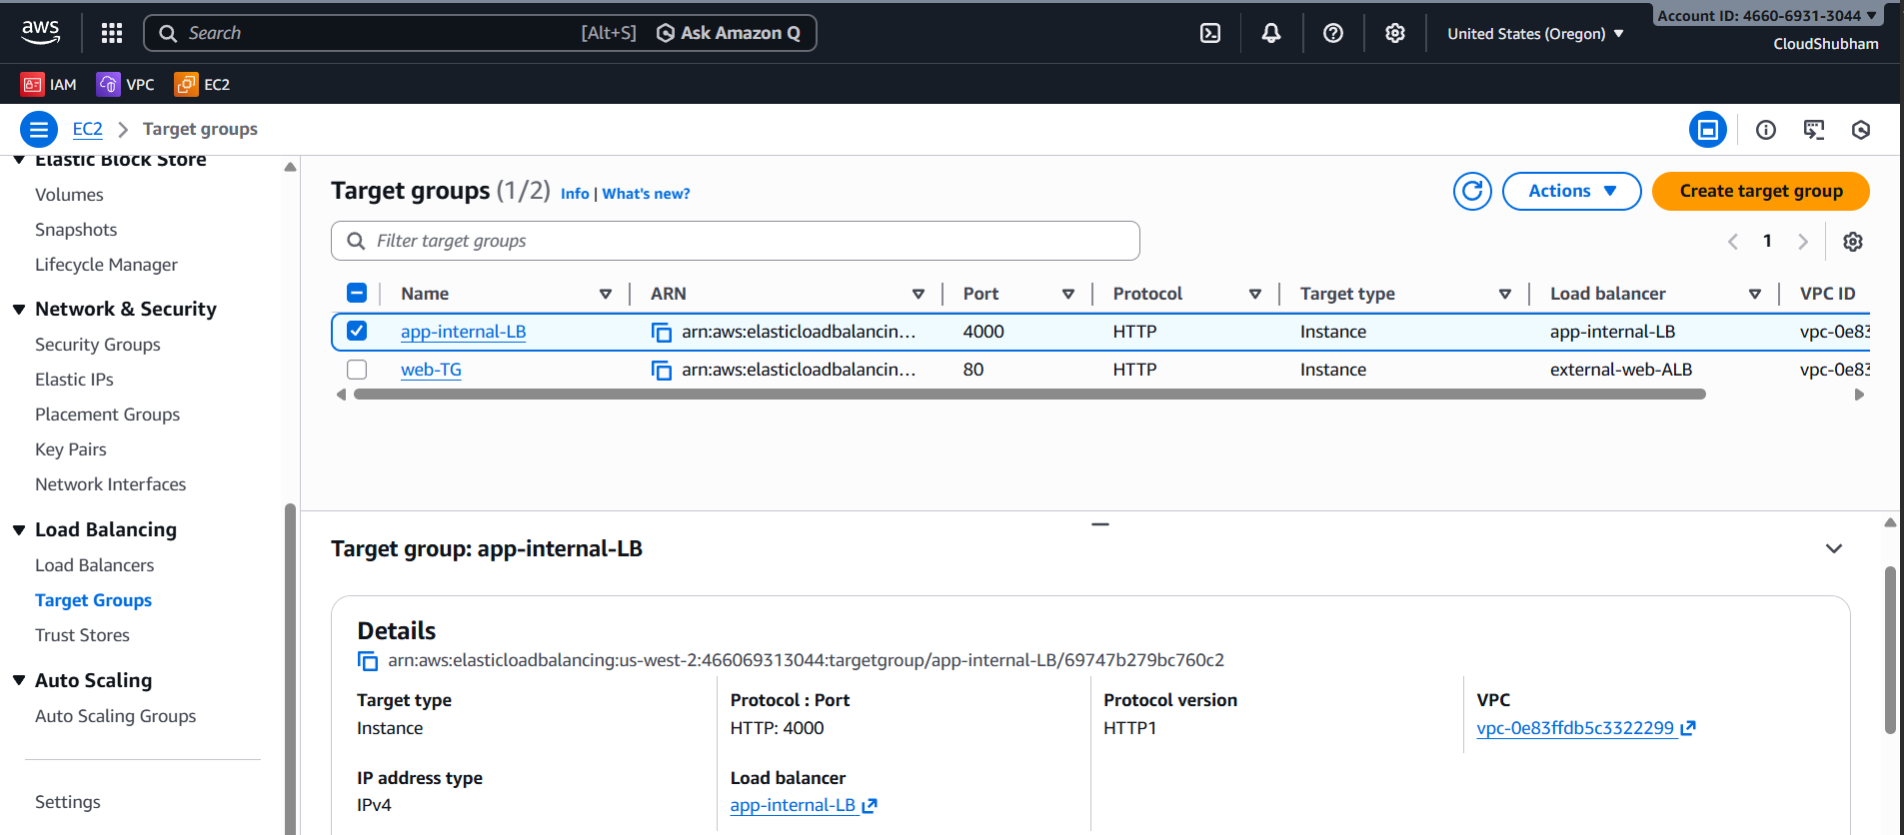

External LoadBalancer ALB has an ALB facing internet and which handles traffic from users directly:
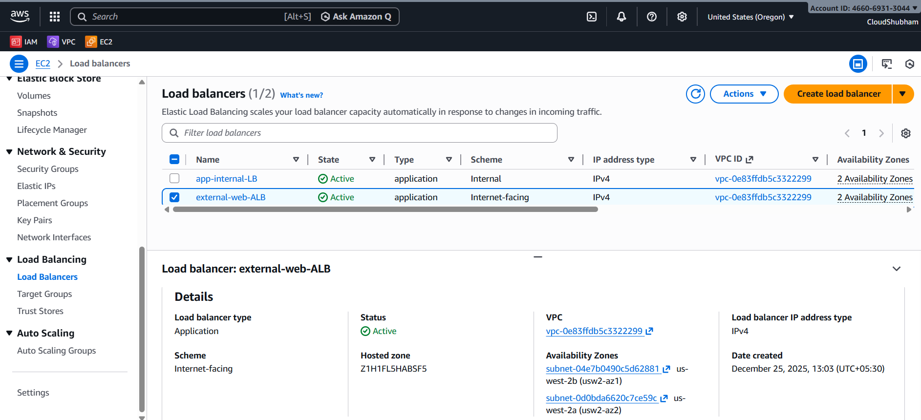

There is a target group which will handle HTTP ( 80 ) port incoming traffic from users :
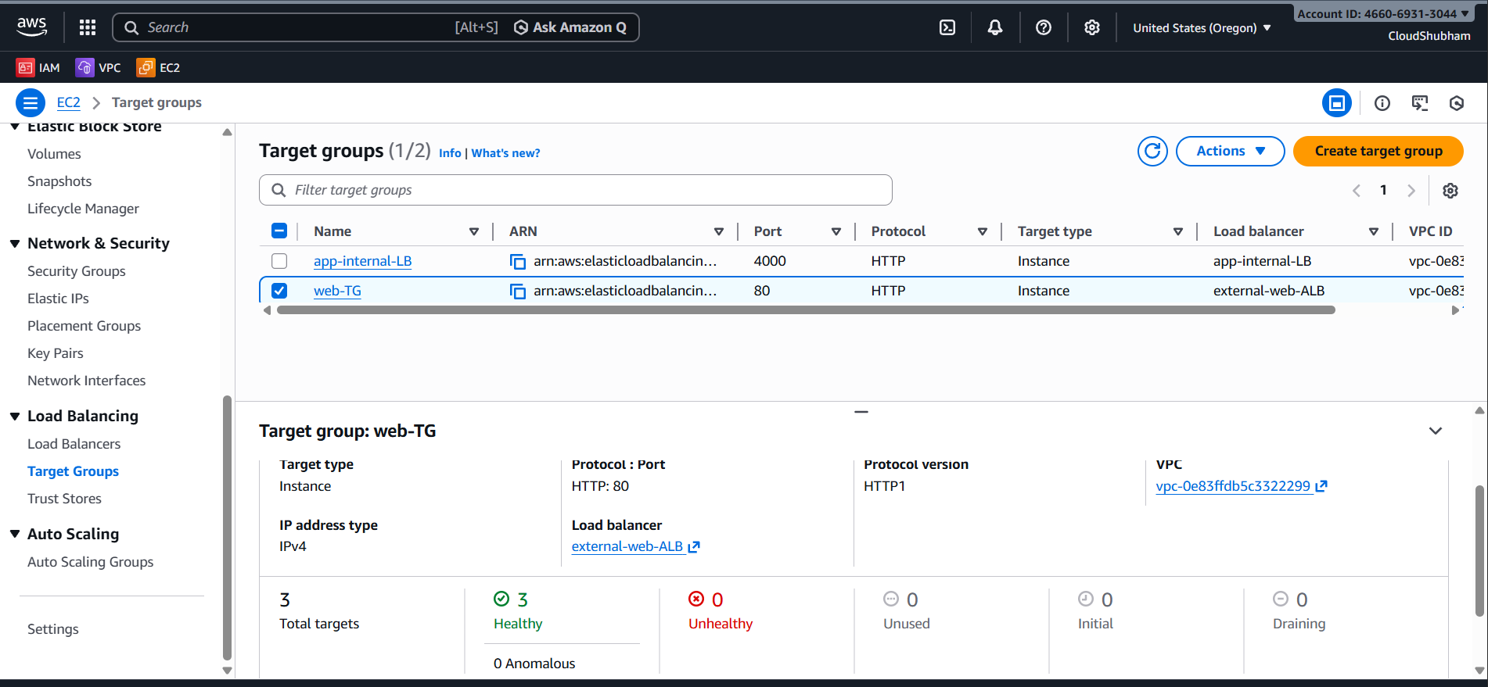

There is an AMI creation using the Instances available Currently and this AMI should be used in Auto Scaling Group:
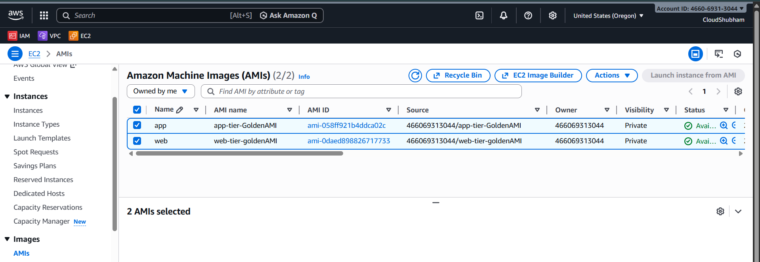
There is an Launch Template which will be used in ASG to launch an instance with associated AMI-1 :
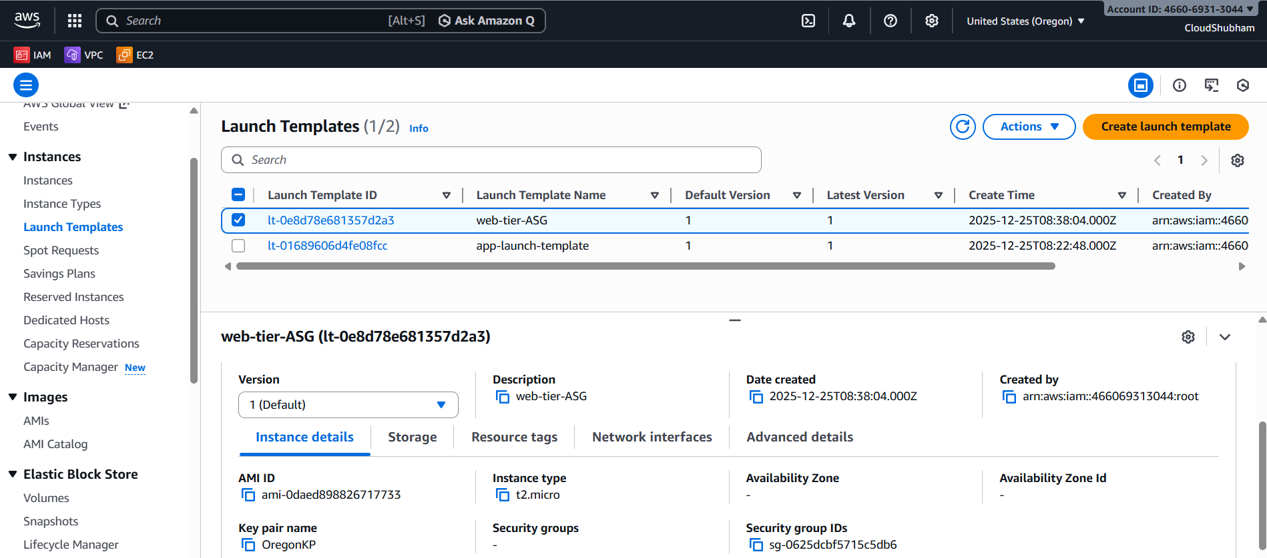
There is an another Launch Template making which is associated with another ami id to launch instances in ASG :
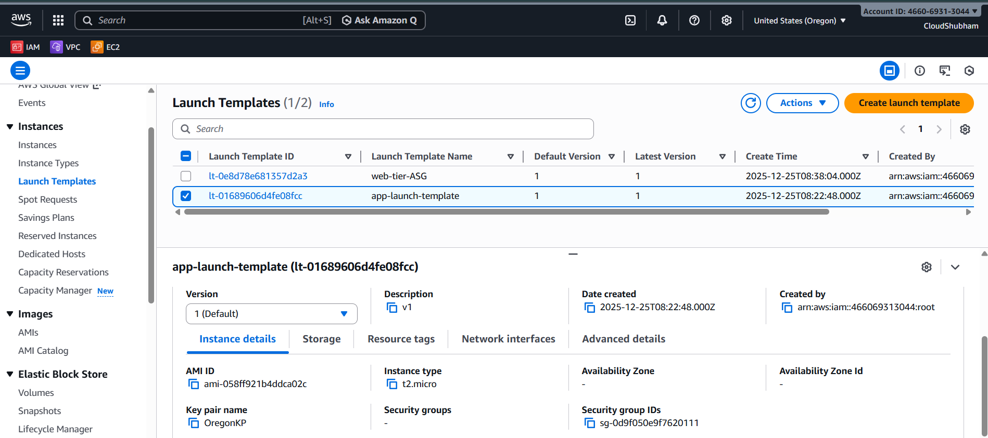

Making an App Tier ASG which will scale up and down as load comes to app tier Instances :
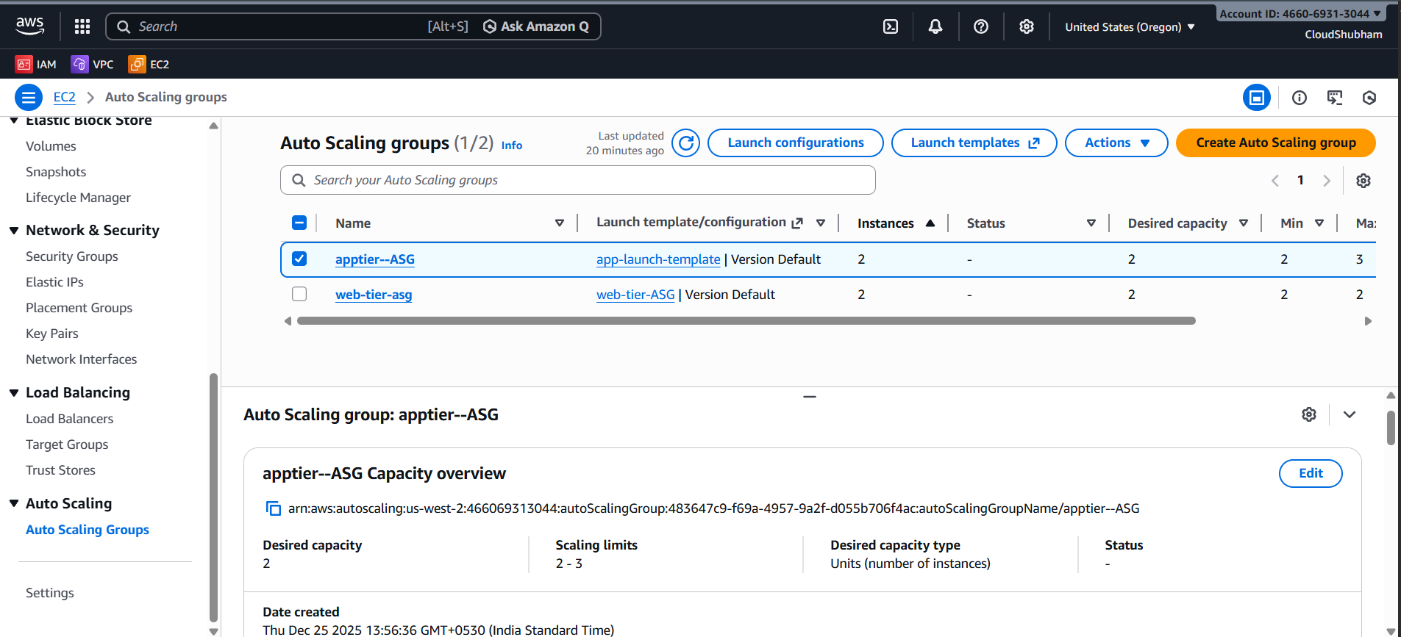

Making an ASG for web tier to handle traffic easily by Scaling Up and down the instances in a web Tier:
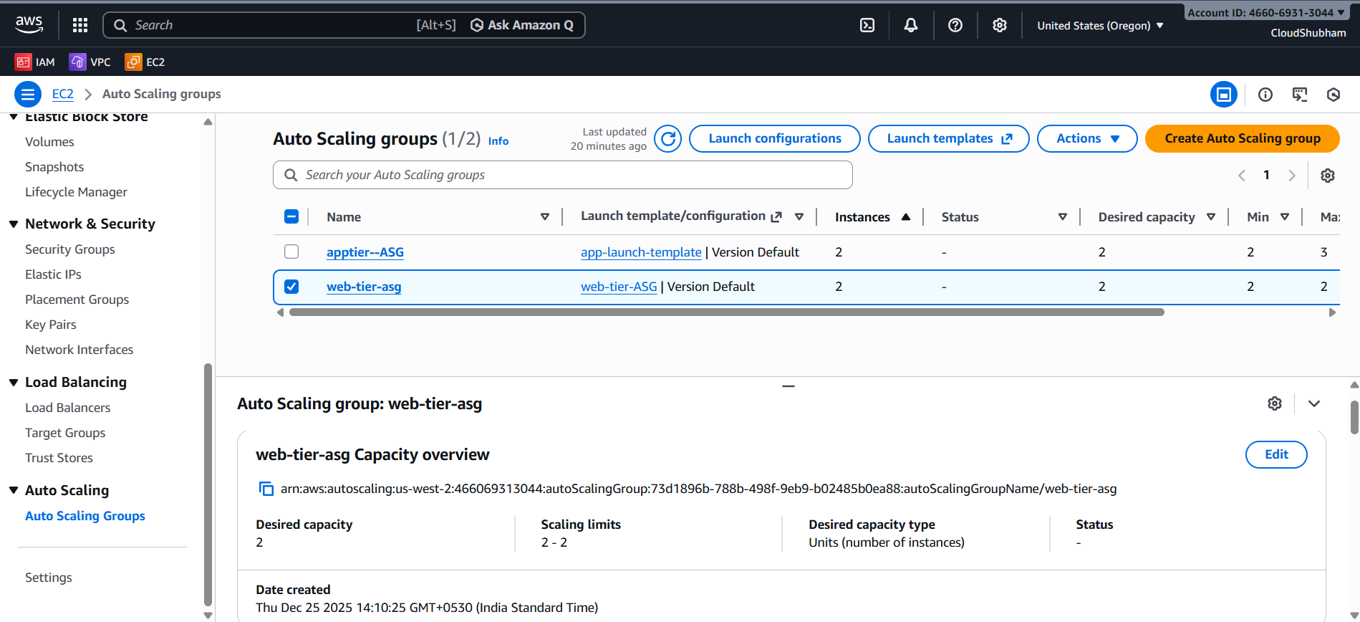

This is an Intitial servers which were used to make an AMI also and 1 for Web tier and 1 for APP tier :
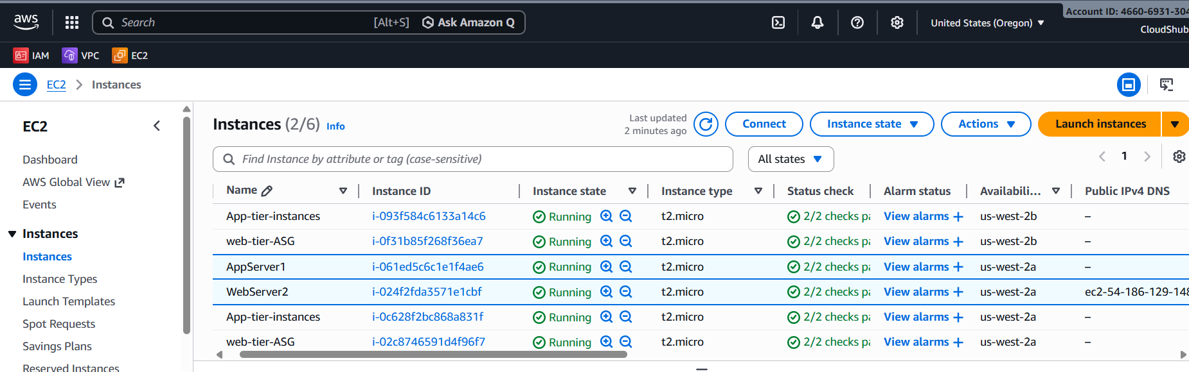

This are servers which are scaled up by ASG 2 for web tier and 2 for app tier :
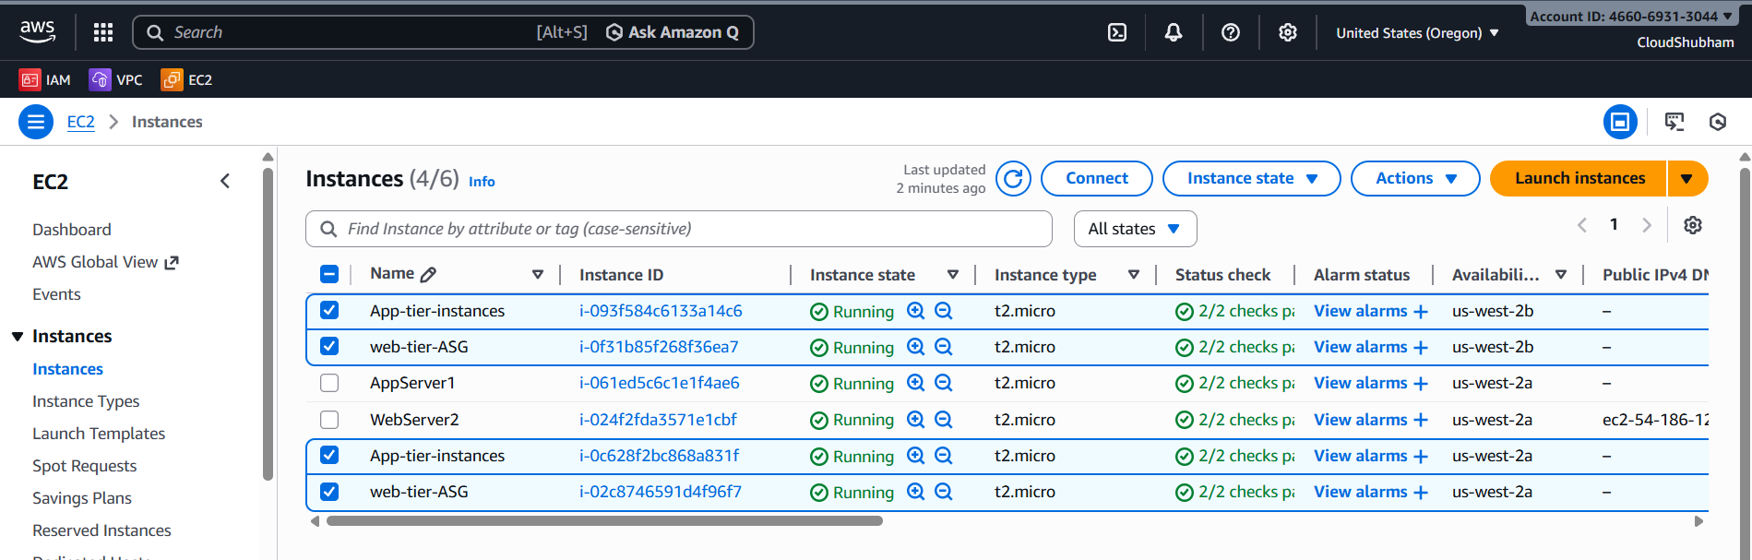

There is an role associated in IAM role for RDS
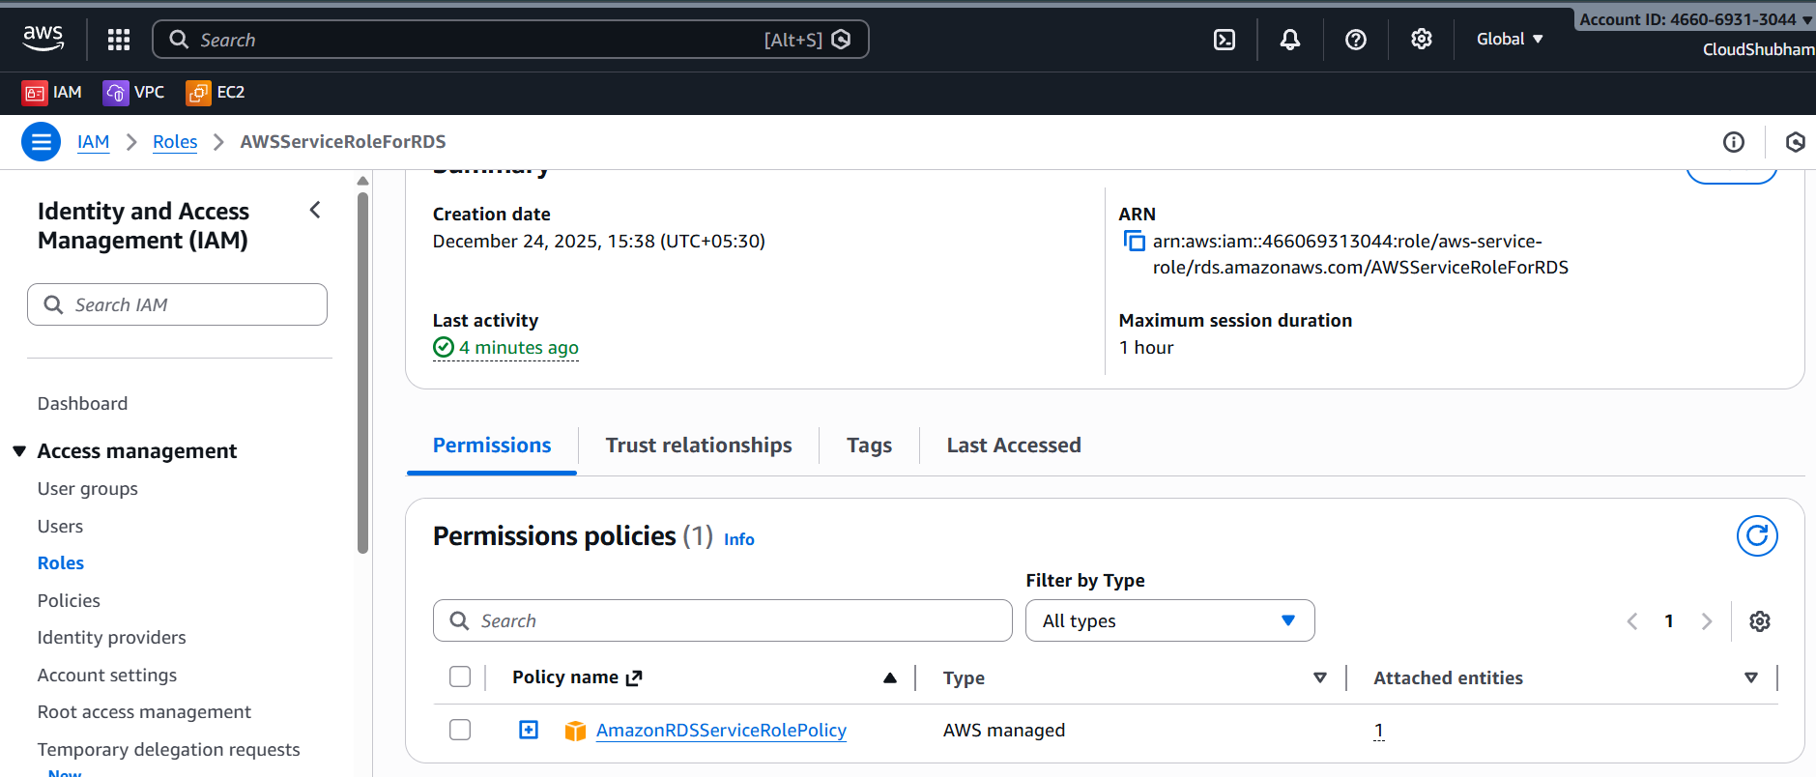

Web Tier Session Manager using NGINX on this:
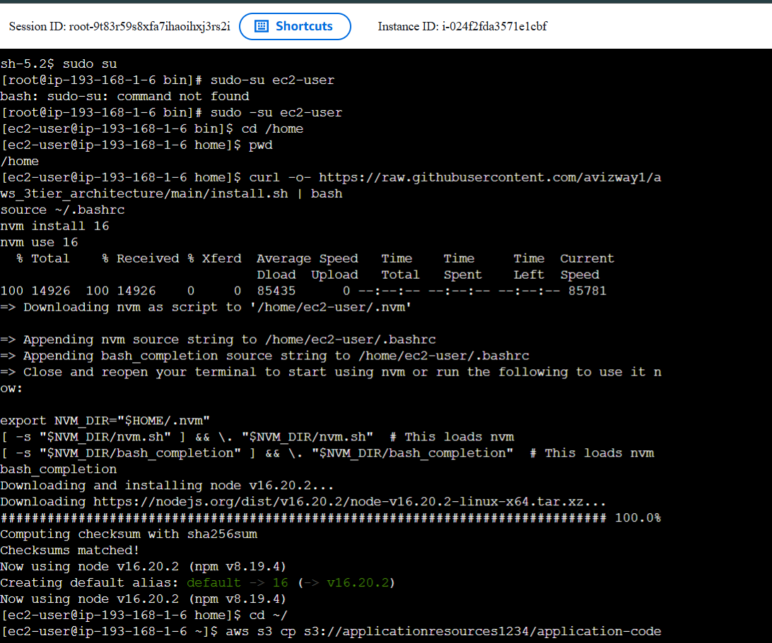

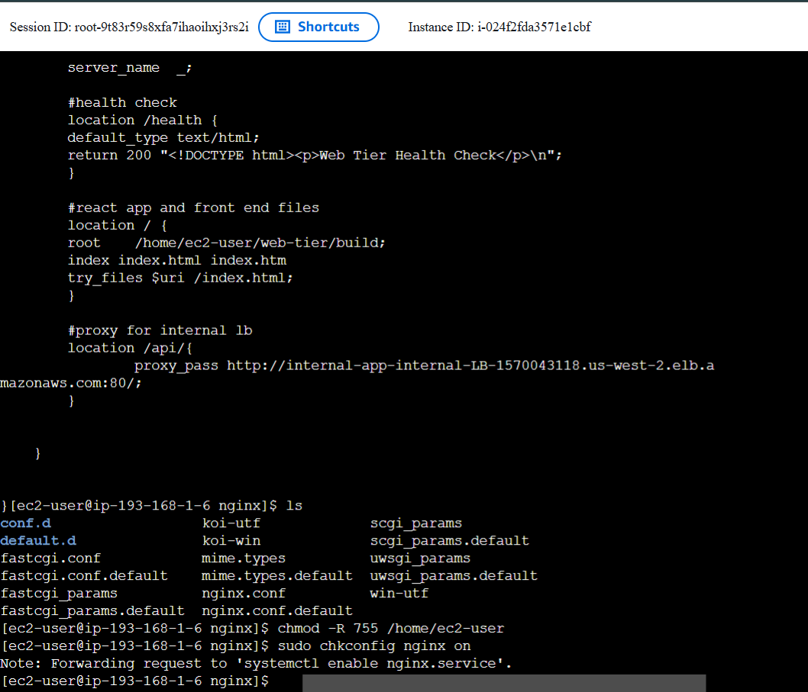

App tier Session Manger Cli using SQL on this siode
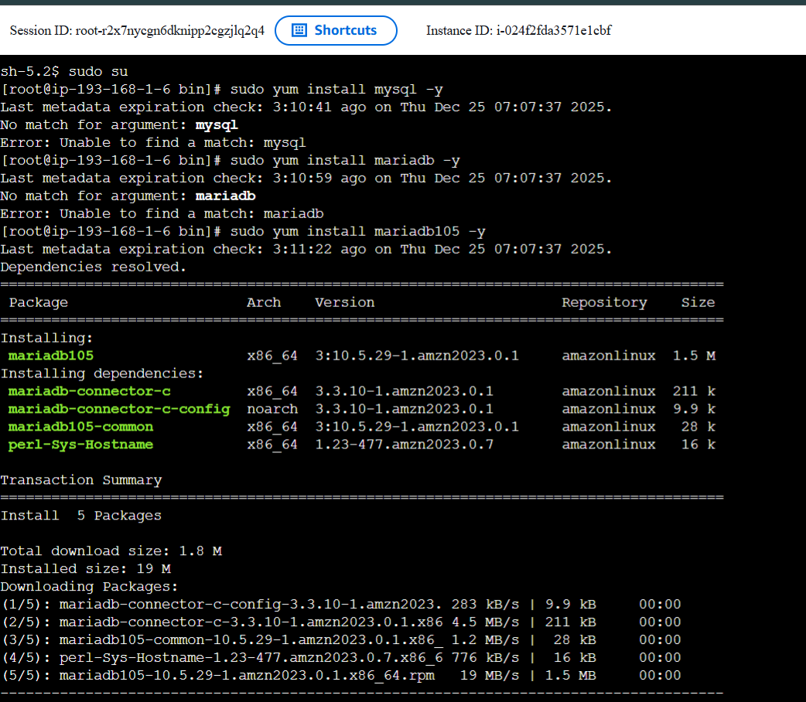

Connecting to MongoDB Database :
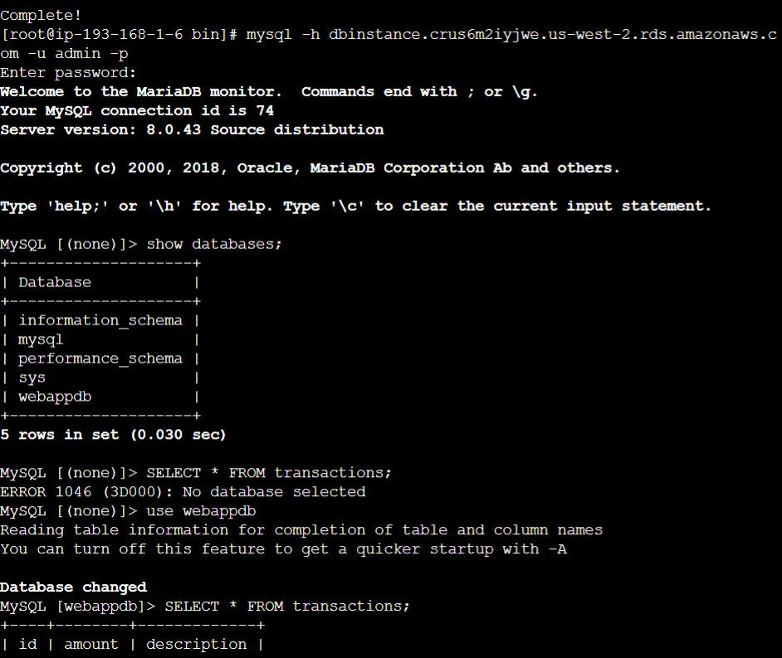

There are different volumes which was auto scaled :

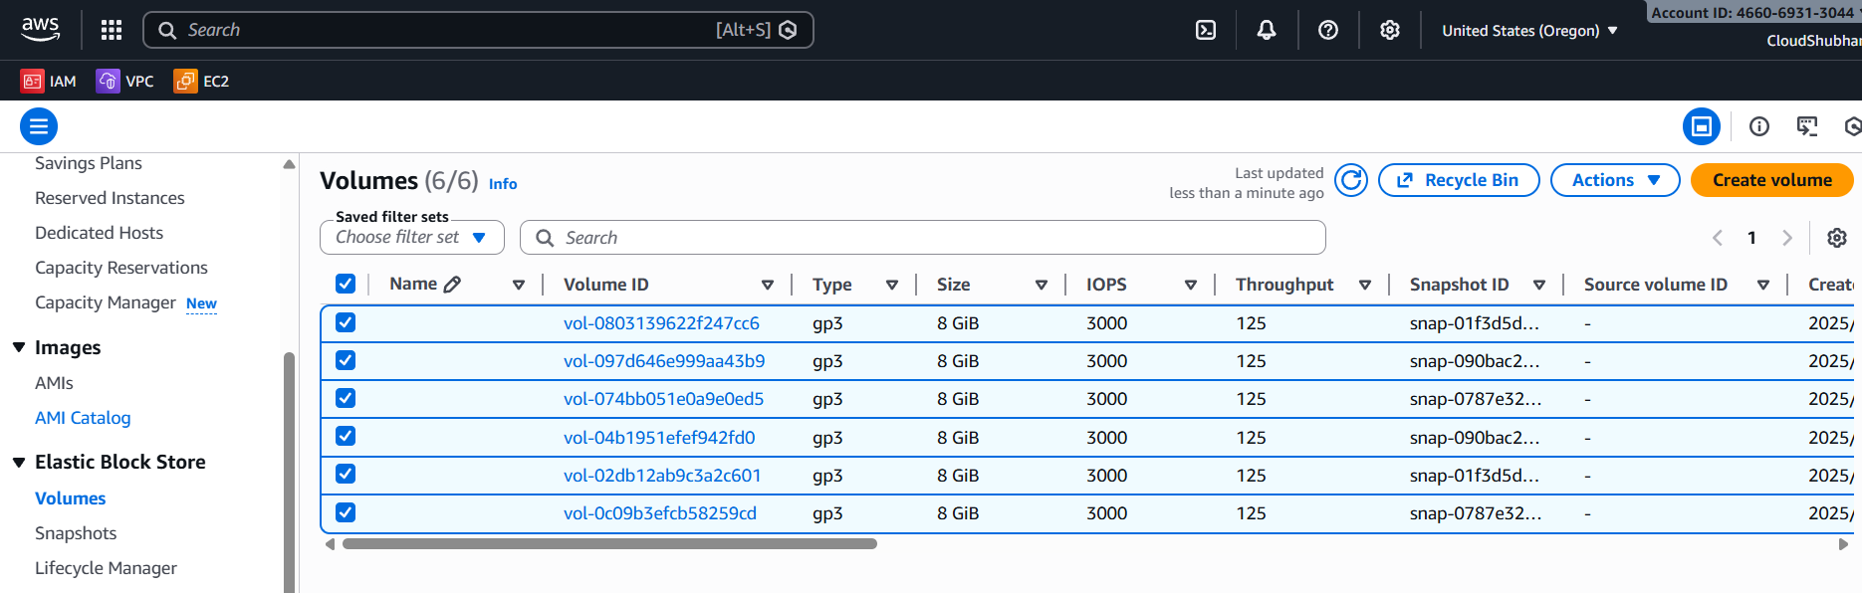

There is snapshots created for 2 Volumes :
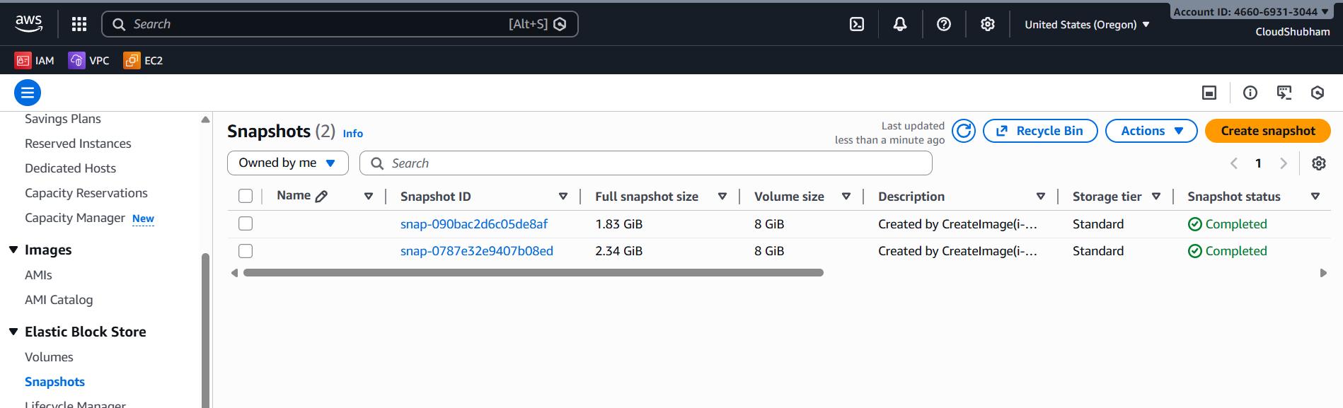

The application code is uploaded to S3 bucket :
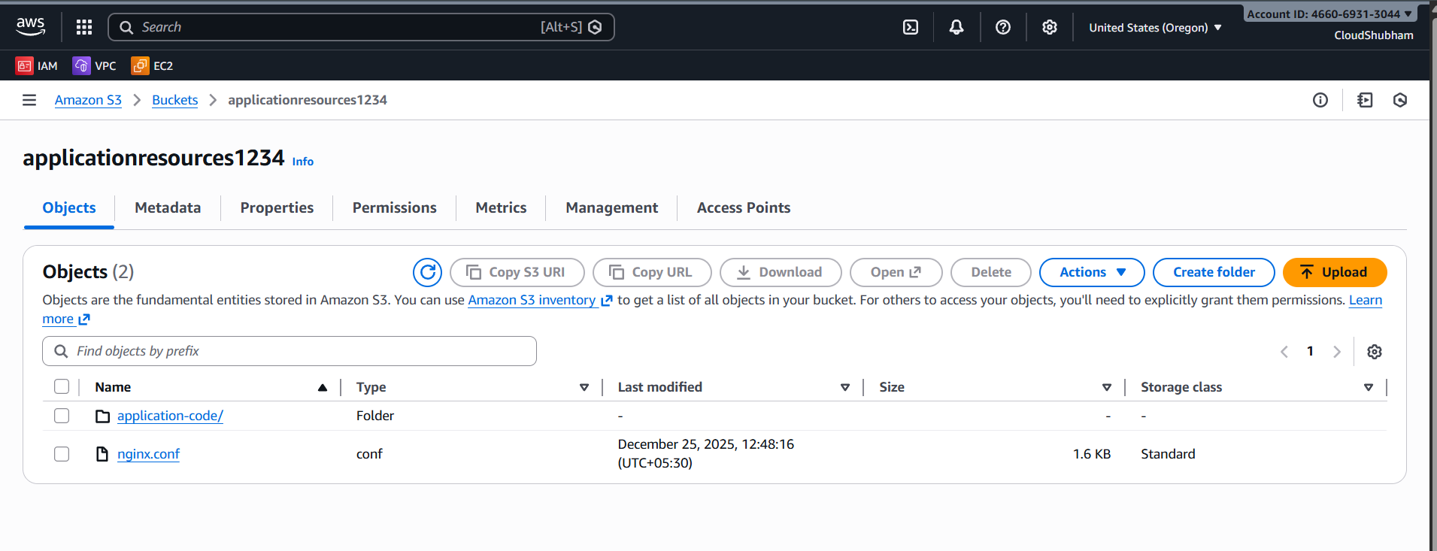

Inside the folder of application code :
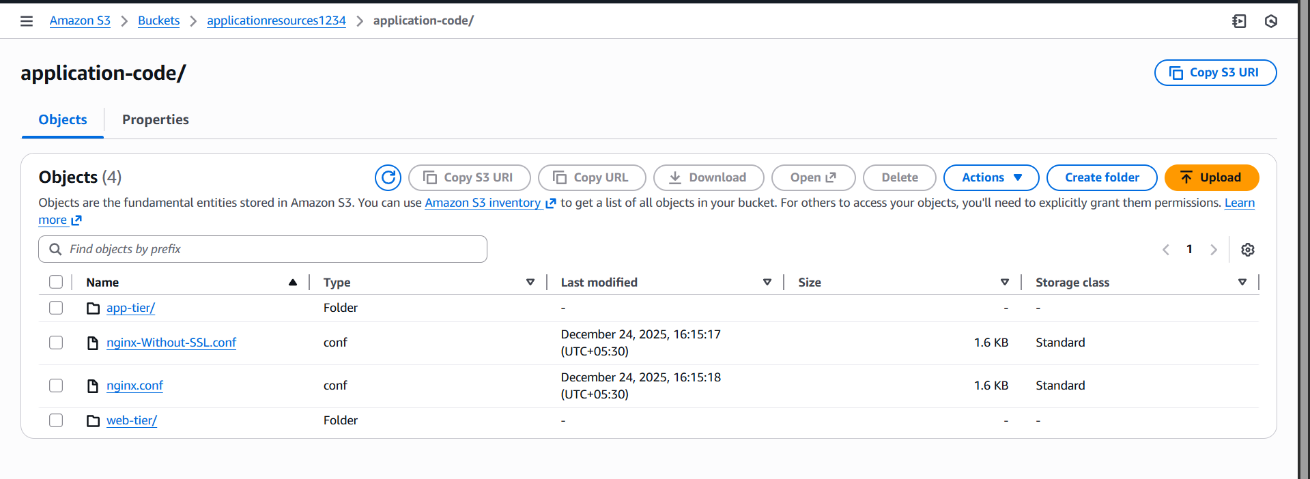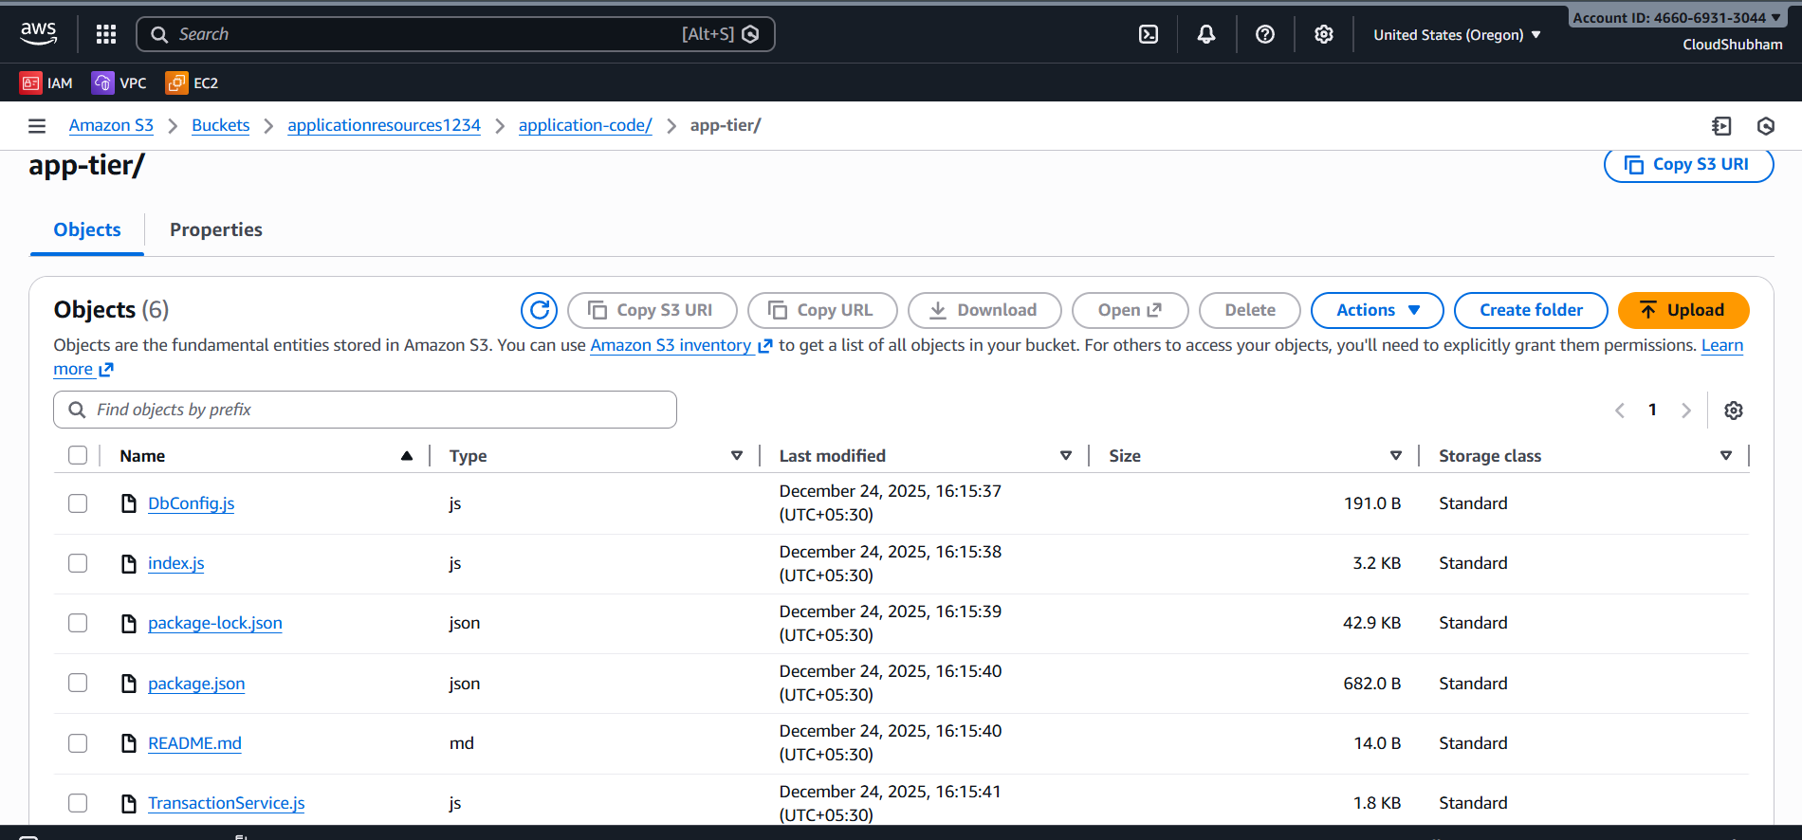
This is a file in which the code for Web tier is there for Fromtent web :
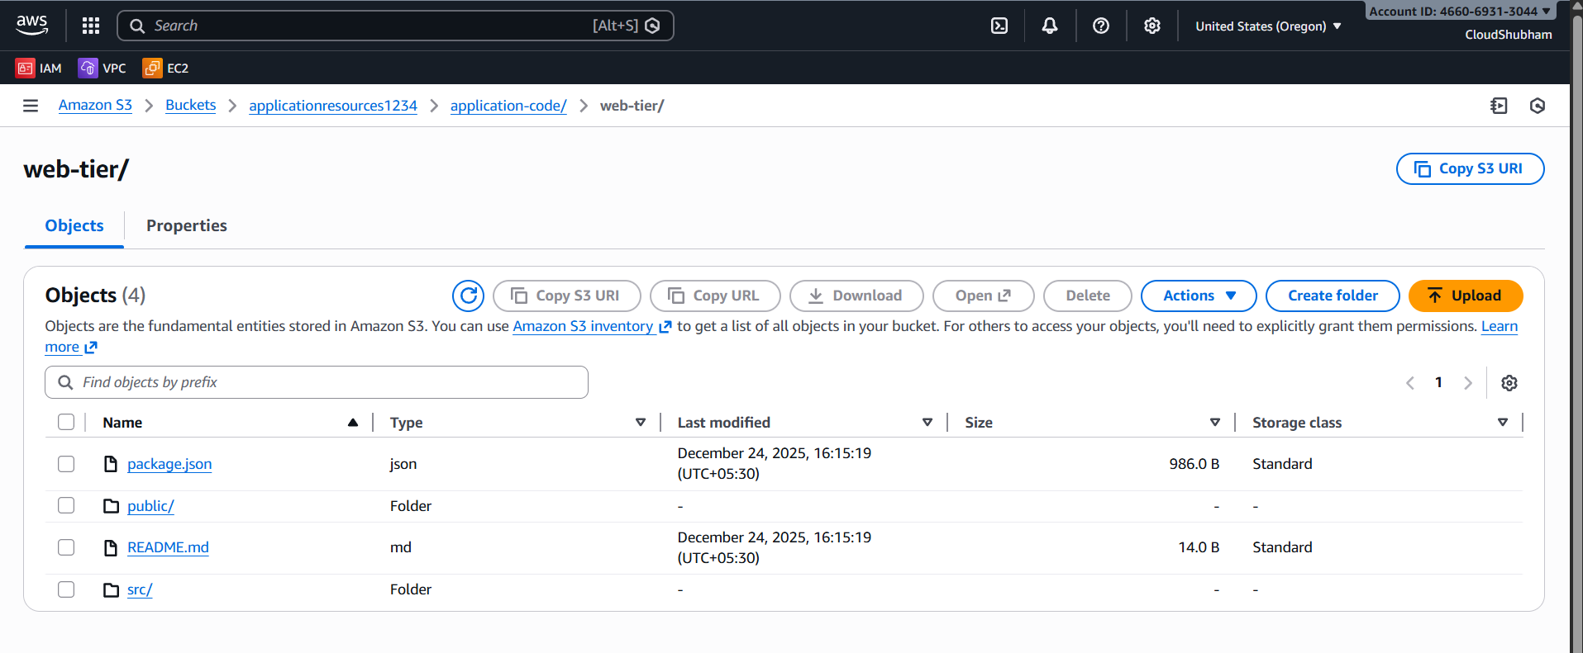

Index.html file frontend web:
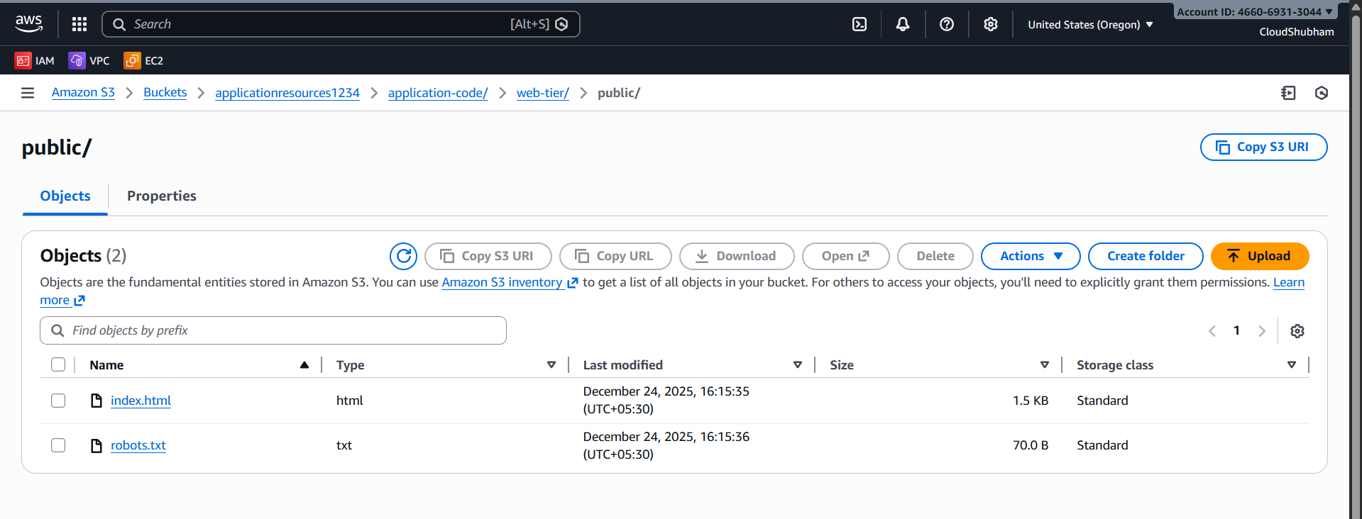
RDE is sucuessfully created
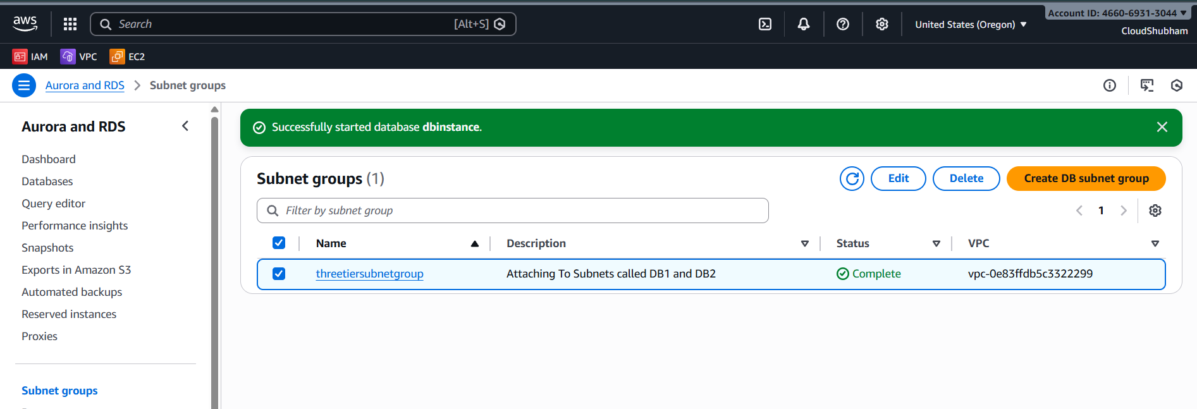

Database is available :
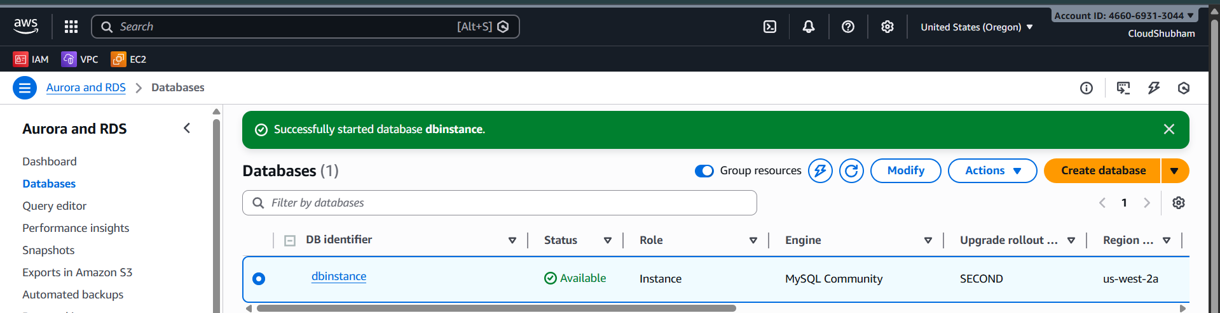

Frontend web
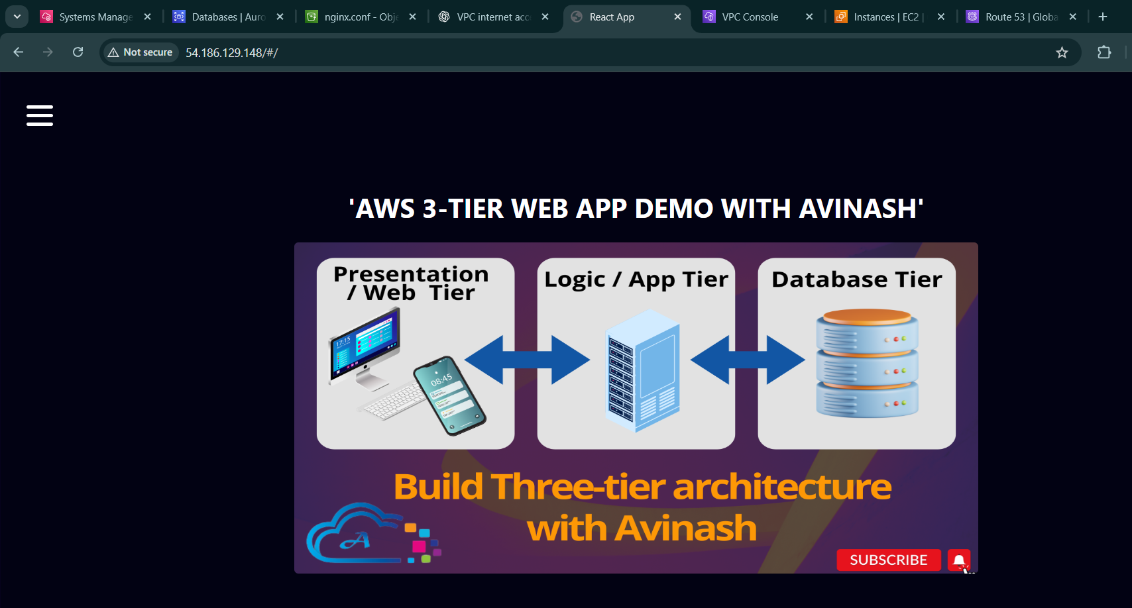

We can see the history of Transaction w.r.t to Items and we can add also here :
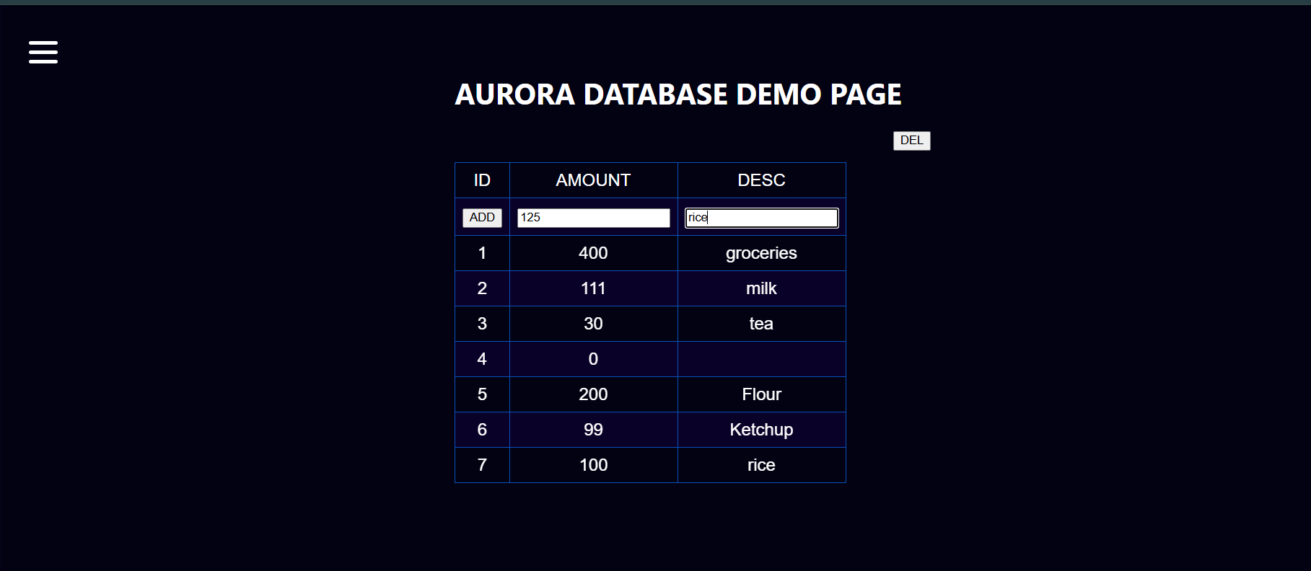

Added Rice item :
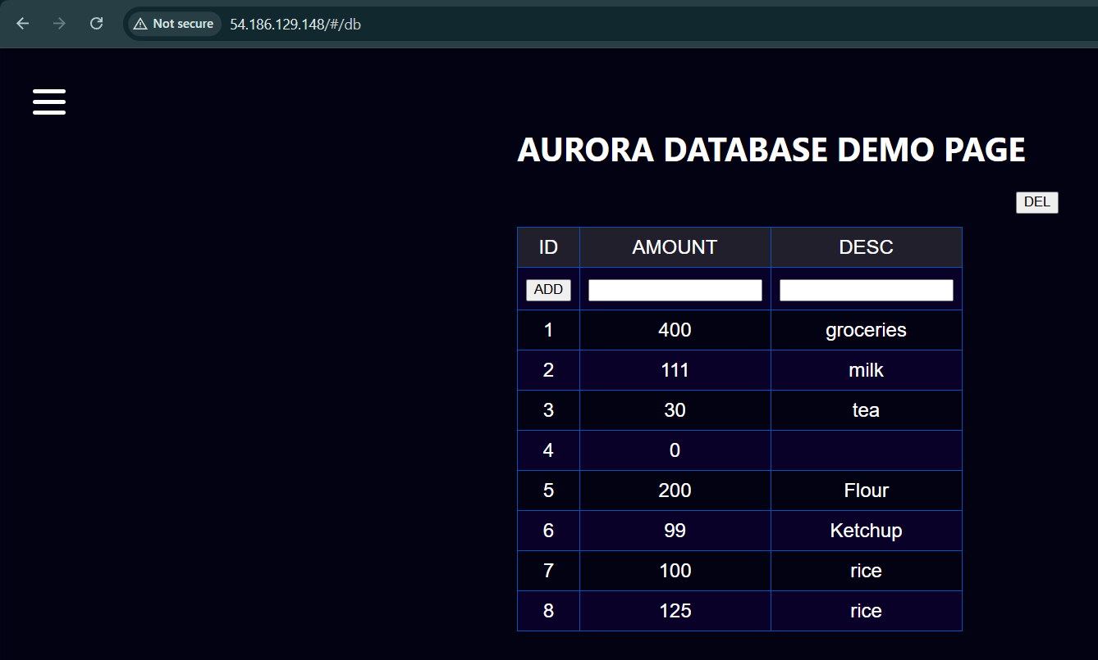

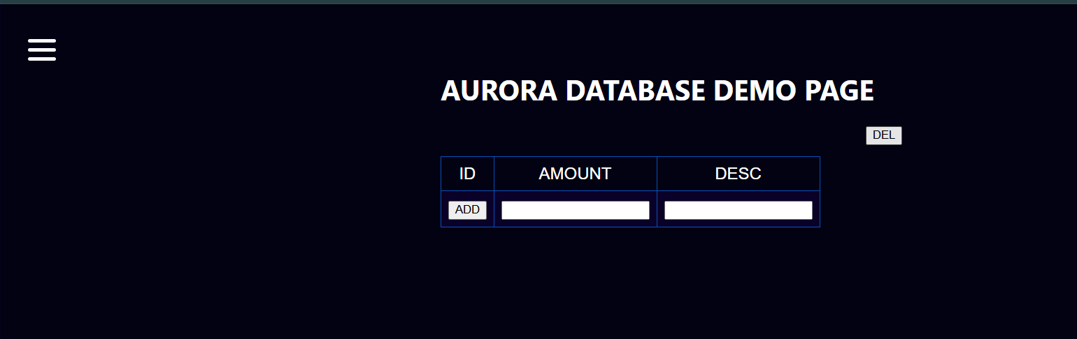
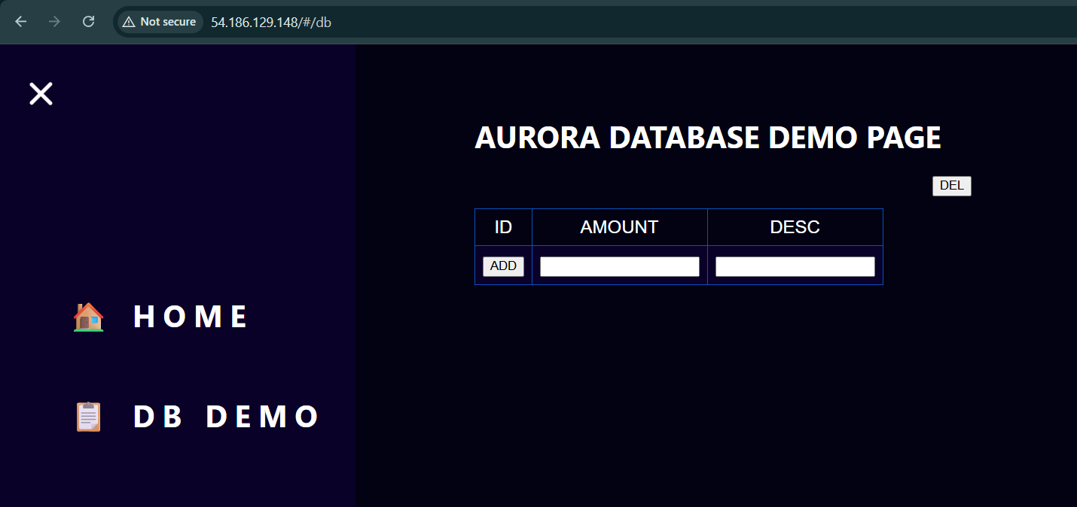
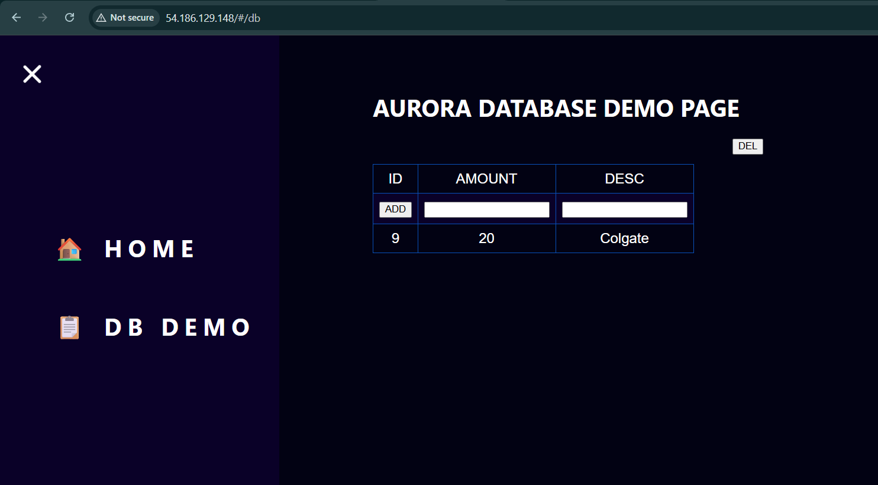

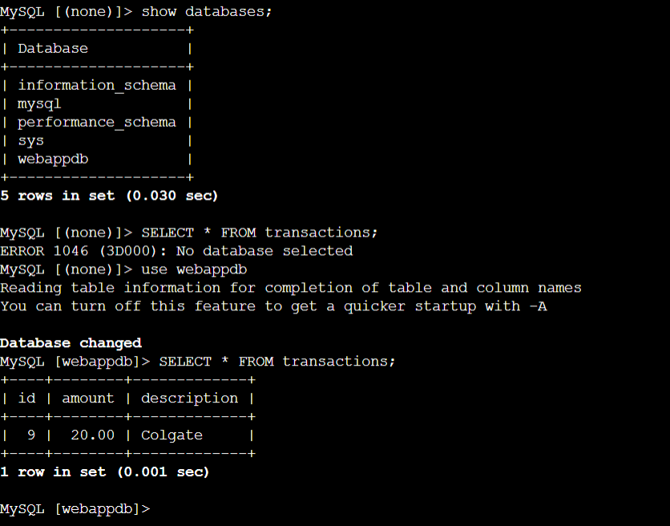

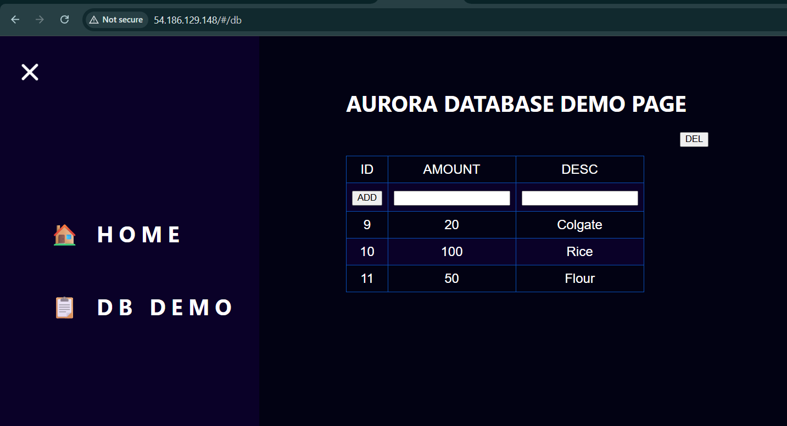

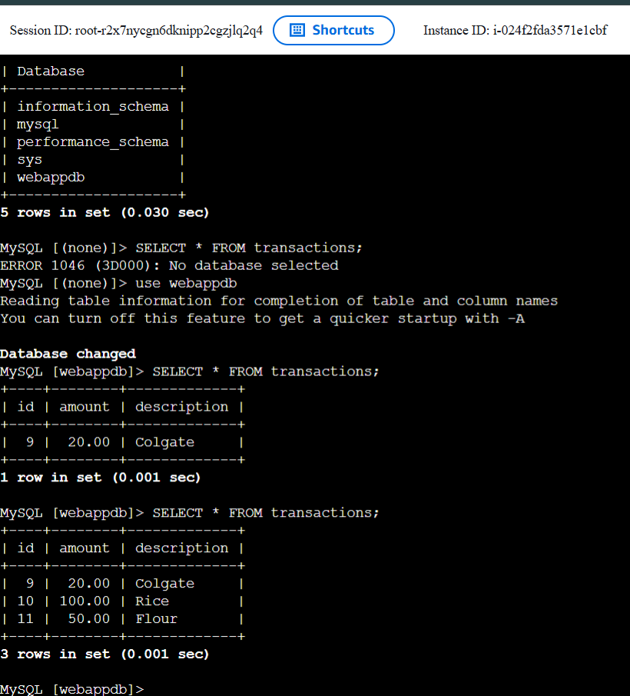

On CLI to show it update on UI also
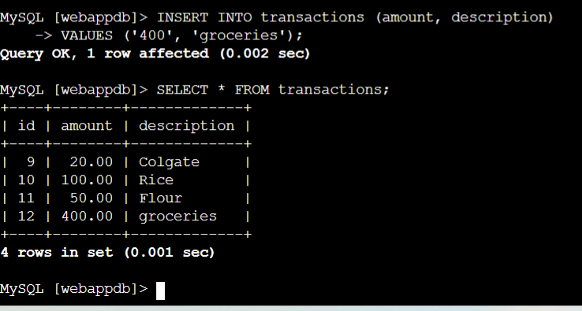
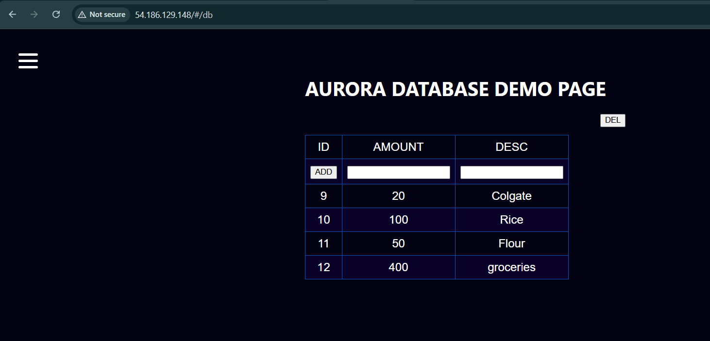

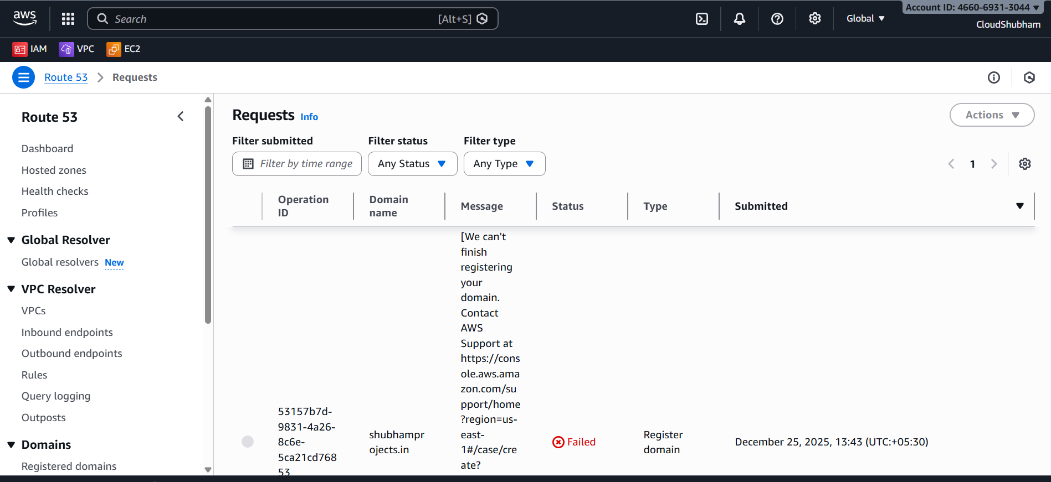

1. What interviewers actually want to see (very precise)
They do not want to see every AWS screen. They want proof that you understand architecture, security, scalability, and cost.
A. Architecture clarity (this is number one)
You must show one clean architecture diagram with:
- VPC (CIDR shown)
- Public subnets:
  - ALB
  - NAT Gateway
- Private subnets:
  - EC2 (ASG)
  - RDS
- Internet Gateway attached to VPC
- Security Group flow (who can talk to whom)
If you can explain this diagram clearly, 50% of the interview is won.

B. Traffic flow (must explain in 30 seconds)
You should be able to say this smoothly:
User hits the ALB → ALB forwards to EC2 in private subnet → EC2 fetches static assets from S3 and data from RDS → NAT allows outbound updates → response goes back through ALB
Interviewers love clear flow explanation.

C. Security decisions (very important)
Show and explain:
- EC2 in private subnet
- No public IP on EC2
- ALB is the only public entry point
- RDS security group allows traffic only from EC2 SG
- NAT used only for outbound internet
- IAM role attached to EC2 for S3 access (not access keys)
Even screenshots of security group rules are very powerful.

D. Scalability and availability
You must highlight:
- Auto Scaling Group across multiple AZs
- ALB health checks
- RDS Multi-AZ (if enabled)
- S3 is inherently highly available
Explain why each exists.

E. Cost awareness (interview gold)
Mention things like:
- NAT Gateway cost awareness
- ASG scaling limits
- Using S3 for static assets instead of EC2
- RDS instance size chosen carefully
This shows real world thinking.

2. How to present it (screenshots alone are not enough)
❌ Screenshots only in a Word document
This is okay, but it looks basic and messy if not structured.
Interviewers prefer one of these:

✅ Best option (recommended)
GitHub repository + short README
Structure:
aws-3tier-architecture/
│
├── architecture/
│ └── architecture-diagram.png
│
├── screenshots/
│ ├── vpc.png
│ ├── alb.png
│ ├── asg.png
│ ├── rds.png
│ └── security-groups.png
│
├── code/
│ ├── web-app/
│ └── user-data.sh
│
└── README.md
In README, explain:
- Architecture
- Flow
- Security
- Scaling
- Known limitations
This looks professional.

✅ Word or PDF (acceptable if done cleanly)
If you must use Word:
- One page per section
- Very short text
- Clear screenshots with labels
- Architecture diagram on first page
Convert to PDF before sharing.
3. Route 53 and ACM issue (how to explain it properly)
This is NOT a negative if explained correctly.
Say this confidently:
Domain and SSL were planned using Route 53 and ACM. Domain registration was blocked due to registrar verification issues for .in domains. The architecture already supports Route 53 and HTTPS, and adding them is a configuration step, not a design change.
You can also show:
- Hosted zone created (if any)
- Planned ALB HTTPS listener
- Planned ACM certificate region (us-east-1 for CloudFront)
This shows foresight.

4. What NOT to over show
- IAM console clutter
- Billing pages
- Every EC2 detail
- Random logs
Focus on design and decisions.

5. What will impress the interviewer most
If you can answer these confidently:
- Why EC2 is private
- Why ALB is public
- Why NAT is needed
- Why SG over NACL
- How scaling works
- How DB is protected
Screenshots then become secondary.

Clear recommendation for you
- Put code in GitHub
- Create one clean architecture diagram
- Add important screenshots only
- Write a short README
- Explain Route 53 + ACM as planned features
You are absolutely on the right track. This is a strong fresher-level to junior-level cloud project.

