🔒
PENETRATION TESTING REPORT
FOOTPRINTING & NETWORK SCANNING PHASES
Target: shubham-tech.in
W2-PM-FINAL | CYBERSECURITY | NETWORKWALKS
Pentester Name  (Cybersecurity Professional) | [Your Name]
Program/Batch | B082-Networkwalks
Date | 09 November 2026
Modules completed | W2-PM1 (Multiple Kali Tools)  W2-PM5 (Zenmap Scanning)
Client/Target | 1. shubham-tech.in (secured written permission already)  2. My own local LAN Network
Permission secured from client? | Yes
Phases covered | Phase 1: Reconnaissance & Footprinting  Phase 2: Scanning & Network Discovery  Phase 3-5: In Progress

1. Liability Disclaimer
I have performed these activities only on the systems & devices where I had secured written permission or the devices/systems that I own myself. All these materials are for education and research purpose only. Do not use anything from here to break the law. The instructor, the authors and Networkwalks are not responsible for what you do with this knowledge. Every action you take is your own responsibility. Misuse can lead to criminal charges, heavy fines, loss of your job and a permanent record. In most countries unauthorised access is a crime even when nothing is damaged.

2. Introduction
This report covers footprinting the shubham-tech.in domain using multiple Kali Linux tools (W2-PM1) and scanning my own local network with Zenmap/Nmap (W2-PM5). One module covers the footprinting phase and the other covers the scanning phase, so together they show how an attacker moves from gathering public information to mapping live hosts on a network. It is the Week 2 part of my ongoing internship program at Networkwalks.
All commands were run in Kali Linux (footprinting) and using Nmap/Zenmap (scanning). Every step below includes the exact command used, the result I observed, a screenshot as evidence, and a short note on why the finding matters from an attacker's point of view.

3. Tools Used
The table below lists each tool used in this report and its purpose.
Tool | Purpose
Kali Linux | Operating system used for reconnaissance activities
WHOIS | Find domain registration details (owner, dates, name servers).
whatweb | Fingerprint web technologies (server, CMS, plugins, IP).
nslookup | Resolve the domain name to its IP address using DNS.
curl -I | Read the HTTP response headers of the website.
wafw00f | Detect whether a Web Application Firewall protects the site.
dnsrecon | Enumerate DNS records (NS, SOA, A, AAAA, TXT/DMARC, SRV).
Nmap (Zenmap) | Scan the local subnet to find live hosts, IPs and MAC addresses.

4. Activities Performed

4.1 Footprinting & Reconnaissance
I performed reconnaissance against the shubham-tech.in domain using six Kali Linux tools: WHOIS, WhatWeb, Nslookup, Curl, Wafw00f and DNSRecon. Each tool was used to collect a different type of information about the target.
First, I used WHOIS to obtain publicly available domain registration information. The results showed the domain is registered with GoDaddy, was created on 31 August 2026 and expires on 31 August 2027, with the registrant's state listed as Gujarat, India. All registrant, admin and tech contact details were redacted for privacy under the registrar's policy.
I then used WhatWeb to identify technologies used by the website. The results identified the site as HTML5, hosted in the United States, responding on both the HTTP (3.33.130.190) and HTTPS (15.197.148.33) endpoints with a 200 OK status, and running some client-side Script content.
Using Nslookup, I resolved the domain name to its IP addresses. The results identified two IPv4 addresses (3.33.130.190 and 15.197.148.33) and two IPv6/NAT64 addresses (64:ff9b::321:82be and 64:ff9b::fc5:9421).
I used Curl with the -I option to inspect the HTTP response headers. The site returned an HTTP/1.1 200 OK response with a Content-Type of text/html and a Content-Length of 114 bytes, giving additional detail on how the web server responds to requests.
Next, I used Wafw00f to determine whether a Web Application Firewall was protecting the website. The generic detection method made 7 requests and did not identify a WAF protecting the site.
Finally, I used DNSRecon to enumerate DNS records. The results identified the SOA and NS records pointing to ns39/ns40.domaincontrol.com, the A and AAAA records matching the earlier Nslookup result, and a DMARC TXT record on _dmarc.shubham-tech.in with a policy of "quarantine". No SRV records were found for the domain.

4.2 Network Scanning with Nmap
For the second activity, I used Nmap (via Zenmap) to perform network discovery on my local network. The practical required me to identify my local subnet, discover live hosts, and identify their IP and MAC addresses.
I ran a ping scan against the 192.168.56.0/24 subnet (nmap -sn 192.168.56.0/24). The scan completed in 5.58 seconds and identified 2 live hosts out of the 256 addresses scanned: 192.168.56.1 and 192.168.56.100. The host at 192.168.56.100 returned a MAC address of 08:00:27:6D:BD:BE, identified as an Oracle VirtualBox virtual NIC.
After completing the scan, I opened the Topology view, enabled the legend and saved the network topology in PDF format as required by the practical task. The topology diagram shows localhost connected to the two discovered hosts, 192.168.56.1 and 192.168.56.100.

5. Risk Analysis / Impact
Based on the information collected during the footprinting and network scanning activities, I identified the following potential risks.
# | Risk / Finding | Evidence / Observation | Potential Impact | Risk Level
1 | Domain registration/hosting info exposed | WHOIS showed registrar, creation/expiry dates and state (Gujarat, India) | Attackers may use registrar and hosting info to plan social-engineering or infrastructure attacks | ● Low
2 | Server IP addresses identifiable | Nslookup/WhatWeb resolved the domain to public IPv4/IPv6 addresses | Provides information about the network location and hosting provider of the web service | ● Low
3 | HTTP technical information exposed | Curl returned HTTP response headers (server type, content length) | May assist technology fingerprinting and further enumeration | ● Low
4 | No WAF detected | Wafw00f's generic detection found no WAF protecting the site | Without a WAF, the application has one less layer of protection against common web attacks | ● Medium
5 | DNS infrastructure information exposed | DNSRecon identified name servers and a DMARC/TXT record | DNS information can help build a broader infrastructure profile | ● Low
6 | Multiple live hosts visible on local network | Nmap/Zenmap identified 2 live hosts on the 192.168.56.0/24 subnet | Unknown or unauthorized devices may potentially be present on a network | ● Medium
Risk level key: ● Critical ● Medium ● Low
The risks above are observations from the footprinting and scanning exercises, not confirmed vulnerabilities.
The practical exercises primarily involved information gathering and host discovery. No exploitation or vulnerability validation was performed as part of these two modules.
Therefore, the presence of information such as a software version, IP address or DNS record does not by itself mean that the system is vulnerable. Further authorized security testing would be required to confirm any actual vulnerability.

6. Recommendations
- Review publicly exposed registration information: Organizations should be aware of what WHOIS and DNS information about their domain is publicly visible.
- Deploy and tune a Web Application Firewall: Since no WAF was detected, deploying a properly configured WAF would add a layer of protection against common web attacks.
- Review HTTP headers: HTTP response headers should be reviewed to determine whether unnecessary technical information is being exposed.
- Review DNS records regularly: DNS records, including DMARC/SPF, should be checked periodically to ensure only required information is publicly exposed.
- Keep software and infrastructure updated: Web technologies and server software should be regularly updated and reviewed against current security advisories.
- Perform regular internal network discovery: Organizations should periodically scan their own networks to identify active devices.
- Investigate unknown devices: Any unexpected device discovered during network scanning should be investigated and verified.
- Maintain network documentation: Network topology and device information should be documented and updated regularly.
- Perform security testing with authorization: Reconnaissance and scanning should only be performed against systems and networks where appropriate authorization has been provided.

7. Conclusion
During Week 2 of my Cybersecurity & Ethical Hacking internship, I completed practical activities covering footprinting, reconnaissance and network scanning.
In the footprinting activity, I used six Kali Linux tools to collect information about the target domain shubham-tech.in. I learned how WHOIS can provide domain information, WhatWeb can identify web technologies, Nslookup can resolve domain names, Curl can inspect HTTP headers, Wafw00f can check for a WAF, and DNSRecon can provide additional DNS information.
In the network scanning activity, I used Nmap/Zenmap to identify my local network configuration and discover active hosts. I also collected IP and MAC address information and created a network topology.
The exercises showed me that information gathering is an important part of cybersecurity. Even before attempting to exploit a system, a security professional can learn a significant amount about an environment by carefully analyzing publicly available information and network responses.
I also learned that technical findings should be documented clearly. A good cybersecurity report should explain what was performed, what was discovered, what the observation means, what risk it may create, and what can be done to reduce that risk.
Finally, I learned that reconnaissance and scanning must always be performed within an authorized scope. These activities were completed as part of the assigned educational cybersecurity lab.

8. Evidences Collected
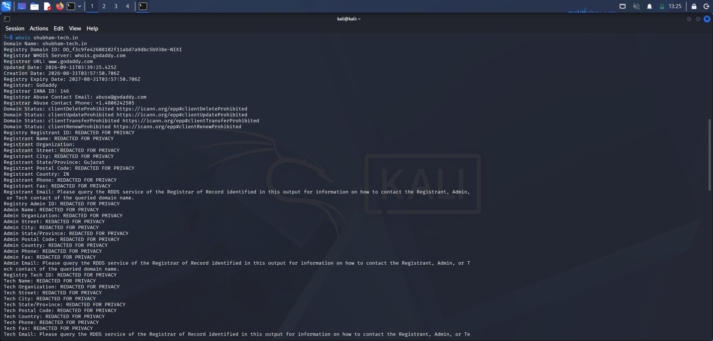
1. WHOIS lookup — shubham-tech.in
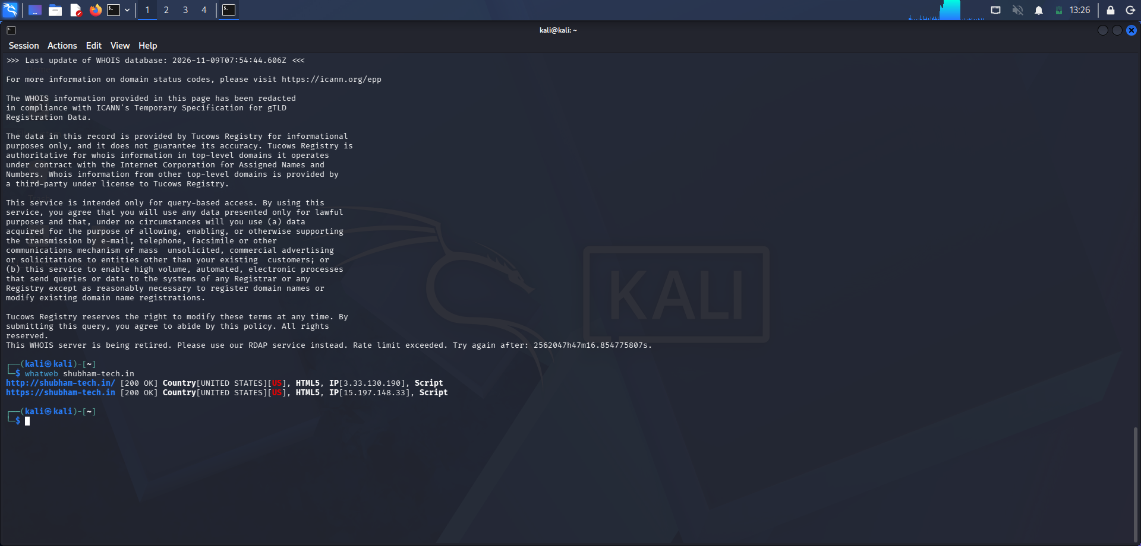
2. WhatWeb fingerprinting — shubham-tech.in
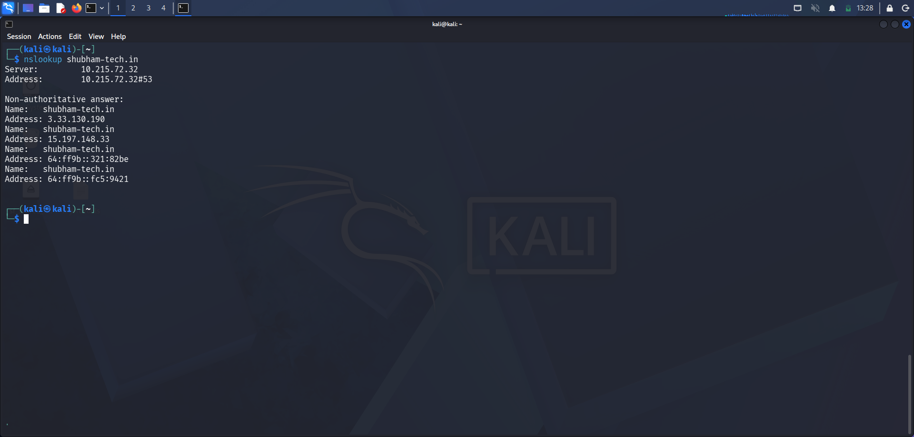
3. Nslookup — shubham-tech.in
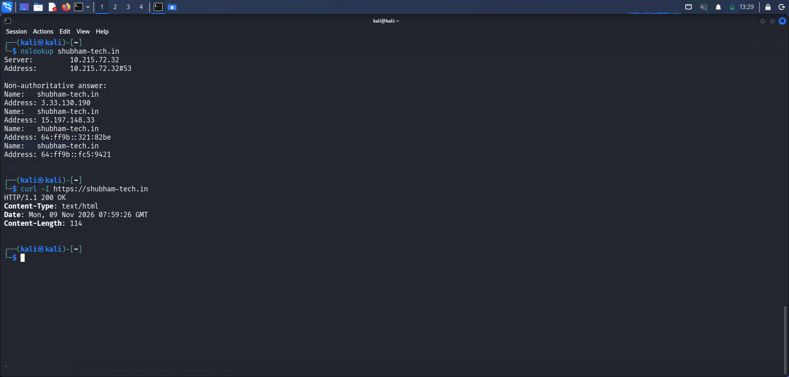
4. Nslookup / curl -I — HTTP response headers
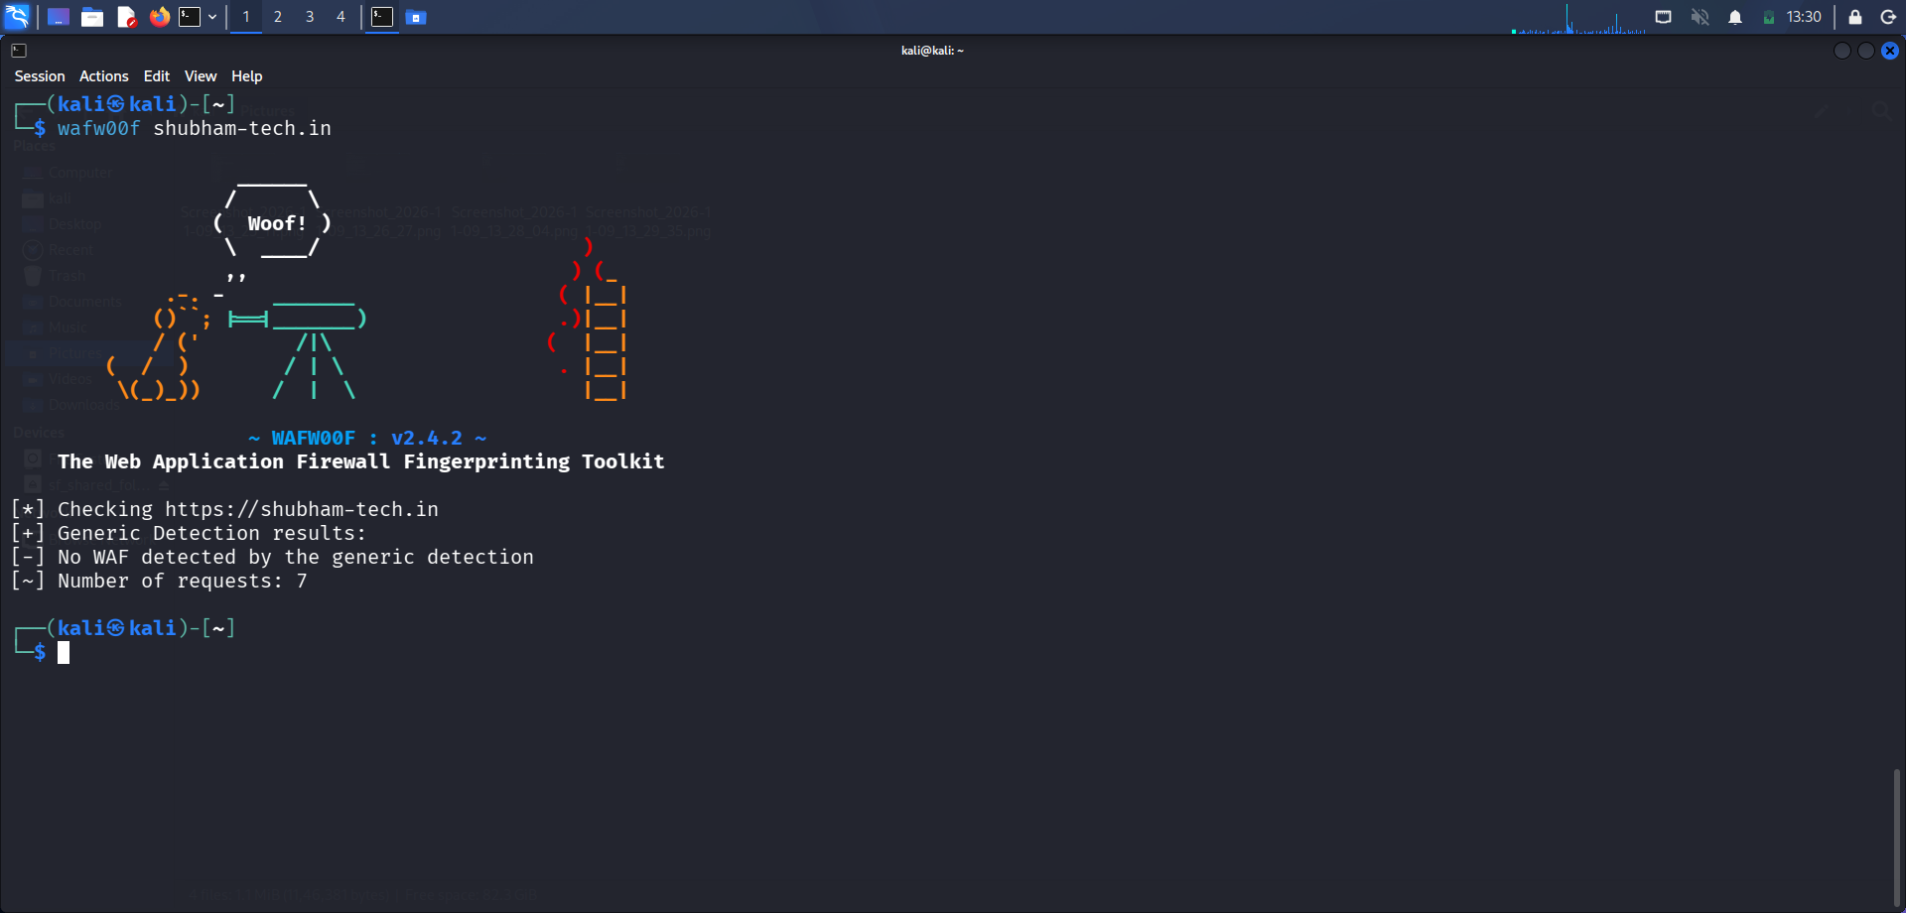
5. Wafw00f — WAF detection
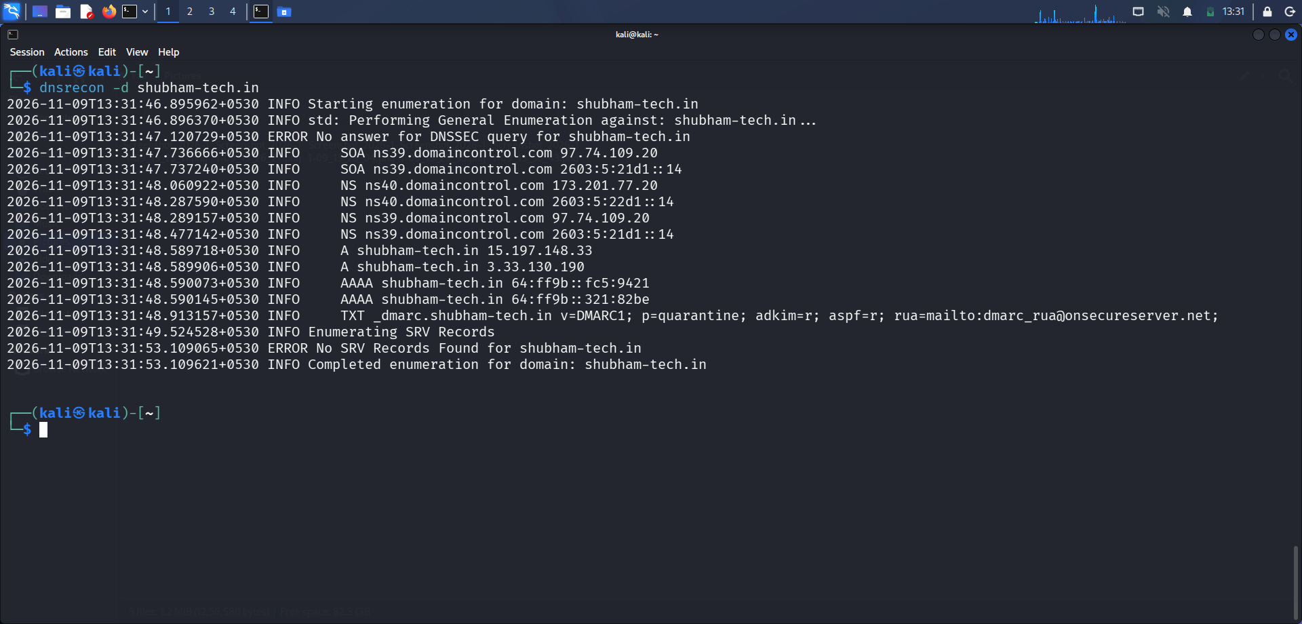
6. DNSRecon — DNS enumeration
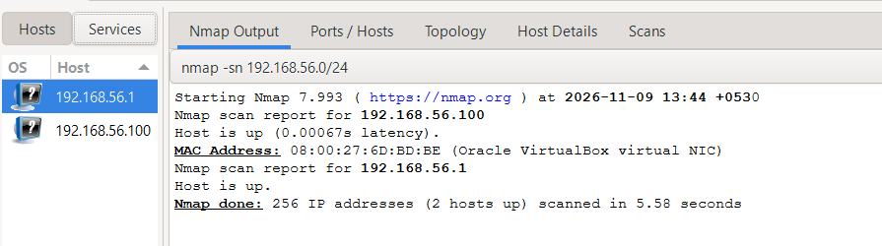
7. Nmap/Zenmap — ping scan of 192.168.56.0/24
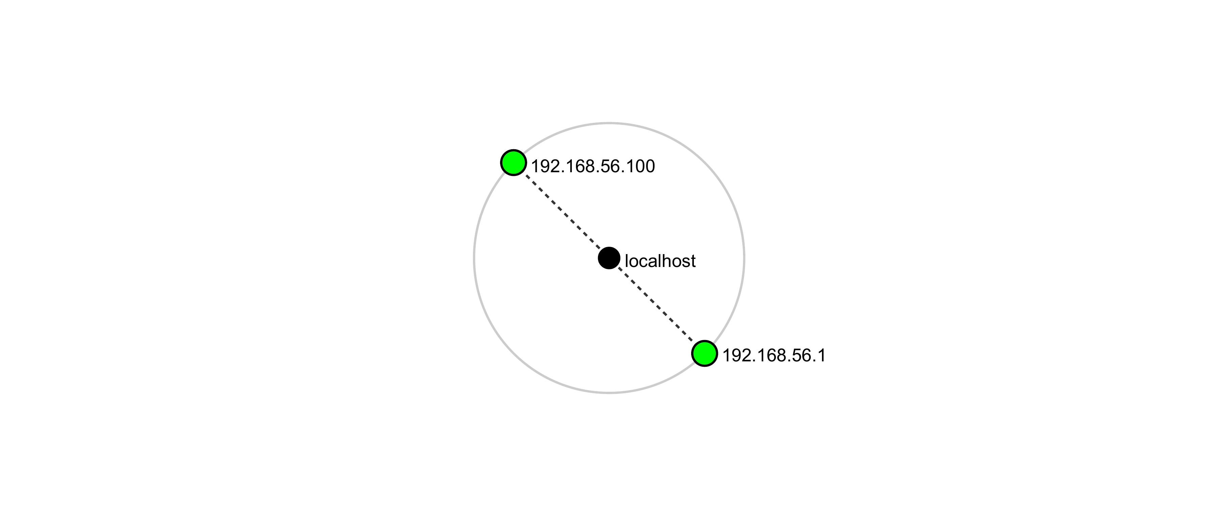
8. Network topology — local hosts
-End-
👤 Author
[Your Name]
Cybersecurity Professional B082
LinkedIn: [your LinkedIn URL]
📌 Project Information
Program Name: Cybersecurity program at Networkwalks | Week: 02 | Repository: GitHub

