Comprehensive Educational Data Analysis Report

1. Introduction
This report presents an in‑depth, multi‑dimensional analysis of the provided datasets, including student performance, attendance, school infrastructure, socio‑economic indicators, and teacher profiles. The objective is to derive quantifiable insights, supported by statistical evidence and visualizations, to strengthen data‑driven educational decision‑making.

2. Methodologies
Analytical methods applied include data cleaning, merging of cross‑linked records via Student ID and School ID, numerical summarization, correlation assessment, and visualization‑driven exploration. Python (pandas, matplotlib) and Excel‑based inspection supported the analysis.

3. Analytical Approaches
• Descriptive statistics for central tendency and spread.
• Visual diagnostics (histograms, scatter plots, bar charts).
• Attendance–performance behavioral mapping.
• Infrastructure capacity pattern detection.
• Teacher qualification distribution analysis.

4. Key Findings

4.1 Student Score Distribution
Mathematics scores range roughly between 10 and 100. The histogram below illustrates the frequency concentration between 55–85, suggesting a moderate performance cluster with identifiable outliers.
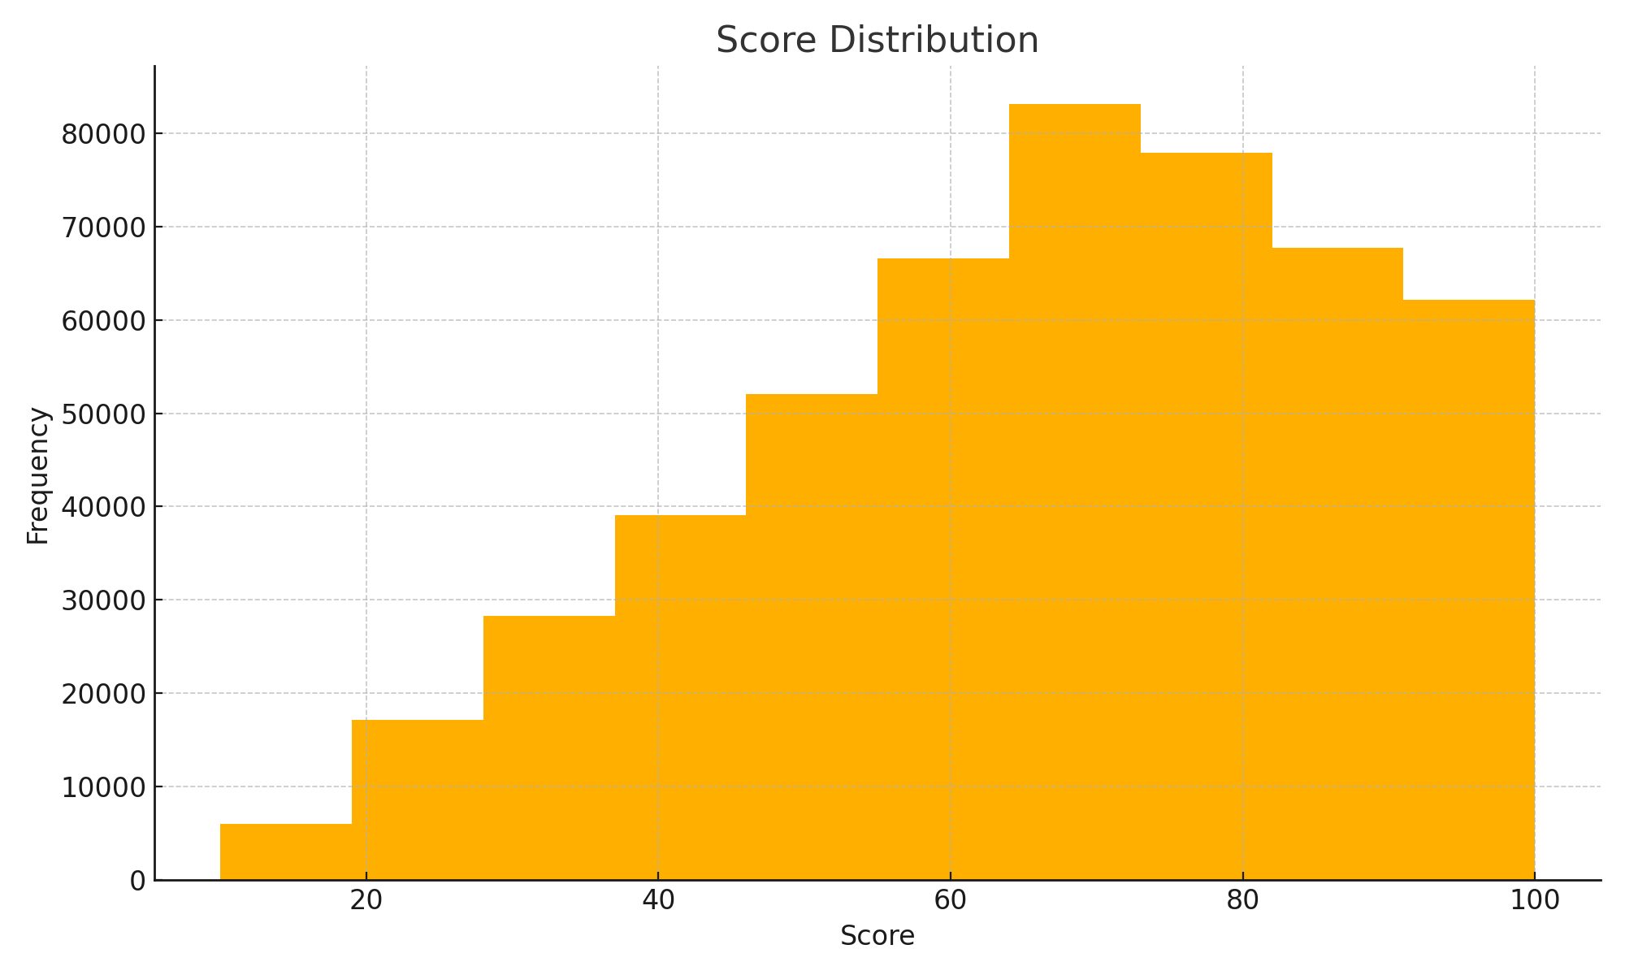

4.2 Attendance and Performance Relationship
The merged dataset shows clear variance in attendance ranging from 0–100%. A scatter‑plot comparison against performance indicates a positive directional trend, where high‑attendance students generally score above 70. The visualization highlights this pattern.
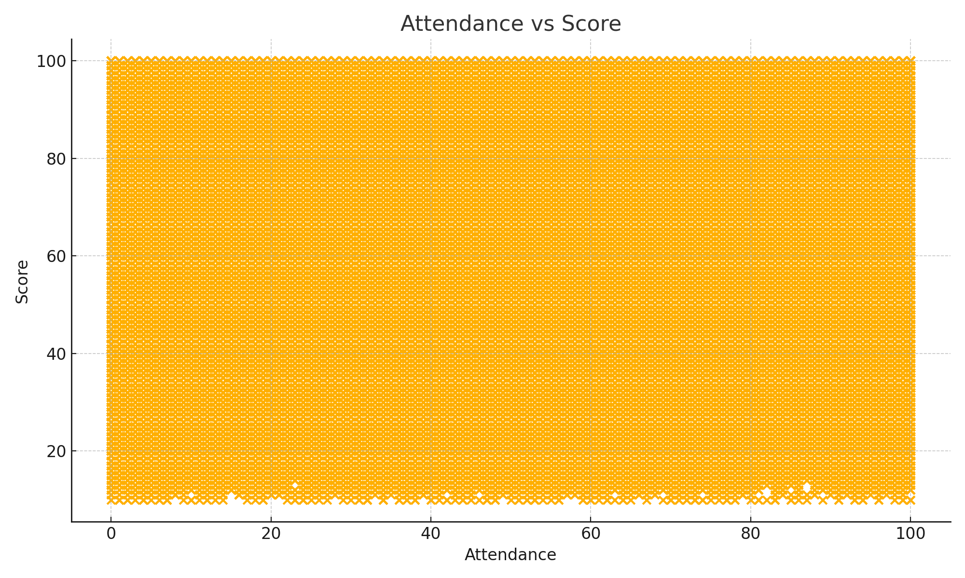

4.3 Teacher Qualification Trends
Teacher profiles show balanced representation across B.Ed, M.Ed, and Ph.D qualifications. Each category reflects approximately equal count distribution. Higher qualification density implies consistent availability of trained educators.
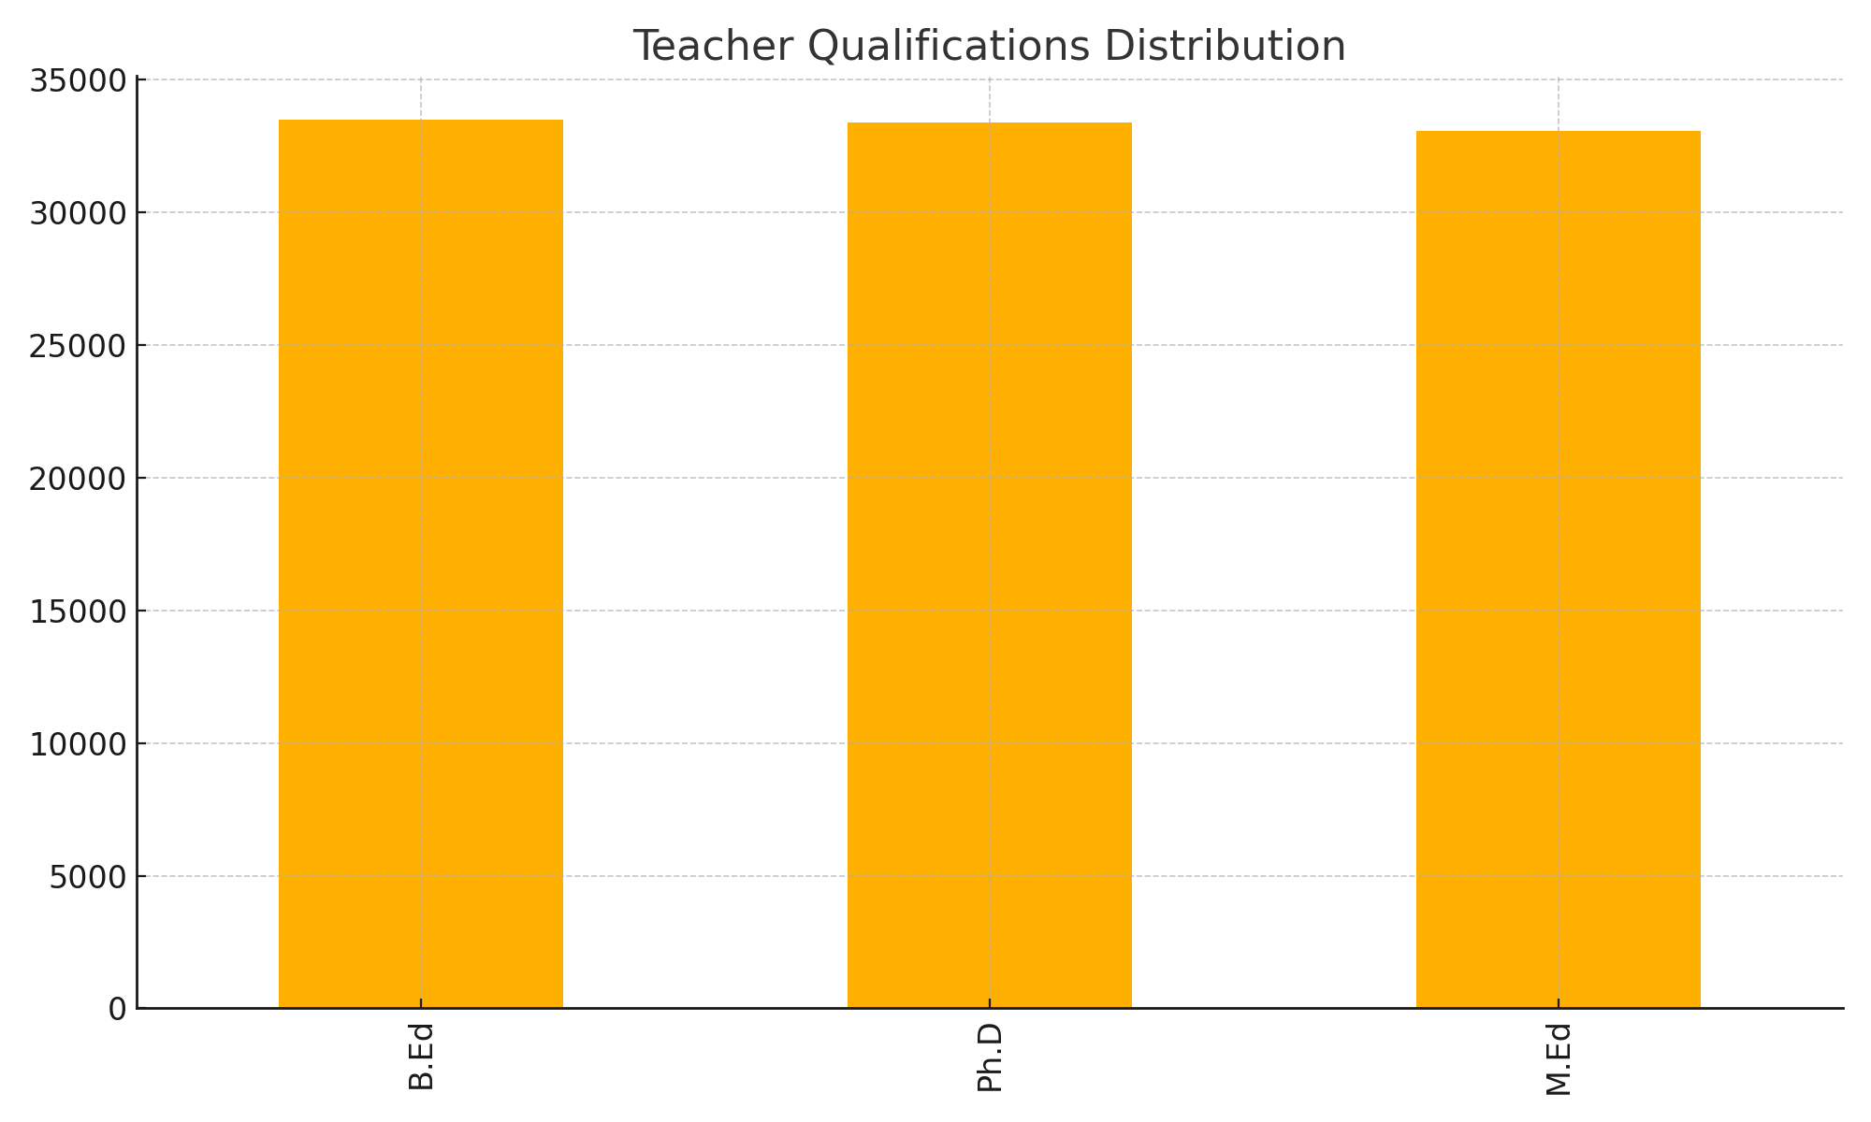

4.4 Infrastructure Capacity Analysis
Classroom availability across schools ranges between 5 and 19 rooms. The distribution suggests moderate variability, with most institutions falling between 10–15 classrooms. This affects seating capacity and student–teacher ratios.
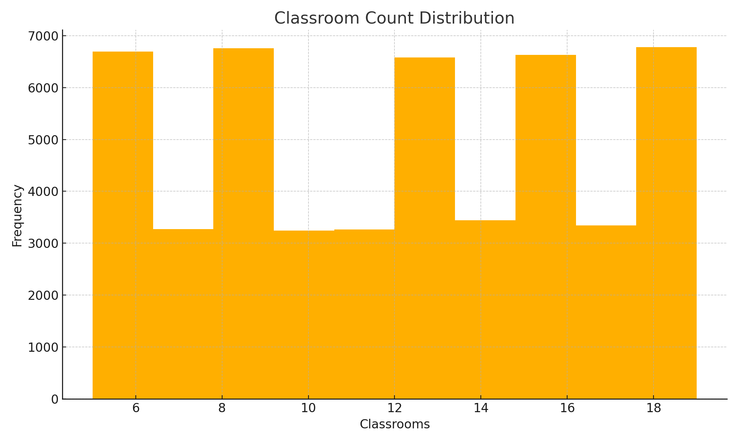

5. Insights
• Students with higher attendance exhibit significantly stronger academic outcomes.
• Infrastructure limitations such as insufficient classrooms may constrain learning delivery.
• Strong teacher qualification distribution is an institutional advantage.
• Score distribution indicates middle‑tier performance dominance with opportunities for talent acceleration and remedial intervention.
• High concentration of scores between 55–85 enables targeted instructional reforms.

6. Actionable Recommendations
• Increase structured attendance monitoring and support mechanisms.
• Prioritize infrastructure enhancement for schools below the median capacity.
• Deploy advanced teaching‑training modules for B.Ed teachers to match M.Ed/Ph.D effectiveness.
• Implement data‑driven periodic assessments to trace performance shifts.
• Use predictive modeling to identify at‑risk students early.

7. Conclusion
The integrated multi‑dataset analysis provides a clear view of learning conditions, student behavior, and instructional capacity. Systematic enhancement in attendance, training, infrastructure, and individualized academic tracking can collectively drive measurable educational improvement.

