**Netflix Data Analysis using SQL**

**Objective**

The objective of this project is to perform Exploratory Data Analysis (EDA) on Netflix's content dataset using SQL. The analysis focuses on identifying content types, common ratings, country-wise distribution, actor appearances, and content trends over time using structured queries.

**Dataset Summary**

* **Source**: Netflix dataset from Kaggle
* **Records**: 8000 Rows
* **Columns** include:
  + title, type, director, cast, country, date_added, release_year, rating, duration, listed_in, description

**Tools Used**

* SQL (PostgreSQL)
* Microsoft Word for documentation

**Exploratory Data Analysis (EDA)**

1. Counted total number of Movies and TV Shows

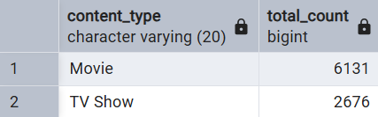

1. Found the most common rating for each content type

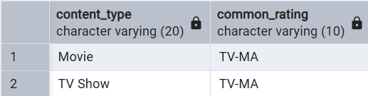

1. Listed all Movies released in 2020

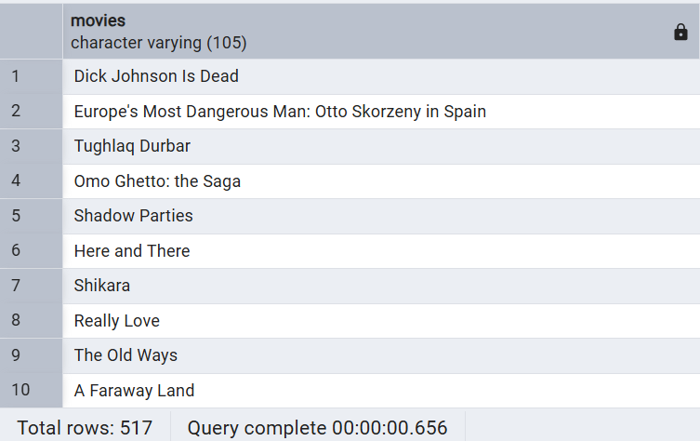

1. Identified Top 5 Countries with the most Netflix content

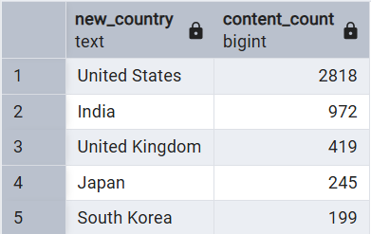

1. Found the longest Movies

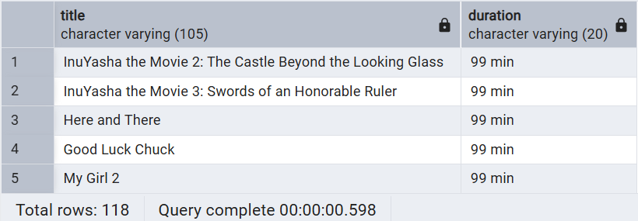

1. Listed TV Shows with more than 5 seasons

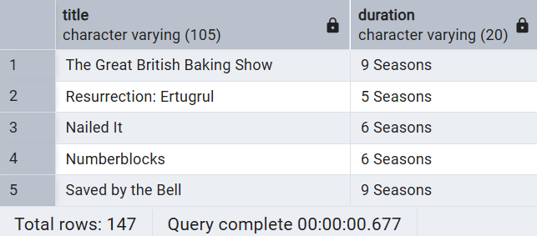

1. Identified content added in the last 5 years

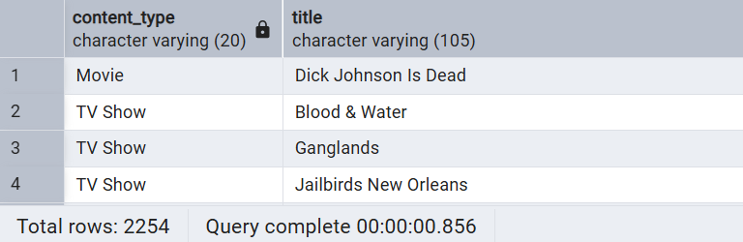

1. Listed Top 10 actors with the most appearances in Indian content

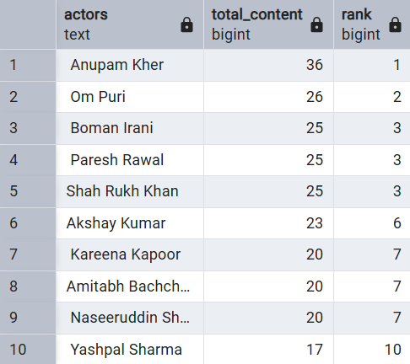

1. Found the number of Movies where actor *Salman Khan* appeared in the last 10 years

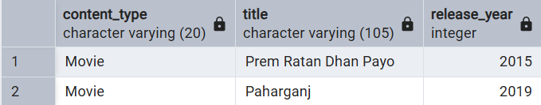

1. Categorized content as *Action_Film* or *Normal_Film* based on keywords in the description

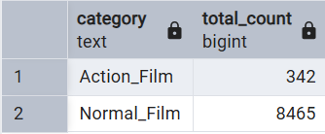

**Conclusion**

This project demonstrates the power of SQL for data analysis on real-world datasets. It highlights patterns in Netflix's catalog across content types, genres, countries, and user-focused classifications.

**Author**

**Name:** Shubham Dalvi  
**Role:** Aspiring Data Analyst   
**GitHub:** https://github.com/Shubham-Dalvii  
**LinkedIn:** https://www.linkedin.com/in/shubham-dalvi-031939376/