* **Flow Chart**

**Main Process and Sub process togather:**

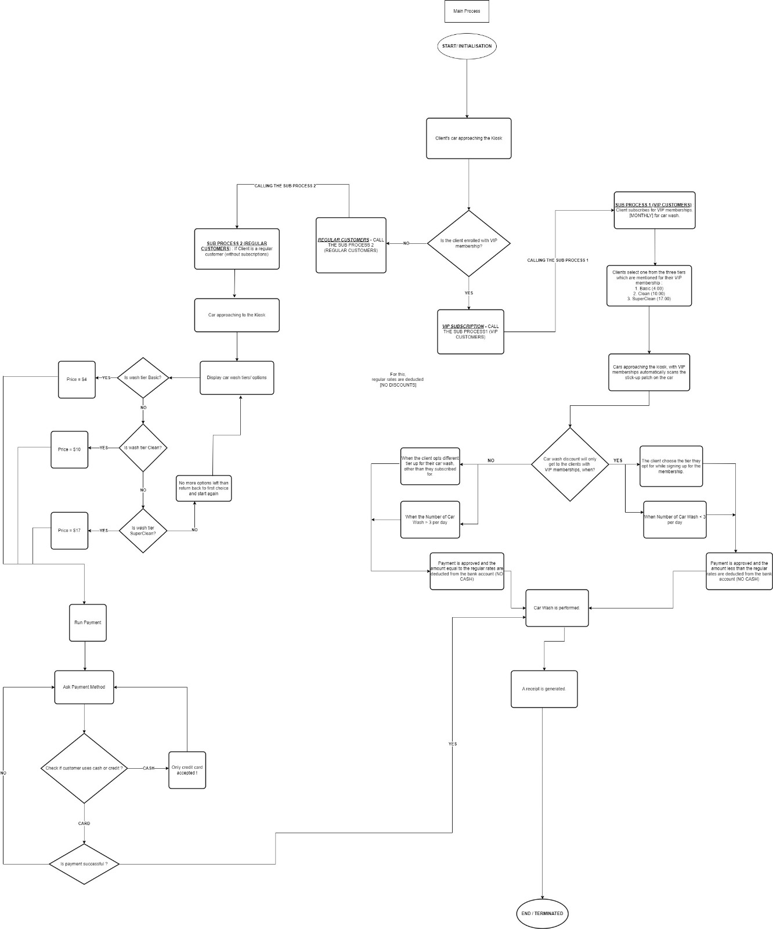

* **Pseudo Code:**

**Data Structure**

- accept_cash: Boolean (to declare whether cash payments are accepted or not)

- washLimit: Integer (to store the wash limit of the VIP member)

- basicOption: String (representing the basic car wash option)

- premiumOption: String (representing the premium car wash option)

- vipOption: String (representing the VIP car wash option)

- car_wash_options: List of Strings (representing different car wash options)

- chosen_option: String (to store the customer's chosen car wash option)

- car_wash_options: List of Strings (representing different car wash options)

- chosen_option: String (to store the customer's chosen car wash option)

**Main process:**

1.start

2.Declare that we don't accept cash payments

3.Scan customer barcode on car windshield

4.Is the customer a VIP member?

i)if yes, step 4

ii) if no, customer is a non-member then go to subprocess regular carwash

5.Does the member want prepaid option?

i) if yes, go to subprocess VIP Member option

ii) if no, determine if the customer exceeded wash limit for the day (sub process wash limit)

6.prompt customer for payment

7.print receipt

8.wash car

9.end

**VIP Member Sub processes:**

1. start

2. Declare washLimit, basicOption, premiumOption,vipOption

3. Is customer washLimit > 3?

i)if yes, go to washLimit subrpocess

ii)if no, step 4

4. Determine customer option

5. Customer membership = basic?

i) yes, basicOption

ii) no, step 6

6. customer membership = premium?

i) yes, premiumOption

ii) no, step 7

7. customer membership = VIP?

i)yes, vipOption, go to step 8

ii)no, customer is a non-member then prompt subrocess regular car wash

8. washLimit + 1

9. go to main process step 5

10. end

**Wash Limit Sub processes:**

1. Start

2. multiply all the car wash options by 2

3. prompt customer car wash options

4. Determine what wash type customer chooses

5. Basic?

i) yes, main process step 5

ii)no, step 6

6. Clean?

i) main process step 5

ii) no, step 7

7. Super Clean?

i) yes, main process step 5 and end this sub process

ii) no, step 4

**Regular wash Sub processes:**

1. Start

2. Prompt car wash options

3. Basic?

i) yes, basicOption then go to main process step 5

ii) no, step 4

4. Clean?

i) yes, premiumOption then go to main process step 5

ii) no, step 5

5. Super clean?

i) yes, vipOption then go to main process step 5 and end this sub process

ii) no, step 2

* **Testing Scenarios:**

**Test Scenario 1 :-**

1. The customer just entered the car wash.

2. Barcode is scanned and he is a monthly member.

3. Its his second wash of the day

4. He didn’t chose different type of wash tier

5. customer proceeds to carwash

6. As monthly member no need of receipt

7. The customer leaves with clean car

**Test Scenario 2 :-**

1. The customer just entered the car wash.

2. No Barcode is there.

3. he is a regular customer(non member)

4. He chose Clean type of wash tier

5. Receipt generated of $8.60

6. customer proceeds to pay with credit card

7.customer proceeds to car wash

8. The customer leaves with clean car

**Computational Thinking:**

**Decomposition:**

The entire process will be broken down into smaller problems of yes or no questions that will help us determine the type of wash the cutomer wants.

Firstly, we must declare that we cannot accept cash payments.

Secondly, we must determine if they are members or non-members

Thirdly, we must determine what type of wash they would like to have

Fourthly, if they have had more than three washes in the span of 12am to 11:59pm