# Scope of Document

This document is useful for Architect and Developer while Designing and Developing Online Learning Portal Solution.

This document covers below details –

* High Level Architecture
  + Software Architecture
  + Deployment Architecture
  + Application Layer Architecture

## Software Architecture

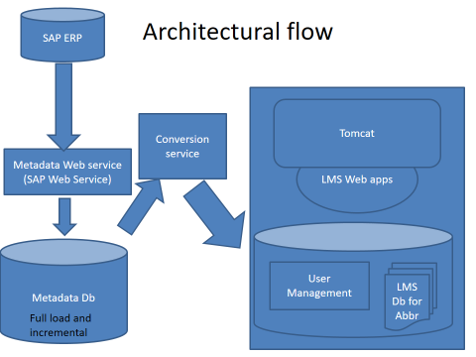

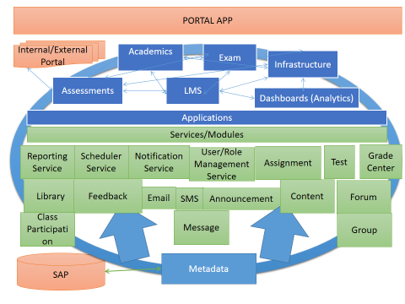

* in Synch and work in equal capacity. The load balancing between them will be done by Traffic Manager.
* **Quorum:** All Data Request / Response To and forth will be passed through **Quorum**. It is used to manage Database Clustering. A Cluster Quorum Disk is the storage medium on which the Configuration Database is stored for a Cluster Computing network.
* **DMZ:** The term DMZ Stands for "Demilitarized Zone," and in the computer world, it refers to a buffer zone that separates the Internet [Public Network] and your Protected Network. Direct access to the Hosted Components is prevented by using Firewall.

## Application Architecture

It is recommended that Proposed Application Solution should be developed in Layered Structure, with clear set of responsibilities of each layer.

With respect to Application Functionalities – Modular Design is recommended.