MIT World Peace University, Pune
School of Computer Science & Engineering
Distributed Systems (DS)
Mini Project Submission
⚡ VoltRoute
Distributed Smart EV Charging Grid & Power Quorum
Group Members | Shubham Nemade & Vansh Kukreja
PRN | 123B1B020 & 123B1B015
Division | A
Submission Date | 21 October 2026

1. Project Title & Description
Project Title: VoltRoute – Distributed Smart EV Charging Grid & Power Quorum
VoltRoute is a distributed systems project that simulates a Smart Electric Vehicle (EV) Charging Station Network. The system manages multiple charging stations across a city, handles concurrent vehicle booking requests, enforces transformer capacity limits using mutual exclusion, and maintains fair charging order using Lamport Logical Clocks.
The project is built as a 3-Tier distributed architecture:
• Tier 1 (Client): A web-based EV Driver Dashboard with real-time updates
• Tier 2 (Middleware): A Flask Web Gateway handling REST/SSE communication
• Tier 3 (Backend): A gRPC Charging Grid Server managing station state, Lamport timestamps, and transformer mutex locks
The entire system is containerized using Docker and orchestrated with Kubernetes, demonstrating modern cloud-native distributed systems deployment.
2. GitHub Repository Link
https://github.com/Shubham-Nemade-24/VoltRoute.git
3. Implementation Details & Technologies Used
3.1 Distributed Systems Concepts Implemented
Unit | Concept | Implementation in VoltRoute
Unit 1 | 3-Tier Architecture | Client UI (Browser) → Flask Gateway (Middleware) → gRPC Server (Backend)
Unit 2 | RPC (gRPC) | Protocol Buffers (.proto) + gRPC service for BookSlot, ReleaseSlot, GetStations, GetQueue
Unit 2 | SSE (Server-Sent Events) | Real-time power telemetry stream from /stream/power endpoint using EventSource API
Unit 2 | Pub/Sub | Event broadcasting for booking alerts, mutex grants, and release notifications via /stream/events
Unit 3 | Lamport Logical Clock | Total ordering of vehicle charging queue using Lamport timestamps (tick on local events, merge on receive)
Unit 3 | Mutual Exclusion | Centralized Mutex algorithm for transformer capacity – coordinator grants/queues access to charging slots
Unit 4 | Docker | Containerized microservices (volt-server, volt-gateway) with Docker Compose
Unit 4 | Kubernetes | K8s Deployments, ClusterIP/NodePort Services, Namespaces, Pod orchestration with 2 gateway replicas

3.2 Technologies & Tools Used
Technology | Purpose
Python 3.11 | Backend programming language
Flask 3.0 | Web framework for Tier-2 Gateway (REST + SSE endpoints)
gRPC + Protocol Buffers | Remote Procedure Call framework for Tier-3 server communication
HTML / CSS / JavaScript | Frontend UI with glassmorphism dark theme and EventSource API
Docker | Containerization of server and gateway microservices
Docker Compose | Multi-container orchestration for local development
Kubernetes | Container orchestration with Deployments, Services, and Namespaces
Git & GitHub | Version control and source code hosting

3.3 System Architecture
The system follows a 3-Tier distributed architecture:
┌──────────────┐ REST/SSE ┌──────────────┐ gRPC ┌──────────────┐
│ Tier 1 │ ──────────────→ │ Tier 2 │ ─────────────→ │ Tier 3 │
│ EV Driver │ │ Flask Gateway│ │ Charging Grid│
│ Browser UI │ ←── SSE Stream │ (Port 5000) │ ←── Protobuf │ (Port 50051)│
└──────────────┘ └──────────────┘ └──────────────┘
• Tier 1 sends REST API requests to Tier 2 and receives SSE streams
• Tier 2 translates REST calls into gRPC RPCs to Tier 3
• Tier 3 manages station state, Lamport clocks, and transformer mutex locks
• In Kubernetes, Tier 3 runs as ClusterIP (internal), Tier 2 as NodePort (external)

4. Project Screenshots
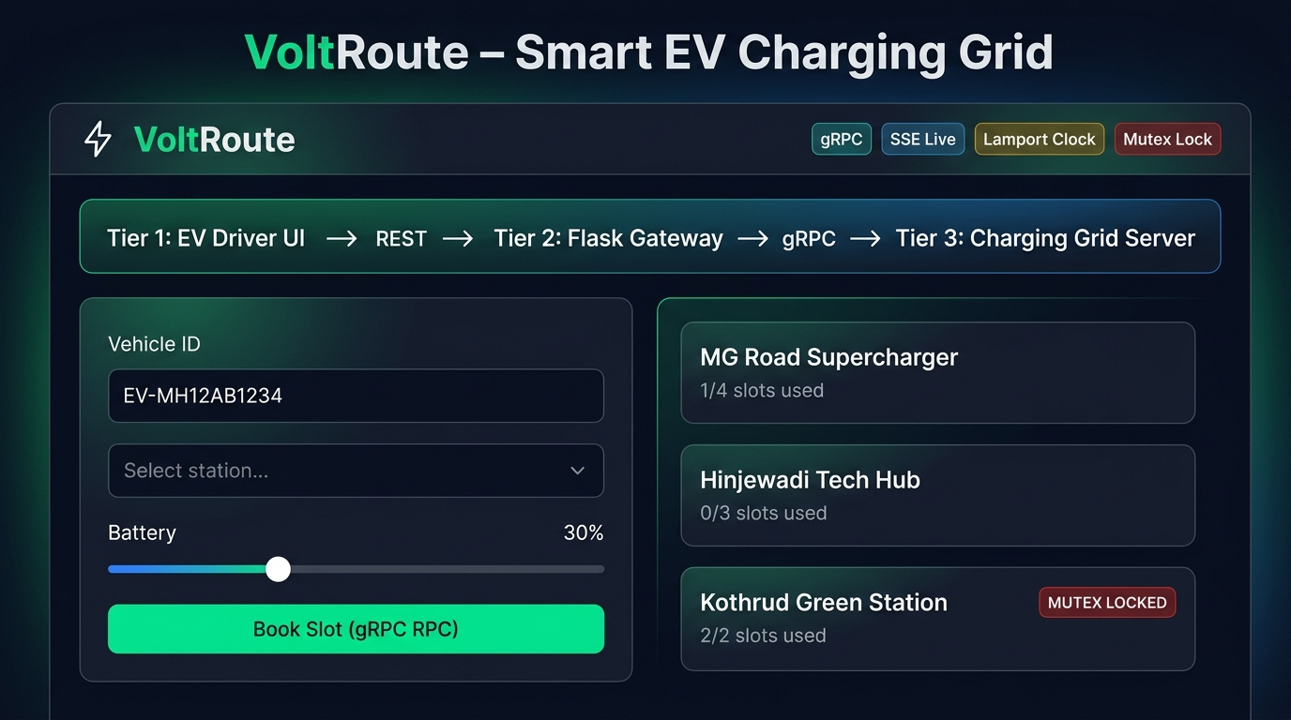
Figure 1: VoltRoute Dashboard – 3-Tier Architecture with Booking Panel and Station Grid
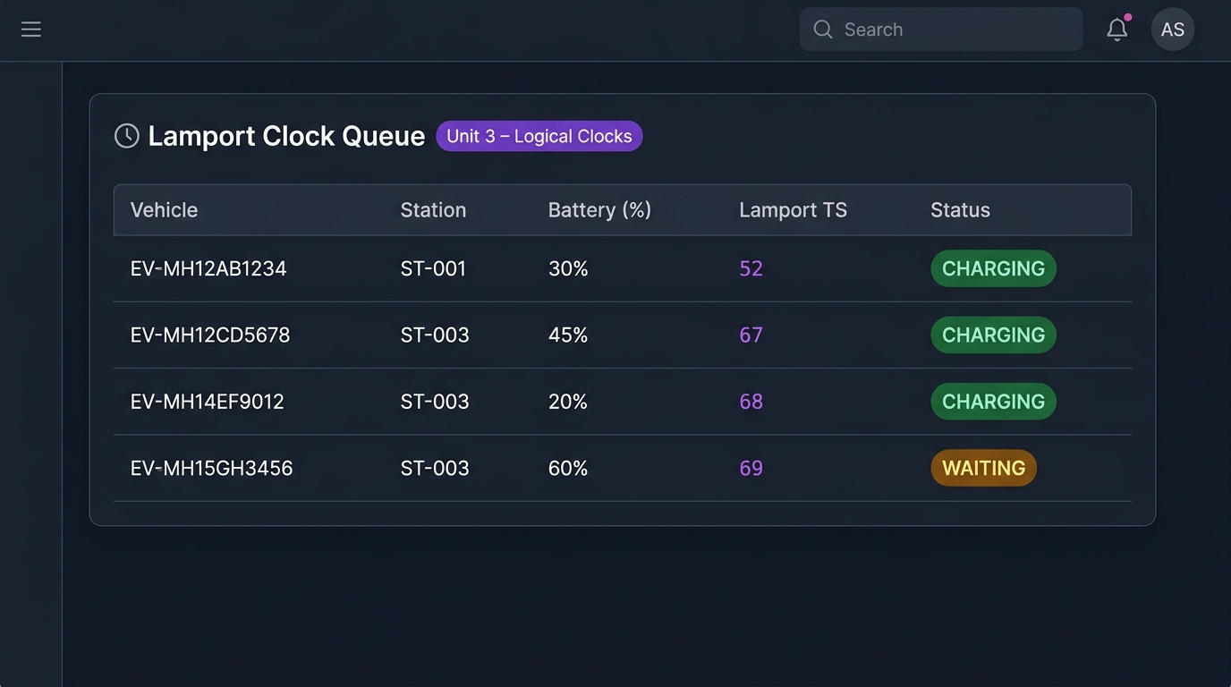
Figure 2: Lamport Logical Clock Queue – Total ordering of charging requests (Unit 3)
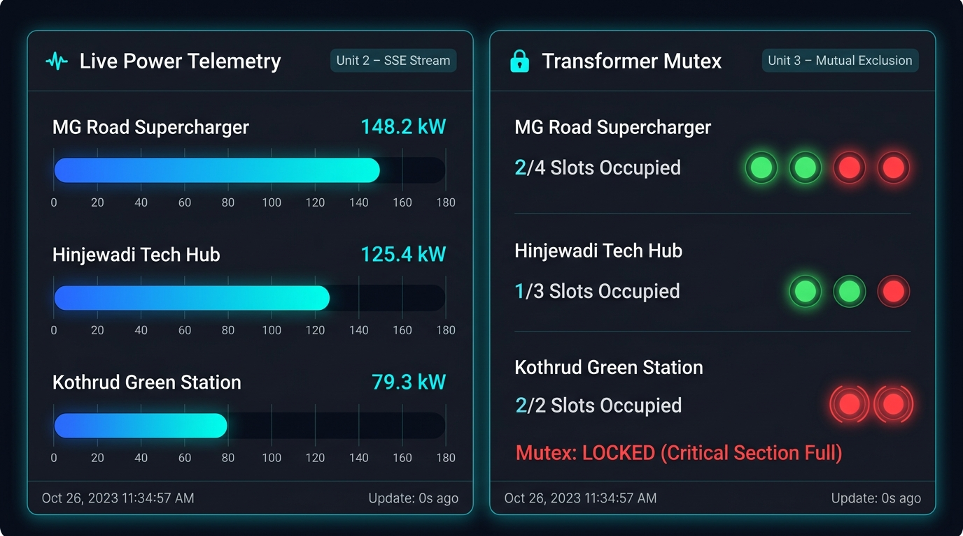
Figure 3: Live Power Telemetry (SSE Stream) and Transformer Mutex Visualization (Unit 2 & 3)
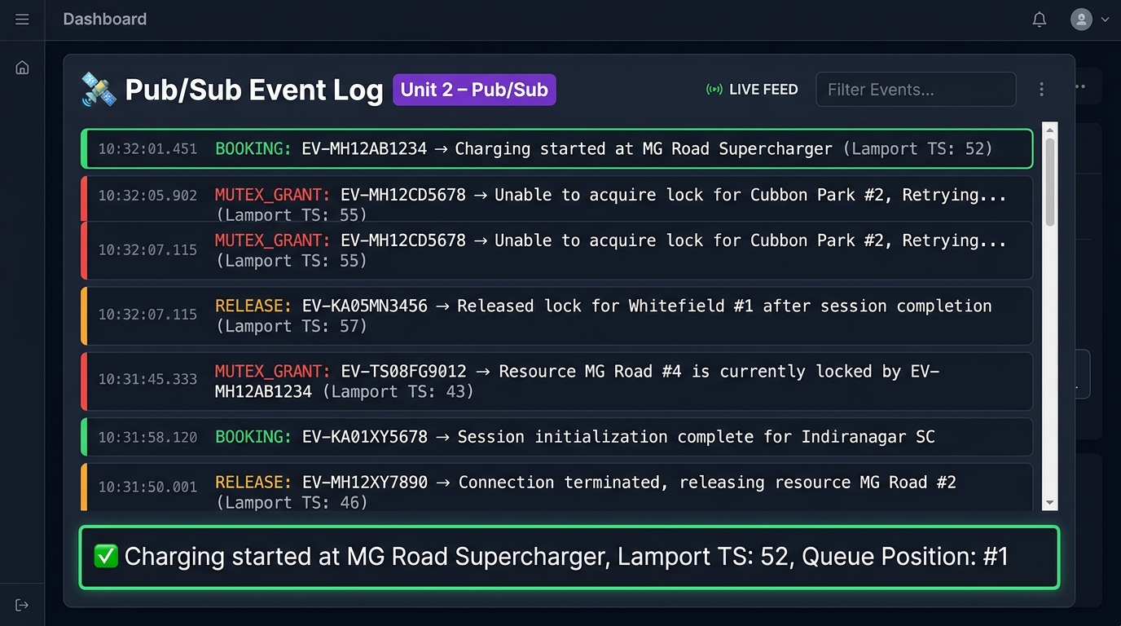
Figure 4: Pub/Sub Event Log – Real-time booking, release, and mutex grant notifications (Unit 2)
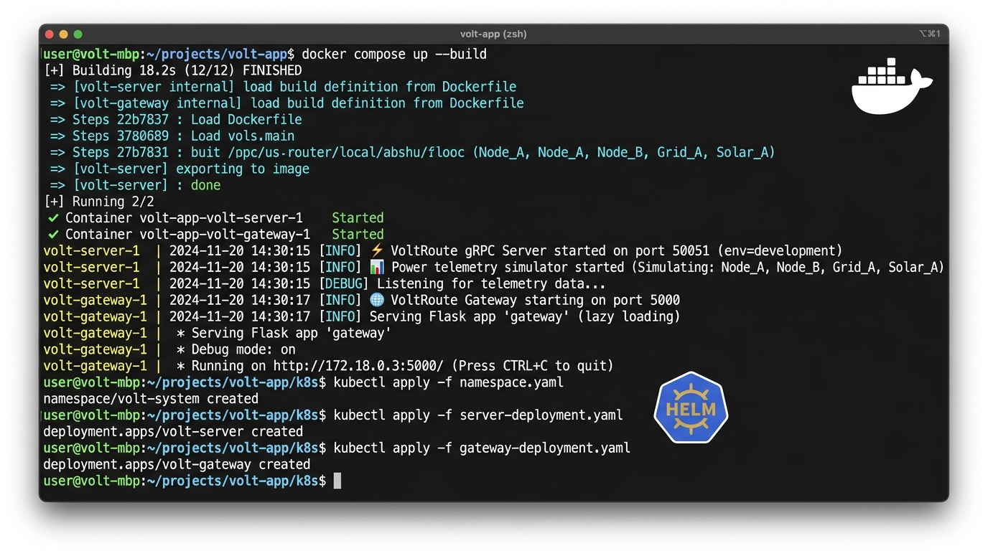
Figure 5: Docker Compose Build & Kubernetes Deployment (Unit 4)

5. Conclusion
VoltRoute successfully demonstrates key distributed systems concepts through a practical, real-world EV charging station management application. The project implements:
• A 3-Tier distributed architecture separating concerns across Client, Gateway, and Server
• gRPC-based Remote Procedure Calls (RPC) for efficient inter-service communication using Protocol Buffers for serialization
• Server-Sent Events (SSE) for real-time power telemetry streaming to connected clients
• A Publish-Subscribe pattern for broadcasting booking, release, and mutex grant events
• Lamport Logical Clocks for establishing total ordering of concurrent charging requests without relying on synchronized physical clocks
• Centralized Mutual Exclusion to protect transformer capacity as a critical section, preventing overloading and ensuring safe concurrent access
• Docker containerization and Kubernetes orchestration for cloud-native deployment with service discovery, replica scaling, and pod management
The application was tested end-to-end with multiple concurrent vehicle bookings, demonstrating proper Lamport timestamp ordering, mutex locking when transformer capacity is reached, automatic mutex grant promotion when slots are released, and live SSE telemetry streaming. The system runs as two Docker containers (volt-server and volt-gateway) and can be deployed to any Kubernetes cluster using the provided manifests.

