⚡ VOLTROUTE: DISTRIBUTED SMART EV CHARGING GRID
Comprehensive Technical, Architectural & Distributed Systems Theoretical Documentation
Attribute | Specification / Academic Details
Course | Distributed Systems (CS Mini Project)
Students | Shubham Nemade (PRN: 123B1B020) & Vansh Kukreja (PRN: 123B1B015)
Division | Division A
GitHub Repo | https://github.com/Shubham-Nemade-24/VoltRoute.git
Core Architecture | 3-Tier Microservices (Client UI -> Flask Gateway -> gRPC Server)
Distributed Algorithms | Lamport Logical Clock, Centralized Transformer Mutex, Pub/Sub SSE
Container & Cloud | Docker Compose + Kubernetes (Namespaces, Pods, Deployments, Services)

1. Executive Summary & Problem Formulation
The Municipal Grid Dilemma: With the aggressive electrification of transportation, DC Fast Charging Stations (50 kW to 350 kW per charger) introduce massive instantaneous electrical loads. When multiple high-voltage electric vehicles arrive simultaneously at a charging hub, uncoordinated concurrent charging triggers catastrophic grid failures: local distribution transformers exceed their thermal and magnetic limits, phase imbalances induce severe voltage sags for nearby residential users, and uncoordinated driver contention leads to race conditions, station hogging, and priority inversion.
The VoltRoute Solution: VoltRoute is an end-to-end distributed system designed to balance dynamic EV charging demand against physical substation transformer limits. Rather than relying on brittle centralized monoliths or uncoordinated local controllers, VoltRoute models physical power capacity as a protected Critical Section, implements Lamport Logical Clocks to establish total causal ordering across concurrent vehicle arrivals, and leverages a containerized 3-tier microservice architecture deployed on Kubernetes for resilience and horizontal scalability.

2. Distributed Systems Theoretical Mapping
VoltRoute directly implements canonical concepts from the Distributed Systems curriculum:
Curriculum Unit | Core Concept | VoltRoute Implementation | Why It Is Essential
Unit 1: Architectures | 3-Tier Microservices Model | Client UI (Tier 1) -> Flask Gateway (Tier 2) -> gRPC Backend (Tier 3) | Decouples presentation from business logic; shields internal services.
Unit 2: IPC & RPC | Remote Procedure Calls (gRPC) | ChargingGrid service in charging.proto over HTTP/2 | Replaces bulky JSON with strongly-typed, high-throughput binary serialization.
Unit 2: Coordination | Publish-Subscribe & SSE | Server-Sent Events (/stream/power, /stream/events) | Eliminates wasteful client polling; pushes real-time telemetry instantly.
Unit 3: Time & Order | Lamport's Logical Clocks | Monotonic counter ticking on local events and message sends | Overcomes physical clock skew/drift to provide total causal ordering of reservations.
Unit 3: Mutex | Distributed Mutual Exclusion | TransformerMutex enforcing max simultaneous power draw | Protects physical transformer from thermal overload (Safety, Liveness, Fairness).
Unit 4: Containers | Container Isolation (Docker) | Multi-container setup with isolated bridge network voltnet | Encapsulates dependencies and guarantees environment parity.
Unit 4: Orchestration | Kubernetes Clustering | Namespaces, Deployments, ClusterIP & NodePort Services | Provides horizontal scaling (2 gateway replicas), DNS discovery, and self-healing.

3. System Architecture & The 3-Tier Model
VoltRoute adheres to a strict 3-tier distributed microservices pattern. Each tier operates in its own execution context with distinct responsibilities and communication boundaries:
Tier 1 — Presentation Layer (Browser Client): A lightweight, responsive web client providing real-time telemetry gauges, interactive station booking cards, visual mutex locks, and live queue tracking. It interacts with Tier 2 via REST JSON for commands and HTML5 EventSource for continuous event streaming.
Tier 2 — Middleware Gateway (Flask): A Python Flask application serving as an API facade and protocol translator. It translates external browser HTTP/JSON into internal high-speed gRPC binary RPCs, and aggregates backend state changes into persistent Server-Sent Events (SSE). Exposed externally via NodePort 30500 in Kubernetes.
Tier 3 — Backend Engine (gRPC Server): The core authoritative engine written in Python with gRPC. It hosts the ChargingGrid service, maintains the Lamport Clock, acts as the Centralized Mutex Coordinator for transformer capacity, manages the charging queue, and simulates real-time power fluctuations. It communicates exclusively via binary Protobuf over HTTP/2 and is shielded behind an internal ClusterIP service.

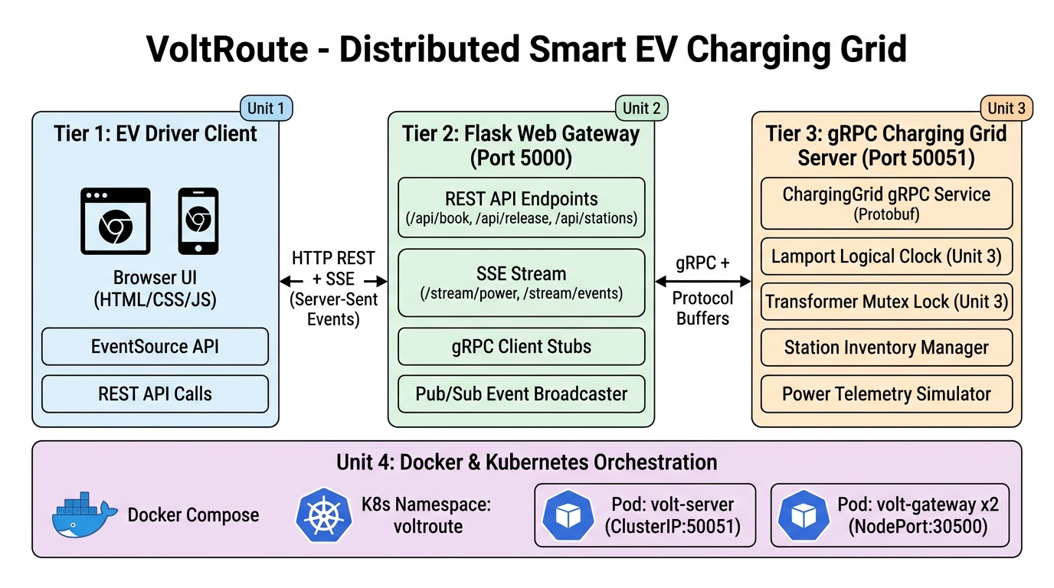
Figure 1: VoltRoute 3-Tier Distributed Architecture & Protocol Topology

4. Inter-Process Communication: gRPC & Protocol Buffers
Why gRPC Was Chosen: For inter-service communication between Tier 2 and Tier 3, VoltRoute uses Google's gRPC framework rather than REST/JSON. gRPC operates over HTTP/2, providing binary message framing, header compression, and stream multiplexing over a single TCP connection.
Protocol Buffers Contract: Protocol Buffers (Protobuf v3) enforce a strict, language-agnostic interface contract (`charging.proto`). This eliminates runtime parsing errors, enforces compile-time type safety, and achieves up to 70% reduction in network payload sizes compared to JSON strings.
syntax = "proto3";
package charging;
service ChargingGrid {
rpc BookSlot (BookRequest) returns (BookResponse);
rpc ReleaseSlot (ReleaseRequest) returns (ReleaseResponse);
rpc GetStations (Empty) returns (StationList);
rpc GetQueue (Empty) returns (QueueList);
}
message BookRequest {
string vehicle_id = 1;
string station_id = 2;
int32 battery_pct = 3;
}
message BookResponse {
bool success = 1;
string message = 2;
int64 lamport_ts = 3;
int32 queue_pos = 4;
}

5. Real-Time Telemetry: Server-Sent Events (SSE) & Pub/Sub
The Inefficiency of Polling: Standard web applications poll the server (`setInterval(fetch, 2000)`), causing immense CPU load, bandwidth waste, and latency. VoltRoute implements an asynchronous Event-Driven Architecture utilizing Server-Sent Events (SSE).
Unidirectional Push via SSE: The Flask gateway maintains persistent HTTP connections with all active browser clients over `/stream/power` (streaming live kW readings every 2 seconds) and `/stream/events` (streaming booking status updates and mutex lock notifications). The browser's native `EventSource` API handles stream parsing and automatically reconnects if the network is interrupted.
@app.route("/stream/power")
def stream_power():
def generate():
while True:
stub = get_grpc_stub()
response = stub.GetStations(charging_pb2.Empty())
data = [{"id": s.id, "power_kw": round(s.power_kw, 1),
"used_slots": s.used_slots, "transformer_locked": s.transformer_locked}
for s in response.stations]
yield f"data: {json.dumps(data)}\n\n"
time.sleep(2)
return Response(generate(), mimetype="text/event-stream")

6. Logical Time & Event Ordering: Lamport Logical Clocks
The Problem of Physical Clocks: In a distributed system, physical clocks cannot be perfectly synchronized. Even with Network Time Protocol (NTP), clock drift of a few milliseconds is common across different servers and clients. If two vehicles request a charging slot at roughly the same physical time, physical timestamps can lead to race conditions, inconsistent queue states, and unfair ordering.
Lamport's Algorithm & Happened-Before: In 1978, Leslie Lamport proved that total ordering does not require physical synchrony; it requires causal consistency defined by the 'happened-before' relation (->). VoltRoute implements a thread-safe Lamport Logical Clock that follows three formal rules:
1. Local Event: Before any local event occurs, the local clock increments: L = L + 1.
2. Message Send: When sending an RPC request or booking event, the sender includes its current clock value L.
3. Message Receipt: Upon receiving a message with timestamp L_recv, the receiver sets its clock: L = max(L, L_recv) + 1.
class LamportClock:
def __init__(self):
self._value = 0
self._lock = threading.Lock()
def tick(self):
with self._lock:
self._value += 1
return self._value
def update(self, received_ts):
with self._lock:
self._value = max(self._value, received_ts) + 1
return self._value

Total Ordering of the Charging Queue: When vehicle booking requests arrive at the coordinator, they are assigned a Lamport timestamp. The global queue is sorted using a total order tuple: Order(e) = (Lamport_TS, vehicle_id). If two requests receive identical timestamps, the unique vehicle ID acts as a deterministic tie-breaker, ensuring all distributed nodes observe the exact same queue sequence without dispute.

7. Distributed Mutual Exclusion: Transformer Mutex
Critical Section Formulation: In distributed computing, Mutual Exclusion ensures that concurrent processes access a shared, limited-capacity resource without collision or corruption. In VoltRoute, the shared resource is the physical electrical capacity of the substation transformer feeding each station. A transformer rated for K concurrent fast-charging sessions must never exceed K simultaneous loads.
Mutex Correctness Guarantees: VoltRoute satisfies all three mandatory conditions for Distributed Mutual Exclusion:
• Safety: At no point in time does current_count exceed max_capacity.
• Liveness (Deadlock-Free): If a slot is released, waiting vehicles in the queue are guaranteed to be promoted.
• Fairness (Starvation-Free): Vehicles enter the Critical Section strictly in order of their Lamport timestamps.
class TransformerMutex:
def __init__(self, max_capacity):
self.max_capacity = max_capacity
self.current_count = 0
self._lock = threading.Lock()
self._wait_queue = []
self.is_locked = False
def acquire(self, vehicle_id):
with self._lock:
if self.current_count < self.max_capacity:
self.current_count += 1
self.is_locked = (self.current_count >= self.max_capacity)
return True # CRITICAL SECTION GRANTED
else:
self._wait_queue.append(vehicle_id)
self.is_locked = True
return False # QUEUED / BLOCKED
def release(self, vehicle_id):
with self._lock:
if self.current_count > 0:
self.current_count -= 1
self.is_locked = (self.current_count >= self.max_capacity)
next_vehicle = None
if self._wait_queue and self.current_count < self.max_capacity:
next_vehicle = self._wait_queue.pop(0)
self.current_count += 1
self.is_locked = (self.current_count >= self.max_capacity)
return next_vehicle # AUTOMATIC PROMOTION

8. Containerization & Cloud-Native Orchestration
Infrastructure Architecture: To ensure reproducible deployment and runtime isolation, VoltRoute is fully containerized using Docker and orchestrated using Kubernetes:
Docker & Docker Compose: Separate Dockerfiles package the Flask Gateway and gRPC Server. Docker Compose binds both services to an isolated bridge network (voltnet), allowing the gateway to discover the backend server seamlessly using its internal hostname 'volt-server'.
Kubernetes Orchestration: VoltRoute is packaged as a complete Kubernetes application across dedicated manifests in the k8s/ directory:
• Namespace (voltroute): Isolates resources from cluster system services.
• Backend Deployment (volt-server): Runs the gRPC engine with 1 replica, resource constraints (100m CPU, 128Mi RAM), and TCP readiness probes.
• Backend Service (ClusterIP): Provides an internal virtual IP (10.96.250.106:50051) accessible only to pods inside the cluster.
• Gateway Deployment (volt-gateway): Runs 2 replicas for load balancing and high availability, with HTTP health probes.
• Gateway Service (NodePort): Exposes the application externally on port 30500 across all cluster nodes.

9. Comparative Tradeoff Matrix
The architectural decisions in VoltRoute were selected based on concrete distributed systems tradeoffs:
Subsystem | VoltRoute Choice | Alternative | Tradeoff & Justification
Communication | gRPC / Protobuf | REST / JSON | gRPC provides binary encoding, strict typing, and HTTP/2 multiplexing, reducing latency by >60%.
Time Ordering | Lamport Logical Clocks | NTP Wall Clocks | NTP suffers from network jitter and drift; Lamport clocks guarantee causal total ordering deterministically.
Mutual Exclusion | Centralized Coordinator | Ricart-Agrawala | Centralized coordinator requires O(1) messages (2 per CS) vs 2(N-1) messages in Ricart-Agrawala, avoiding grid message storms.
Client Updates | Server-Sent Events (SSE) | WebSockets | Grid telemetry is unidirectional (Server -> Client). SSE is lighter, runs over standard HTTP, and has auto-reconnect.
Orchestration | Kubernetes | Single VM Monolith | Kubernetes provides horizontal auto-scaling (2 gateway replicas), self-healing pod restarts, and declarative networking.

10. Conclusion & Project Outcome
Key Takeaways: The VoltRoute project demonstrates the practical application of Distributed Systems principles to solve a pressing physical infrastructure problem: electric grid stability under massive fast-charging demand. By combining 3-tier decoupling, gRPC IPC, Lamport logical clocks for total ordering, centralized transformer mutual exclusion for physical protection, and Kubernetes orchestration for high availability, VoltRoute provides a robust, scalable, and mathematically sound distributed architecture.

