Assignment –4

Retrieving Information from Tables.

1) Write a select command that produces the order number, amount, and date for all

rows in the Orders table.

SELECT Onum, Amt, Odate FROM ORDERS;

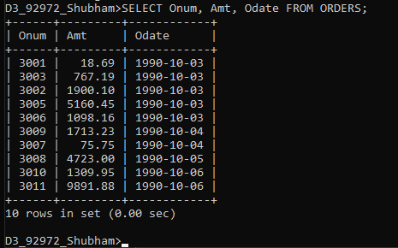

2) Write a query that produces all rows from the Customers table for which the

salesperson’s number is 1001.

SELECT \*

FROM CUSTOMERS

WHERE Snum = 1001;

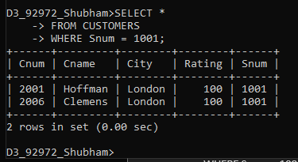

3) Write a query that displays the Salespeople table with the columns in the

following order: city, sname, snum, comm.

SELECT city, sname, snum, comm

FROM salespeople;

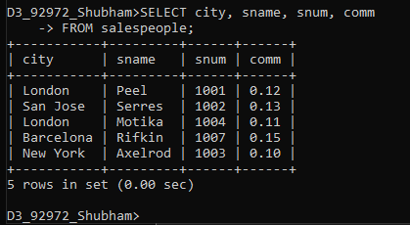

4) Write a select command that produces the rating followed by the name of each

customer in San Jose.

SELECT Rating, Cname

FROM CUSTOMERS

WHERE City = 'San Jose';

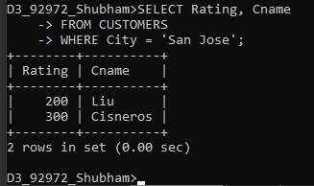

5) Write a query that will produce the snum values of all salespeople (suppress the

duplicates) with orders in the Orders table.

SELECT DISTINCT snum

FROM ORDERS;

