***Assignment –1***

Creating sample tables and inserting values.

Create the following tables with the given structures and insert sample data as specified: -

1. *SALESPEOPLE*

Snum int(4)

Sname varchar(10)

City varchar(10)

Comm float(3,2)

1. *CUSTOMERS*

Cnum int(4)

Cname varchar(10)

City varchar(10)

Rating int(4)

Snum int(4)

1. *ORDERS*

Onum int(4)

Amt float(7,2)

Odate date

Cnum int(4)

Snum int(4)

*SALES PEOPLE*

|  |  |  |  |
| --- | --- | --- | --- |
| SNUM | SNAME | CITY | COMM |
| 1001 | Peel | London | .12 |
| 1002 | Serres | San Jose | .13 |
| 1004 | Motika | London | .11 |
| 1007 | Rifkin | Barcelona | .15 |
| 1003 | Axelrod | New York | .10 |

*CUSTOMERS*

|  |  |  |  |  |
| --- | --- | --- | --- | --- |
| CNUM | CNAME | CITY | RATING | SNUM |
| 2001 | Hoffman | London | 100 | 1001 |
| 2002 | Giovanni | Rome | 200 | 1003 |
| 2003 | Liu | San Jose | 200 | 1002 |
| 2004 | Grass | Berlin | 300 | 1002 |
| 2006 | Clemens | London | 100 | 1001 |
| 2008 | Cisneros | San Jose | 300 | 1007 |
| 2007 | Pereira | Rome | 100 | 1004 |

*ORDERS*

|  |  |  |  |  |
| --- | --- | --- | --- | --- |
| ONUM | AMT | ODATE | CNUM | SNUM |
| 3001 | 18.69 | 03-OCT-1990 | 2008 | 1007 |
| 3003 | 767.19 | 03- OCT -1990 | 2001 | 1001 |
| 3002 | 1900.10 | 03- OCT -1990 | 2007 | 1004 |
| 3005 | 5160.45 | 03- OCT -1990 | 2003 | 1002 |
| 3006 | 1098.16 | 03- OCT -1990 | 2008 | 1007 |
| 3009 | 1713.23 | 04- OCT -1990 | 2002 | 1003 |
| 3007 | 75.75 | 04- OCT -1990 | 2004 | 1002 |
| 3008 | 4723.00 | 05- OCT -1990 | 2006 | 1001 |
| 3010 | 1309.95 | 06- OCT -1990 | 2004 | 1002 |
| 3011 | 9891.88 | 06- OCT -1990 | 2006 | 1001 |

Queries:

Table 1:

CREATE TABLE salespeople

(

Snum int(4),

Sname varchar(10),

City varchar(10),

Comm float(3,2)

);

Select * from salespeople;

Insert into salespeople values(1001, “Peel”, ”London”, .12);

Insert into salespeople values(1002,"Serres","San Jose",0.13,);

Insert into salespeople values(1004,"Motika","London",0.11,);

Insert into salespeople values(1007,"Rifkin","Barcelona",0.15,);

Insert into salespeople values(1003,"Axelrod","New York",0.1,);

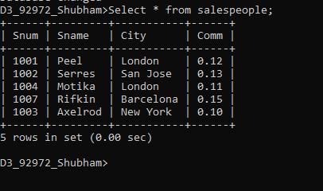

CREATE TABLE CUSTOMERS

(

Cnum int(4),

Cname varchar(10),

City varchar(10),

Rating int(4),

Snum int(4)

);

Insert into CUSTOMERS values

(2001,"Hoffman","London",100,1001);

Select * from CUSTOMERS;

Insert into CUSTOMERS values(2001,"Hoffman","London",100,1001);

Insert into CUSTOMERS values(2002,"Giovanni","Rome",200,1003);

Insert into CUSTOMERS values(2003,"Liu","San Jose",200,1002);

Insert into CUSTOMERS values(2004,"Grass","Berlin",300,1002);

Insert into CUSTOMERS values(2006,"Clemens","London",100,1001);

Insert into CUSTOMERS values(2008,"Cisneros","San Jose",300,1007);

Insert into CUSTOMERS values(2007,"Pereira","Rome",100,1004);

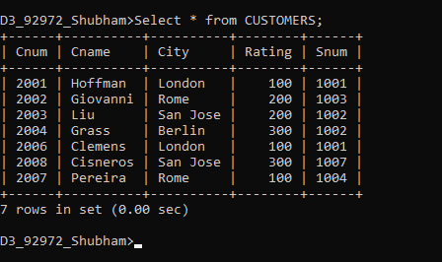

DROP TABLE CUSTOMERS;

CREATE TABLE ORDERS

(

Onum int(4),

Amt float(7,2),

Odate date,

Cnum int(4),

Snum int(4)

);

Insert into ORDERS values(3001, 18.69, '1990-10-3',2008,1007);

Insert into ORDERS values(3003, 767.19, '1990-10-3',2001,1001);

Insert into ORDERS values(3002, 1900.1, '1990-10-3',2007,1004);

Insert into ORDERS values(3005, 5160.45, '1990-10-3',2003,1002);

Insert into ORDERS values(3006, 1098.16, '1990-10-3',2008,1007);

Insert into ORDERS values(3009, 1713.23, '1990-10-4',2002,1003);

Insert into ORDERS values(3007, 75.75, '1990-10-4',2004,1002);

Insert into ORDERS values(3008, 4723.00, '1990-10-5',2006,1001);

Insert into ORDERS values(3010, 1309.95, '1990-10-6',2004,1002);

Insert into ORDERS values(3011, 9891.88, '1990-10-6',2006,1001);

Select * from ORDERS;

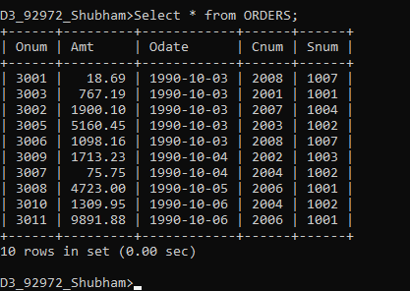

DROP TABLE ORDERS;

