**Customer Billing System**

Customer Billing System Project is a simple console application designed to demonstrate the practical use of C programming language and its features as wells as to generate an application which can be used in any departmental store, shops, cafes etc. for billing to the customer.

You can use this application to keep the records such as name, address, mobile number, paid amount, due amount, payment date etc. of your regular costumer. Moreover, if you have a new customer, you can add and edit the account at any time.

**Features:**

1. It can hold any number of accounts and account can be added to the program at any time.
2. The programming of simple calculations such as calculation of due amount, balance etc. have been embed in the code of project.
3. The Customer Billing System project in C gives you the facility of searching the account by two ways, either by name of the customer or by the number of customer.
4. The due amount to be paid is shown as negative balance.
5. If you have nothing to do with the program, you can directly exit from the main menu.

Output :

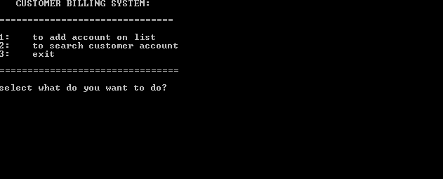

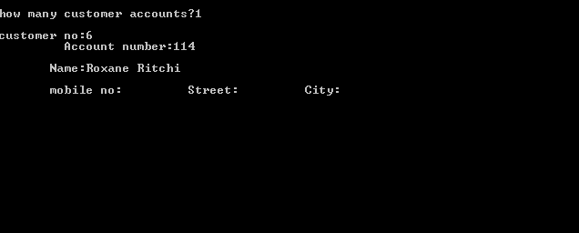

Module

#include<stdio.h>

#include<conio.h>

#include<stdlib.h>

#include<string.h>

Interface

struct date{

int month;

int day;

int year;

};

struct account {

int number;

char name[100];

int acct_no;

float mobile_no;

char street[100];

char city[100];

char acct_type;

float oldbalance;

float newbalance;

float payment;

struct date lastpayment;

}customer;

Integration Testing

In this individual software, modules are combined and tested as a group.

Functions and Non-Functions

* void input()
* void write file()
* void search()
* void output()