**Lab 2**

**Name:**Vaghani Smit Dhirubhai

**Roll No:**166

**College Id:**19CEUEG022

1. **Copy the data from source to destination variable using different data types and different addressing modes.**

**Ans:**

data segment

num db 10;

data ends

code segment

assume cs:code,ds:data

mov ax,data

mov ds,ax

mov dl,num

mov bX,5000H ;immediate addressing mode

mov dX,bX ;register addressing mode

mov dx,[5000H];direct addressing mode

mov dx,[bx];register indirect addressing mode

mov dx,[bx+02];based addressing mode

mov bx,[si+10]; index addressing mode

mov ax,[si+bx]; based index addressing mode

mov ax,[bx+di+07]

;based index with displacement addressing mode

code ends

end

1. **Add 2 16-bit numbers. The 16 bit numbers are stored into the data segment.**

**Ans:**

data segment

a dw 1234h

b dw 9479h

c dw ?

data ends

code segment

assume cs:code,ds:data

mov ax,data

mov ds,ax

mov ax,a

mov bx,b

add ax,bx

mov c,ax

int 3

code ends

end

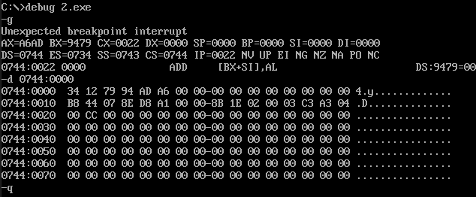

1. **Add 2 32-bit numbers stored in the data segment.**

**Ans:**

data segment

a dd 1F341234h

b dd 9F79F479h

c dw ?

data ends

code segment

assume cs:code,ds:data

mov ax,data

mov ds,ax

mov dl,00H

mov ax,word ptr a ;lsb of a

mov bx,word ptr b ;lsb of b

add ax,bx;

mov word ptr c,ax ;lsb of answer

mov ax,word ptr a+2 ;msb of a

mov bx,word ptr b+2 ;msb of b

adc ax,bx;

mov word ptr c+2,ax;

jnc jump

inc dl

jump:mov byte ptr c+4,dl

int 3

code ends

end

