**Lab 3**

**Name:** Vaghani Smit Dhirubhai

**Roll No:**CE166

**College Id:** 19CEUEG022

1. **Program to Multiply two unsigned 16 bit numbers.**

**Ans:**

data segment

num1 dw 0F12FH

num2 dw 000FFH

answer dd ?

data ends

code segment

assume cs:code,ds:data

mov ax,data

mov ds,ax

mov ax,num1

mov bx,num2

mul bx

mov word ptr answer,ax

mov ax,dx

mov word ptr answer+2,ax

int 03

code ends

end

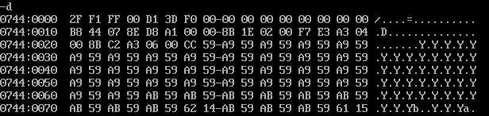**ScreenShots:**

1. **Multiply Two 16 bit Sign number.**

**Ans:**

data segment

num1 dw 1212H

num2 dw -2323H

answer dd ?

data ends

code segment

assume cs:code,ds:data

mov ax,data

mov ds,ax

mov ax,num1

mov bx,num2

imul bx

mov word ptr answer,ax

mov ax,dx

mov word ptr answer+2,ax

int 03

code ends

end

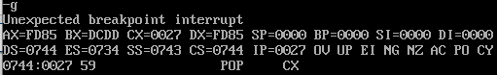**Screenshots:**

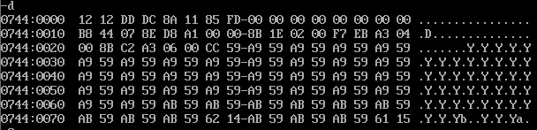

1. **program to divide 16 bit sign/unsign number.**

**Ans:**

data segment

num1 dw 1234H

num2 dw 0012H

answer dw ?

data ends

code segment

assume ds:data,cs:code

mov ax,data

mov ds,ax

mov ax,num1

mov bx,num2

div bx

mov answer,ax

int 03

code ends

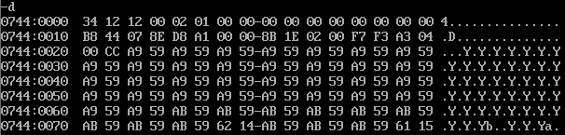end

data segment

num1 dw 1200H

num2 dw -10H

answer dw ?

data ends

code segment

assume ds:data,cs:code

mov ax,data

mov ds,ax

mov ax,num1

mov bx,num2

idiv bx

mov answer,ax

int 03

code ends

end

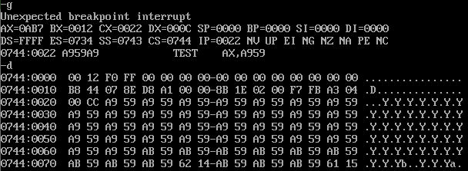**Screenshots:**

1. **Find the Checksum and verify validity of a 32 bit data.**

**Ans:**

data segment

num1 dd 20103832H

num2 dd 12341231H

data ends

code segment

assume cs:code,ds:data

mov ax,data

mov ds,ax

mov ax,word ptr num1

mov bx,word ptr num1+2

mov cx,word ptr num2

mov dx,word ptr num2+2

xor ax,cx

xor bx,dx

int 03H

code ends

end

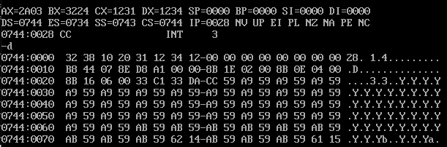**ScreenShots:**

**5. Program to copy an array of bytes/words from the variable “SOURCE” to variable “DEST” which are defined in data segment.**

**Ans:**

data segment

src db 1,2,2,3,11

dest db 5 dup(?)

data ends

code segment

assume cs:code,ds:data

mov ax,data

mov ds,ax

mov cx,4

mov si,offset src

mov di,offset dest

l1:mov dx,[si]

mov [di],dx

inc si

inc di

loop l1

int 03H

code ends

end

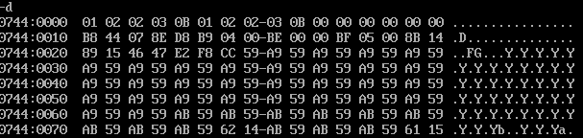**ScreenShot:**

**6.find the sum of array**

**Ans:**

data segment

arr db 3H,2H,10H,11H,2H

ans db ?

data ends

code segment

assume cs:code,ds:data

mov ax,data

mov ds,ax

mov si,offset arr

mov di,offset ans

mov cx,5

mov ax,0000H

l1:add al,[si]

inc si

loop l1

mov [di],ax

int 03h

code ends

end

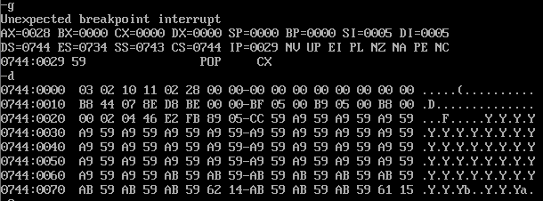**Screenshot:**