Noise-Aware Grover Key Search: How Per-Iteration Logical Error Limits the Quantum Speed-Up Against Symmetric Ciphers
Rahul Bansode  Roll No. 24102A0058  Dept. of Computer Engineering  Vidyalankar Institute of Technology  Mumbai, India  rahul.bansode@vit.edu.in | Rishabh Hatlunkar  Roll No. 26102A2006  Dept. of Computer Engineering  Vidyalankar Institute of Technology  Mumbai, India  rishabh.hatlunkar@vit.edu.in | Shubham Vaidya  Roll No. 24102A0059  Dept. of Computer Engineering  Vidyalankar Institute of Technology  Mumbai, India  shubham.vaidya@vit.edu.in | Dhiraj Pawar  Roll No. 24102A0017  Dept. of Computer Engineering  Vidyalankar Institute of Technology  Mumbai, India  dhiraj.pawar@vit.edu.in

Abstract—Grover’s algorithm is the standard reason that symmetric key lengths are doubled in the post-quantum setting, but the usual “n-bit key gives n/2 bits of quantum security” rule assumes a noiseless machine. We ask a narrower question: how much error per Grover iteration can a key-search attack tolerate before the quadratic speed-up is lost? We model each iteration as suffering a global depolarizing fault with probability ε and derive a closed form for the success probability, which we confirm against exact density-matrix simulation (maximum deviation 4.3×10⁻¹⁴). Optimizing the iteration count with restarts gives an expected cost of (e/4)·ε·N iterations once ε exceeds a critical value ε_{c} = π/(e√N), and the ideal (π/4)√N below it. For a 128-bit key this places the threshold near ε ≈ 2^{-63.8}; at ε = 2⁻⁴⁰ the attack costs about 2^{87.4} iterations instead of 2^{63.7}. Using a surface-code heuristic and illustrative circuit-volume assumptions, meeting the threshold for a 128-bit key needs a code distance of about 51, i.e. on the order of 10⁷ physical qubits for error suppression alone. We argue that quantum-security estimates for symmetric ciphers should report the logical error budget alongside gate counts.
Index Terms—Grover’s algorithm, quantum key search, symmetric cryptography, post-quantum security, quantum error correction, depolarizing noise.
I. INTRODUCTION
Large-scale quantum computers threaten deployed public-key cryptography through Shor’s algorithm [1], which solves factoring and discrete logarithms in polynomial time. Symmetric primitives are affected differently: Grover’s algorithm [2] finds a marked element among N candidates with O(√N) queries, so exhaustive search over an n-bit key costs roughly 2^{n/2} quantum iterations instead of 2^{n}. This is why 256-bit keys are routinely recommended for long-term security, and why NIST’s post-quantum evaluation criteria [3] use key search against AES as reference points for its security categories.
These estimates treat the quantum computer as ideal. A real Grover attack on a 128-bit key must run about 2⁶⁴ sequential iterations, each containing a full reversible cipher evaluation, without a single uncorrected fault corrupting the register. The natural question, and the problem studied here, is: how large may the per-iteration error probability be before Grover’s quadratic advantage disappears, and what does meeting that bound cost in error-correction overhead?
Our contributions are: (i) a closed-form success probability for Grover search under per-iteration depolarizing noise, verified numerically; (ii) the optimal restart strategy, a critical error rate ε_{c} = π/(e√N), and an “effective security” formula for ε > ε_{c}; (iii) a density-matrix study of per-qubit noise showing how it maps onto the global model; and (iv) an illustrative surface-code overhead estimate for 128-, 192- and 256-bit keys.
II. BACKGROUND AND RELATED WORK
Grover’s algorithm is optimal up to a constant: Zalka showed that no quantum algorithm can search an unstructured space faster than order √N [4], and Boyer et al. gave tight bounds on the iteration count, including the case of an unknown number of solutions [5]. Applying the algorithm to block ciphers requires a reversible circuit for the cipher. Grassl et al. produced the first detailed resource estimates for AES [6], and Jaques et al. later reduced the cost and extended the analysis to LowMC, reporting logical-qubit counts in the thousands for AES key search [7]. These works count gates and qubits for a fault-free machine.
The effect of imperfections on Grover search has been studied, for example for a noisy oracle by Shenvi et al. [8]. In the NISQ regime [9] such noise limits the achievable problem size; in the fault-tolerant regime it becomes a question of how much error correction is needed. Surface codes [10] are the leading candidate, with logical error rates that fall exponentially in code distance. Gidney and Ekerå’s estimate for factoring 2048-bit RSA with about 20 million noisy qubits [11] is a useful scale reference for our results. To our knowledge the direct link between a per-iteration error budget and the effective bit-security of a key-search attack is rarely stated explicitly in resource-estimate papers, which is the gap this paper addresses; we have not performed an exhaustive literature survey, so this claim should be read cautiously.
III. PROBLEM FORMULATION
A. Ideal Key Search
Let the key space be of size N = 2^{n} with a single marked key. One Grover iteration applies the oracle (a reversible cipher evaluation on a known plaintext–ciphertext pair, its comparison, and uncomputation) followed by inversion about the mean. With θ = arcsin(N^{-1/2}), the success probability after t iterations is
P_{t} = sin²((2t + 1)θ), (1)
maximized near t = (π/4)√N, giving an ideal cost of (π/4)√N iterations.
B. Noise Model
We abstract the effect of faults in each iteration by a global depolarizing channel acting on the N-dimensional register state ρ [12]:
E(ρ) = (1 − ε)ρ + ε I/N. (2)
Here ε is the probability that an iteration suffers an uncorrected fault that fully randomizes the state. For a deep fault-tolerant circuit this is a pessimistic but natural abstraction: once a logical fault occurs mid-circuit, the final measurement is essentially uninformative. Section V tests how well the abstraction matches per-qubit noise.
C. Attack Strategy and Cost
The attacker runs t iterations, measures, checks the candidate key with one classical cipher evaluation, and restarts on failure. The expected number of iterations until success is
C(t) = t/P_{t}(ε), (3)
and the attacker chooses t to minimize it. We write C* for the minimum. The verification cost is neglected.
IV. ANALYTICAL RESULTS
Proposition 1. Under (2), the success probability after t iterations is
P_{t}(ε) = (1 − ε)^{t} sin²((2t + 1)θ) + [1 − (1 − ε)^{t}]/N. (4)
Proof sketch. The unitary of one iteration maps I/N to itself, and (2) is linear, so by induction the state is ρ_{t} = (1 − ε)^{t}|ψ_{t}⟩⟨ψ_{t}| + [1 − (1 − ε)^{t}]I/N, where |ψ_{t}⟩ is the noiseless Grover state. Reading off the marked-state population gives (4). ∎
Proposition 2 (approximate optimum). For ε ≫ 1/√N and t ≪ √N, sin²((2t + 1)θ) ≈ 4t²/N and (1 − ε)^{t} ≈ e^{-εt}, so C(t) ≈ N e^{εt}/(4t). Setting the derivative to zero gives
t* ≈ 1/ε, C* ≈ (e/4)·ε·N. (5)
The expression is linear in N: the attacker is forced to short runs, and the quadratic speed-up is replaced by a speed-up that shrinks only linearly in the error rate. Equating (5) with the ideal cost (π/4)√N gives the critical error rate
ε_{c} = π/(e√N) ≈ 1.16·2^{-n/2}. (6)
Taking logarithms, the effective security level of an n-bit key against noisy Grover search is
b_{eff}(ε) ≈ n − log₂(1/ε) − 0.55 for ε > ε_{c}, (7)
and b_{eff} ≈ n/2 − 0.35 for ε ≤ ε_{c}. Each factor of two in the error rate therefore costs the defender nothing and the attacker one bit, until the threshold is reached.
V. SIMULATION METHODOLOGY
All experiments use NumPy in double precision. Global-noise validation: for n = 8 we evolve the full 256 × 256 density matrix through 30 Grover iterations, applying (2) after each, for ε ∈ {0, 0.01, 0.03, 0.1}, and compare the marked-state population with (4).
Per-qubit noise: for n ∈ {6, 8} we apply, after each iteration, a single-qubit depolarizing channel ρ → (1 − p)ρ + p(I/2 ⊗ Tr_{q}ρ) to every qubit q, for p ∈ {5×10⁻⁴, 10⁻³, 2×10⁻³, 5×10⁻³, 10⁻²}, over T = 2⌊(π/4)√N⌋ + 4 iterations. For each run we fit the single parameter ε_{eff} of (4) by least squares on a grid of step 2.5×10⁻⁴ over [0, 0.5].
Cost at cryptographic sizes: for n ∈ {128, 192, 256} we minimize C(t) of (3) numerically over integer t (a 4000-point logarithmic grid plus 200 points around 1/ε), evaluating (1 − ε)^{t} through log1p for numerical stability.
Error-correction overhead: we use the common surface-code heuristic [10] p_{L}(d) = 0.1(p/p_{th})^{(d+1)/2}, with physical error rate p = 10⁻³, threshold p_{th} = 10⁻², and 2d² physical qubits per logical qubit. A Grover iteration is assumed to occupy a space-time volume of V logical qubit-cycles, so ε = V·p_{L}, and the requirement ε ≤ ε_{c} reads
p_{L} ≤ π/(e·V·√N). (8)
We set V = 2²⁴ and Q = 3000 logical qubits as illustrative values of the order suggested by published AES oracle estimates [6], [7]; they are not taken from a specific circuit.
VI. RESULTS AND DISCUSSION
A. Closed-Form Validation
Across all four noise levels, the closed form (4) and the density-matrix simulation agree to within 4.3×10⁻¹⁴ (Fig. 1), which is rounding error. This confirms Proposition 1 for the global model; it is a consistency check of the algebra, not evidence that real hardware is globally depolarizing. Noise lowers the attainable peak and moves it earlier: at ε = 0.1 the success probability never rises far above the noise floor.
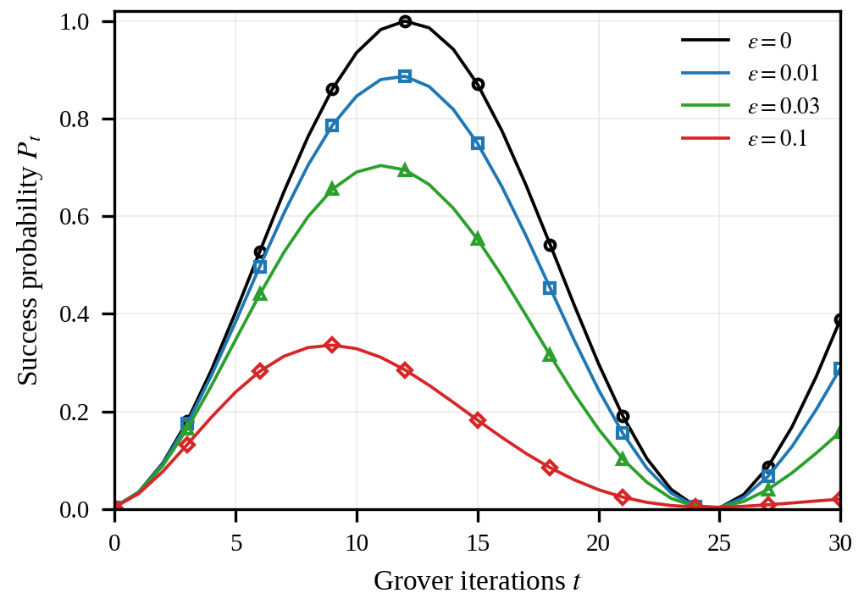
Fig. 1. Success probability P_{t} for n = 8 (N = 256). Lines: closed form (4); markers: exact density-matrix simulation (every third point).
B. Per-Qubit Noise
Table I shows the fitted global error rate for per-qubit depolarizing noise. Across all ten runs ε_{eff} ≈ 0.50–0.54 × n·p, roughly independent of n and p in the tested range. We observed this empirically and have not derived it. The fit is imperfect: the root-mean-square error between the fitted model and the simulated curve grows with p (from 0.001 at p = 5×10⁻⁴, n = 6, to 0.029 at p = 10⁻², n = 8), so the global model should be read as an effective description that captures the scale of the error budget, not its exact shape. Only two small sizes were simulated; extrapolating the ratio to n = 128 is unverified.
TABLE I
Fitted Global Error Rate for Per-Qubit Depolarizing Noise
n | p | ε_{eff} | ε_{eff}/(np) | max P_{t} | argmax t
6 | 0.001 | 0.0033 | 0.54 | 0.977 | 6
6 | 0.005 | 0.0158 | 0.53 | 0.903 | 6
6 | 0.010 | 0.0308 | 0.51 | 0.819 | 6
8 | 0.001 | 0.0043 | 0.53 | 0.948 | 12
8 | 0.005 | 0.0208 | 0.52 | 0.769 | 11
8 | 0.010 | 0.0410 | 0.51 | 0.604 | 11

C. Effective Security at Cryptographic Key Sizes
Fig. 2 plots the optimized cost for n = 128. The numerical optimum follows the ideal value 2^{63.7} for ε well below ε_{c} ≈ 2^{-63.8}, then tracks the asymptote (5) closely; for ε ≥ 2⁻⁶⁰ the two differ by less than 0.01 bit. The optimal run length matches t* ≈ 1/ε in this regime (for example t* ≈ 2^{40.0} at ε = 2⁻⁴⁰).
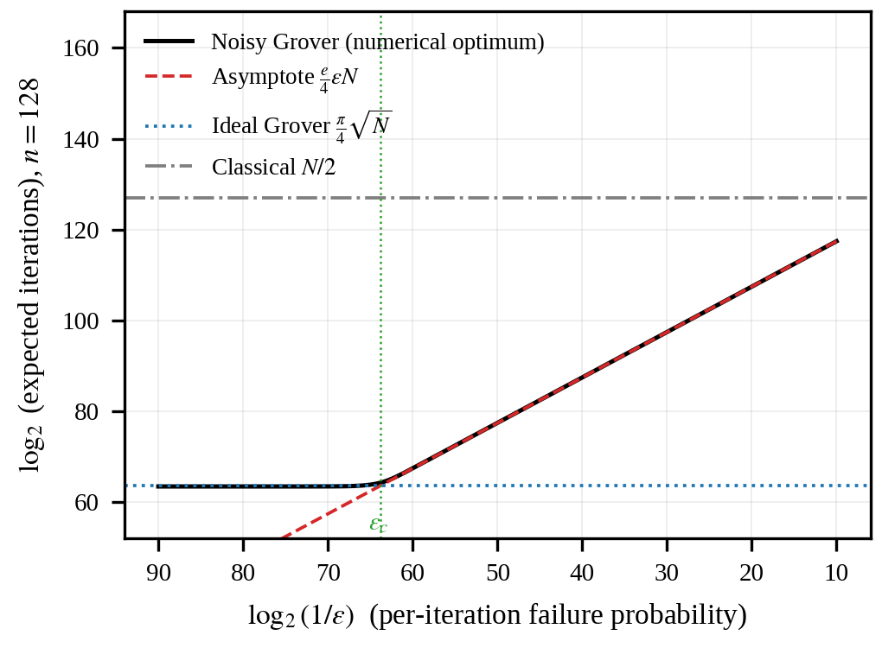
Fig. 2. Expected iterations to recover a 128-bit key versus per-iteration failure probability ε. The curve is the numerical optimum over run length t; the classical line counts cipher evaluations and is shown for scale only.
Table II gives b_{eff} for the three AES key sizes. A 128-bit key retains its ideal 63.7 bits only if ε ≲ 2⁻⁶⁴; at ε = 2⁻⁴⁰ the attack costs 2^{87.4} iterations, and at ε = 2⁻²⁰ it costs 2^{107.4}. The same absolute error rate is far less damaging for larger keys relative to their thresholds, but the thresholds themselves (≈ 2⁻⁹⁶ and 2⁻¹²⁸) become correspondingly stricter.
TABLE II
Expected Grover Iterations (log₂) for Per-Iteration Failure Probability 2^{-x}
n | x=80 | x=64 | x=40 | x=30 | x=20 | Ideal
128 | 63.5 | 64.2 | 87.4 | 97.4 | 107.4 | 63.7
192 | 111.4 | 127.4 | 151.4 | 161.4 | 171.4 | 95.7
256 | 175.4 | 191.4 | 215.4 | 225.4 | 235.4 | 127.7

D. Error-Correction Overhead
Table III applies (8) with the illustrative parameters of Section V. For n = 128 the logical error rate must reach about 2^{-87.8}, requiring a distance-51 surface code and about 1.6×10⁷ physical qubits for the 3000 logical qubits, before counting magic-state factories or routing. This is the same order as the 2×10⁷ qubits estimated for RSA-2048 [11], which is a reason to treat Grover key search and Shor-style attacks as comparable engineering challenges rather than the former being easy. The dependence on V is mild: sweeping V from 2²⁰ to 2³² changes the distance only from 49 to 55 (1.4×10⁷ to 1.8×10⁷ physical qubits), because p_{L} falls exponentially with d.
TABLE III
Illustrative Surface-Code Requirement for ε ≤ ε_{c} (V = 2²⁴, Q = 3000)
n | log₂ ε_{c} | log₂ p_{L} | d | Physical qubits
128 | −63.8 | −87.8 | 51 | 1.56×10⁷
192 | −95.8 | −119.8 | 71 | 3.02×10⁷
256 | −127.8 | −151.8 | 89 | 4.75×10⁷

E. Limitations
The conclusions rest on several simplifications. (1) The global depolarizing model is an effective abstraction; Section VI-B (Table I) shows it fits per-qubit noise only approximately, and only for n ≤ 8. (2) V and Q are illustrative, and the same Q is reused for all key sizes for comparability, although larger keys need more qubits. (3) The surface-code formula is a heuristic with uniform physical error rates; it ignores magic-state distillation, routing and decoder latency. (4) The attack is purely sequential: parallel Grover with limited circuit depth, as considered in NIST’s depth-bounded analysis [3], is not modeled. (5) The classical baseline N/2 counts cipher evaluations, whereas a Grover iteration includes at least two, so the real crossover against classical search is less favorable to the quantum attacker than the figure suggests. None of this implies that AES is weakened or broken: the results show that the √N speed-up demands extreme error suppression.
VII. CONCLUSION
We showed that under a per-iteration depolarizing model, Grover key search keeps its quadratic speed-up only when the failure probability per iteration stays below ε_{c} = π/(e√N), about 2⁻⁶⁴ for a 128-bit key. Above this threshold the optimal attack degrades to a cost of (e/4)εN, which loses one bit of security per halving of the error budget. Verified against exact density-matrix simulation, the model gives practical guidance: resource estimates for symmetric-key attacks should state the logical error budget they presuppose, and security categories based on 2^{n/2} implicitly assume it. Future work includes error-detecting oracles that discard faulty runs early, noisy parallel Grover search under depth limits, validation of the per-qubit-to-global mapping at larger n, and execution on small fault-tolerant devices as they become available.
ACKNOWLEDGMENT
The authors thank the Department of Computer Engineering, Vidyalankar Institute of Technology, for academic support. An AI language model (Anthropic’s Claude) was used to assist with drafting the manuscript text, writing the simulation code and generating the figures. The authors reviewed the content, reproduced the simulations and take full responsibility for the results and claims in this paper.
REFERENCES
[1] P. W. Shor, “Algorithms for quantum computation: Discrete logarithms and factoring,” in Proc. 35th Annu. Symp. Found. Comput. Sci. (FOCS), 1994, pp. 124–134.
[2] L. K. Grover, “A fast quantum mechanical algorithm for database search,” in Proc. 28th Annu. ACM Symp. Theory Comput. (STOC), 1996, pp. 212–219.
[3] NIST, “Submission requirements and evaluation criteria for the post-quantum cryptography standardization process,” 2016.
[4] C. Zalka, “Grover’s quantum searching algorithm is optimal,” Phys. Rev. A, vol. 60, no. 4, pp. 2746–2751, 1999.
[5] M. Boyer, G. Brassard, P. Høyer, and A. Tapp, “Tight bounds on quantum searching,” Fortschr. Phys., vol. 46, no. 4–5, pp. 493–505, 1998.
[6] M. Grassl, B. Langenberg, M. Roetteler, and R. Steinwandt, “Applying Grover’s algorithm to AES: Quantum resource estimates,” in Post-Quantum Cryptography (PQCrypto), LNCS vol. 9606, 2016, pp. 29–43.
[7] S. Jaques, M. Naehrig, M. Roetteler, and F. Virdia, “Implementing Grover oracles for quantum key search on AES and LowMC,” in Advances in Cryptology—EUROCRYPT 2020, LNCS vol. 12106, 2020, pp. 280–310.
[8] N. Shenvi, K. R. Brown, and K. B. Whaley, “Effects of a random noisy oracle on search algorithm complexity,” Phys. Rev. A, vol. 68, 052313, 2003.
[9] J. Preskill, “Quantum computing in the NISQ era and beyond,” Quantum, vol. 2, p. 79, 2018.
[10] A. G. Fowler, M. Mariantoni, J. M. Martinis, and A. N. Cleland, “Surface codes: Towards practical large-scale quantum computation,” Phys. Rev. A, vol. 86, 032324, 2012.
[11] C. Gidney and M. Ekerå, “How to factor 2048 bit RSA integers in 8 hours using 20 million noisy qubits,” Quantum, vol. 5, p. 433, 2021.
[12] M. A. Nielsen and I. L. Chuang, Quantum Computation and Quantum Information, 10th anniv. ed. Cambridge, U.K.: Cambridge Univ. Press, 2010.

