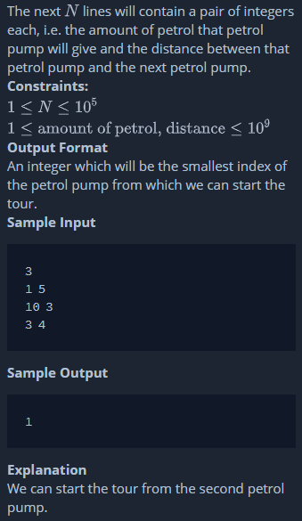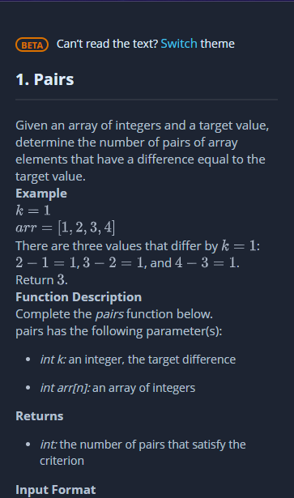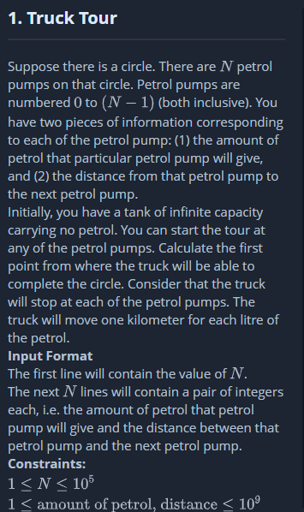

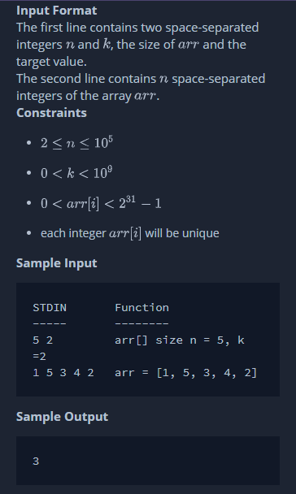

|  |  |  |  |  |  |  |  |
| --- | --- | --- | --- | --- | --- | --- | --- |
| 11 | 11 | 11 |  | 12 | 11 |  | 13 |
| 13 | | |  | 13 | |  | 13 |

|  |  |  |  |  |  |  |  |  |
| --- | --- | --- | --- | --- | --- | --- | --- | --- |
| 11 | 12 |  | 13 | | |  | 13 | |
| 13 | |  | 11 | 11 | 11 |  | 12 | 11 |

|  |  |  |  |  |  |  |  |  |  |
| --- | --- | --- | --- | --- | --- | --- | --- | --- | --- |
| 13 | |  | 11 | 12 | |  | 12 | | 11 |
| 11 | 12 |  | 12 | | 11 |  | 11 | 12 | |