# Unit 2

# Chapter 3: Unlocking the Atom

# Lesson 2: Atomic Number and Mass Number

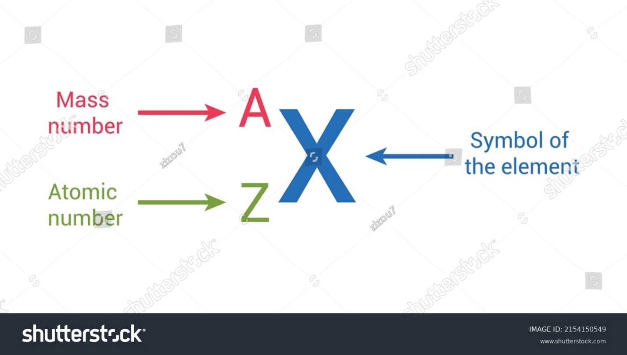

Figure 3.12 Atomic number and Mass number

# <H1> Essential Question

What can the atomic number and mass number of an element tell us about it?

# <H1> Big Idea

The atomic number holds the key to an element's identity, while the mass number reveals the number of protons and neutrons in an element.

# <H1> Lesson Objectives

By the end of the lesson, I you will be able to:

* identify the subatomic particles (protons, neutrons, and electrons) and their charges.
* describe the relationship between the number of protons, neutrons, and electrons in an atom.
* calculate the atomic mass of an element from the number of subatomic particles.

# <H1> Curiosity Corner

What happens to salt in contact with ice and snow? To answer this, you need to look inside the structure of salt and water. Every substance, whether salt, water, or metals, is made of atoms. There are different types of atoms that make up the substances. The types of atoms differ in many ways, for example, in how they are composed or how much they weigh. For example, hydrogen and oxygen atoms that form water differ in the subatomic particles they are composed of and in the mass of each atom.

# <H1> **Key Vocabulary**

Atomic number - the number of protons in an atom

Element symbol - a one- or two-letter abbreviation used to represent a chemical element

Mass number - the sum of the total number of protons and neutrons

## <H1> Ignite: What Happens to Salt in Contact with Ice and Snow?

## To answer this, we need to understand the charged particles within salt and water. These particles, anions and cations, are made up of atoms that lost or gained electrons. Electrons are the most mobile of the subatomic particles. Let us find evidence of the existence of electrons in our daily life.

**Materials Required:**

* Comb
* Silk cloth
* Small pieces of paper
* Glass rod
* Inflated balloon

**Procedure**

1. Comb your dry hair. Now bring the comb near the small pieces of paper. Does it attract the small pieces of paper?



Figure 3.13. Comb attracts pieces of paper

1. Rub the glass rod with a silk cloth and bring it near the inflated balloon. What happens?

The charge in atoms originates from smaller charged particles like protons and electrons.

## <H2> **Progress Check 1**

1. What charge would an atom that lost one electron have?
2. What charge would an atom that gained two electrons have?

# <H1> **Subatomic Particles**

**Direct Instruction: Recall** from the previous lesson that discoveries made during the late 19th and early 20th centuries revealed that the atom is indivisible, but has a structure. These studies showed that atoms are made up of smaller particles, such as electrons, protons, and neutrons, which can be separated.

* Protons: These are positively charged particles found in the nucleus. The number of protons determines the element’s identity (e.g., a sodium atom always has 11 protons, and a chlorine atom always has 17 protons).
* Neutrons: These are neutral particles that also reside in the nucleus. A neutron has no charge, and it has approximately the same mass as a proton.
* Electrons: These are negatively charged particles found in the electron cloud around the nucleus. Electrons have such little mass compared to protons and neutrons that it can be ignored. Because they are outside the nucleus, it is much easier to move electrons from one atom to another. In fact, this is how almost all chemical reactions happen.

# <H1> **Mass of Subatomic Particles**

Subatomic particles are so tiny that their masses cannot be easily measured in grams or kilograms, like you do with other materials. A new unit of measurement is needed to represent such a small quantity.

The atomic mass unit (amu) is defined as one-twelfth the mass of a single atom of carbon-12. This atom has 6 protons and 6 neutrons in its nucleus, so it has 12 nucleons, particles in the nucleus that have mass.

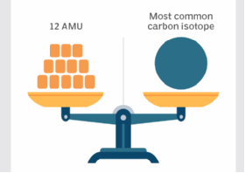

Fig 3.14. Atomic mass unit: One-twelfth the mass of a carbon-12 atom

In terms of grams, 1 amu is approximately 1.66053906660 × 10−24 g.

1 amu = 1.66×1024 g

The amu is a convenient unit to work with when dealing with atoms and molecules. For example, most hydrogen atoms have a mass of 1 amu; they just have one proton in their nucleus and their electrons have negligible mass. Most oxygen atoms are about 16 amu; they have eight protons and eight neutrons in their nucleus. Amu is a very convenient way to compare atomic and molecular masses.

Nowadays, the term *Dalton* (Da) is used interchangeably with amu, particularly in biochemistry and molecular biology, where large molecules like proteins are often measured in kilodaltons (kDa).

|  |  |  |  |
| --- | --- | --- | --- |
| **Particle** | **Location in an atom** | **Mass** | **Charge** |
| Proton | Nucleus | 1 amu | +1 |
| Neutron | Nucleus | 1 amu | 0 |
| Electron | Outside the nucleus | 0 | −-1 |

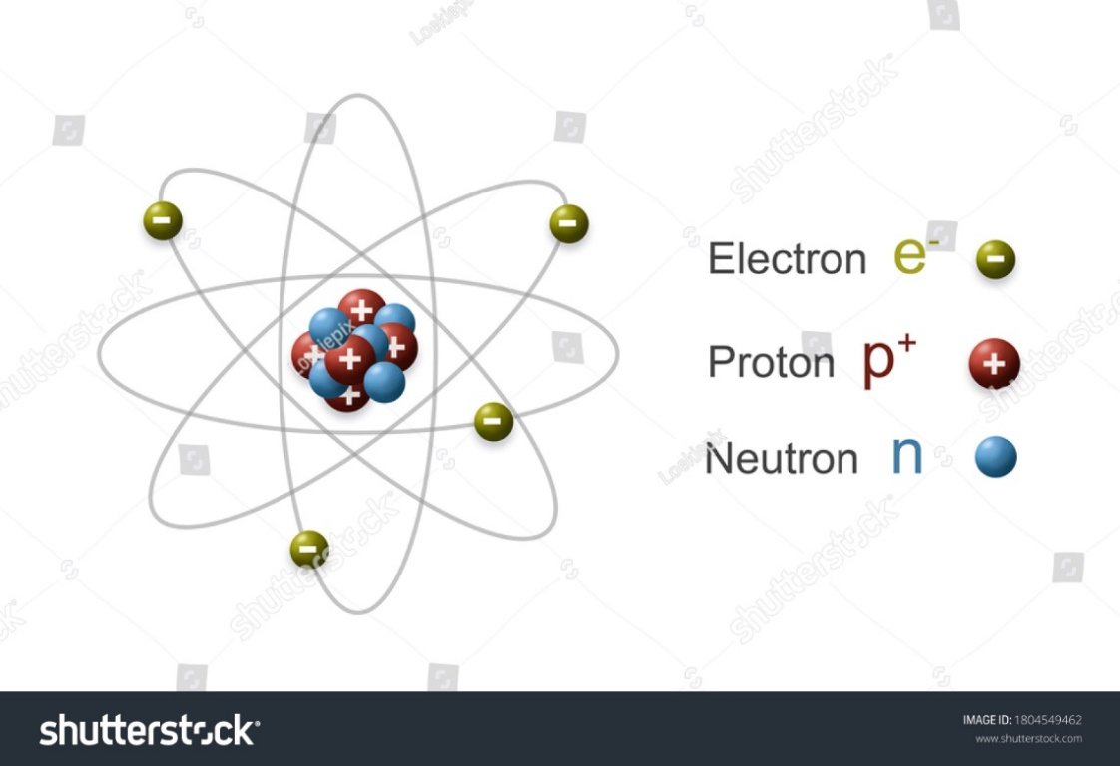

Figure 3.4. Subatomic particles

## <H2> **Progress Check 2**

In a neutral atom (atom that has no charge), how does the number of protons compare to the number of neutrons?

# <H1> **Pathfinder: Building Atomic Models**

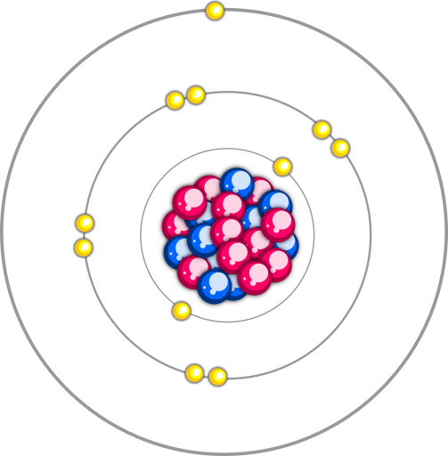

Figure 3.15 Electrons, protons, and neutrons in a sodium atom

**Materials Required**

* Colored beads (red for electrons, blue for protons, and green for neutrons)
* Element cards (Na, Cl, H, and O)
* A chart
* String
* Glue
* Marker

**Instructions**

1. Take a chart and an element card (Na).
2. On the chart, draw a circle using a string representing the nucleus and glue 11 blue beads for Na as it has 11 protons. Similarly, glue 12 green beads to represent the neutrons inside the circle.
3. Draw three circles (using string) around the nucleus to represent energy levels.
4. Glue two red beads on the first circle, eight on the second, and one on the third to represent electrons.
5. Label each part of the atom (nucleus, electrons, protons, and neutrons) and explain how the number of each particle relates to the atomic number and mass number of the element.
6. Build similar models for the elements Cl, H, and O.

**Group Discussion**

After building the model, discuss with your classmates:

1. What are protons and neutrons collectively known as? What are the numbers of electrons, protons, and neutrons in Cl, H, and O?
2. For chlorine (Cl) how many red beads are glued in the third circle to represent electrons?

# <H1> **Lightbulb**: **Atomic Number**

As you know, protons are present in the nucleus of an atom. They determine the element’s identity or type of atom it is. For example, all hydrogen atoms have one proton in their nucleus, all carbon atoms have six protons in their nucleus, and all oxygen atoms have eight protons in their nucleus. The number of protons in an atom is called the **atomic number** and it is designated by Z. Conversely, the atomic number indicates the number of protons in the nucleus. For example, chlorine has Z = 17, meaning it has 17 protons in its nucleus.

The number of protons in a neutral atom is equal to the number of electrons. So, the atomic number of an element represents both the number of protons in the nucleus and the number of electrons orbiting around it if the atom is neutral.

Atomic number = number of protons = number of electrons in a neutral atom

# <H1> **Mass Number**

The mass of an atom is mainly due to protons and neutrons, which are in the nucleus. Because of this, protons and neutrons are also referred to as nucleons. As Rutherford discovered in the gold foil experiment, almost all the mass of an atom is concentrated in its nucleus. The sum of the total number of protons and neutrons is known as the **mass number**. It is denoted by “A.” In the notation for an atom, the atomic number, mass number, and **element** **symbol** are to be written as:

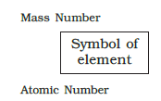 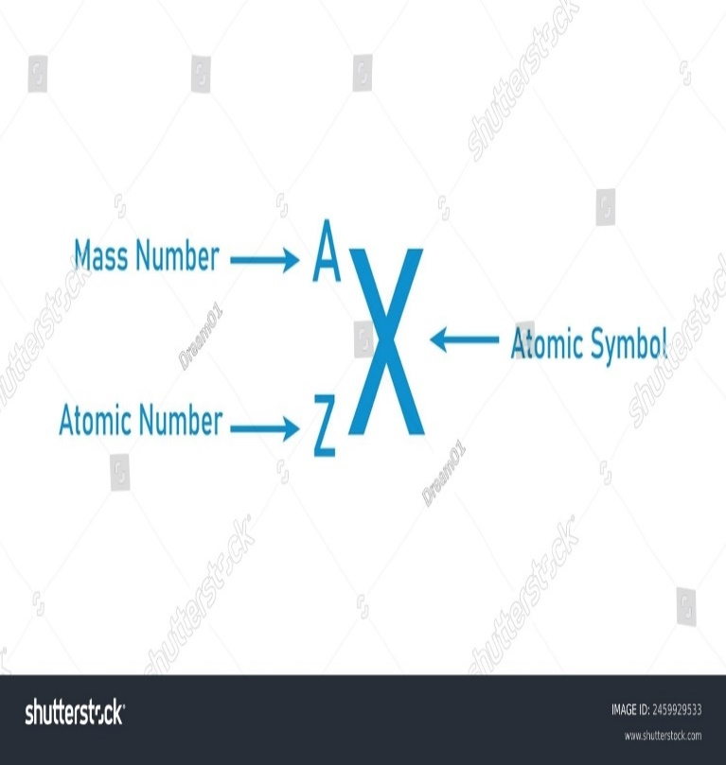

Figure 3.16. Notation for an atom

Mass number = Number of protons + Number of neutrons

**Problem example**

The number of neutrons and protons in an oxygen atom is eight and eight, respectively. What will be its mass number?

Number of protons = 8

Number of neutrons = 8

Use the formula, Mass number = Number of protons + Number of neutrons

So, the mass number is 8 + 8 = 16

## <H2> **Progress Check 3**

**An atom contains 17 electrons, 17 protons, and 18 neutrons. Assign the proper Z and A for this atom.**

# <H1> **Power Up**

**TheQuestioneer Icon**

Reflect on the following prompts to think critically about the content and come up with meaningful questions for inquiry about atomic number and mass.

1. A standard unit of mass quantifies the mass of atomic and subatomic particles.
2. An atom is overall electrically neutral.
3. The mass of an atom is concentrated in its nucleus.
4. The number of protons in the nucleus of an atom.

# <H1> **Lesson Check**

1. Choose an element and describe how its atomic number, mass number, and atomic mass in grams amu provide information about its structure.
2. If an atom has 12 protons and 15 neutrons, calculate its mass number?.
3. What is an atomic mass unit (amu), and why is it important in chemistry? Give an example of how it is used to compare the atomic masses of different atoms to measure atomic masses.
4. Define atomic number, and how does it help identify an element? Give an example using any element.
5. An atom contains nucleus which is made up of protons and neutrons. The number of protons determines the identity of an element. For example, all hydrogen atoms have one proton in their nucleus, all carbon contains six and all oxygen atoms contain eight protons respectively. The number of protons is known as atomic number and designated by Z.
6. Which factor helps in identifying an atom?

A) Neutrons of the atom

B) Electrons in the atom

C) Protons of the atom

D) Chemical bonds of the atom

b)Which subatomic particle/s determines the atomic number of an element?

A) Neutrons in the atom

B) Protons in nucleus of the atom

C) Both protons and neutrons in the atom

D) Electrons in the atom

c) The element has a mass number of 14 and the number of electrons are 6, calculate its number of neutrons in the atom.

A) 5

B) 6

C) 10

D) 8

# <H1> **Beyond the Lesson**

Atomic and mass numbers are foundational concepts in chemistry that impact our daily lives in numerous ways, from health care to energy production. In everyday life, the atomic number helps to understand the behavior of elements in various materials, from the oxygen we breathe (atomic number 8) to the iron in our blood (atomic number 26). Elements used in nuclear fission, like uranium, are identified by their atomic number, while their suitability depends on specific isotopes with mass numbers. Mass numbers are crucial in determining the isotopes used in medical imaging techniques, such as PET scans.