# Lesson 1: The Nature of Matter

## <H1> Essential Question

How can we differentiate between pure substances and mixtures and between the various forms of matter?

## <H1>Big Idea

## Matter exists in four main states: solid, liquid, gas, and plasma.

## <H1> Lesson Objectives

By the end of the lesson, you will be able to:

* classify materials based on their physical states (solid, liquid, gas, and plasma)
* identify the physical properties of matter, including mass, volume, density, shape, and state
* predict how intermolecular forces of attraction and particle movement determine the physical state of matter (solid, liquid, gas, or plasma)

## <H1> Curiosity Corner

## The forensic chemist discovers a mysterious compound in the stolen bracelet. The compound has unusual properties: At room temperature, part of it remains a solid, while another part flows like a liquid. When the container holding the bracelet is opened, a faint gas is released. The chemist is left puzzled: How can the same compound exhibit behaviors typical of a solid, a liquid, and a gas all at once? Using careful observation and scientific analysis, the chemist begins to explore the nature of this mysterious compound, investigating how temperature, pressure, and particle motion can explain its unique states of matter.

## <H1> Key Vocabulary

Particles - is a broader term that can refer to atoms, ions, or molecules whereas an atom is the smallest unit of matter that retains the properties of an element

Matter - anything that occupies space and has mass is called matter

Mass - **t**he quantity of matter in an object, generally measured in grams (g) or kilograms (kg)

Volume - the space occupied by an object or substance

Solid - a state of matter characterized by particles arranged in a fixed, closely packed structure

Liquid - a state of matter in which particles are close together but not in a fixed arrangement

Gas - a state of matter where particles are far apart and move freely

Plasma - contains a significant number of charged particles (ions and electrons) due to the high energy levels involved

<H2> Ignite: Use AI tools to generate questions

1. Enter the following prompts in an AI tool to obtain information. Set the AI tool to produce answers at the high school level:

* states of matter
* particle nature of matter

1. Compile a list of at least two questions related to each prompt.
2. Share your questions with your classmates.

## <H1> Direct Instruction: Do **all forms of matter have the same properties**?

## Recall that **matter** is anything that has mass and takes up space. Matter includes all physical material in the universe, from the air we breathe to objects we see around us. This matter exists in different forms and can be classified according to its physical and chemical properties.

Physical properties include the physical state of matter. In this regard, matter can be categorized as **solid**, **liquid**, **gas**, or **plasma**.

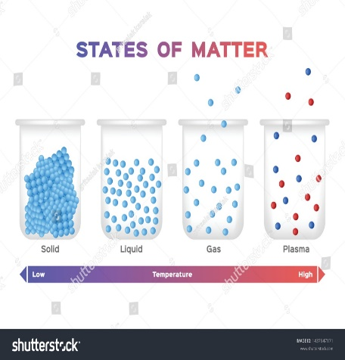

Figure 2.1. Physical classification of matter

Based on its chemical composition, matter is categorized as either a pure substance or a mixture.

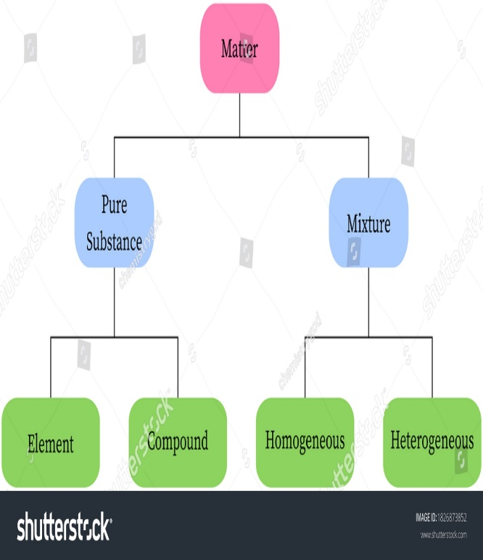

Figure 2.2. Chemical classification of matter

### <H2> Lightbulb: How are solids, liquids, gases, and plasma different?

**Solid**: The **particles** that make up a solid are closely packed in a fixed arrangement. They vibrate in place but do not move freely, showing low energy compared to other states of matter. Hence, a solid has a fixed shape and a fixed volume.

**Liquid**: The particles in a liquid are loosely packed, resulting in weak attractive forces. However, these forces are strong enough to keep the particles from separating completely. As a result, a liquid has a definite volume but no fixed shape.

**Gas**: The particles of a gas are loosely packed, with a lot of empty space between them, resulting in very weak attractive forces. This allows them to move easily and quickly. Therefore, gas has neither a fixed shape nor a fixed volume.

**Plasma:** The particles that make up plasma are not in a fixed arrangement and can move freely, like gas. However, unlike gas, plasma contains a significant number of charged particles (ions and electrons) due to the high energy levels involved. Plasma has neither a fixed shape nor a fixed volume.

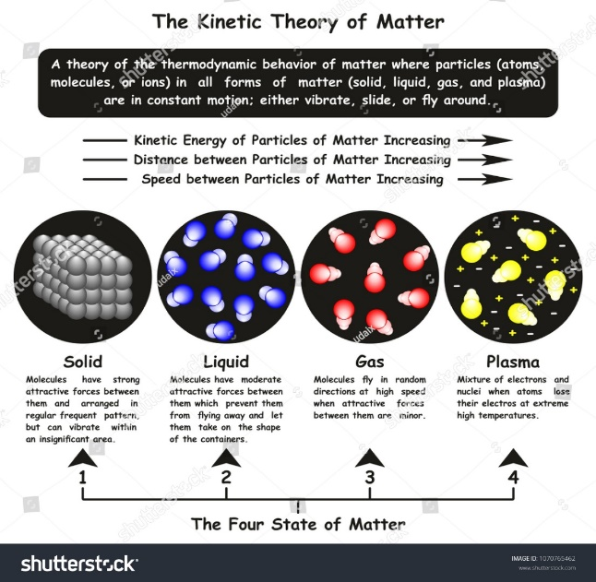

Figure 2.3. Arrangement of particles in the different states of matter

### <H2>Progress Check 1

* 1. What causes liquids to flow, and how does this differ from the movement of particles in gases?
  2. Describe how matter is classified into solid, liquid, gas, or plasma. Why is this classification system useful in understanding the properties of matter?

The chemist noticed that the mysterious compound is made up of particles and has a definite shape as well as a definite volume. The chemist decided to investigate further to understand the behavior of the compound.

<H2>Do physical properties help understand the behavior of matter?

Physical properties of matter fall under two categories: extensive and intensive. help the chemist to predict how substances behave under different conditions. They allow the chemist to understand responses to changes in temperature or pressure, such as melting, boiling, or floating. These properties are essential for determining materials’ practical uses.

**Extensive properties:** If the property depends on the amount of matter present, then it is known as extensive property. For example, mass, volume, shape.

**Mass: T**he quantity of matter in an object, generally measured in grams (g) or kilograms (kg). The mass stays the same whether on Earth or in space. Unlike weight, mass is constant. For example, a brick will have the same mass on both Earth and the Moon, but its weight will differ due to varying gravitational forces.

**Volume**: The space occupied by an object or a substance, measured in cubic units, such as cubic centimeters (cm³) or liters (L). All states of matter have volume. The way volume is measured depends on the state. A solid’s dimensions determine its volume, while a container is used to measure the volume of a liquid. For an irregularly shaped solid, water displacement is often used to find volume.

**Shape**: The shape of a substance is influenced by its state of matter. Solids have a definite shape due to closely packed particles with minimal movement. Liquids lack a definite shape, taking the form of their container while maintaining a fixed volume. Gases have neither a definite shape nor a fixed volume, expanding to fill the available space.

Why they matter: These properties are essential for understanding how much of a substance is involved in a process. For example, calculating the mass or volume of reactants is helpful for understanding chemical reactions.

**Intensive properties**: If the property does not depend on the amount of matter present. For example, density, state.

**Density**: The property of a substance that relates the mass of an object to its volume. The forensic chemist used the property of density to solve the mystery of the unknown compound. Density is calculated by using the formula:



**State:** Changes in temperature or pressure can change the state of matter, causing transitions between these forms.

Why they matter: These properties are essential for identifying substances. For example, knowing the density of a liquid helps you determine what it is, regardless of its quantity.

**Similarities Between Intensive and Extensive Properties**

• They are measurable physical properties of matter.

• They help in describing and characterizing substances.

• They play a role in understanding material behavior.

Differences Between Intensive and Extensive Properties

|  |  |  |
| --- | --- | --- |
| Property | Intensive | Extensive |
| Depends on amount | No | Yes |
| Examples | Temperature, density, state | Mass, volume, shape |
| Purpose | |  | | --- | |  |  |  | | --- | | Identifying and characterizing substances | | Measuring quantities for calculations |

The chemist concluded from the behavior of the unknown compound that it is a solid, not a liquid, gas, or plasma.

Solved sample problem:

If the mass of an object is 100 grams and its density is 50 grams per cubic centimeter, what will be its volume?

Solution: Mass of an object = 100 grams

Density = 50 grams per cubic centimeter

Volume can be calculated by using the formula:



Or



Therefore, the volume of the object =  = 2 cm3.

<H2>Progress Check 2

1. Define mass. How is it different from weight?
2. How can the physical properties of matter be observed in everyday life? Discuss with classmates.

## <H1>Power Up

The Questioneer Icon

Reflect on the following prompts to think critically about the content and come up with meaningful questions for inquiry about the **nature of matter**.

1. The particle arrangement and movement in solids, liquids, gases, and plasmas.
2. A brick will have the same mass on both Earth and the Moon, but its weight will be different.

## <H1> Lesson Check

1. Classify the given substances (water, oxygen, iron, and neon) based on their physical states at room pressure and temperature. Explain the criteria you used for classification.
2. Calculate the density of an object with a mass of 50 grams and a volume of 5 cubic centimeters. After calculating, explain what this density indicates about the object's properties.
3. Explain the physical properties of matter. Give suitable examples of three different materials for each property.
4. Plasma is the fourth state of matter. What are its unique properties? What is one example of plasma in everyday life?
5. Identify and explain how you determined the state of matter of each common item: ice, juice, air, and a light bulb. How do the physical properties of the items help in your identification?
6. When water boils and changes from a liquid to a gas, what happens to the motion of its particles?
   1. the particles move slower and get closer together
   2. the particles move faster and spread farther apart
   3. the particles stay in the same place but vibrate faster
   4. the particles stop moving altogether
7. During a family visit to a beach in the UAE, a group of students observe various aspects of matter and its physical properties. They notice the **liquid** water in the sea, which takes the shape of the shoreline while maintaining its **volume**. They fill a bottle with seawater observing that the liquid has both mass and density. As the sunlight heats the water, they see steam rising from the surface, a change in **state**. Nearby, children build sandcastles with **solid** sand, shaping it easily. They notice a glowing flame from a barbecue setup, which demonstrates **plasma**.
   1. What state of matter is represented by the steam rising from the sea under the sunlight?
      1. Solid
      2. Gas
      3. Liquid
      4. Plasma
   2. What physical property of water allows it to take the shape of the shoreline but maintain its volume?
      1. Volume
      2. Shape
      3. State
      4. Mass
   3. What is the relationship between the mass and volume of seawater?
      1. It determines the density.
      2. It determines the temperature.
      3. It changes the shape of the water.
      4. It increases the volume of the water

## <H1> Beyond the Lesson

**Impact of Physical Properties of Matter in Everyday Life and Industries:** Every physical property of matter, such as **density** (the amount of mass in a given volume of a substance), **mass** (the heaviness of an object), and **volume** (the space an object occupies), directly impacts the way we interact with and use materials in daily life. Students use reliable resources to research how these properties are used in different industries (such as construction, pharmaceuticals, healthcare, or technology).