# Unit 2

# Chapter 4: Electrons in Action

# Lesson 1: Electron Configuration and Quantum Numbers

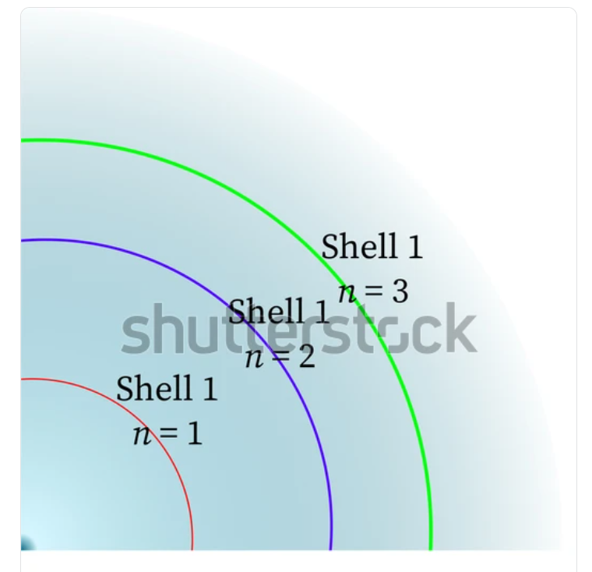

Figure 4.1. Electron shells and energy levels

# <H1> Essential Question

How does the arrangement of electrons in an atom determine its properties?

# <H1> Big Idea

Understanding how electrons are arranged around an atom helps explain the behavior and properties of elements.

# <H1> Lesson Objectives

By the end of the lesson, you will be able to:

* write the electron configuration for a given atom
* determine the electron configuration of an atom by analyzing its valence electrons
* describe the concept of quantized energy levels in atoms

# <H1> Curiosity Corner

Imagine a busy highway at night, where the bright lights of cars, streetlamps, and traffic signals guide drivers safely through the dark. Each of these lights works because of the movement of electrons. But how do these tiny particles produce such visible effects? Just like satellites orbiting a planet, electrons orbit the nucleus of an atom, and their arrangement follows specific patterns. These patterns, or electron configurations, determine how elements behave and interact, including how they produce light.

# <H1> Key Vocabulary

aufbau principle- electrons fill atomic orbitals in order of increasing energy levels, starting with the lowest energy orbitals first.

electron configuration- the arrangement of electrons in an atom’s orbitals using notation.

hund's rule- electrons occupy orbitals of equal energy, one electron enters each orbital until all are half-filled before any orbital gets a second electron. In orbitals of the same energy, electrons fill each orbital singly before pairing up.

orbital- region of space around the nucleus of an atom where there is a high probability of finding an electron.

pauli exclusion principle- it states that no two electrons in the same atom can have the same set of four quantum numbers.

subshell (s,p,d,f)- grouping of orbitals within an electron shell that have the same energy level and type

quantum numbers (n, l, ml, ms)- set of four values that describe the unique position and properties of each electron within an atom.

# <H1> Ignite: Can You Be In Between Steps?

Picture yourself going up a ladder, like the one shown in the figure. It goes from down below to the 4th level. You can stand on the steps. But can you be at any height? Can you be in between steps? 

## <H2> Use AI tools to generate questions

Enter the following prompts in an AI tool to obtain information. Remember that information obtained from AI tools always need to be verified, but it helps to generate questions, which is what you should do. Indicate to the AI tool to produce information at the High School level.

* Electrons are located in atomic orbitals.
* Energy is quantized.

Share your questions with classmates.

# <H1> Direct Instruction: Why does electron arrangement in an atom matter?

Electrons in an atom are arranged in specific regions called orbitals, much like the steps in a ladder, you are on one step or another, but you cannot be in between steps. The arrangement of electrons determines how elements interact with each other. In this lesson, we’ll explore electron configurations, where electrons are located around an atom’s nucleus, and how understanding this helps us predict how elements behave, including why certain elements conduct electricity or shine brightly.

### <H2> Progress Check 1:

Why might it be useful to know how electrons are arranged around an atom?

## <H1> **Lab Experiment: Mystery Orbital Box Challenge**

Materials Required:

small colored balls (to represent electrons)

model atom (a sphere or ball representing the nucleus)

boxes or trays labeled as orbital zones (s, p, d, f)

colored markers or stickers

printable periodic table

Activity Steps:

Setting Up:

* Provide a model atom, colored balls, and labeled boxes for orbitals (s, p, d, f). Each ball represents an electron, and each box represents a region around the nucleus.

Placing Electrons:

* Start with a simple element like hydrogen and place a single ball near the nucleus, representing the first orbital.
* Continue with elements that have more electrons, such as helium and lithium. Decide where additional electrons should be placed.
* Record the configurations for each element as the activity progresses, moving on to more complex atoms.
* Compare the models created during the activity with AI-generated answers, noting any differences.
* Discussion Question: Why do you think electrons are placed closer to the nucleus first before filling other orbitals further out?

## <H1> **Lightbulb: Electron Configuration**

The arrangement of electrons in an atom helps us understand why certain elements glow brightly, conduct electricity, or interact in specific ways. Consider sodium and chlorine: their interaction to form salt involves the transfer of electrons, and this is what allows salt to dissolve in water.

**Electron Configuration**: How electrons are arranged in an atom’s orbitals. This arrangement is crucial because it defines how atoms interact, bond, and react with other atoms.

## <H1> The Structure of an Atom

An atom has a nucleus made of protons and neutrons, surrounded by electrons that exist in regions called **orbitals.**

These orbitals are organized into energy levels, each of which can hold a specific number of electrons:

1st energy level: Up to 2 electrons

2nd energy level: Up to 8 electrons

3rd energy level: Up to 18 electrons

4th energy level: Up to 32 electrons

Electrons fill these levels starting from the lowest energy and moving to higher ones, much like filling seats in a stadium from the front row to the back.

<H2> Progress Check 2

How does the arrangement of electrons in an atom affect its ability to bond with other atoms?

## <H1> Quantum Numbers

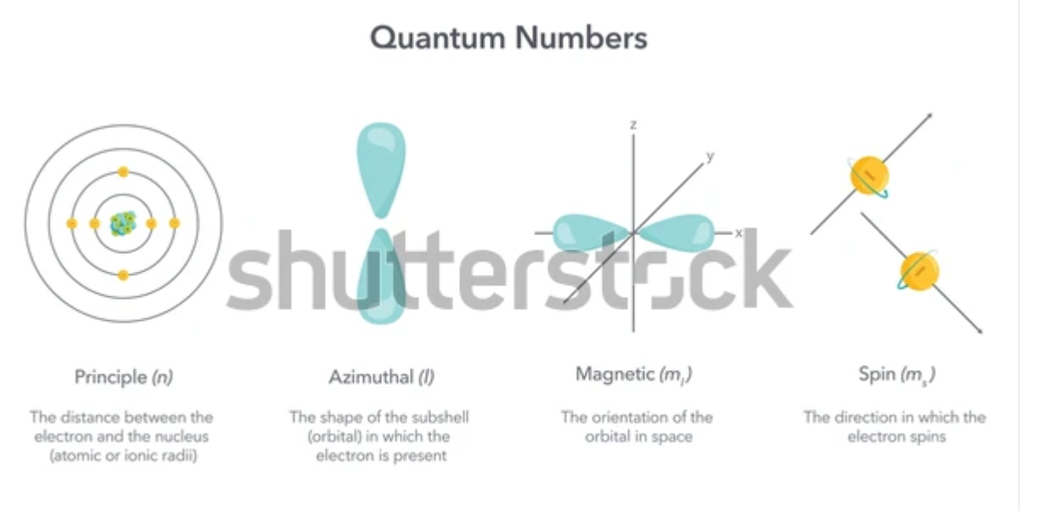

Figure 4.2. Image showing four quantum numbers.

**Quantum numbers** are values that describe the properties and behavior of electrons within an atom. They specify the electron’s position, energy level, shape of the orbital, and orientation in space. There are four quantum numbers.

Principal quantum number: This indicates the main energy level at which an electron is present. It is denoted by n.

Azimuthal quantum number: This shows the shape of the orbitals (s, p, d, f). It is denoted by l. Its value gives the subshell in a given principal energy shell to which an electron belongs. It ranges from zero to n – 1.

Magnetic quantum number: This determines the orientation of orbitals present in a given subshell and denoted by (ml). For a given value of l, ml can have values -l…..0…..+l.

Spin quantum number: This describes the direction of the electron’s spin. It is denoted by (ms). It can have values = +1/2 or –1/2.

**Representation of Quantum numbers**

|  |  |  |  |
| --- | --- | --- | --- |
| **Quantum number** | **Symbol** | **Explanation** | **values** |
| Principal Quantum number | *n* | Represents the main energy level known as shell of the electron | positive integers (1, 2, 3 ,….) |
| Azimuthal Quantum number | *l* | Represents the orbital shape (s, p, d, f) known as subshell | Integers dependent upon principal quantum numbers, values are varied from 0 to *n*−1 |
| Magnetic Quantum Number | *ml* | Represents the spatial orientation of the orbitals within a subshell | Integers varies from −*l* to +*l*  The total number of the same orbitals (having same value of *l*) is determined by 2*l* + 1 |
| Spin Quantum Number | *ms* | Presents the direction of the spin of electrons | + or − |

Let us consider an example of an atom of Chlorine with number of electrons are 17. The electrons are arranged in different energy levels or shells. *n*=1 shell which contains 2 electrons, *n*=2 shell contains 8 electrons and *n*=3 shell contains 7 electrons of chlorine atom. The last shell electron can be considered for the determination of quantum numbers.

|  |  |  |  |
| --- | --- | --- | --- |
| **Quantum number** | **Symbol** | **Description** | **Value/s** |
| Principal Quantum number | *n* | The last shell electrons remain in third shell | *n=*3 |
| Azimuthal Quantum number | *l* | According to shell number, the *l* value could be 0 to n−1, when n=3, n−1=3−1=2.  *l values could be 0, 1, 2*  *where, l=0 represents* ***s*** *orbital*  *l=1 represents* ***p*** *orbital*  *l=2 represents* ***d*** *orbital* | Three *l* values possible: 0, 1, 2 |
| Magnetic Quantum Number | *ml* | *l=0; the number of same orbital is* ***2l+1=1***  *For l=1*  *the number of same orbitals are* ***2l+1=3***  *For l=2*  *the number of same orbitals are* ***2l+1=5*** | *The specific orientation of the orbitals:*  *For s orbital the value is: 0*  *For p orbital the values are: −1, 0. +1*  *For d orbital the values are: −2, −1, 0, +1, +2.* |
| Spin Quantum Number | *ms* | *The spin quantum number for any electron, regardless of its location in the atomic orbital, has only two values:* + and− *. The energies of electrons having ms=* + *and ms* =− *are different if an external magnetic field is applied.* | *For s orbital the number of ml is 1 so ms valuesare 2.*  *For p orbital the number of ml are: 3 so ms are* for each *ml values are 2, so total 6*  *For d orbital the number of ml are: 5 so ms are* for each *ml values are 2, so total 10*  *So, s orbital can maximum 2 electrons*  *p orbital can contain a maximum of 6 electrons*  *d orbital can contain a maximum of 10 electrons* |

# <H1> Rules for Electron Configuration

# Aufbau Principle:

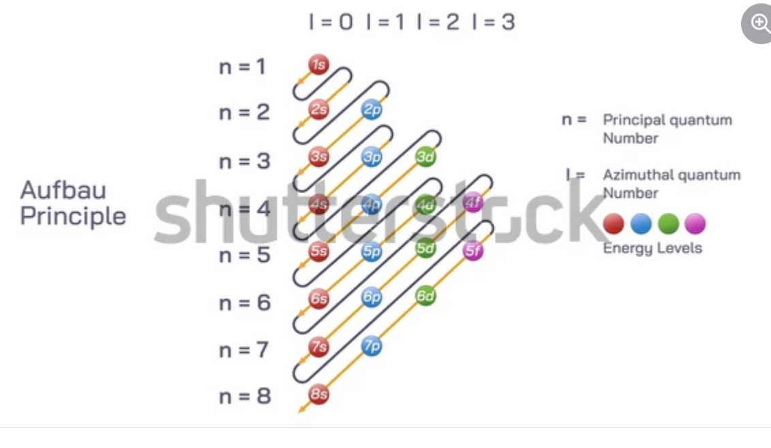

Figure 4.3. Sequence of filling atomic orbitals.

It states that in the ground state of an atom, an electron always occupies the lowest energy orbital first before moving to higher energy orbitals (levels). Think of it like pouring water into the lowest part of a cup before it can overflow to higher levels.

**Pauli’s Exclusion Principle:**

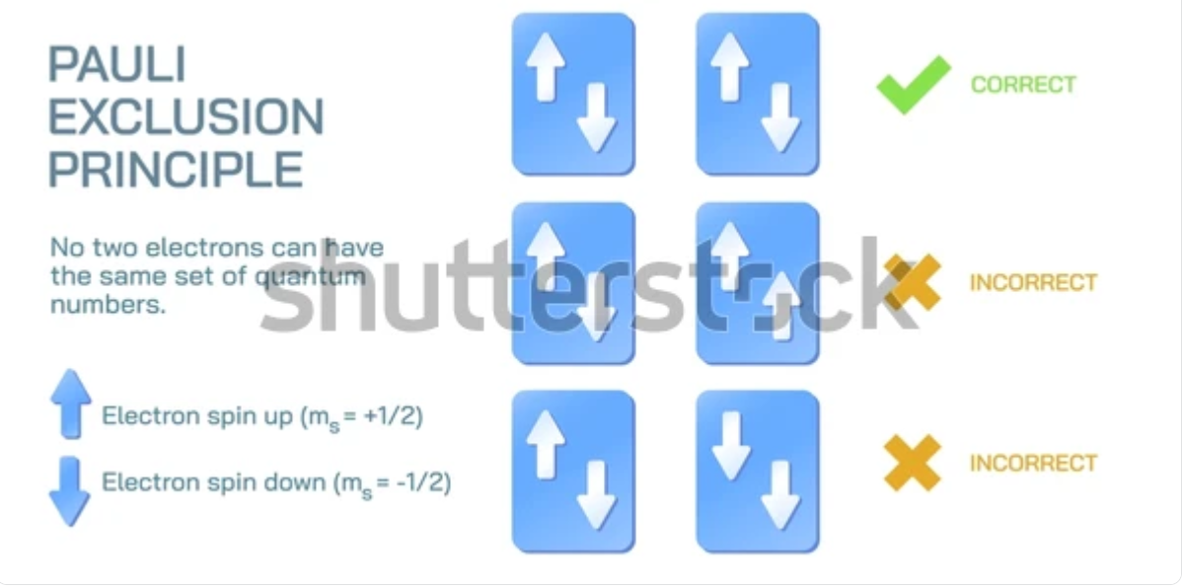

Figure 4.4. Representation of Electron Spins in an Orbital.

According to this principle, an orbital can hold a maximum of two electrons, which must have opposite spins. In other words, no two electrons can have the same set of quantum numbers.

**Hund’s Rule of Maximum Multiplicity**: It states that electron pairing will not take place in orbitals of same energy (like the p orbitals), until each orbital contains one electron.

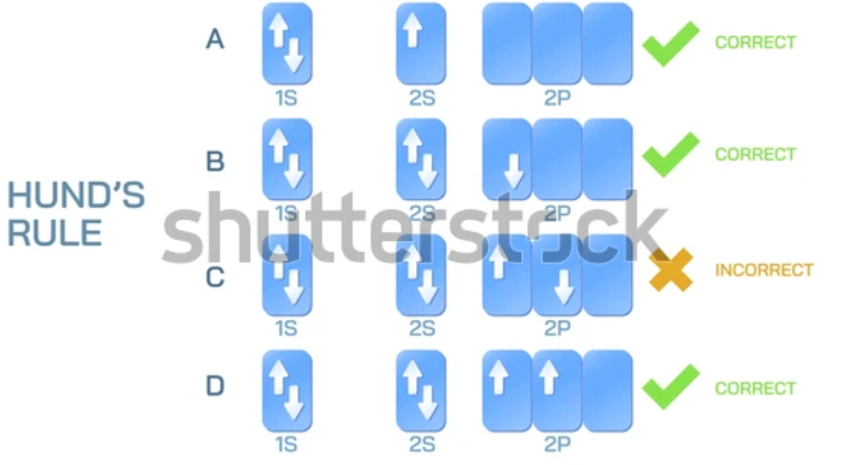

Figure 4.5. Filling of Orbitals according to Hund’s rule.

# <H1> **Stability of Subshells**

A **subshell** is a division of electron shells in an atom that groups orbitals based on their shape and energy. When a subshell (like s, p, d, or f) is fully filled, the atom is more stable. This is why noble gases have completely filled outer shells and are unreactive. They don’t need to gain or lose electrons. For example, the s subshell holds 2 electrons, and when it’s full, the atom is more stable.

Half-Filled Subshells: They are also stable because electrons are evenly distributed, reducing repulsion. For example, chromium. It is both stable and reactive.

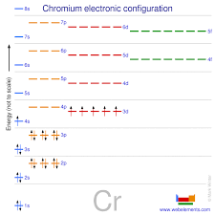

Figure 4.6. Chromium element showing even electron distribution in orbitals

## <H2> Writing Electron Configurations

Let us write the electronic configuration of a sodium ( Na ) atom, one of the elements of the compound salt (NaCl). It has 11 electrons. Therefore, it is 1s² 2s² 2p6 3s1. This tells us that there are: two electrons at the first energy level, s orbital.

eight electrons at the second energy level, distributed across the s and p orbitals.

one electron in third energy level, s orbital.

By understanding this, you can predict how sodium will bond with other atoms.

**Solved Problem:** Copper has an electron configuration of 1s² 2s² 2p⁶ 3s² 3p⁶ 3d¹⁰ 4s¹. Explain why copper is stable and how this configuration relates to its use in electrical wiring.

The 3d subshell is completely filled with 10 electrons, which makes copper stable because filled subshells lower energy and minimize electron repulsion.

The 4s subshell has 1 electron that can move easily, allowing copper to conduct electricity effectively.

The presence of a single, free moving 4s electron is why copper is commonly used in wiring, as it makes copper electrically conductive.

Examples of Stability:

Copper (Cu): The electron configuration 1s² 2s² 2p⁶ 3s² 3p⁶ 3d¹⁰ 4s¹ shows a completely filled 3d subshell, leading to greater stability, which is why copper is often used in wiring.

Chromium (Cr): 1s² 2s² 2p⁶ 3s² 3p⁶ 3d⁵ 4s¹ has a half-filled 3d subshell, providing stability and making it useful in various alloys.

## <H2>Progress Check 3

Why do noble gases like neon rarely react with other elements, based on their electron configurations?

Consider the electron configuration for oxygen: 1s² 2s² 2p⁴. How might this arrangement explain why oxygen is so reactive and forms bonds easily?

Explain how the stability of half-filled and completely filled subshells impacts the reactivity of elements like chromium and copper.

# **<H1> Power Up**

The Questioneer Icon

Reflect on the following prompts to think critically about the content and come up with meaningful questions for inquiry about electron configuration and quantum numbers:

1. Electron configurations determine how atoms bond with each other.
2. The arrangement of electrons in orbitals follows specific rules to ensure stability.
3. Completely filled and half-filled subshells are more stable than partially filled ones.
4. Quantum numbers provide a detailed 'address' for each electron in an atom.

# **<H1> Lesson Check**

1. Explain how electron configurations determine the chemical properties of an element. Provide an example of how the arrangement of electrons affects an element’s reactivity.
2. Imagine a busy highway at night, with cars guided by streetlights. How is this similar to how electrons behave within an atom, and how does this behavior explain the properties of elements like neon that emit light?
3. How does Pauli’s exclusion principle help explain the arrangement of electrons within an atom? Use an example to illustrate your explanation.
4. Compare the electron configurations of carbon (1s² 2s² 2p²) and neon (1s² 2s² 2p⁶). Explain why neon is less reactive than carbon, based on their configurations.
5. Using the example of copper (Cu), explain how the electron configuration (1s² 2s² 2p⁶ 3s² 3p⁶ 3d¹⁰ 4s¹) contributes to its stability and conductivity.
6. How do quantum numbers provide a more detailed understanding of an electron’s position within an atom? Explain each of the four quantum numbers and how they describe an electron’s address.
7. Which correctly describes Hund’s Rule? Which statement describes Hund’s rule correctly?
8. Electrons fill the lowest energy orbitals first.
9. No two electrons can have the same set of four quantum numbers.
10. Electrons will fill each orbital singly before pairing up.
11. Electrons in the same orbital must have opposite spins.
12. Why do elements like chromium and copper have electron configurations that seem to deviate from the expected pattern?
    1. To maximize the number of electrons in the 4s orbital
    2. To achieve fully filled 4s subshells
    3. To achieve greater stability by having half-filled or fully filled d subshells
    4. To allow for easier ion formation

# <H1> Beyond the Lesson

Understanding electron configurations and quantum numbers has practical applications that extend into technology, healthcare, and industry. For example, controlling electron behavior is key to developing semiconductors used in smartphones, computers, and solar panels, making these devices faster and more efficient. In medicine, technologies like X-rays and MRI scans rely on manipulating atomic properties to provide clearer imaging for diagnostics. Additionally, knowledge of electron arrangements allows scientists to create new materials—from corrosion-resistant alloys to lightweight plastics—by understanding how atoms bond. These insights drive innovations that enhance everyday life, from safer medical procedures to advanced electronics.