# **Lesson 3: The Bohr Model and Atomic Spectra**

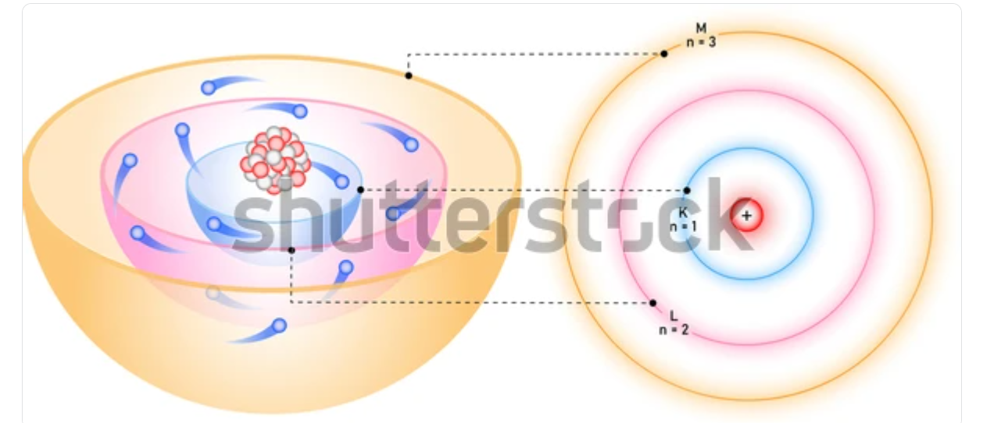

Figure 4.x: Bohr model of the atom.

## <H1> **Essential Question**

How does the Bohr model explain the emission of light from excited atoms?

## <H1> **Big Idea**

The Bohr model explains how electrons move between energy levels, emitting or absorbing light, which helps understand atomic behavior and the unique spectra of elements.

## <H1> **Lesson Phenomenon**

Imagine satellites orbiting Earth – electrons orbit an atom’s nucleus in a similar way. Like gravity keeps satellites in place, electric forces keep electrons in specific energy levels. When electrons shift between these levels, they absorb or release energy. These electron movements explain how substances interact, like salt melting ice and how atoms emit light. This lesson explores the reasons behind electron movement and the resulting light emissions.

## <H1> **Key Vocabulary**

Absorption spectra

Emission spectra

Energy level

Photons

Transition

## <H1> **Lesson Objectives**

By the end of this lesson, I will be able to:

Compare and contrast the Bohr model and the quantum mechanical model of the atom.

Compare experimental atomic spectra to the spectra of known elements to identify elements.

Analyze why atomic spectra appear as distinct lines and how this relates to electron transitions in the Bohr model.

<H1> **Why Do You Think Different Elements Emit Different Colors? How Might This Relate to the Movement of Electrons?**

Use a simple AI-powered tool to find information about the colors emitted by different elements when they are excited.

**Task:** Type any element name (hydrogen, neon, sodium) and ask, "What color light does this element emit when excited?"

## <H1> **Direct Instruction**

Imagine you're walking outside on a winter night, and the street is glowing under the warm yellow light of sodium street lamps. Have you ever wondered why those lamps emit a specific color? To understand this, let's dive into the world of atoms, where tiny particles called electrons are constantly on the move.

According to Niels Bohr's model, electrons orbit the nucleus of an atom in specific paths, much like how satellites orbit the Earth. These paths are called **energy levels**. Each energy level has a fixed amount of energy. When an electron absorbs energy, it jumps to a higher energy level, and when it releases that energy, it falls back to a lower level, emitting a photon—a tiny packet of light. Therefore, when atoms are energized (like in street lamps), they emit light of specific colors.

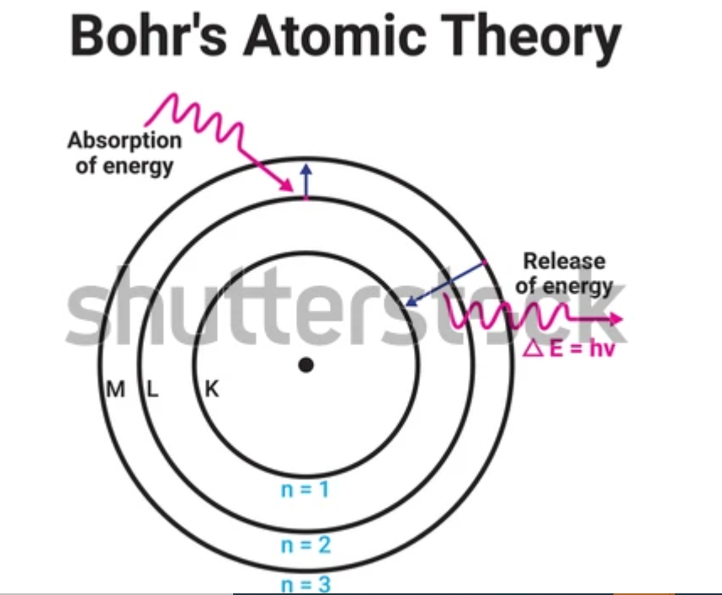

Figure 4.x: Energy changes in electron jump.

The Bohr Model helped scientists understand why hydrogen emits a distinct set of colored lines when viewed through a spectroscope. Each line represents a transition – an electron jumping between specific energy levels.

### <H2> **Progress Check 1**

Explain how the concept of energy levels helps to describe the arrangement of electrons in an atom and why electrons in higher energy levels are farther from the nucleus.

## <H1> **Pathfinder – Exploring Light and Color to Understand Atomic Spectra**

**Materials Required:**

Clear glass jars or containers

Water

Food coloring (various colors)

Small flashlights

Blank paper and colored pencils

**Steps:**

1. Create a spectrum with colored water:

Fill a jar with water and add food coloring to create different colors. Mix colors to see how combinations change the appearance.

1. Light reflection:

In a dimly lit area, shine a flashlight through the colored water and observe how the light changes.

On a blank sheet of paper, draw the light patterns created by passing through the water.

**Discussion Questions:**

How did the color of the water change the appearance of the light?

How can this experiment relate to atomic spectra?

## <H1> **The Bohr Model versus the Quantum Mechanical Model**

Think of electrons like planets orbiting the sun. Bohr proposed that electrons revolve around the nucleus only in a selected circular path, which has a fixed value of radius and energy. However, as scientists learned more, they discovered that this model was too simple. The Quantum Mechanical Model introduced a new concept. Instead of fixed orbits, electrons exist in cloud-like regions called orbitals, where they are more likely to be found. This model explains that electrons do not have set paths but rather move in areas of probability.

**Solved Question**: How does the Bohr model differ from the quantum mechanical model?

Answer: The Bohr model describes electrons in fixed orbits around the nucleus, while the quantum mechanical model describes electrons as existing in probabilistic regions called orbitals.

## <H2> **Progress Check 2**

Compare how the Bohr model and the quantum mechanical model explain the behavior of electrons in an atom. What are the key differences, and how do these differences affect our understanding of atomic structure?

## <H1> **Energy Levels, Photons, and Transitions**

Let’s go back to the street with the yellow glow of streetlights lighting your path. Inside those lights, something fascinating is happening. The sodium atoms in the lamps are being energized, causing their electrons to move. But they don’t move randomly; they can only exist at certain levels, almost like staying in specific lanes on the road.

When the electrons absorb energy, they jump up to a higher level, just like a car accelerating to a faster lane. But they don’t stay there forever; they soon lose that energy and drop back down to a lower level, releasing the energy they gain as light. Each element has its own unique colors based on its energy levels. If the drop is small, the light emitted might be red, a lower-energy color. But if they fall a greater distance, the light is blue or violet, colors that carry more energy.

This is exactly why the sodium streetlights give off a distinct yellow color. The energy difference in the sodium atoms' electron **transitions** produces that specific shade.

**Solved Question:** What determines the color of the light emitted by an electron when it drops to a lower energy level?

**Answer:** The color of the light is determined by the energy difference between the two energy levels the electron transitions between. Larger energy differences result in higher energy photons (shorter wavelengths, like blue or violet), while smaller energy differences result in lower energy **photons** (longer wavelengths, like red).

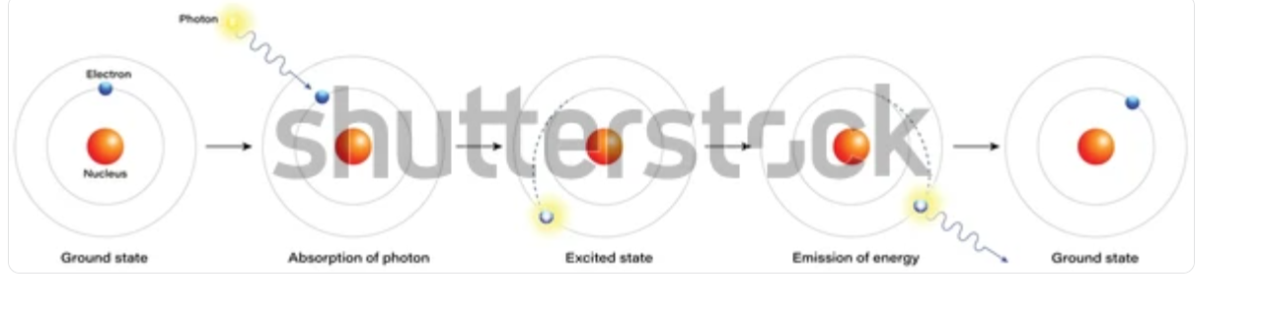

Figure 4.x: Electron transition process.

## <H2> **Progress Check 3**

Why do different elements emit different colors of light? (DOK 2)

What is a photon, and how is it different from protons?

## <H1> **Atomic Spectra**

When sunlight passes through a prism, it separates into a spectrum of colors known as VIBGYOR, forming a rainbow-like band. This process of splitting light into different colors is called dispersion. The series of color bands is known as spectrum.

If there is a continuity of color bands, then it is known as a continuous spectrum, and if there are dark spaces between them, then it is known as line spectra or **Atomic Spectra.**

There are two types of atomic spectra:

1. Emission spectra
2. Absorption spectra

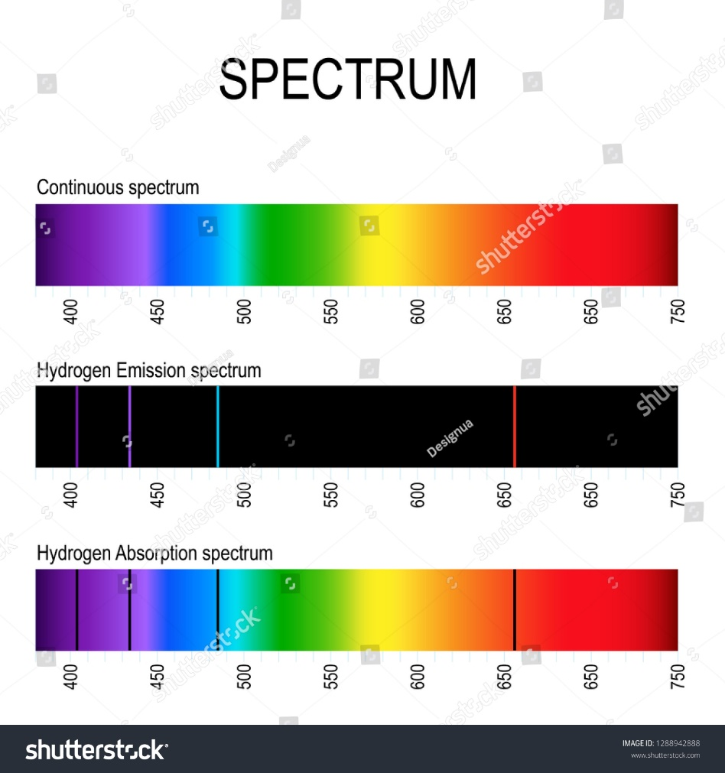

Fig 5.x Image showing spectrum.

When electrons absorb energy, they jump to a higher energy level, creating an absorption spectrum – a series of dark lines where light is absorbed. Conversely, when electrons release energy and drop to a lower energy level, they emit light, producing an emission spectrum. Each element has a unique set of energy levels, so it emits and absorbs specific colors of light, much like a fingerprint. So, scientists can use spectra to identify elements. Imagine using a barcode scanner at a store; the atomic spectra work in a similar way, identifying each element.

**Solved Question**: Why does hydrogen’s emission spectrum show distinct lines rather than a continuous range of colors?

**Answer**: Hydrogen’s emission spectrum shows distinct lines because electrons in hydrogen atoms can only jump between specific energy levels, emitting light at certain wavelengths during each transition.

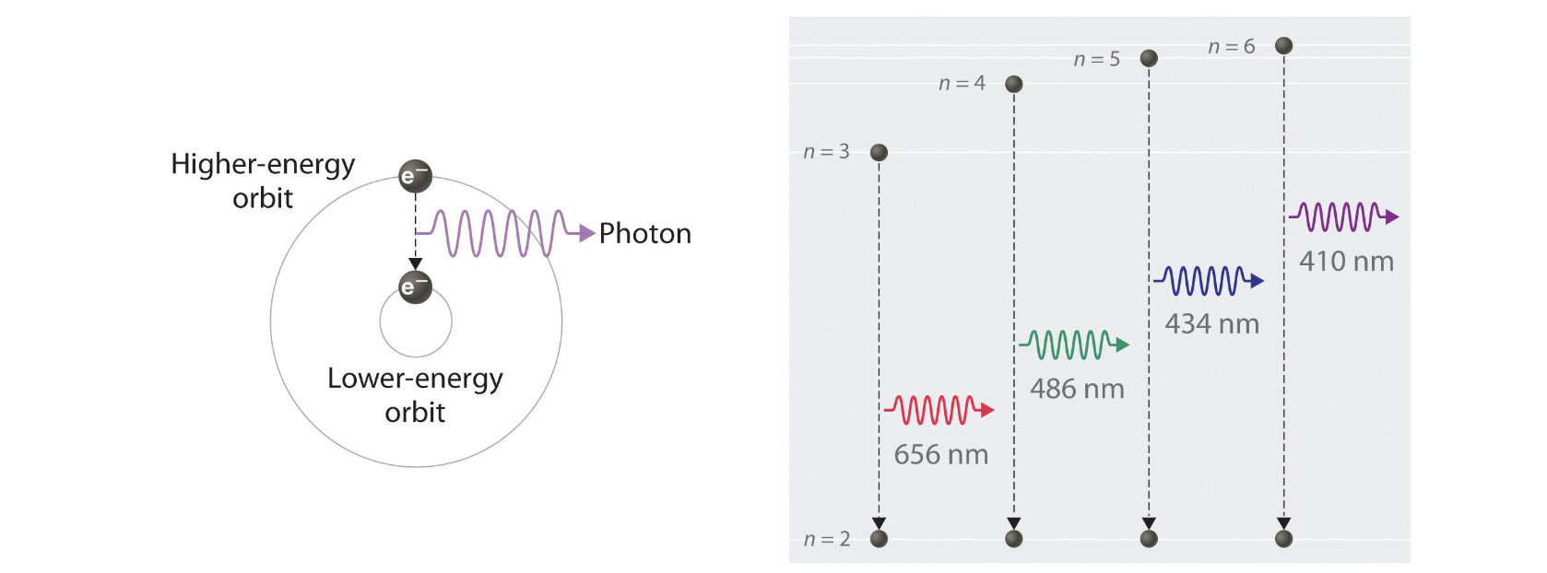

Figure 4.x: Emission spectrum.

## <H2> **Progress Check 3**

Describe what happens when an electron in an atom absorbs a photon. (DOK 2)

Distinguish between absorption and emission spectra.

## <H1> **Power Up**

Reflect on the following prompts to think critically about the content and come up with meaningful questions for inquiry about **The Bohr Model and Atomic Spectra.**

* Electrons can only exist in specific energy levels, not in between, much like specific lanes on the road.
* When electrons absorb energy, they move to higher energy levels; when they release energy, they drop to lower levels, emitting light.
* The color of light emitted by an atom depends on the energy difference between the levels the electron transitions between.
* Each element has a unique arrangement of energy levels, which results in distinct colors being emitted.

## <H1> **Lesson Check**

1. How does the Bohr model explain the emission of light from excited atoms, and why are these emissions seen as specific colors?
2. Explain why the sodium streetlights give off a yellow glow when energized.
3. Describe what happens when an electron absorbs a photon. What changes occur within the atom?
4. How can the unique arrangement of energy levels in each element help scientists identify unknown elements through their emission spectra? Provide an example.

## <H1> **Beyond the Lesson**

The concepts of energy levels, electron transitions, and atomic spectra are applied in many real-world technologies. For example, neon signs glow brightly in different colors. Similarly, streetlights, lasers, and even the colors in fireworks are based on the principles of electron transitions and photon emission. In scientific research, spectrometers use atomic spectra to identify elements in stars, helping astronomers understand the composition of distant celestial bodies. Use reliable resources to research and create presentations on how concepts of atomic spectra are used in different fields.