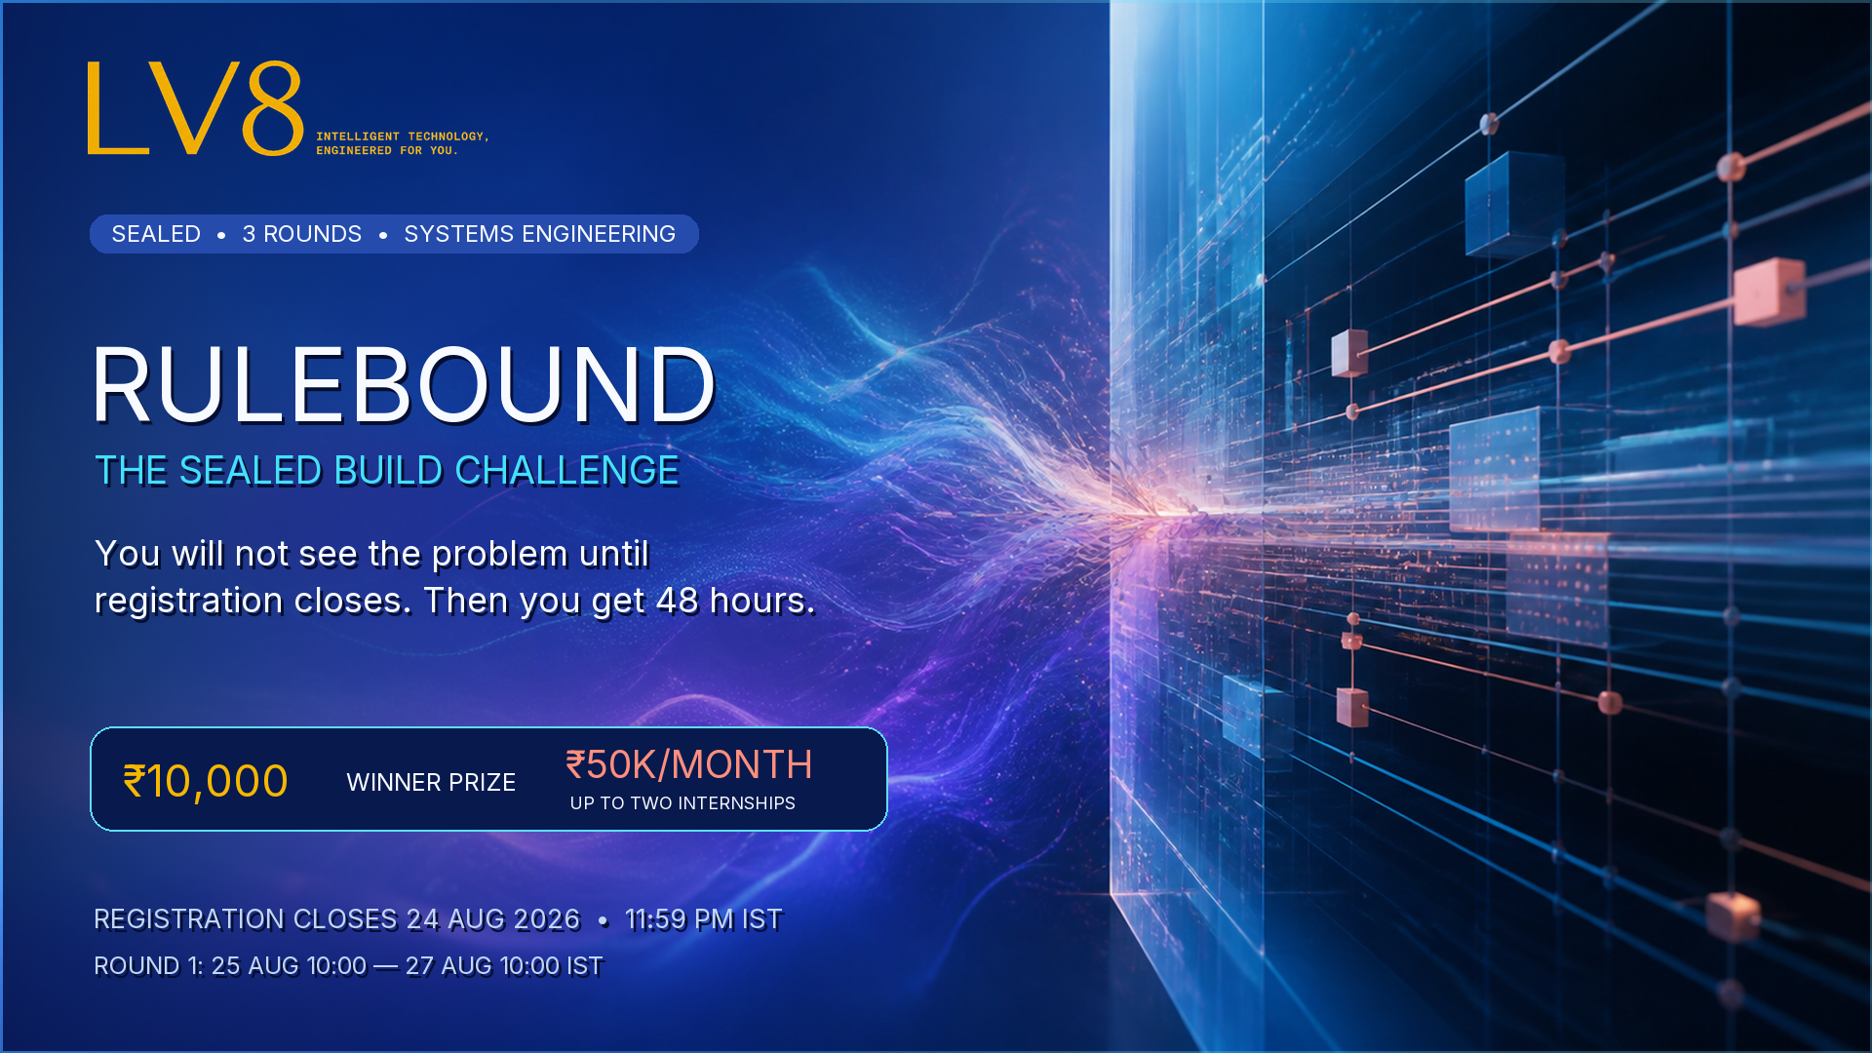
OFFICIAL CANDIDATE GUIDE
RuleBound
The Sealed Build Challenge
THE PROMISE
You will not see the problem until registration closes. Every registered participant receives the same brief, the same synthetic data and the same starter kit at the same time. Then the 48-hour clock begins.

Published by LV8 Tech | 18 August 2026 | All times IST

1. At a Glance
Item | Candidate information
Organizer | LV8 Tech
Format | Online sealed-brief hackathon; three rounds
Participation | Individual participation only
Registration | 18-24 August 2026; closes 24 August at 11:59 PM IST
Round 1 | 25 August 10:00 AM to 27 August 10:00 AM IST; every registrant participates
Round 2 | 28 August 2026; live technical defence for the top 8-10
Round 3 | 29 August 10:00 AM to 31 August 10:00 AM IST; four finalists
Winner announcement | 1 September 2026
Winner prize | ₹10,000 cash
Internship opportunity | Up to two finalists may receive ₹50,000/month paid internship offers, subject to final evaluation and role fit

READ THIS BEFORE REGISTERING
This is a sealed challenge. The domain, scoring and submission expectations are public now; the exact problem and files are released only after registration closes.

2. What This Challenge Is About
RuleBound tests the boundary between creative AI and deterministic software. Generative systems are good at proposing plausible answers. Real commercial systems also need constraints, traceable decisions and numbers that do not change when the same inputs are run twice.
The exact problem is intentionally sealed. The public domain is: constrained AI generation, rules engines, deterministic pricing, structured output and the engineering seam between probabilistic and deterministic components.

What is public now
- The theme, format, dates, eligibility, scoring rubric, submission requirements, prize and internship opportunity.
- The technical qualities LV8 Tech is looking for.
- The starter-kit promise and the rules every candidate agrees to.

What is released on 25 August at 10:00 AM IST
- The complete problem statement.
- A synthetic dataset and machine-readable rule pack.
- Worked reference examples and a submission checklist.
- Schemas, Python and TypeScript loaders, a runner harness, a determinism checker and a reference validator.

3. Who Should Participate
This is for builders who enjoy unfamiliar systems problems and can explain their architecture under pressure. Portfolio and demonstrated ability matter more than institution or job title.
- Backend and systems engineers with experience in rules engines, pricing engines, schedulers, constraint solvers or compilers.
- AI engineers working with structured output, tool use, constrained decoding or agent orchestration—not prompt writing alone.
- Computational-design creators using OR-Tools, CP-SAT, Grasshopper, Dynamo or similar systems.
- Developers who have parsed CAD or spatial formats such as DXF, DWG, IFC, ezdxf or Autodesk Platform Services.
- Final-year students and recent graduates with a substantial systems project.
PRACTICAL FIT
You do not need every listed skill. You do need a working software portfolio, comfort with one-command reproducible builds, and the ability to defend your own decisions live.

4. Round Structure and Schedule
Phase | Date and time (IST) | Who participates | Purpose
Registration | 18-24 Aug; closes 24 Aug, 11:59 PM | Open | Review the public standard and register.
Round 1: Sealed Sprint | 25 Aug 10:00 - 27 Aug 10:00 | Every registrant | Build a defensible solution to a problem revealed at the start.
Round 2: Live Defence | 28 Aug; slots from 2:00 PM | Top 8-10 | Run the work live and defend key decisions.
Round 3: Final | 29 Aug 10:00 - 31 Aug 10:00 | Four finalists | Adapt the existing solution to a change released at the start.
Decision | 1 Sep | Finalists | Winner and internship outcomes communicated.

HARD DEADLINES
Registration and round deadlines are hard closes. Late entry or late submission may be rejected.

5. Round 1 Submission Requirements
Every registrant enters Round 1. The detailed technical task arrives with the reveal pack. Candidates should be prepared to submit the following by 27 August at 10:00 AM IST:
Deliverable | Requirement
Repository | Shared with the judging account and runnable from one documented command against an input directory.
ARCHITECTURE.md | Maximum two pages, including a required section titled “Arbitration.”
Demo video | Maximum five minutes, showing one end-to-end case including a deliberate constraint violation and its repair.
Committed output | Output generated for every released specification.
Determinism statement | The exact command judges can run twice to verify byte-identical output.

What will not earn points
- UI polish. A terminal and a static plan view score the same as a polished web interface.
- Unrelated features such as authentication, billing, multi-tenancy or mobile support.
- A model-generated price. No language model may operate inside the deterministic pricing path.

Optional bonus tracks
- DXF or DWG ingest or export.
- Deployment on Azure with Entra ID authentication.

6. Published Scoring Rubric
Weight | Criterion | How it is judged
35 | Arbitration | Quality of the boundary, contracts, repair loop, termination and handling of unsatisfiable cases.
25 | Price integrity and determinism | Byte-identical repeat runs, correct pricing behaviour, line-level traceability and blocking of unpriced items.
15 | Constraint enforcement | Performance against held-back specifications containing known violations.
10 | Generation quality | Whether the proposed result meaningfully answers the brief.
10 | Engineering quality | Tests, documentation, clean-machine execution and credible commit history.
+5 | DXF/DWG bonus | Successful ingest or export.
+5 | Azure bonus | Working Azure deployment with Entra ID authentication.

7. Live Defence and Final

Round 2: Live Technical Defence
The top 8-10 candidates receive a 25-minute screen-share slot on 28 August. Candidates will clone and run their own repository, explain the boundary between system components, respond to a live variation and answer technical questions. This round verifies authorship and depth of understanding.

Round 3: The Final
Four finalists continue from their Round 1 system. They receive a new change pack on 29 August at 10:00 AM IST and have 48 hours to adapt the existing architecture rather than start again.
Final deliverables will include the updated working system, a CHANGELOG.md describing exactly what changed, a revised architecture explanation, committed output and a short video focused on the specified final-round case.

8. Prize and Internship Opportunity
Outcome | Offer
Winner | ₹10,000 cash prize.
Internships | Up to two finalists may receive paid internship offers at ₹50,000 per month.
Conditions | Internship decisions depend on final evaluation, technical defence, demonstrated authorship, availability and role fit. Ranking alone does not guarantee an offer.

9. Rules and Eligibility
- Participation is individual only. Teams and joint submissions are not permitted.
- Registration closes on 24 August 2026 at 11:59 PM IST. No late entry.
- All challenge work must begin after the Round 1 reveal at 25 August 2026, 10:00 AM IST.
- Substantial work committed before the reveal timestamp may result in disqualification.
- The submission must be original and the participant must have the right to use every included dependency, asset and dataset.
- AI assistants may be used, but candidates remain responsible for the entire submission and must be able to explain and modify it live.
- The repository, documentation, video and links must remain accessible throughout judging.
- Any attempt to obtain the sealed brief early or share restricted files with another participant or third party may result in disqualification.
- Judging decisions are final after eligibility and originality verification.

10. Intellectual Property and Use of Submissions
IMPORTANT
Read this section before registering. Participation confirms acceptance of the applicable terms shown on the official Unstop listing.

- Prize-winning submissions assign all rights to LV8 Tech when the winner accepts the prize.
- All submissions grant LV8 Tech a perpetual, irrevocable, royalty-free licence to the concepts and architecture contained in the submission.
- Participants warrant that their submissions are original or properly licensed and do not infringe third-party rights.
- Candidate names and submitted demo material may be used to administer and communicate the hackathon, subject to the official platform terms.
If you do not agree to these terms, do not register or submit. Any separate internship engagement will be governed by its own written agreement.

11. Submission and Conduct Standards
- Use only the released synthetic packs. Do not introduce confidential employer, client or personal data.
- Do not privately request architectural help from organizers. Clarifications will be answered in the common participant channel so everyone receives the same information.
- Report suspected starter-kit or schema defects through the official support channel.
- Keep a clear commit history that reflects the work completed during each round.

12. Frequently Asked Questions
Will the problem be available before registration closes?
No. The exact problem and files are released to registered participants on 25 August at 10:00 AM IST.
Does everyone enter Round 1?
Yes. Every valid registrant enters Round 1; there is no preliminary qualifier.
Can I participate in a team?
No. RuleBound is an individual-participation challenge; teams and joint submissions are not permitted.
Which language or framework should I use?
Use any stack that satisfies the published one-command interface and judging environment. Python and TypeScript loaders will be provided.
Does UI quality matter?
No. UI polish receives zero points. Architecture, determinism, constraints and engineering quality matter.
Can I use AI coding assistants?
Yes, but you must understand, defend and modify the submission live. You remain responsible for originality and compliance.
Is the internship guaranteed to the top two?
No. Up to two paid internships at ₹50,000/month may be offered based on final evaluation and role fit.
When will the winner be announced?
1 September 2026.
How will clarifications be handled?
All material clarifications will be posted to the common participant channel. Private architectural coaching will not be provided.

13. Registration Checklist
- Review the complete schedule and confirm your availability.
- Confirm that you will participate and submit individually.
- Prepare your resume, portfolio, GitHub profile and best systems project.
- Register before 24 August 2026, 11:59 PM IST.
- Join and monitor the official participant communication channel.
- Keep 25-27 August available for the complete 48-hour Round 1 window.
- Confirm that you can share a repository and a five-minute video.
- Read and accept the intellectual-property terms before submitting.

14. Official Contact
Channel | Information
Organizer | LV8 Tech
Platform | Unstop
Support email | lv8tech@gmail.com
Registration link | Published on the official Unstop opportunity page
Timezone | All dates and deadlines use Indian Standard Time (IST)

