[AWS-S3-bucket-lisiting-Service](https://github.com/Shubham051997/AWS-S3-bucket-lisiting-Service)

1) From AWS root user we have created a user name one2n from IAM  
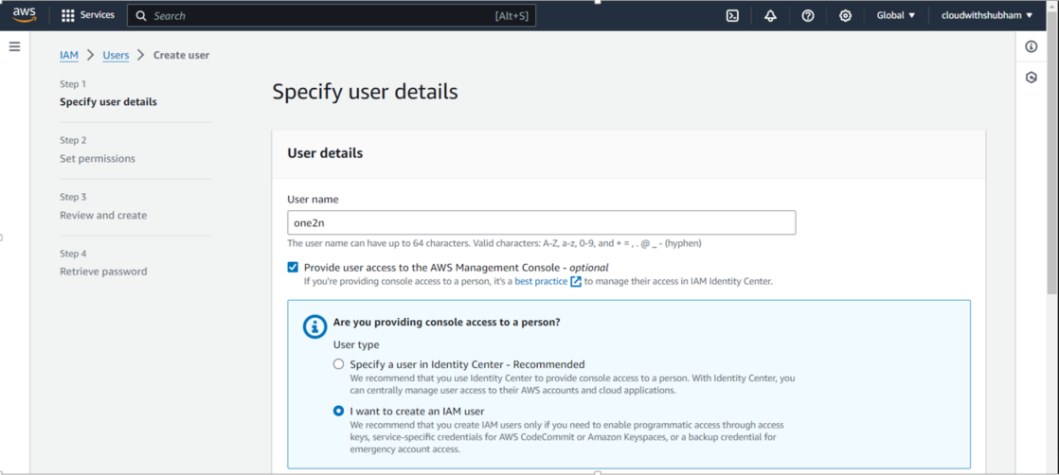   
  
  
  
Signed in as one2n user  
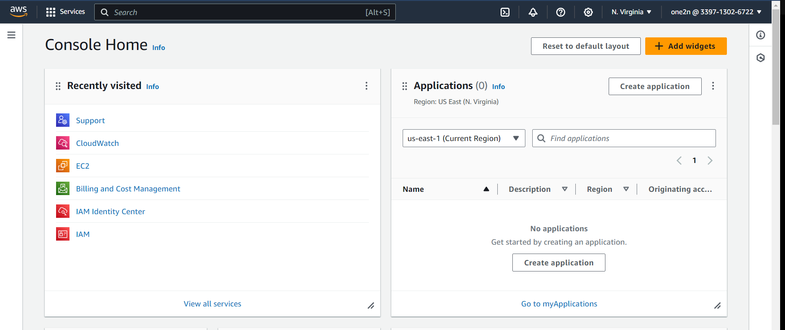

Bucket content  
  
