CampusConnect
One platform for your entire campus
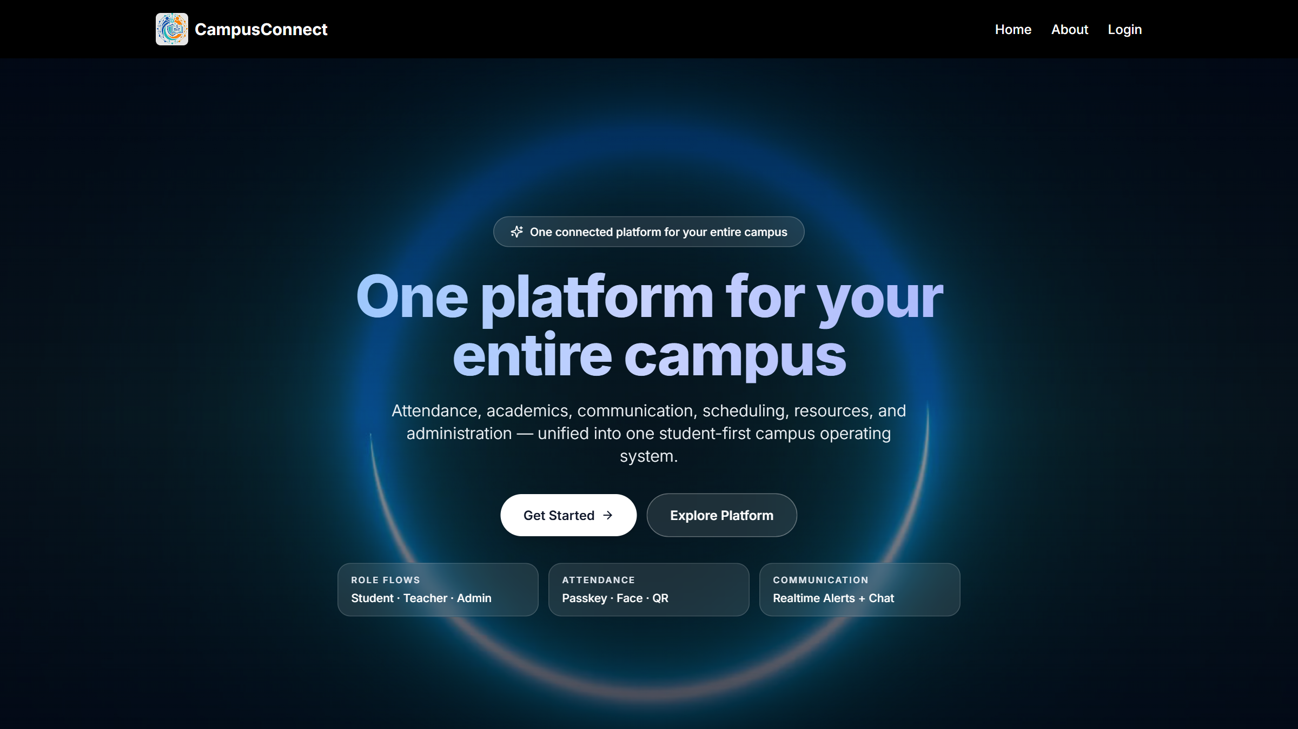
Complete Client User Manual
A visual guide to the Admin, Teacher, and Student experience
September 2026 · Client Edition

Table of Contents

Table of Contents 2
1. Welcome to CampusConnect 4
2. About CampusConnect 5
The three roles 5
3. Getting Started 6
4. Signing In 7
Forgot your password? 8
5. Understanding the Interface 9
6. Administrator — Complete Visual Guide 10
6.1 Admin Dashboard 10
6.2 Student Management 10
6.3 Teacher Management 13
6.4 Subject Sets 14
6.5 Exam Timetable 15
6.6 Student Onboarding (Bulk) 17
6.7 Academic Update (Bulk) 18
6.8 Announcements 18
6.9 Calendars 20
6.10 Settings 21
6.11 Profile 22
6.12 Logging out 22
7. Teacher — Complete Visual Guide 24
7.1 Teacher Dashboard 24
7.2 Smart Attendance 24
7.3 Attendance Tracker 26
7.4 Timetable 27
7.5 My Students 28
7.6 Courses 29
7.7 Study Material 30
7.8 Exam Timetable 30
7.9 Announcements 31
7.10 Calendars 31
7.11 Messages 32
7.12 Profile 32
8. Student — Complete Visual Guide 34
8.1 Student Dashboard 34
8.2 Attendance 34
8.3 My Timetable 35
8.4 Exam Timetable 36
8.5 Study Resources 36
8.6 Announcements 37
8.7 Calendars 37
8.8 Discussions 38
8.9 Messages 38
8.10 Profile 39
9. How the Three Roles Differ 40
10. Common Workflows 42
Workflow A — Add a new student (Admin) 42
Workflow B — Add a teacher with subject assignments (Admin) 42
Workflow C — Publish an announcement (Admin) 42
Workflow D — Run a live attendance session (Teacher + Student) 42
Workflow E — Schedule a lecture (Teacher) 42
Workflow F — Onboard an admission list (Admin) 43
11. Notifications, Profile & Account 44
Notifications 44
Profile & password 44
Logging out 44
12. Troubleshooting 45
13. Frequently Asked Questions 46
14. Complete Feature Overview 47

In Microsoft Word, right-click the table above and choose "Update Field" to fill in the page numbers.

1. Welcome to CampusConnect
Welcome to CampusConnect — a modern campus management platform that brings a college's daily operations together in one place. Attendance, timetables, exams, study materials, announcements, calendars, and communication are all managed through a single, easy-to-use web application.
This manual is a complete visual guide to the platform. It walks through every screen an Administrator, a Teacher, and a Student sees after logging in, explains what each screen does, and shows the exact steps for the most common tasks. Every screenshot in this document is taken directly from the live CampusConnect application.
How to use this manual:
- If you are evaluating CampusConnect, read Chapters 2–5 for an overview, then browse the role guides (Chapters 6–8) to see the product in action.
- If you are an administrator, teacher, or student, jump straight to your role's chapter — each one is a self-contained walkthrough of your workspace.
- Chapter 10 collects the most common step-by-step workflows in one place for quick reference.

2. About CampusConnect
CampusConnect replaces scattered spreadsheets, notice boards, and messaging groups with one connected platform. Every user signs in with a personal account and sees a workspace built specifically for their role.
Figure 2.1 — About CampusConnect
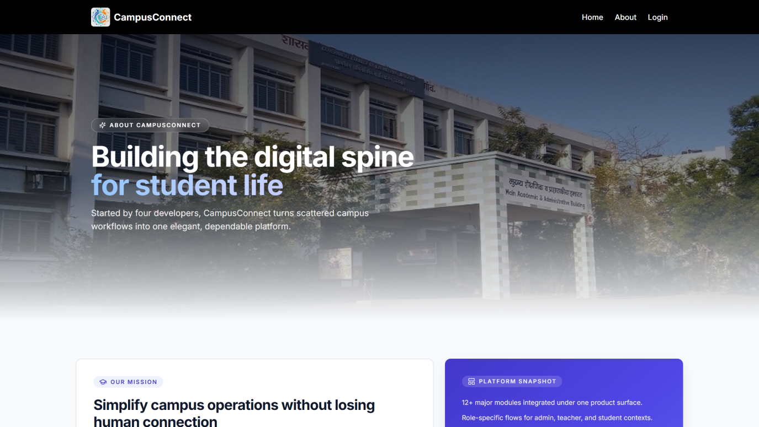
The About page introduces the platform's mission, values, and the team behind it. It is publicly accessible from the website header.

The three roles
Role | Who it is for | What they use it for
Administrator | College management and office staff | Manage students, teachers, subjects, exams, announcements, calendars, and bulk operations
Teacher | Faculty members | Run attendance sessions, manage timetables, view assigned students, share study material, post announcements
Student | Enrolled students | Mark attendance, view timetables and exams, download study resources, read announcements, join discussions

Highlights at a glance:
- Smart attendance — live attendance sessions with secure fingerprint (passkey), face recognition, and a QR-code backup method.
- Central academics — branch-wise subject sets, shared class timetables, and year-wise exam schedules.
- Campus communication — announcements with urgency levels, events and academic calendars, direct messages, and student discussions.
- Bulk operations — onboard an entire admission list and update academic years in one step.
- Role-based security — every user sees only the screens and actions that belong to their role.

3. Getting Started
CampusConnect is a web application — there is nothing to install. It works on any modern browser (Chrome, Edge, Firefox, Safari) on desktops, laptops, and mobile devices.
Figure 3.1 — CampusConnect Home Page
The public home page is the front door of the platform. From here, visitors can learn about the product and existing users can sign in.
Visible elements:
1. Header navigation — Home, About, and Login links.
2. Get Started — takes you to the login area.
3. Explore Platform — scrolls through the platform overview.
4. Feature highlights — role flows, attendance methods, and communication capabilities.

NOTE: Your institution shares the website address and your login details with you. Students and teachers receive their login credentials by email when their account is created.

4. Signing In
Every user signs in through a role-specific login page. Choose your role first, then enter your credentials.
Figure 4.1 — Choose Your Role
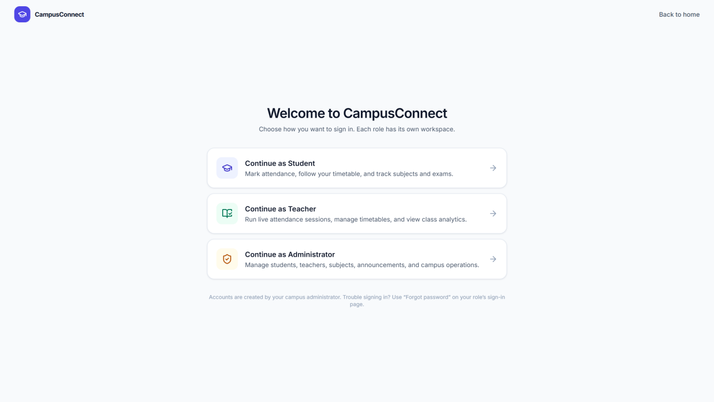
The login chooser presents the three roles. Selecting a card opens the matching sign-in form.
Visible elements:
1. Student — sign in with your student email and password.
2. Teacher — sign in with your Teacher ID (or login email) and password.
3. Admin — sign in with your administrator email and password.

Figure 4.2 — Admin Sign-in
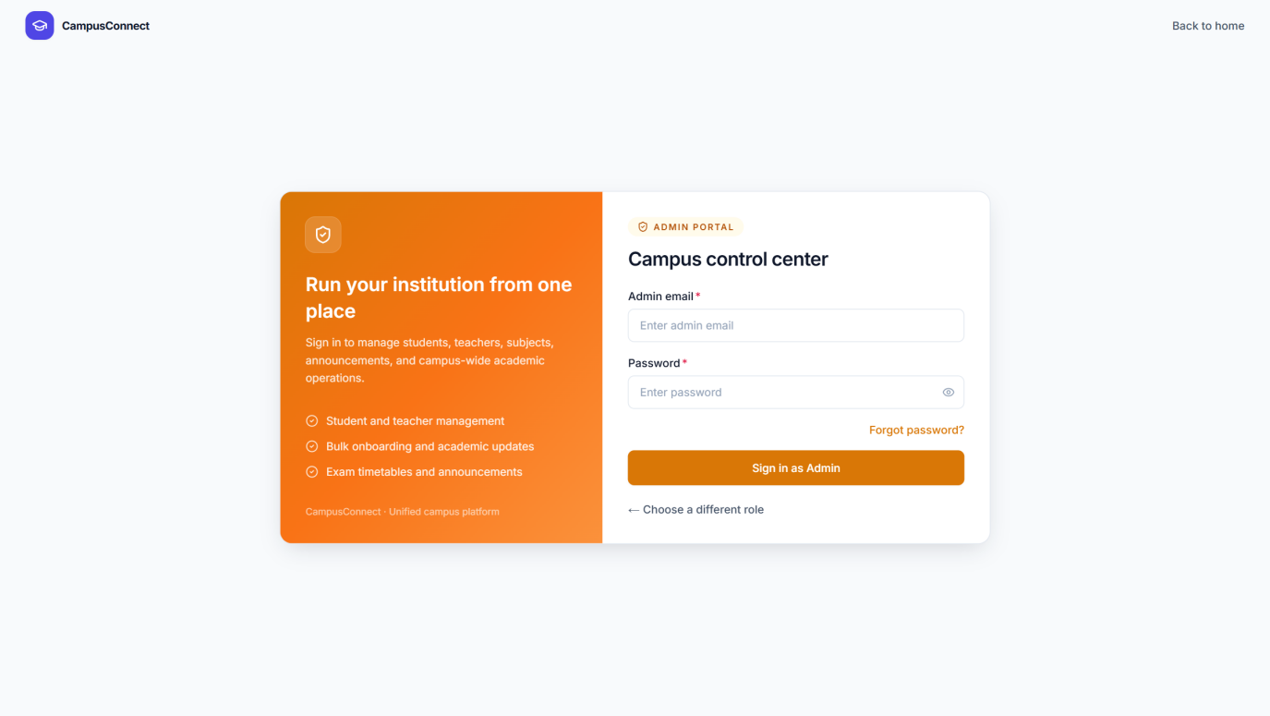
Administrators sign in with their admin email address and password.
Figure 4.3 — Teacher Sign-in
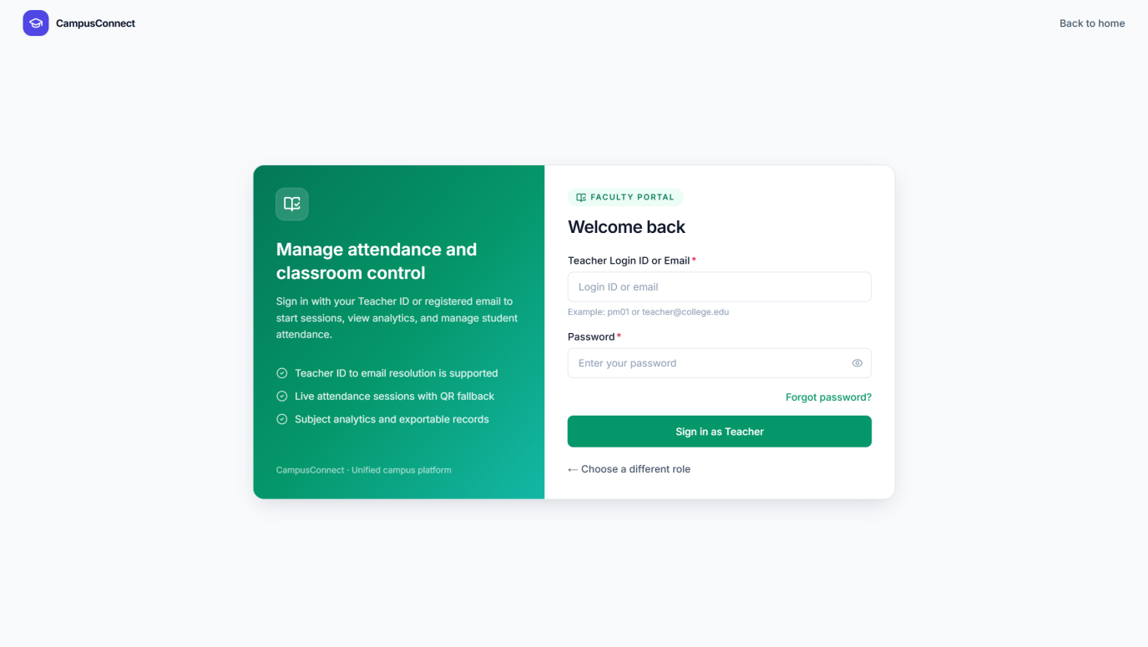
Teachers can sign in with just their Teacher ID (for example, PM01) — the platform finds the matching account automatically. The full login email also works.
Figure 4.4 — Student Sign-in
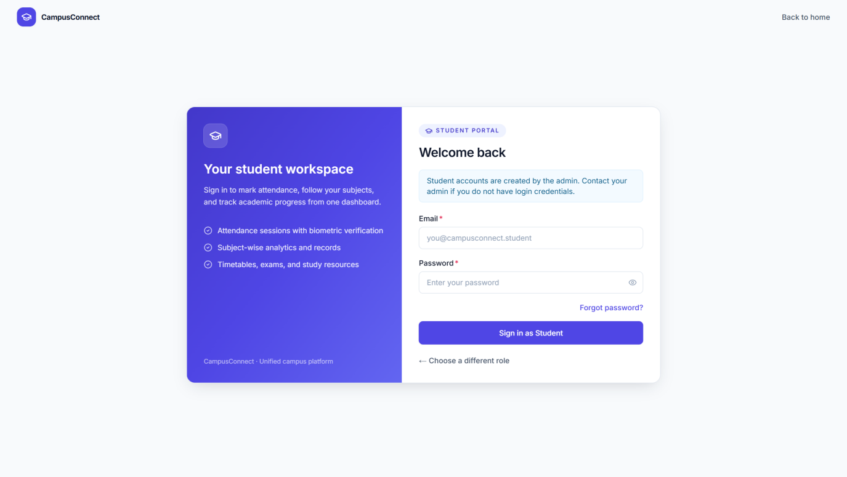
Students sign in with their student email address and password.

Forgot your password?
Every sign-in page has a "Forgot password?" option. Enter your registered email address and the platform sends a one-time verification code. After entering the code, you set a new password and can sign in immediately.
TIP: After signing in, you land on your role's dashboard automatically. The platform recognises your role — there is no extra step.

5. Understanding the Interface
All three workspaces share the same clean layout, so anything you learn in one role carries over to the others.
Figure 5.1 — The CampusConnect Workspace Layout (Admin example)
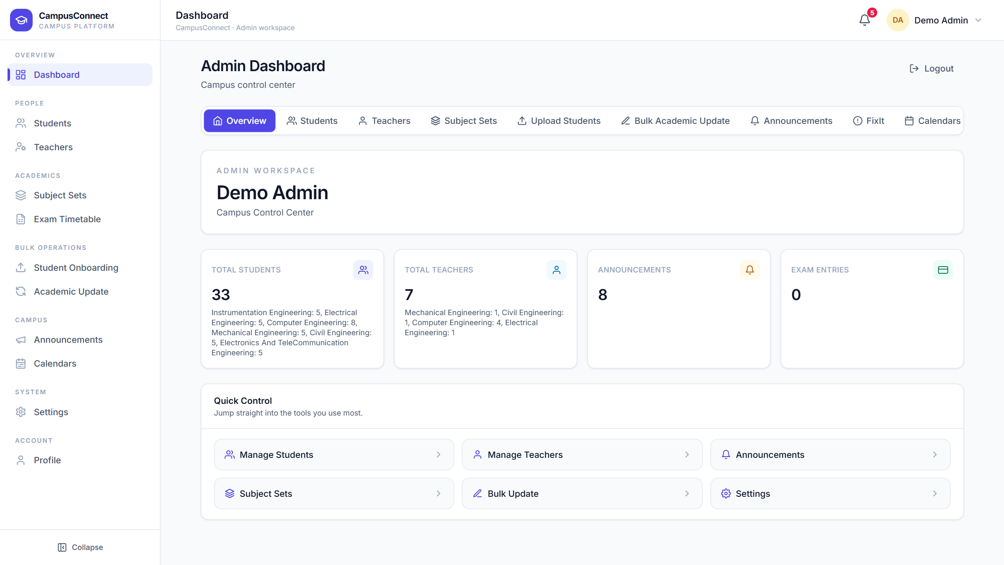
Every page follows this structure:
Visible elements:
1. Sidebar (left) — grouped navigation for your role. The active page is highlighted.
2. Header (top) — the current page name, a notification bell with an unread count, and your profile chip.
3. Profile chip — shows your name; it opens account options, and the workspace label under the page title confirms the role you are signed in as.
4. Main area — the content of the current page: cards, tables, forms, and charts.
5. Quick-access pills — dashboards offer one-click shortcuts to the most used areas.
6. Collapse — the sidebar can be collapsed to give the content more space.

TIP: The bell icon in the header shows how many unread notifications you have. Announcements marked urgent stand out so nobody misses them.

6. Administrator — Complete Visual Guide
The administrator workspace is the control centre of CampusConnect. This chapter walks through every screen in the admin sidebar, in order.

6.1 Admin Dashboard
Access: sign in as Admin → Dashboard.
Figure 6.1 — Admin Dashboard
The dashboard summarises the whole campus at a glance and offers shortcuts into every admin tool.
Visible elements:
1. Total Students — live student count with a per-department breakdown.
2. Total Teachers — faculty count by department.
3. Announcements — number of published announcements.
4. Exam Entries — exam timetable entries currently saved.
5. Quick Control — one-click shortcuts to Manage Students, Manage Teachers, Announcements, Subject Sets, Bulk Update, and Settings.
6. Quick-access pills — jump straight to any admin area, including FixIt and Calendars.

6.2 Student Management
Access: Admin → Students. What you can do here: search students, browse them by department, add a new student, edit or delete an existing one, and jump to bulk academic updates.
Figure 6.2 — Student Management
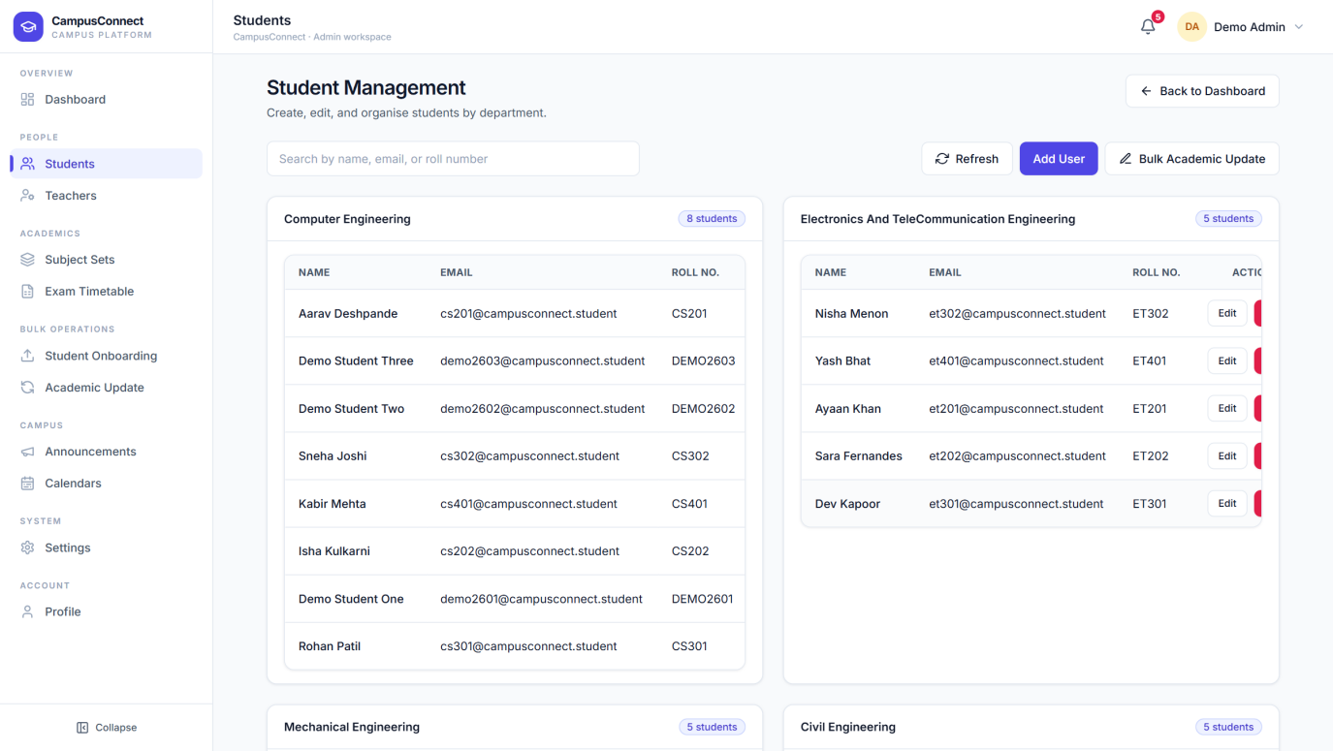
Students are organised into one card per department, each showing its student count.
Visible elements:
1. Search — find a student by name, email, or roll number.
2. Refresh — reload the latest student list.
3. Add User — opens the Add Student form.
4. Bulk Academic Update — shortcut to the bulk year/semester update tool.
5. Department cards — each card lists that department's students with a student count badge.

Figure 6.3 — Student Records by Department
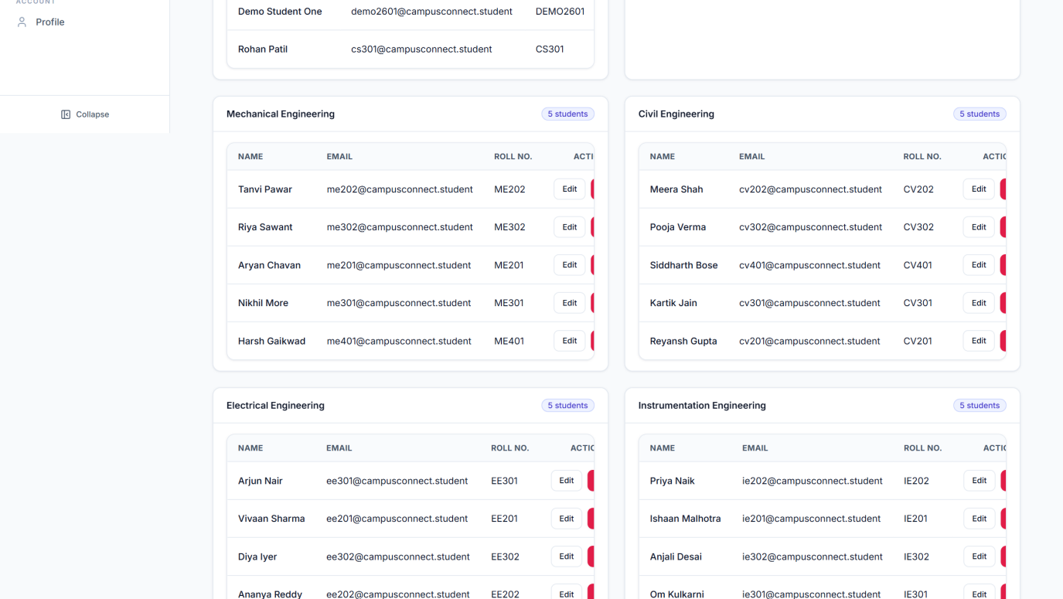
Scrolling down shows each department's table: student name, email, roll number, and per-student Edit and Delete actions.
Figure 6.4 — Searching for a Student
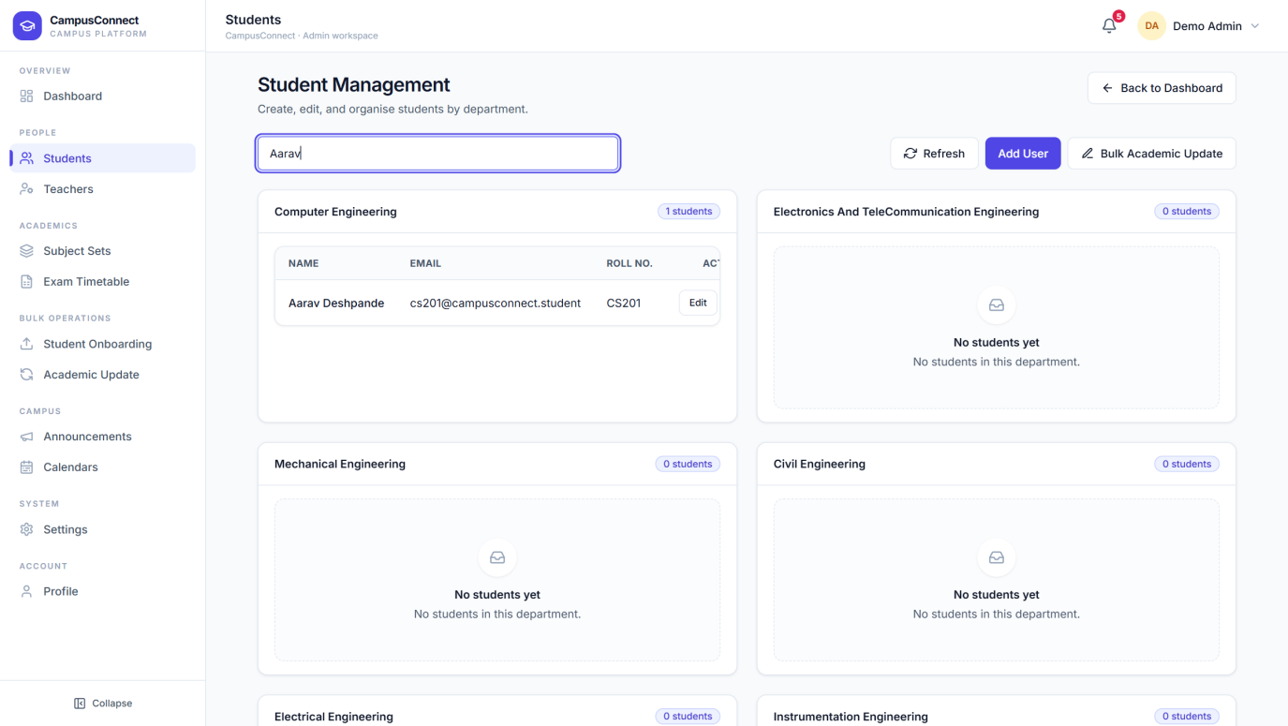
Typing in the search box filters every department instantly. Here, searching "Aarav" narrows the list to the matching student.
Figure 6.5 — Add Student Form
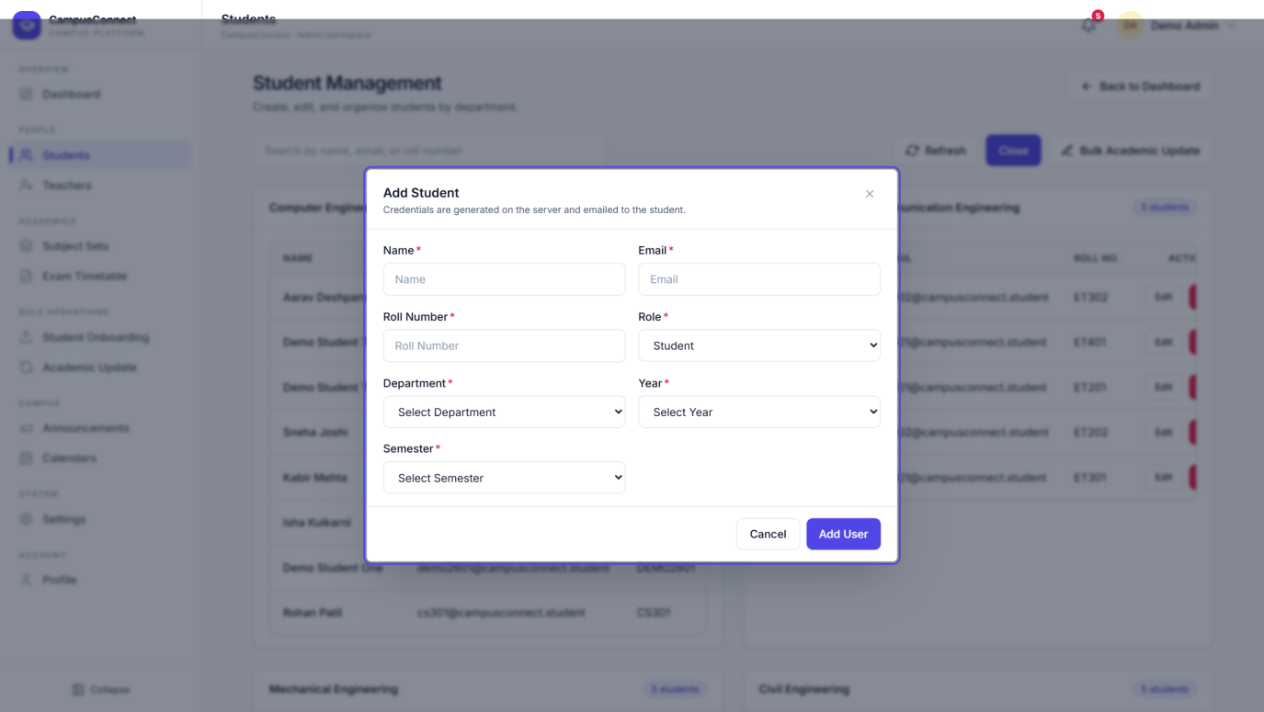
Add User opens this form. Fill in the student's name, email, roll number, department, year, and semester, then select Add User.
Visible elements:
1. Name, Email, Roll Number — the student's identity details.
2. Role — fixed to Student for this form.
3. Department, Year, Semester — the student's academic placement.
4. Add User / Cancel — save the record or close without saving.

NOTE: When a student is added, the platform creates their account and emails the login credentials to the student automatically — the administrator never has to handle passwords.
What happens after: the student appears in their department card immediately and can sign in with the emailed credentials. Editing works the same way — select Edit next to a student to open the same form pre-filled.

6.3 Teacher Management
Access: Admin → Teachers. What you can do here: search faculty, add a teacher with subject assignments, edit teacher details, and remove a teacher.
Figure 6.6 — Teacher Management
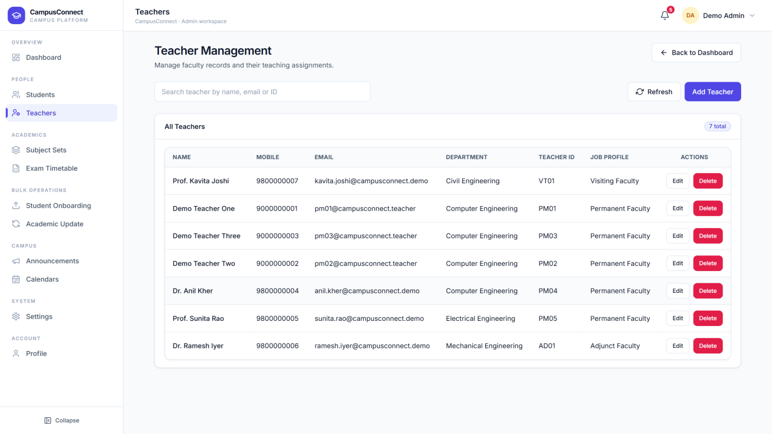
Every teacher is listed with their ID, job profile, department, and assigned subjects.
Visible elements:
1. Search — find a teacher by name, email, or ID.
2. Add Teacher — opens the Add Teacher form.
3. Teacher list — each row shows the teacher's details with Edit and Delete actions.

Figure 6.7 — Add Teacher Form
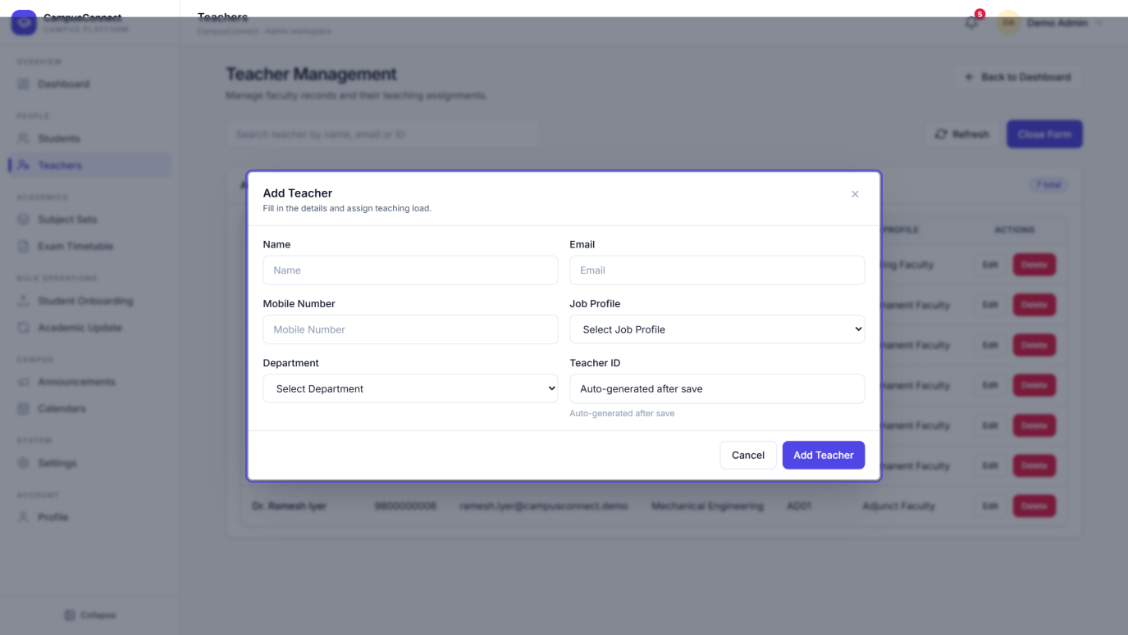
The Add Teacher form captures the teacher's details and their teaching assignments.
Visible elements:
1. Name, Email, Mobile Number — contact details.
2. Job Profile — Permanent, Adjunct, or Visiting Faculty.
3. Department — the teacher's home department.
4. Teacher ID — generated automatically by the platform.
5. Assignments — pick a branch and year, tick the subjects the teacher will teach, and select Add Assignment.

What happens after: the platform generates the Teacher ID, creates the account, emails the login details to the teacher, and links the teacher to every student who studies the assigned subjects.

6.4 Subject Sets
Access: Admin → Subject Sets. What you can do here: define the official subject list for every branch, year, and semester — the single source used across student onboarding, teacher assignment, timetables, and study materials.
Figure 6.8 — Subject Set Management
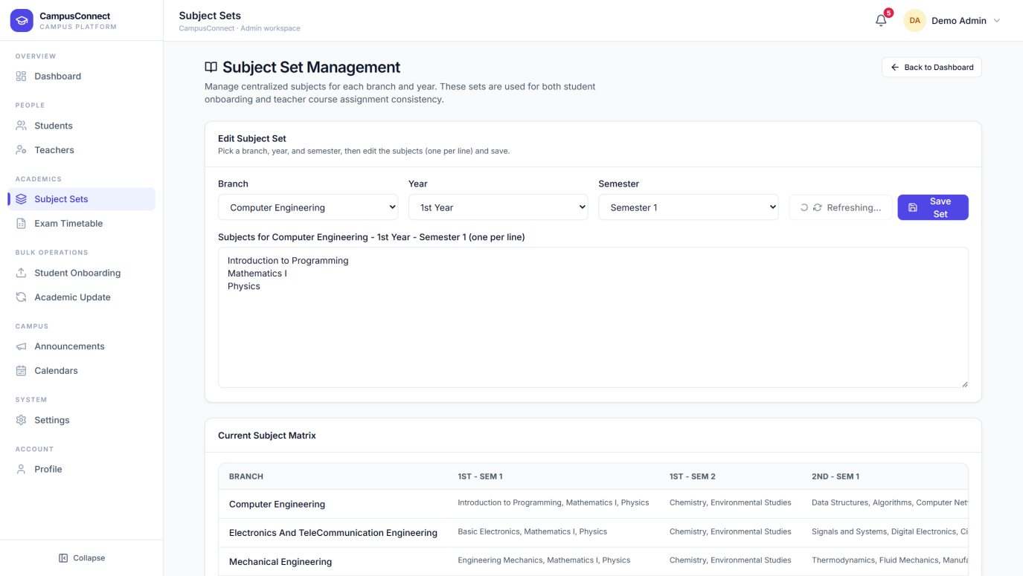
Pick a branch, year, and semester, edit the subjects (one per line), and save.
Visible elements:
1. Branch / Year / Semester — choose which subject set to edit.
2. Subjects editor — the subject list, one subject per line.
3. Save Set — publish the updated list.
4. Current Subject Matrix — a live overview of every branch's subjects across years and semesters.

6.5 Exam Timetable
Access: Admin → Exam Timetable. What you can do here: build each academic year's exam schedule three ways — import from a scanned timetable, type entries manually, or upload the official PDF — then review everything in one table.
Figure 6.9 — Exam Timetable — OCR Upload
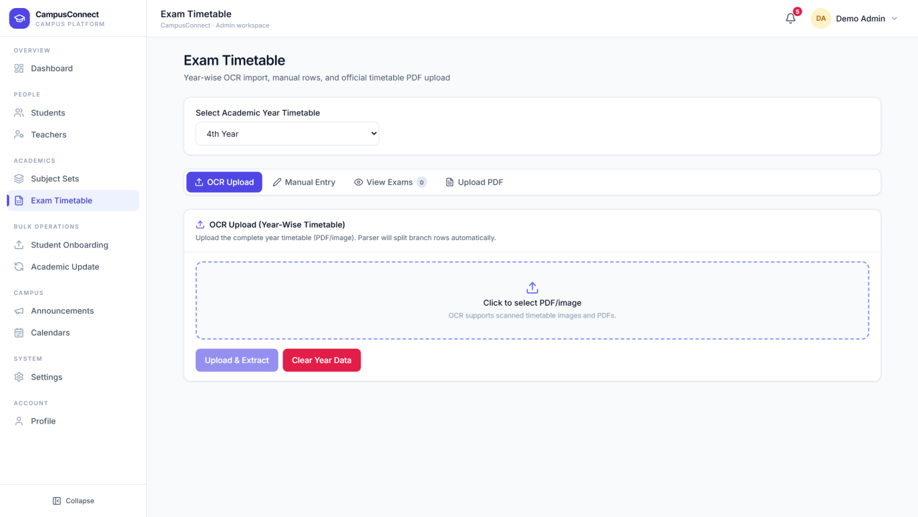
Select the academic year, then upload a scanned timetable image or PDF. The platform reads it and splits the rows per branch automatically.
Visible elements:
1. Select Academic Year Timetable — which year's schedule you are editing.
2. OCR Upload / Manual Entry / View Exams / Upload PDF — the four working modes.
3. Upload area — click to select the PDF or image.
4. Upload & Extract — run the automatic reader.
5. Clear Year Data — remove the selected year's entries and start over.

Figure 6.10 — Exam Timetable — Manual Entry
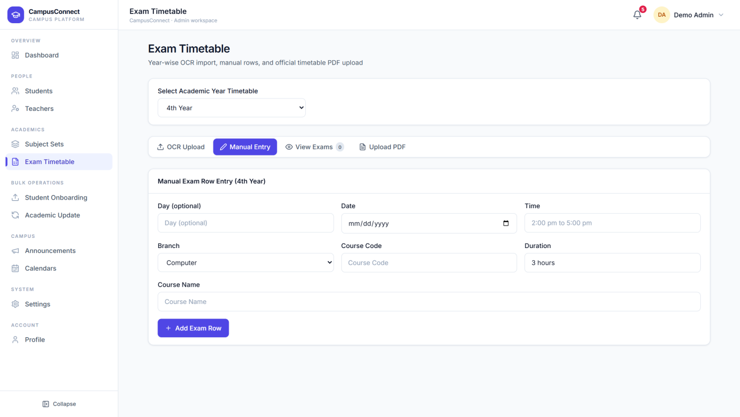
Manual Entry lets you add exams row by row — day, date, time, course code, duration, and course name — and edit any previously extracted rows before saving.
Figure 6.11 — Exam Timetable — View Exams
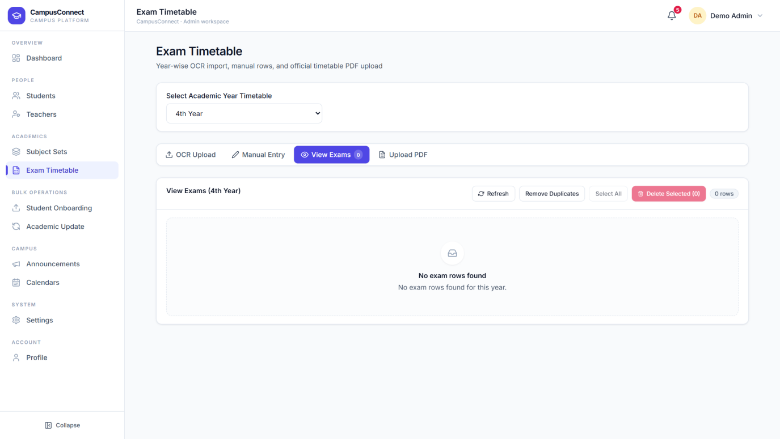
View Exams shows every saved entry for the selected year in one table, with inline editing and per-row delete.
What happens after: saved exams appear on every relevant student's and teacher's Exam Timetable page, and exam reminders are sent automatically as the date approaches.

6.6 Student Onboarding (Bulk)
Access: Admin → Student Onboarding. What you can do here: create an entire intake of student accounts from one admission-list file instead of typing them one by one.
Figure 6.12 — Bulk Student Onboarding
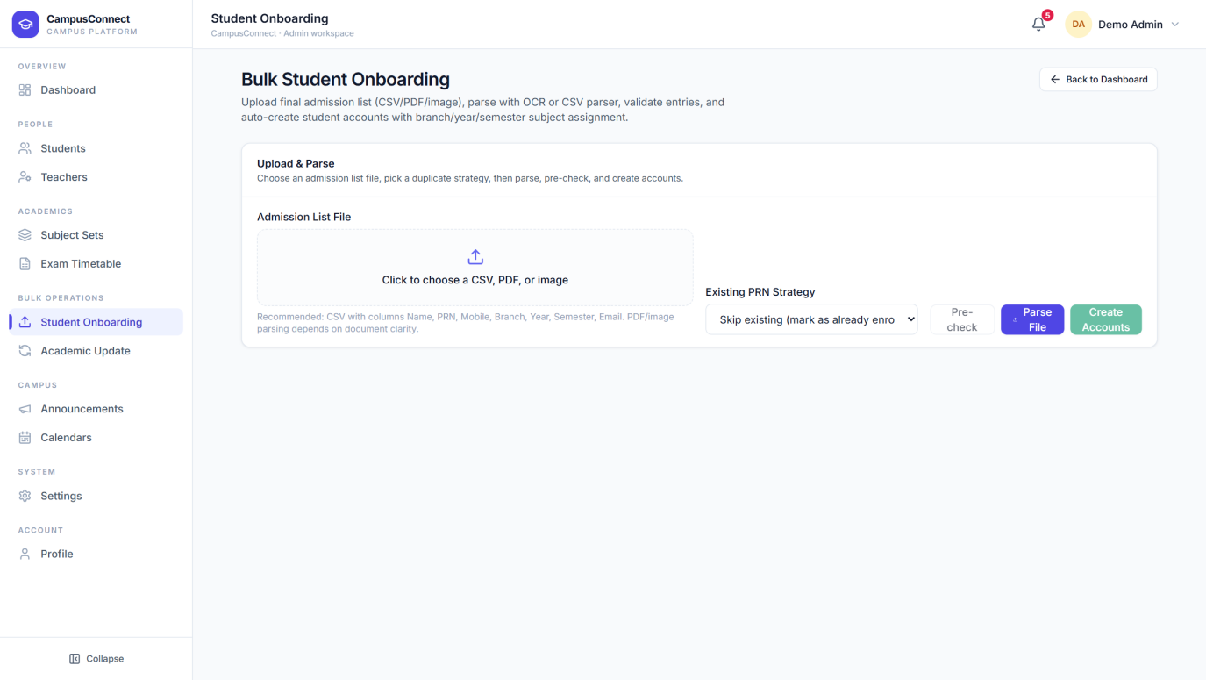
Upload the admission list, choose how to treat students that already exist, pre-check the data, then create all accounts in one step.
Visible elements:
1. Admission List File — upload a CSV, PDF, or image of the admission list.
2. Existing PRN Strategy — choose what happens when a listed student already has an account.
3. Pre-check — validate the file and preview what will be created before committing.
4. Parse File — read the uploaded file into editable rows.
5. Create Accounts — create every account and email each student their credentials.

6.7 Academic Update (Bulk)
Access: Admin → Academic Update. What you can do here: move whole groups of students to their next year or semester in one operation — for example, promoting all of 2nd Year to 3rd Year at the start of a new session — with a preview before anything is changed.
Figure 6.13 — Bulk Academic Update
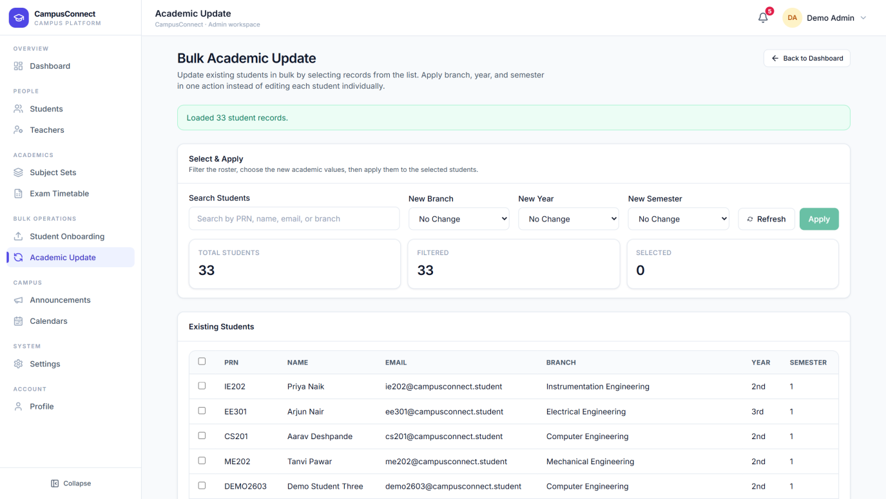
Select the students by department and year, choose the new year/semester, preview the change, and apply it to everyone at once.

6.8 Announcements
Access: Admin → Announcements. What you can do here: publish campus-wide announcements, mark them urgent or as events, see how many students have read each one, and edit, hide, or delete any announcement.
Figure 6.14 — Announcement Management
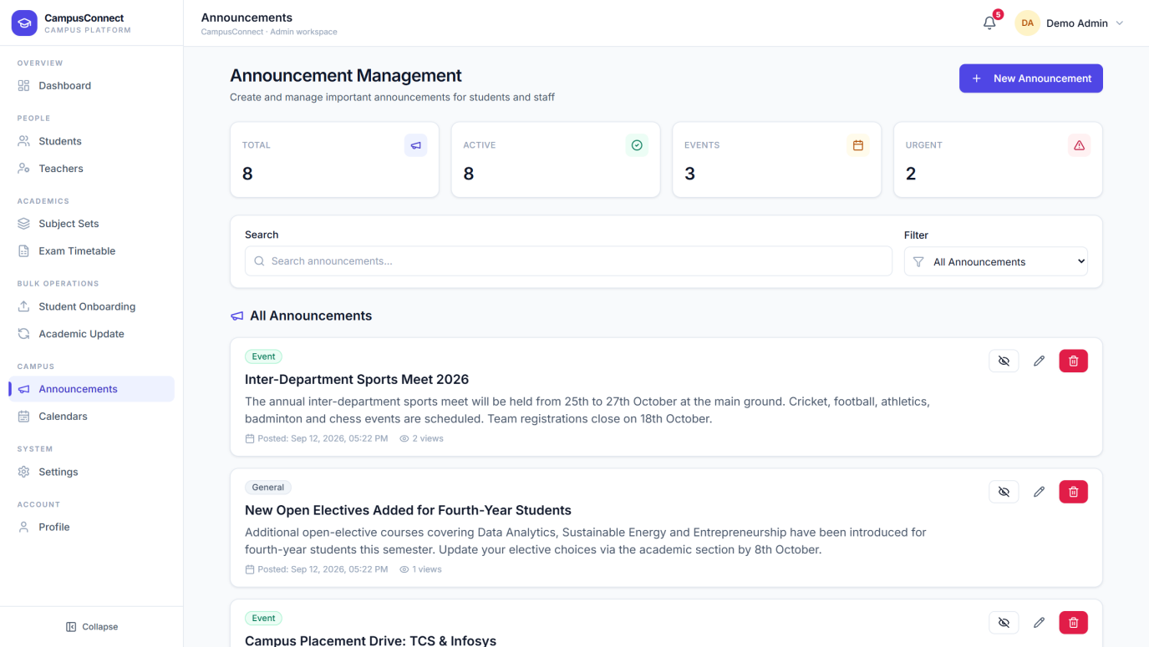
All announcements in one place, with live statistics.
Visible elements:
1. Statistics — Total, Active, Events, and Urgent announcement counts.
2. Search and Filter — find announcements by text or show only one type.
3. New Announcement — open the publishing form.
4. Announcement cards — each shows its type badge, message, posting time, and view count.
5. Hide / Edit / Delete — per-announcement controls.

Figure 6.15 — New Announcement
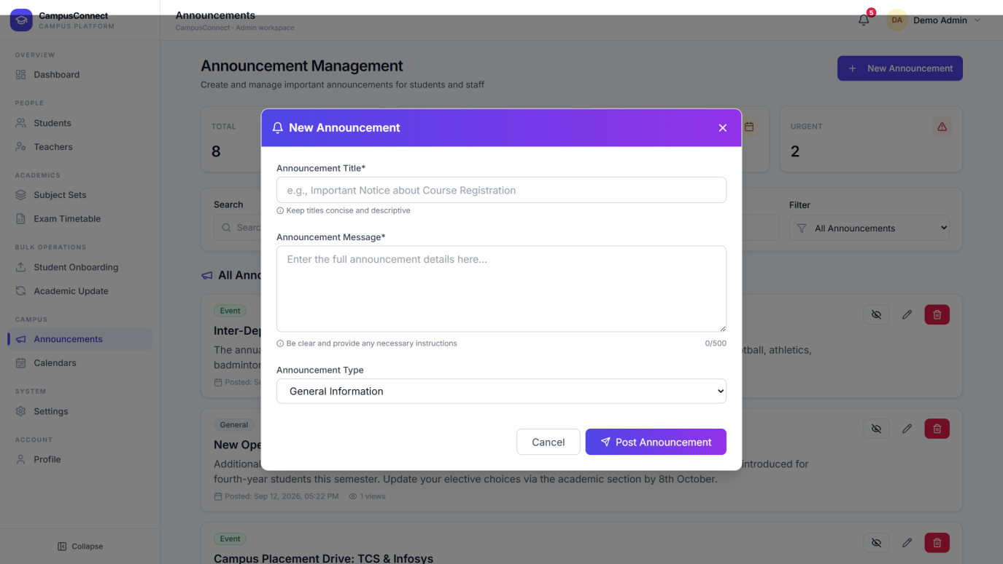
Publishing takes three inputs: a title, the message, and a type — General, Urgent, or Event. The announcement is visible to students and teachers the moment it is posted, and urgent ones are highlighted.

6.9 Calendars
Access: Admin → Calendars. What you can do here: maintain the two campus calendars everyone sees.
Figure 6.16 — Calendars Hub
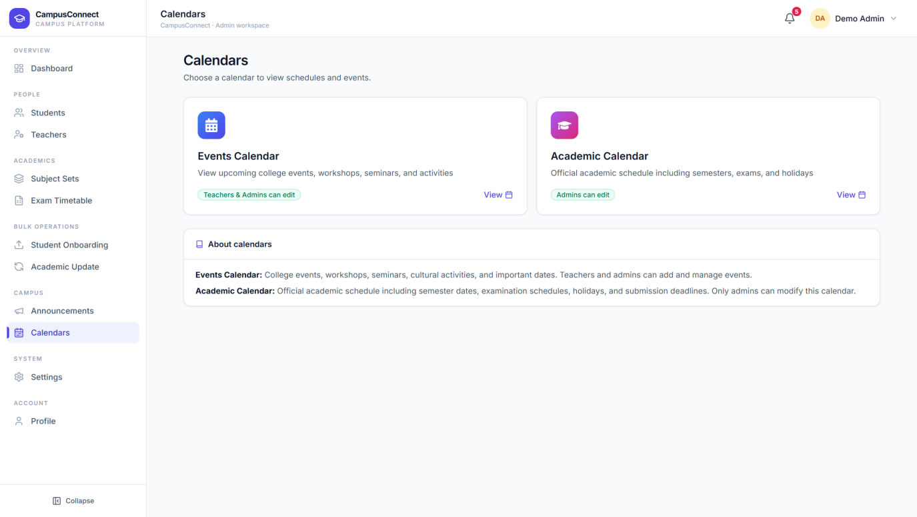
Two calendars serve different purposes, with clearly stated edit rights.
Visible elements:
1. Events Calendar — workshops, seminars, and activities; teachers and admins can add events.
2. Academic Calendar — the official academic schedule; only admins can modify it.

Figure 6.17 — Events Calendar
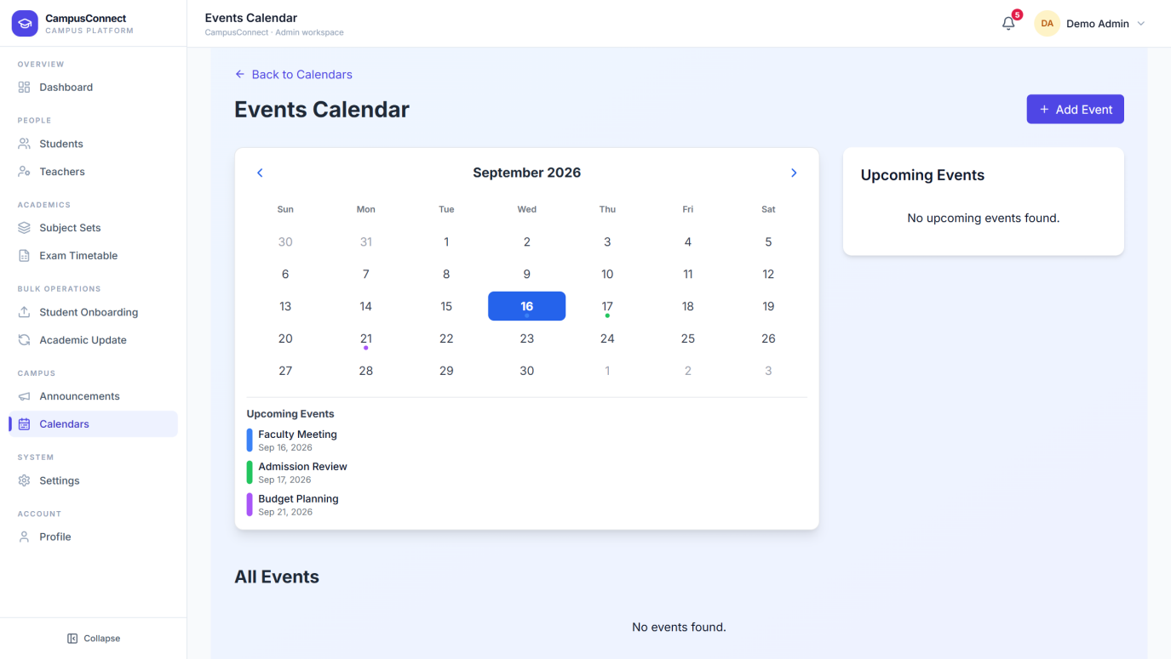
A month view of campus events. Administrators and teachers can add events; everyone else sees them instantly.
Figure 6.18 — Academic Calendar
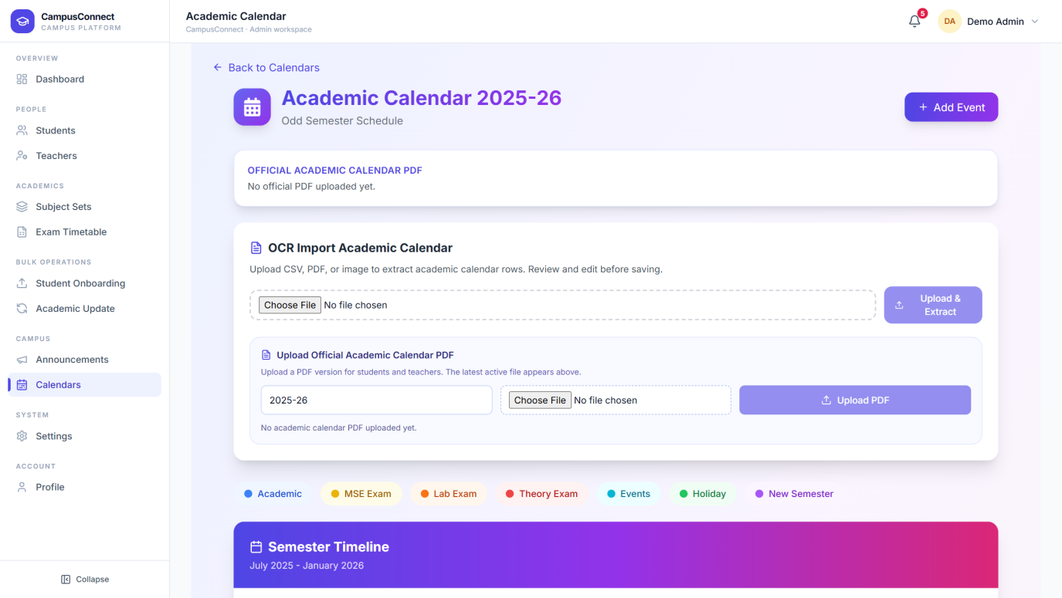
The official academic schedule — semester dates, examinations, holidays, and deadlines — maintained by administrators.

6.10 Settings
Access: Admin → Settings. What you can do here: review your administrator account and manage platform preferences, organised into tabs.
Figure 6.19 — Admin Settings
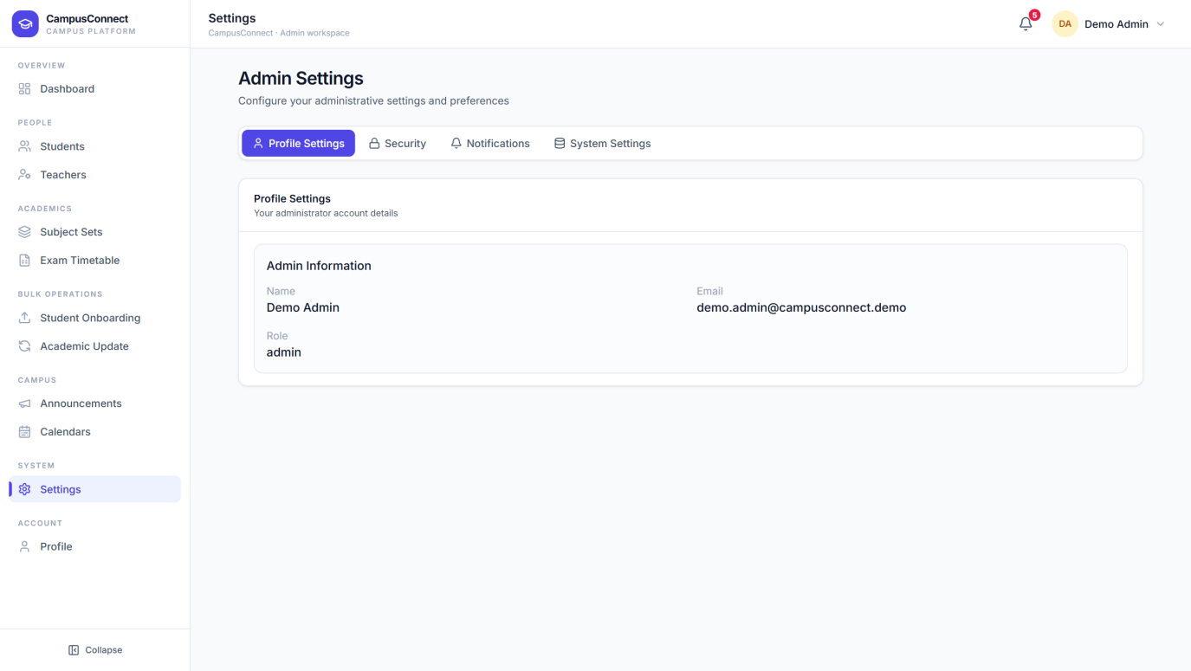
Settings are grouped into Profile Settings, Security, Notifications, and System Settings tabs. Profile Settings shows the signed-in administrator's name, email, and role.

6.11 Profile
Access: Admin → Profile. Your personal account page — the same page every role has. From here you can review your details, update your profile, and change your password.
Figure 6.20 — Admin Profile
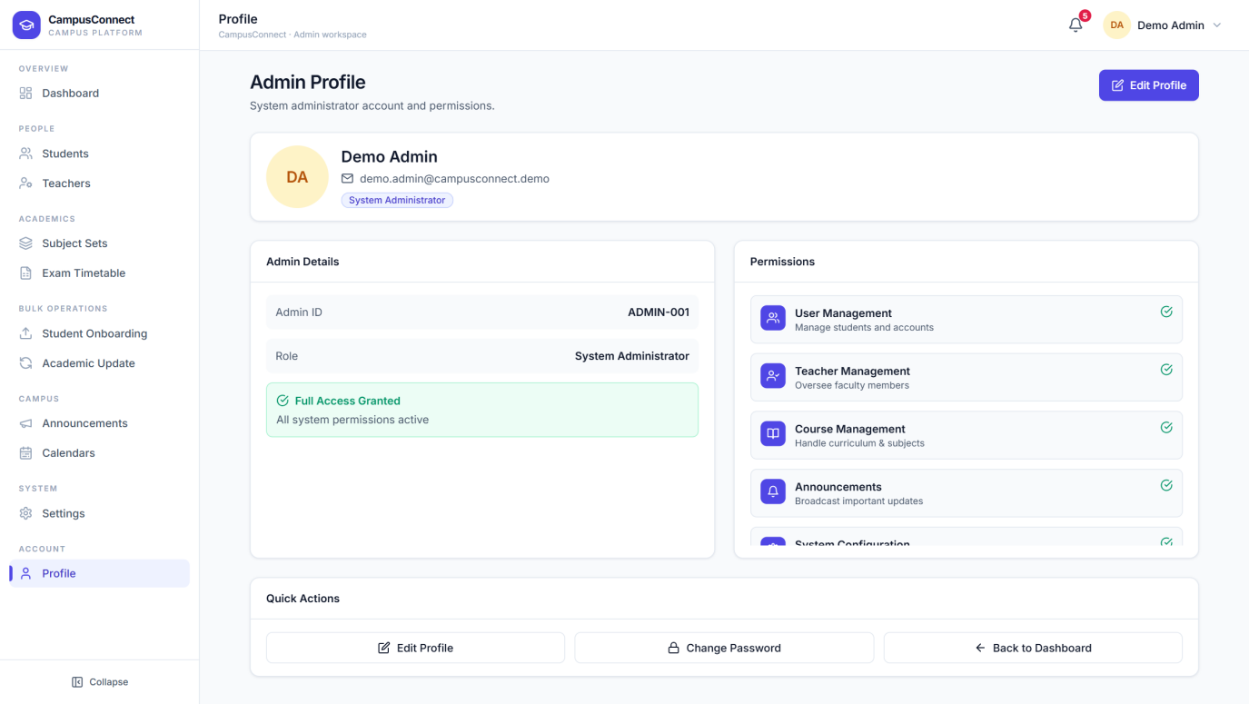
The profile page shows your account information with options to edit the profile and manage your password.

6.12 Logging out
Select Logout (shown on the dashboard header) or open the profile chip menu and choose Logout. You are returned to the sign-in page immediately.

7. Teacher — Complete Visual Guide
The teacher workspace focuses on the daily teaching routine: attendance, the class timetable, students, courses, and study material.

7.1 Teacher Dashboard
Figure 7.1 — Teacher Dashboard
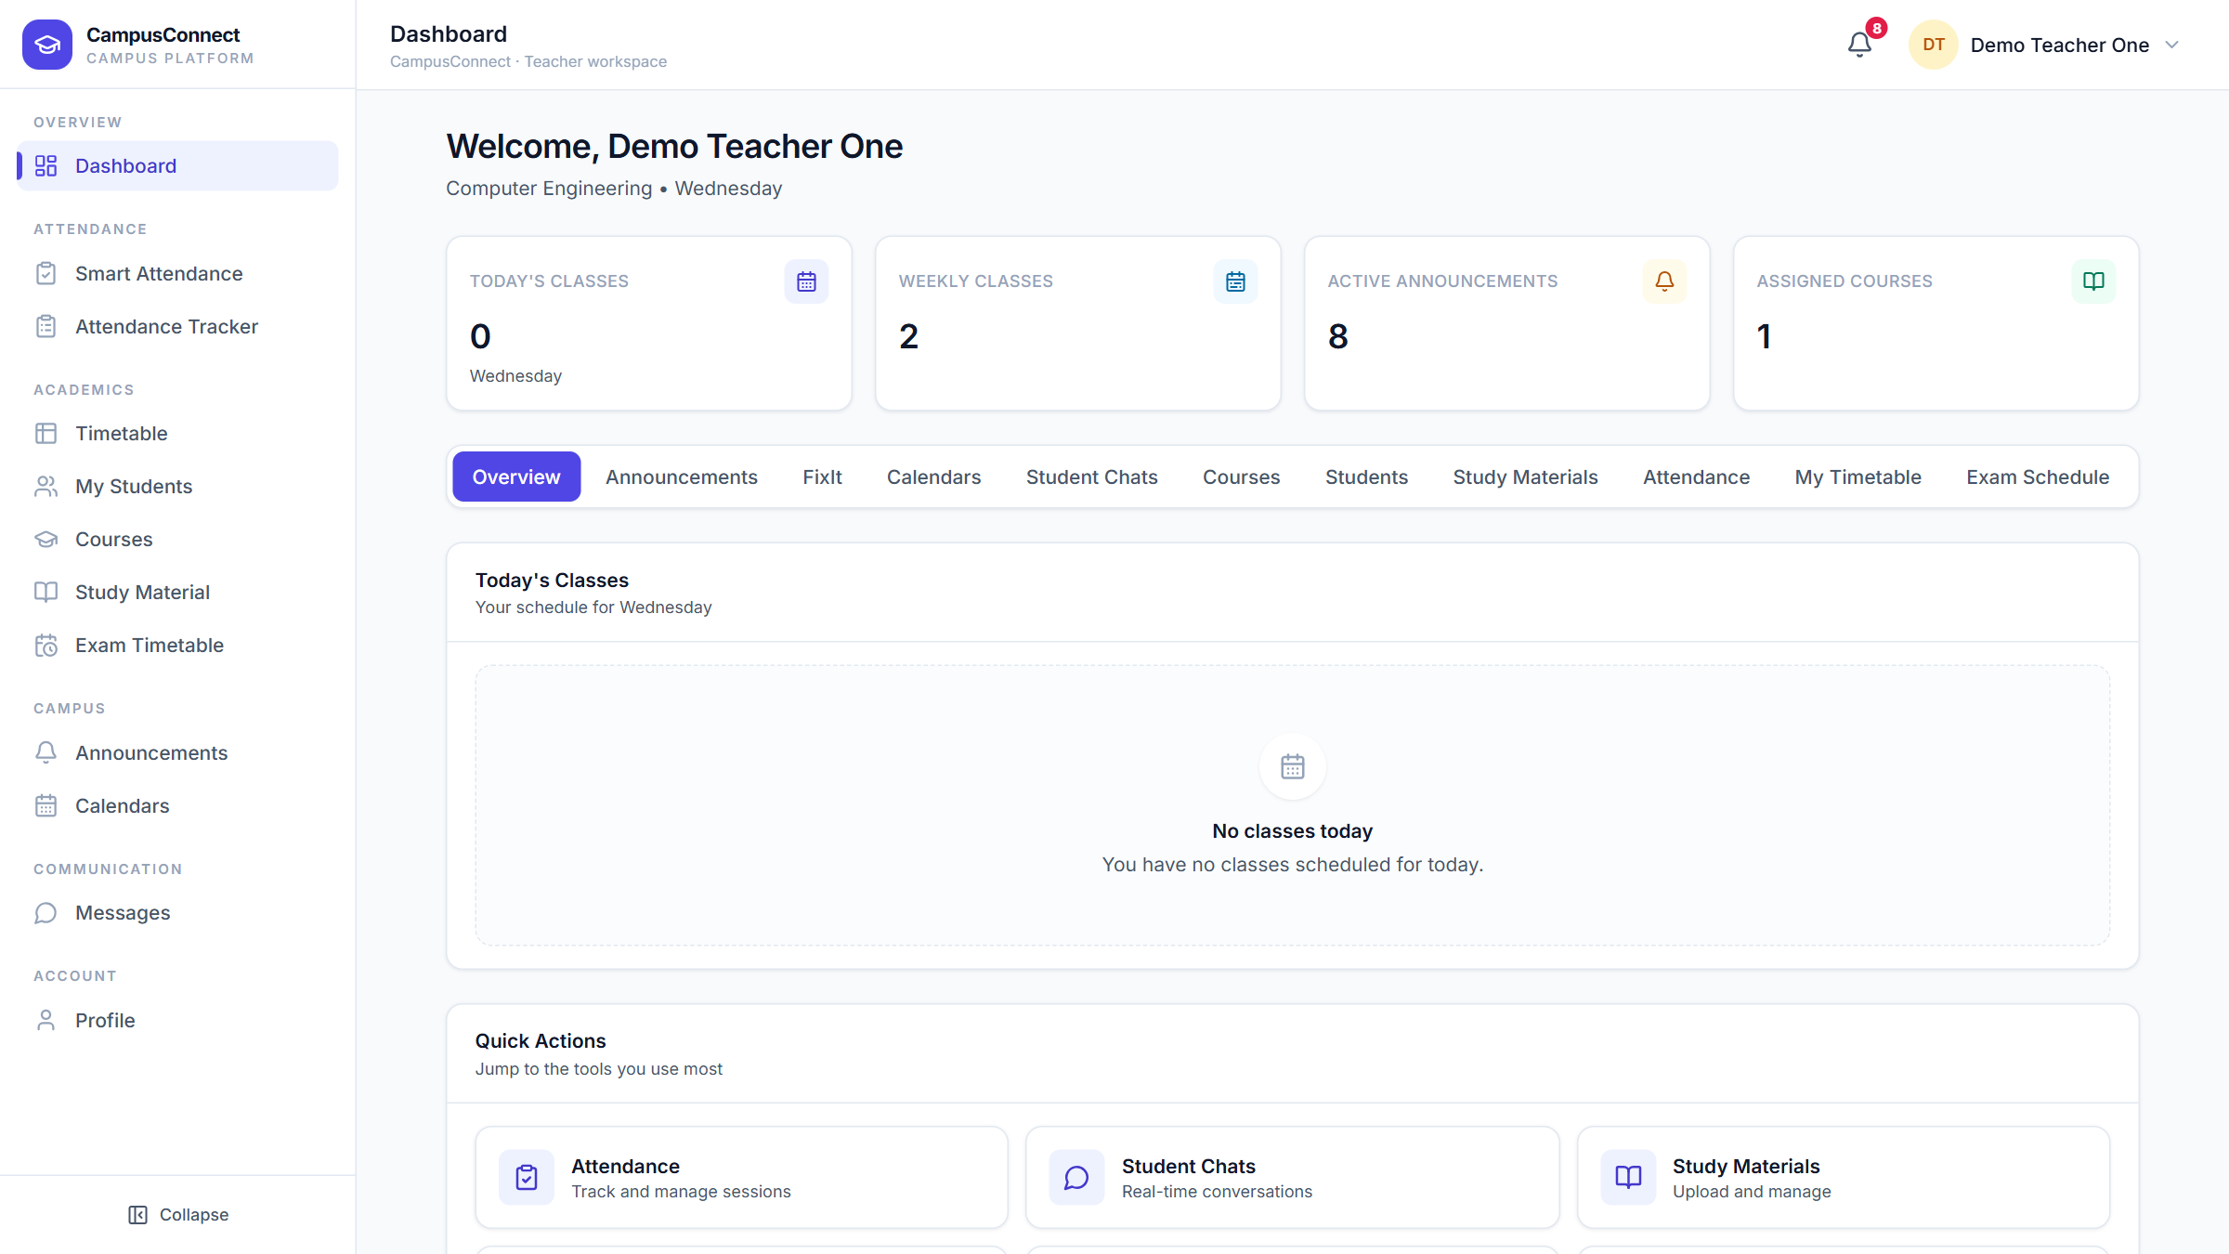
The dashboard greets the teacher with their department and today's teaching load.
Visible elements:
1. Today's Classes — lectures scheduled for today.
2. Weekly Classes — total lectures this week.
3. Active Announcements — campus announcements currently live.
4. Assigned Courses — subjects this teacher teaches.
5. Today's Classes panel — today's schedule (with a friendly empty state on free days).
6. Quick Actions — jump to Attendance, Student Chats, and Study Materials.

7.2 Smart Attendance
Access: Teacher → Smart Attendance. What you can do here: run live, verified attendance sessions and monitor attendance analytics for your subjects.
Figure 7.2 — Smart Attendance
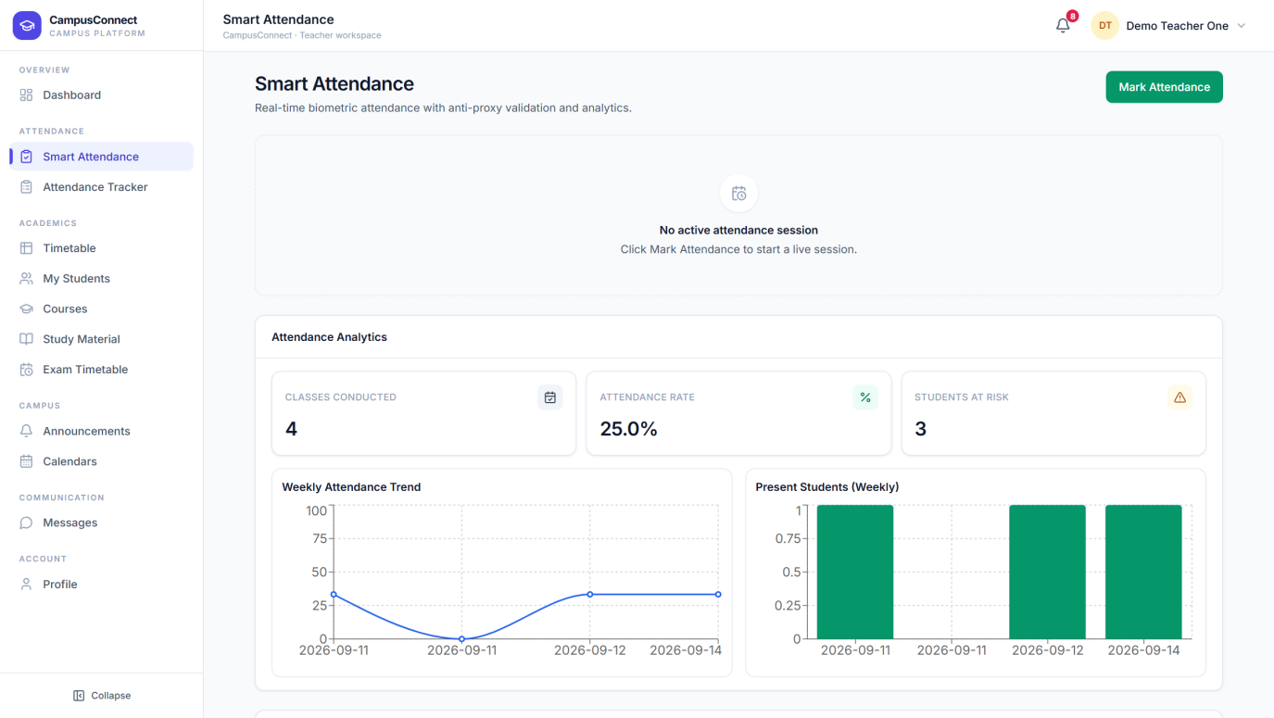
The attendance hub shows the current session area and analytics for the teacher's subject.
Visible elements:
1. Mark Attendance — starts a new live session.
2. Active session area — shows the running session, or an empty state when none is live.
3. Classes Conducted / Attendance Rate / Students at Risk — headline analytics.
4. Weekly Attendance Trend and Present Students — charts of recent attendance.

Figure 7.3 — Start Attendance Session
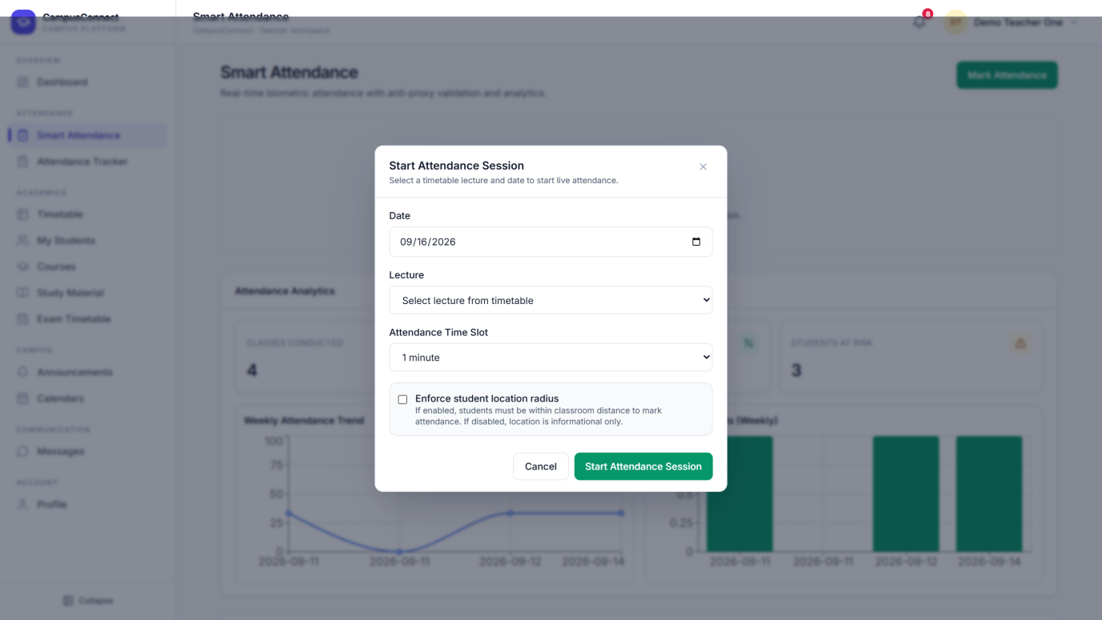
Mark Attendance opens this form. Pick the date, choose the lecture from your timetable, and set how long the attendance window stays open.
Visible elements:
1. Date — the session date (must match the lecture's weekday).
2. Lecture — select from your scheduled timetable lectures.
3. Attendance Time Slot — how long students have to mark themselves present.
4. Location check — optionally require students to be physically nearby.

What happens after: the session goes live instantly. Students see it on their Attendance page and verify with fingerprint or face recognition; the teacher watches students appear live as they mark, can mark students manually by scanning their profile QR code, and ends the session at any time.
Figure 7.4 — Past Session Details
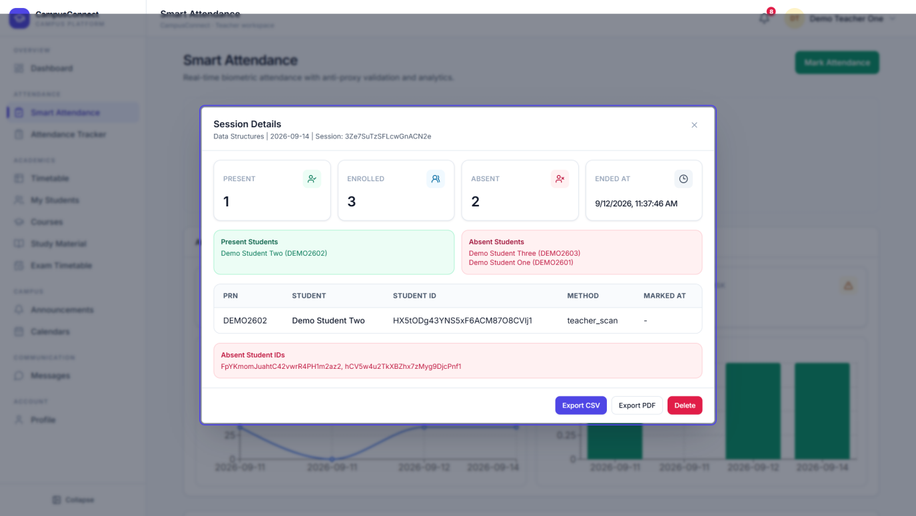
Every finished session keeps its full record. View Details shows who was present, how each student verified, and the session timing.

7.3 Attendance Tracker
Access: Teacher → Attendance Tracker. What you can do here: review attendance across all sessions and students — percentages per student, session history, and printable reports.
Figure 7.5 — Attendance Tracker
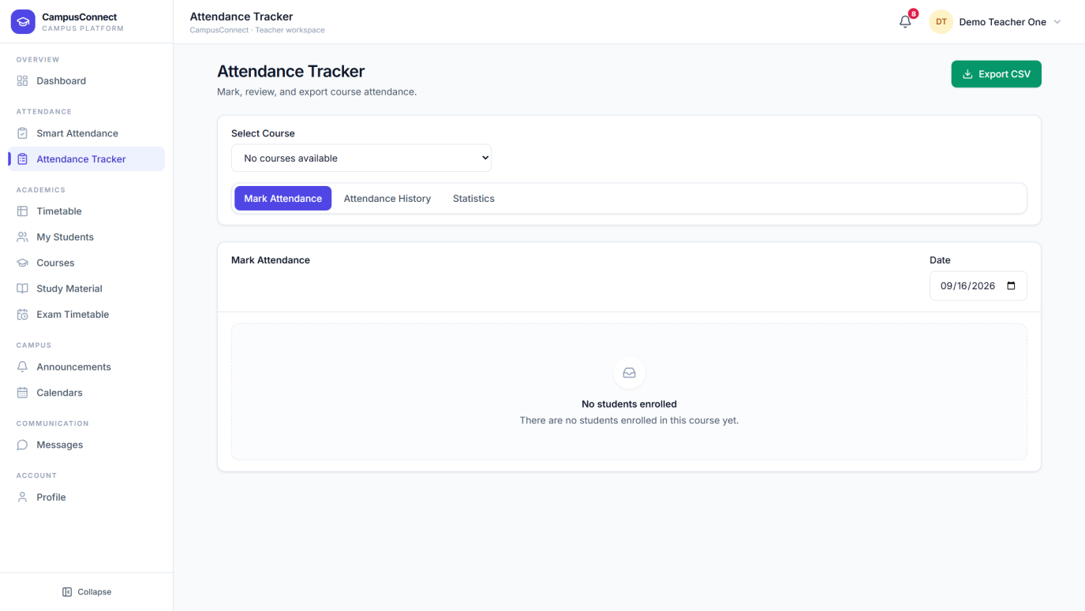
The tracker aggregates every session for the teacher's subjects, highlighting each student's attendance percentage and flagging students below the safe threshold.

7.4 Timetable
Access: Teacher → Timetable. What you can do here: view the shared weekly class timetable for any branch, year, and semester, and add your own lectures — with automatic protection against double-booking a slot.
Figure 7.6 — My Timetable
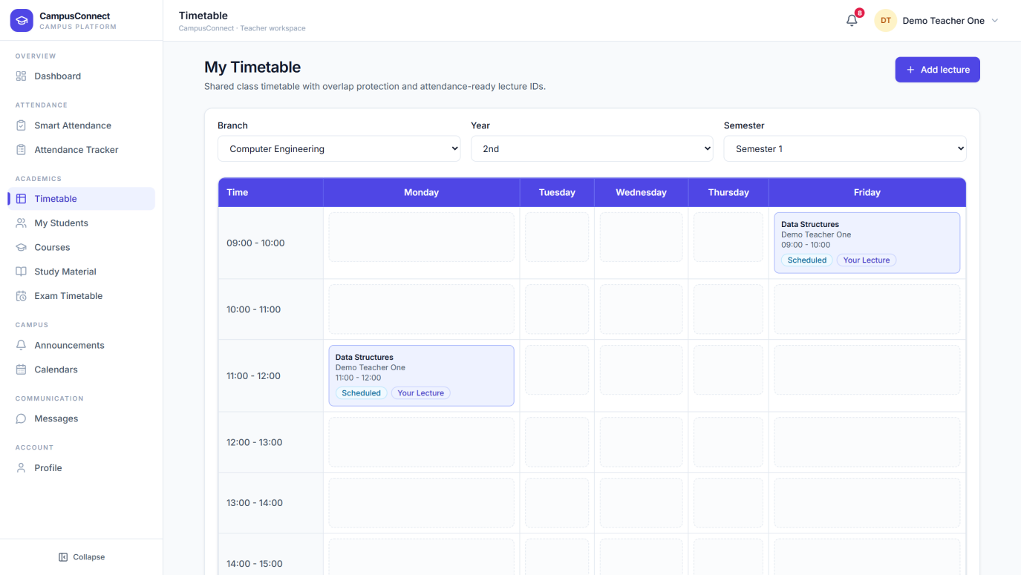
The weekly grid shows every scheduled lecture. The teacher's own lectures carry a "Your Lecture" badge.
Visible elements:
1. Branch / Year / Semester — choose which class group's timetable to view.
2. Weekly grid — time slots down the side, weekdays across the top.
3. Lecture cards — subject, teacher, time, and status badges.
4. Add lecture — schedule a new lecture in a free slot.

Figure 7.7 — Add Lecture
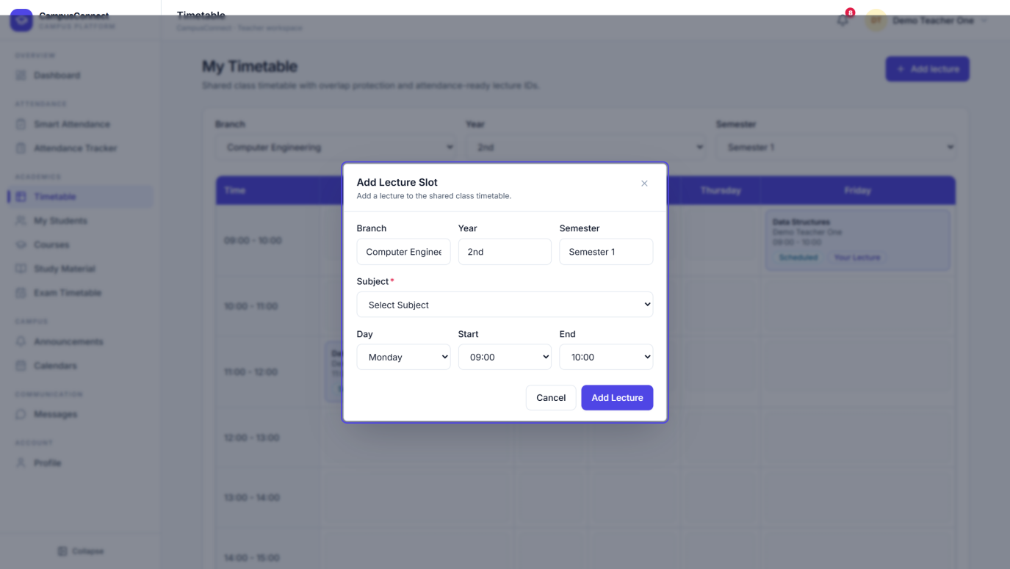
Adding a lecture takes the class group (pre-filled), the subject from the official subject set, the weekday, and the time slot. The platform blocks overlapping bookings automatically.
What happens after: the lecture appears on the shared timetable for every student in that class group, and it becomes selectable when starting an attendance session.

7.5 My Students
Access: Teacher → My Students. What you can do here: see exactly which students you teach, per assigned subject, and export the list.
Figure 7.8 — My Students
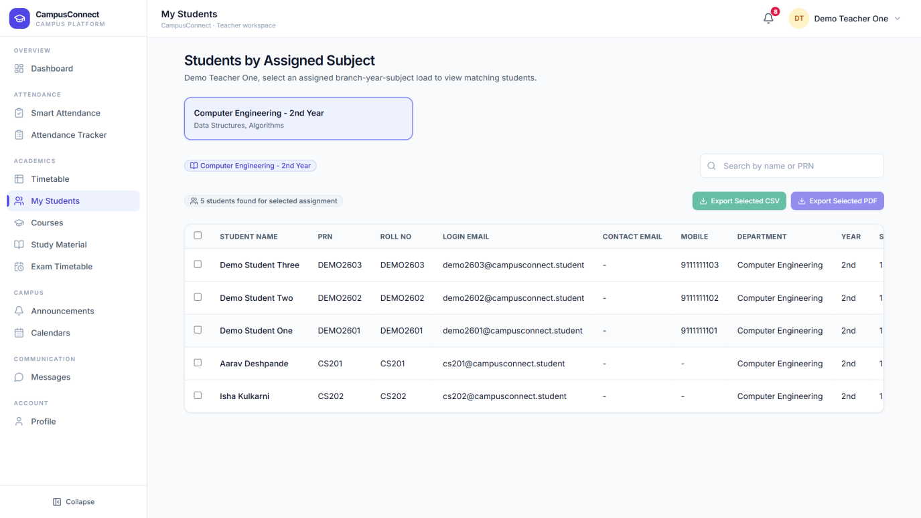
Selecting an assignment card loads every matching student.
Visible elements:
1. Assignment cards — one per branch-year assignment with its subjects.
2. Search — filter the loaded students by name or PRN.
3. Students table — name, PRN, roll number, login email, contact details, department, and year.
4. Export Selected CSV / PDF — download the selected students as a spreadsheet or document.

7.6 Courses
Access: Teacher → Courses. A clear summary of every subject you are assigned to teach, organised by branch and year.
Figure 7.9 — Courses
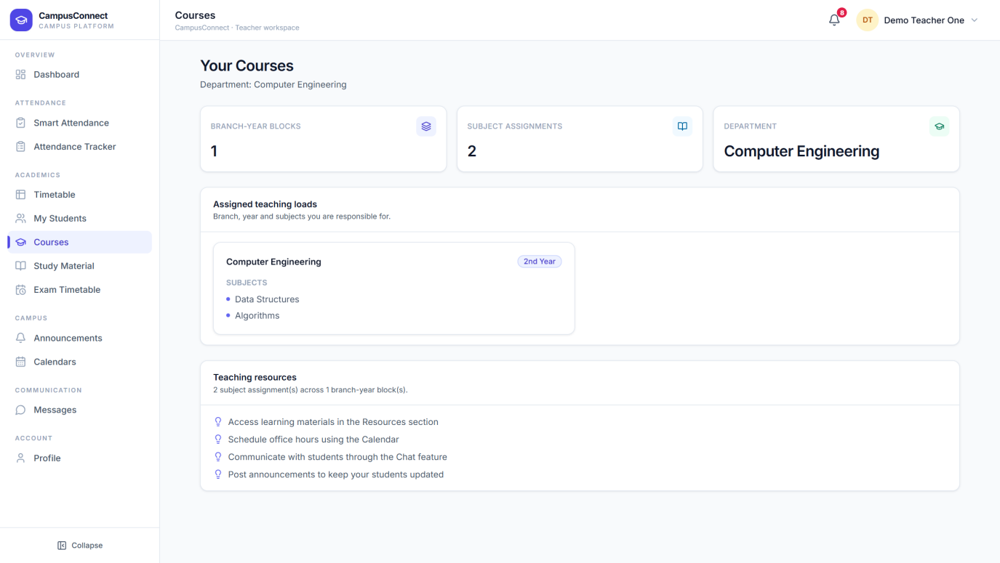
Each assigned course is shown with its branch, year, and subject details.

7.7 Study Material
Access: Teacher → Study Material. What you can do here: upload notes and resources for your subjects and manage what you have shared. Students in the matching class see the material instantly.
Figure 7.10 — Study Material
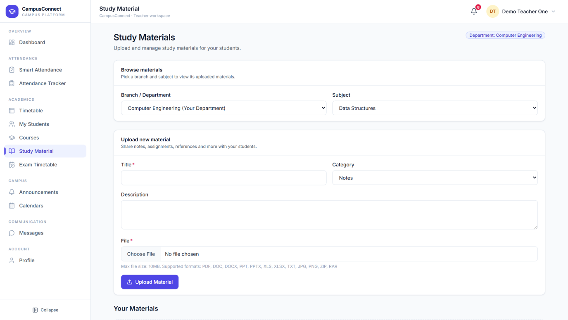
Upload a file, tag it with the branch, year, and subject it belongs to, and publish. Your uploaded materials are listed for review or removal.

7.8 Exam Timetable
Figure 7.11 — Exam Timetable (Teacher view)
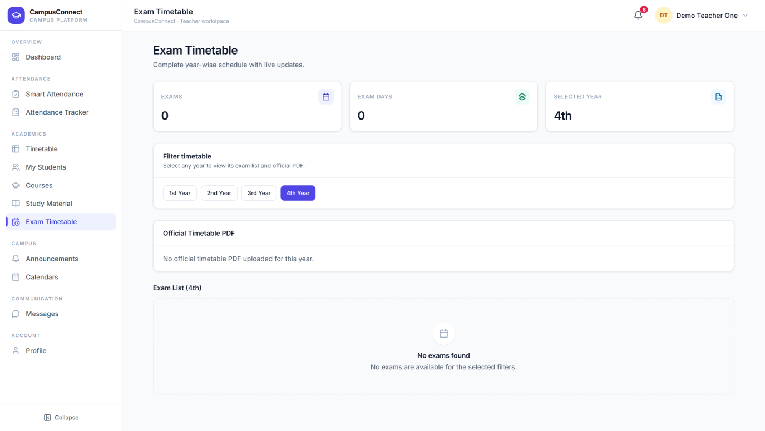
Teachers see the same official exam schedule the administrators publish, filtered by academic year.

7.9 Announcements
Figure 7.12 — Announcements (Teacher view)
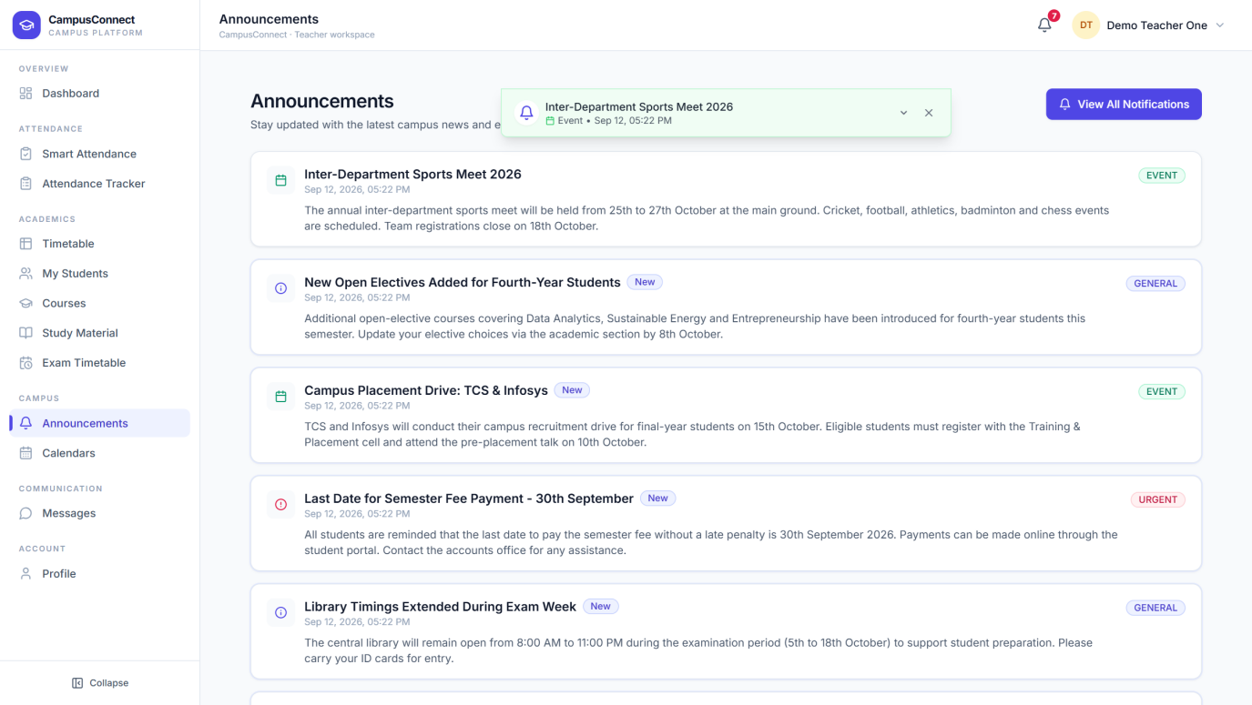
Teachers read campus announcements here, with urgent items highlighted.

7.10 Calendars
Figure 7.13 — Calendars (Teacher view)
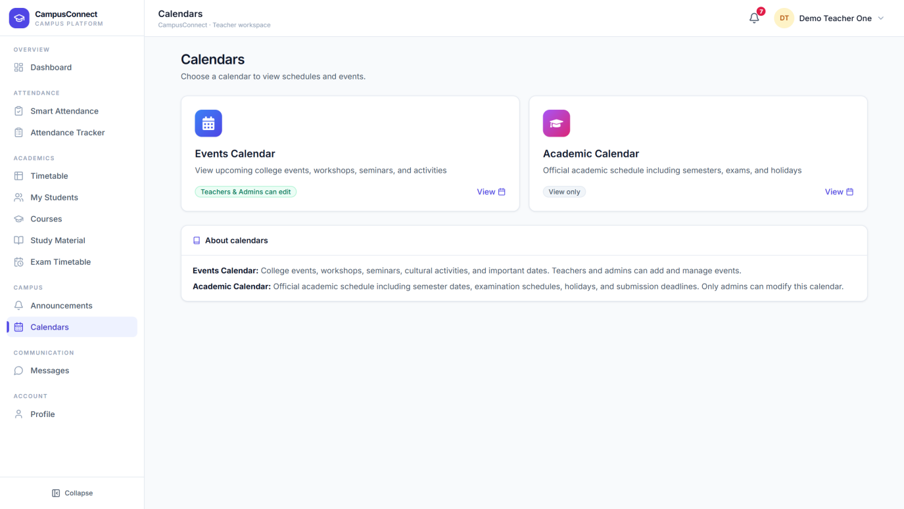
Teachers can view both calendars and add events to the Events Calendar.

7.11 Messages
Access: Teacher → Messages. Direct, real-time chat between teachers and their students — questions answered without exchanging phone numbers.
Figure 7.14 — Messages
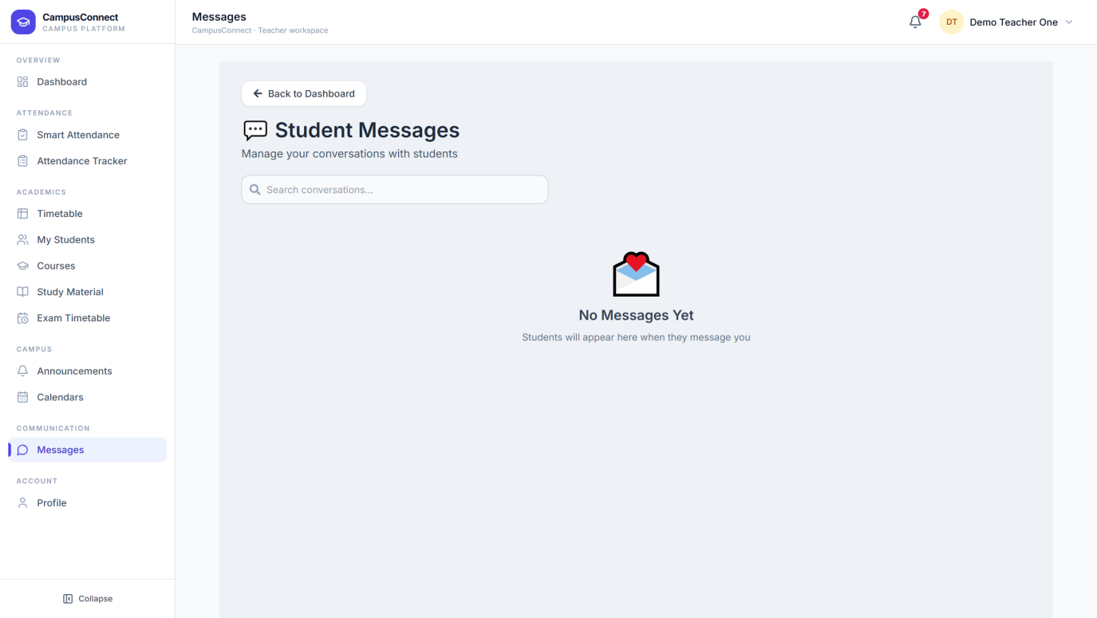
Conversations are listed on the left; the selected conversation opens on the right. Attachments are supported.

7.12 Profile
Figure 7.15 — Teacher Profile
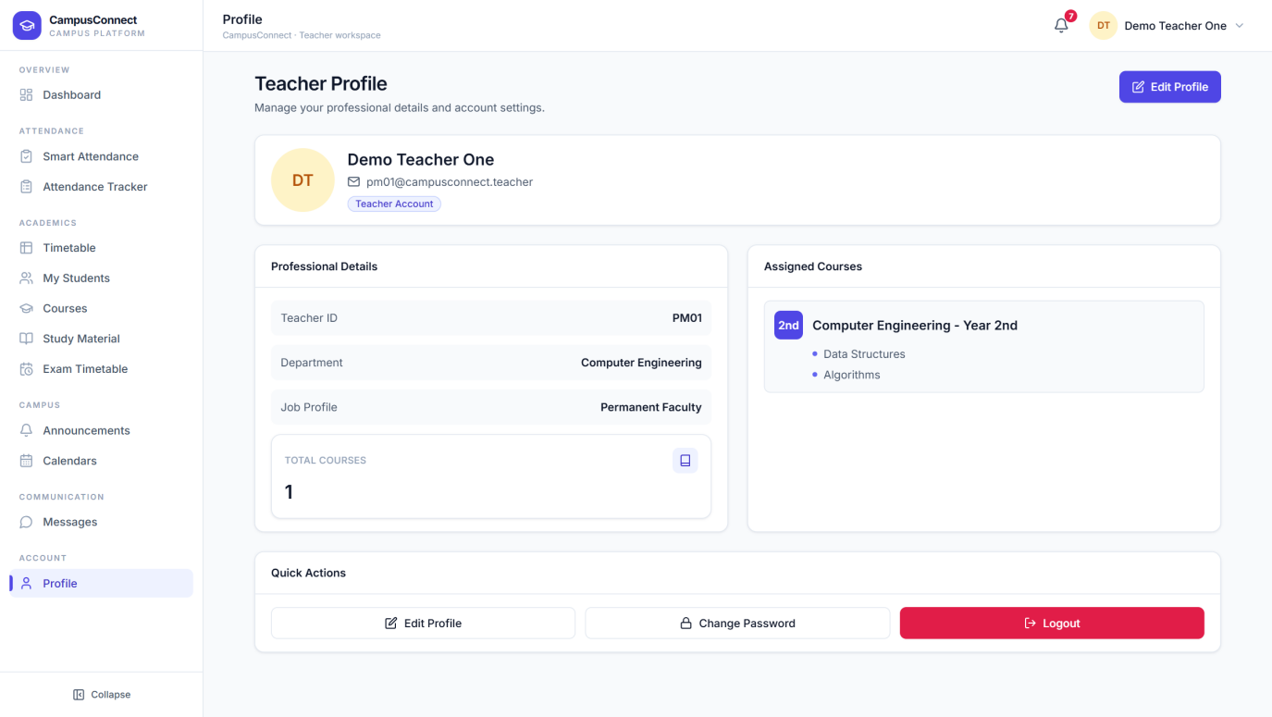
The teacher's account page — personal details, profile photo, and password management.

8. Student — Complete Visual Guide
The student workspace puts everything a student needs day to day one click away: attendance, timetables, exams, study resources, announcements, and communication.

8.1 Student Dashboard
Figure 8.1 — Student Dashboard
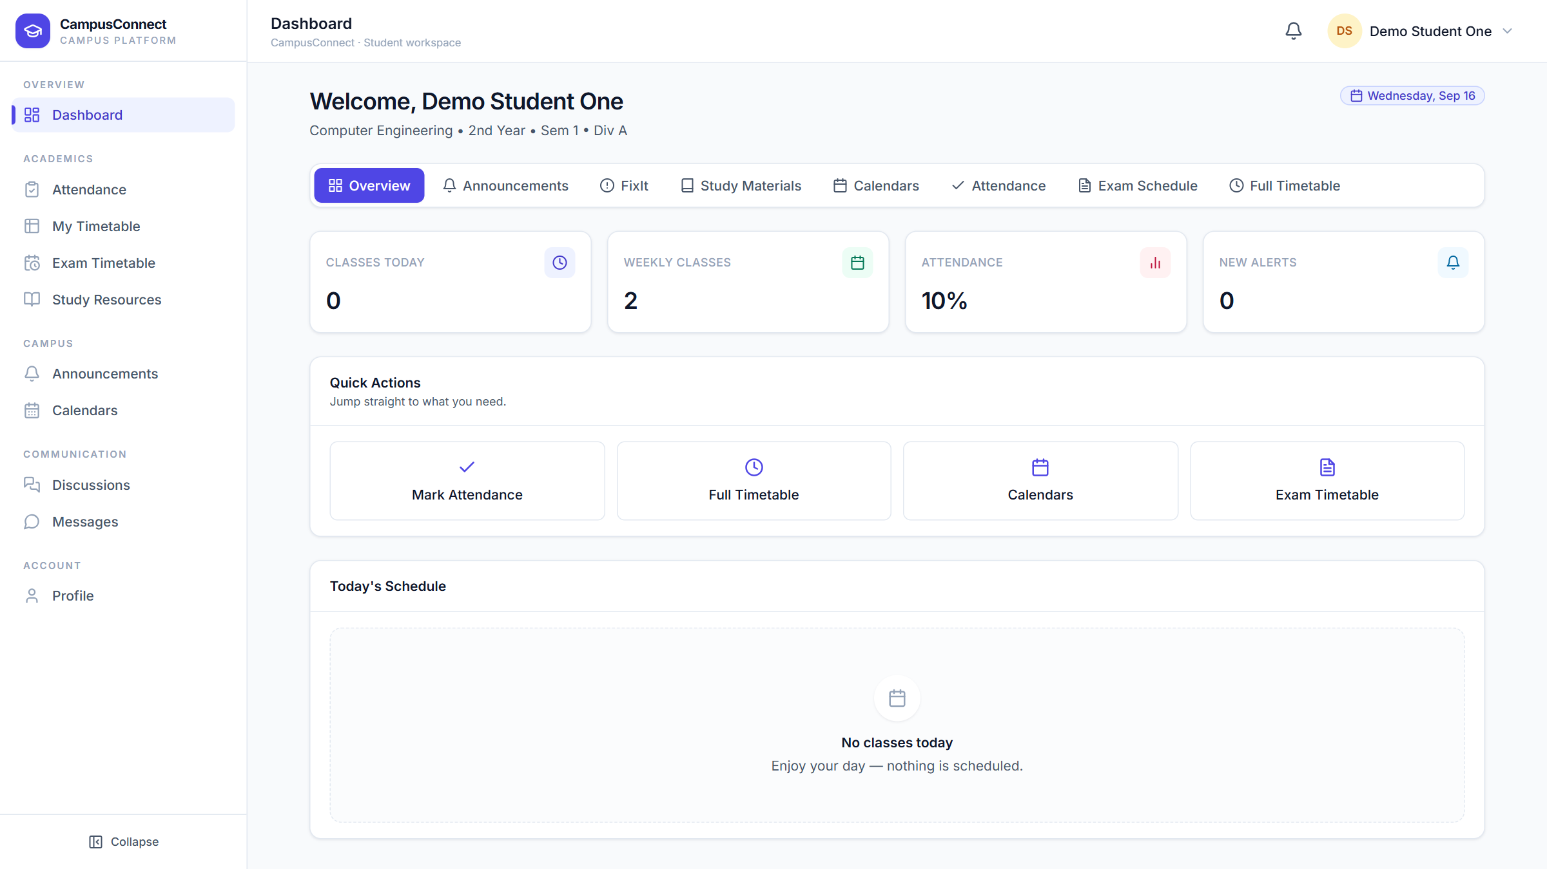
The dashboard greets the student with their programme details and today's outlook.
Visible elements:
1. Programme line — department, year, semester, and division.
2. Classes Today / Weekly Classes — schedule at a glance.
3. Attendance — the student's current attendance percentage.
4. New Alerts — unread notifications.
5. Quick Actions — Mark Attendance, Full Timetable, Calendars, and Exam Timetable.
6. Today's Schedule — the day's lectures (with a friendly empty state on free days).

8.2 Attendance
Access: Student → Attendance. What you can do here: join a live attendance session started by your teacher and verify your presence securely.
Figure 8.2 — Student Attendance
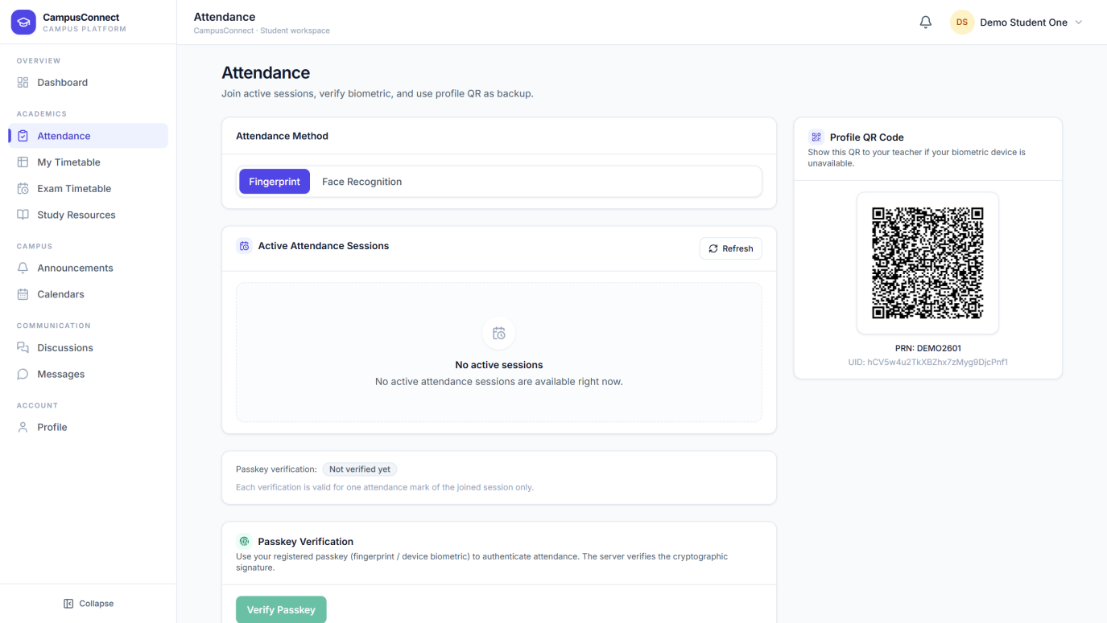
The attendance page offers two verification methods and a backup QR code.
Visible elements:
1. Attendance Method — switch between Fingerprint and Face Recognition.
2. Active Attendance Sessions — live sessions appear here with a Join option; Refresh checks for new ones.
3. Profile QR Code — a personal QR the teacher can scan if your device's biometrics are unavailable.
4. Passkey Verification — register once, then verify each session with your device's fingerprint or biometric.

How it works: when a teacher starts a session for your class, it appears under Active Attendance Sessions. Join it, verify with your fingerprint or face, and your attendance is recorded instantly — each verification counts for that one session only, which keeps proxy attendance out.

8.3 My Timetable
Figure 8.3 — My Timetable
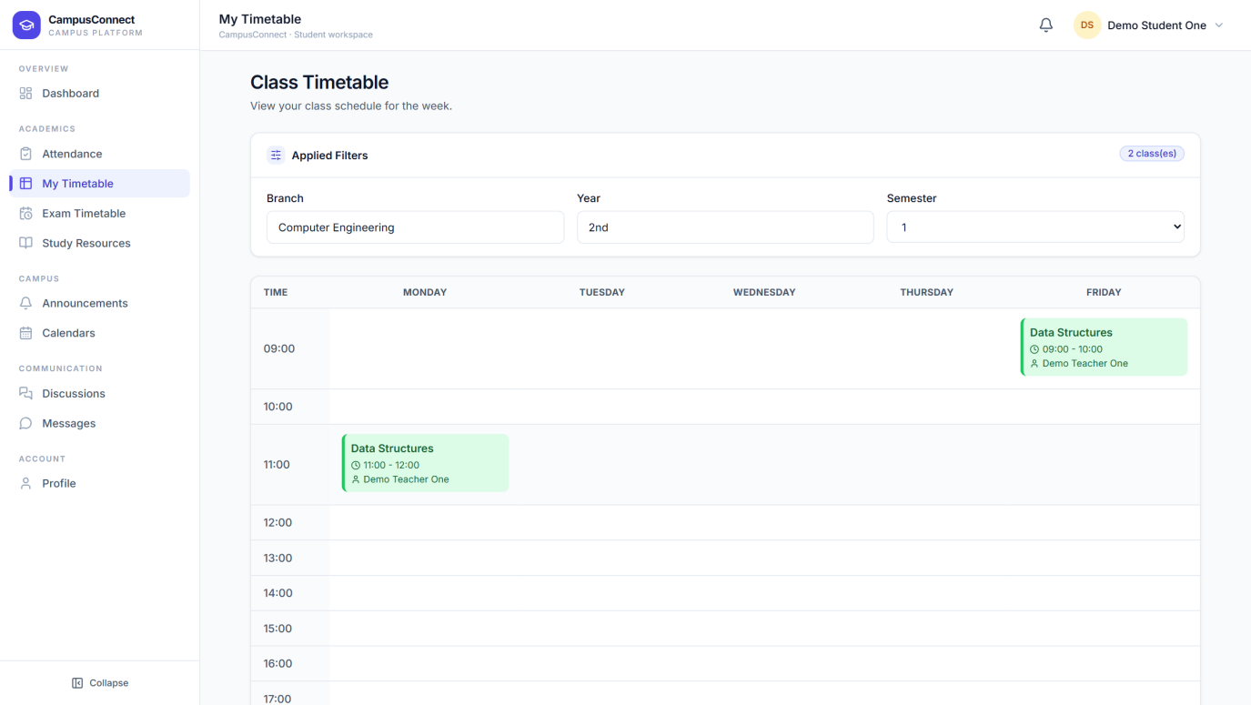
The student's weekly class schedule — every lecture for their branch, year, and semester in a single grid.

8.4 Exam Timetable
Figure 8.4 — Exam Timetable (Student view)
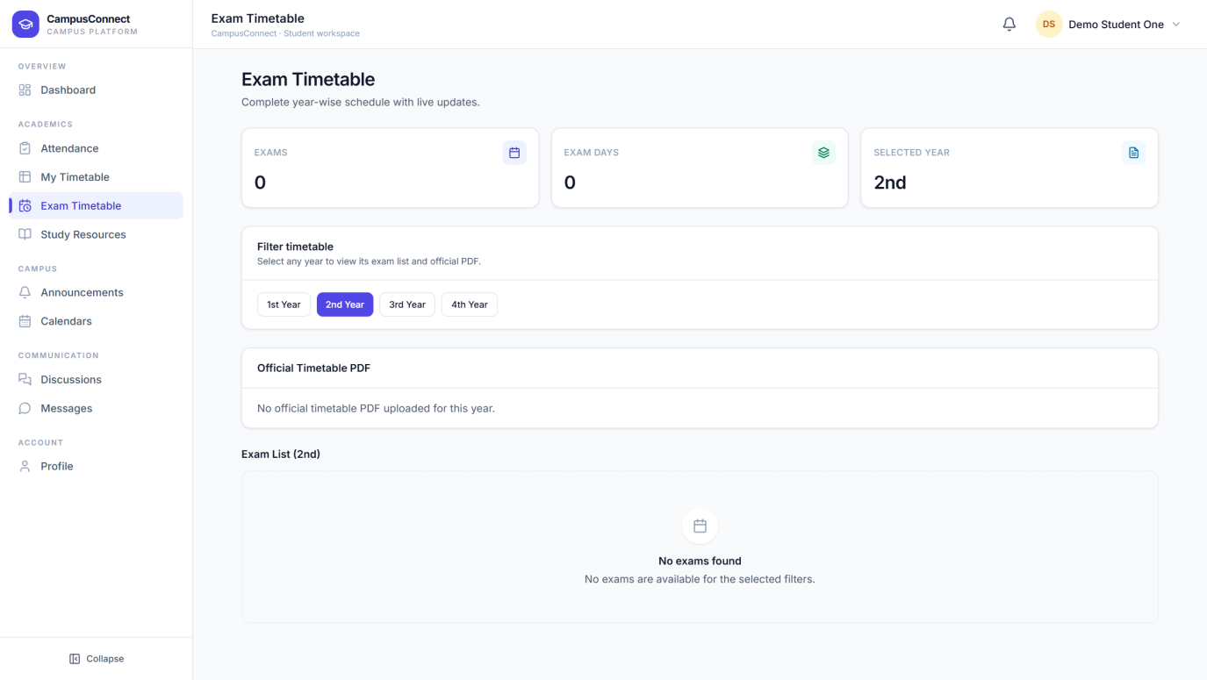
The official exam schedule for the student's academic year, exactly as published by the administration. Exam reminders arrive automatically as dates approach.

8.5 Study Resources
Figure 8.5 — Study Resources
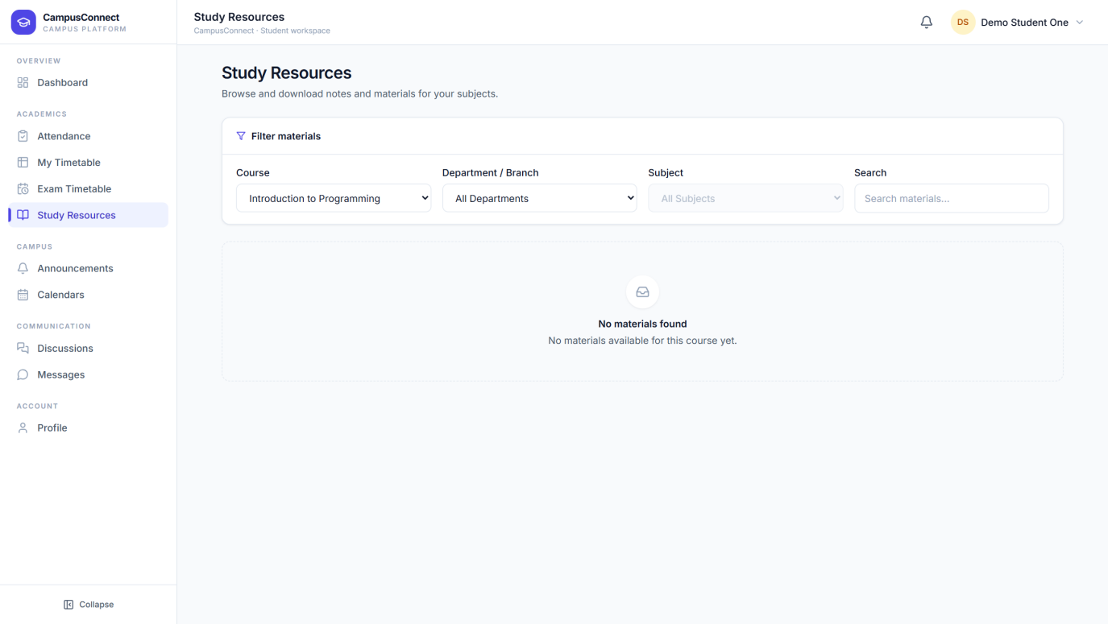
Notes and materials shared by teachers, filterable by course, department, and subject, with keyword search. Each material can be viewed or downloaded; a clear message is shown when a course has no materials yet.

8.6 Announcements
Figure 8.6 — Announcements (Student view)
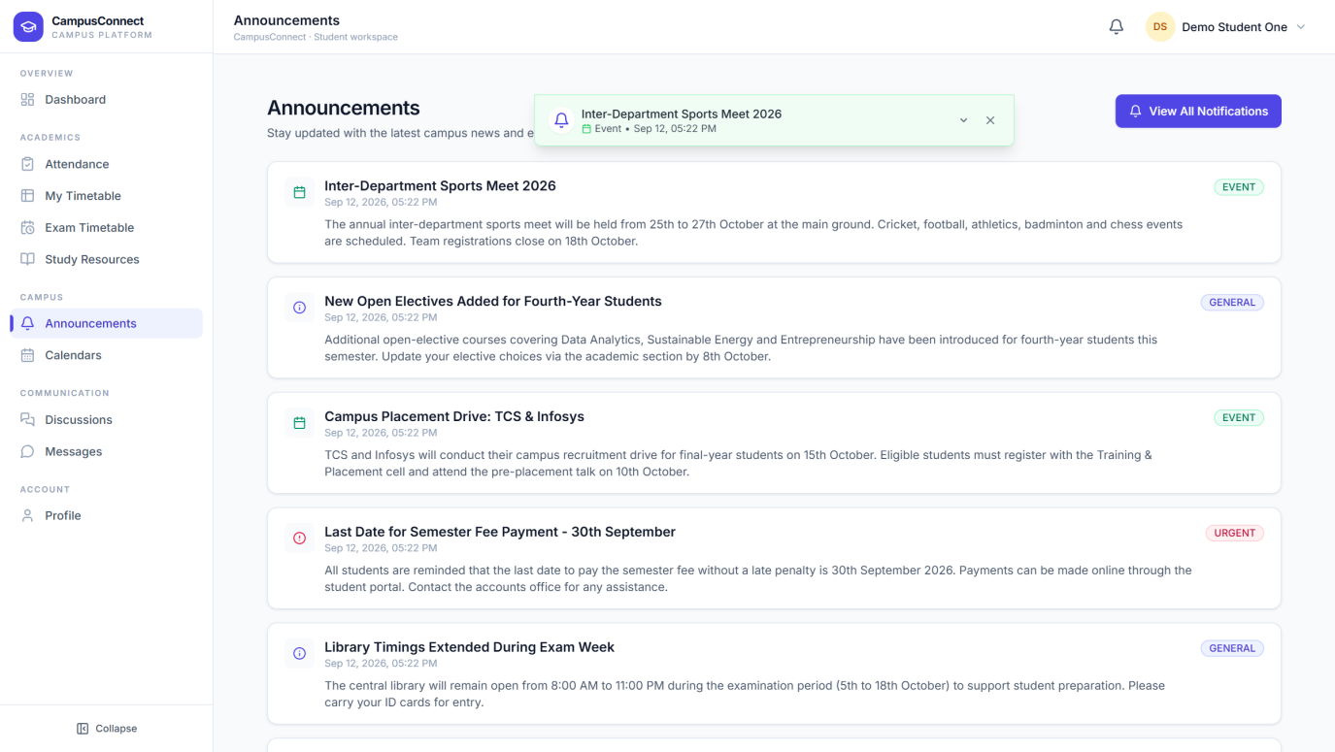
Campus announcements in one feed — urgent notices, events, and general updates. Reading an announcement marks it as read.

8.7 Calendars
Figure 8.7 — Calendars (Student view)
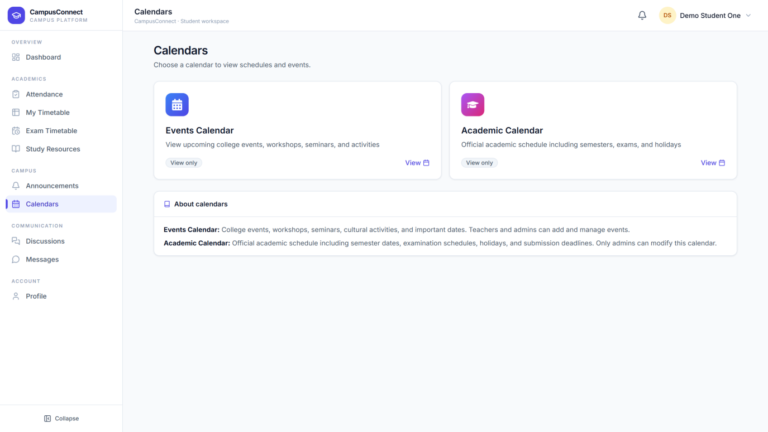
Students view the Events Calendar and the official Academic Calendar — semester dates, exams, and holidays — in read-only mode.

8.8 Discussions
Figure 8.8 — Discussions
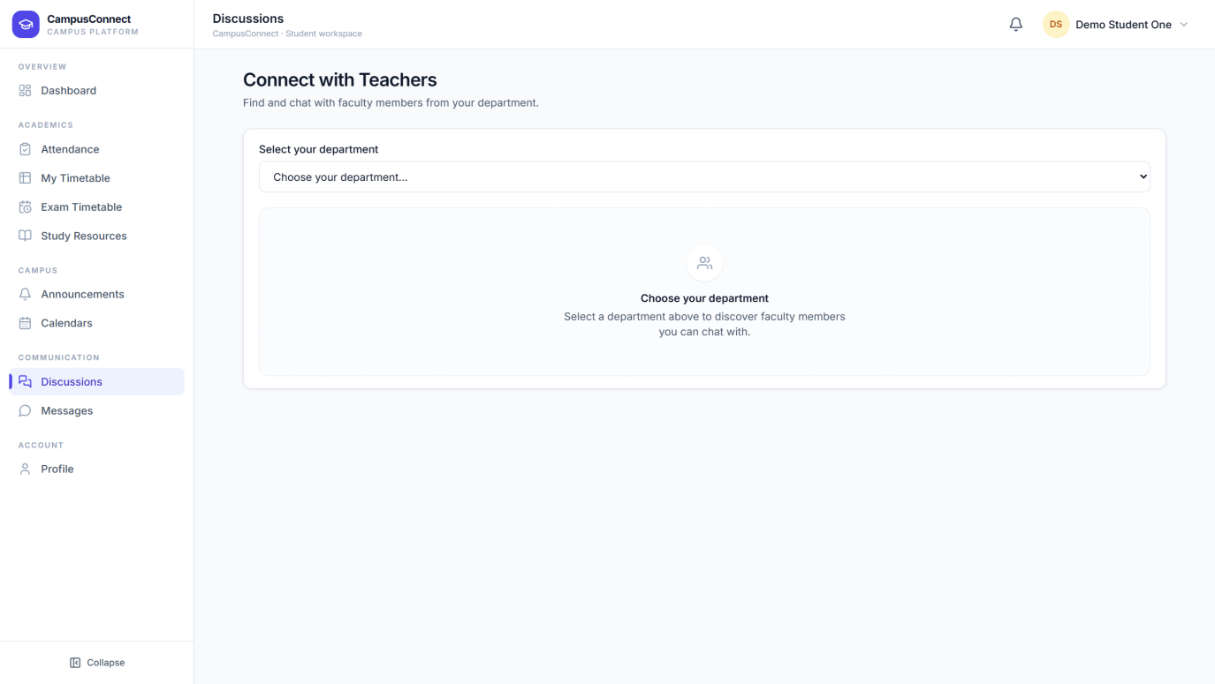
A campus discussion space where students post questions and ideas and reply to classmates — moderated and organised by topic.

8.9 Messages
Figure 8.9 — Messages (Student view)
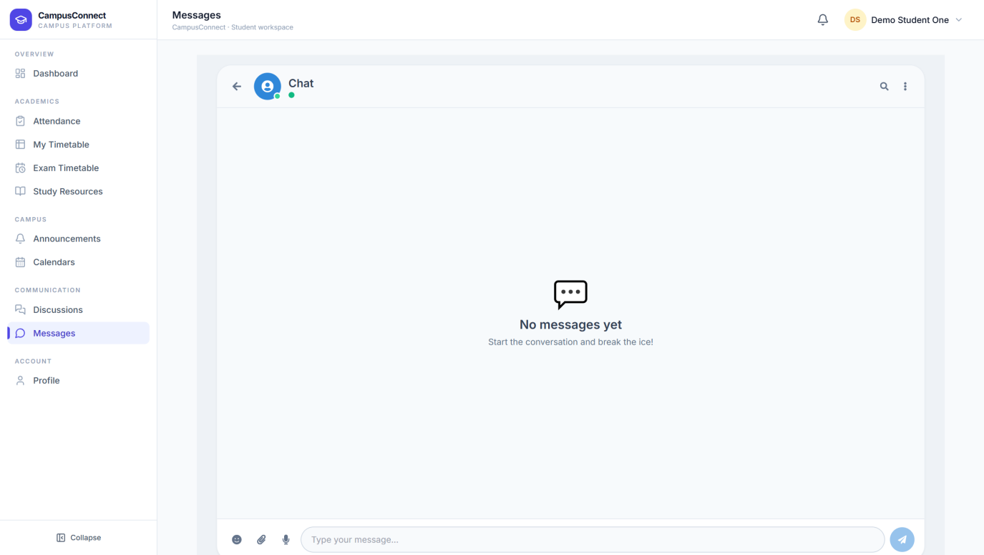
Direct chat with your teachers. Pick a teacher, ask your question, and get a reply in the same thread.

8.10 Profile
Figure 8.10 — Student Profile
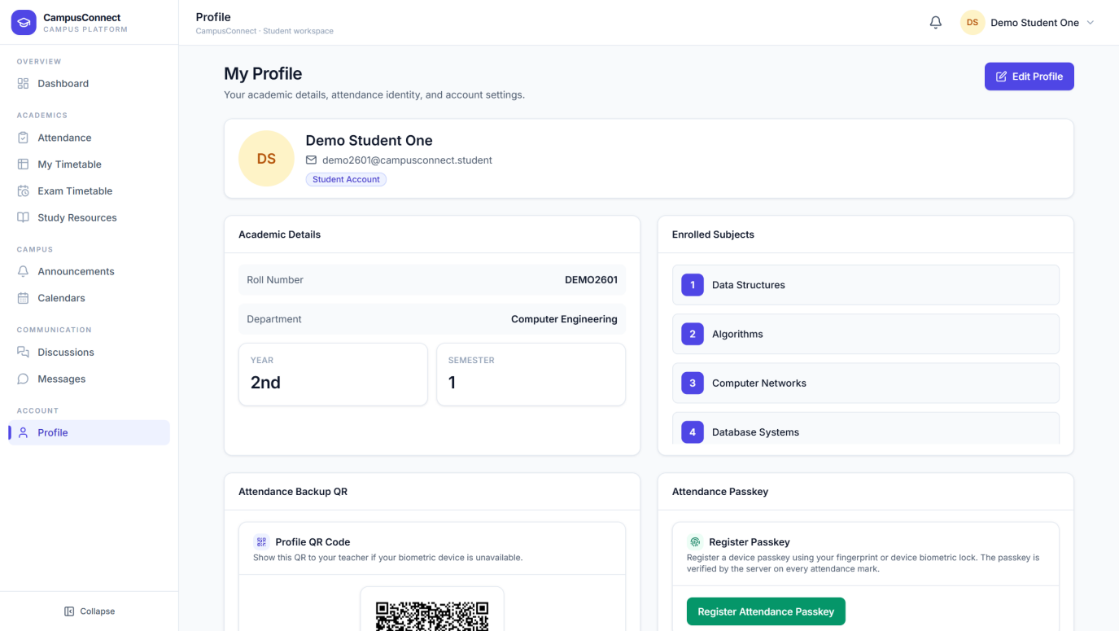
The student's account page — personal and academic details, profile photo, and password management. The profile QR code used for backup attendance also lives here.

9. How the Three Roles Differ
The same platform, three tailored experiences. The side-by-side views below show how each role's dashboard and sidebar are built around that role's daily work.
Figure 9.1 — Admin Dashboard — campus control centre
Administrators see campus-wide counts and management shortcuts; their sidebar covers people, academics, bulk operations, campus content, and system settings.
Figure 9.2 — Teacher Dashboard — the teaching day
Teachers see their classes, courses, and attendance tools; their sidebar covers attendance, academics, campus content, and communication.
Figure 9.3 — Student Dashboard — the student day
Students see their schedule, attendance percentage, and alerts; their sidebar covers academics, campus content, and communication.
Area | Admin | Teacher | Student
Students & Teachers | Full management | Views own students | —
Subjects & Exams | Defines both | Views schedules | Views schedules
Attendance | — | Runs sessions, tracks | Marks & monitors own
Timetable | — | Views & adds lectures | Views own
Study Material | — | Uploads & manages | Views & downloads
Announcements | Publishes & manages | Reads | Reads
Calendars | Edits both | Adds events | Views
Messages & Discussions | — | Chats with students | Chats & discusses
Bulk operations & Settings | Yes | — | —

10. Common Workflows
The everyday tasks, condensed into steps. Each workflow references the figures shown earlier.

Workflow A — Add a new student (Admin)
1. Open Admin → Students (Figure 6.2).
2. Select Add User — the Add Student form opens (Figure 6.5).
3. Enter the student's name, email, and roll number; choose department, year, and semester.
4. Select Add User to save.
5. The student appears in their department card, and their login credentials are emailed to them automatically.

Workflow B — Add a teacher with subject assignments (Admin)
1. Open Admin → Teachers (Figure 6.6).
2. Select Add Teacher (Figure 6.7).
3. Enter the teacher's details and job profile; the Teacher ID is generated automatically.
4. Pick the branch and year, tick the subjects, and select Add Assignment — repeat for more classes.
5. Save. The teacher receives their login by email and is linked to all matching students.

Workflow C — Publish an announcement (Admin)
1. Open Admin → Announcements (Figure 6.14).
2. Select New Announcement (Figure 6.15).
3. Enter a title and message, choose General, Urgent, or Event.
4. Publish. It is instantly visible to students and teachers, and its view count tracks reach.

Workflow D — Run a live attendance session (Teacher + Student)
1. Teacher: open Smart Attendance (Figure 7.2) and select Mark Attendance.
2. Teacher: pick the date, lecture, and attendance window; start the session (Figure 7.3).
3. Student: open Attendance (Figure 8.2) — the live session appears; join and verify by fingerprint or face.
4. Teacher: watch verified students appear live; scan a profile QR for any student whose device fails.
5. Teacher: end the session — the record is saved and appears in the tracker and analytics (Figures 7.4, 7.5).

Workflow E — Schedule a lecture (Teacher)
1. Open Teacher → Timetable (Figure 7.6).
2. Select Add lecture (Figure 7.7).
3. Choose the subject, weekday, and free time slot — overlapping slots are blocked automatically.
4. Save. The lecture appears on every matching student's timetable and becomes available for attendance sessions.

Workflow F — Onboard an admission list (Admin)
1. Open Admin → Student Onboarding (Figure 6.12).
2. Upload the admission list (CSV, PDF, or image) and choose the strategy for already-enrolled students.
3. Select Parse File, review the rows, then Pre-check to validate.
4. Select Create Accounts — every student account is created and credentials are emailed automatically.

11. Notifications, Profile & Account

Notifications
The bell icon in the header is visible on every page and shows your unread count. Announcements, exam reminders, and activity relevant to you arrive here — urgent announcements are visually highlighted so they are never missed.

Profile & password
Every role has a Profile page (Figures 6.20, 7.15, 8.10) with personal details and a profile photo. Passwords can be changed from the profile area at any time, and the "Forgot password?" flow on the sign-in page recovers access with an emailed verification code.

Logging out
Use the Logout control in the header area (or the profile chip menu) on any page. You return to the sign-in screen immediately, and the next user of the device cannot see your data.

12. Troubleshooting
Situation | What to do
I can't sign in | Check you are on the correct role's sign-in page (Chapter 4). Verify your email/ID spelling. If needed, use "Forgot password?" to reset with an emailed code.
I didn't receive my credentials | Check your email's spam folder first, then ask your administrator to re-create or update your account — a fresh credential email is sent automatically.
The page opens slowly the first time | The very first visit of the day can take a few extra seconds while the service warms up. It is immediate afterwards.
No active attendance session is showing | Sessions appear only while your teacher is running one for your class. Use Refresh; if it still doesn't appear, confirm with your teacher that the session covers your branch, year, and subject.
My fingerprint isn't working for attendance | Switch to Face Recognition, or show your Profile QR Code to the teacher — they can mark you present by scanning it.
A page says I'm not authorised | You are signed in with a role that doesn't own that page. Sign out and sign in with the correct role.
A list looks out of date | Use the page's Refresh control, or reload the browser page.

13. Frequently Asked Questions

Q. Do we need to install anything?
A. No. CampusConnect runs entirely in the browser on desktops, laptops, and phones.

Q. How do new students and teachers get their passwords?
A. The platform generates credentials and emails them automatically when an account is created — individually or in bulk.

Q. Can attendance be faked by a friend?
A. No. Each verification uses the student's own registered fingerprint/biometric or face, is valid for one session only, and can additionally require the student to be physically nearby.

Q. What if a student's phone battery dies during attendance?
A. The teacher scans the student's Profile QR code (also available to the teacher from the student's record) and marks them present manually.

Q. Who can post announcements?
A. Administrators publish campus-wide announcements. Everyone can read them; urgent ones are highlighted.

Q. Can we bring in our existing student list?
A. Yes — Student Onboarding accepts your admission list as a CSV, PDF, or even a scanned image, validates it, and creates every account in one step.

Q. What happens at the start of a new academic year?
A. Academic Update promotes whole groups of students to their next year or semester in one bulk operation, with a preview first.

Q. Is every role's data separated?
A. Yes. Each role sees only its own workspace and actions; the platform enforces this on every page and every action.

14. Complete Feature Overview
Every module in the platform, and who uses it:
Module | Description | Used by
Dashboards | Role-specific overview with live counts and quick actions | All roles
Student Management | Add, edit, search, and organise students by department | Admin
Teacher Management | Add and manage faculty with subject assignments | Admin
Subject Sets | Official subjects per branch, year, and semester | Admin
Exam Timetable | Build by scan, manual entry, or PDF; auto reminders | Admin publishes; all view
Student Onboarding | Bulk account creation from an admission list | Admin
Academic Update | Bulk year/semester promotion | Admin
Smart Attendance | Live sessions with fingerprint, face, and QR backup | Teacher runs; Student marks
Attendance Tracker | Percentages, history, at-risk flags, reports | Teacher
Timetable | Shared weekly class schedule with overlap protection | Teacher adds; Student views
My Students | Per-subject student lists with CSV/PDF export | Teacher
Study Material | Upload and browse notes per subject | Teacher uploads; Student views
Announcements | Campus-wide notices with urgency and view tracking | Admin publishes; all read
Calendars | Events Calendar and official Academic Calendar | All roles
Messages | Real-time teacher–student chat | Teacher, Student
Discussions | Student discussion forum | Student
FixIt | Report and track campus issues | All roles
Profiles & Settings | Account details, photos, passwords, preferences | All roles

— End of manual —

