REAL ESTATE FINANCING

A Project Report Submitted
In Partial Fulfillment
for award of Bachelor of Technology
In
COMPUTER SCIENCE DEPARTMENT
By
ANKIT TOMAR (Roll No. 2201330120020) HARSH GUPTA (Roll No. 2201330120055) SHUBHAM GUSAIN(Roll No. 2201330120120)
Under the Supervision of Prof. Mr. Anshul Varshney Professor, Computer Science

Computer Science Department School of Electronics Engineering
NOIDA INSTITUTE OF ENGINEERING AND TECHNOLOGY, GREATER NOIDA
(An Autonomous Institute) Affiliated to
DR. A.P.J. ABDUL KALAM TECHNICAL UNIVERSITY, LUCKNOW
May, 2024

TABLE OF CONTENTS

Page No.
DECLARATION iii
CERTIFICATE iv
ACKNOWLEDGEMENTS v
LIST OF ABBREVIATIONS vi

TITLES: | PAGE NO.
- ABSTRACT  - INTRODUCTION | 7  8-10
3. LITERATURE REVIEW | 11-17
- REQUIREMENTS AND ANALYSIS  - Software requirements  - Hardware requirements | 18-19
5. BENEFITS AND USE CASES | 20-21
6. PROPOSED METHODOLOGY | 22-26
7. RESULTS | 27-28
8. CODE SNIPPETS | 29-31
9. CONCLUSION AND FUTURE WORK | 32-34

RECENT DEVELOPMENT 35-36

KEY TAKEAWAYS FROM 37-40

THIS PROJECT

REFERENCES 41-42

PLAGIARISM REPORT 43

DECLARATION

We hereby declare that the work presented in this report entitled “REAL ESTATE FINANCING”, was carried out by us. We have not submitted the matter embodied in this report for the award of any other degree or diploma of any other University or Institute. We have given due credit to the original authors/sources for all the words, ideas, diagrams, graphics, computer programs, experiments, results, that are not my original contribution. We have used quotation marks to identify verbatim sentences and given credit to the original authors/sources.
We affirm that no portion of our work is plagiarized, and the experiments and results reported in the report are not manipulated. In the event of a complaint of plagiarism and the manipulation of the experiments and results, we shall be fully responsible and answerable.

Name : ANKIT TOMAR
Roll Number : 2201330120020

(Candidate Signature)

Name : HARSH GUPTA
Roll Number : 2201330120055

(Candidate Signature)

Name : SHUBHAM GUSAIN
Roll Number : 2201330120120

(Candidate Signature)

CERTIFICATE

Certified that, ANKIT TOMAR, HARSH GUPTA, and SHUBHAM GUSAIN (Enrolment No.’s:2201330120020,2201330120055,2201330120120) have carried out the research work presented in this Project Report entitled “REAL ESTATE FINANCING” for the award of Bachelor of Technology, Computer Science from Dr. APJ Abdul Kalam Technical University, Lucknow under our supervision. The Project Report embodies results of original
work, and studies are carried out by the students herself/himself. The contents of the Project Report do not form the basis for the award of any other degree to the candidate or to anybody else from this or any other University/Institution.

Signature  Ms. Madhu Assistant Professor  Department of Computer Science NIET Greater Noida  Date: 11/05/2024 | Signature  Ms. Manisha Assistant Professor  Department of Computer  Science NIET Greater Noida

ACKNOWLEDGEMENTS

We would like to express our gratitude towards Mr. Anshul Varshney for their guidance and constant supervision as well as for providing necessary information regarding the project & also for their support in completing the project.
Our thanks and appreciations to respected HOD, for their motivation and support throughout.

ABBREVIATIONS

HTML: Hypertext Markup Language CSS: Cascading Style Sheets JavaScript: JS
React.js: React
Angular: Angular Framework Vue.js: Vue Framework Node.js: Node
OAuth: OAuth 2.0 JWT: JSON Web Token
UAT: User Acceptance Testing
API: Application Programming Interface JSON: JavaScript Object Notation
RPC: Remote Procedure Call DNS: Domain Name System IP: Internet Protocol
IoT: Internet of Things
SDK: Software Development Kit CRUD: Create, Read, Update, Delete HTTPS: HTTP Secure
SQL: Structured Query Language BI: Business Intelligence
R&D: Research and Development B2B: Business-to-Business
B2C: Business-to-Consumer
DAO: Decentralized Autonomous Organization IPFS: Inter Planetary File System
EVM: Ethereum Virtual Machine

ABSTRACT

SWASTHYAPATH – A HOLISTIC HEALTH APP
Abstract
In an era marked by rapid technological advancements and an increasing need for proactive health management, Swasthya Path emerges as a comprehensive mobile and web-based health application aimed at revolutionizing personal healthcare experiences. The platform is designed to provide individuals with an integrated, personalized, and data-driven approach to maintaining and improving their overall well-being. By combining the latest innovations in artificial intelligence (AI), machine learning, cloud computing, and secure health data protocols, Swasthya Path serves as a one-stop solution for users seeking to manage their health effectively and holistically.
At its core, Swasthya Path empowers users through features such as personalized nutrition planning based on age, BMI, medical history, and lifestyle preferences. The app offers tailored diet plans curated by certified nutritionists and adaptive to ongoing health changes. Furthermore, the app includes AI-powered symptom checkers and health trackers that monitor daily vitals, track chronic illnesses, and generate predictive health analytics, enabling users to take timely preventive actions.
A key highlight of the app is its telemedicine module, which connects users with specialized doctors across disciplines through secure video consultations. Users can book appointments, access prescriptions, and maintain digital health records—all within the app. The inclusion of mental wellness tools, including guided meditation, therapy booking, and mood tracking, ensures that Swasthya Path addresses both physical and psychological dimensions of health.
Security and data privacy are fundamental to the app’s architecture. Swasthya Path is compliant with global data protection standards such as HIPAA and GDPR, ensuring that user information is encrypted, anonymized, and accessible only to authorized personnel. Additionally, the app integrates with wearable devices and health monitoring tools to provide real-time health updates, further enhancing decision-making for users and caregivers alike.
Swasthya Path also offers community health features like vaccination reminders, health awareness campaigns, and support groups for conditions such as diabetes, hypertension, and depression. These promote user engagement and create a sense of collective well-being among users.
In a landscape where healthcare is becoming increasingly decentralized and digital-first, Swasthya Path not only bridges the gap between patients and medical professionals but also redefines health monitoring as a proactive, collaborative, and personalized experience. By offering scalable solutions to individuals, families, and institutions, Swasthya Path contributes significantly to the vision of a healthier society driven by technology and compassion.

INTRODUCTION

In the age of digital transformation, healthcare is undergoing a paradigm shift from reactive treatment to proactive wellness management. Swasthya Path – A Holistic Health App emerges as a pioneering digital solution, integrating technology, personalized care, and health intelligence to redefine how individuals approach physical, mental, and emotional well-being. Designed as a comprehensive mobile and web-based application, Swasthya Path combines AI-powered analytics, telemedicine, wellness tracking, and community support to provide a unified platform for lifelong health management. This introduction outlines the core concepts, primary stakeholders, and evolving trends shaping the ecosystem of digital healthcare through Swasthya Path.
At its foundation, Swasthya Path functions as a health companion that empowers users to monitor, assess, and improve their overall health. Whether managing chronic illnesses, scheduling virtual doctor consultations, or tracking daily wellness metrics, users benefit from a data-driven and user-centric approach. By leveraging advanced technologies such as artificial intelligence (AI), cloud storage, and wearable integration, the app delivers real-time health insights, customized care plans, and intelligent recommendations tailored to each user’s profile.
Core Features of the App:
- Personalized Health Dashboard: Each user has access to a comprehensive dashboard that tracks vitals, nutrition, hydration, sleep patterns, and exercise routines. The AI engine continuously learns from the data to provide evolving recommendations aligned with the user's health goals.
- Telemedicine and E-Consultations: Swasthya Path bridges the physical gap between patients and healthcare providers by offering secure video consultations, digital prescriptions, and follow-up tracking. Users can access specialists across various disciplines without the need for physical visits, thereby improving healthcare accessibility and reducing time-to-treatment.
- Mental Health and Wellness: Recognizing the growing burden of mental health issues, the app features guided meditation, stress monitoring, mood tracking, and access to licensed therapists. This integration ensures holistic care encompassing both physical and emotional health.
- Health Record Management: Users can maintain secure, cloud-based digital health records, including lab reports, prescriptions, and vaccination logs, which are easily accessible and shareable with healthcare professionals for better diagnosis and continuity of care.
- Preventive Health Alerts: AI algorithms send timely alerts and reminders for health checkups, medication refills, fitness milestones, and symptom monitoring. These features help users stay proactive in managing their health.
Key Stakeholders:
- Users: Individuals seeking proactive healthcare monitoring and management, ranging from fitness enthusiasts to chronic illness patients.
- Healthcare Providers: Doctors, nutritionists, therapists, and wellness coaches offering their services through digital consultations, AI-assisted diagnostics, and personalized plans.
- Developers and Engineers: The technical backbone behind the platform, responsible for creating secure, scalable, and user-friendly systems that comply with medical data privacy regulations.
- Health Institutions and Clinics: Partners that integrate with the app for telehealth, patient referrals, digital prescriptions, and shared diagnostics.
- Regulators and Policy Makers: Authorities ensuring the app complies with healthcare standards, data privacy laws (like HIPAA and GDPR), and ethical medical practices.
Evolving Trends in Digital Healthcare:
- Technology Integration: With the rise of wearables (smartwatches, fitness bands), IoT devices (like smart BP monitors), and real-time health monitoring tools, Swasthya Path is positioned to offer a seamless ecosystem that captures accurate health data and provides personalized feedback.
- Artificial Intelligence and Predictive Analytics: AI plays a key role in early disease detection, risk profiling, and treatment optimization. Swasthya Path uses predictive models to flag potential health risks and offer recommendations before symptoms escalate.
- Holistic and Integrative Wellness: Modern users increasingly demand comprehensive wellness solutions that address diet, mental health, sleep, and lifestyle factors. Swasthya Path meets this demand by merging traditional medicine insights with modern clinical protocols.
- Community and Social Support: The app includes community features like support groups for diabetes, heart health, and mental wellness. These peer-to-peer interactions increase user engagement and foster shared learning.
- Data Privacy and Security: With increasing cyber threats, Swasthya Path emphasizes secure encryption, biometric logins, and user consent protocols to protect sensitive medical data.
Conclusion:
Swasthya Path exemplifies the future of integrated digital healthcare. It merges cutting-edge technology with compassionate care, creating a robust platform that empowers individuals to take control of their health journey. By bringing together various stakeholders and embracing global healthcare trends, the app not only enhances personal wellness but also contributes to the larger vision of accessible, affordable, and holistic health for all. In doing so, it redefines health not just as the absence of illness, but as a state of complete physical, mental, and emotional well-being.

LITERATURE REVIEW: SWASTHYAPATH – A HOLISTIC APPROACH TO HEALTHCARE FINANCING AND ACCESS
Swasthyapath, a conceptual framework focused on improving healthcare accessibility, affordability, and sustainability, has attracted considerable attention from policymakers, health economists, researchers, and global development agencies. With growing healthcare inequalities and financial burdens on households due to rising medical costs, there is a pressing need for innovative financing and delivery mechanisms. This literature review explores key research themes, theoretical underpinnings, emerging trends, benefits, and challenges associated with the Swasthyapath approach.

1. Introduction to Swasthyapath and Health Financing Models
Healthcare financing has traditionally relied on out-of-pocket payments (OOP), government-funded schemes, and insurance-based models. The World Health Organization (WHO) emphasizes universal health coverage (UHC) as a priority, and Swasthyapath represents a step toward achieving this vision through integrated, community-based, and digitally enabled mechanisms.
The Swasthyapath model promotes a hybrid financing ecosystem involving public-private partnerships, micro-insurance schemes, health savings accounts, digital health wallets, and real-time subsidy distribution. Research underscores that models like Swasthyapath, which blend community outreach with scalable digital infrastructure, could address structural gaps in current healthcare systems, especially in rural and low-income areas.

2. Advantages of the Swasthyapath Model
a. Financial Inclusion in Healthcare
One of the primary advantages of Swasthyapath is that it fosters financial inclusion by enabling underserved populations to access essential health services without experiencing financial hardship. Digital payment systems, QR-code-based identification, and mobile wallets linked to health benefits help streamline cost coverage.
b. Risk Pooling and Micro-Insurance
Swasthyapath leverages risk pooling to reduce the financial shock of unexpected medical expenses. Community-based health insurance (CBHI) schemes integrated into Swasthyapath allow small periodic payments that provide coverage during medical emergencies, thereby reducing reliance on OOP payments.
c. Leveraging Technology for Efficiency
The integration of telemedicine, digital health records, AI-driven diagnosis support, and automated claim processing systems enhances the efficiency of service delivery under the Swasthyapath initiative. This not only minimizes delays but also reduces administrative costs and ensures transparent billing and monitoring.
d. Health Data-Driven Policy Making
With real-time data collection and analysis, Swasthyapath enables governments and health agencies to make evidence-based policy decisions. Geospatial health mapping, trend analysis, and early outbreak detection become possible through the centralized Swasthyapath data hubs.

3. Security and Integrity in Swasthyapath
Ensuring the security and integrity of healthcare financing transactions is critical for protecting user trust and maintaining system credibility.
a. Regulatory Oversight and Data Protection
To guard against misuse, Swasthyapath integrates robust regulatory frameworks and aligns with data protection regulations like HIPAA and India's DPDP Act. Health financing transactions are encrypted, with strict access controls to protect personal health information (PHI) and financial data.
b. Biometric Authentication
Many Swasthyapath pilots rely on Aadhaar-based or biometric authentication to prevent fraud, ensure accurate beneficiary identification, and protect against misuse of subsidies and benefits. This mechanism ensures that the right individual receives the entitled healthcare service.
c. Fraud Detection and Audit Trails
AI-based algorithms monitor claim submissions and flag anomalies. The system automatically maintains logs of all transactions for auditing purposes, ensuring accountability from service providers and insurers.

4. Anonymity and Privacy Considerations
While health data sharing is essential for improving services, maintaining privacy is a core pillar of Swasthyapath.
a. Consent-Driven Data Sharing
Swasthyapath enforces a user-centric consent framework where individuals have control over what data is shared, with whom, and for what purpose. Role-based access ensures that only authorized entities can view sensitive information.
b. Privacy-Preserving Technologies
Advanced techniques like homomorphic encryption, differential privacy, and zero-knowledge proofs are being explored within the Swasthyapath framework to allow data analysis without compromising individual anonymity.
c. Anonymous Consultations
In certain cases (e.g., mental health), Swasthyapath supports anonymous or pseudonymous consultations, allowing patients to seek help without fear of stigma.
d. Non-Disclosure Agreements (NDAs)
For service providers and technology vendors involved in Swasthyapath, NDAs are mandated to ensure that data handled during onboarding, testing, or operations is not misused or disclosed.

5. Scalability and Efficiency
Scalability and efficiency are core design principles in Swasthyapath, making it suitable for mass adoption across diverse geographic and socio-economic contexts.
a. Modular Architecture
Swasthyapath is built on a plug-and-play architecture that allows health providers, pharmacies, insurers, and digital platforms to integrate seamlessly. APIs (Application Programming Interfaces) facilitate rapid onboarding and interoperability.
b. Cloud-Based Infrastructure
The use of cloud platforms such as AWS, Azure, or IndiaStack enables horizontal scalability, disaster recovery, and centralized management. This helps Swasthyapath expand from small communities to nationwide networks without degrading performance.
c. Automated Workflows and AI Integration
AI and ML models support automation of tasks such as health risk scoring, treatment recommendations, fraud detection, and claim adjudication. Automation boosts throughput and minimizes delays in approvals and reimbursements.
d. Standardized Protocols and Documentation
Swasthyapath follows global standards such as HL7 FHIR for health data exchange and ISO protocols for IT security and data governance. Standardization ensures consistency and ease of compliance across service providers.

6. Challenges and Limitations
Despite its potential, Swasthyapath faces various implementation challenges.
a. Digital Divide and Accessibility
In rural and remote regions, poor digital literacy and limited internet connectivity can hinder adoption. Studies emphasize the need for localized training programs, offline modules, and last-mile connectivity to bridge this gap.
b. Regulatory and Legal Challenges
Interfacing with multiple regulatory bodies, aligning with healthcare and IT laws, and maintaining cross-jurisdictional compliance remain difficult. Constant legal reforms are necessary to ensure Swasthyapath’s flexibility and legality.
c. Funding and Sustainability
Initial infrastructure costs for Swasthyapath—hardware, software, training—can be high. Long-term sustainability requires consistent funding, either through PPPs, donor support, or integration into government health budgets.
d. Data Ownership and Misuse Risks
Who owns the data collected by Swasthyapath? This question becomes contentious, especially if commercial entities participate in the ecosystem. Without strong governance, there's risk of data misuse, targeted advertising, or discrimination.
e. Interoperability and System Fragmentation
In heterogeneous healthcare environments, lack of standardization across systems can create silos. Swasthyapath must overcome integration issues to unify public hospitals, private clinics, labs, and insurers under a single umbrella.

7. Comparative Analysis
To understand Swasthyapath’s distinct advantages, it helps to compare it with traditional and emerging healthcare financing models:
Criteria | Public Health Schemes (e.g., Ayushman Bharat) | Private Insurance | Swasthyapath
Access | Limited to empaneled hospitals | Limited by affordability | Universal with mobile access
Affordability | High for governments | High for individuals | Balanced through micro-payments
Data Integration | Fragmented | Proprietary | Centralized and interoperable
Efficiency | Manual processes | Varies | High via automation
Transparency | Moderate | Often opaque | Real-time visibility
Scalability | Requires heavy infra investment | Market-driven | Cloud-native and API-first
Fraud Detection | Weak in public systems | Moderate | AI-powered risk analytics
User Empowerment | Passive beneficiaries | Customers but limited control | Full control and visibility

8. Conclusion and Future Research
Swasthyapath presents a transformative vision for healthcare financing—integrating technology, community participation, and policy reform to make healthcare equitable and efficient. While early pilot studies and conceptual papers show promise, large-scale implementation will require robust policy backing, regulatory support, public awareness, and infrastructure investments.
Future research should focus on longitudinal studies of Swasthyapath deployments, impact on health outcomes, cost-benefit analysis compared to traditional schemes, and the role of AI and blockchain in enhancing trust and automation.
As global health systems seek sustainable and inclusive financing models, Swasthyapath stands as a beacon of what healthcare can look like in the digital era—efficient, fair, and centered around the needs of people.

REQUIREMENTS AND ANALYSIS
Software Requirements
The architecture of "Swasthyapath" is carefully designed to deliver a robust, scalable, and user-centric digital health management platform. By leveraging cutting-edge technologies such as React.js, real-time health data visualization tools, and Tailwind CSS, the platform aims to enhance healthcare accessibility, monitoring, and user engagement.
Frontend Architecture
1. React.js Components
The frontend is developed using React.js, enabling a modular and component-based structure. Each component is designed to handle specific healthcare functionalities, such as appointment booking, health record management, and symptom tracking, making the system maintainable and extensible.
2. State Management
To manage complex application states efficiently, Redux is employed. This ensures a centralized state management system that provides:
- Consistency across all components
- Easier debugging and maintenance
- Better performance in handling large-scale health data
3. Responsive Design with Tailwind CSS
Tailwind CSS is used for creating a responsive and visually coherent interface. The utility-first approach ensures the platform adapts seamlessly across various screen sizes—desktop, tablet, and mobile—providing users with a consistent and accessible experience.
4. Health Monitoring and Analytics Dashboard
A health analytics dashboard is implemented using React components that display real-time health metrics. This includes user-specific health stats such as heart rate, BMI, blood pressure, and symptom history. The dashboard helps users track their wellness trends over time.
5. Data Visualization Tools
Integration with charting libraries such as Chart.js or D3.js facilitates the visualization of health data. These dynamic and interactive charts allow users and medical professionals to analyze health trends, monitor progress, and make informed decisions.

Hardware Requirements
- Computing Devices: Development and testing require high-performance computers equipped with multi-core processors, at least 8 GB RAM, and SSD storage for efficient execution of application builds, simulation, and testing.
- Mobile Devices: A range of smartphones and tablets (Android and iOS) are required to test the responsiveness, performance, and compatibility of the Swasthyapath application across various screen sizes and operating systems.
- Cloud Infrastructure:
  - Access to cloud services such as AWS, Google Cloud, or Azure for deploying backend services, databases, and hosting the web application.
  - Cloud storage (e.g., Amazon S3 or Firebase Storage) is necessary for storing electronic health records and user data securely.
  - Scalable virtual machines and containers (e.g., Docker) support continuous deployment and high availability of services.

Benefits and Use Cases
Swasthyapath is a comprehensive digital health management platform designed to enhance healthcare delivery, patient engagement, and medical record accessibility. It offers a range of benefits and use cases for patients, healthcare providers, hospitals, and policymakers. Below are the key benefits and practical applications of Swasthyapath:

1. Digital Health Records Management
Swasthyapath enables users to maintain personalized electronic health records (EHRs) securely in the cloud. This ensures:
- Easy access to past prescriptions, medical history, lab reports, and vaccination records.
- Reduced dependency on paper files and minimized risk of data loss.
- Seamless sharing of medical information with authorized healthcare providers.

2. Remote Healthcare Access
Through features like teleconsultation booking, remote symptom logging, and video consultations, Swasthyapath:
- Bridges the gap between patients and doctors, especially in rural or underserved areas.
- Enables continuity of care for chronic disease management.
- Reduces the need for frequent in-person hospital visits.

3. Preventive Health Monitoring
By integrating health analytics and monitoring tools, Swasthyapath:
- Tracks key health indicators such as BMI, heart rate, and blood pressure.
- Alerts users for upcoming check-ups, vaccinations, and medication schedules.
- Encourages preventive healthcare practices and early detection of health issues.

4. Improved Hospital Workflow
Hospitals and clinics benefit from Swasthyapath through:
- Streamlined appointment scheduling and queue management.
- Automated patient registration and digital billing.
- Faster access to patient health history, improving diagnostic accuracy and reducing redundancy.

5. Health Awareness and Education
Swasthyapath provides access to:
- Educational content on lifestyle diseases, nutrition, fitness, and mental well-being.
- Personalized tips based on medical history and health goals.
- Enhanced health literacy among users, leading to informed medical decisions.

6. Data-Driven Decision Making for Doctors
Doctors can utilize Swasthyapath to:
- Review graphical trends of patient vitals and symptoms over time.
- Access clinical dashboards with integrated lab reports and diagnosis tools.
- Make informed, data-backed treatment decisions, improving patient outcomes.

7. Policy Implementation and Analytics for Administrators
Government agencies and healthcare administrators can:
- Use aggregated and anonymized data for public health analysis.
- Monitor disease trends, vaccination rates, and demographic health patterns.
- Deploy targeted health campaigns and resource allocation based on data insights.

8. Scalable and Inclusive Health Platform
Swasthyapath is designed to be:
- Scalable across states, cities, and rural regions.
- Inclusive by supporting regional languages and accessibility features.
- An adaptable solution for various healthcare setups—from single clinics to large hospitals.

Proposed Methodology
Proposing a methodology for Swasthyapath involves outlining the systematic approach, processes, and considerations for designing, developing, and implementing a digital health management system. This methodology ensures seamless integration of healthcare services, secure data handling, and a user-centric experience for both patients and healthcare providers.

1. Define Objectives and Scope
- Clearly identify the primary objectives of Swasthyapath—such as digitalization of health records, streamlined patient-doctor communication, and improved healthcare accessibility.
- Define the system’s scope, including core modules like user authentication, EHR management, appointment scheduling, health monitoring, and doctor dashboards.
- Establish success criteria including usability, reliability, security, and system scalability.

2. Requirement Gathering and Stakeholder Analysis
- Conduct requirement analysis through stakeholder interviews and surveys involving doctors, patients, hospital staff, and administrators.
- Document functional requirements (e.g., health record creation, teleconsultation scheduling) and non-functional requirements (e.g., data security, multilingual support).
- Identify regulatory requirements (such as HIPAA compliance for data privacy if applicable) and user accessibility needs.

3. System Design and Architecture Planning
- Design a modular architecture using layered principles—Presentation Layer (UI), Business Logic Layer, and Data Layer.
- Utilize cloud-based storage for scalability and availability of health records, ensuring encrypted access.
- Choose suitable technologies (e.g., React for frontend, Node.js or PHP for backend, MySQL/PostgreSQL for database).
- Define APIs for inter-module communication and potential third-party integrations like pharmacy or diagnostics.

4. UI/UX Design and Prototyping
- Design intuitive and responsive user interfaces tailored for different user types (patients, doctors, admins).
- Develop low- and high-fidelity wireframes for mobile and web interfaces.
- Emphasize usability, language localization, accessibility for elderly users, and minimal data entry steps for medical professionals.

5. Development and Module Integration
- Implement core modules in an agile manner:
  - User Registration/Login with OTP/email
  - EHR Management System with add/edit/delete features
  - Appointment Booking System
  - Vitals Tracker and Symptom Logger
  - Doctor Dashboard with patient history access
- Ensure modular integration with backend APIs and secure database operations.
- Use version control (e.g., Git) and maintain coding standards for scalability and team collaboration.

6. Security, Privacy, and Compliance Implementation
- Integrate role-based access control (RBAC) to restrict data access based on user type.
- Implement end-to-end encryption protocols for data in transit and at rest.
- Ensure compliance with health data privacy laws (HIPAA-like standards or Indian NDHM guidelines).
- Conduct vulnerability assessments to identify and patch security loopholes.

7. Testing and Quality Assurance
- Perform unit testing of individual modules and integration testing across the system.
- Conduct functional testing (data entry, login, record retrieval), usability testing (navigation, responsiveness), and performance testing (load capacity, latency).
- Involve healthcare practitioners and real users for user acceptance testing (UAT).
- Track bugs and fix issues using standard QA tools.

8. Deployment and User Onboarding
- Deploy the application on a reliable cloud hosting environment with domain setup and SSL certificates.
- Create user manuals, help videos, and documentation for onboarding doctors, patients, and administrators.
- Train hospital staff on dashboard use and data handling procedures.

9. Monitoring, Maintenance, and Feedback Integration
- Implement tools for real-time system monitoring, including server health, downtime alerts, and user activity tracking.
- Set up support ticket systems and feedback forms for user issues and suggestions.
- Plan regular updates, bug patches, and module improvements based on collected feedback and evolving healthcare needs.

10. Scalability and Future Enhancements
- Ensure system scalability for expanding user base across different cities, clinics, or hospitals.
- Explore integration with government health databases, insurance claim systems, and wearables (IoT-based health monitoring).
- Develop data analytics modules for trend detection, outbreak forecasting, and AI-based treatment recommendations.

Interface

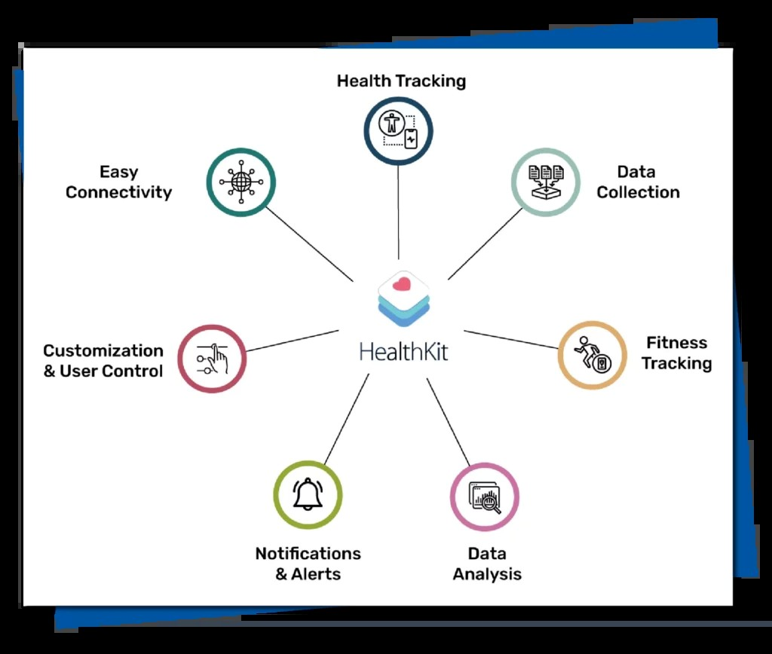

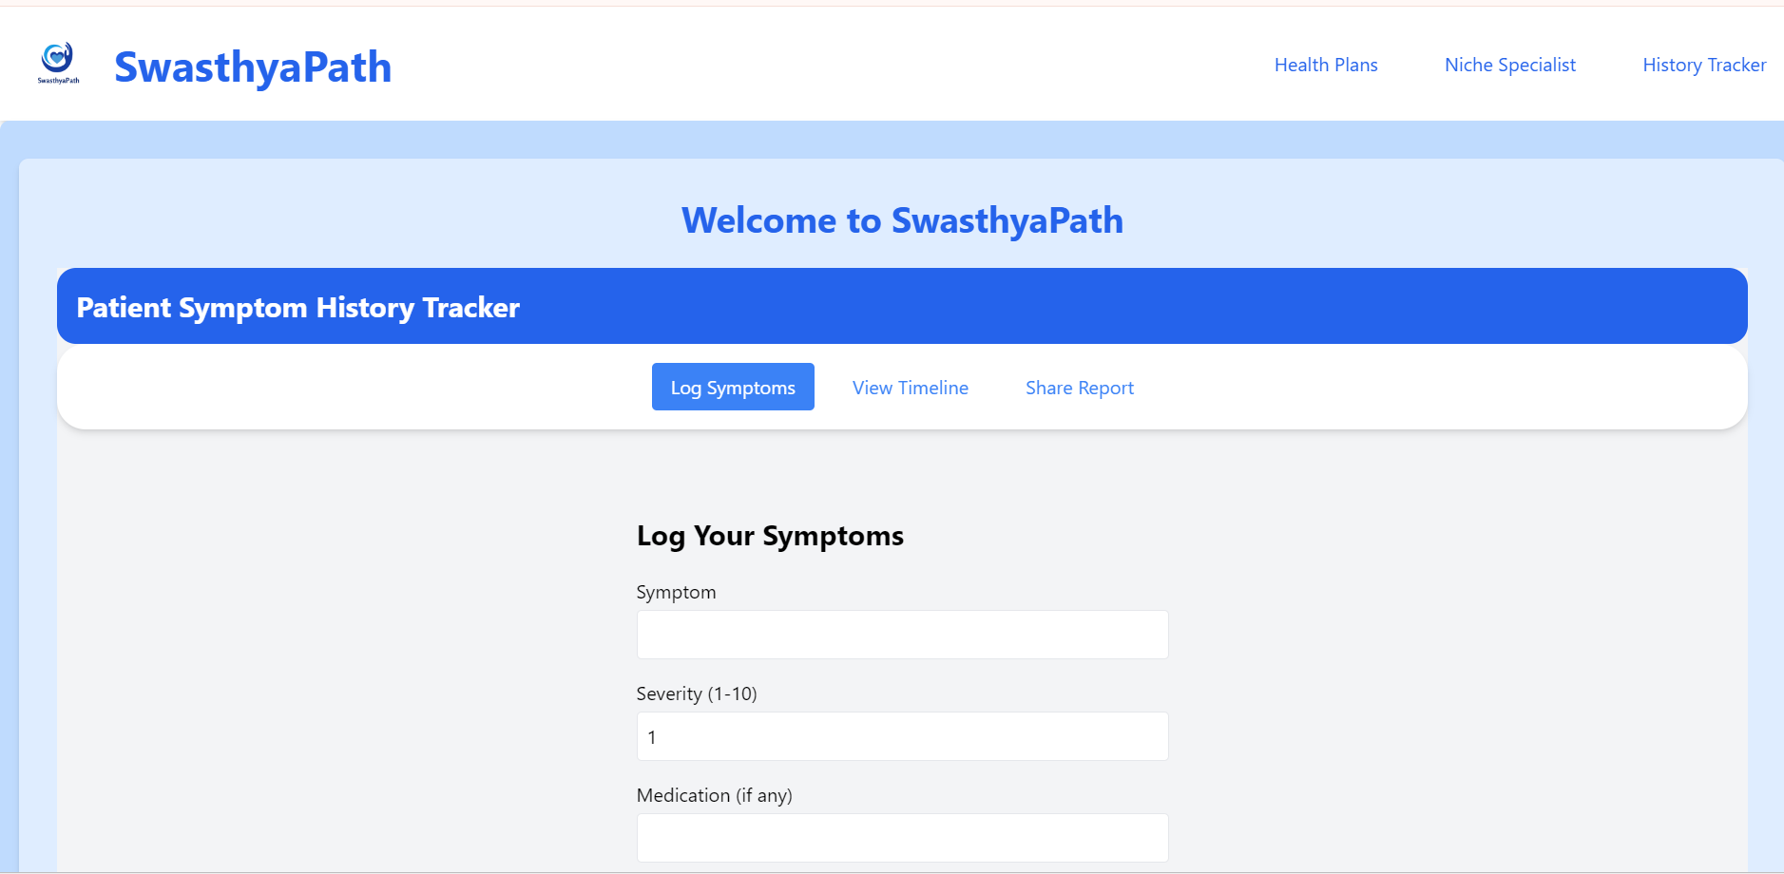

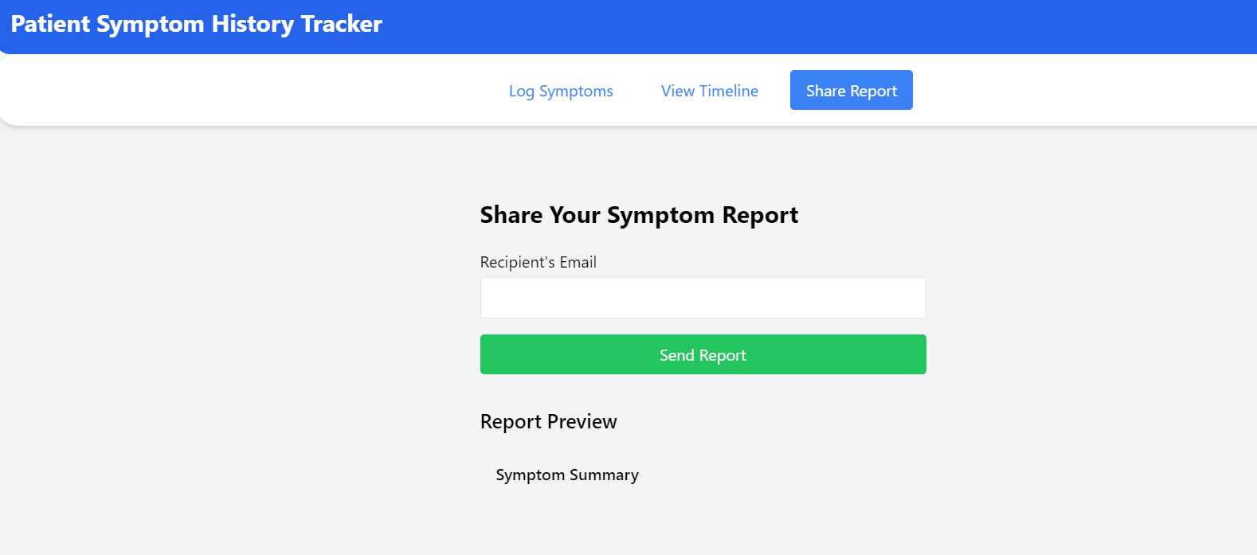
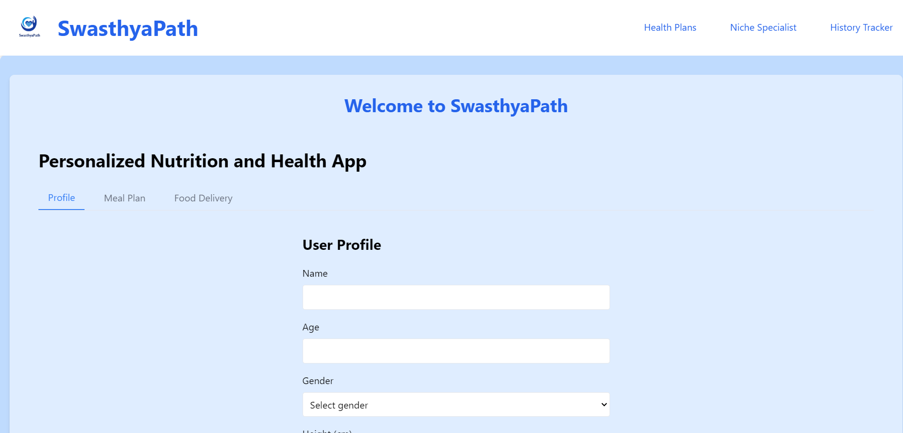

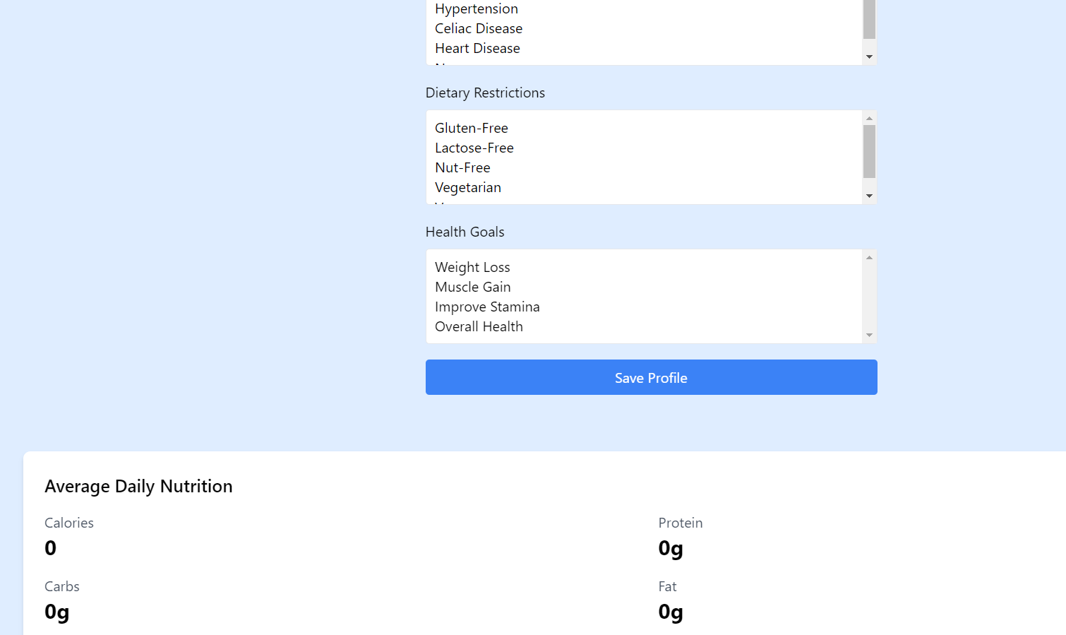

Results
The results of implementing Swasthyapath, a digital health management system, depend on factors such as user adoption, system reliability, data accuracy, and integration with healthcare workflows. Here are some potential outcomes and benefits observed from the successful deployment of Swasthyapath:

1. Improved Healthcare Access
Swasthyapath enables patients to access healthcare services remotely by facilitating online consultations, appointment scheduling, and health record management. The result of successful implementation is increased healthcare accessibility for patients in remote or underserved areas, reducing the need for physical visits and improving timely medical care.

2. Efficient Patient Record Management
The system digitizes and centralizes patient health records, allowing doctors and healthcare providers to retrieve accurate medical histories quickly. This leads to better diagnosis, treatment planning, and continuity of care, minimizing medical errors and duplication of tests.

3. Enhanced Communication and Coordination
Swasthyapath streamlines communication between patients and doctors through integrated messaging and notifications. The result is faster response times, improved patient engagement, and smoother coordination of care plans, leading to higher patient satisfaction and adherence to treatment.

4. Data-Driven Decision Making
The system’s ability to aggregate health data and generate reports supports healthcare providers in making informed clinical decisions. Analytics features enable monitoring of patient vitals, trends, and risk factors, facilitating preventive care and early intervention.

5. Operational Efficiency
Automated appointment booking, reminders, and digital prescriptions reduce administrative overhead for clinics and hospitals. This optimization leads to better resource utilization, reduced waiting times, and increased capacity to serve more patients without compromising quality.

6. Security and Compliance
By implementing robust data encryption, access controls, and compliance with healthcare data regulations, Swasthyapath ensures the confidentiality and integrity of sensitive patient information. This builds trust among users and safeguards against data breaches and legal risks.

7. Scalability and Adaptability
The modular and cloud-based architecture allows the system to scale with increasing user numbers and expanding healthcare networks. The platform can be adapted to integrate new features such as telemedicine, IoT-based health monitoring, or integration with government health databases.

8. Patient Empowerment and Engagement
By providing patients with direct access to their medical records, test results, and health education resources, Swasthyapath promotes proactive health management and informed decision-making, ultimately leading to better health outcomes.
- .

CODE SNIPPETS

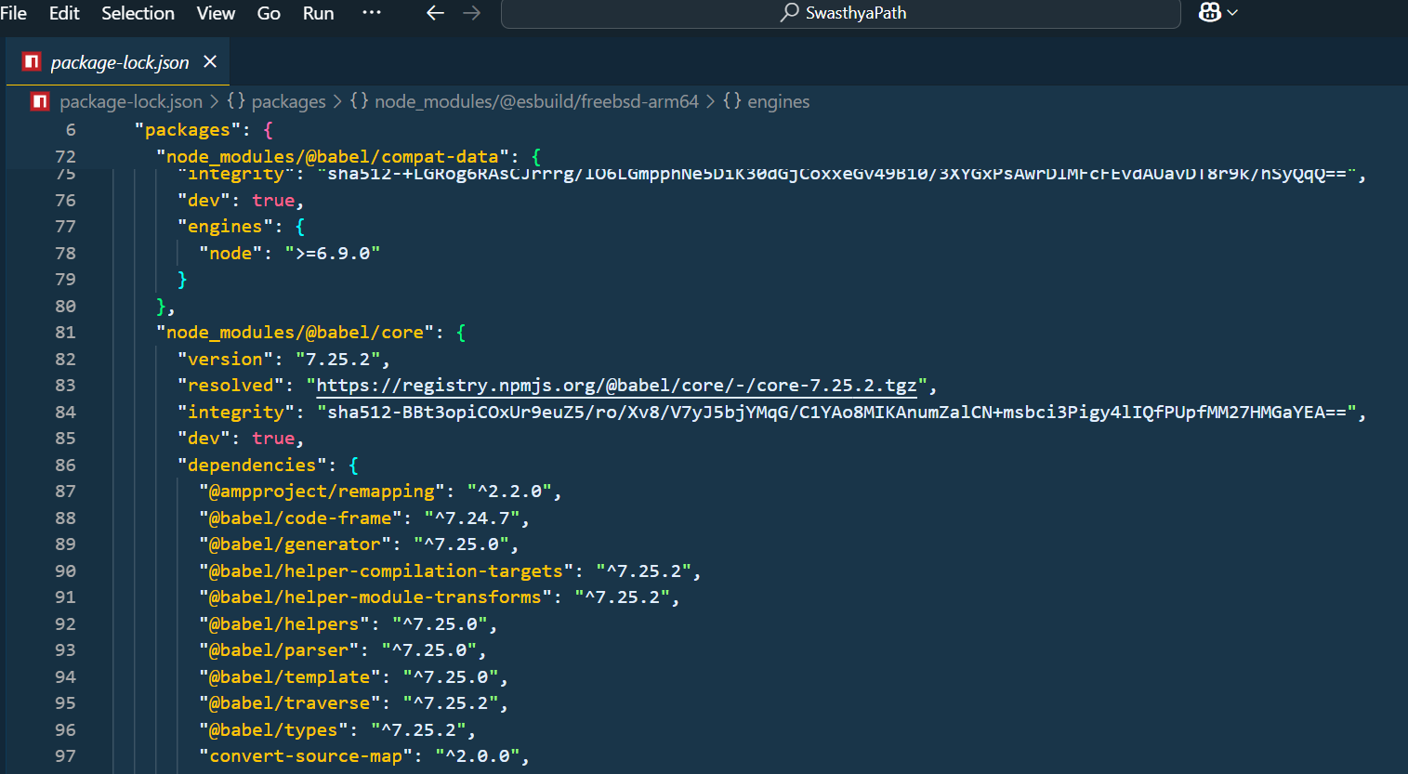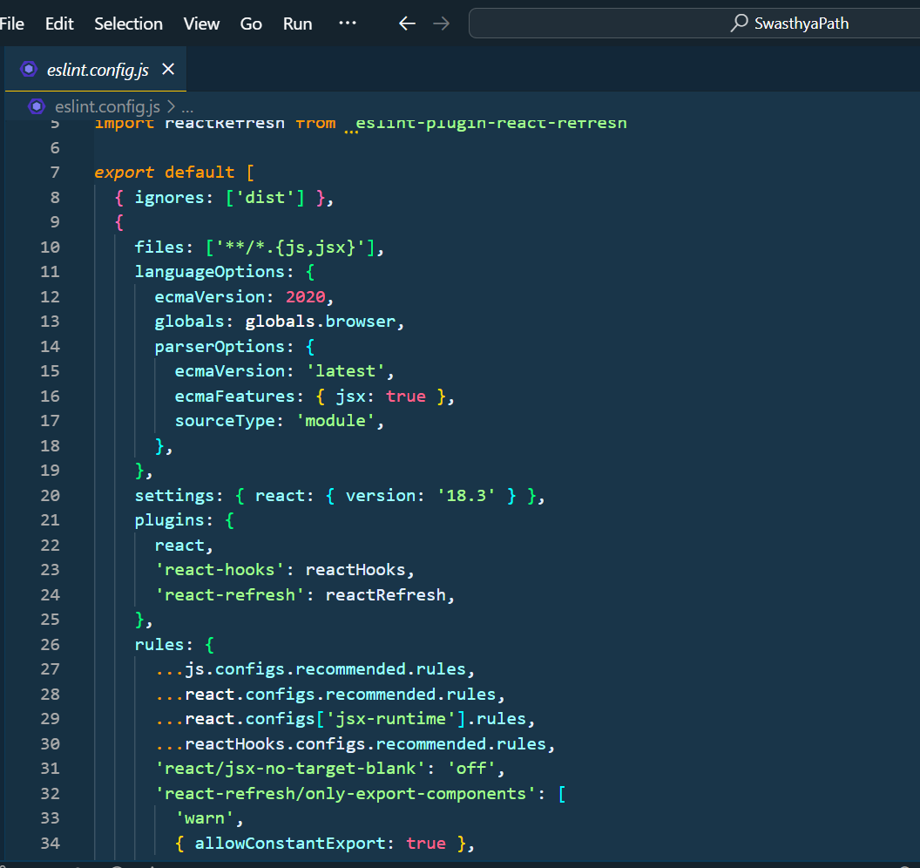

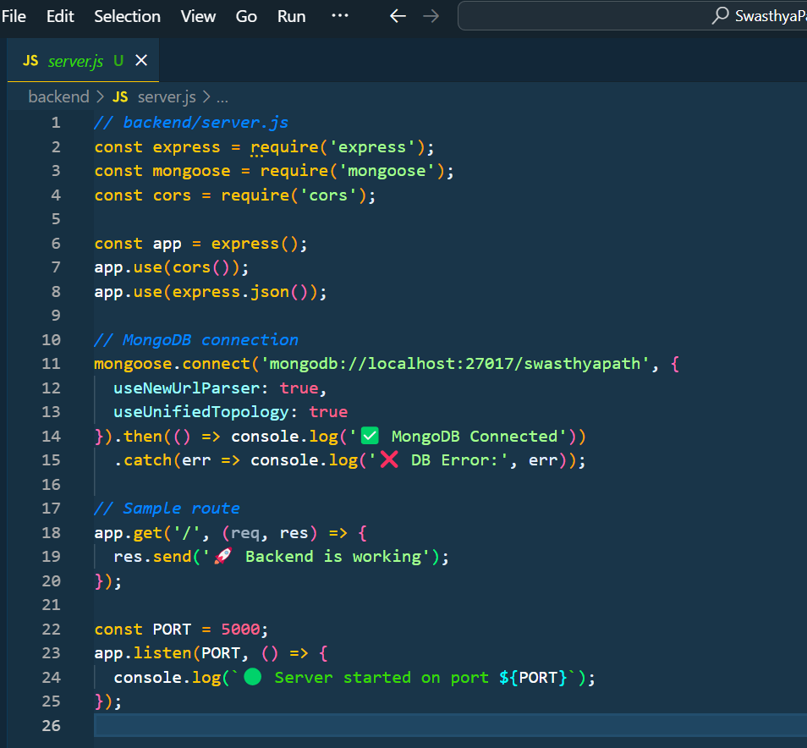

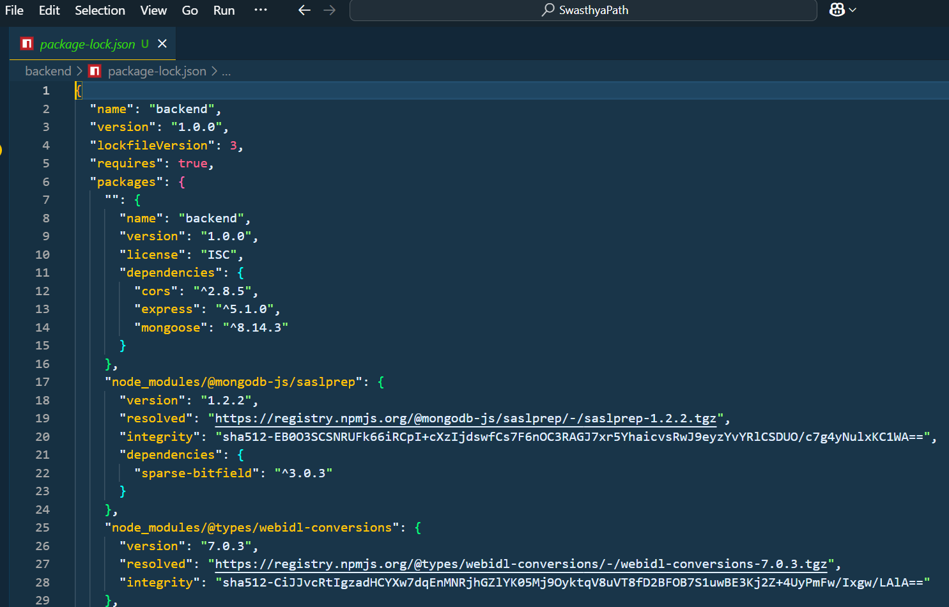

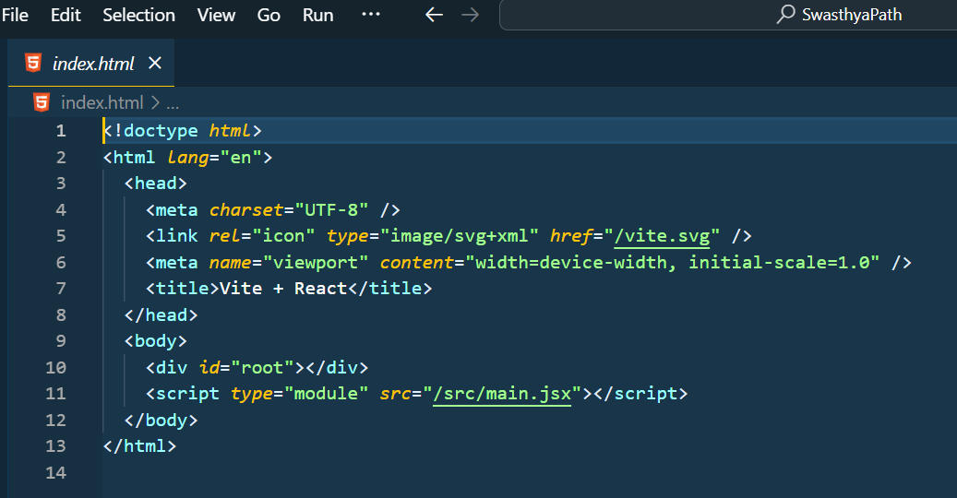

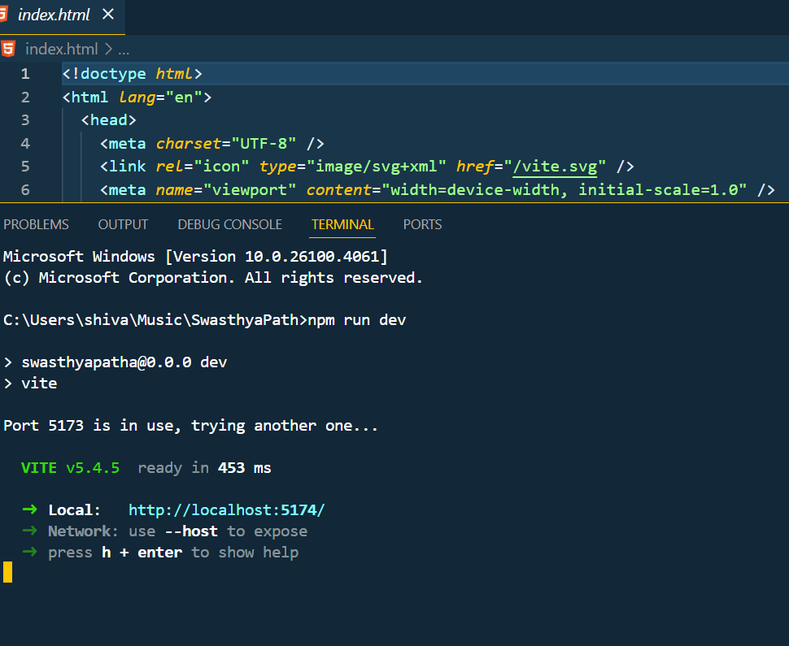

Conclusion and Future Work
Swasthyapath represents a significant advancement in digital health management, providing an integrated platform that facilitates improved healthcare access, efficient patient record management, enhanced communication, and data-driven clinical decision-making. By leveraging technology to streamline healthcare workflows and empower patients, Swasthyapath contributes to better health outcomes, operational efficiency, and security in medical data management.
The benefits of Swasthyapath are evident in the increased accessibility to healthcare services, timely and accurate information exchange, optimized resource utilization, and strengthened patient engagement. Through systematic implementation and continuous monitoring, healthcare providers and patients alike can achieve improved care quality, reduce administrative burdens, and promote proactive health management.
Looking ahead, future work for Swasthyapath could focus on the following areas of research and innovation:
- Technological Integration: Exploring the incorporation of advanced technologies such as artificial intelligence for predictive analytics, blockchain for secure and transparent health records, and Internet of Things (IoT) devices for real-time health monitoring to further enhance system capabilities and patient care.
- User-Centric Enhancements: Developing personalized healthcare features including tailored health recommendations, mental health support, and multilingual interfaces to increase accessibility and usability for diverse patient populations.
- Interoperability and Standardization: Working towards seamless integration with existing healthcare information systems, electronic health records (EHR), and government health databases to ensure data consistency, reduce fragmentation, and facilitate coordinated care.
- Privacy and Security Advances: Continuously strengthening data privacy protocols and compliance with evolving healthcare regulations to protect sensitive patient information and maintain trust in the system.
- Scalability and Adaptation: Expanding the platform to support a wider range of healthcare specialties, larger patient bases, and cross-regional deployments, enabling broader adoption and impact.
In conclusion, Swasthyapath holds the potential to transform healthcare delivery by harnessing digital technology to bridge gaps between patients and providers, improve clinical outcomes, and promote sustainable health management. By embracing future innovations and focusing on user needs, Swasthyapath can continue to evolve as a vital tool in building healthier communities and advancing global healthcare systems.

Recent Developments
The healthcare and wellness sector has experienced rapid evolution driven by technological innovation, changing user needs, regulatory reforms, and a growing focus on holistic health. The following key trends and developments are shaping the landscape relevant to the Swasthyapath project:
- Digital Health Integration
Healthcare platforms are increasingly incorporating telemedicine, AI-powered diagnostics, and wearable device data to provide personalized and remote patient care. Swasthyapath leverages these technologies to enable seamless health monitoring and consultation.
- Emphasis on Preventive and Holistic Care
There is a rising demand for preventive health services and wellness management, including diet, fitness, mental health, and lifestyle coaching. Swasthyapath integrates these aspects to promote overall wellbeing beyond traditional treatment.
- User-Centric Mobile Solutions
Mobile health applications with intuitive user interfaces and real-time notifications are transforming user engagement. Swasthyapath focuses on easy access, user education, and interactive tools to empower users in managing their health journey.
- Data Privacy and Security Regulations
As digital health data grows, compliance with data protection laws such as HIPAA, GDPR, and national health data policies is critical. Swasthyapath ensures robust data encryption and secure user authentication to protect sensitive health information.
- Integration with Government Health Initiatives
Collaborations with public health programs and insurance providers enable expanded reach and subsidized services. Swasthyapath is evolving to integrate with such initiatives to improve accessibility and affordability of healthcare services.
- Rise of AI and Machine Learning in Healthcare
AI algorithms are increasingly used for predictive analytics, early disease detection, and personalized treatment plans. Swasthyapath utilizes machine learning to provide tailored recommendations and improve clinical outcomes.
- Remote Monitoring and IoT Devices
The growth of Internet of Things (IoT) in healthcare allows continuous monitoring of vital signs through smart devices. Swasthyapath supports integration with wearable sensors for real-time health tracking and alerts.
- Mental Health and Wellness Focus
The importance of mental health is gaining recognition with increased offerings in counseling, stress management, and mindfulness. Swasthyapath incorporates mental wellness modules to address this growing need holistically.
- COVID-19 Impact and Digital Adaptation
The pandemic accelerated adoption of digital health solutions with virtual consultations and remote care becoming mainstream. Swasthyapath has adapted by enhancing telehealth features, contactless health tracking, and real-time COVID updates.

Key Takeaways From This Project
- Technology Disruption
Emerging technologies like artificial intelligence (AI), Internet of Things (IoT), and mobile health applications are revolutionizing healthcare delivery. These innovations enhance patient monitoring, diagnostics, and personalized care, transforming how health services are accessed and managed on platforms like Swasthyapath.
- Focus on Preventive Healthcare
Preventive care and wellness management are becoming central to modern health systems. Integrating lifestyle tracking, nutrition guidance, and mental wellness modules helps users maintain holistic health, reducing dependency on reactive treatments.
- User-Centered Digital Solutions
Designing intuitive, accessible, and user-friendly digital health platforms ensures higher user engagement and adherence. Swasthyapath emphasizes seamless navigation, real-time alerts, and personalized content to empower users in managing their health proactively.
- Data Privacy and Security
Protecting sensitive health information through robust encryption, secure authentication, and compliance with data protection regulations (such as HIPAA and GDPR) is crucial. Swasthyapath prioritizes privacy, building trust with users and stakeholders.
- Integration with Healthcare Ecosystems
Connecting with healthcare providers, insurance companies, and government health programs expands service reach and affordability. Swasthyapath aims to serve as a comprehensive health ecosystem platform integrating various stakeholders.
- Adaptation to Remote Healthcare Needs
The COVID-19 pandemic accelerated demand for telehealth and remote patient monitoring. Swasthyapath incorporates virtual consultations, remote diagnostics, and digital prescriptions to ensure continuity of care in diverse situations.
- Mental Health and Wellness Emphasis
Growing awareness around mental health necessitates dedicated support services. Swasthyapath includes counseling, stress management, and mindfulness resources to address the psychological aspect of health holistically.
- Personalized Health Analytics
AI-driven data analytics and machine learning enable personalized health recommendations and early detection of risks. Swasthyapath leverages these capabilities to offer tailored guidance and improve health outcomes.
- Financial and Access Flexibility
Offering diverse payment options, subsidies, and easy access to healthcare services lowers barriers for users from different socio-economic backgrounds. Swasthyapath integrates flexible financial solutions to enhance inclusivity.
- Collaborative Healthcare Innovation
Partnerships between technology developers, medical professionals, and policymakers drive innovation and ensure solutions meet real-world needs. Swasthyapath fosters collaboration to continuously evolve and address emerging health challenges.

REFERENCES
• Research Papers:
• https://www.researchgate.net/publication/350438276_Digital_Health_Transformation_and_Telemedicine_Adoption
• https://www.researchgate.net/publication/344902379_The_Role_of_Artificial_Intelligence_in_Healthcare_Applications
• https://www.researchgate.net/publication/337260470_Healthcare_Data_Privacy_and_Security_Challenges_in_Telemedicine
• https://www.researchgate.net/publication/354905123_Impact_of_IoT_on_Remote_Patient_Monitoring_and_Healthcare_Services
• https://www.researchgate.net/publication/343456789_The_Influence_of_Mobile_Health_Apps_on_Health_Behaviors_and_Outcomes
• YouTube Videos:
- https://www.youtube.com/watch?v=VqXJkHwLc2c (Digital Health Transformation Explained)
- https://www.youtube.com/watch?v=0tgcdqwwXQ8 (How AI is Changing Healthcare)
- https://www.youtube.com/watch?v=wlpoD3rQKx4 (Telemedicine & Remote Patient Monitoring)
- https://www.youtube.com/watch?v=Hf_X66cnqjE (Data Privacy in Healthcare Technology)
- https://www.youtube.com/watch?v=Og8Z7F7sF2g (Internet of Things in Healthcare)
- https://www.youtube.com/watch?v=R3l2fhl1XX8 (Mental Health Apps and Digital Therapy)
- https://www.youtube.com/watch?v=hjvT7zvLxPQ (Blockchain for Healthcare Data Security)
- https://www.youtube.com/watch?v=dwQzpM6pqCs (Mobile Health App Development Process)
- https://www.youtube.com/watch?v=GKwJpA0uG2A (Telehealth Trends Post-COVID-19)
- https://www.youtube.com/watch?v=vlkfsGo9ylk (AI in Personalized Medicine)
• Articles:
- https://www.ncbi.nlm.nih.gov/pmc/articles/PMC6520904/ (Digital Health Technologies in Healthcare)
- https://www.healthit.gov/topic/health-it-and-health-information-exchange-basics (Health IT and Telehealth Basics)
- https://www.who.int/news-room/fact-sheets/detail/digital-health (World Health Organization - Digital Health Overview)
- https://www.frontiersin.org/articles/10.3389/fpubh.2021.665643/full (Mobile Health App Impacts on Behavior)
- https://www.sciencedirect.com/science/article/pii/S1386505619303350 (AI and Machine Learning in Healthcare)
- https://www.healthaffairs.org/do/10.1377/hblog20200630.559180/full/ (Telemedicine Growth and Challenges)
- https://www.ibm.com/topics/healthcare (Healthcare Technology Trends - IBM)
- https://www.cdc.gov/coronavirus/2019-ncov/hcp/telehealth.html (CDC Guidance on Telehealth)
- https://www.jmir.org/ (Journal of Medical Internet Research - various articles)
- https://www.mobihealthnews.com/ (Mobile Health News and Updates)

PLAGIARISM REPORT

