**REPORT ON REST BASED WEB APPLICATION USING SPRINGBOOT**

**Problem Statement:**

1. Create a form where a user/employee has to register himself/herself.
2. The attributes are: Employee ID, Employee Name, and the Type of the Job of the Employee.
3. When the employee inputs all the attributes, then the details of that particular employee has to be stored in a database.
4. It should display a ‘success’ message when the employee data has been stored in the database.
5. There should be a button, which on clicking returns the details of all the employees who have been registered.

**Pre-requisites:**

1. Knowledge of Spring framework
2. Knowledge of Java
3. Knowledge of Spring boot Application
4. Database : Any one (Oracle, MySQL, H2, Postgre)

**Solution:**

I have developed a Maven Project which consists of the following files:

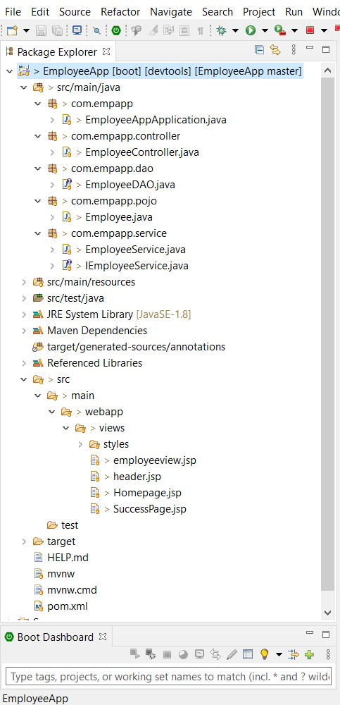

The following diagram shows the working of the Maven project i.e. the Web Application project that I have created.

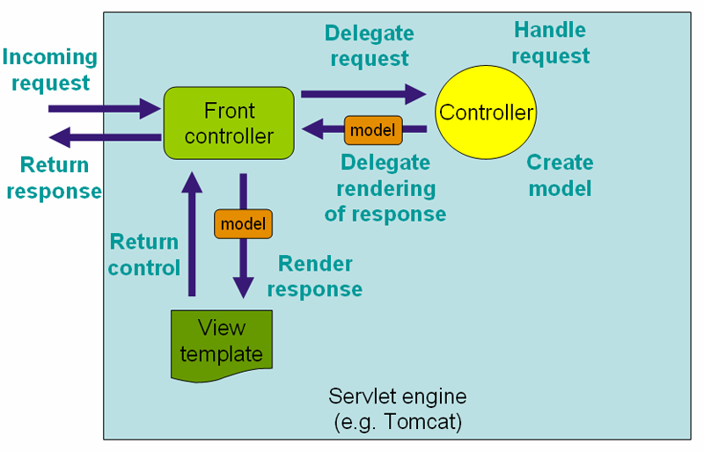

According to the above template, we have made our java files, which consists of:

1. One main Java file – SpringBootApplication
2. Controller Java file
3. Database Access/storage file
4. Entity Java file
5. Service Java file and Service Interface file

In the “application.properties” file, we have given our tomcat server port number which will run in the localhost. Also, we have instantiated mvc prefix and suffix so when the controller calls the action, the file of the name provided in controller file creates it with the given suffix as (.jsp). The Oracle database and the Hibernate properties are also included in the mentioned file.

The next file, pom.xml, we are injecting all the dependencies which are more than required for our project. Thanks to SpringBoot which provides a better approach to include all the dependencies at once in a packet. We not need to include everytime. That’s the major advantage of SpringBoot.

In the “/EmployeeApp/src/main/webapp/views”, all the .jsp files have been coded so that when action returns to the controller, it should command the files and show us the corresponding webpages.

**What I have done additionally in this project –**

1. I have included form validations.
2. If there is a record present of existing employee id, and new user enters the same id, then it shows “The id is already present, please enter a different id”.
3. Bootstrap has been included for better designing of the web page.
4. “Reset” button is there which resets the values entered by the user.

The UI and the functionality of the REST Based Web Application using SpringBoot has been shown below:

* **Home Page: It includes the form where the employee has to fill his/her details. The buttons are “Home” which will redirect to the Home Window as shown below. “Reset” button which will reset the details entered by the employee. “Show All Employee Details” which will show all the details of the employees who have been registered successfully.**

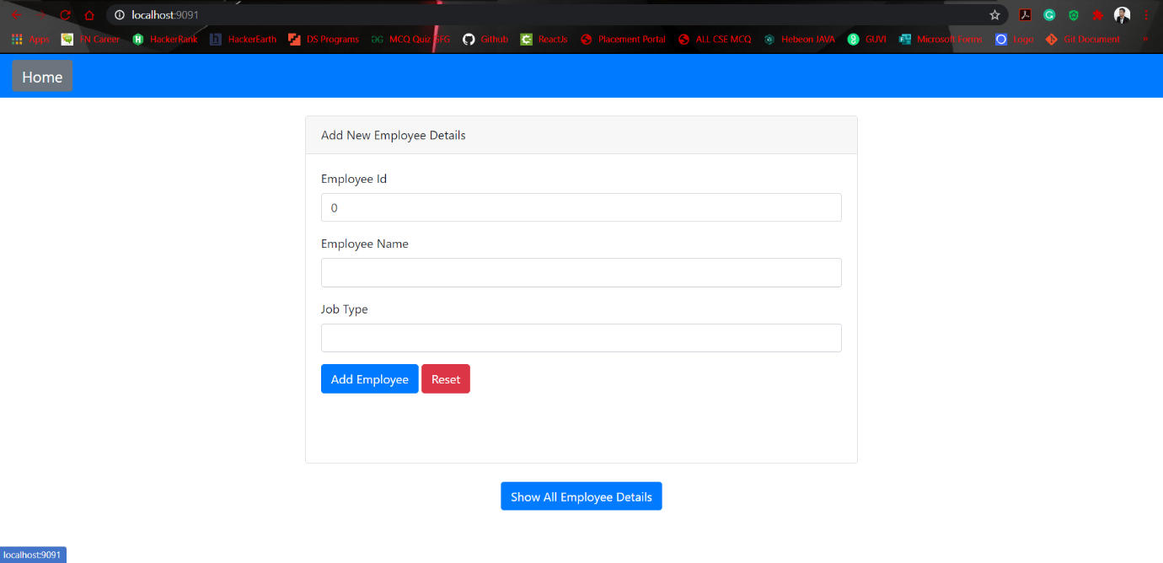

* **It shows that Employee Name and Job Type can’t be empty. This is a Form Validation.**

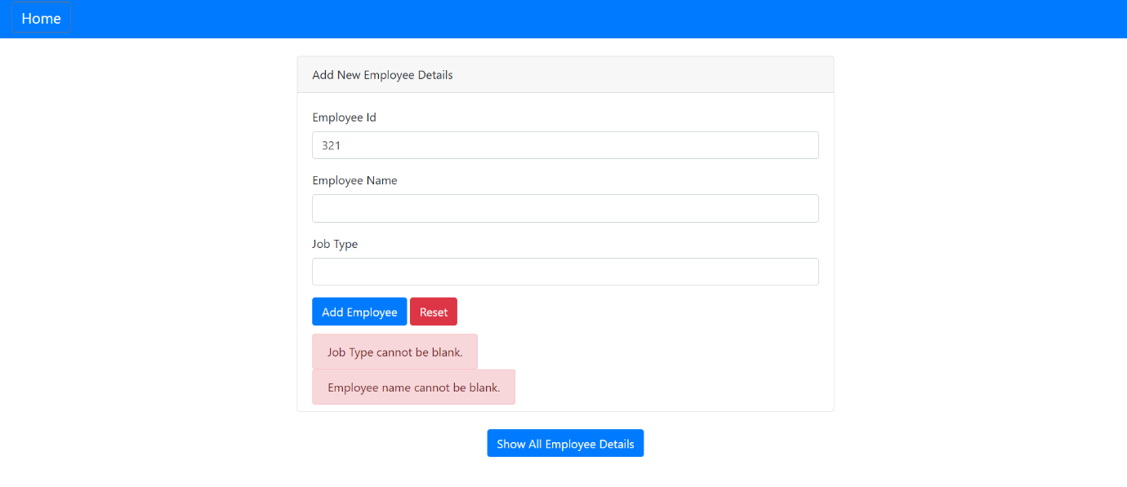

* **It shows that Employee Name and Job Type only include Alphabets and Employee ID only include Integers. This is also a form validation.**

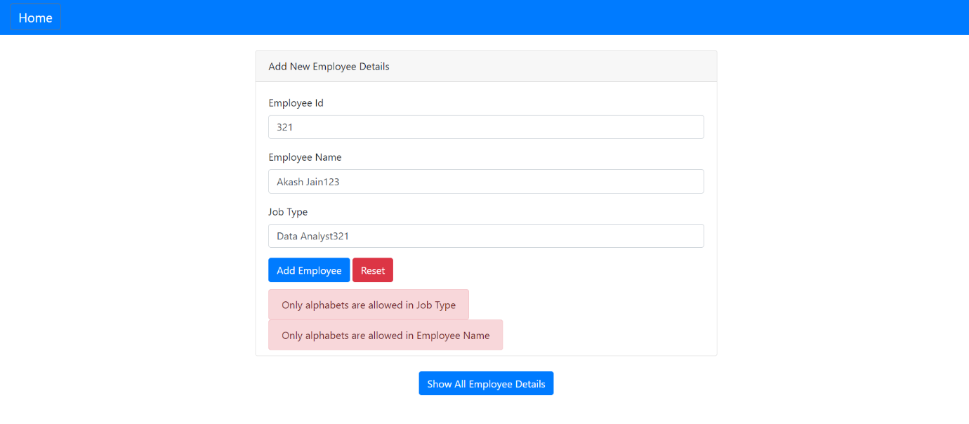

* **After filling all the correct details, when the employee clicks on the “Add Employee” button, the details of that particular employee has been stored in the Oracle Database (that I used here). There is also a “Reset” button, so if you want to reset the Name and Job Type, you can just simply click on the mentioned button.**

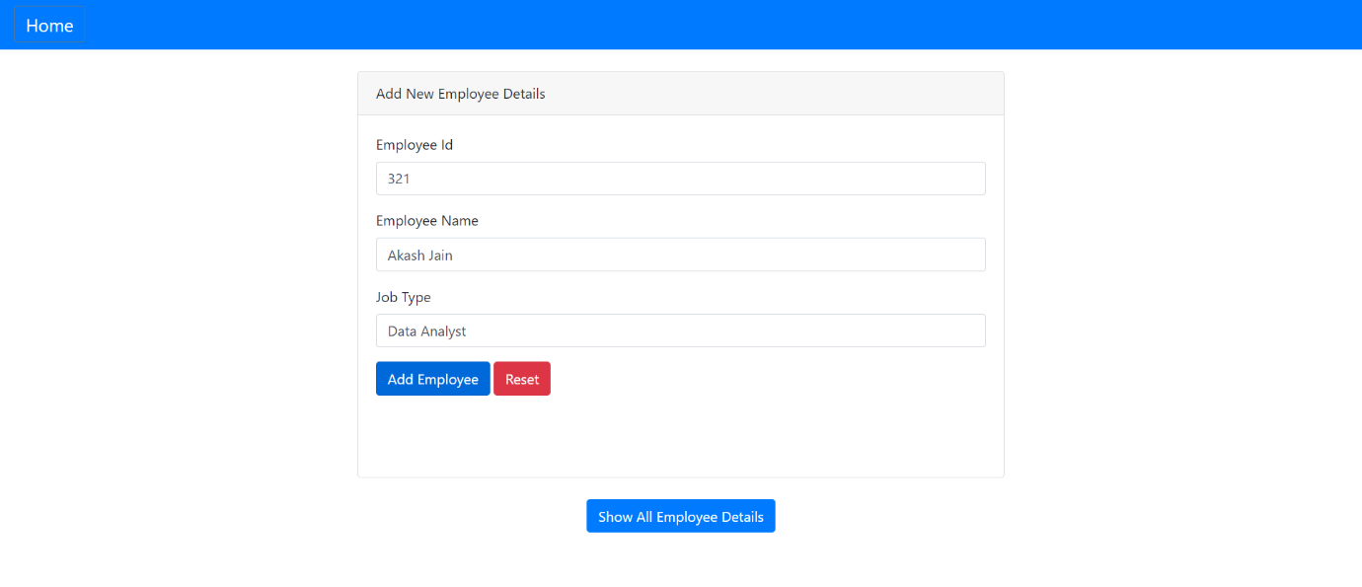

* **When the employee clicks on the “Add Employee” button, a response message/success message has been displayed that ‘Data Inserted Successfully’.**

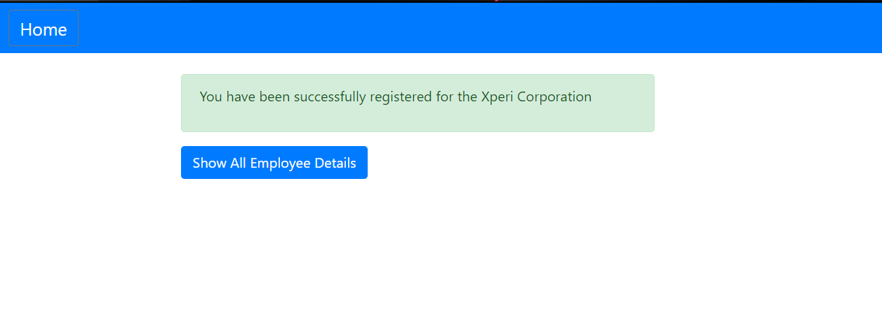

* **By clicking on the “Show All Employee Details”, one can check the details of all the employees registered in the form of tables which has 3 entries: Employee ID, Name and Job Type.**

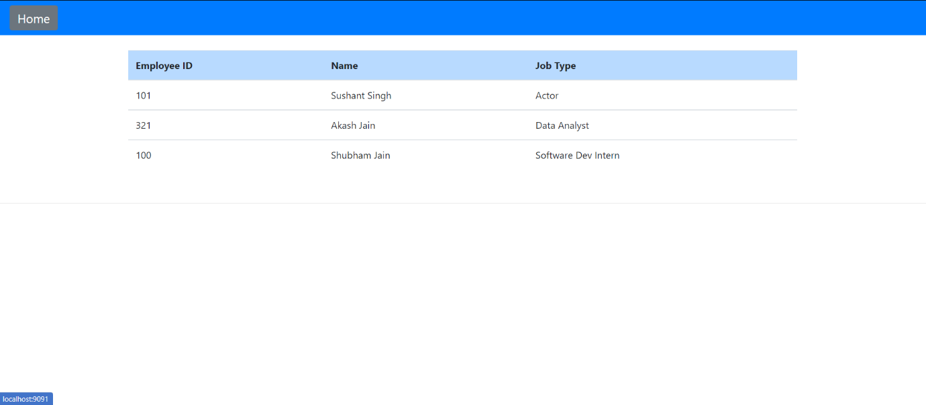

**Created by:**

**Shubham Jain**