Low Level Document (LLD)

Portfolio Website Making

Version number: 1.0

Last date of revision: 30 January 2023

Shubham Saptasagare

**DECLARATION**

We declare that this written submission represents us ideas is our own words and where others' ideas or words have been included, we have adequately cited and referenced the original sources.

We also declare that we have adhered to all principles of academic honesty

and integrity and have not misrepresented or fabricated or falsified any idea/data/fact/source in my submission.

We understand that any violation of the above will be cause for disciplinary action by the Institute and can also evoke penal action from the sources which have thus not been properly cited or from whom proper permission has not been taken when

needed.

**Revision History**

|  |  |  |  |  |  |
| --- | --- | --- | --- | --- | --- |
| **Version** | **Date** | **Author** | **Reviewer** | **Approver** | **Comments** |
| 0.1 | 22-01-2023 | Shubham |  |  | Draft version |
| 0.2 | 27-01-2022 | Shubham |  |  | Suggested some selections like key notes, screen validations and attributes to be added |
| 0.3 | 28-01-2022 | Shubham |  |  | Suggested document format related comments like correction of version, adding one sections for open issues etc |
| 0.4 | 29-01-2022 | Shubham |  |  | Suggested some changes like correct sequence diagram, changes in data design sections etc |
| 1.0 | 30-01-2022 | Shubham |  |  | Baseline version |

Table of Contents

1. Introduction ………………………………………………………………………………….6

1.1 Scope of the document…………………………………………………………………6

1.2 Intended Audience………………………………………………………………………6

1.3 System Overview………………………………………………………………………..7

1. Project Briefing……………………………………………………………………………….
2. Problem Statement…………………………………………………………………………..
3. Problem Solution……………………………………………………………………………..
4. Objective of Project…………………………………………………………………………..
5. Scope of Project………………………………………………………………………………
6. Block Diagram…………………………………………………………………………………
7. Requirements Gathering…………………………………………………………………….
8. Analysis……………………………………………………………………………………….
9. Final Screenshot of Project Output…………………………………………………………
10. **Introduction:**

**1.1 Scope of the Document**

* This section will cover details regarding scope of the document
* Low level design document will be at component level i.e., for website portal there will be one LLD

**1.2 Intended Audience**

* This section will cover categories of audiences who will be referring/reviewing this document

**1.3 System Overview**

* This section will capture overview of system application i.e for what system is being developed
* Who are the stake holders of system?
* What are other external Systems through which this will be interacting

1. **Project Briefing:**

A personal portfolio website is a digital platform that showcases an individual's skills, accomplishments, and projects. The main purpose of a personal portfolio website is to serve as a personal branding tool and help individuals stand out in their job search or professional career.

A project briefing for a personal portfolio website should include the following information:

Purpose: Clearly state the reason for creating the personal portfolio website, such as personal branding or job search.

Target Audience: Identify the target audience for the website, such as potential employers, clients, or peers.

Design Requirements: Outline any specific design requirements, such as the desired color scheme, font choices, or layout.

Content Requirements: Specify the type of content to be included in the website, such as a personal bio, resume, projects, testimonials, and contact information.

Technical Requirements: Define the technical requirements for the website, such as the preferred platform for building the website, responsive design, and integration with social media.

Timeline: Establish a timeline for completing the project, including any deadlines for each step of the process.

Budget: Provide an estimated budget for the project, including any costs associated with web hosting, domain registration, and any additional services needed. This project briefing should serve as a guide for creating a personal portfolio website that effectively showcases the individual's skills and accomplishments.

1. **Problem Statement:**

* To create a digital presence that demonstrates the creator's skills, experiences, and projects to potential clients, employers, or collaborators.
* To establish credibility and promote one's brand by presenting a polished, professional image of their work.
* To increase visibility and discoverability by making it easier for others to find the creator's work online.
* To effectively communicate the creator's value proposition and differentiate them from others in the same field.
* To provide a platform for showcasing current and past work and demonstrating their ongoing growth and development.

1. **Problem Solution:**

* Make a personal portfolio website and host it on internet so that everyone can see work of the creator.

1. **Objective of the Project:**

* The objective of a portfolio website project is typically to showcase an individual or organization's skills, experiences, and work in a professional and appealing manner to potential clients, employers, or customers.
* The aim is to create an online presence that showcases the individual or organization's abilities and strengths and provides an effective platform for marketing their services or products.
* Additionally, a portfolio website can serve as a central location for storing and displaying relevant information about the individual or organization, making it easy for visitors to find the information they need.

1. **Scope of Project:**

* Design and layout: Creating a visually appealing and user-friendly design that showcases the portfolio and highlights the individual's skills and experiences.
* Content creation: Writing and organizing the content that will be displayed on the website, including text, images, videos, and other multimedia.
* Development: Building the website using a chosen platform, programming language, and web development framework, making sure it is responsive, accessible, and optimized for search engines. Deployment: Hosting the website on a server and making it live and accessible to the public.

1. **Block Diagram:**

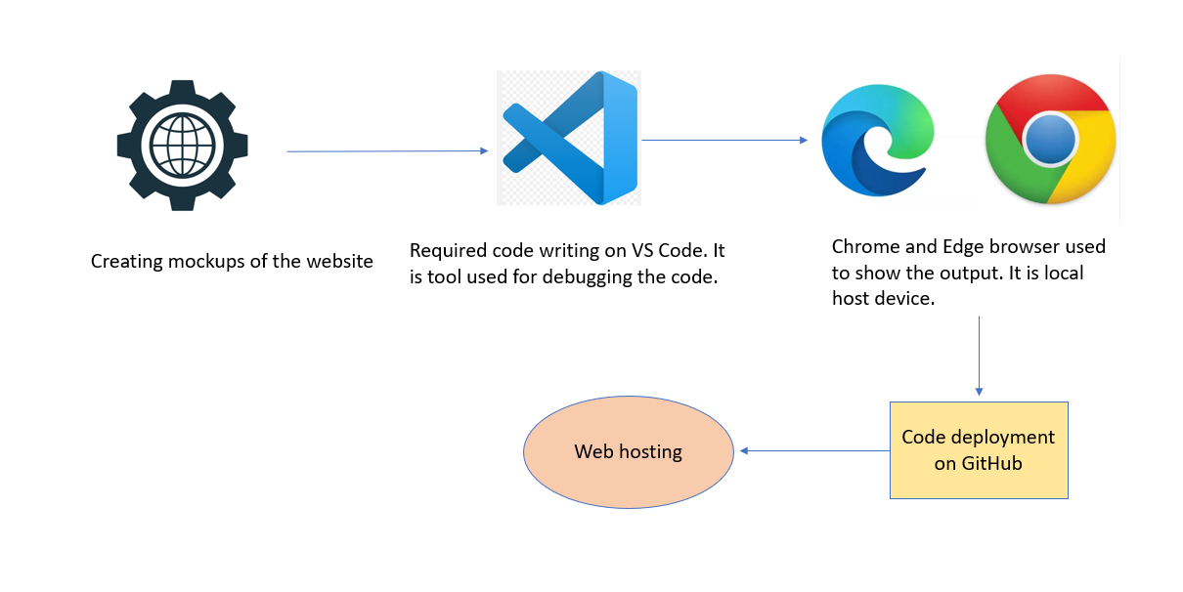

1. **Requirements Gathering:**

* Window 10 Operating system
* Visual studio software
* Project integration idea from IEEE website
* Few Github Non copyrighted source codes
* Watched some Youtube videos

1. **Analysis:**

A portfolio website is a platform for showcasing a person's work, skills, and achievements. When analyzing a portfolio website, the following aspects should be considered:

* Design and layout: The design should be visually appealing and user-friendly, with a clear navigation structure.
* Content: The content should be relevant, up-to-date, and showcase the best work of the individual. The website should clearly communicate their skills, experience, and achievements.
* Functionality: The website should be easy to use, with fast load times and no technical issues. It should be optimized for all devices, including desktop, tablet, and mobile.
* Branding: The portfolio website should reflect the individual's personal brand, with a consistent look and feel throughout the site.
* User experience: The website should provide a positive user experience, with clear calls to action and a simple way for potential clients or employers to get in touch.
* Search engine optimization (SEO): The website should be optimized for search engines to ensure it appears high in search results for relevant keywords. Overall, a portfolio website should effectively communicate the individual's skills, achievements, and personality, while providing a positive user experience

1. **Final Screenshot of Project Output**