

**Hope Foundation's**

# International Institute of Information Technology, Pune-57

**DEPARTMENT OF COMPUTER ENGINEERING**

**2019 Pattern**

**WEB TECHNOLOGY Mini Project Report**

**Academic Year: 2022-2023 Semester: I Year: T. E Date: 14/05/2023**

**Mini Project Title:**

Animephile Episode tracker

**Team Members:**

|  |  |  |  |
| --- | --- | --- | --- |
| **Roll. No.** | **Name** | **Mail-id** | **Contact No.** |
| TC 20 | Hitesh A. Jain | [hiteshjainhd@gmail.com](mailto:hiteshjainhd@gmail.com) | 8459492271 |
| TC 42 | Prathmesh R. Ingole | [pratham111ingole@gmail.com](mailto:pratham111ingole@gmail.com) | 8208938760 |
| TC 55 | Shubham L. Hippargi | [shubhamhippargi@gmail.com](mailto:shubhamhippargi@gmail.com) | 9921563596 |

`

# INDEX

1. **Project Details**
   1. Project Title
   2. Problem Statement
2. **Purpose**
3. **Technical Requirements Details**
4. **Flowchart**
5. **Detailed Description**
6. **Installation & project Execution steps**
7. **Output Screenshots**
8. **Conclusion**

**Project Details**

* 1. **Project Title: -**

AnimePhile – Episode Tracker

**1.2 Problem Statement: -**

Design and develop an efficient anime episode tracker that enables users receive timely notifications for new episode releases, search and follow their favorite series.

**Purpose**

The Animephile episode tracker was created to give anime lovers a quick and easy way to keep track of the most recent episodes of the anime series they are currently watching. Users can easily track their progress and maintain tabs on upcoming episodes by utilizing the tracker.

By lowering the possibility of missing episodes, the tracker hopes to improve anime fans' viewing experiences. To solve the issue of managing several anime series at once and remaining current with new episodes, the Animephile episode tracker was created. Users may stay informed about the most recent developments in their favorite anime series with the aid of the Animephile episode tracker, which sends notifications for new episodes.

The tracker can also assist users in finding new series by giving them information on the most recent episodes of their favorite shows, as well as suggestions for comparable anime and the ability to follow some of their favorite series.

In the end, the Animephile episode tracker aims to improve anime fans' viewing pleasure by making it simpler for them to keep track of their favorite series and watch their favorite shows without worrying about missing any episodes.

**Technical Requirements Details**

* 1. **Platform:**
     1. Operating system Window’s 11 or Ubuntu.
     2. VSCode IDE.
     3. Browser: - Google Chrome or Firefox.
  2. **Frontend Technology & Language: -**
     1. NextJS
     2. Sass
  3. **Server and API’s:**
     1. Jikan API.
     2. Firebase Realtime Database
  4. **library packages & Dependencies:**
     1. react
     2. react-dom
     3. react-router-dom
     4. firebase sdk
     5. nodemailer
     6. next
     7. sass

Flowchart

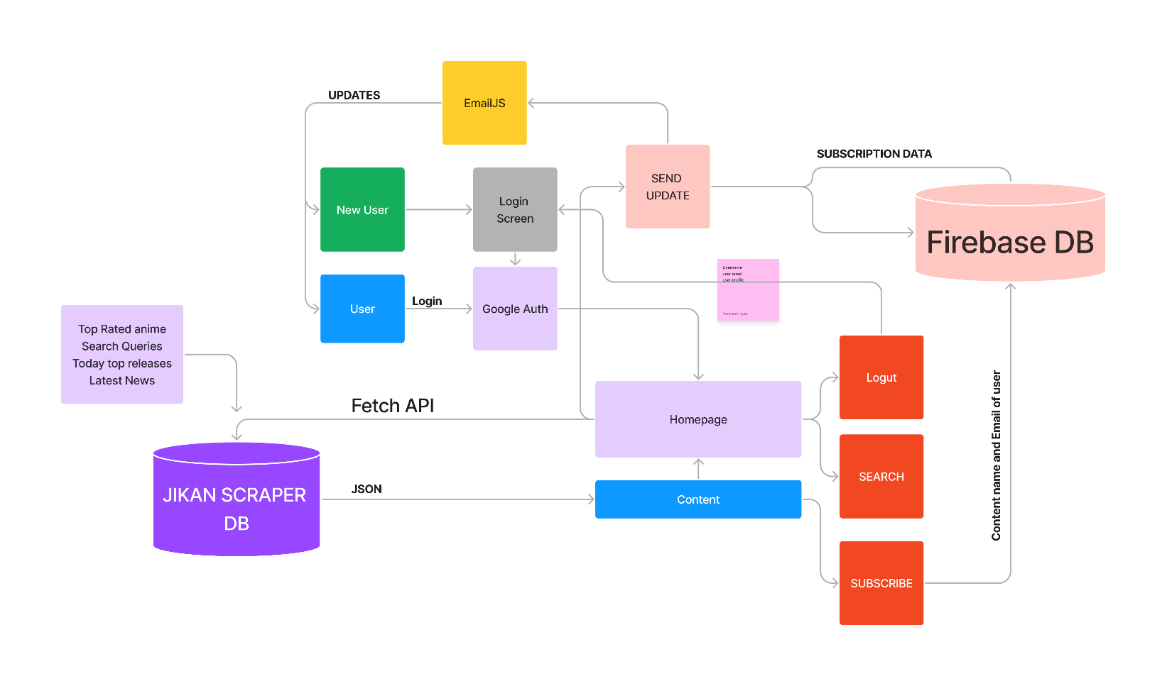

**Detailed Description of Animephile**

Animephile Episode Tracker is a web application that helps anime fans keep track of the latest episodes of their favorite anime series. It uses Jikan API, a RESTful API for fetching anime/manga data, and Firebase, a cloud-based NoSQL database, to store user preferences and update the latest episodes.

Animephile have a user-friendly and intuitive interface, allowing users to easily navigate and interact with the tool. The UI is responsive and adaptable to different screen sizes and devices. Animephile have integrated with the Jikan API to fetch relevant data about users, anime series and other related information.

The Animephile is designed for performance and scalability. It handles a large volume of data and users, utilizing caching mechanisms, efficient database queries, and server-side optimizations to ensure fast response times and scalability. The tool is compatible with different web browsers and operating systems and integrates smoothly with other third-party tools or services that enhance its functionality, such as project management tools or version control systems.

When a user signs up for the Animephile Episode Tracker, they can search for the anime series they are interested in tracking. The application will use the Jikan API to fetch the latest episodes and store them in the Firebase database. The user can then view the list of episodes, follow the series they are interested, and receive notifications when a new episode is released. Moreover, our website provides the list of the series that are top rated as per the imdb ratings and recommends the users to watch the trailer.

The Jikan API is a free and open-source API that provides access to anime and manga data such as episode information, character information, and more. It is maintained by the [jikan.moe](https://docs.api.jikan.moe) team and is widely used by developers to build anime/manga-related applications. The Animephile Episode Tracker uses the Jikan API to fetch episode data such as episode number, release date, and synopsis.

Firebase is a cloud-based NoSQL database that allows real-time data synchronization and offline data storage. The Animephile Episode Tracker uses Firebase to store user preferences such as the anime series they are tracking, the episodes they have watched, and the time zone they are in. Firebase also allows the application to send notifications to users when a new episode is released.

To summarize, the Animephile Episode Tracker is a web application that helps anime fans keep track of the latest episodes of their favorite anime series. It uses Jikan API to fetch episode data and Firebase to store user preferences and update the latest episodes. With this application, anime fans can stay up to date with their favorite anime series and never miss a new episode.

**Installation and project execution steps**

Step 01: npm install

Step 02: Install the dependencies to the local node_modules folder.

Step 03: npm run dev

This command is used to run the dev script defined in the project's package.json file. The app starts running.

Step 04: signup with google account.

Step 05: follow or subscribe the series that you are interested in.

Step 06: the subscribed series will be added to the database and user will be notified each time a new episode is released.

Step 07: search for the series that you may be interested in and follow the series.

Step 08: watch trailer of the series that are top IMDB rated.

Step 09 scroll down and examine the latest news about anime.

Step 10: logout

**Output**

**01 Login screen:**



**02 Logging In with Google Authenticator**

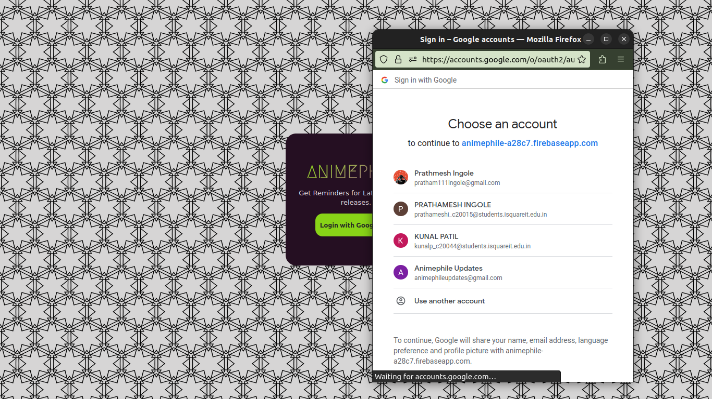

**03 Home Screen**

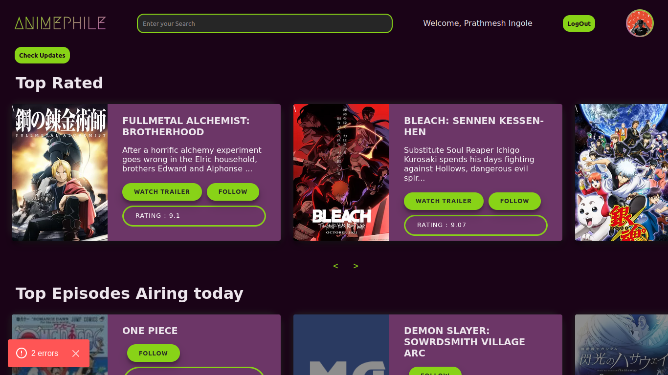

**04 Latest Episodes and News**

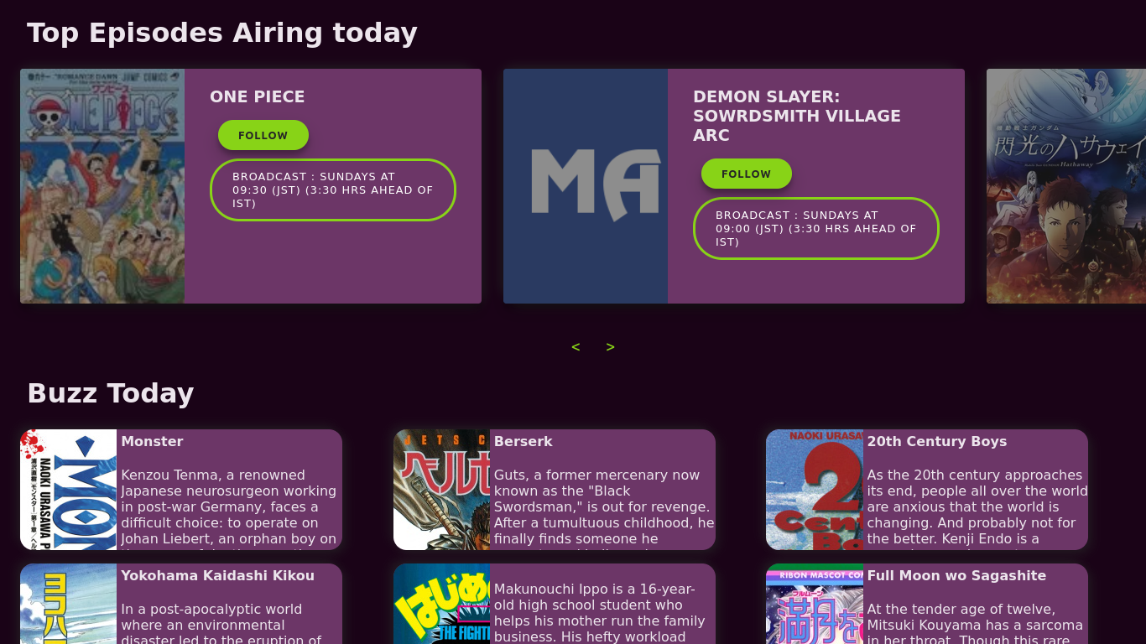

**05 Followed a Series**



**Conclusion**

Successfully build a web application with Next.js, Firebase, and the Jikan API to create an application that keeps users updated on newly released episodes of their subscribed anime. By combining these technologies, we have developed a robust and efficient solution to address the needs of anime enthusiasts who want to stay informed about the latest episodes.

The project's implementation utilized Next.js, a powerful React framework that provides server-side rendering, static site generation, and API routing capabilities. This allowed us to build a fast and responsive application with a seamless user experience.

Firebase, a comprehensive suite of cloud-based tools, played a crucial role in our project. We utilized Firebase Authentication to manage user registration and authentication, enabling personalized subscriptions for each user. Additionally, Firebase Cloud Firestore served as our database solution, storing user information and anime subscriptions in a structured and scalable manner.

The integration of the Jikan API, a reliable and feature-rich anime information API, provided us with the necessary data to fetch and display anime details, including episode updates. By leveraging Jikan's extensive database, we were able to retrieve and notify users about the release of new episodes for their subscribed anime. Throughout the development process, careful attention was given to ensuring data security, user privacy, and optimized performance. Firebase's built-in security rules and authentication mechanisms helped us safeguard user information, while Next.js's performance optimizations contributed to a smooth browsing experience.

In conclusion, the project successfully achieved its goal of creating a Next.js-based application integrated with Firebase and the Jikan API to deliver timely episode updates to subscribed anime users. The combination of these technologies provided a solid foundation for building a feature-rich and user-friendly platform, catering to the needs of anime enthusiasts worldwide. With further enhancements and continuous updates, this application holds great potential to become a go-to resource for anime lovers seeking to stay up to date with their favorite shows.