ECDAT
Enterprise Cryptographic Discovery & Analysis Tool
SIH26164 - NTRO | Demo Product Architecture + Product Requirements Document

Discover. Prove. Assess. Plan. Validate.

Product type: defensive security / cryptographic intelligence platform
Primary output: cryptographic inventory + CycloneDX 1.7 CBOM + quantum-risk and migration analysis
Development posture: demo product first, research-grade architecture underneath
Current standards basis: NIST PQC / crypto-agility + CycloneDX + current IETF PQ TLS work

Scope note
This PRD keeps the product anchored to SIH26164. The 36-hour submission is not treated as the project boundary. The demo is a focused vertical slice of the full architecture; advanced modalities and research experiments are staged behind extensible interfaces.

1. Product concept
ECDAT discovers cryptographic artefacts across software and infrastructure, records evidence for each finding, builds a cryptographic dependency graph, evaluates quantum and business risk, and produces evidence-backed PQC/hybrid migration recommendations.
Core product loop:
DISCOVER -> VERIFY -> INVENTORY -> FUSE EVIDENCE -> GRAPH -> ASSESS -> PRIORITIZE -> RECOMMEND -> SIMULATE -> VALIDATE -> EXPORT
This remains the SIH26164 solution. Evidence fusion, dependency reasoning, uncertainty-aware risk, crypto-agility, blast-radius analysis, and migration optimization are deeper layers that make the same requested capabilities more useful and more researchable.

2. SIH requirement mapping
SIH requirement | ECDAT implementation
Discover algorithms, keys, certificates, protocols, libraries, hardware modules and cloud services | Discovery Engine + Knowledge Registry
Scan source repositories | Source/AST Engine
Scan binaries | Binary Engine
Scan libraries/dependencies | Dependency Engine
Scan container images | Container Engine
Comprehensive quantum risk assessment | Quantum Risk Engine
Classify by type, lifetime, criticality | Asset + Context model
Mosca-style analysis | Temporal risk model
Recommend PQC/hybrid alternatives | Migration Engine
Standardized crypto report | CycloneDX 1.7 CBOM export
Interactive GUI | Next.js dashboard

3. Target demo product

Demo promise
- A cryptographic inventory with algorithm, role, version/mode and lifecycle metadata.
- A CycloneDX 1.7 CBOM.
- Evidence and provenance for every finding.
- A dependency/cryptographic graph.
- Mosca-style quantum-risk analysis with visible inputs.
- A crypto-agility profile.
- Migration-impact / blast-radius analysis.
- PQC/hybrid candidate recommendations.
- A migration plan with validation gates.

Demo boundary
The demo should be truthful about coverage. It should deeply support a controlled set of modalities and provide extensible adapters for the rest. It should not claim exhaustive binary reverse engineering or complete live cloud coverage.

4. System architecture
The architecture is intentionally layered so the demo can ship without forcing every enterprise connector into the first release.
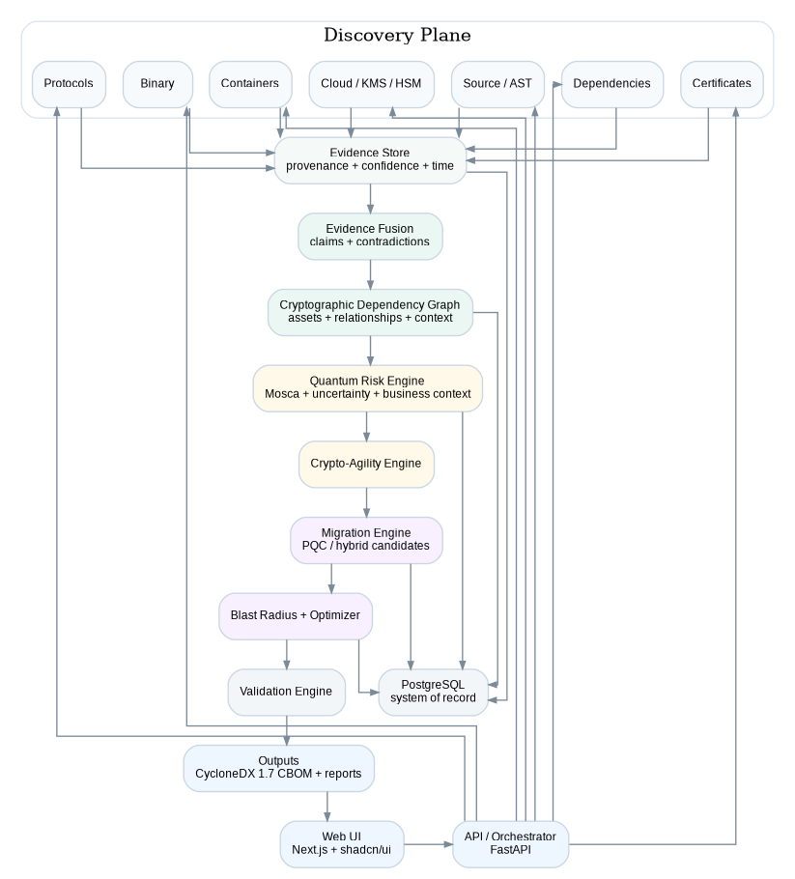

End-to-end workflow
CONNECT / UPLOAD -> DISCOVER -> VERIFY -> INVENTORY -> FUSE EVIDENCE -> BUILD GRAPH -> ASSESS RISK -> ASSESS AGILITY -> RECOMMEND -> SIMULATE -> VALIDATE -> EXPORT

Component responsibilities
Web UI: Scan submission, asset inventory, asset detail, risk dashboard, graph explorer, migration planner and reports.
API / Orchestrator: Authentication, scan lifecycle, job orchestration, result aggregation, export and audit logging.
Discovery Engine: Pluggable collectors for source, AST, dependency, certificates, binaries, containers, protocols and cloud metadata.
Evidence Store: Every finding is represented as evidence with provenance, detector, source location, observation time and confidence.
Evidence Fusion: Combines multiple observations into claims and handles corroboration or contradiction.
Cryptographic Graph: Connects applications, services, repositories, libraries, algorithms, certificates, keys, protocols, containers, KMS/HSM and data assets.
Quantum Risk Engine: Mosca-style temporal analysis, uncertainty, harvest-now-decrypt-later sensitivity, business criticality and exposure.
Crypto-Agility Engine: Assesses abstraction, configuration flexibility, dependency coupling, certificate/key agility, vendor coupling, testing and rollback.
Migration Engine: Compares PQC/hybrid candidates using security, latency, compatibility, cost and lifecycle constraints.
Blast Radius + Optimizer: Computes affected assets and migration waves; later supports constrained/Pareto optimization.
Validation Engine: Checks migration proposals with static, dependency, build, test and security gates.

5. Discovery architecture

Deeply supported in the demo
- Git repository / ZIP upload
- Python source and AST analysis
- Dependency manifests and lockfiles
- X.509 certificate parsing
- Container image filesystem/package inspection
- Controlled TLS endpoint observation

Controlled adapters
- Java / Go / C/C++ source rules
- Binary strings and symbol signals
- Cloud/KMS/HSM metadata via imported JSON

Future adapters
- Full binary implementation analysis
- Runtime / eBPF observation
- AWS/Azure/GCP live connectors
- SSH / QUIC / EAP-TLS / DTLS / IoT protocol adapters

6. Evidence model
Every cryptographic claim should have multiple supporting observations when available.
Evidence
- evidence_id
- asset_id
- source_type
- source_location
- detector
- raw_signal
- normalized_claim
- observation_time
- confidence
- provenance
- status
Core semantic rule: Capability != implementation != configured use != negotiated use.

7. Asset and graph model

Core asset types
Application, Service, Repository, Library, Binary, Container, Algorithm, Key metadata, Certificate, Protocol, KMS/HSM, Data asset, Business service.

Core relationships
USES, DEPENDS_ON, IMPLEMENTS, PROTECTS, SIGNS, ENCRYPTS, NEGOTIATES, DEPLOYED_ON, ISSUED_BY, STORED_IN.
Payment Service
|-- DEPENDS_ON --> OpenSSL
| |-- PROVIDES --> RSA
| |-- PROVIDES --> ECDSA
|
|-- USES --> RSA-2048 --> SIGNS --> JWT
|-- USES --> ECDSA-P256 --> CERTIFICATE
|-- NEGOTIATES --> X25519 + ML-KEM-768 --> TLS
|-- PROTECTS --> Payment Data

8. Quantum-risk model

Baseline
X + Y > Z
X = data/security lifetime
Y = migration time
Z = time horizon to a cryptographically relevant quantum capability

Research-grade extension
Rather than forcing a single hard-coded Z, allow Z to be represented as a distribution and compute P(X + Y > Z). The business/context layer can then incorporate criticality, sensitivity, exposure and migration difficulty. Any weights are an ECDAT analytic model and must be configurable and validated; they are not NIST normative weights.

Demo output
Quantum exposure probability/band; data lifetime; estimated migration duration; business criticality; data sensitivity; exposure; migration difficulty; confidence; recommended migration wave.

9. Crypto-agility model
- Algorithm abstraction
- Configuration externalization
- Protocol negotiation flexibility
- Dependency coupling
- Certificate agility
- Key-management flexibility
- Vendor dependency
- Deployment coupling
- Test coverage
- Rollback capability
Research question: do these measurable architectural features predict migration effort and blast radius?

10. PQC knowledge and recommendation engine
Baseline standards registry: ML-KEM (FIPS 203) for key establishment, ML-DSA (FIPS 204) for signatures, and SLH-DSA (FIPS 205) for signatures.
The long-term recommendation engine should use a versioned registry containing algorithm identifier, family/role, standard/status, security level, parameter set, size characteristics, performance, protocol support, implementation availability, certification/lifecycle metadata, evidence sources and last verification date.
Current use | Candidate direction | Important constraint
RSA/ECDSA signing | Evaluate ML-DSA candidates | Certificate and protocol support
X25519/ECDH in TLS | Evaluate hybrid ML-KEM integration | Protocol/library/client support
AES-256-GCM | Usually retain; context-sensitive quantum review | Do not auto-classify as a PQ migration replacement

11. Migration engine
CLASSICAL
-> PQ-CAPABLE
-> HYBRID / DUAL-STACK
-> PQ AUTHENTICATION / PQ KEM
-> PQ PREFERRED
-> CLASSICAL RETIREMENT
Migration strategies: source refactor, dependency upgrade, configuration change, certificate/PKI migration, protocol migration, gateway/termination change, and future sidecar/infrastructure strategies.

12. Blast-radius engine
For a selected crypto change, traverse graph edges to identify affected services, repositories, libraries, certificates, protocols, containers and business/data assets.
Proposed change: RSA-2048 -> ML-DSA
Affected services: derived from graph
Affected repositories: derived from graph
Affected certificates: derived from graph
Dependency upgrades: derived from graph
Protocol constraints: derived from graph
Rollback checkpoints: derived from migration plan

13. Migration optimizer
For the demo, use a transparent heuristic whose inputs are visible to the user. For research, compare greedy risk-first, risk/cost ratio, constrained optimization and Pareto-frontier approaches. No internal heuristic should be presented as a standards formula.

14. Validation engine
Migration proposal
-> syntax / static checks
-> dependency consistency
-> build
-> unit / integration tests
-> cryptographic tests
-> protocol regression
-> security regression
-> human approval

15. Product screens
Screen | Primary purpose
Overview | Enterprise crypto posture, scan history, top risks
Scan Center | Repository/image/endpoint ingestion and scan controls
Inventory | Search/filter cryptographic assets and findings
Asset Detail | Evidence, dependencies, protocol/cert context, risk and migration
Graph Explorer | Explore cryptographic and business dependencies
Risk Dashboard | Quantum exposure, criticality, agility and migration priorities
Migration Planner | Candidate algorithms, constraints, blast radius, migration waves
Reports | CBOM, risk register, executive report, migration roadmap

16. PRD - functional requirements
ID | Requirement | Acceptance-oriented description
FR-01 | Target ingestion | Accept a Git repository URL or uploaded repository archive.
FR-02 | Scan orchestration | Create a scan record, execute enabled collectors, and expose scan state/progress.
FR-03 | Source crypto detection | Detect supported crypto APIs, algorithms, modes and common usage patterns.
FR-04 | AST context | Associate findings with file, line/range and syntactic context where available.
FR-05 | Dependency discovery | Parse supported manifests/lockfiles and connect libraries to applications.
FR-06 | Certificate discovery | Discover X.509 certificates and public metadata without persisting private key material.
FR-07 | Container inspection | Inspect provided container images or extracted image contents for crypto artefacts and dependencies.
FR-08 | Protocol evidence | Support controlled TLS endpoint inspection in the demo.
FR-09 | Evidence capture | Retain source type, detector, location, timestamp and confidence for each finding.
FR-10 | Evidence fusion | Merge corroborating observations and explicitly mark contradictions.
FR-11 | Crypto graph | Build nodes/edges connecting crypto assets to software, protocols, certificates, dependencies and data/business context.
FR-12 | CBOM export | Export a CycloneDX 1.7 compatible CBOM.
FR-13 | Quantum risk | Calculate a Mosca-style temporal risk result and show its parameters.
FR-14 | Business context | Allow input for data lifetime, business criticality, sensitivity and exposure.
FR-15 | Crypto agility | Present an explicit crypto-agility profile.
FR-16 | PQC recommendations | Recommend candidate PQC/hybrid options from a versioned registry.
FR-17 | Blast radius | Simulate graph impact for a selected migration change.
FR-18 | Migration plan | Generate an ordered migration plan with dependencies and validation gates.
FR-19 | Auditability | Retain scan IDs, detector versions, timestamps and report versions.
FR-20 | Export | Support JSON and CSV exports in addition to CBOM.

17. Non-functional requirements
ID | Requirement
NFR-01 | Reproducible scan: same input + same detector version should produce stable normalized findings.
NFR-02 | No private key material should be persisted by the platform.
NFR-03 | Scans must run in isolated workspaces.
NFR-04 | Every risk result must show the inputs used.
NFR-05 | UI should remain usable for at least tens of thousands of findings in the demo dataset.
NFR-06 | APIs should expose scan IDs and deterministic result retrieval.
NFR-07 | System should degrade gracefully when a detector cannot prove a finding.
NFR-08 | Security-sensitive actions require authorization and audit logging.

18. Data model
Table | Important fields
projects | id, name, owner, created_at
scans | id, project_id, target_type, target_ref, status, detector_version, started_at, completed_at
assets | id, scan_id, asset_type, name, algorithm, parameter_set, role, version, mode, lifecycle_status
evidence | id, asset_id, source_type, location, detector, raw_signal, confidence, observed_at, provenance
relationships | id, src_asset_id, dst_asset_id, relationship_type, confidence
contexts | id, asset_id, data_lifetime, criticality, sensitivity, exposure, migration_time
risk_assessments | id, asset_id, temporal_probability, contextual_score, overall_band, model_version
migration_options | id, asset_id, target_algorithm, strategy, compatibility, estimated_cost, latency_impact
migration_plans | id, name, objective, constraint_json, status
migration_steps | id, plan_id, asset_id, sequence_no, strategy, prerequisites, rollback, validation_status
audit_events | id, actor, action, object_type, object_id, timestamp, metadata

19. API surface
POST /api/v1/projects
POST /api/v1/scans
GET /api/v1/scans/{scan_id}
GET /api/v1/scans/{scan_id}/assets
GET /api/v1/assets/{asset_id}
GET /api/v1/assets/{asset_id}/evidence
GET /api/v1/graph/{scan_id}
GET /api/v1/risks/{scan_id}
POST /api/v1/migrations/simulate
POST /api/v1/migrations/plan
GET /api/v1/migrations/{plan_id}
GET /api/v1/reports/{scan_id}/cbom
GET /api/v1/reports/{scan_id}/risk
GET /api/v1/reports/{scan_id}/migration

20. Recommended implementation stack
Layer | Recommended stack | Demo notes
Frontend | Next.js / React, TypeScript, Tailwind, shadcn/ui | Fast, clean security-dashboard UI
Charts / graph | Recharts or Plotly; Cytoscape.js or React Flow | Use graph for blast-radius exploration
Backend | Python 3.12+, FastAPI, Pydantic, SQLAlchemy | Single API boundary
Storage | PostgreSQL | System of record; adjacency tables sufficient for demo
Jobs | Redis + worker | Background scan jobs and progress
AST | Tree-sitter + custom rules; optional Semgrep adapters | Multi-language architecture
Certificates | Python cryptography library | Parse public X.509 metadata
TLS | OpenSSL CLI / controlled endpoint adapter | Demo protocol evidence
Binary | LIEF + strings/symbol signals | Honest limited binary coverage
Containers | OCI/image extraction tooling | Inspect files and package metadata
Graph future | Neo4j adapter | Only when graph workloads justify it
Deployment | Docker Compose | One-command local demo

21. Demo data strategy
Use a synthetic, controlled repository corpus so every finding has known ground truth.
- legacy-auth-service - RSA signing + JWT
- legacy-api - ECDSA certificate metadata
- payment-service - AES-256-GCM
- tls-gateway - X25519 / hybrid TLS evidence
- old-utils - deprecated hash examples
- pqc-ready-service - ML-KEM / ML-DSA examples
- lockfiles, sample PEM certificates, container manifests and dependency relationships
- hidden/wrapped crypto calls for benchmark cases
Store the ground truth separately from the scanner and use it only for evaluation.

22. Demo narrative
- Open ECDAT.
- Upload the controlled enterprise demo repository.
- Start a scan.
- View cryptographic assets discovered across source, dependencies, certificates and containers.
- Open an RSA-2048 JWT-signing asset and inspect evidence/provenance.
- Open the graph and select the RSA asset to preview migration blast radius.
- Set data lifetime and business criticality.
- Run Mosca-style temporal and contextual risk analysis.
- Compare ML-DSA / hybrid candidates and their constraints.
- Run migration simulation and view ordered plan/validation gates.
- Export the CycloneDX 1.7 CBOM and migration report.

23. Research layer after the demo
Research track | Experiment
Evidence fusion | Single-modality vs multimodal discovery; measure precision, recall, F1, false-negative rate, localization and confidence calibration.
Graph reasoning | Compare flat-CBOM prioritization vs graph-based vs evidence+graph prioritization.
Probabilistic Mosca | Compare deterministic and probabilistic quantum-risk ranking under uncertain quantum timelines.
Crypto agility | Test whether explicit agility features predict migration effort.
Blast radius | Test whether graph structure predicts impacted components after seeded migrations.
Agentic migration | Test whether evidence-grounded validation reduces migration regression versus unconstrained LLM editing.

24. Demo acceptance criteria
- A controlled repository scans end-to-end.
- At least 20+ crypto assets are discovered with known ground truth.
- At least 4 discovery modalities contribute evidence.
- Every finding has source location and confidence.
- A graph renders asset/dependency relationships.
- Mosca parameters are visible for each risk decision.
- At least three PQC/hybrid recommendations are demonstrated.
- A selected migration displays its blast radius.
- A migration plan is generated with validation gates.
- A CycloneDX 1.7 CBOM is downloadable.
- Inventory, risk and migration views are usable.
- The product does not store private key material.

25. Product roadmap
Release | Scope
A - Demo foundation | Repository ingestion, source/AST, dependencies, certificates, evidence store, CBOM, basic risk dashboard.
B - Intelligence | Evidence fusion, graph explorer, contextual risk, crypto-agility profile, TLS evidence.
C - Migration | PQC registry, migration options, blast radius, migration planner, simulator.
D - Advanced discovery | Binary, containers, runtime, cloud/KMS/HSM and additional protocols.
E - Research / agentic | Uncertainty models, optimization, benchmark suite, validated migration copilot.

26. Security and trust principles
- Scan only repositories/endpoints the operator is authorized to analyze.
- Never ingest private key material into the analytics database.
- Store certificate/key metadata and hashes where possible.
- Isolate uploaded repositories and container extraction.
- Record detector/version provenance.
- Make every risk score explainable from stored inputs.
- Treat external intelligence and LLM output as advisory until validated.
- Keep human approval before production-changing remediation.

27. Source and standards basis
[1] SIH26164, NTRO - Enterprise Cryptographic Discovery & Analysis Tool. Requirements are based on the SIH26164 problem statement supplied for this project and corroborated by current indexed SIH2026 copies. The official SIH portal was not directly retrievable in this session, so this report does not claim a newly verified official modification.
[2] NIST CSWP 39-upd1 - Considerations for Achieving Crypto Agility: Strategies and Practices, final June 29, 2026.
[3] NIST NCCoE - Migration to Post-Quantum Cryptography FAQ, updated June 30, 2026.
[4] CycloneDX v1.7 - released October 21, 2025, with expanded CBOM capabilities and provenance-oriented features.
[5] CycloneDX Cryptography Registry - machine-readable algorithm family and curve normalization introduced with v1.7.
[6] IETF draft-ietf-tls-mlkem-11 - ML-KEM Post-Quantum Key Agreement for TLS 1.3, dated September 17, 2026.

28. Final product definition
ECDAT is an evidence-driven enterprise cryptographic intelligence platform. It does not stop at finding an algorithm. It connects evidence to actual usage, dependencies, business context and data, translates those facts into quantum and lifecycle risk, and produces a migration plan that can be simulated and validated.
For the demo, the winning vertical slice is:
Repository -> Discovery -> Evidence -> CBOM -> Risk -> Graph -> Blast Radius -> PQC Recommendation -> Migration Plan -> Validation

