To find the schema of the data we are about to install

wget http://media.sundog-soft.com/es7/shakes-mapping.json

Now we have downloaded data type mapping let push that to es7

curl -H "Content-Type: application/json" -XPUT 127.0.0.1:9200/shakespeare --data-binary @shakes-mapping.json

To download data
wget http://media.sundog-soft.com/es7/shakespeare_7.0.json

curl -H "Content-Type: application/json" -XPOST '127.0.0.1:9200/shakespeare/_bulk' --data-binary @shakespeare_7.0.json

To create index movie with mapping

curl -XPUT localhost:9200/movies -H 'Content-Type: application/json' -d '
{
"mappings": {
"properties":{
"year":{
"type":"date"
}
}
}
}'

To see the mapping

curl -XGET 127.0.0.1:9200/movies/_mapping?pretty

curl -XPOST localhost:9200/movies/_doc/109487 -H 'Content-Type: application/json' -d '
{
"genre":["IMAX","SCI-FI"],
"title":"Interstellar",
"year":2014
}'

curl -XGET 127.0.0.1:9200/movies/_search?pretty

To enter data in bulk

wget http://media.sundog-soft.com/es7/movies.json (Downloads a json)

curl -XPOST localhost:9200/_bulk?pretty -H 'Content-Type: application/json' --data-binary @movies.json

- _bulk- used for inserting data in bulk
- --data-binary : To insert data into curl from a file without typing
- @movies.json - @ followed by file name

Movies.json

{ "create" : { "_index" : "movies", "_id" : "135569" } }
{ "id": "135569", "title" : "Star Trek Beyond", "year":2016 , "genre":["Action", "Adventure", "Sci-Fi"] }
{ "create" : { "_index" : "movies", "_id" : "122886" } }
{ "id": "122886", "title" : "Star Wars: Episode VII - The Force Awakens", "year":2015 , "genre":["Action", "Adventure", "Fantasy", "Sci-Fi", "IMAX"] }
{ "create" : { "_index" : "movies", "_id" : "109487" } }
{ "id": "109487", "title" : "Interstellar", "year":2014 , "genre":["Sci-Fi", "IMAX"] }
{ "create" : { "_index" : "movies", "_id" : "58559" } }
{ "id": "58559", "title" : "Dark Knight, The", "year":2008 , "genre":["Action", "Crime", "Drama", "IMAX"] }
{ "create" : { "_index" : "movies", "_id" : "1924" } }
{ "id": "1924", "title" : "Plan 9 from Outer Space", "year":1959 , "genre":["Horror", "Sci-Fi"] }

_id – document id
_index – name of index

Updating ElasticSearch

In elastic search, documents are immutable, you can't actually change a document once it's been written,but they give you a workaround for this. Elastic search automatically maintains an _version field on every document that you put into it.So what you can do to update a document is to create a new copy of that document with an incremented _version number. All that matters is that the unique id for the document and its version together are unique, so you can have multiple versions of a given document and elsatic search will automatically use the most recent version that you've created.So when you do an update request on elastic search, what really happens is a new document, an entirely new document, gets created with an incremented_version number, and then the old document gets marked for deletion. Elastic search will do a cleanup pass later on, whenever it feels the need to do so, and at that point the old version will go away.

Two ways to update-
Specify all the fields with a put command or perform partial update using -update.The version number changes every time with update.which is later deleted by es.
- Curl -XPUT localhost:9200/movies/_doc/109487 -H 'Content-Type: application/json' -d '
{
"genre":["IMAX","SCI-FI"],
"title":"Interstellar FOO",
"year":2014
}'
- Curl -XPUT localhost:9200/movies/_doc/109487/_update -H 'Content-Type: application/json' -d '
{
“doc”: {
“title” : “Interstellar again”
}
}’

Deleting Document in ElasticSearch

- To find id first we perform search - curl -XGET 127.0.0.1:9200/movies/_search?q=dark
- Curl -XDELETE localhost:9200/movies/_doc/58559

Concurrency Management in ElasticSearch

optimistic concurrency control
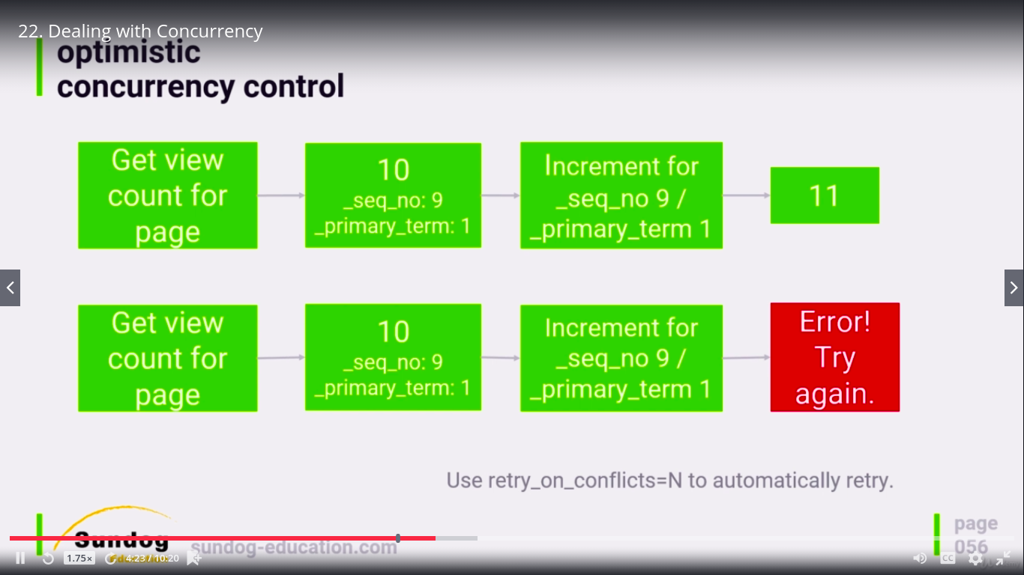

In optimistic concurrency control we use document sequence number and primary term.so when if multiple user are trying to update on same sequence it will throw error for one .and after updatiion the sequence number changes.so the user can retry on new sequence.we can do it manually by specifying sequence number or by using retry_on_conflict.It is telling to retry 5 times.

- Curl -XPOST localhost:9200/movies/_doc/109487/_update?retry_on_conflict=5 -H 'Content-Type: application/json' -d '
{
“doc”: { “title” : “Interstellar again”
}
}’

Using Analyzers and Tokens

Once mapped the index cannot be changed.so we need to drop the index recreate mappings and populate data.

Dropping and index

curl -XDELETE 127.0.0.1:9200/movies

curl -XPUT localhost:9200/movies -H 'Content-Type: application/json' -d '
{
"mappings": {
"properties":{
"id":{"type": "integer"},
"year":{"type":"date"},
"genre":{"type":"keyword"}, // Exact Match
"title":{"type":"text","analyzer":"english"}
}
}
}'

Searching on newly mapped index

curl -XGET localhost:9200/movies/_search?pretty -H 'Content-Type: application/json' -d '
{
"query": {
"match":{
"genre":"sci"
}
}
}
'

Result – no hit as genre is keyword now.so exact match is needed.i.e Sci-Fi.

Lets check title field which is text so not case sensitive .

curl -XGET localhost:9200/movies/_search?pretty -H 'Content-Type: application/json' -d '
{
"query": {
"match":{
"title":"star wars"
}
}
}
'

Result-
Returns both star wars and star trek .where star wars score is obviously higher.so for exact match use keyword..

Data Normalization and Denormalization

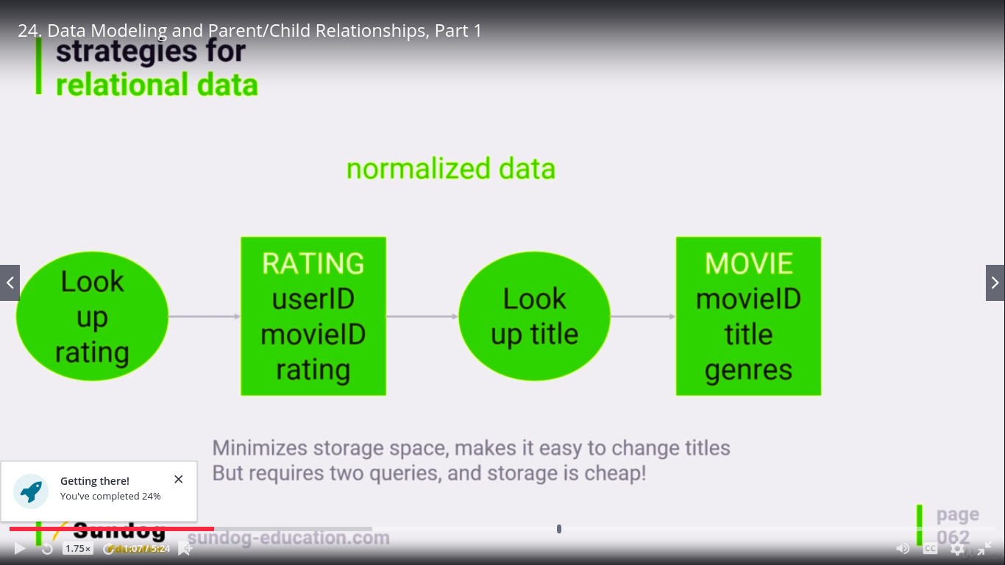
Normalized data

This helps to reduce redundancy of data, and hence save storage.But to display movie ratings with movie title.we need to perform two queries.Since storage is cheaper this days we better reduce page response time by keeping data denormalized.That obviously comes with its own issues, if we need to update movie name we would need to do it everywhere that movieid is used and extra space.
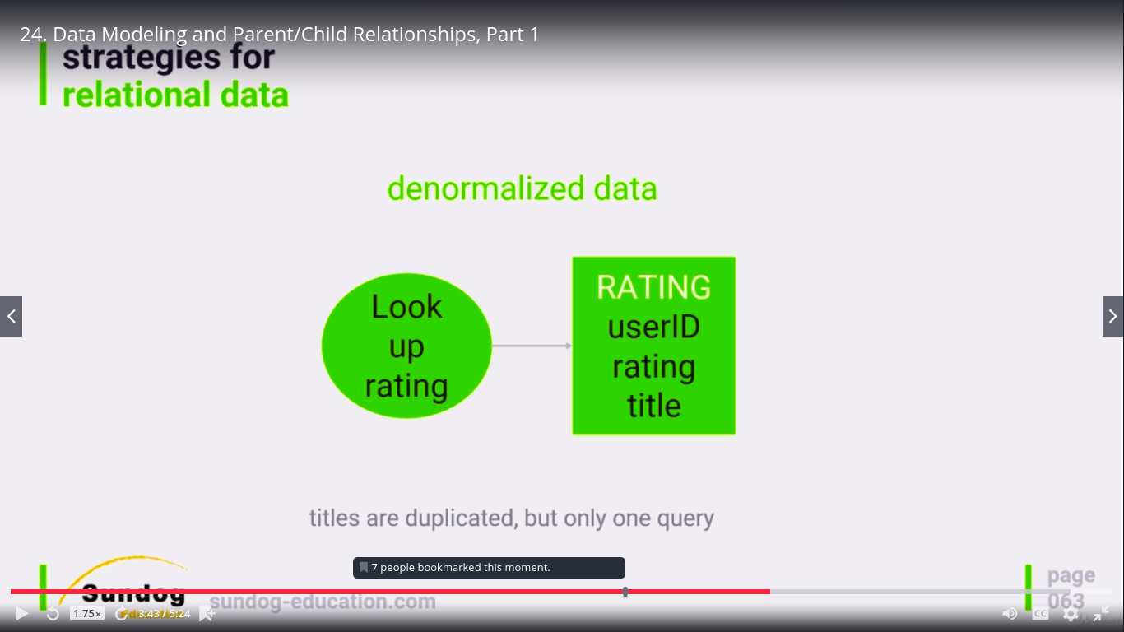

QUERIES

Normal match Query

curl -XGET localhost:9200/movies/_search?pretty -H 'Content-Type: application/json' -d '
{
"query": {
"match":{
"title":"star wars"
}
}
}
'
In response we get star wars, star trek....

Match Phrase

curl -XGET localhost:9200/movies/_search?pretty -H 'Content-Type: application/json' -d '
{
"query": {
"match_phrase":{
"title":"star wars"
}
}
}’

Result : This will only return star wars

Match Phrase with slop

curl -XGET localhost:9200/movies/_search?pretty -H 'Content-Type: application/json' -d '
{
"query": {
"match_phrase":{
"title":{"query": "star beyond","slop":1}
}
}
}’

This will return
star trek beyond.The slop of 1 means the words can be seperated by one word either side.

Proximity Query

curl -XGET localhost:9200/movies/_search?pretty -H 'Content-Type: application/json' -d '
{
"query": {
"match_phrase":{
"title":{"query": "star beyond","slop":1}
}
}
}’

The query with a higher slop.In this case it allows word seperated by over 100 words.But will rate higher the response where words are closer.

PAGINATION

To specify number of response we want per page.and we can also give start index.

curl -XGET localhost:9200/movies/_search?pretty -H 'Content-Type: application/json' -d '
{
"from":2,
"size":2,
"query":{"match":{"genre":"Sci-Fi"}}
}'

SORTING

To perform sorting , if it is numeric field it is very easy.But to perform sorting on an analysed field, it is not possible.as each word index is maintained seperately.so sorting whole string won’t be possible.so we can keep two copies of that field one as analyzed and one as keyword.and we can perform sorting on keyword.But this needs to be decided while we do mapping.

Mapping operation

curl -XGET localhost:9200/movies/ -H 'Content-Type: application/json' -d ' {
“mappings”:{
“properties”:{
“title”:{
“type”:”text”,
“fields”:{
“raw”:{
“type”:”keyword”
}
}
}
}
}
}’

Sorting operation

curl -XGET ‘localhost:9200/movies/ _search?sort=title.raw&pretty’

FILTER

curl -XGET localhost:9200/movies/_search?pretty -H 'Content-Type: application/json' -d '
{
"query":{
"bool":{
"must":{
"match":{"genre":"Sci-Fi"}},
"must_not":{"match":{"title":"trek"}},
"filter":{"range":{"year":{"gte":2010,"lt":2015}}}
}
}
}'

FUZZINESS

Levenshtein edit distance

- substitution (interstellar -> intersteller)
- insertion(interstellar-> intersstellar)
- deletion (interstellar -> interstelar)
all of the above have an edit distance of 1

Fuzzy Query

curl -XGET localhost:9200/movies/_search?pretty -H 'Content-Type: application/json' -d '
{
"query":{
“fuzzy”:{
“title”:{“value”:”intrsteller”,”fuzziness”:2}
}'
}
}’

fuzziness : Auto

0 for 1-2 charcter string
1 for 3-5 charcter string
2 for anything else

curl -XGET localhost:9200/movies/_search?pretty -H 'Content-Type: application/json' -d '
{
"query":{
"fuzzy":{
"title":{"value":"intersatuullar","fuzziness":"AUTO"}
}
}
}'

Logstash.conf Backup

input {
file {
path => "/home/shubham/Desktop/dummy_full.csv"
start_position => "beginning"
sincedb_path => "/dev/null"
}
}
filter {
csv {
separator => "|"
columns => ["sr_No","provider_Name","address","city_Name","state_Name","pin_Code","tel_No","fax_No","provider_No"]
}
}
output {
elasticsearch {
hosts => "http://localhost:9200"
index => "hospital3"
}
stdout{
codec=>rubydebug
}
}

