**Name:SHUBHAM SRIVASTAVA**

**Registration No:-200905152**

**Section:-C**

**Lab 2 : Classes and Objects, Constructors and Static**

**Members**

**Question 1:-Define a class to represent a complex number called Complex.**

**Provide the following methods and write a main method to test the class.:**

**1. To assign initial values to the Complex object.**

**2. To display a complex number in a+ib format.**

**3. To add 2 complex numbers. (the return type should be Complex)**

**4. To subtract 2 complex numbers**

**Solution:-**

import java.io.*;

import java.lang.*;

class Complex

{

double real;

double imag;

public Complex()

{ real

= 0;

imag = 0;

}

public Complex(double real, double imag)

{

this.real = real;

this.imag = imag;

}

public void display(Complex temp)

{

System.out.println("\nResult ="+temp.real+ "+i"+temp.imag);

}

public Complex add(Complex n1, Complex n2)

{

Complex temp = new Complex(0.0, 0.0);

temp.real = n1.real + n2.real;

temp.imag = n1.imag + n2.imag;

display(temp);

return(temp);

}

public Complex subtract(Complex n1, Complex n2)

{

Complex temp = new Complex(0.0, 0.0);

temp.real = Math.abs(n1.real - n2.real);

temp.imag = Math.abs(n1.imag - n2.imag);

display(temp);

return(temp);

}

}

class ComplexDemo

{

public static void main(String[] args)

{

Complex n1 = new Complex(5.0, 1.0);

Complex n2 = new Complex(2.5, 4.0);

Complex temp = new Complex(0,0);

temp.add(n1, n2);

temp.subtract(n1,n2);

}}

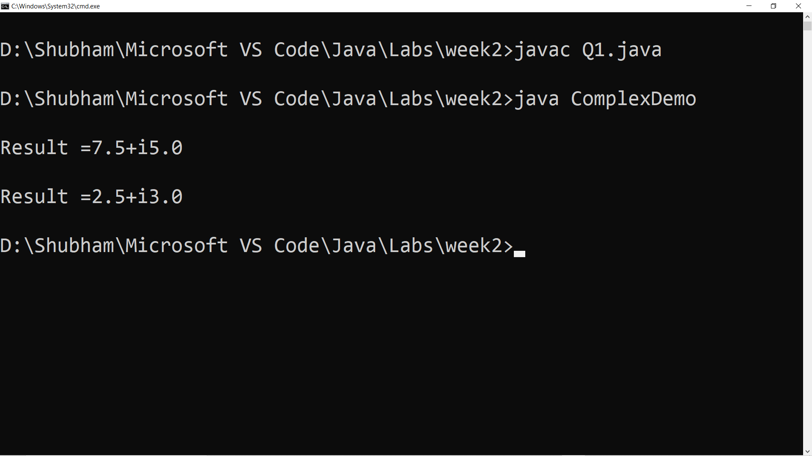

**Question 2:- Create a class called Time that has instance variables to**

**represent hours, minutes and seconds. Provide the following methods and**

**write a main method to test the class.:**

**1. To assign initial values to the Time object.**

**2. To display a Time object in the form of hh:mm:ss {24 hours format}**

**3. To add 2 Time objects (the return type should be a Time )**

**4. To subtract 2 Time objects (the return type should be a Time )**

**5. To compare 2 Time objects and to determine if they are equal or if the**

**first is greater or smaller than the second one.**

**Solution:-**

import java.util.Scanner;

import java.lang.*;

import java.io.*;

class Time

{ int hr; int min; int sec;

public void input(int hr,int min, int sec)

{ this.hr = hr; this.min = min; this.sec = sec;

}

public void add(Time obj1, Time obj2)

{

Time ob = new Time();

ob.hr = obj1.hr+obj2.hr; ob.min = obj1.min+obj2.min; ob.sec =

obj1.sec+obj2.sec;

if(ob.sec>=60)

{

ob.min = ob.min+1;

ob.sec = ob.sec-60;

}

if(ob.min>=60)

{

ob.hr = ob.hr+1;

ob.min = ob.min-60;

}

if(ob.hr>=24)

{

ob.hr = ob.hr-24;

}

display(ob);

}

public void subtract(Time obj1,Time obj2)

{

Time ob = new Time();

ob.hr = (int) Math.abs(obj1.hr-obj2.hr); ob.min = (int)

Math.abs(obj1.min-obj2.min); ob.sec = (int) Math.abs(obj1.secobj2.

sec); display(ob);

}

public void display(Time ob)

{

System.out.println(ob.hr+":"+ob.min+":"+ob.sec);

}

public void compare(Time obj1,Time obj2)

{

if(obj1.hr==obj2.hr&&obj1.min==obj2.min&&obj1.sec==obj2.sec)

{

System.out.println("Both Time are Equal");

}

else if(obj1.hr>obj2.hr){

System.out.println("Time 1 is greater");

}

else if(obj2.hr>obj1.hr){

System.out.println("Time 2 is greater");

}

else

{

if(obj1.min>obj2.min)

{

System.out.println("Time 1 is greater");

}

else if(obj2.min>obj1.min)

{

System.out.println("Time 2 is greater");

}

else

{

if(obj1.sec>obj2.sec)

{

System.out.println("Time 1 is greater");

}

else

{

System.out.println("Time 2 is greater");

}

}

}

}

}

public class TimeMain

{

public static void main(String[] args)

{

Time obj1 = new Time();

Time obj2 = new Time();

Time ob = new Time();

obj1.input(9,49,39);

obj2.input(2,6,9);

ob.compare(obj1,obj2);

ob.add(obj1,obj2);

ob.subtract(obj1,obj2);

}

}

**Question 3:-Consider the already defined Complex class. Provide a default**

**constructor and parameterized constructor to this class. Also provide a display**

**method. Illustrate all the constructors as well as the display method by defining**

**Complex objects**

Solution:- Done in Question 1.

**Question 4:- Create a class called Counter that contains a static data**

**member to count the number of Counter objects being created. Also define**

**a static member function called showCount() which displays the number of**

**objects created at any given point of time. Illustrate this**

**Solution:**

import java.util.Scanner;

class Counter

{ static int count = 0;

Counter()

{

count++;

}

public static void showCount()

{

System.out.println("Count = "+count);

}

}

class CounterDemo

{ public static void main(String[] args)

{

Scanner sc = new Scanner(System.in);

System.out.println("Enter Number of Objects to be created : ");

int n = sc.nextInt();

Counter obj[] = new Counter[n];

for(int i = 0 ; i < n ; i++)

{

obj[i] = new Counter();

obj[i].showCount();

}

}

} 