**SQL Assignment**

**Submitted by**-Shubham Sharma AU’21 Delhi Group

1. **Create Student Database**

CREATE DATABASE Student;

USE Student;

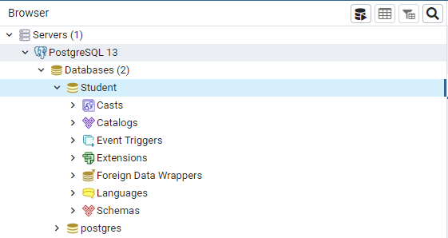

1. **Create the following table under the Student Database:**
   1. **StudentBasicInformation**

**i. Columns**

* + - 1. **StudentName**
      2. **StudentSurname**
      3. **StudentRollNo**
      4. **Add more four basic columns of the name of your own**

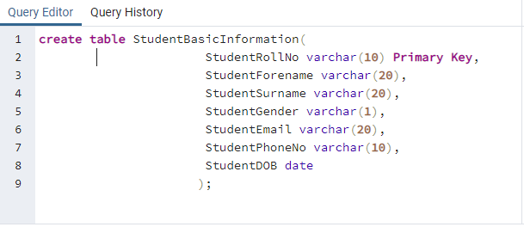

* 1. **StudentAdmissionPayment**

**i. Columns**

* + - 1. **StudentRollNo**
      2. **AmountPaid**
      3. **AmountBalance**
      4. **Add more four basic columns of the name of your own**

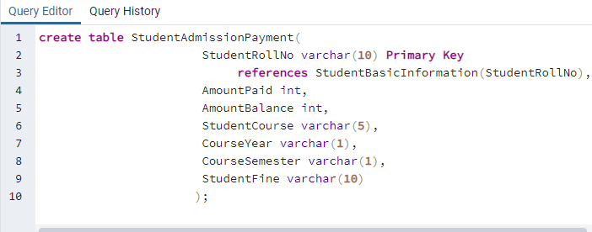

**c. StudentSubjectInformation**

* + 1. **Columns**
       1. **SubjectOpted**
       2. **StudentRollNo**
       3. **SubjectTotalMarks**
       4. **SubjectObtainedMarks**
       5. **StudentMarksPercentage**
       6. **Add more one columns of the name of your own**

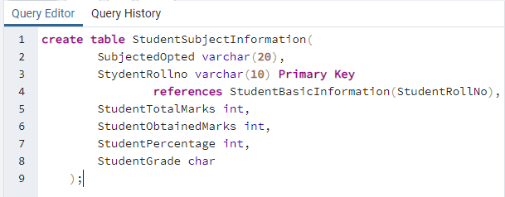

**d. SubjectScholarshipInformation**

* + 1. **Columns**
       1. **StudentRollNo**
       2. **ScholarshipName**
       3. **ScholarshipDescription**
       4. **ScholarshipAmount**
       5. **ScholarshipCategory**
       6. **Add more two columns of the name of your own**

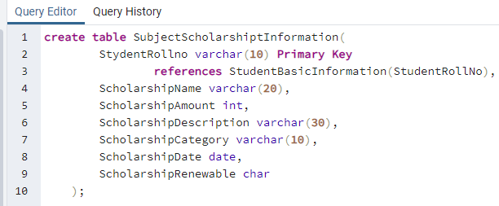

1. **Insert more than 10 records in each and every table created**

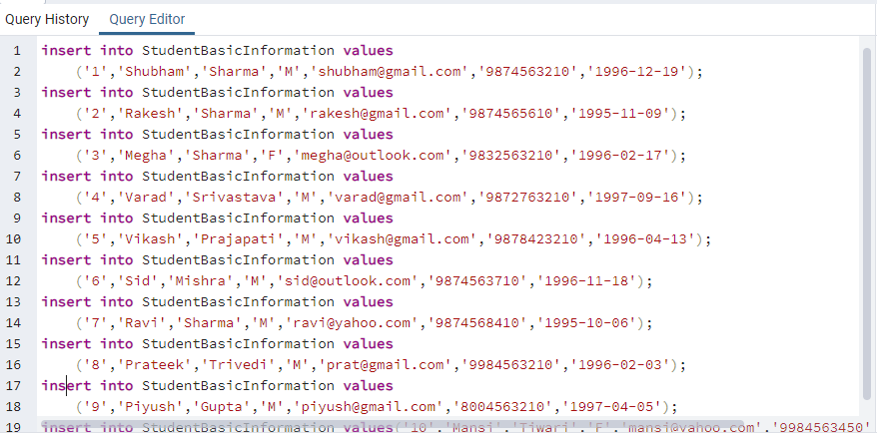

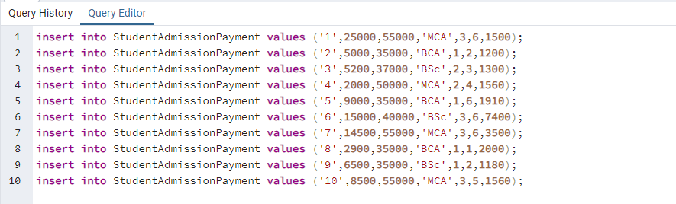

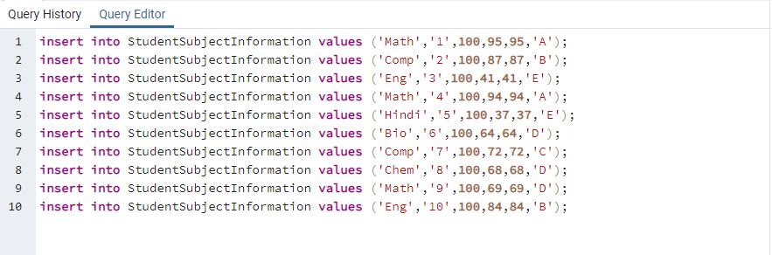

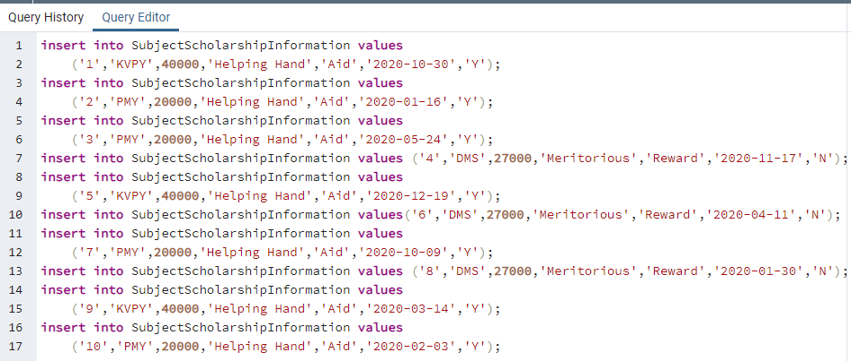

1. **Snap of the all the tables once the insertion is completed**

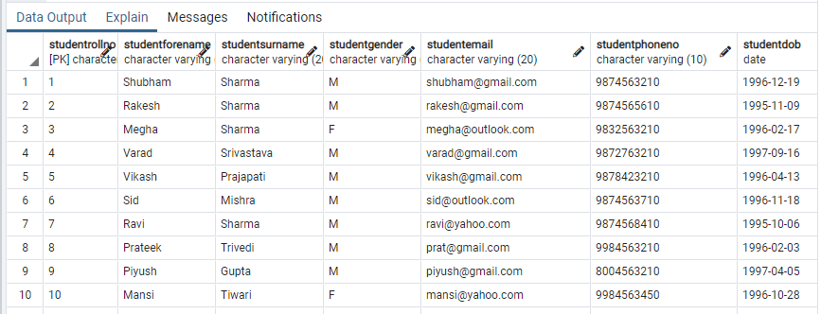

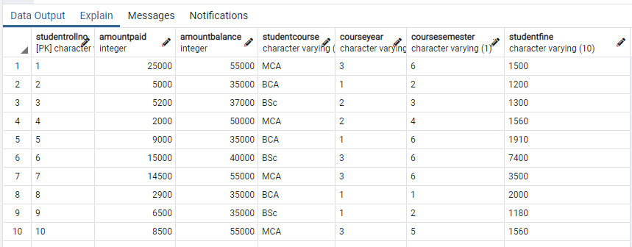

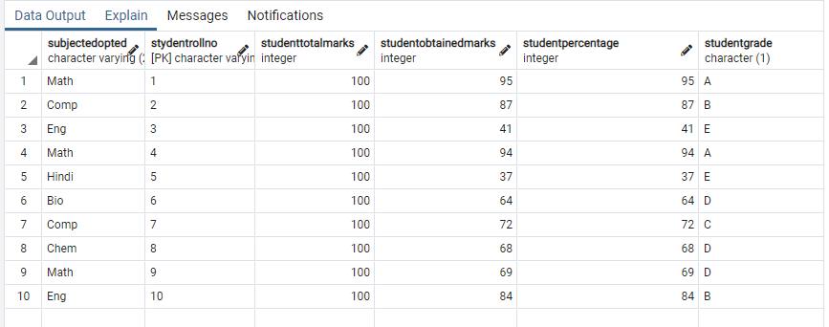

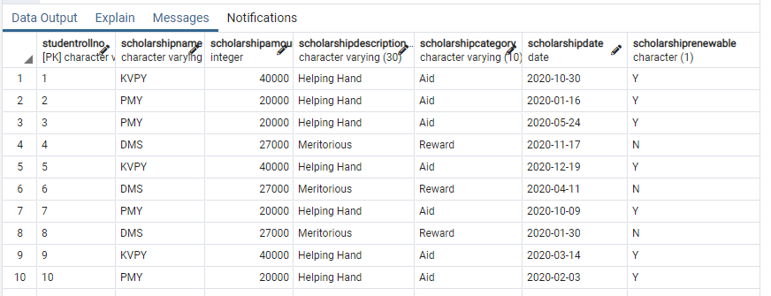

1. **Update any 5 records of your choice in any table like update the StudentAddress with some other address content and likewise so on with any records of any table of your choice**











1. **Snap of the all the tables post updation**

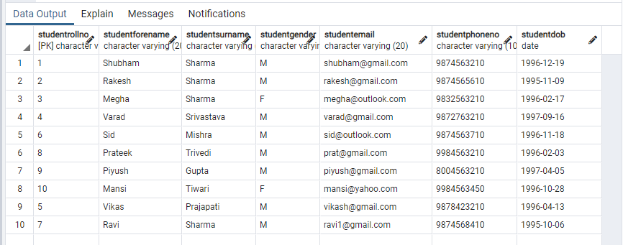

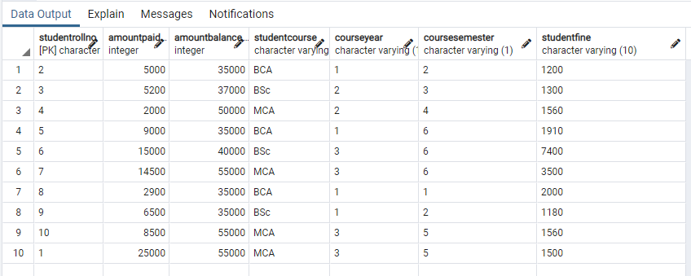

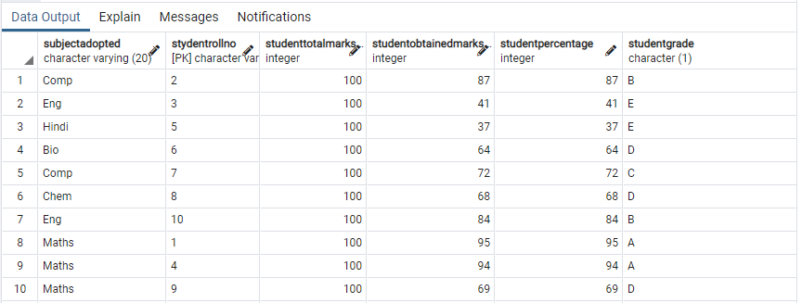

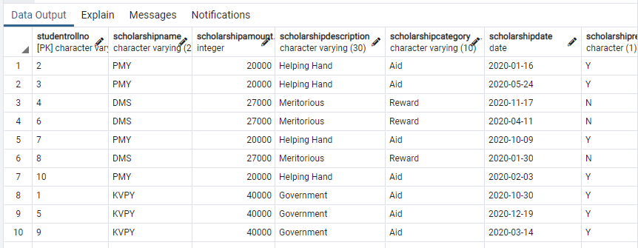

1. **Select the student details records who has received the scholarship more than 5000Rs/-**

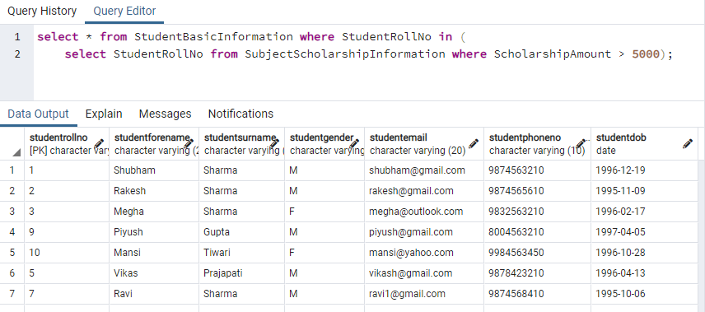

1. **Select the students who opted for scholarship but has not got the scholarship**

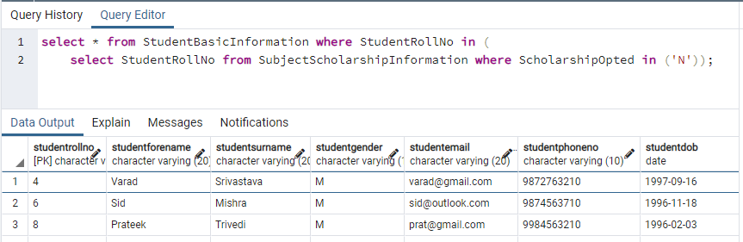

1. **Fill in data for the percentage column i.e. StudentMarksPercentage in the table StudentSubjectInformation by creating and using the stored procedure created**

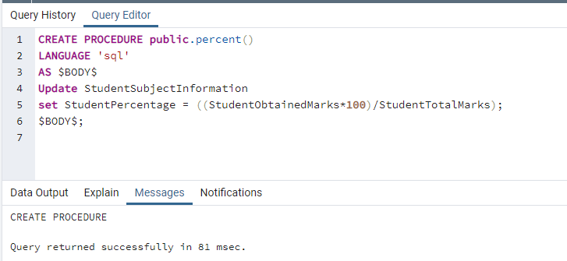

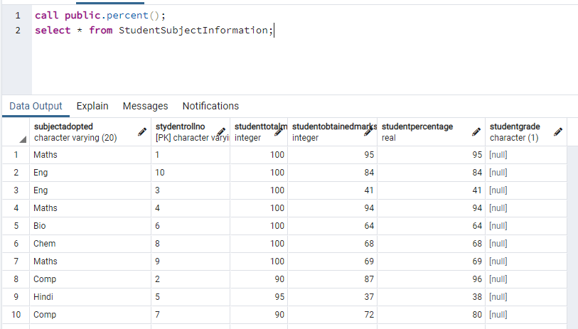

1. **Decide the category of the scholarship depending upon the marks/percentage obtained by the student and likewise update the ScholarshipCategory column, create a**

**stored procedure in order to handle this operation**

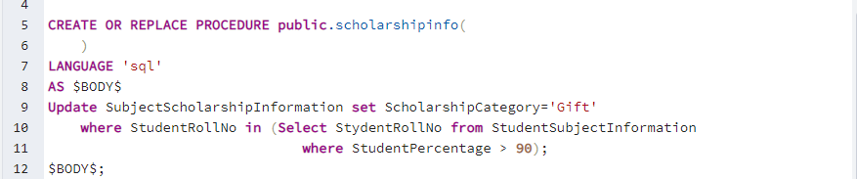

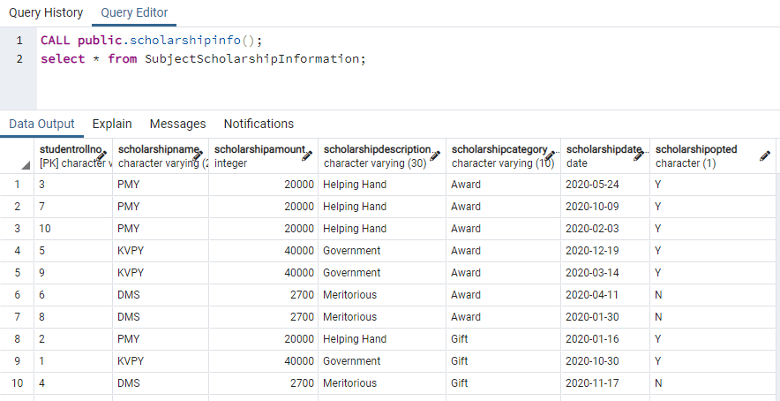

1. **Create the View which shows balance amount to be paid by the student along with the student detailed information (use join)**

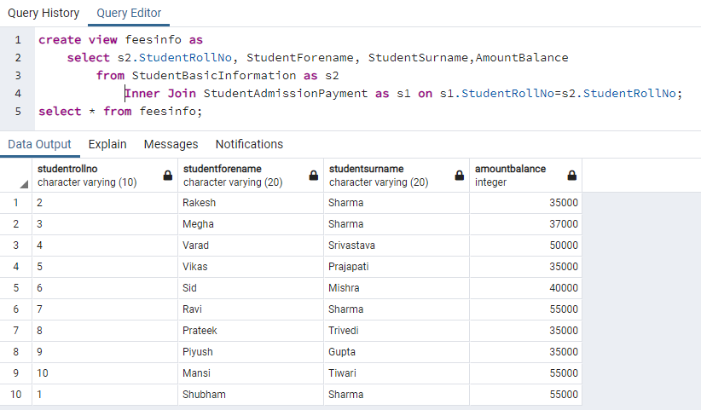

1. **Get the details of the students who haven’t got any scholarship (use joins/subqueries)**

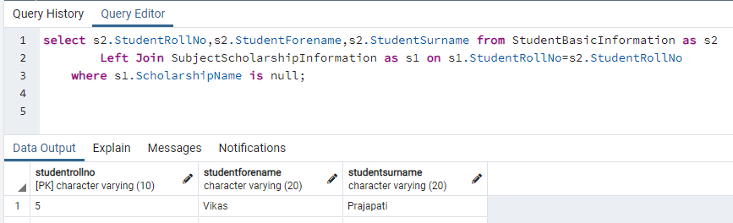

1. **Create Stored Procedure which will be return the amount balance to be paid by the student as per the student roll number passed through the stored procedure as the input**

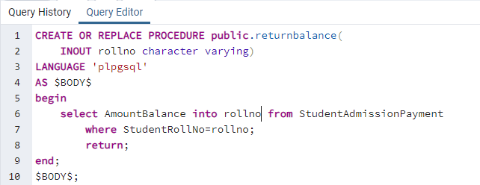

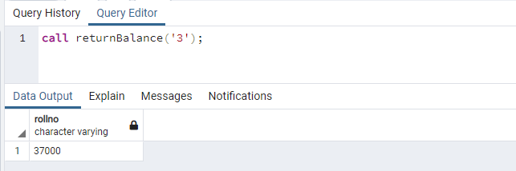

1. **Retrieve the top five student details as per the StudentMarksPercentage values (use subqueries)**

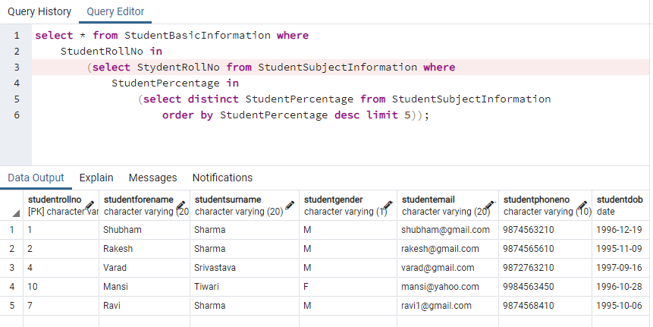

1. **Try to use all the three types of join learned today in a relevant way, and explain the same why you thought of using that particular join for your selected scenarios (try to cover relevant and real time scenarios for all the three studied joins)**



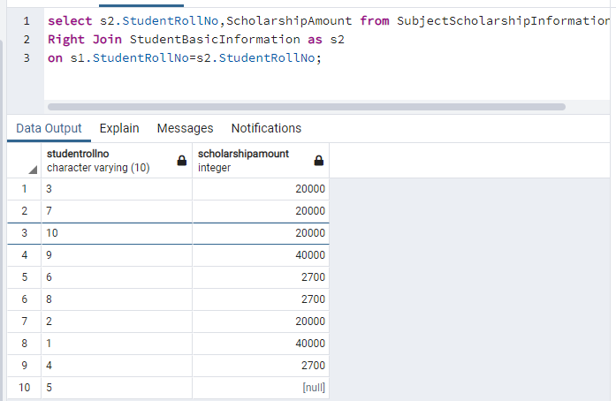



1. **Mention the differences between the delete, drop and truncate commands.**

**1.DELETE:**Basically, it is a Data Manipulation Language Command (DML). It is use to delete the one or more tuples of a table. With the help of “DELETE” command we can either delete all the rows in one go or can delete row one by one. i.e., we can use it as per the requirement or the condition using Where clause. It is comparatively slower than TRUNCATE cmd.

**Note –**  
Here we can use the “ROLLBACK” command to restore the tuple.

**2.DROP:**It is a Data Definition Language Command (DDL). It is use to drop the whole table. With the help of “DROP” command we can drop (delete) the whole structure in one go i.e., it removes the named elements of the schema. By using this command, the existence of the whole table is finished or say lost.

**Note –**  
Here we can’t restore the table by using the “ROLLBACK” command.

**3.TRUNCATE:**It is also a Data Definition Language Command (DDL). It is use to delete all the rows of a relation (table) in one go. With the help of “TRUNCATE” command we can’t delete the single row as here WHERE clause is not used. By using this command, the existence of all the rows of the table is lost. It is comparatively faster than delete command as it deletes all the rows lastly.

**Note –**  
Here we can’t restore the tuples of the table by using the “ROLLBACK” command.

1. **Get the count of the Scholarship category which is highly been availed by the students, i.e., get the count of the total number of students corresponding to each scholarship’s category**

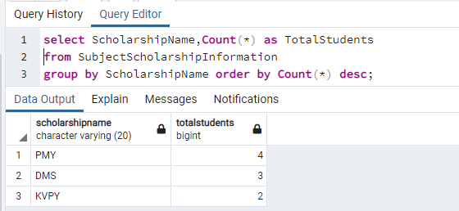

1. **Along with the assignment no. 17 try to retrieve the maximum used scholarship category**

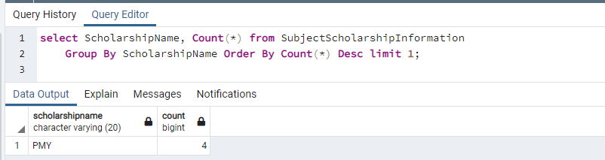

1. **Retrieve the percentage of the students along with students detailed information who has scored the highest percentage along with availing the maximum scholarship amount**

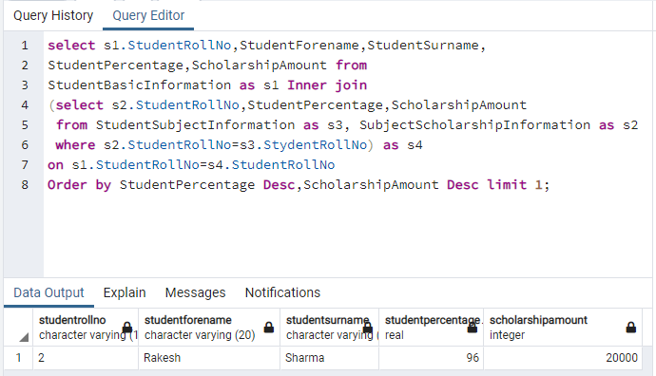

1. **Difference between the Triggers, Stored Procedures, Views and Functions**

**Stored Procedures-** Stored Procedures are pre-compiled objects which are compiled for the first time and its compiled format is saved, which executes (compiled code) whenever it is called. Even a procedure can return zero or n values.

**Functions-** A function is compiled and executed every time whenever it is called. A function must return a value and cannot modify the data received as parameters.

**Views-** A view is a database object that is of a stored query. A view can be accessed as a virtual table in PostgreSQL. In other words, a PostgreSQL view is a logical table that represents data of one or more underlying tables through a SELECT statement.

**Triggers-** A trigger is a set of actions that are run automatically when a specified change operation (SQL INSERT, UPDATE, DELETE or TRUNCATE statement) is performed on a specified table. Triggers are useful for tasks such as enforcing business rules, validating input data, and keeping an audit trail.