**Selenium Remote Control (RC)**

Is a test tool that allows you to write automated web application UI tests in any programming language against any HTTP website using any mainstream JavaScript-enabled browser.

Selenium RC comes in two parts.

A server which automatically launches and kills browsers, and acts as a HTTP proxy for web requests from them.

Client libraries for your favourite computer language.

Here is a simplified architectural representation....

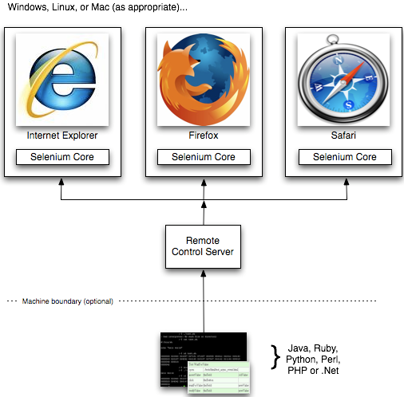

java -jar selenium-server-standalone-<version-number>.jar