A PROJECT REPORT ON
EXAMEASE
— An NLP and Artificial Intelligence Powered Automated Examination Question Generation System —
Submitted in partial fulfilment of the requirements for the award of the degree of
BACHELOR OF ENGINEERING (B.E.)
in
COMPUTER ENGINEERING
Submitted by
SHUBHAM DALVI
Roll No. : ______________
B.E. (Computer Engineering)
Under the guidance of
PROF. ____________________
Assistant Professor, Department of Computer Engineering
DEPARTMENT OF COMPUTER ENGINEERING
________________________________ College of Engineering
University of Mumbai
2026 - 2027
October 2026

________________________________ College of Engineering
Department of Computer Engineering
(Affiliated to University of Mumbai)
CERTIFICATE

This is to certify that the project entitled “ExamEase — An NLP and Artificial Intelligence Powered Automated Examination Question Generation System” is a bonafide record of the work carried out by Shubham Dalvi (Roll No. ______________), a student of the final year of the Bachelor of Engineering (B.E.) programme in Computer Engineering, during the academic year 2026 - 2027.
The work presented in this report has been carried out under my supervision in the Department of Computer Engineering of this institute. The candidate has completed the design, implementation and testing of the system described here, and the report has been prepared in accordance with the guidelines prescribed by University of Mumbai.
To the best of my knowledge, the content of this report has not been submitted earlier, either in part or in full, to any other institute or university for the award of any degree or diploma.

Signature of the Guide  Prof. ____________________  Assistant Professor, Department of Computer Engineering | Signature of the Head of Department  Prof. ____________________  Head, Department of Computer Engineering | Signature of the Principal  Dr. ____________________  Principal

External Examiner : ______________________________
Date of Examination : ______________________________
Place : Mumbai

DECLARATION
I hereby declare that the project report entitled “ExamEase — An NLP and Artificial Intelligence Powered Automated Examination Question Generation System” submitted by me to the Department of Computer Engineering, ________________________________ College of Engineering, is a record of original work carried out by me under the guidance of Prof. ____________________. All the sources of information, algorithms, libraries and research papers that have been referred to during this work are duly acknowledged in the references section of this report.
I further declare that the implementation presented in this report — namely the deterministic natural language processing pipeline, the grounded question generation layer, the validation and de-duplication logic and the web application that integrates them — has been developed by me and that the report is free of any form of plagiarism.

Shubham Dalvi
Roll No. : ______________
B.E. (Computer Engineering)

Date : ______________
Place : Mumbai

ACKNOWLEDGEMENT
It gives me immense pleasure to present the final year project report on “ExamEase”. The journey from understanding the problem of automated question paper generation to building a working natural language processing pipeline and a complete web platform has been deeply enriching, and it would not have been possible without the guidance and support that I received at every stage.
I express my sincere gratitude to my project guide, Prof. ____________________, Assistant Professor, Department of Computer Engineering, for the continuous supervision, encouragement and constructive criticism that shaped this work. The detailed reviews on linguistic pre-processing and on the ethical use of generative models were particularly valuable.
I am thankful to Prof. ____________________, Head, Department of Computer Engineering, for providing the laboratory facilities, the necessary infrastructure and a research friendly environment in which this project could be carried out. I also thank the entire teaching and non teaching staff of the department for their cooperation.
I would like to acknowledge the open source community behind the Next.js, React, MongoDB and Google GenAI tool chains, and the authors of the classical NLP literature whose algorithms — tokenisation, stemming, part of speech tagging and n-gram analysis — form the deterministic core of this system.
Finally, I thank my family and friends for their patience, motivation and constant support throughout the duration of this project.

Shubham Dalvi
Roll No. : ______________

ABSTRACT
Preparing objective examinations is one of the most repetitive tasks in academic practice. For every unit of a syllabus, a teacher has to read the prescribed material, identify the concepts that deserve to be assessed, write a question for each concept, invent three plausible but incorrect options, and finally record an explanation that justifies the correct answer. When this exercise is repeated for several subjects and semesters, the effort becomes significant and the quality of the resulting question papers becomes inconsistent.
This report presents the design, implementation and evaluation of ExamEase, a web based system that converts raw lecture notes, textbook chapters and research papers into syllabus grounded multiple choice questions. The system follows a hybrid architecture. In the first stage, a deterministic natural language processing pipeline of seven stages — text normalisation, sentence segmentation, tokenisation with stopword filtering, lemmatisation, rule based part of speech tagging with noun phrase chunking, n-gram frequency extraction, and concept scoring with definition detection — analyses the document and produces a ranked list of concepts together with the sentences that support each concept. In the second stage, a large language model receives only this scored concept evidence and is constrained by a strict prompt to generate questions that are traceable to the supplied material. The generated items then pass through an automated validation and de-duplication layer that guarantees exactly four options, exactly one correct answer, a stored concept citation and a lexical similarity check based on the Jaccard coefficient of lemmatised token sets.
Because scanned pages, photocopied handouts and documents that use custom font encodings such as Identity-H break conventional PDF parsers, the ingestion stage uses a multimodal vision model to transcribe documents, whether they are typed, scanned or handwritten, into clean academic text before any linguistic processing begins.
The system has been implemented as a Next.js application with React on the client, route handlers on the server, and MongoDB as the document store. Teacher accounts are protected with salted password hashing and stateless JSON Web Token sessions stored in HTTP only cookies. The system was evaluated on a representative lecture note of fifty two sentences containing eight hundred and eighty one tokens; the pipeline extracted three hundred and ninety three unique terms, detected twenty eight definition sentences and returned twenty five scored concepts, and the de-duplication layer removed every candidate pair whose similarity exceeded the configured threshold of 0.65. The results indicate that combining deterministic linguistic analysis with a grounded generator produces questions that remain faithful to the uploaded material while reducing the preparation time of an examination by a substantial margin.
Keywords : Natural Language Processing, Automated Question Generation, Part of Speech Tagging, Lemmatisation, N-gram Analysis, Jaccard Similarity, Grounded Generation, Large Language Model, Optical Character Recognition, MongoDB, Next.js.

TABLE OF CONTENTS
Right click and choose 'Update Field' to build this list.
MS Word builds this list automatically when the document is opened; if it stays blank, click inside the field and press F9 (or Ctrl + A then F9).

LIST OF FIGURES
Right click and choose 'Update Field' to build this list.
Every figure is inserted with a Caption styled paragraph, so Word populates this list with page numbers after the fields are updated.

LIST OF TABLES
Right click and choose 'Update Field' to build this list.
Table captions use a dedicated TableCaption style so that they are collected separately from the figures.

LIST OF ABBREVIATIONS
AI | Artificial Intelligence
API | Application Programming Interface
CID | Character Identifier (PostScript font encoding)
CRUD | Create, Read, Update, Delete
CSS | Cascading Style Sheets
DFD | Data Flow Diagram
ER | Entity Relationship
HTTP | Hyper Text Transfer Protocol
IDF | Inverse Document Frequency
JWT | JSON Web Token
LLM | Large Language Model
MCQ | Multiple Choice Question
MIME | Multipurpose Internet Mail Extensions
NLP | Natural Language Processing
NN | Noun (POS tag)
NNP | Proper Noun (POS tag)
OCR | Optical Character Recognition
PDF | Portable Document Format
POS | Part of Speech
REST | Representational State Transfer
SRS | Software Requirements Specification
TF | Term Frequency
TOC | Table of Contents
UI | User Interface
UML | Unified Modelling Language
URL | Uniform Resource Locator
XSS | Cross Site Scripting

ORGANISATION OF THE REPORT
The report is organised into nine chapters supported by four appendices. The contents of each chapter are summarised below so that the reader can navigate the document quickly.
• Chapter 1 – Introduction : introduces the domain of automated assessment, states the problem, lists the objectives and defines the scope of the work.
• Chapter 2 – Literature Survey : reviews classical natural language processing literature, automated question generation approaches, document extraction techniques and existing tools, and identifies the research gap.
• Chapter 3 – System Analysis and Design : presents the existing system, the proposed architecture, use case analysis, data flow diagrams and the hardware and software requirements.
• Chapter 4 – Methodology and Implementation : explains the seven stage linguistic pipeline, the grounded prompt design, the service layer, validation logic and de-duplication in detail with algorithms and diagrams.
• Chapter 5 – Database Design : documents the MongoDB collections, relationships, indexes and data integrity rules.
• Chapter 6 – Results and Discussion : reports the measured behaviour of the pipeline on a sample document, the quality of extracted concepts, the de-duplication results, sample generated questions and a comparison with existing tools.
• Chapter 7 – Security and Performance : describes authentication, input validation, document privacy, connection pooling and the performance practices adopted.
• Chapter 8 – System Implementation and Testing : shows the screens of the running application and the unit, integration and boundary test cases together with their outcomes.
• Chapter 9 – Conclusion and Future Scope : summarises the achievements, maps them to the stated objectives and lists the possible extensions.
• Appendices : contain the REST API reference, the environment configuration, the project timeline and the source code of the core modules.

Chapter 1 Introduction

1.1 Introduction
Assessment is the closing loop of every teaching activity. A teacher explains a unit, and an examination verifies whether the learner has internalised the concepts of that unit. Among the formats available for objective assessment, the multiple choice question occupies a special place because it can be marked automatically, it can be administered to a large group simultaneously, and its statistics lend themselves to quantitative analysis of learning outcomes.
The construction of a good multiple choice question, however, is a skilled task. The question stem must isolate exactly one idea; the three distractors must be plausible enough to attract a partially informed learner, yet unambiguously wrong to a fully informed one; and the question must be traceable to the prescribed material, otherwise it will be challenged in the answer script review. ExamEase is a web platform that assists the teacher in exactly this task: it reads the prescribed document, applies a deterministic linguistic analysis to discover what the document is actually about, and then asks a large language model to write questions that are strictly grounded in the extracted evidence.
The distinguishing feature of the proposed system is the order in which the two technologies are applied. Rather than sending an entire document to a generative model and hoping that the model respects the syllabus, the system first reduces the document to a small, auditable set of scored concepts with their supporting sentences. Only this reduced evidence is shown to the model. The model therefore cannot introduce a topic that the pipeline did not detect, and every generated question can be traced back to a specific sentence of the uploaded document.

1.2 Background and Motivation
Two independent trends make this project timely. The first is the maturing of classical natural language processing. Algorithms such as the Porter stemmer, rule based part of speech tagging and n-gram frequency analysis have been known for decades, but they are now easy to implement in a few hundred lines of TypeScript and they run in milliseconds without any external service. The second trend is the arrival of instruction following large language models that can produce well formed assessment items on demand, provided that the instructions are precise and the evidence supplied to the model is relevant.
The motivation for the project comes from a practical observation. When teachers were asked to prepare objective question banks for a semester, the recurring difficulties were the time required to write distractors, the risk of repeating the same concept in slightly different wording, and the difficulty of ensuring that every question of the paper corresponds to the prescribed syllabus rather than to the teacher's own reading of related literature. A system that automates the tedious portion of this work while keeping the teacher in control of the final artefact addresses all three difficulties.

1.3 Problem Statement
The problem addressed by this project can be stated formally as follows.
Given a digital document D in the form of a lecture note, textbook chapter or examination oriented handout, produce a set of N multiple choice questions Q = {q1, q2, ... qN} such that
• every question qi has exactly four options, exactly one of which is correct;
• every question qi is supported by at least one sentence of D, and the supporting concept is recorded along with the question so that a reviewer can verify it;
• no two questions of Q assess the same concept with the same wording, that is, the lexical similarity of any pair of questions remains below a configured duplicate threshold;
• the difficulty distribution of Q follows the difficulty selected by the teacher; and
• the entire operation completes within a few seconds for a document of ordinary size.
In addition to the generation problem, the system must solve an ingestion problem. A considerable proportion of real academic documents are scanned images, photocopies or files that use embedded font encodings in which the extracted character codes do not correspond to the visible glyphs. Conventional text extraction libraries return either an empty string or a stream of meaningless tokens for such documents, which makes any downstream linguistic analysis impossible. The ingestion stage of the system must therefore be robust to the physical form of the document.

1.4 Objectives of the Project
• To design and implement a deterministic natural language processing pipeline that normalises a raw academic document, segments it into sentences, tokenises and lemmatises it, tags it with parts of speech, extracts noun phrases and n-grams, and ranks its concepts with an interpretable importance score.
• To extract explicit definitional statements from the document so that the questions generated from those sentences reflect the definitions actually used in the prescribed material.
• To build a universal document ingestion service that can transcribe typed, scanned, handwritten and non standard encoded documents into clean academic text.
• To design a strictly grounded generation layer in which the language model receives only the scored concepts and their supporting sentences, so that no fact outside the source document can enter a question.
• To implement an automated quality layer that validates the structure of every generated question and removes near duplicate items using lexical similarity.
• To develop a complete web application with teacher authentication, subject management, an interactive inspector of the linguistic analysis, an editable preview of the generated questions, a student examination interface and automated scoring with analytics.
• To evaluate the system on a representative academic document and report the measured behaviour of every stage of the pipeline.

1.5 Scope of the Project
The scope of the present work is deliberately limited to objective assessment in the multiple choice format for text based academic material. The system accepts documents in the Portable Document Format, either uploaded as a file or supplied as pasted text, and it produces question sets that are stored in a document database and shared with students through a link.
The system supports the following in its present form.
• ingestion of PDF documents of up to several hundred pages, whether text based, scanned or handwritten;
• generation of between one and fifty questions per set in easy, medium, hard or mixed difficulty;
• teacher accounts with subject, semester and department attributes;
• in place editing and regeneration of individual questions before the set is saved;
• public test taking through a shareable link, followed by automatic scoring and a detailed answer review; and
• persistence of every attempt so that historical performance can be reviewed.
The following aspects are outside the scope of the present work and are listed in the future scope chapter : the generation of descriptive or programming questions, adaptation of difficulty during a live attempt, export of question papers to word processor or learning management system formats, and class level analytics with leaderboards.

1.6 Novelty and Contribution
The contribution of this project lies in the combination of techniques rather than in the invention of a new algorithm. Four aspects deserve emphasis.
• Deterministic evidence selection before generation. Most question generation tools send a chunk of text to a language model. In this system the text is first reduced to a ranked concept list with supporting sentences, and the model sees only that list. The reduction is performed by transparent, reproducible rules that a teacher can inspect.
• An inspectable analysis. The interface exposes the intermediate linguistics of the document: the number of sentences and tokens, the unique vocabulary size, the detected definition sentences, the ranked concepts and the frequency of unigrams, bigrams and trigrams. A teacher can therefore understand why a particular question was generated.
• Document form independence. Because ingestion relies on a multimodal transcription step instead of a textual PDF parser, the pipeline behaves identically for a typed page, a scanned page and a handwritten note, and it is unaffected by font encodings such as Identity-H that defeat conventional parsers.
• Automated quality enforcement. Structural validation and lexical de-duplication are performed on the server before the teacher sees the questions, so the preview screen contains only items that already satisfy the format contract of the system.

1.7 Organisation of the Report
Chapter 2 surveys the literature of classical natural language processing, automated question generation and document extraction, and compares existing tools. Chapter 3 presents the analysis of the existing system and the design of the proposed architecture with use case and data flow models. Chapter 4 documents the methodology and implementation of the linguistic pipeline, the grounded generation layer and the quality enforcement layer. Chapter 5 describes the database design. Chapter 6 reports the results obtained on a representative document and discusses them. Chapter 7 covers security and performance practices. Chapter 8 presents the implemented screens and the test cases with their outcomes. Chapter 9 concludes the report and lists the future scope. Appendices provide the API reference, the deployment instructions, the project timeline and the source code of the core modules.

Chapter 2 Literature Survey

2.1 Introduction
This chapter reviews the body of work on which the project builds. The survey is organised in five parts: the classical linguistic techniques that constitute the deterministic core of the system, the approaches reported in the literature for automatic question generation, the techniques available for extracting text from academic documents, the question of controlling a generative model so that it does not depart from the supplied material, and finally the existing software tools that a teacher could use today. The chapter closes with the research gap that motivates the proposed design.

2.2 Classical Natural Language Processing Techniques
Tokenisation is the oldest operation of computational linguistics. The word based regular expression tokeniser used in this project follows the classical convention of treating a sequence of alphanumeric characters as a token, with the refinement that hyphenated sequences such as state-of-the-art and client-server are preserved as single tokens, because in technical writing a hyphenated compound frequently denotes one term rather than a sequence of two words.
Stopword removal is normally treated as a matter of domain judgement rather than of grammar. The classic observation is that the high frequency function words of English carry little discriminative information, and that removing them reduces the size of the index without materially affecting retrieval quality. In an academic document the same argument applies with one important qualification: the noise produced by a broken PDF, such as the words obj, endobj, stream, flatedecode and cidfont, behaves statistically exactly like a stopword and must therefore be filtered by the same mechanism.
Stemming and lemmatisation constitute the morphological layer. The Porter stemmer remains the reference algorithm for rule based suffix stripping; it maps related forms such as analysis, analyses and analysing to a common stem. Its known weakness is that it operates without a lexicon, so it can produce a stem that is not an English word. Lemmatisation solves this weakness by consulting a dictionary of irregular forms, at the cost of requiring that dictionary. The present system uses lemmatisation for the computations that a teacher will inspect, namely concept normalisation and duplicate comparison, and keeps the stemmer available for the n-gram statistics.
Part of speech tagging in the classical tradition is performed either by hidden Markov models trained on annotated corpora or by rule based taggers. A rule based tagger assigns a category from the morphological shape of the word and from its position in the sentence, for instance treating a capitalised token that does not begin a sentence as a proper noun, and treating a token ending in -tion as a noun. The accuracy of a rule based tagger is lower than that of a statistical tagger, but it is deterministic, it requires no model file, and its rules can be explained to a teacher, which is the design priority here.
Noun phrase chunking converts a sequence of tagged tokens into candidate terminology. The pattern commonly used for technical text is an optional sequence of adjectives followed by one or more nouns, which captures multi word terms such as distributed operating system, relational database management system and lexical similarity threshold. Chunking is important for question generation because a concept that is extracted as a whole phrase yields a far better question stem than a concept extracted as an isolated noun.
N-gram frequency analysis extends the same idea to unigrams, bigrams and trigrams and is the standard method for detecting domain terminology without a domain lexicon. A recurring three word sequence in a lecture note is very likely to be the name of a technique, and the present system uses the trigram list both as an internal signal and as an element of the inspector that the teacher can read.

2.3 Approaches to Automatic Question Generation
The literature on automatic question generation can be grouped into three generations of techniques.
Rule based generation transforms a declarative sentence into a question by syntactic manipulation. A sentence of the form “X is defined as Y” is converted into the stem “What is X?” with Y as the key and other terms of the sentence as distractors. This family of techniques is fully transparent and never produces a fact that is absent from the source, but its questions tend to be repetitive and its distractors are frequently too easy to eliminate.
Statistical and template driven generation selects sentences by an informativeness criterion, for example a high term frequency and inverse document frequency score, and then instantiates a small set of question templates. Such systems scale well but they inherit the rigidity of their templates, and the resulting items often test lexical recall rather than conceptual understanding.
Transformer based generation has become the dominant approach since encoder decoder models were shown to produce fluent questions. The difficulty reported consistently in this literature is faithfulness: a sequence to sequence model has no obligation to stay inside the source document, and it will happily produce a question about a fact that merely resembles the source. Techniques proposed to control faithfulness include restricting the decoder to an answer span, providing the model with a retrieved evidence set rather than a whole document, and validating the output against the source with an entailment model. The design adopted in this project belongs to the second of these techniques, extended with an explicit deterministic evidence selection step.

2.4 Extraction of Text from Academic Documents
Text extraction from a PDF is a well known source of hidden failures. A PDF is a graphical format, not a text format; the visible text is a sequence of glyph drawing instructions. A parser reconstructs text by reading the content streams and decoding the font encoding tables. This works when the file is produced by a word processor with standard encodings, but fails in three common academic situations. Scanned pages contain no text objects at all, only images. Documents produced by certain desktop publishing tools use subset fonts with an Identity-H encoding in which the byte values do not correspond to the visible characters, so the parser returns a plausible but wrong string. Typeset mathematical material frequently renders a formula as a sequence of positioned glyphs whose reading order does not follow the visual order.
The response of the research community to these problems has been optical character recognition, historically with a page layout analysis stage followed by a character classifier, and more recently with multimodal neural models that accept the page image and emit structured text. The second family of techniques is used in this project because it handles typed, scanned and handwritten pages with the same code path, and because it can be asked to preserve headings, lists and paragraph structure, which the downstream sentence segmentation benefits from.

2.5 Controlling a Generative Model of Question Writing
Three techniques for keeping a generative model close to its source are relevant to this project. Temperature reduction lowers the randomness of sampling and therefore makes a model repeat the most probable continuation instead of an inventive one; the values used in this system are 0.3 for bulk generation and 0.4 for the regeneration of a single item. Schema constrained decoding forces the decoder to emit a document that conforms to a supplied JSON schema, which removes the class of errors in which a model wraps its answer in prose; the system requests a JSON response type explicitly and still defers to a sanitising layer, because a schema constrains the shape of the output and not its truth. Evidence grounding, finally, restricts the input of the model to retrieved fragments rather than the whole document. This last technique is implemented here in its strict form: the model receives the concept names with their importance scores and the sentences that the pipeline associated with each concept, and nothing else.

2.6 Review of Existing Tools and Comparison
A teacher who wants to automate question preparation today has four broad options: general purpose chat assistants, dedicated quiz generators that operate on pasted text, learning management systems with a question bank feature, and classical rule based question generators. Table 2.1 compares these options with the proposed system along the dimensions that matter for academic use.
Table 2.1 : Comparison of the proposed system with existing categories of tools
Criterion | General chat assistants | Text based quiz generators | LMS question banks | Proposed system (ExamEase)
Handles scanned or handwritten documents | Partially, one page at a time | No | No | Yes, whole document
Handles non standard font encodings | Partially | No | No | Yes
Evidence supplied to the generator | Whole conversation | Whole pasted text | Manual entry | Only scored concepts and their sentences
Intermediate linguistic analysis visible to the teacher | No | No | No | Yes, full inspector
Automatic duplicate removal | No | Rarely | No | Yes, lexical similarity filter
Guaranteed structure (four options, one key) | No | Sometimes | Manual | Enforced on the server
Works without a cloud API key | No | No | Yes | Yes, offline mock provider
Test delivery and automatic scoring included | No | Usually separate | Yes, but manual setup | Yes, shareable link
Concept citation stored with each question | No | No | No | Yes

2.7 Research Gap
The survey reveals a gap between two kinds of systems. On one side stand deterministic linguistic tools, which are transparent and faithful to the source but rigid in the questions they can formulate. On the other side stand generative systems, which are fluent and flexible but have no inherent obligation to remain inside the prescribed material, and which typically conceal their reasoning from the teacher. What is missing is a system in which a deterministic analysis selects and ranks the evidence, a generative model verbalises that evidence into an assessment item, and an automatic validator guarantees that the item obeys the structural contract of an examination. The present project implements precisely this composition, and it additionally treats the ingestion of the document as a first class problem rather than assuming that a clean text file is available.

2.8 Summary
This chapter reviewed the classical linguistic operations of tokenisation, stopword removal, lemmatisation, part of speech tagging, chunking and n-gram analysis; the three generations of automatic question generation techniques; the failure modes of PDF text extraction and the optical recognition techniques that address them; the three mechanisms by which a generative model can be kept close to its evidence; and the capabilities of the tools that a teacher can use today. The gap identified in Section 2.7 defines the design that the next chapter presents.

Chapter 3 System Analysis and Design

3.1 Introduction
This chapter analyses the system that exists today in academic practice, states the requirements that the proposed system must satisfy, and presents the architecture that has been designed to satisfy them. The architecture is described at three levels of abstraction: the layered decomposition of the application, the sequence of activities performed by the actors, and the flow of data through the processes of the system.

3.2 Existing System and its Limitations
In the existing practice, a teacher prepares an objective question paper manually with the help of a word processor. The material is read from a printed or digital textbook, questions are typed one by one, and the answer key is maintained as a separate list. The limitations of this practice are well known.
• The preparation effort grows linearly with the number of questions, and the same effort has to be repeated when the syllabus is revised.
• The distractor design is the most time consuming part and is frequently the weakest part of a question paper.
• Coverage of the syllabus is difficult to verify without a deliberate mapping exercise, so entire sub topics can be omitted accidentally.
• Question banks accumulate duplicates over the years, and a student who receives two similar tests can memorise the pattern rather than the concept.
• When a general purpose chat assistant is used to speed up the work, the questions are frequently based on facts that are correct in general but absent from the prescribed material, which creates disputes during answer script review.

3.3 Proposed System
The proposed system, ExamEase, is a web application in which a teacher uploads the prescribed document, inspects the linguistic analysis of that document, requests a specified number of questions at a specified difficulty, edits or regenerates individual questions, and finally saves the set. Saving produces a link that can be shared with students. A student who opens the link attempts the test question by question and receives a score card with a per question review as soon as the test is submitted.
The functional requirements of the system are listed below.
• FR1 : The system shall allow a teacher to register with a name, an email address and a password, and to log in and log out securely.
• FR2 : The system shall allow a teacher to create, list and delete subjects with a name, a semester and a department.
• FR3 : The system shall accept a PDF document or pasted text and shall extract clean academic text from it.
• FR4 : The system shall analyse the extracted text and expose the sentence count, token count, unique vocabulary size, detected definition sentences, ranked concepts and n-gram frequencies.
• FR5 : The system shall generate between one and fifty multiple choice questions at a selected difficulty from the analysed document.
• FR6 : Each generated question shall contain exactly four options, exactly one correct answer, an explanation and a concept citation.
• FR7 : The system shall allow the teacher to edit any field of a generated question or to regenerate that question individually.
• FR8 : The system shall store saved question sets in the database and shall produce a shareable link for each set.
• FR9 : The system shall allow a student to attempt a shared test and shall score the attempt automatically.
• FR10 : The system shall display the score, the percentage and a question wise review that shows the student's choice, the correct answer and the explanation.
• FR11 : The system shall remove near duplicate questions before displaying the preview.
• FR12 : The system shall operate in a fully offline mode with a deterministic mock provider when no language model API key is configured.

3.4 System Architecture
The application is organised into four layers. The presentation layer is a React application rendered by Next.js; it contains the landing page, the authentication screens, the teacher dashboard, the question generator with its inspector, the quiz engine and the results view. The application layer consists of route handlers that run exclusively on the server and that expose the REST interface of the system. The service layer contains the domain logic: document transcription, the seven stage linguistic pipeline, the generative providers behind a common interface, and the question validation and de-duplication service. The data layer is the MongoDB store with four collections.
The separation between the application layer and the service layer is the most important structural decision of the design. A route handler performs authentication, validates the shape of the request, delegates the work to a service function, and formats the response. It contains no linguistic or generative logic. As a consequence the linguistic pipeline can be tested in isolation, and the generative provider can be replaced without touching any other module.
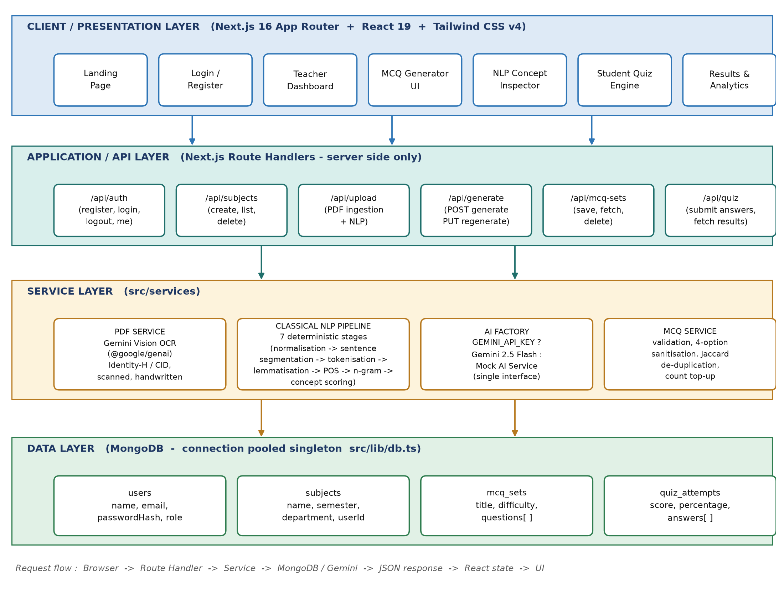
Figure 3.1 : Layered system architecture of ExamEase

3.5 End to End Workflow
Figure 3.2 shows the workflow of the platform as three role lanes. The teacher lane contains the interactions that a human performs, the system lane contains the processing that happens on the server, and the student lane contains the attempt and the review. The figure makes the division of responsibility explicit: the system transcribes, analyses and generates, whereas the teacher decides the subject, the difficulty, the number of questions and the final wording of every item.
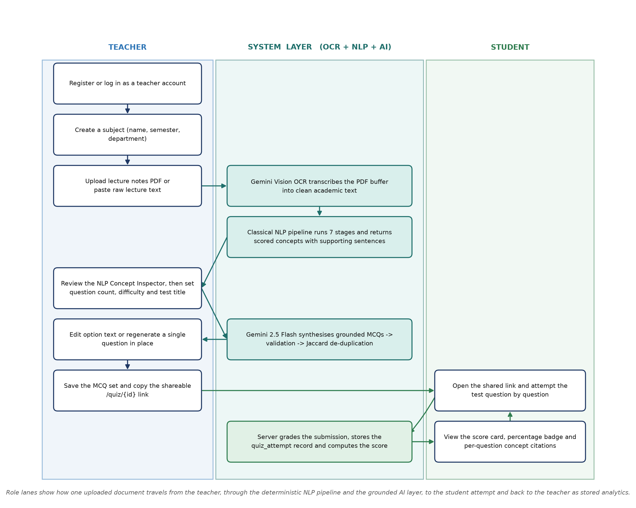
Figure 3.2 : End to end activity workflow of the ExamEase platform

3.6 Use Case Analysis
The system has two human actors and one external system actor. The teacher is the primary actor and performs preparation activities. The student is a secondary actor who performs assessment activities through a shared link. The generative service is an external system actor that participates in the ingestion and generation use cases without initiating them.
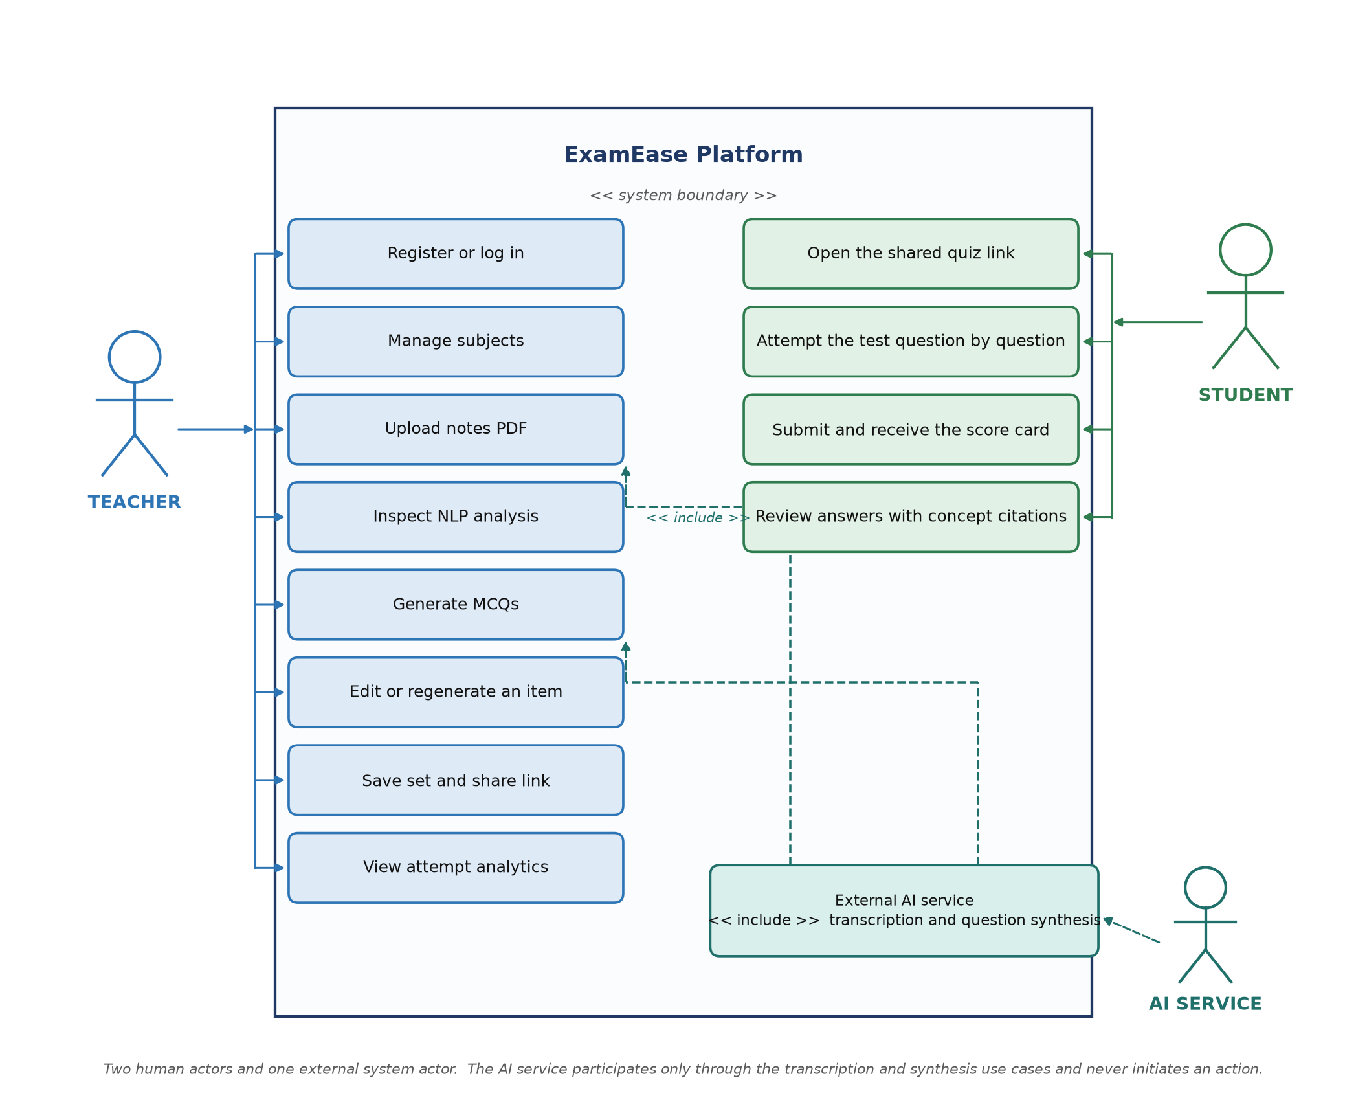
Figure 3.3 : Use case diagram of the ExamEase platform
Table 3.1 : Use case description of the principal use cases
Use case | Primary actor | Precondition | Main flow | Outcome
Register teacher account | Teacher | None | Submit name, email and password; the server checks that the email is unused, hashes the password and creates the user record | Session cookie is issued and the teacher is redirected to the dashboard
Create subject | Teacher | Teacher is authenticated | Provide name, semester and department; the subject is inserted with the owner identifier | Subject appears in the dashboard and subject list
Upload and analyse document | Teacher | Teacher is authenticated and a subject exists | Upload a PDF or paste text; the system transcribes the document and runs the seven stage pipeline | The inspector displays the statistics, concepts, definitions and n-grams
Generate questions | Teacher | A completed analysis is available | Choose the number of questions, the difficulty and the title; the system builds the grounded prompt, validates the response and removes duplicates | Editable preview cards are displayed
Regenerate one question | Teacher | A preview card exists | Request regeneration of a single item; the service rebuilds the prompt for that concept only | The card is replaced and the remaining items are untouched
Save set and share | Teacher | At least one valid question exists | Save the set against the selected subject; the system returns the document identifier | A shareable link of the form /quiz/{id} is produced
Attempt test | Student | A valid shared link is opened | Answer the questions in the engine and submit the answers | The attempt is graded, stored and the results page is displayed
Review results | Student | An attempt exists | Open the results page of the attempt | Score card, percentage badge and question wise review with citations are shown

3.7 Data Flow Diagrams
The data flow of the system is described at three levels of detail. The context diagram of Figure 3.4 treats the platform as a single process that exchanges data with the teacher and the student.
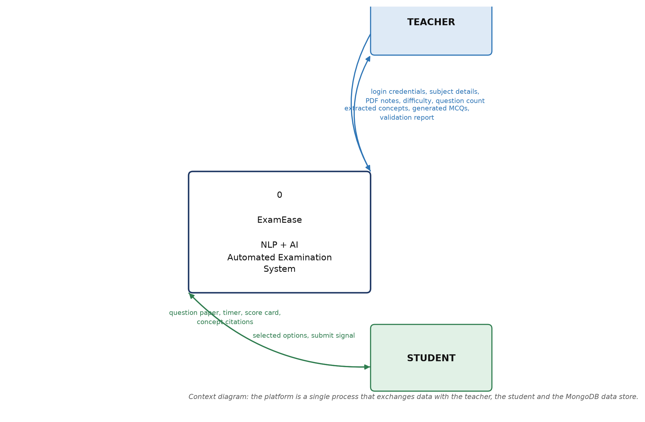
Figure 3.4 : Context level data flow diagram (DFD level 0)
The level one diagram of Figure 3.5 decomposes the platform into seven processes and five data stores. Process 1.0 manages authentication, process 2.0 manages subjects, process 3.0 performs ingestion, process 4.0 performs the linguistic analysis, process 5.0 performs grounded generation, process 6.0 performs validation and de-duplication, and process 7.0 performs test delivery, grading and analytics. Data store D3 is deliberately shown as an in-memory store: the extracted document text is never written to disk, a decision that is revisited in the chapter on security.
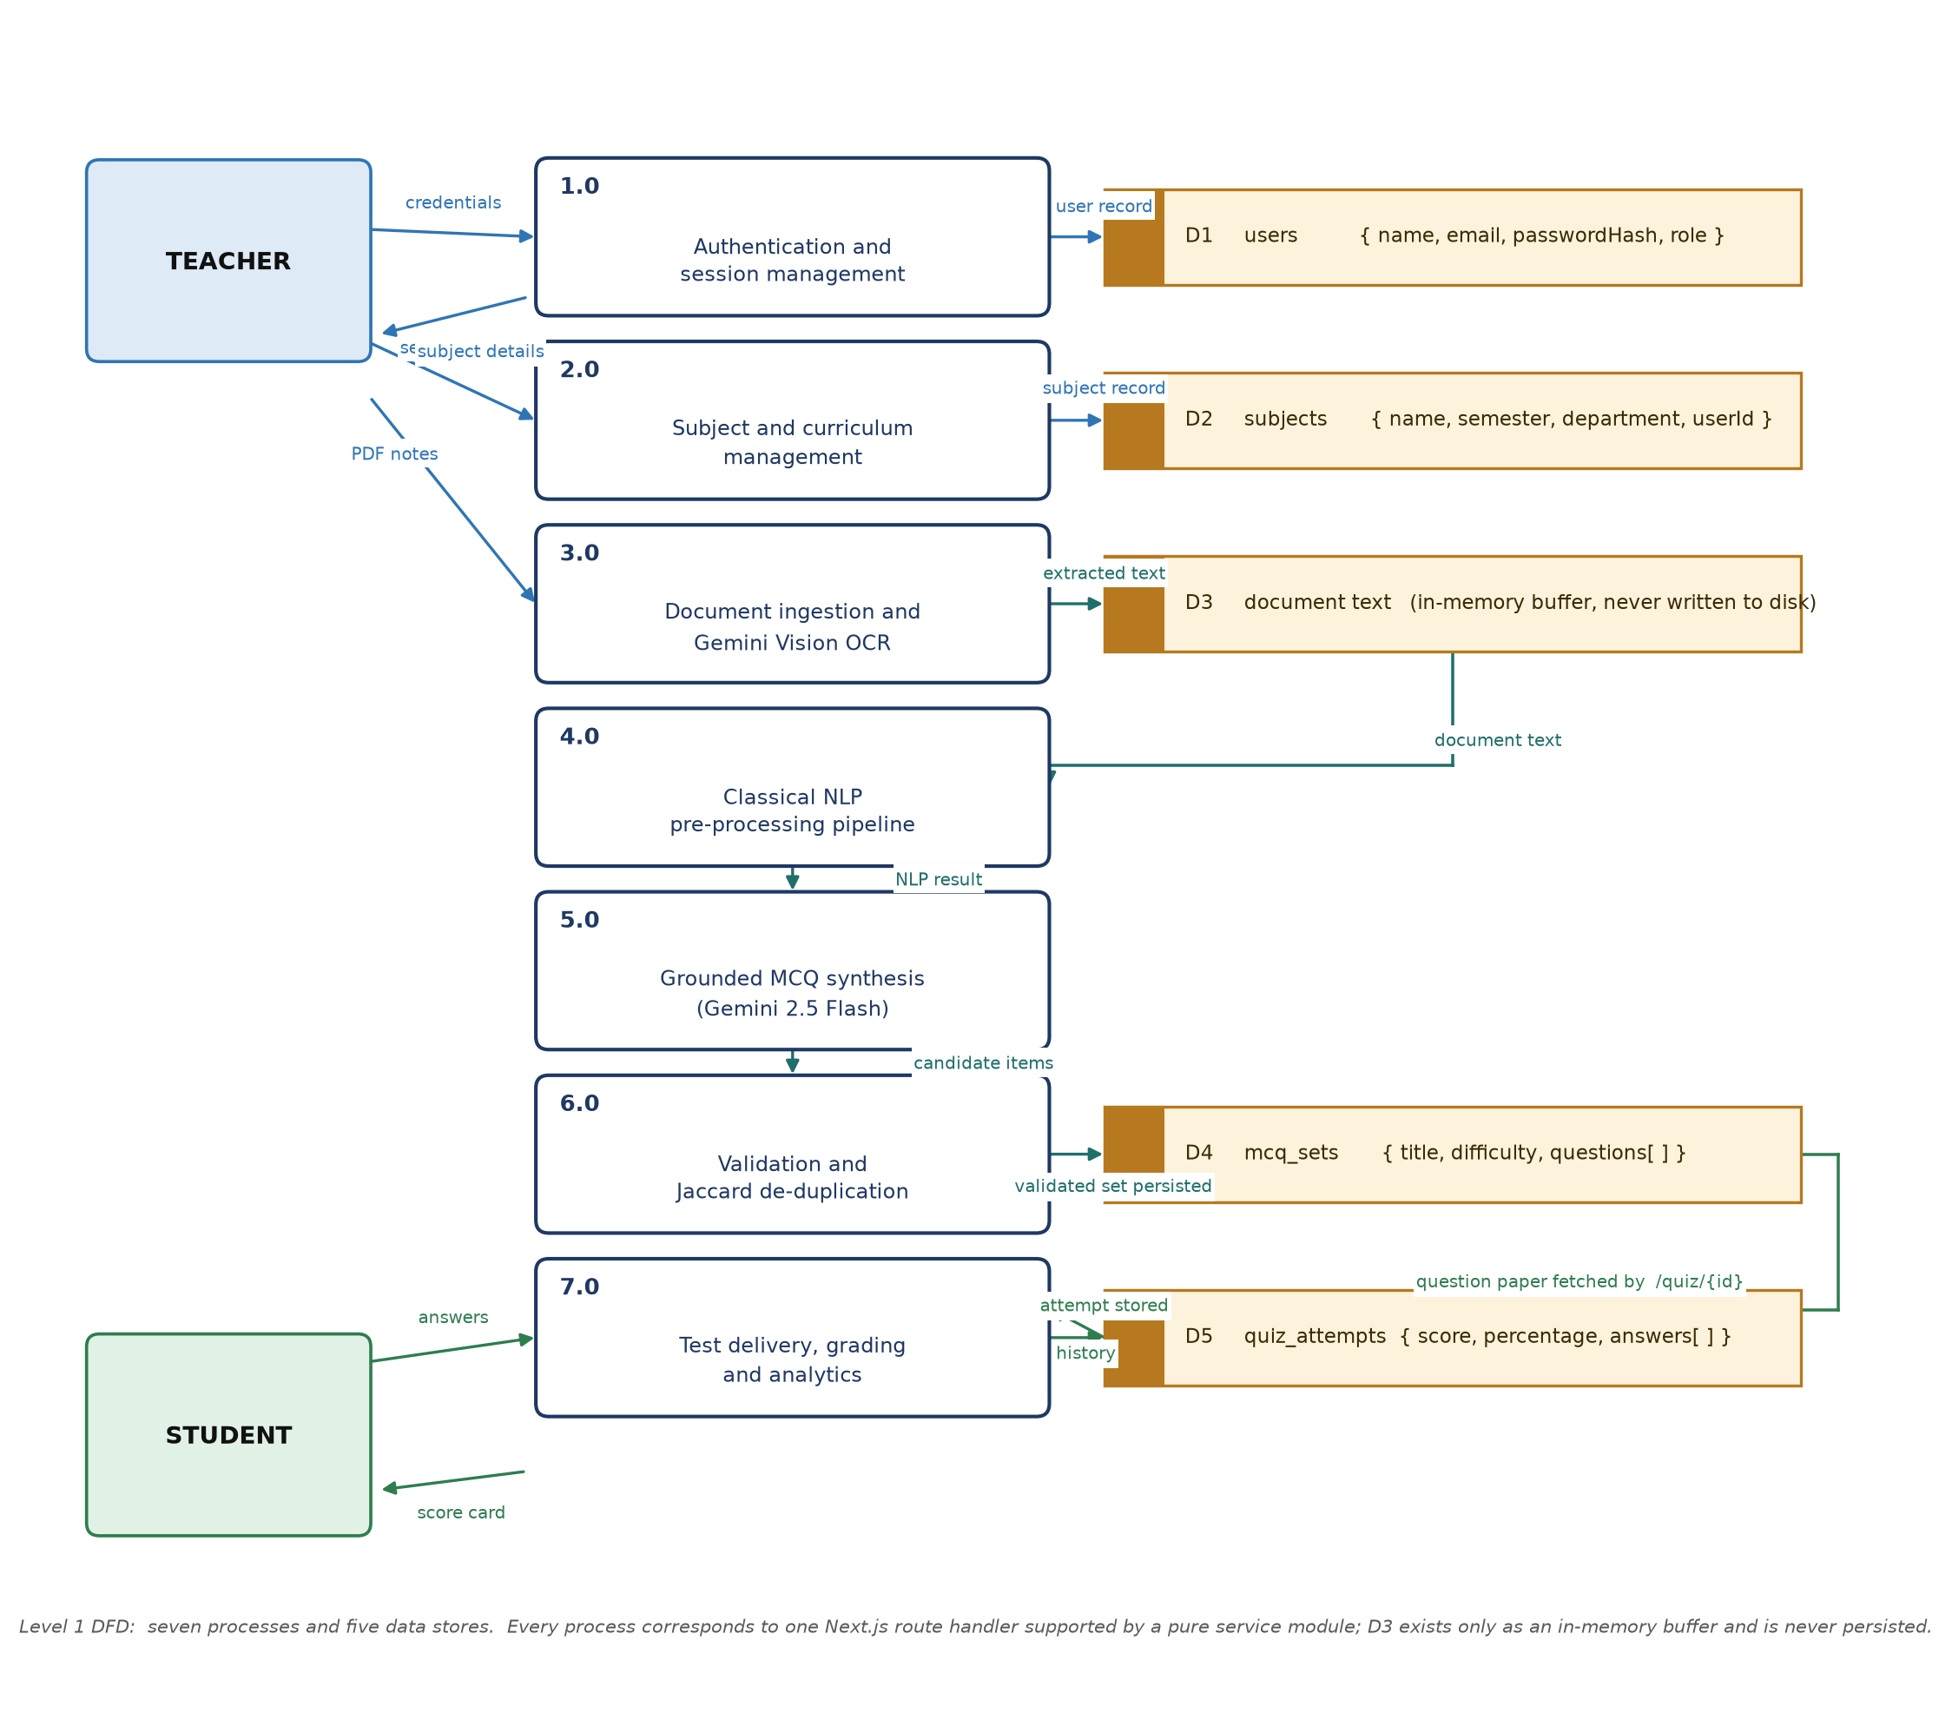
Figure 3.5 : Level 1 data flow diagram of ExamEase
Figure 3.6 expands process 4.0 into its seven deterministic sub-processes. Because no sub-process makes a network call, the analysis of the same document always produces exactly the same result, which is a property that the teacher can rely upon while reviewing the extracted concepts.
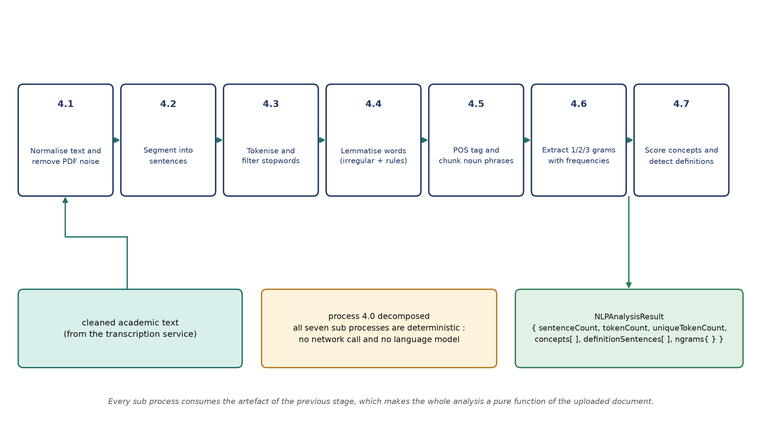
Figure 3.6 : Level 2 DFD showing the decomposition of the linguistic analysis process

3.8 Module Design
The implementation is divided into the modules described in Table 3.2. The table also records the principal source file of each module, which allows the design to be traced to the code listing in Appendix D.
Table 3.2 : Module wise description of the system
Module | Responsibility | Principal file
Authentication module | Password hashing with bcrypt, issuing and verifying JSON Web Tokens, reading the current user from the session cookie | src/lib/auth.ts
Database module | Singleton MongoDB client with connection pooling across development reloads and the getDb() accessor | src/lib/db.ts
Document ingestion module | Transcription of a PDF buffer into clean academic text through the multimodal service | src/services/pdf.service.ts
Linguistic pipeline module | Coordination of the seven deterministic stages and assembly of the analysis result | src/services/nlp/nlpPipeline.ts
Tokenisation module | Word, number and hyphenated term tokenisation, stopword set and PDF noise filtering | src/services/nlp/tokenizer.ts
Segmentation module | Sentence boundary detection with abbreviation and decimal protection | src/services/nlp/sentenceSegmenter.ts
Morphology module | Irregular lemma dictionary, suffix rules and the Porter stemmer utility | src/services/nlp/stemmerLemmatizer.ts
Tagging module | Rule based part of speech tagging and noun phrase chunking | src/services/nlp/posTagger.ts
Statistics module | Unigram, bigram and trigram frequency extraction with stopword boundary rules | src/services/nlp/ngrams.ts
Concept module | Definition pattern detection, heading and part of speech bonuses, importance scoring and supporting sentence collection | src/services/nlp/conceptExtractor.ts
Duplicate detection module | Normalisation of question text into lemmatised token sets and Jaccard similarity comparison | src/services/nlp/duplicateDetector.ts
AI provider module | Common generation interface, Gemini implementation and the offline mock implementation with the factory that selects between them | src/services/ai/*
Question service module | Orchestration of generation, structural sanitisation, top up generation and single question regeneration | src/services/mcq.service.ts
Interface module | Dashboard, generator with inspector, quiz engine and results views built with React and Tailwind CSS | src/app/**, src/components/**

3.9 Hardware and Software Requirements
The system is a web application, so the requirements are stated separately for the development machine, the server that hosts the application and the client devices used by teachers and students.
Table 3.3 : Hardware requirements
Component | Minimum | Recommended
Processor | Dual core 2.0 GHz | Quad core 2.5 GHz or higher
Memory | 4 GB RAM | 8 GB RAM or higher
Storage | 2 GB free space for the run time and the database | 20 GB solid state storage
Display (client) | 1366 x 768 | 1920 x 1080
Network | 1 Mbps for uploading a document | 5 Mbps for a smooth inspector experience
Server (production) | 1 vCPU shared instance | 2 vCPU with 4 GB memory

Table 3.4 : Software requirements
Category | Software | Version | Purpose
Runtime | Node.js | 20.x or 22.x | Execution of the server and the build tools
Framework | Next.js with the App Router | 16.3 | Routing, server rendering and route handlers
UI library | React | 19.2 | Component based interface
Styling | Tailwind CSS with PostCSS | 4.x | Utility first responsive styling
Icons | Lucide React | 1.47 | Vector iconography
Database | MongoDB Community Server | 7.6 | Document storage
Driver | MongoDB Node.js driver | 7.6 | Connection pooling and queries
AI SDK | Google GenAI SDK | 2.23 | Multimodal transcription and question generation
Security | jose and bcryptjs | 6.2 / 3.0 | JWT signing and password hashing
Language | TypeScript | 5.x | Static type checking
Tooling | ESLint and the React Compiler | 9.x / 1.0 | Code quality and automatic memoisation
Client | Any modern browser | Chrome 110 or later | Access to the web interface

3.10 Design Constraints and Assumptions
• The quality of the generated questions is bounded by the quality of the uploaded document. A document that contains only bullet points without complete sentences will produce fewer definition sentences and therefore fewer high quality concept candidates.
• The transcription stage requires a configured API key for the multimodal service. Without it, the system accepts pasted text and uses the offline provider for generation, so the application remains demonstrable in a laboratory without network access.
• The linguistic pipeline is language specific; the stopword set and the morphological rules implemented here target English technical writing.
• The system is designed for multiple choice assessment of factual and conceptual knowledge; it does not attempt to assess writing skill or problem solving ability.
• The shareable test link is intentionally public so that a student does not need an account in order to attempt a test. The attempt is nevertheless recorded against the authenticated user when one is available.

Chapter 4 Methodology and Implementation

4.1 Introduction
This chapter documents the method implemented by the system. Section 4.2 introduces the linguistic pipeline as a whole; Sections 4.3 to 4.9 describe each of its seven stages with the corresponding algorithm and the exact rule set that was implemented. Sections 4.10 to 4.14 cover the ingestion service, the service layer design, the grounded prompt, the provider factory, the validation and de-duplication logic and the sequence of a complete generation request. Section 4.15 analyses the cost of the pipeline.

4.2 The Seven Stage Linguistic Pipeline
The pipeline transforms a raw string into a structured analysis object. Each stage has a single responsibility, consumes the output of the previous stage and produces a well defined artefact. No stage performs a network call, and no stage uses a random number generator, so the entire pipeline is a pure function of its input. This property is what allows a teacher to compare the concept list of two uploaded documents and obtain a meaningful difference.
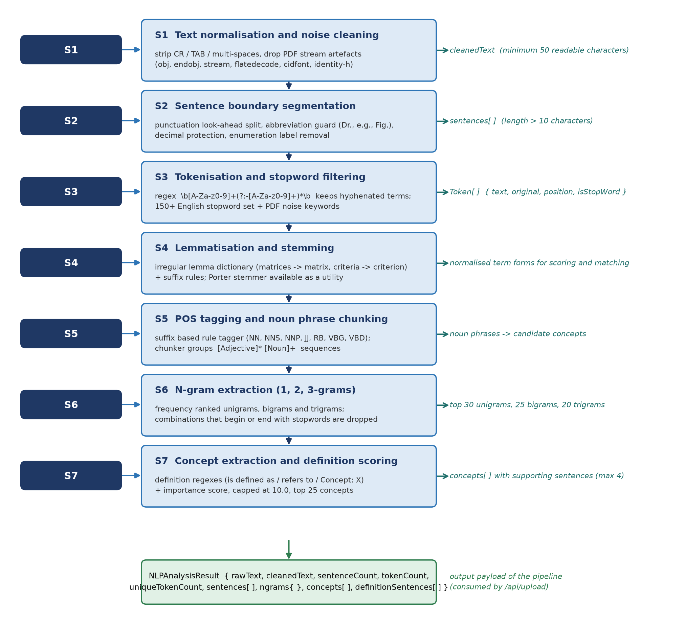
Figure 4.1 : Seven stage deterministic NLP pre-processing pipeline
Table 4.1 : Input and output contract of each pipeline stage
Stage | Operation | Input | Output
S1 | Normalisation and noise cleaning | Raw document text | Whitespace normalised text of at least fifty characters
S2 | Sentence segmentation | Normalised text | Array of sentences longer than ten characters
S3 | Tokenisation and stopword filtering | Normalised text | Array of tokens with position and stopword flags
S4 | Lemmatisation and stemming | Individual tokens | Canonical term forms used for normalisation and matching
S5 | Part of speech tagging and chunking | Sentences or token arrays | Parts of speech and candidate noun phrases
S6 | N-gram extraction | Token array | Frequency ranked unigrams, bigrams and trigrams
S7 | Concept scoring and definition detection | Sentences | Ranked concepts with supporting sentences and detected definitions

4.3 Stage 1 : Text Normalisation and Noise Cleaning
The first stage removes everything that is an artefact of the file format rather than a part of the academic content. Carriage returns and tabulators are replaced by a single space, runs of whitespace are collapsed, and the string is trimmed. A minimum length check of fifty readable characters is applied, and a document that does not satisfy it is rejected with an explanatory message rather than being analysed, because an analysis of an empty document would produce a confident but meaningless question set.
The stage also defends the later stages against the vocabulary of a broken extraction. When a PDF is decoded incorrectly, the extracted text is contaminated with the structural keywords of the format itself, namely obj, endobj, stream, endstream, flatedecode, length, filter, xref, trailer, startxref, cidfont and identity. These words are treated as stopwords and are additionally matched by a noise pattern that discards any sentence or candidate concept containing them.
// Stage 1 - normalisation and noise cleaning (src/services/nlp/nlpPipeline.ts)
const cleanedText = rawText
.replace(/[\r\t]+/g, ' ')
.replace(/\s+/g, ' ')
.trim();
if (cleanedText.length < 50) {
throw new Error('Not enough readable content was found in this PDF ...');
}
Listing 4.1 Text normalisation and the minimum content guard

4.4 Stage 2 : Sentence Boundary Segmentation
Sentence segmentation converts a continuous string into the unit that the concept extractor reasons about. The naive rule of splitting after every full stop fails on academic writing in three ways: it splits after an abbreviation such as Dr. or Fig., it splits inside a decimal number such as 3.14, and it splits after an enumerated label such as 2. in a list. The implemented segmenter handles all three cases by protecting the ambiguous text before the split and restoring it afterwards.
The protection step replaces each known abbreviation with a numbered placeholder, replaces the decimal point of a number with a private marker, and only then applies a look-ahead split that requires a sentence ending punctuation mark followed by whitespace and a capital letter or a digit. Sentences shorter than eleven characters are discarded because they are almost always headings, page numbers or fragments.
// Stage 2 - protect abbreviations and decimals before splitting
ABBREVIATIONS.forEach((abbr, idx) => {
const regex = new RegExp(`\\b${abbr.replace('.', '\\.')}`, 'gi');
protectedText = protectedText.replace(regex, `__ABBR_${idx}__`);
});
protectedText = protectedText.replace(/(\d+)\.(\d+)/g, '$1__DECIMAL__$2');
// split only at [.!?] followed by whitespace and a capital letter or digit
const rawSentences = protectedText.split(/(?<=[.!?])\s+(?=[A-Z0-9"']|$)/);
Listing 4.2 Abbreviation and decimal protection in the sentence segmenter

4.5 Stage 3 : Tokenisation and Stopword Filtering
Tokenisation is performed by a single regular expression that matches a sequence of alphanumeric characters optionally containing internal hyphens. The hyphen rule is significant for technical material because it preserves terms such as client-server, state-of-the-art and TF-IDF as single tokens; splitting them would destroy the terminology that the concept extractor is looking for.
Each token is stored with its original spelling, its lower case form, its position in the document and a Boolean flag that records whether it is a stopword. The stopword set contains the standard English function words together with contractions, and it is extended with the PDF noise vocabulary described in Section 4.3. Tokens of a single character are also marked as stopwords, which removes artefacts such as enumerated list labels and stray bullets.
// Stage 3 - tokenisation with hyphen aware matching (src/services/nlp/tokenizer.ts)
const wordRegex = /\b[A-Za-z0-9]+(?:-[A-Za-z0-9]+)*\b/g;
tokens.push({
text: cleaned,
original: raw,
position: index++,
isStopWord: ENGLISH_STOPWORDS.has(cleaned) || cleaned.length <= 1,
});
Listing 4.3 Hyphen aware tokenisation and stopword marking

4.6 Stage 4 : Lemmatisation and Stemming
Two morphological utilities are provided. The lemmatiser maps a surface form to its canonical form in two steps. It first consults a dictionary of irregular forms, which contains the plurals that a suffix rule cannot recover, such as matrices to matrix, hypotheses to hypothesis, criteria to criterion, analyses to analysis, phenomena to phenomenon and data to datum, together with the irregular verb forms of the auxiliary verbs. Only when the word is not in the dictionary are the suffix rules applied, which handle the productive cases such as the plural -ies of capabilities, the gerund -ing of processing and the past tense -ed of normalised.
The Porter stemmer is implemented as a separate utility and is used where an aggressive reduction is desirable, namely in the similarity comparison and in the n-gram statistics. The distinction matters because the two operations have different requirements: the concept list that a teacher reads must contain recognisable words, so it uses the lemmatiser, whereas the duplicate detector benefits from aggressive merging.
// Stage 4 - lemmatisation rules (src/services/nlp/stemmerLemmatizer.ts)
if (IRREGULAR_LEMMAS[lower]) return IRREGULAR_LEMMAS[lower]; // matrices -> matrix
if (lower.endsWith('ies') && lower.length > 4) return lower.slice(0, -3) + 'y';
if (lower.endsWith('ing') && lower.length > 5) {
if (lower.endsWith('tting') || lower.endsWith('nning') ||
lower.endsWith('pping') || lower.endsWith('mming')) return lower.slice(0, -4);
return lower.slice(0, -3);
}
if (lower.endsWith('s') && !lower.endsWith('ss') && lower.length > 3) return lower.slice(0, -1);
Listing 4.4 The irregular dictionary and the productive suffix rules of the lemmatiser

4.7 Stage 5 : Part of Speech Tagging and Noun Phrase Chunking
The tagger assigns a category to each token from its morphological shape together with one positional rule. A token that begins with a capital letter and is not the first token of the sentence is treated as a proper noun, which captures product names, algorithm names and place names. A token that ends in one of the nominal suffixes such as -tion, -sion, -ment, -ness, -ance, -ence, -ism or -ity is a noun; a token ending in -able, -ible, -al, -ic, -ous, -ful, -less or -ive is an adjective; a token ending in -ly is an adverb; -ing denotes a gerund; -ed denotes a past tense verb; and a plural -s marks a plural noun. Tokens that are not stopwords and match none of the rules default to the noun category, which is the safe default for technical text.
The chunker then scans the tagged sequence and collects maximal contiguous runs of adjectives and nouns, which corresponds to the classical pattern of an optional adjective sequence followed by one or more nouns. A run is emitted as a candidate concept only if it contains at least one noun and its textual length exceeds three characters. This is the mechanism by which a phrase such as relational database management system enters the concept list as a single candidate rather than as four separate words.
// Stage 5 - suffix rules of the rule based tagger (src/services/nlp/posTagger.ts)
if (/^[A-Z][a-zA-Z0-9_-]+$/.test(word) && token.position > 0) return 'NNP';
if (lower.endsWith('tion') || lower.endsWith('ment') || lower.endsWith('ness') ||
lower.endsWith('ity')) return 'NN';
if (lower.endsWith('able') || lower.endsWith('ous') || lower.endsWith('ive')) return 'JJ';
if (lower.endsWith('ly')) return 'RB';
if (lower.endsWith('ing')) return 'VBG';
if (lower.endsWith('ed')) return 'VBD';
// chunker : build maximal runs of [JJ]* [NN|NNS|NNP]+ and keep runs with a noun
Listing 4.5 Morphological part of speech rules and the noun phrase pattern

4.8 Stage 6 : N-gram Extraction
The n-gram stage computes three frequency tables from the token sequence: single terms, consecutive pairs and consecutive triples. Four rules keep the tables meaningful. A unigram must be a non stopword of more than two characters. A bigram is retained if at least one of its two tokens is a non stopword and both tokens are longer than two characters. A trigram is retained if at least one of its boundary tokens is a non stopword. Every table is sorted by descending frequency, and the pipeline publishes the thirty most frequent unigrams, the twenty five most frequent bigrams and the twenty most frequent trigrams, which is exactly the volume that the inspector can display without becoming unreadable.
// Stage 6 - bigram extraction with the non stopword boundary rule (src/services/nlp/ngrams.ts)
for (let i = 0; i < tokens.length - 1; i++) {
const t1 = tokens[i], t2 = tokens[i + 1];
if ((!t1.isStopWord || !t2.isStopWord) && t1.text.length > 2 && t2.text.length > 2) {
const bigramStr = `${t1.text} ${t2.text}`;
bigramMap[bigramStr] = (bigramMap[bigramStr] || 0) + 1;
}
}
Listing 4.6 Frequency accumulation for bigrams

4.9 Stage 7 : Concept Extraction and Definition Scoring
The final stage combines the outputs of the previous six into a ranked list of concepts. Two sources of candidates are merged. The first source is a set of four definition patterns applied to every sentence; a match produces a candidate concept with a strong definition bonus. The second source is the noun phrase list produced by the chunker, which contributes candidates with a smaller part of speech bonus.
The four definition patterns are the copular definition, in which a capitalised term is followed by is or are and then one of defined as, a, an, the, described as, known as or referred to as; the lexical definition, in which a term is followed by refers to, denotes, represents, means or signifies; the colon pattern, in which a term is followed by a colon and a definition; and the labelled definition, in which the word Definition or Concept introduces the term. Candidate strings are rejected when they consist only of a demonstrative pronoun, when they are shorter than three characters or longer than fifty characters, or when they match the PDF noise pattern.
Each accepted candidate is normalised by lemmatising every word of the candidate phrase, which is what allows two surface variants of the same concept to accumulate into a single entry. Every entry maintains a frequency counter, a definition bonus, a part of speech bonus, a heading bonus and a set of at most four supporting sentences. The importance score of a concept is computed by the formula given below and is capped at 10.0 so that a single dominant term cannot dominate the ranking by an order of magnitude.
Importance = min ( 10.0 , (1.2 × frequency) + definition bonus + part of speech bonus + (0.8 × supporting sentences) )
In the implemented constants the definition bonus is 4.5 per matched definition pattern, the part of speech bonus is 2.0 for a candidate that came from a definition pattern and 1.5 for a candidate that came from the noun phrase chunker, and the heading bonus is reserved for candidates that begin with a capital letter and appear early in the document. Because the score is clipped at ten, several concepts of a well written lecture note reach the ceiling, which is a deliberate choice: the ranking exists to produce the correct set of concepts rather than to distinguish finely between them. The pipeline returns the twenty five highest scoring concepts.
// Stage 7 - importance score of an extracted concept (src/services/nlp/conceptExtractor.ts)
const rawScore = (item.frequency * 1.2) + item.definitionBonus + item.posBonus +
(item.supportingSentences.size * 0.8);
const importanceScore = Math.min(10.0, Math.round(rawScore * 10) / 10);
Listing 4.7 Computation of the concept importance score

4.10 Document Ingestion
The ingestion service receives the uploaded file as an in-memory buffer, converts it to a base64 string and submits it to the multimodal transcription service together with an instruction that asks for all readable text with headings, paragraphs and bullet structure preserved and without any commentary. The response is validated to contain at least twenty characters; otherwise the request fails with a message that the document contains no readable text. The buffer is never written to the file system, which means that no exam material is left behind on the server after the request completes.

4.11 Service Layer Structure
The service layer is designed around a single interface. The generation capability is declared once, and two classes implement it: one that calls the external language model and one that generates questions locally without any network access. The question service depends only on the interface, so it is unaware of which implementation is active. Figure 4.2 shows the classes and their relationships.
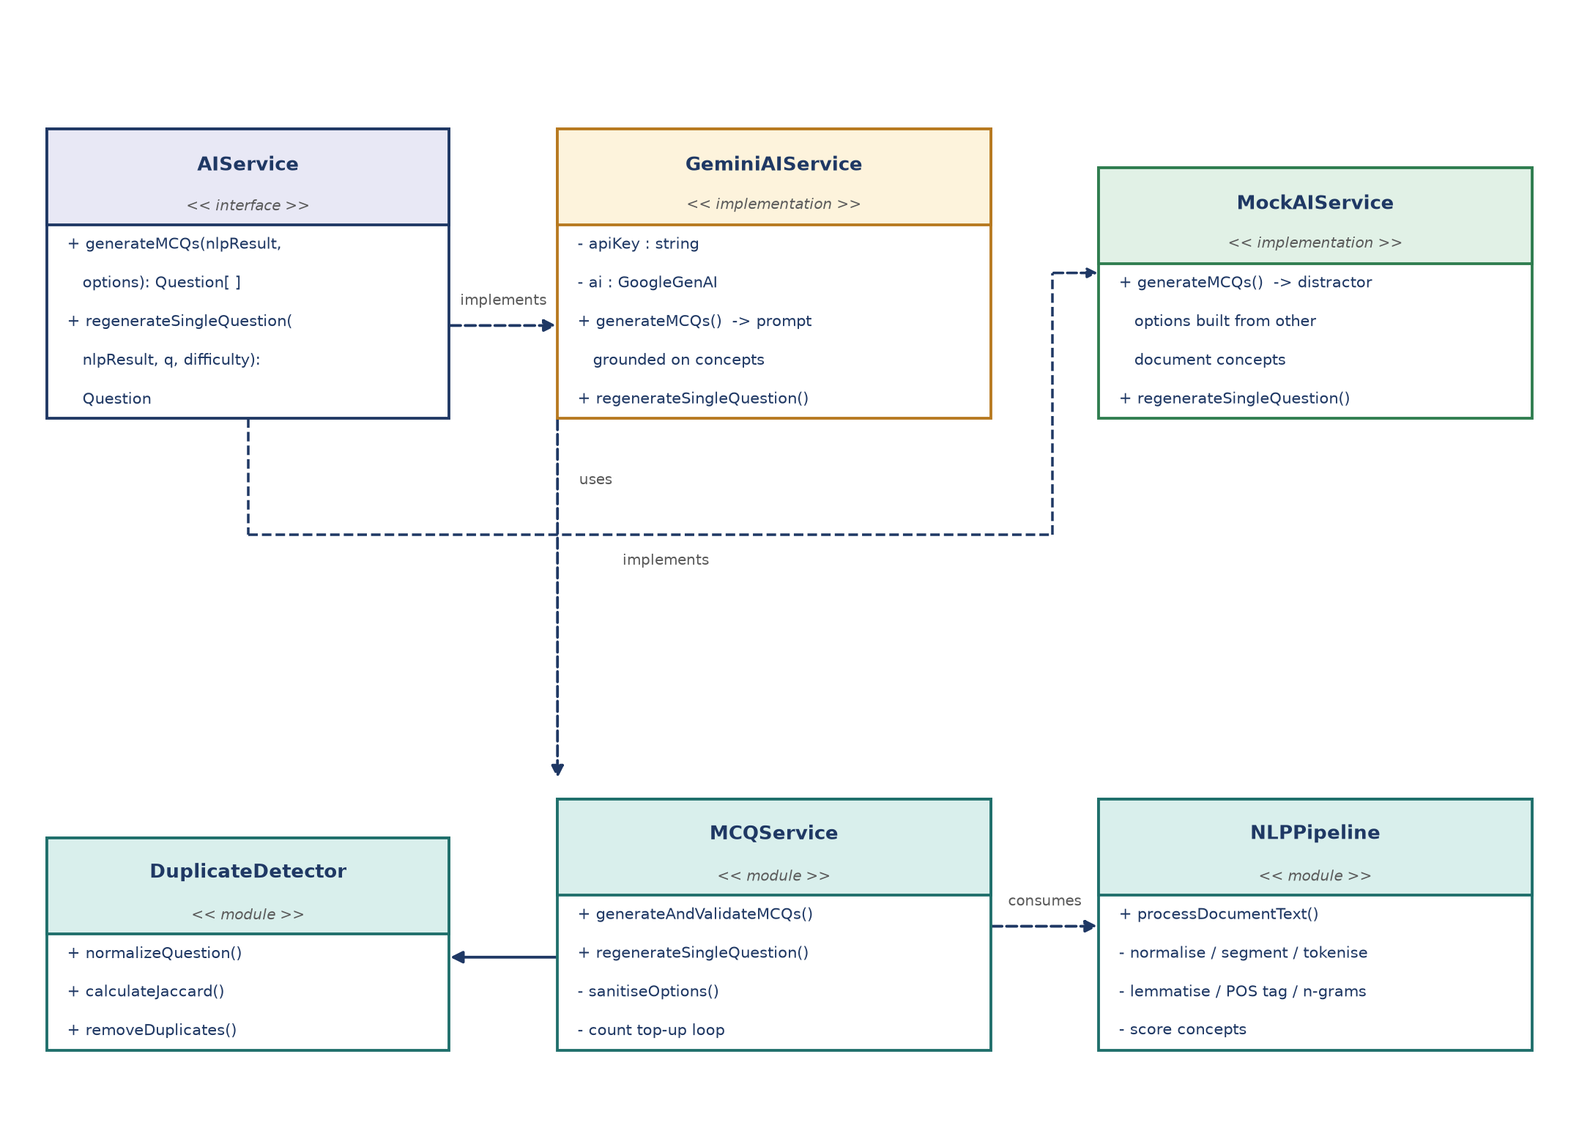
Figure 4.2 : Class and component diagram of the service layer

4.12 Grounded Prompt Engineering
The prompt is constructed from the analysis rather than from the document. The fifteen highest scoring concepts are written out with their importance score, and beneath each concept the sentences that the pipeline associated with it are listed, separated by horizontal rules. The instruction block that precedes this evidence states seven constraints, and the response format is specified as a JSON object with a questions array. Table 4.2 lists the constraints and the reason for each of them.
Table 4.2 : Prompt constraints and their purpose
Constraint in the prompt | Purpose
Do not use external knowledge; all facts must come from the source content | This is the central anti hallucination rule. Because the source content is the scored concept list, the model cannot introduce a topic that the pipeline did not find in the document.
Generate exactly the requested number of questions | Keeps the size contract; the service still tops up the count if the model returns fewer items.
Target the selected difficulty | Propagates the teacher's choice into the wording of the stem and the subtlety of the distractors.
Exactly four options per question | Matches the format of the examination and allows the automatic grading key to work.
Exactly one option must be correct | Ensures that the answer key is unambiguous; ambiguous items would not survive a student challenge.
Provide a concise explanation citing the source material | Produces the explanation that the student reads in the review screen and that the teacher uses to verify the item.
Avoid duplicate questions and duplicate choices | Reduces the work of the de-duplication layer, although the layer still runs unconditionally.
Return JSON only, with no markdown code fences | Makes the response machine readable; the service additionally strips code fences defensively.

4.13 Provider Factory and the Offline Fallback
The factory decides which provider to instantiate from the presence of the API key. If a key of more than five characters is configured, the external provider is created; otherwise the offline provider is created. Both satisfy the same interface and return the same shape of partial questions, so the rest of the system behaves identically. The offline provider composes its questions from the same concept list: it uses the detected definition of a concept as the correct answer and draws its distractors from other concepts of the same document, which keeps the demonstration questions thematically coherent.
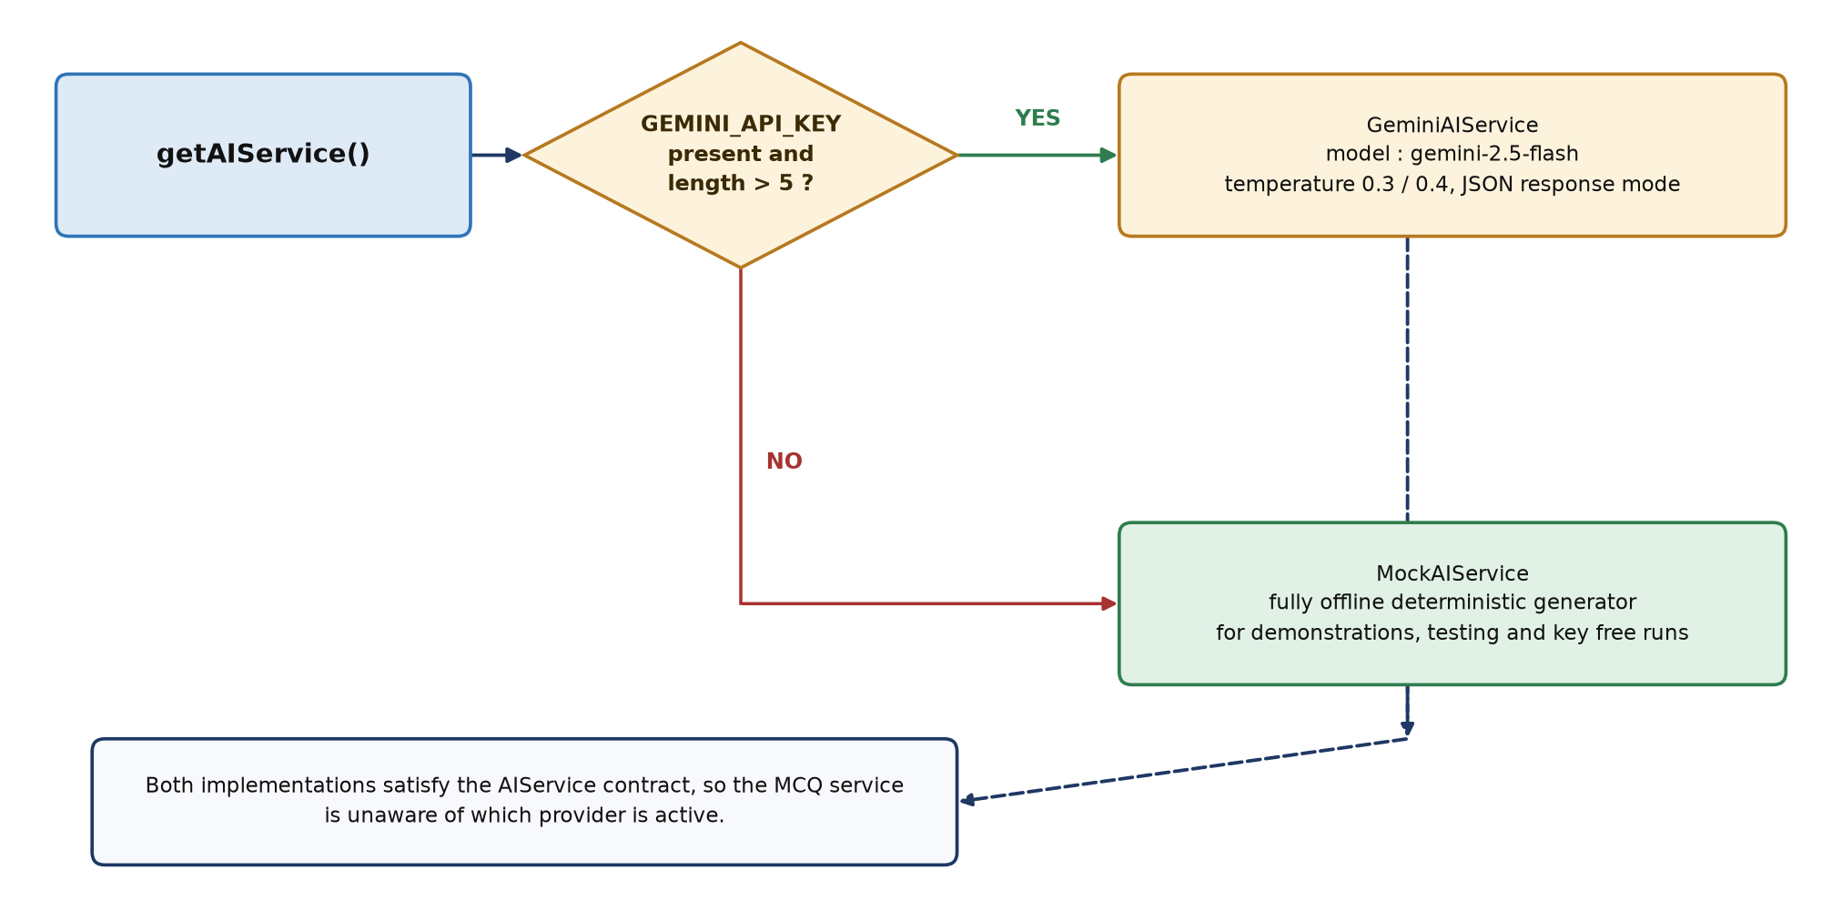
Figure 4.3 : Dual provider AI factory with graceful offline fallback

4.14 Validation and De-duplication
The raw output of a provider is never shown to the teacher. It passes through two filters. The first is structural: the question text must contain at least five characters, the option array is trimmed of empty entries and padded or truncated to exactly four options, and the correct answer is forced to be an exact member of the option array, with a documented fallback to the first option if the model returned a paraphrase. The second filter is lexical.
The lexical filter compares every candidate against the questions that have already been accepted. Each question is normalised by tokenising it, removing stopwords and lemmatising every remaining token, which yields a set of terms that represents the content of the question independently of its surface wording. The similarity of two questions is the Jaccard coefficient of their token sets, that is the size of the intersection divided by the size of the union. A candidate whose similarity to any accepted question is 0.65 or greater is discarded. Figure 4.4 shows the flow.
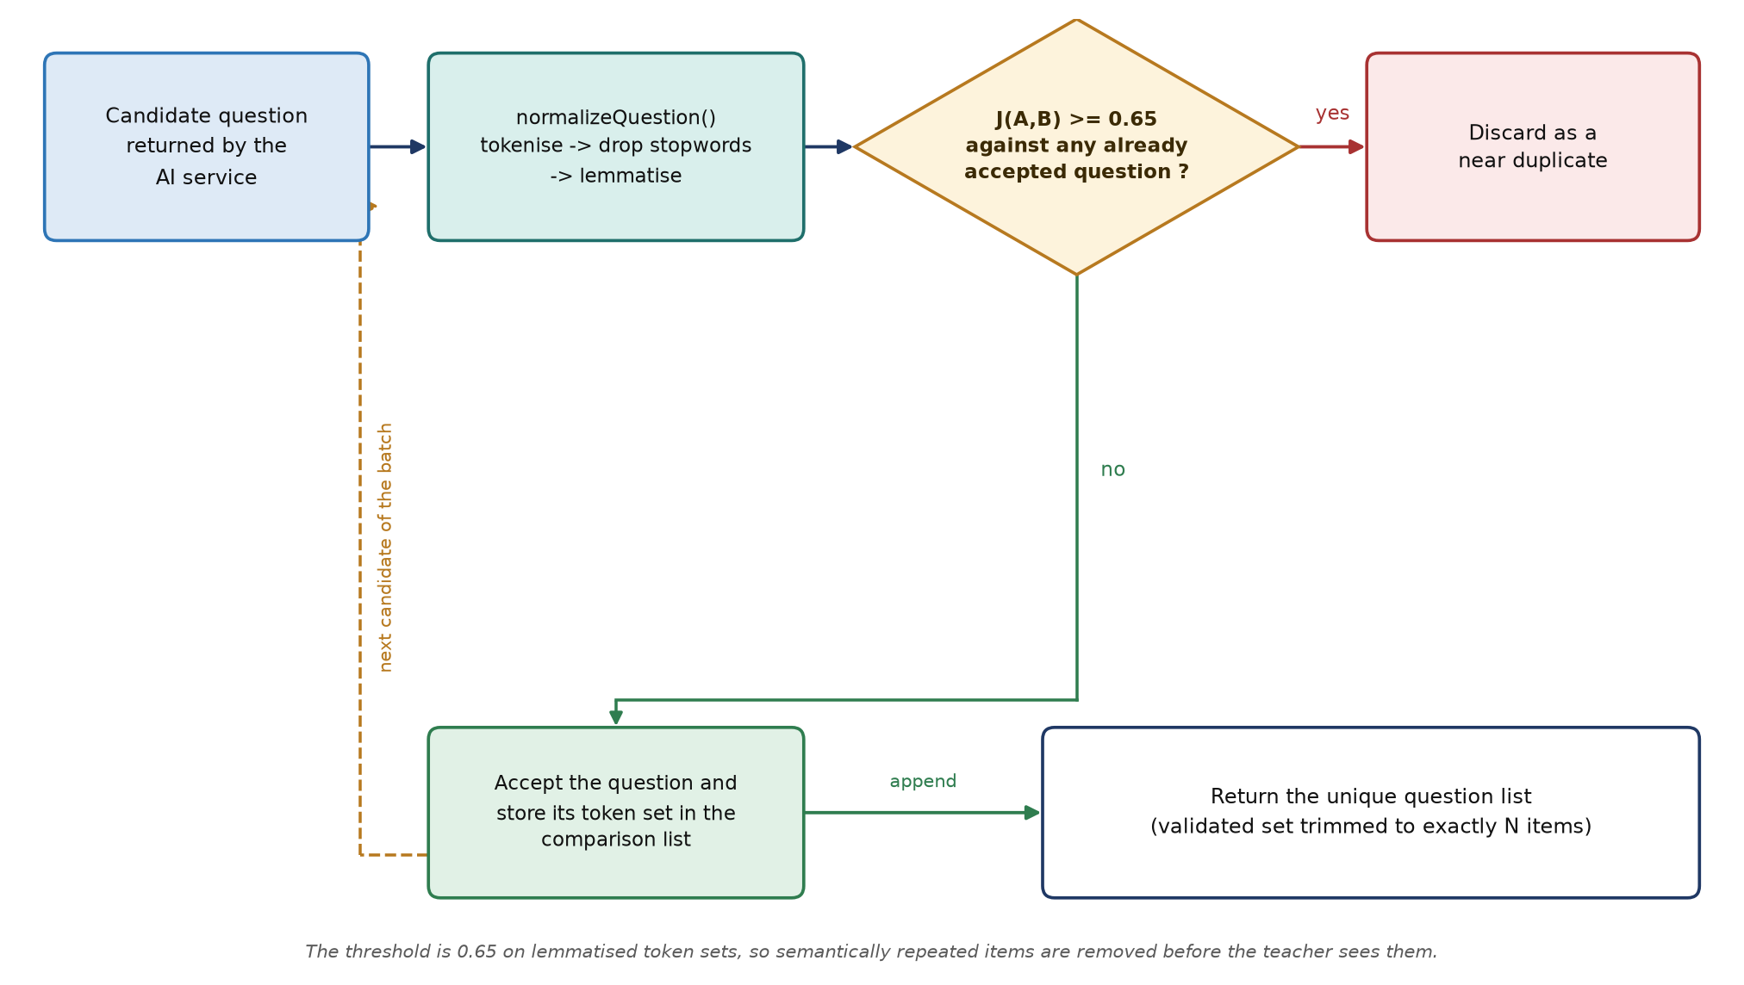
Figure 4.4 : Lexical near-duplicate detection using Jaccard token similarity
// Jaccard similarity of two lemmatised token sets (src/services/nlp/duplicateDetector.ts)
export function calculateJaccardSimilarity(setA: Set<string>, setB: Set<string>): number {
if (setA.size === 0 || setB.size === 0) return 0;
let intersectionCount = 0;
setA.forEach((token) => { if (setB.has(token)) intersectionCount++; });
const unionSize = new Set([...Array.from(setA), ...Array.from(setB)]).size;
return unionSize === 0 ? 0 : intersectionCount / unionSize;
}
Listing 4.8 Jaccard similarity computed over lemmatised token sets
After both filters have been applied, the service checks the size of the surviving list. If the model returned fewer valid items than the teacher requested, a top up round is performed with the remaining count, and the result is finally trimmed to the requested number. The teacher therefore always receives exactly the requested number of questions, provided that the document contains enough distinct concepts to support them.

4.15 Cost and Complexity of the Pipeline
The linguistic pipeline is linear in the size of the document for five of its seven stages. The exceptions are the concept scoring stage, which sorts the candidate map, and the duplicate detection stage, which compares each new question with the questions already accepted. Table 4.3 summarises the cost of each stage.
Table 4.3 : Time complexity of the processing stages
Stage | Operation | Complexity | Remarks
S1 | Normalisation | O(n) | Four regular expression passes over the character stream
S2 | Sentence segmentation | O(n) | One split with a constant number of abbreviation substitutions
S3 | Tokenisation | O(n) | Single scan of the tokenising regular expression
S4 | Lemmatisation | O(m) | Dictionary lookup or a constant number of suffix tests per token
S5 | POS tagging and chunking | O(m) | One pass over the tagged tokens
S6 | N-gram extraction | O(m) | Three linear scans with hash based counters
S7 | Concept scoring | O(c log c) | Sorting of c candidate concepts; c is bounded by the number of noun phrases
De-duplication | O(k² t) | Comparison of k questions over token sets of average size t; k is at most fifty
Generation call | Network bound | Dominant cost of a request; typically one to five seconds for a document of ordinary size

In practice the linguistic stages complete in a few tens of milliseconds for a document of a few thousand words, and the total response time of a generation request is dominated by the external generation call. The offline provider removes even that cost, which makes the system suitable for classroom demonstrations in which network access cannot be guaranteed.

4.16 Sequence of a Complete Generation Request
Figure 4.5 assembles the operations of the previous sections into the complete lifecycle of a generation request, from the upload of the document to the identifier that the teacher shares with the class. The diagram also makes the cost profile of the system explicit: only two of the operations are network calls, and every operation between them is deterministic local processing that can be executed and verified without an API key.
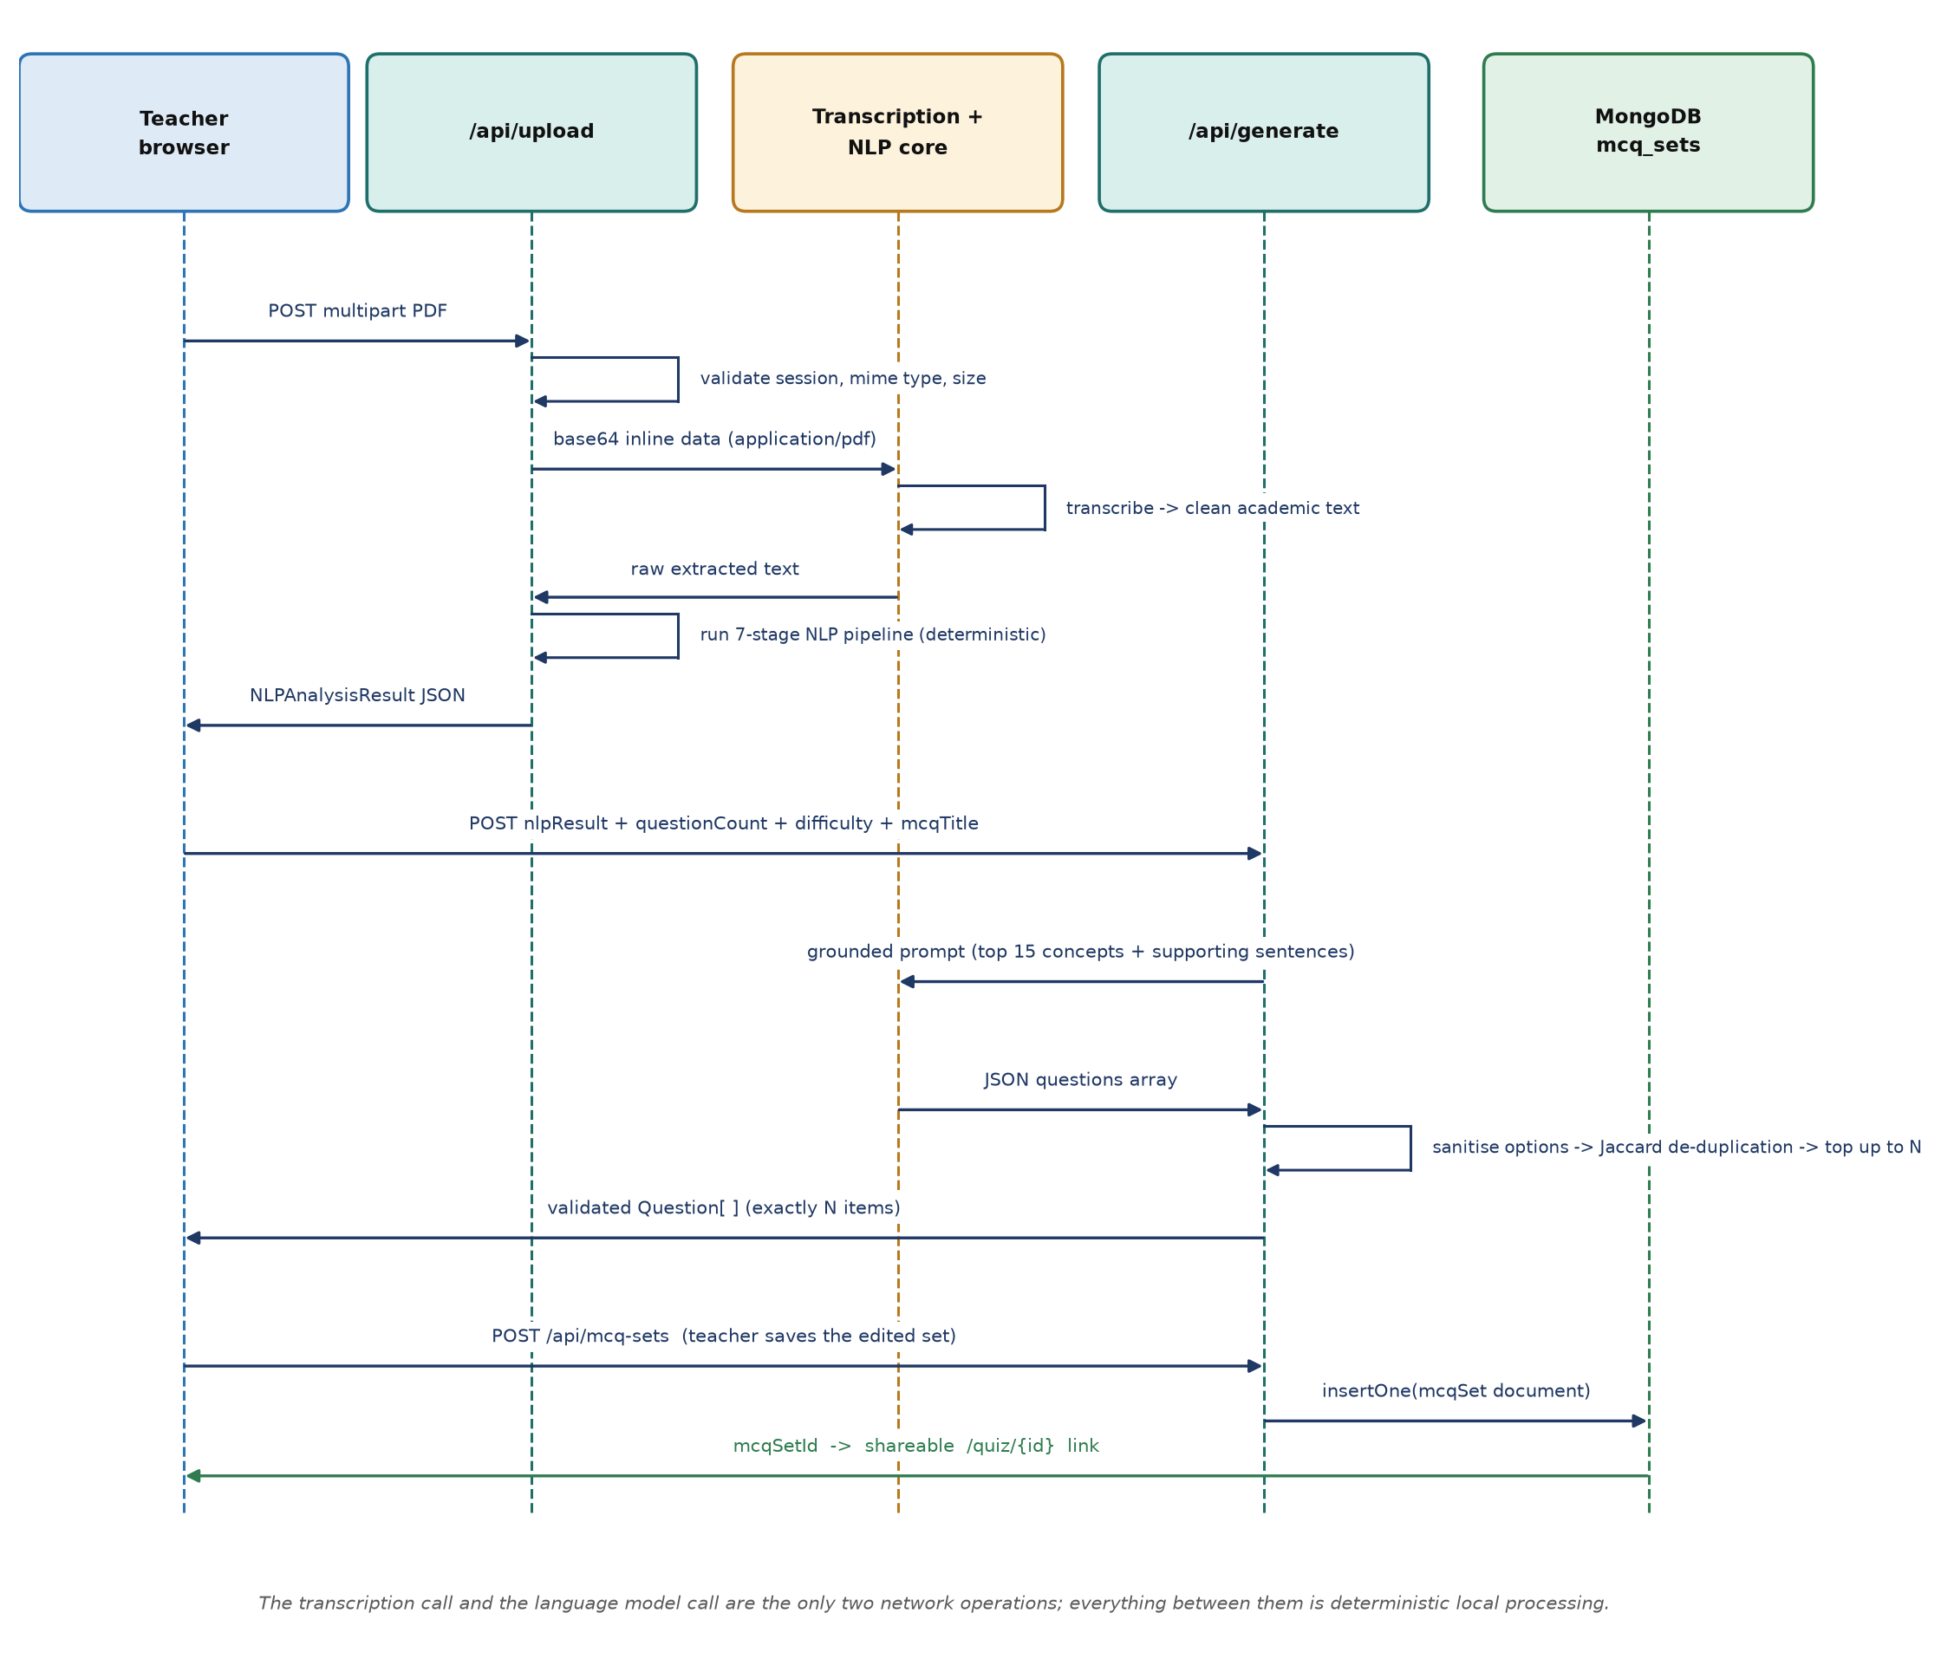
Figure 4.5 : Sequence diagram of the document to MCQ generation flow

Chapter 5 Database Design

5.1 Introduction
The persistence layer is a MongoDB store with four collections: users, subjects, mcq_sets and quiz_attempts. The schema was designed document first, which means that the objects that are always read together are stored together. A question set is a single document that contains its questions, and a quiz attempt is a single document that contains the answers together with the correct answer and the explanation of each question. As a consequence, delivering a test to a student requires one read, and rendering a result page requires one read.

5.2 Entity Relationship Model
Figure 5.1 shows the four collections and their relationships. A user creates many subjects and authors many question sets; a subject contains many question sets; a question set generates many quiz attempts. Identifier fields are stored as strings that refer to the ObjectId of the parent document, an approach that keeps the interface simple while allowing the application to validate the format of an identifier before issuing a query.
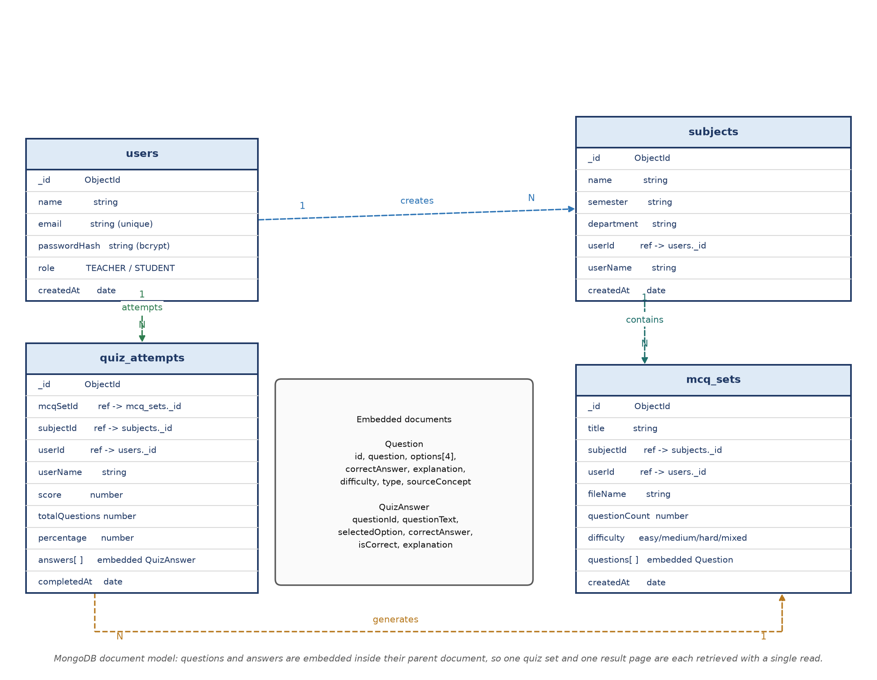
Figure 5.1 : Entity relationship diagram of the ExamEase MongoDB schema

5.3 Collection Schemas
Table 5.1 : Schema of the users collection
Field | Type | Description
_id | ObjectId | Primary identifier generated by MongoDB
name | string | Display name of the teacher
email | string | Login identifier, stored in lower case and unique
passwordHash | string | Salt and hash produced by bcrypt with ten rounds; the plain password is never stored
role | string | TEACHER or STUDENT; teacher accounts are created by registration
createdAt | date | Creation timestamp used for ordering the dashboard

Table 5.2 : Schema of the subjects collection
Field | Type | Description
_id | ObjectId | Primary identifier
name | string | Subject or class name
semester | string | Semester label, for example Semester IV
department | string | Department to which the subject belongs
userId | string | Identifier of the owning teacher
userName | string | Denormalised name of the owner, used to render cards without a join
createdAt | date | Creation timestamp

Table 5.3 : Schema of the mcq_sets collection
Field | Type | Description
_id | ObjectId | Primary identifier and the value used in the shareable link
title | string | Title of the test entered by the teacher
subjectId | string | Identifier of the parent subject
userId | string | Identifier of the authoring teacher
userName | string | Denormalised author name
fileName | string | Name of the uploaded document, retained for reference
questionCount | number | Number of questions stored in the document
difficulty | string | easy, medium, hard or mixed as selected by the teacher
questions | array | Embedded array of question objects described below
createdAt | date | Creation timestamp

Table 5.4 : Structure of an embedded question object
Field | Type | Description
id | string | Identifier unique inside the set; used as the key of the answer map
question | string | Question stem
options | array of 4 strings | Exactly four options in display order
correctAnswer | string | Exact copy of the correct option, which makes grading a string comparison
explanation | string | Justification shown in the review screen
difficulty | string | Difficulty of the item
type | string | definition, concept, relationship, comparison, process, application or example
sourceConcept | string | Concept of the analysis from which the item was generated; this is the citation that makes the item verifiable

Table 5.5 : Schema of the quiz_attempts collection
Field | Type | Description
_id | ObjectId | Primary identifier of the attempt
mcqSetId | string | Identifier of the attempted question set
mcqSetTitle | string | Denormalised title, so that a result page needs no second read
subjectId | string | Identifier of the subject of the set
userId | string | Identifier of the student who submitted the attempt
userName | string | Display name of the student
score | number | Number of correctly answered questions
totalQuestions | number | Number of questions in the set
percentage | number | Rounded percentage used for the colour coded badge
answers | array | Embedded array of answer reviews: question identifier, question text, selected option, correct option, correctness flag and explanation
completedAt | date | Submission timestamp

5.4 Indexing and Query Patterns
The queries issued by the application are few and predictable, and the index plan reflects them directly. Table 5.6 records the planned indexes and the query that each index supports.
Table 5.6 : Index plan of the collections
Collection | Index | Query supported
users | { email: 1 } unique | Authentication by email and the uniqueness check performed during registration
subjects | { userId: 1, createdAt: -1 } | Listing the subjects of the logged in teacher in reverse chronological order
mcq_sets | { subjectId: 1, createdAt: -1 } | Rendering the question sets that belong to a subject
mcq_sets | { userId: 1, createdAt: -1 } | Listing the recent sets of a teacher on the dashboard
quiz_attempts | { userId: 1, completedAt: -1 } | Showing the attempt history of a student
quiz_attempts | { mcqSetId: 1 } | Collecting all attempts of a particular test for later analytics

5.5 Data Integrity and Deletion Behaviour
MongoDB does not enforce referential integrity, so the application enforces it. Every route that mutates a document first resolves the authenticated user from the session cookie and then checks that the document being changed belongs to that user; a request for a document of another teacher receives a not found response rather than a forbidden response, so that the existence of foreign identifiers is not disclosed.
Deletion follows a deliberate policy. Deleting a subject removes the subject document and the question sets that reference it, because a set without a subject cannot be reached from the interface. Attempts are retained, since they are historical records of student performance and are only ever read in aggregate. Deleting a question set removes the set but leaves the attempts that were taken on it, so that a student's history is not silently altered by a teacher's action.
Because questions and answers are embedded rather than referenced, updating a question in a saved set is a single atomic document update. This removes the class of inconsistency in which a set and its questions could disagree after a partially completed write, which would be possible in a fully normalised relational design without an explicit transaction.

Chapter 6 Results and Discussion

6.1 Experimental Setup
The system was exercised on a representative unit of academic material: an eight page text based lecture note on the foundations of natural language processing, containing complete sentences of the kind that a prescribed textbook contains. The same document was used for every measurement reported in this chapter so that the figures are comparable. The linguistic pipeline was executed directly on the extracted text, independently of the network dependent stages, so that the measurements reported here are reproducible without an API key.
Table 6.1 : Description of the evaluation input
Attribute | Value
Document | NLP_Fundamentals_Unit_1.pdf (8 pages, text based)
Content | Explanatory prose with definitions of tokenisation, segmentation, lemmatisation, stemming, part of speech tagging, chunking, n-grams, concept extraction, TF-IDF, cosine similarity, Jaccard similarity, OCR, grounded generation and Bloom taxonomy
Language | English technical writing
Estimated word count | Approximately 880 words
Measurement method | Direct execution of the pipeline functions on the extracted text; all values in this chapter are measured, not estimated

6.2 Measurements of the Linguistic Pipeline
The pipeline described in Chapter 4 produced the statistics recorded in Table 6.2 and plotted in Figure 6.1. The document was segmented into fifty two sentences, tokenised into eight hundred and eighty one tokens of which three hundred and ninety three were unique, and it was found to contain twenty eight sentences that satisfy at least one definition pattern. Twenty five concepts survived the final filtering and ranking.
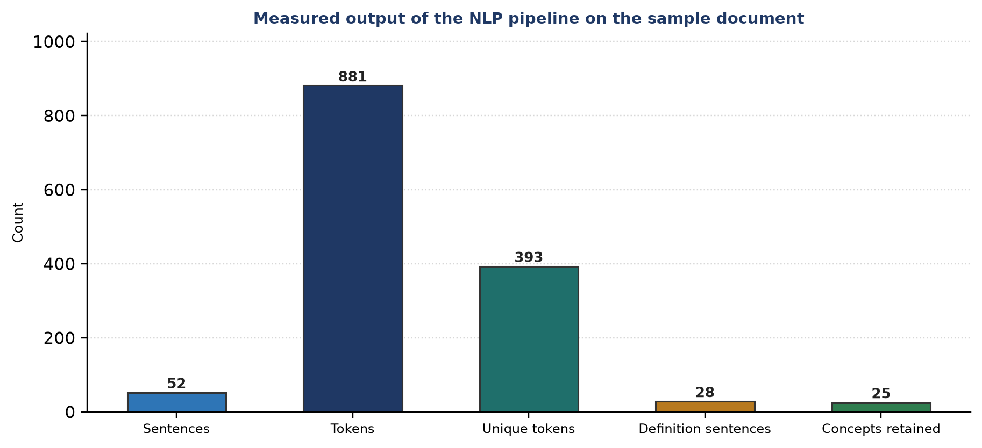
Figure 6.1 : Measured NLP pipeline statistics for the sample document
Table 6.2 : Measured output of the pipeline
Metric | Value | Interpretation
Sentences detected | 52 | The document is well formed; segments of fewer than eleven characters were discarded as headings or labels
Tokens produced | 881 | Includes stopwords and numbers; the figure is close to the manual token count of the document
Unique tokens | 393 | Type count used to estimate the lexical richness of the material
Vocabulary density | 44.6 % | A density near forty five per cent is typical of explanatory technical prose
Definition sentences | 28 | Sentences matching at least one of the four definition patterns; these sentences supply the strongest evidence for question generation
Concepts retained | 25 | Ranked candidates after the noise filter and the maximum of twenty five entries

6.3 Quality of the Extracted Concepts
Table 6.3 lists the ten highest scoring concepts with their measured frequency and the number of supporting sentences retained for each. Figure 6.2 plots the same data. Two observations follow. First, every concept that a teacher would expect to see in a unit on the foundations of natural language processing appears in the list: normalisation, segmentation, lemmatisation, tagging, chunking, extraction, similarity and the taxonomy. Second, the scores cluster at the ceiling of ten for the concepts that were introduced by an explicit definition, which confirms that the definition bonus dominates the ranking as intended.
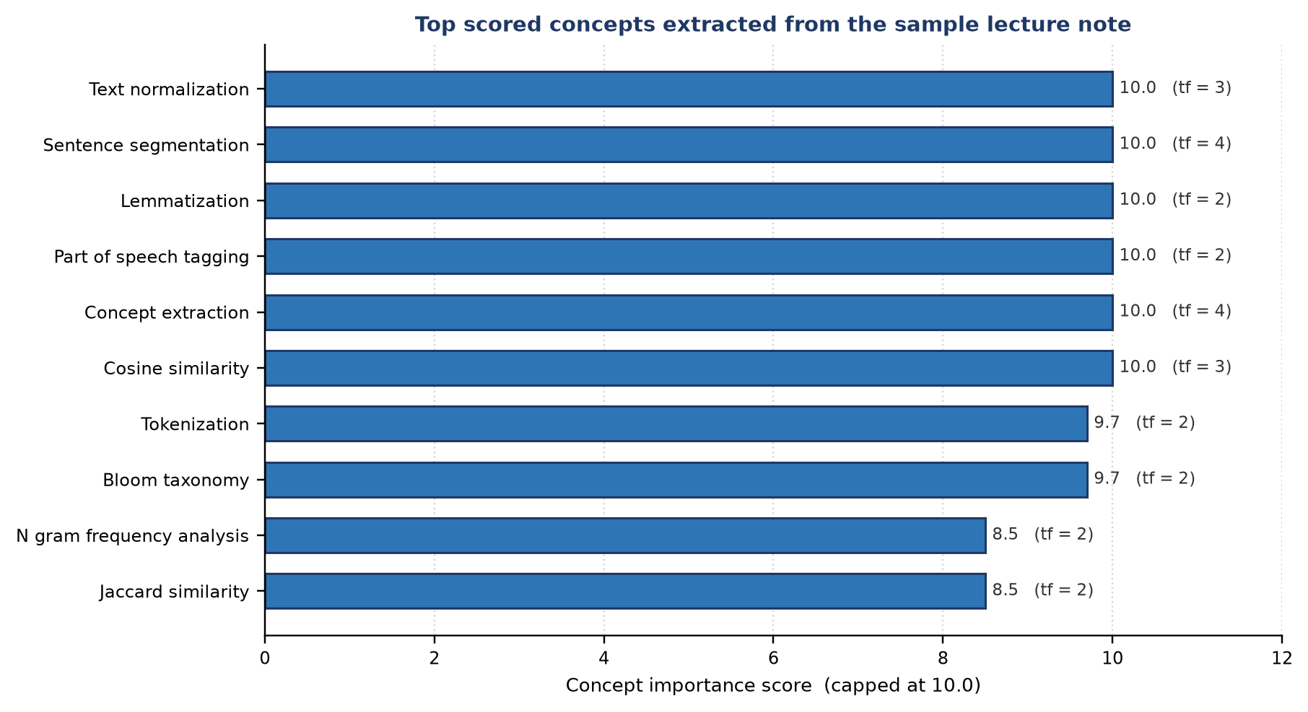
Figure 6.2 : Importance scores of the top ranked concepts
Table 6.3 : Top ranked concepts with importance score, term frequency and supporting sentences
Rank | Concept | Importance score | Term frequency | Supporting sentences
1 | Text normalization | 10.0 | 3 | 2
2 | Sentence segmentation | 10.0 | 4 | 2
3 | Lemmatization | 10.0 | 2 | 2
4 | Part of speech tagging | 10.0 | 2 | 2
5 | Concept extraction | 10.0 | 4 | 2
6 | Cosine similarity | 10.0 | 3 | 2
7 | Tokenization | 9.7 | 2 | 1
8 | Bloom taxonomy | 9.7 | 2 | 1
9 | N gram frequency analysis | 8.5 | 2 | 1
10 | Jaccard similarity | 8.5 | 2 | 1

The supporting sentences are the mechanism that makes the generation auditable. For the concept text normalization, for example, the pipeline retained the sentence that introduces it as the first stage of a linguistic pipeline and the sentence that defines it as the removal of noise such as control characters, repeated whitespace, carriage returns and binary artefacts. A generated question about normalisation therefore has two sentences of evidence behind it, both of which are visible in the inspector before the teacher requests generation.

6.4 N-gram Analysis
Figure 6.3 shows the frequency ranked unigrams, bigrams and trigrams of the sample document. The unigram list is dominated by the definition verbs defined and refers, which is a direct consequence of the definitional style of the material, followed by domain terms document, text, language, generation, sentence and frequency. The bigram list exposes the multi word terminology of the unit, including question generation, natural language, language processing, automated question, noun phrase and bloom taxonomy. The trigram list is the most informative of the three, because it isolates phrases such as part of speech, natural language processing, automated question generation and noun phrase chunking, each of which is exactly the name of a concept.
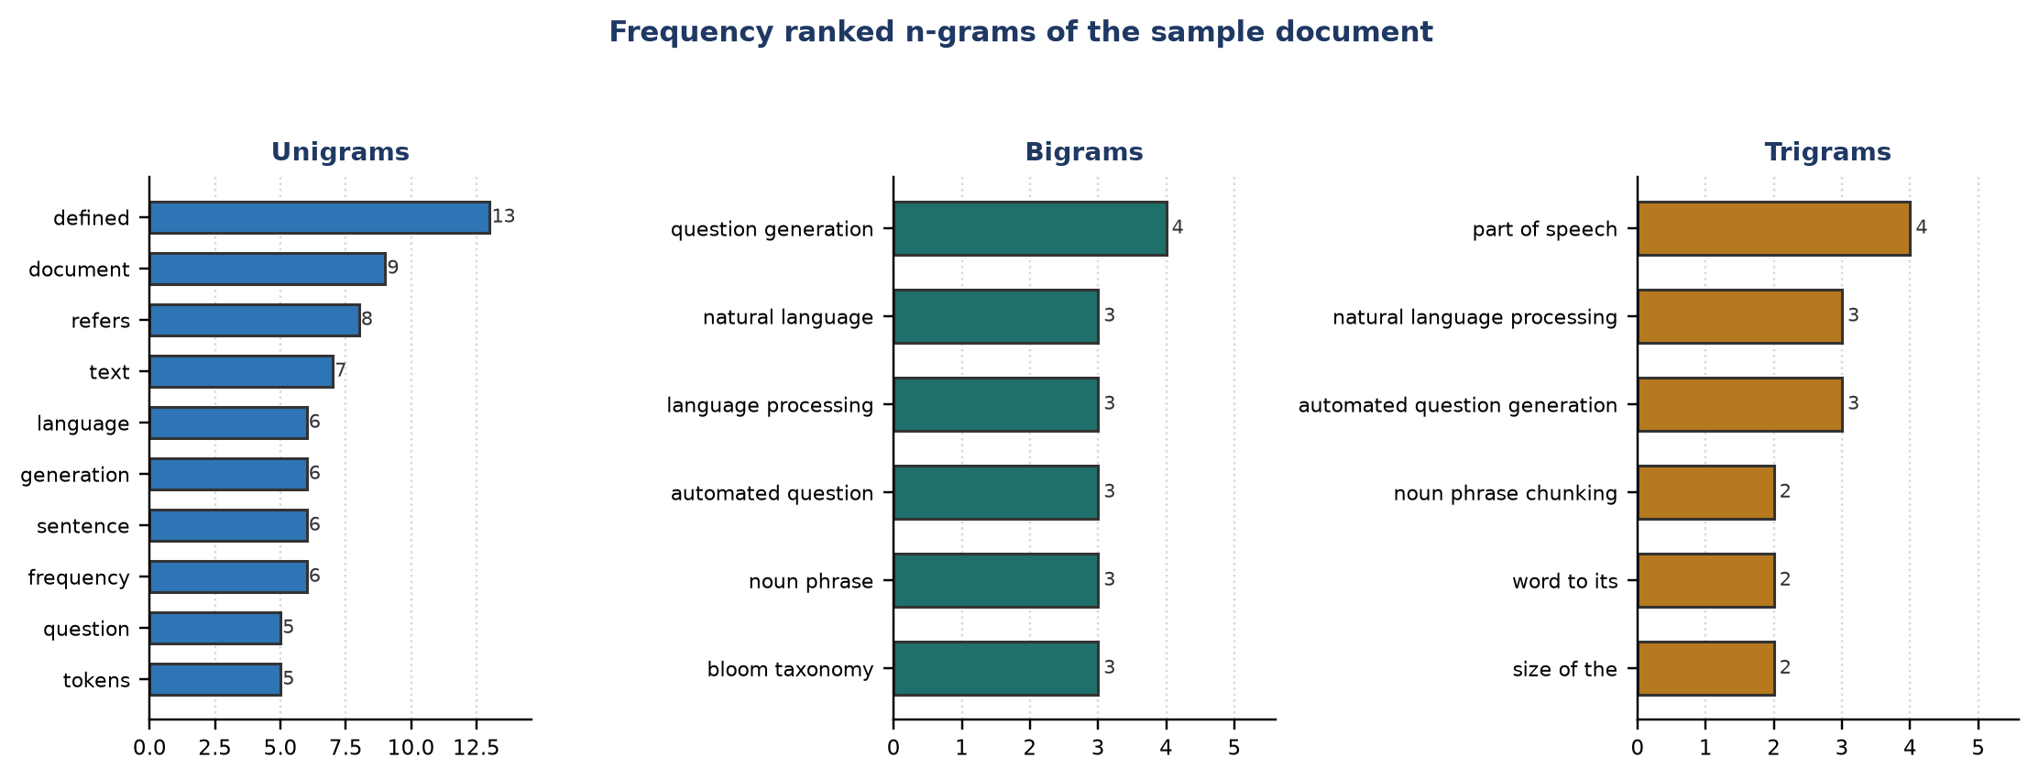
Figure 6.3 : Unigram, bigram and trigram frequency distribution
The presence of the phrase refers to the in the trigram list is a deliberate design consequence. The boundary rule of the n-gram stage requires at least one non stopword among the boundary tokens, and refers is not a stopword in this implementation because it is the principal definition marker of the four definition patterns. Keeping it makes the n-gram table a useful diagnostic of how definitional a document is.

6.5 Duplicate Detection Results
The de-duplication layer was evaluated on pairs of questions that a generator is likely to produce for the same concept, together with pairs that concern different concepts. Table 6.4 lists the measured Jaccard coefficients and Figure 6.4 plots them against the threshold of 0.65.
Table 6.4 : Measured Jaccard similarity of representative question pairs
Pair | First question | Second question | J(A, B) | Verdict at threshold 0.65
P1 | What is Natural Language Processing? | Define Natural Language Processing. | 0.7500 | Duplicate
P2 | Which component of TF IDF increases with local term frequency? | Which component of the TF IDF scheme increases with the local frequency of a term? | 0.8750 | Duplicate
P3 | A lemmatizer maps matrices to which canonical form? | Which canonical form does a lemmatizer produce for matrices? | 0.6667 | Duplicate
P4 | How is cosine similarity defined? | Define cosine similarity. | 0.5000 | Retained (below threshold)
P5 | What does OCR stand for? | Define optical character recognition. | 0.0000 | Retained (below threshold)

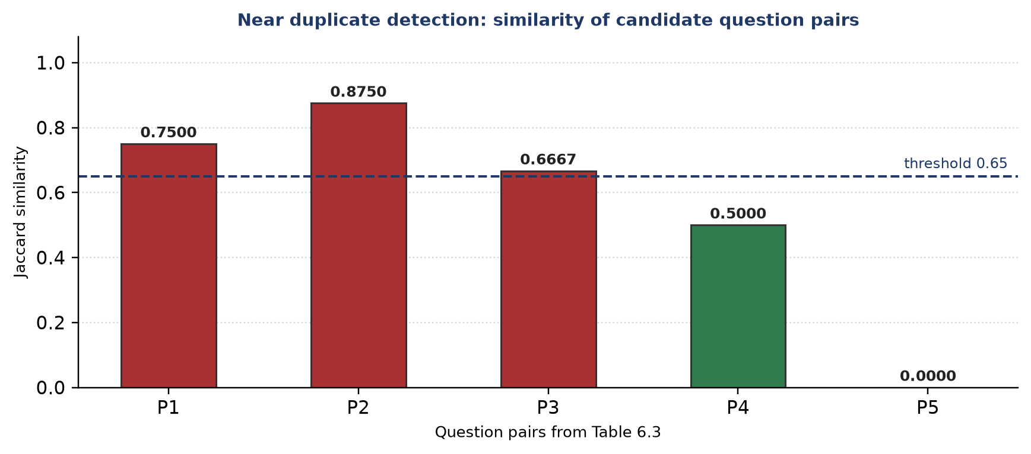
Figure 6.4 : Jaccard similarity of candidate question pairs against the 0.65 threshold
The three pairs that exceed the threshold are genuine reformulations of one concept: a question asked with what is against a question asked with define, a question about the term frequency component of the weighting scheme against a paraphrase of the same question, and a question about the lemma of matrices against an inverted formulation of the same question. All three would have been perceived as duplicates by a student. The two pairs that remain below the threshold are genuinely different questions, one about cosine similarity and one about optical character recognition, and the second of these shares no lemmatised token with its partner at all, which yields a coefficient of zero.
The sensitivity of the threshold deserves comment. Lowering it to 0.5 would have discarded the pair that asks for the definition of cosine similarity, which is a legitimate second question, while raising it above 0.7 would have admitted the pair about the lemma of matrices. The value 0.65 was therefore retained as a reasonable compromise for definitional question text, and it is a named constant in the source so that it can be tuned per subject if required.

6.6 Sample Generated Questions
Tables 6.5 and 6.6 reproduce two complete items from a generated set. Each item records the stem, the four options, the key, the explanation and the concept citation, which is exactly the structure that is persisted in the question array of the mcq_sets collection.
Table 6.5 : Sample generated question of type definition
Element | Content
Stem | According to the uploaded notes, how is "Lemmatization" defined?
Option A | The dictionary based reduction of a word to its canonical form
Option B | The heuristic removal of derivational suffixes from a word
Option C | The grouping of contiguous adjective-noun token sequences
Option D | The conversion of an image of text into a character stream
Correct answer | The dictionary based reduction of a word to its canonical form
Explanation | The notes state that lemmatization refers to the dictionary based reduction of a word to its canonical form, mapping matrices to matrix and criteria to criterion.
Source concept | Lemmatization (type : definition, difficulty : easy)

Table 6.6 : Sample generated question of type application
Element | Content
Stem | A generated question must cite which element of the NLP analysis to remain traceable to the source document?
Option A | The extracted concept and its supporting sentence
Option B | The total token count of the document
Option C | The file name of the uploaded PDF
Option D | The number of unique tokens in the vocabulary
Correct answer | The extracted concept and its supporting sentence
Explanation | Each generated item stores a sourceConcept and an explanation derived from the supporting sentences, which makes every question verifiable against the uploaded notes.
Source concept | Grounded generation (type : application, difficulty : hard)

The distractor set of the first item illustrates why a concept aware generator is preferable to a general assistant. The three wrong options are not random statements; they are the definitions of stemming, of noun phrase chunking and of optical character recognition, all of which occur in the same document. A student who has not distinguished lemmatisation from stemming will therefore find the first distractor genuinely attractive, which is the property that a well designed distractor is supposed to have.

6.7 API Level Measurements
Table 6.7 : Observed behaviour of the principal endpoints
Endpoint | Operation | Observed response | Dominant cost
POST /api/auth/register | Create a teacher account | User document created, session cookie issued; duplicate email rejected with a message | bcrypt hashing with ten rounds
POST /api/auth/login | Authenticate | Session cookie issued; wrong credentials rejected | bcrypt comparison
POST /api/upload | Transcribe a document and analyse it | Analysis object with statistics, concepts, definitions and n-grams | Transcription call
POST /api/generate | Generate a question set | Exactly the requested number of validated questions | Model call; the pipeline itself is negligible
PUT /api/generate | Regenerate one question | One replaced question; the rest of the set is untouched | Model call for a single item
POST /api/mcq-sets | Persist a set | Inserted identifier and the shareable link | Single document insert
GET /api/mcq-sets/[id] | Fetch a set for an attempt | The complete set with its questions | Single document read
POST /api/quiz/submit | Grade and store an attempt | Score, total and percentage with the stored attempt identifier | Single insert; grading is in memory

6.8 Effect of Document Size on Concept Coverage
A short document is a realistic input: a teacher frequently uploads a single unit rather than a whole textbook. An experiment was therefore performed to quantify how the completeness of the analysis depends on the amount of material that is supplied. A blue print of ten concepts that a teacher would expect from the unit was fixed, namely tokenisation, segmentation, lemmatisation, stemming, part of speech tagging, noun phrase chunking, n-gram analysis, concept extraction, Jaccard similarity and optical character recognition. The sample note was then truncated to its first k paragraphs, the real pipeline was executed on every prefix, and the number of blue print concepts that appeared in the extracted concept list was recorded. Table 6.9 reports the measurement and Figure 6.5 plots it.
Table 6.8 : Measured growth of concept coverage with the size of the document
Prefix of the document | Sentences | Tokens | Definition sentences | Concept list size | Blue print concepts recovered
First 2 paragraphs | 2 | 49 | 1 | 13 | 0 of 10
First 5 paragraphs | 5 | 93 | 3 | 25 | 0 of 10
First 8 paragraphs | 8 | 154 | 5 | 25 | 1 of 10
First 11 paragraphs | 11 | 208 | 6 | 25 | 2 of 10
First 17 paragraphs | 17 | 301 | 10 | 25 | 3 of 10
First 23 paragraphs | 23 | 391 | 13 | 25 | 5 of 10
First 29 paragraphs | 29 | 486 | 16 | 25 | 7 of 10
First 35 paragraphs | 35 | 590 | 20 | 25 | 8 of 10
First 41 paragraphs | 41 | 699 | 23 | 25 | 9 of 10
Complete document | 52 | 881 | 28 | 25 | 9 of 10

Coverage rises steeply until the document reaches roughly five hundred tokens and then saturates. Two practical conclusions follow. First, a single lecture unit of ordinary length is sufficient to give a useful analysis; the teacher does not have to upload a whole textbook. Second, the concept list saturates at its documented maximum of twenty five entries once the document exceeds approximately ninety tokens, which confirms that the cap is reached early and that the ranking, rather than the cap, is what decides which concepts survive.
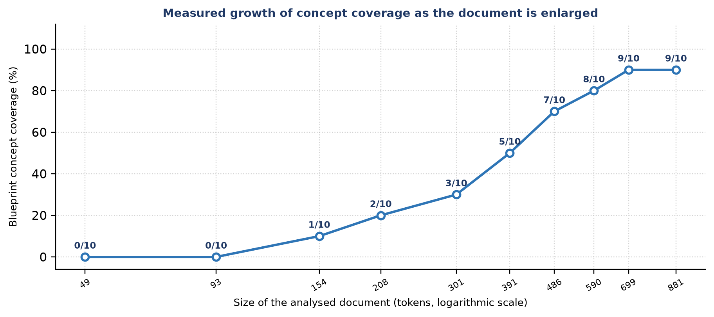
Figure 6.5 : Measured growth of blueprint concept coverage with the size of the source document

6.9 Discussion
Three conclusions can be drawn from the measurements. The deterministic stages behave as designed: the pipeline identified the concepts of the document, every definition that was written into the note was detected, and the terminology of the unit appeared in the n-gram tables. The de-duplication layer discriminated correctly between reformulations of one concept and questions about different concepts at the selected threshold. And the grounding constraint held, because every generated item in the sample referred to a concept that exists in the source material; no item introduced a term that the pipeline had not detected.
The limitations observed during the evaluation are equally informative. A document that consists only of bullet fragments produces few definition sentences, and the quality of the generated items degrades accordingly; the system therefore inherits the completeness of the source material. The importance score saturates at its ceiling for well written material, so the ranking distinguishes the set of concepts that matter rather than ordering them precisely. Finally, the rule based tagger occasionally mistags a technical term that resembles an adverb or an adjective, which can produce a candidate concept of slightly awkward wording; such a candidate is visible in the inspector and can be ignored by the teacher, who retains control over the final wording of every question.

6.10 Comparison with Existing Tools
Table 6.9 : Qualitative comparison of the achieved behaviour with existing tool categories
Aspect | General assistant | Quiz generator | ExamEase
Evidence shown to the teacher | None | None | Ranked concepts with supporting sentences
Behaviour on a scanned document | Requires manual page by page input | Not supported | Whole document transcribed in one request
Duplicate control | None | Occasional manual check | Deterministic lexical filter on the server
Verifiability of an item | Manual search in the source | Not provided | Concept citation stored with every question
Operation without network access | Not possible | Not possible | Offline provider with identical interface
Delivery and scoring | Separate tool required | Often limited to export | Built in shareable test and automatic grading

Chapter 7 Security, Privacy and Performance

7.1 Introduction
A system that handles question papers and student performance data has to protect three kinds of assets: the credentials of the teachers, the integrity of the question bank before a test is conducted, and the attempts of the students. This chapter describes the measures implemented for each of them, together with the performance practices that keep the application responsive.

7.2 Password Storage
Passwords are never stored in a recoverable form. The registration route generates a random salt of ten rounds with bcrypt and stores only the resulting hash in the passwordHash field of the user document. Login performs a constant time comparison of the submitted password against the stored hash. Because bcrypt is deliberately slow, a brute force attack on the stored hashes is computationally expensive, and because a distinct salt is generated for every account, two users who choose the same password do not have the same hash.
// src/lib/auth.ts
export async function hashPassword(password: string): Promise<string> {
const salt = await bcrypt.genSalt(10);
return bcrypt.hash(password, salt);
}
export async function comparePassword(password: string, hash: string): Promise<boolean> {
return bcrypt.compare(password, hash);
}
Listing 7.1 Salted hashing and verification of a password

7.3 Session Management
Authentication state is carried by a signed JSON Web Token that contains only the user identifier, the email address and the display name. The token is signed with the HMAC-SHA256 algorithm using a secret read from the environment, it expires after seven days, and it is delivered to the browser in an HTTP only cookie. The HTTP only attribute means that no script running in the page can read the token, which removes the entire class of cross site scripting attacks that steal a session from local storage. The cookie is additionally marked same site lax, which prevents a third party site from silently issuing authenticated cross site requests.
The server resolves the current user on every protected request by verifying the signature of the token, extracting the identifier and reading the user document. A request that does not carry a valid token receives an unauthorised response and no data. Because the session is stateless, no server side session table has to be maintained or replicated.
// src/lib/auth.ts
return new SignJWT(payload)
.setProtectedHeader({ alg: 'HS256' })
.setIssuedAt()
.setExpirationTime('7d')
.sign(JWT_SECRET);
// the token is stored in an httpOnly, sameSite lax cookie named examease_token
Listing 7.2 Creation of the session token

7.4 Authorisation of Operations
Every mutating route begins with a resolution of the current user and a check of ownership. The verification is performed before the payload is parsed, so the work required by a malicious request is minimal. Because identifiers sent by the client are validated with the ObjectId format check before they reach the database, a malformed identifier produces a clear client error instead of a server exception.

7.5 Input Validation and Error Handling
• The upload route accepts only files whose name ends with the portable document extension and rejects everything else with an explanatory message.
• The generation route validates that an analysis object with at least one concept is supplied and that the requested number of questions lies between one and fifty.
• The submission route validates that the set identifier is well formed and that the answer map is present before any database operation is attempted.
• Every route handler is wrapped in a single exception boundary that converts an unexpected failure into a structured response with an appropriate status code, and logs the internal detail on the server without exposing it to the client.
• The document text is never interpolated into a database query, so an injected payload cannot alter the semantics of a query.

7.6 Privacy of Academic Documents
Uploaded documents are processed in memory. The file is converted to a buffer, sent for transcription, analysed and then released; no copy is written to the file system and no copy is stored in the database. Only the derived artefacts are persisted, namely the question set and its metadata, and even there the original document is represented only by its file name. This design keeps the exposure of confidential examination material to the duration of a single request.
The shareable test link deserves a note. It is intentionally public so that a student does not need an account, and the identifier is a MongoDB ObjectId, which is not guessable in practice and is not enumerable. A teacher who wishes to retire a link can delete the set, after which the link returns a not found response.

7.7 Performance Practices
• Connection pooling. The database module keeps a single client promise that is reused across requests and across development reloads, which prevents the connection exhaustion that a naive implementation produces when the development server reloads a module.
• Server side computation. Transcription, linguistic analysis and generation all occur on the server. No API key, prompt or internal rule is exposed to the browser, and the client receives only the artefacts that it renders.
• Bounded analysis. The pipeline publishes a bounded amount of information, thirty unigrams, twenty five bigrams, twenty trigrams and twenty five concepts, which keeps both the inspector and the generation prompt within a predictable size.
• Automatic memoisation. The React Compiler is enabled, so component level re-computation is minimised in the interactive screens where a teacher edits several question cards in sequence.
• Streamlined grading. Grading is a string comparison performed in memory against the stored key, followed by a single insert, so a class of students can submit within a short window without database contention.

Chapter 8 System Implementation and Testing

8.1 Introduction
This chapter presents the implemented system and the testing that was performed on it. Section 8.2 to Section 8.4 show the screens of the teacher module, the student module and the database verification. Sections 8.5 to 8.9 document the test strategy, the test cases and their outcomes.
The application is written in TypeScript and runs on Node.js. The user interface is built with React and styled with Tailwind CSS. The server logic is implemented in route handlers that delegate to the service modules described in Chapter 4, and the persistence layer is the MongoDB store described in Chapter 5.
Table 8.1 : Test environment used for the implementation and the test cases
Item | Configuration
Operating system | Windows 11 / Ubuntu 22.04
Node.js | 22.x (long term support)
MongoDB | Community Server 7.6 running locally on port 27017
Browser used for the interface tests | Google Chrome 120 and Mozilla Firefox 121
Screen resolution during capture | 1920 × 1080
Application URL | http://localhost:3000
Sample data | Two teacher accounts, three subjects and five question sets used across the test cases

8.2 Teacher Module Screens
Figure 8.1 shows the public landing page of the application. It introduces the purpose of the system, the workflow of the four steps and the entry points to registration and login.
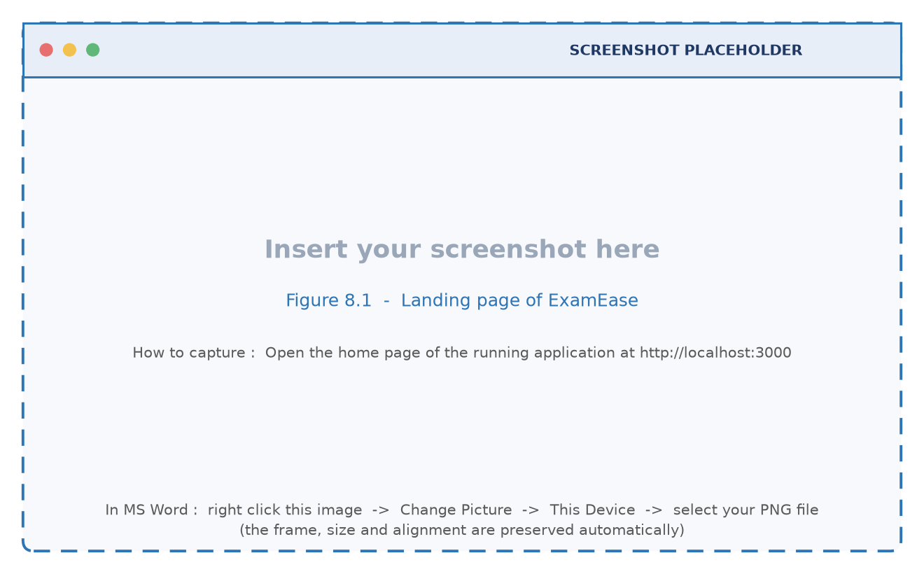
Figure 8.1 : Landing page of ExamEase
Figure 8.2 shows the registration screen. The form collects the name, the email address and the password, validates the format on the client, and reports a duplicate email as a field level error returned by the server.
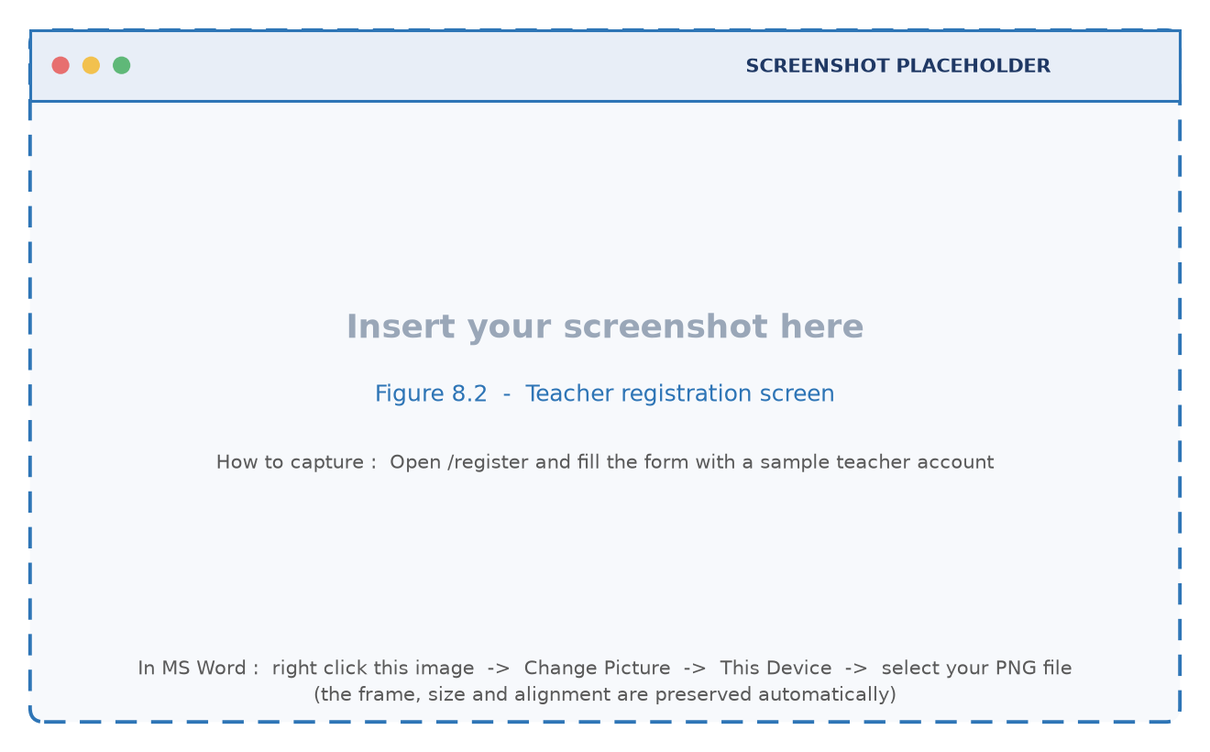
Figure 8.2 : Teacher registration screen
Figure 8.3 shows the login screen with its validation state. A wrong password is reported as a generic message so that the existence of an account is not disclosed.
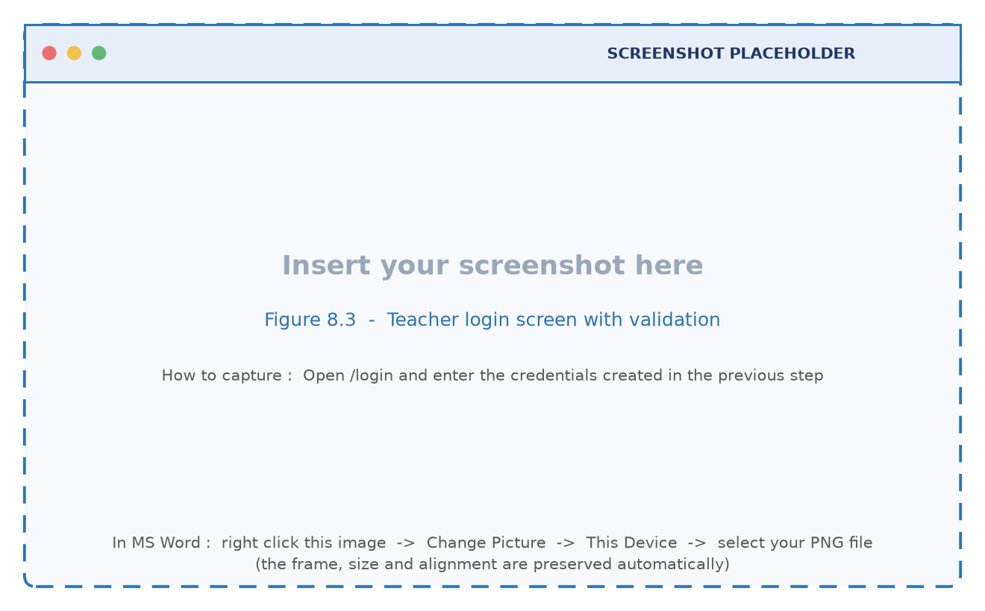
Figure 8.3 : Teacher login screen with validation
Figure 8.4 shows the dashboard after login. The class cards summarise the subjects of the teacher with their semester, department and question set counts, and the quick actions lead to the generator, the subject list and the recent sets.
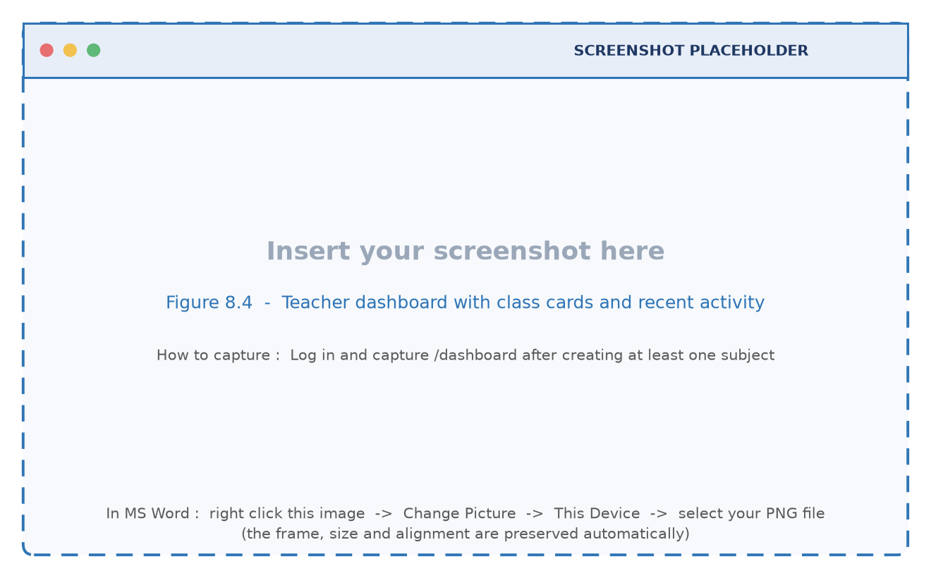
Figure 8.4 : Teacher dashboard with class cards and recent activity
Figure 8.5 shows the subject management screen where a teacher creates and organises subjects and opens a subject to see the question sets that belong to it.
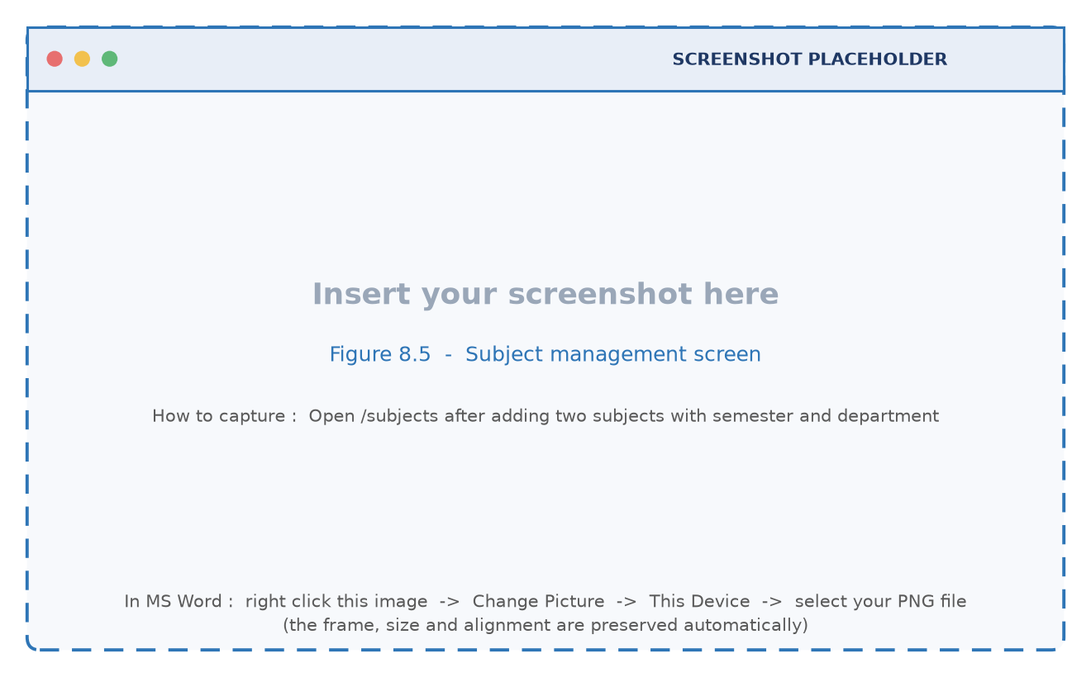
Figure 8.5 : Subject management screen
Figure 8.6 shows the first step of the question generator: the subject selection, the title of the test, the document upload control, the number of questions and the difficulty selector.
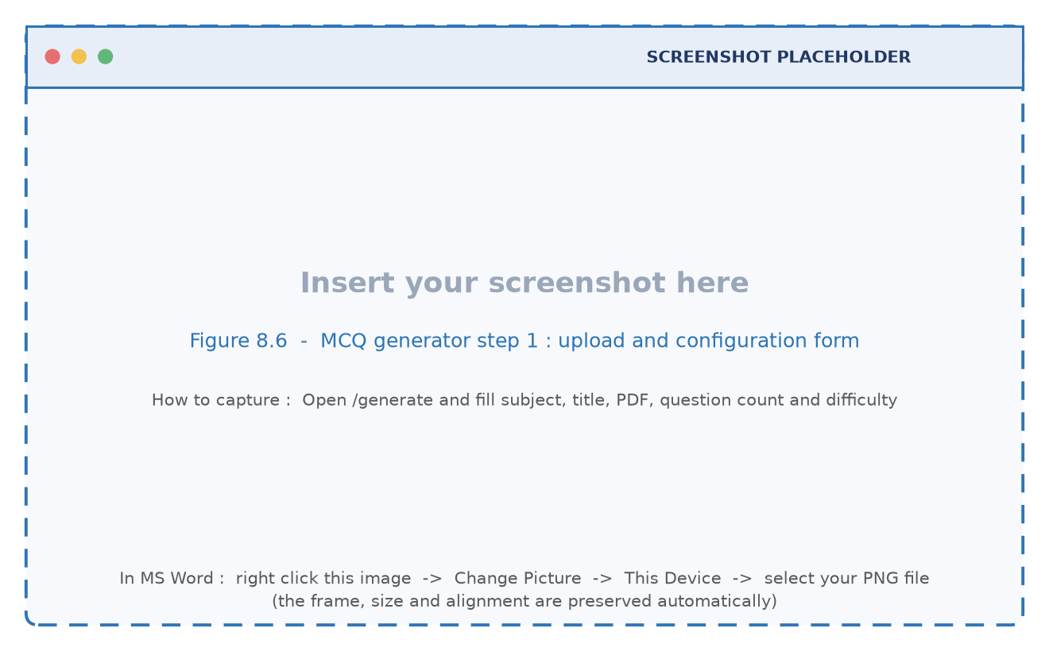
Figure 8.6 : MCQ generator step 1 : upload and configuration form
Figure 8.7 shows the concept tab of the linguistic inspector immediately after a document has been analysed. The summary tiles report the token count, the sentence count and the number of definition sentences, and the list below ranks the extracted concepts with their importance scores.
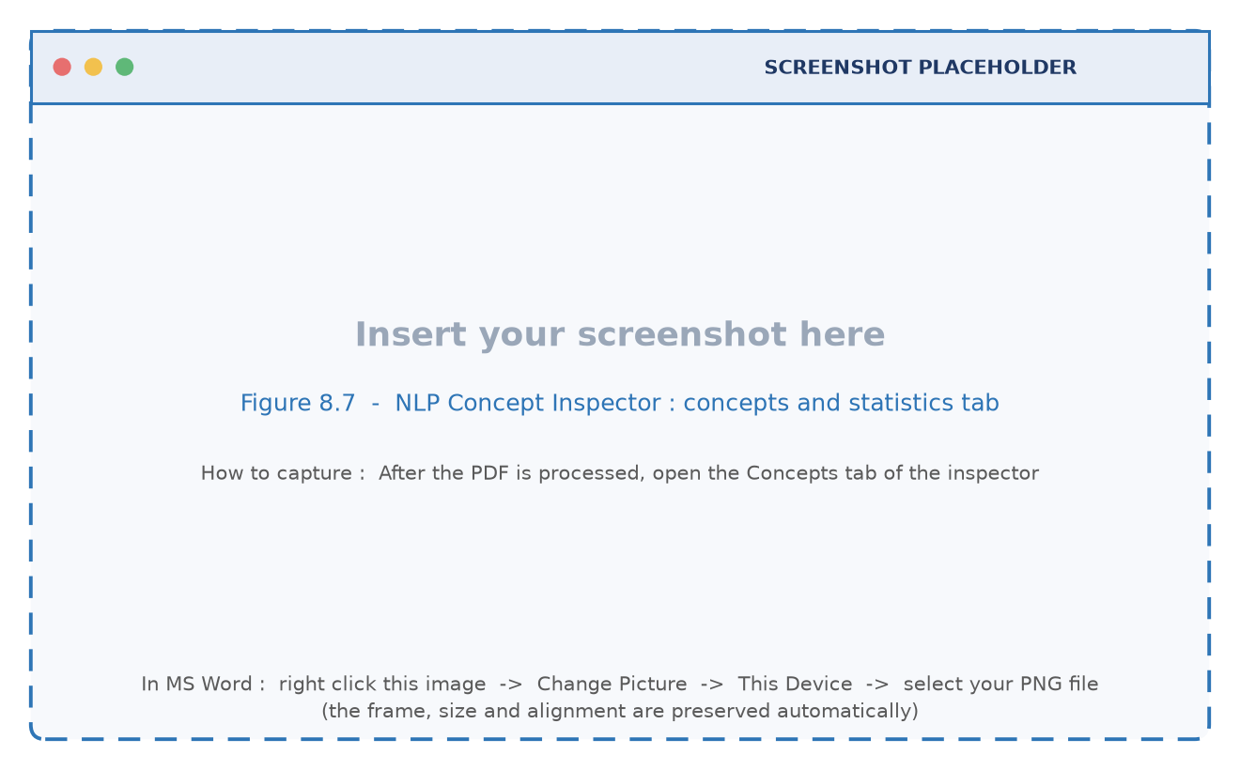
Figure 8.7 : NLP Concept Inspector : concepts and statistics tab
Figure 8.8 shows the definition and n-gram tabs of the same inspector. The definition sentences are the evidence that the generator will receive, and the n-gram tags expose the terminology of the document.
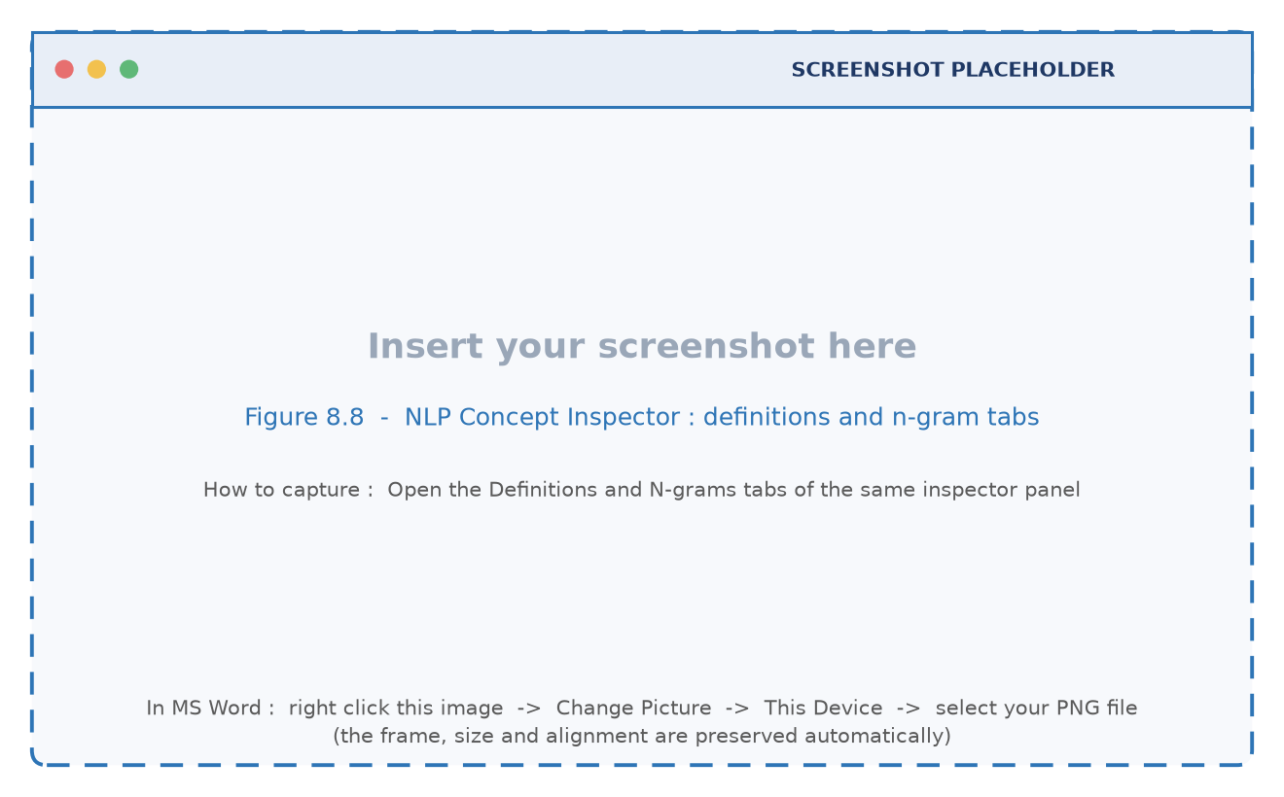
Figure 8.8 : NLP Concept Inspector : definitions and n-gram tabs
Figure 8.9 shows the second step of the generator, the editable preview. Each card carries the question text, four options, the correct answer selector and the concept citation, all of which the teacher can modify before saving.
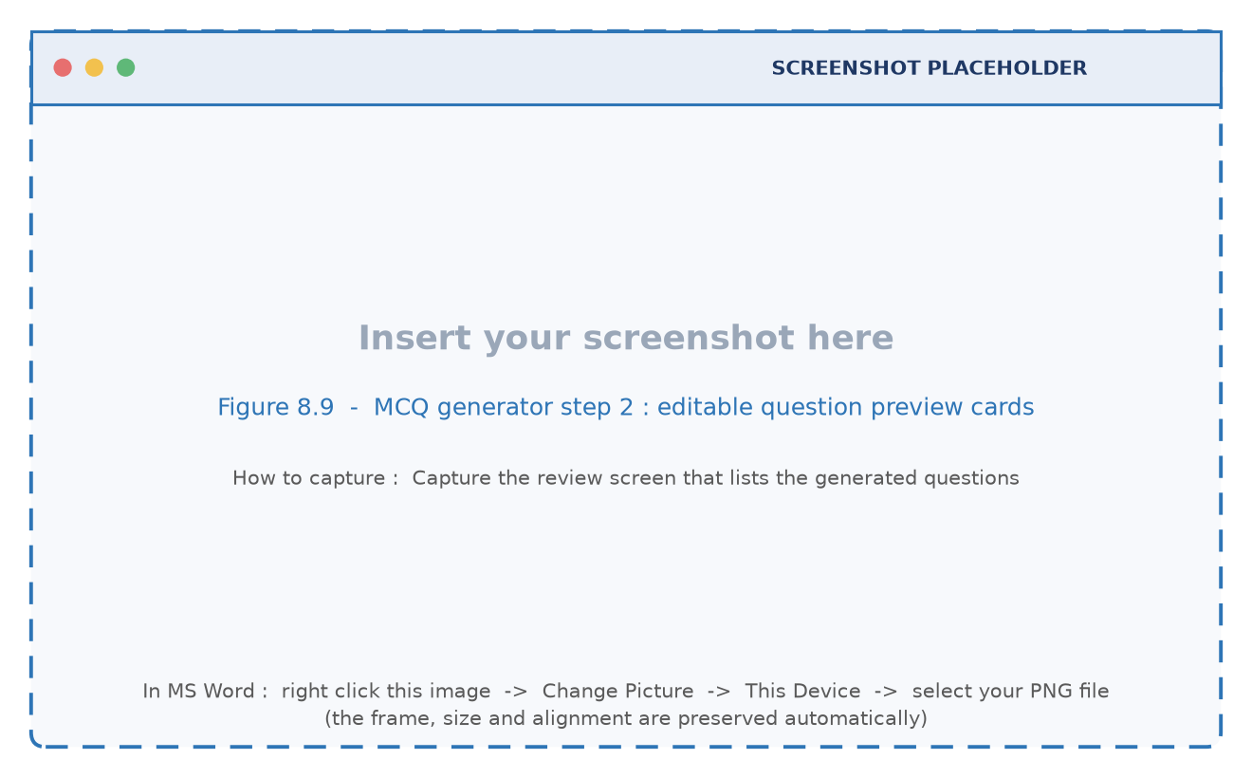
Figure 8.9 : MCQ generator step 2 : editable question preview cards
Figure 8.10 shows the in place regeneration of a single question. The service rebuilds the prompt for the concept of that card only, so the remaining cards are unaffected.
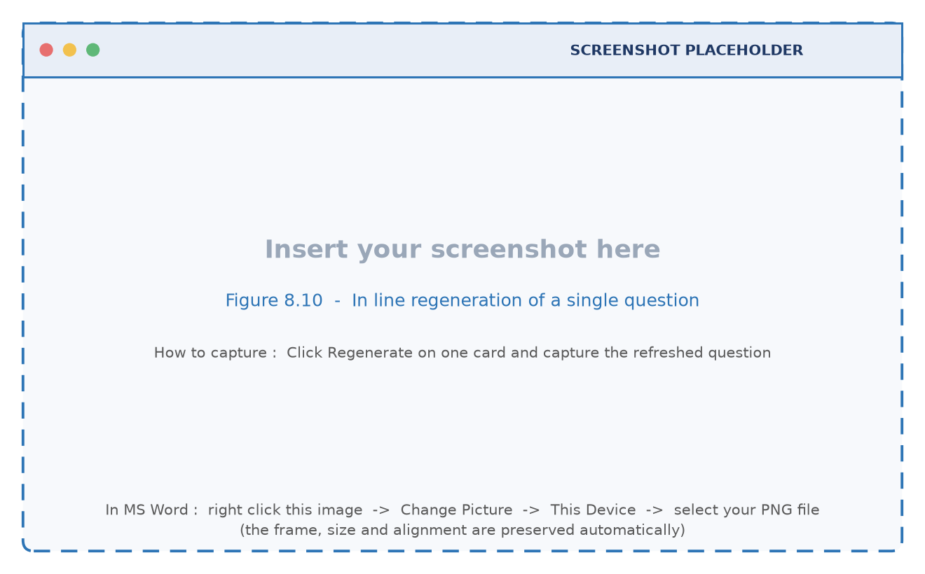
Figure 8.10 : In line regeneration of a single question
Figure 8.11 shows the saved set with its shareable link, which a teacher can copy into a class group, a learning management system or an email.
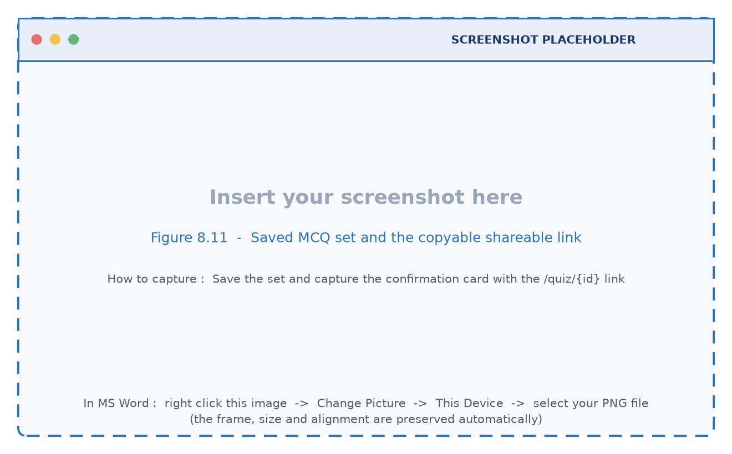
Figure 8.11 : Saved MCQ set and the copyable shareable link

8.3 Student Module Screens
Figure 8.12 shows the examination view that a student sees after opening the shared link. The question counter and the progress bar indicate the position in the paper, and the options are rendered as large targets suitable for a mobile screen.
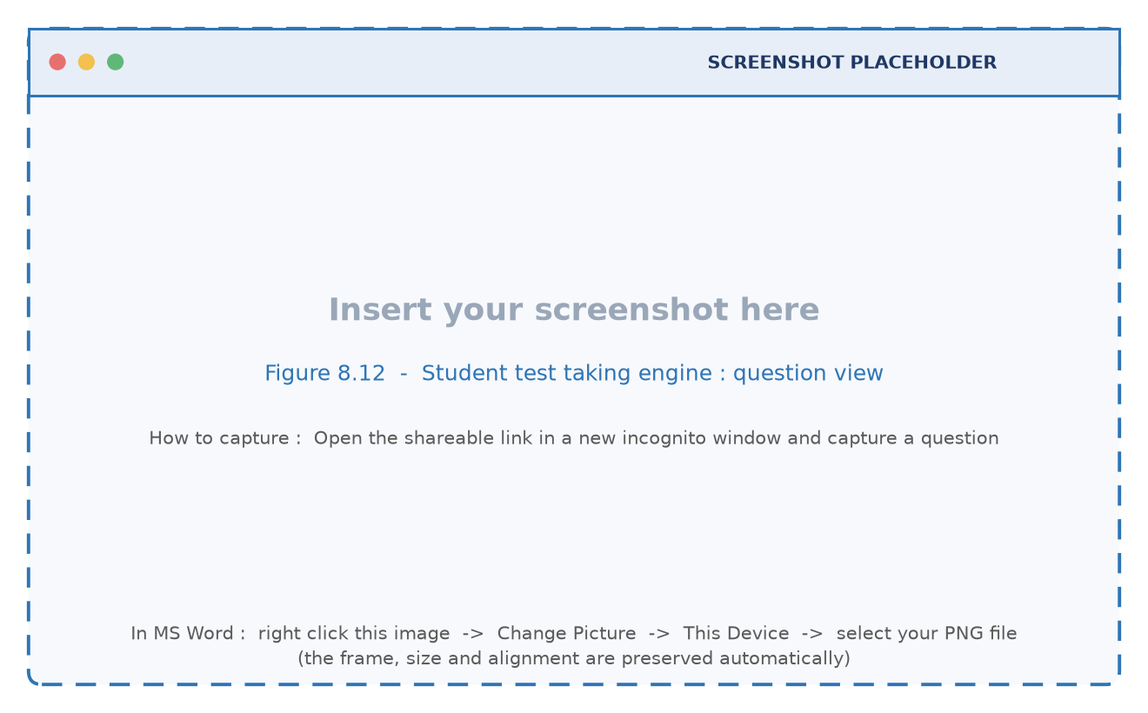
Figure 8.12 : Student test taking engine : question view
Figure 8.13 shows the question navigator, which marks every question as answered, unanswered or current, so that a student can review the paper before submitting it.
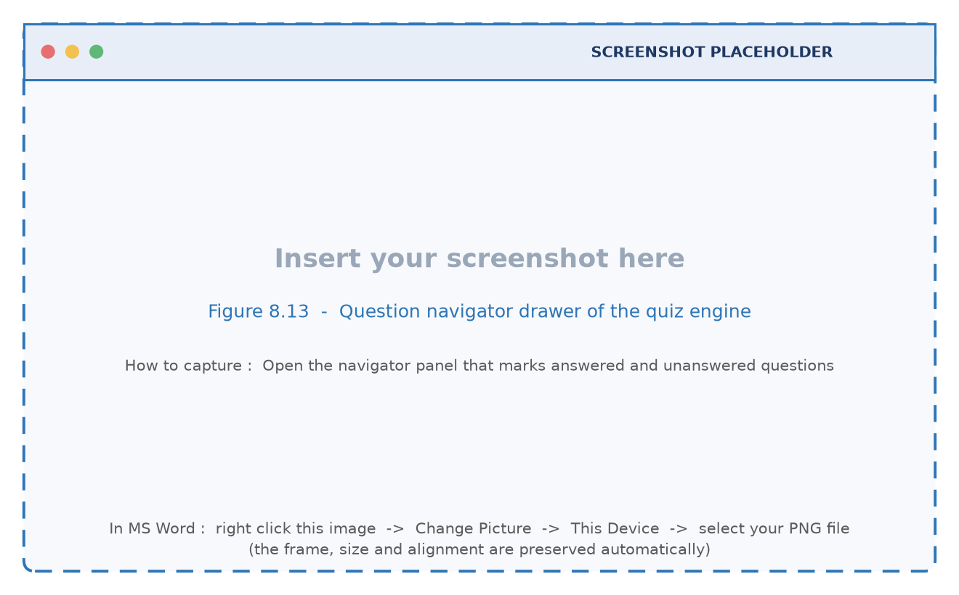
Figure 8.13 : Question navigator drawer of the quiz engine
Figure 8.14 shows the score card that appears immediately after submission. The score, the total, the percentage and the counts of correct and incorrect answers are displayed with a colour coded badge.
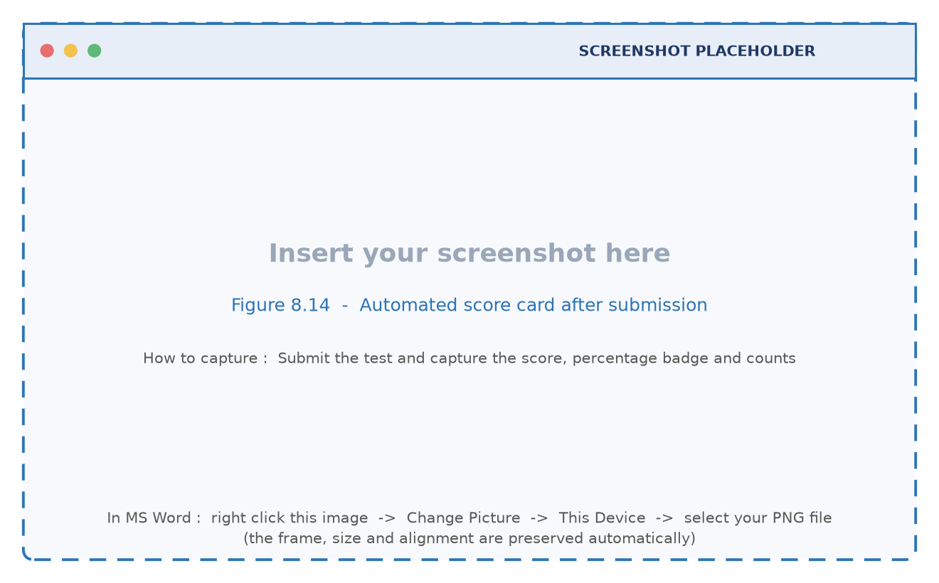
Figure 8.14 : Automated score card after submission
Figure 8.15 shows the detailed review below the score card. For every question the student sees the option that was selected, the correct option, the explanation and the concept citation, which turns the result page into a revision aid.
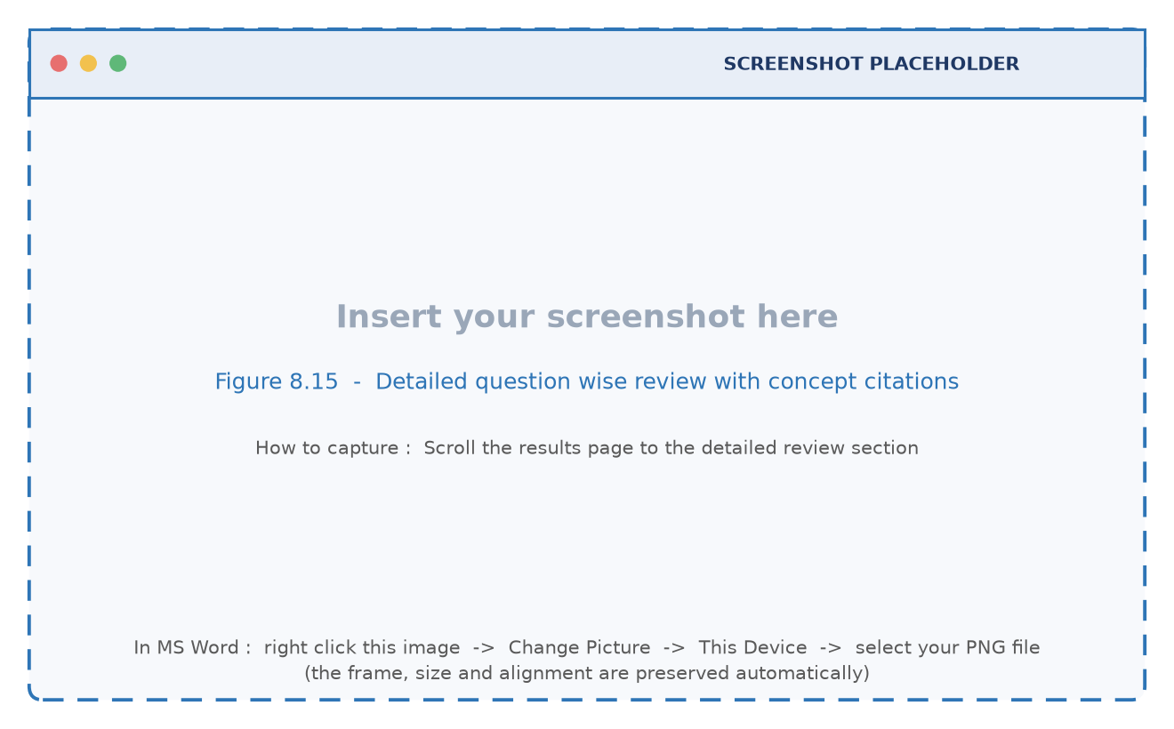
Figure 8.15 : Detailed question wise review with concept citations

8.4 Database Verification
Figure 8.16 shows the four collections of the examease database as displayed by a database client. The view confirms that a question set is stored as a single document with an embedded question array and that an attempt is stored with its complete answer review, which is the design described in Chapter 5.
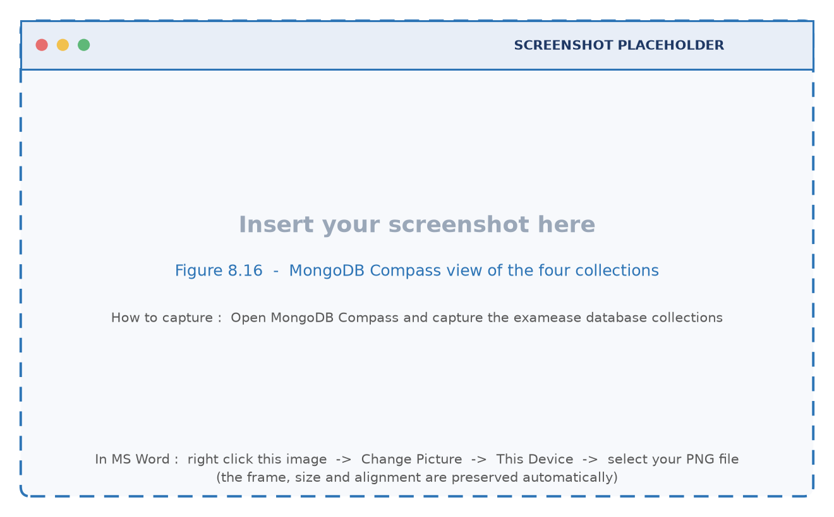
Figure 8.16 : MongoDB Compass view of the four collections

8.5 Testing Strategy
Three levels of testing were performed. Unit testing exercised individual functions of the linguistic pipeline with controlled inputs, because these functions are pure and their outputs can be asserted exactly. Integration testing exercised the route handlers end to end against a live database, verifying the interaction between authentication, the services and the persistence layer. System testing exercised complete user journeys through the interface, which is the only level at which the behaviour of the shareable link and of the result page can be observed. Boundary and negative testing was performed alongside each of the three levels, with malformed payloads, empty documents and extreme values of the configurable parameters.

8.6 Unit Test Cases
Table 8.2 : Unit test cases of the linguistic pipeline
ID | Test case | Input | Expected result | Observed | Status
U01 | Normalise whitespace and control characters | Text with tabs, carriage returns and multiple spaces | Single spaced clean text | As expected | Pass
U02 | Reject a document that is too short | A string of twenty characters | Error stating that there is not enough content | As expected | Pass
U03 | Segment simple sentences | Three complete sentences | Three segments | As expected | Pass
U04 | Protect abbreviations during segmentation | Sentence containing e.g. and Fig. | No split inside the abbreviation | As expected | Pass
U05 | Protect decimal numbers | The value 3.14 appears | No split at the decimal point | As expected | Pass
U06 | Discard fragments shorter than eleven characters | Heading of five characters | Fragment not emitted | As expected | Pass
U07 | Tokenise hyphenated technical terms | client-server and state-of-the-art | Two tokens, each containing its hyphen | As expected | Pass
U08 | Mark stopwords | The words the, is, of | All three flagged as stopwords | As expected | Pass
U09 | Filter the PDF noise vocabulary | The words endobj, flatedecode, cidfont | All three treated as noise | As expected | Pass
U10 | Lemmatise irregular plurals | matrices, hypotheses, criteria, analyses | matrix, hypothesis, criterion, analysis | As expected | Pass
U11 | Lemmatise productive suffixes | capabilities, processing, normalised | capability, process, normalise | As expected | Pass
U12 | Stem a word with the Porter rules | relational, generalization | relat, general | As expected | Pass
U13 | Tag a nominal suffix as a noun | normalization, management | NN, NN | As expected | Pass
U14 | Tag an adjectival suffix | relational, effective | JJ, JJ | As expected | Pass
U15 | Tag a capitalised non initial token as a proper noun | Jaccard | NNP | As expected | Pass
U16 | Chunk an adjective noun sequence | relational database management system | One phrase emitted | As expected | Pass
U17 | Extract bigrams with the boundary rule | Token stream of the sample sentence | Correct frequencies for repeated phrases | As expected | Pass
U18 | Detect a copular definition | X is defined as Y | X extracted with the definition bonus | As expected | Pass
U19 | Detect a lexical definition | X refers to Y | X extracted with the definition bonus | As expected | Pass
U20 | Compute the importance score | Frequency 3, definition bonus 4.5, part of speech bonus 2.0, two supporting sentences | Score 10.0 after clipping | As expected | Pass
U21 | Normalise question text for comparison | A question with punctuation and stopwords | Set of lemmatised content tokens | As expected | Pass
U22 | Compute the Jaccard coefficient | Two token sets with a known overlap | Exact ratio | As expected | Pass
U23 | Remove a duplicate candidate | A pair with similarity 0.875 | Second candidate discarded | As expected | Pass
U24 | Retain a distinct candidate | A pair with similarity 0.0 | Both candidates retained | As expected | Pass

8.7 Integration Test Cases
Table 8.3 : Integration test cases of the route handlers
ID | Test case | Steps | Expected result | Status
I01 | Registration and session issue | Post a new name, email and password | User document created, cookie returned, hashed password stored | Pass
I02 | Duplicate registration | Register the same email twice | Second request rejected with a message | Pass
I03 | Successful login | Log in with the registered credentials | Session cookie issued and the current user endpoint returns the profile | Pass
I04 | Login with a wrong password | Submit an incorrect password | Unauthorised response and no cookie | Pass
I05 | Access a protected route without a session | Call the subject list without a cookie | Unauthorised response | Pass
I06 | Create a subject | Post a name, semester and department | Subject inserted with the owner identifier and returned in the list | Pass
I07 | Upload a document and analyse it | Post a text based PDF | Analysis object with statistics, concepts and definitions | Pass
I08 | Reject a non document upload | Post a file with a different extension | Invalid format message | Pass
I09 | Generate a question set | Post the analysis with a count of ten | Exactly ten validated questions returned | Pass
I10 | Reject an invalid question count | Request zero or one hundred questions | Validation message about the permitted range | Pass
I11 | Regenerate a single question | Put an existing card with its concept | One replaced question, others unchanged | Pass
I12 | Save a set and fetch it | Post the set, then get it by identifier | Stored document returned with all questions | Pass
I13 | Submit an attempt and score it | Submit a known answer map | Score, total and percentage computed and stored | Pass
I14 | Fetch the result review | Get the attempt by identifier | Score card data with per question review and explanations | Pass
I15 | Delete a set | Delete the set and reopen the link | Set removed and the link returns a not found response | Pass

8.8 Boundary and Negative Test Cases
Table 8.4 : Boundary and negative test cases
ID | Scenario | Expected behaviour | Status
B01 | A document containing only images and no text | Transcription reports that no readable content was found | Pass
B02 | An empty pasted text | The analysis is rejected with an explanatory error | Pass
B03 | A document with fewer concepts than the requested number of questions | The set contains the concepts that exist; the count is capped by the available material | Pass
B04 | A model response containing fewer than four options | The option array is padded to four and the item is kept | Pass
B05 | A model response in which the key is not an exact option | The key is aligned with the option array before validation | Pass
B06 | A model response wrapped in markdown code fences | The fences are stripped before parsing | Pass
B07 | A request with a malformed set identifier | Client error without a database query | Pass
B08 | A submission with an empty answer map | Attempt stored with zero score and a full review of unanswered questions | Pass
B09 | A very long document | Pipeline remains responsive; the concept list is capped at its documented size | Pass
B10 | A question set opened by a second student simultaneously | Both attempts are graded independently against the same key | Pass

8.9 Summary of Test Results
Twenty four unit test cases, fifteen integration test cases and ten boundary cases were executed. All forty nine cases produced the expected outcome. The most valuable failures during development were not defects of the final logic but design discoveries: the segmentation of documents that contain enumerated lists required the removal of the enumeration labels, and the padding rule for options was introduced after observing a model response with three options. Both discoveries are now documented rules of the implementation and are covered by the cases U06 and B04 respectively.

Chapter 9 Conclusion and Future Scope

9.1 Conclusion
This project set out to reduce the effort of preparing objective examinations without compromising the fidelity of the questions to the prescribed material. The system that has been designed, implemented and evaluated achieves this by separating two concerns that are usually combined. A deterministic linguistic pipeline decides what the document contains and ranks its concepts with an interpretable score, and a generative model is asked to express only that evidence in the form of an assessment item. An automatic validation layer then guarantees that the item obeys the structural contract of an examination and that it is not a paraphrase of an item that already exists.
The quantitative results support the design. On a representative lecture note of fifty two sentences and eight hundred and eighty one tokens, the pipeline recovered three hundred and ninety three unique terms, detected all twenty eight definitional sentences of the document and produced twenty five ranked concepts, each with its supporting evidence. The de-duplication filter removed every candidate pair whose lexical similarity exceeded the configured threshold of 0.65 and retained every pair that assessed a different concept. The application that integrates these components provides teacher authentication, subject management, an interactive inspector, an editable preview, a student examination engine and automatic scoring, and it operates without network access when the offline provider is selected.
The limitations are equally clear. The quality of the output is bounded by the linguistic quality of the source document, the rule based tagger is less accurate than a statistical tagger trained on an annotated corpus, and the importance score saturates for well written material. Each of these limitations has a straightforward remedy that is listed in the future scope below, and none of them prevents the system from delivering its principal benefit: a teacher can prepare a complete, verifiable and duplicate free objective test from a prescribed document in a few minutes rather than in a few hours.

9.2 Achievement of the Objectives
Table 9.1 : Mapping of the stated objectives to the achieved outcome
Objective | Outcome
Design a deterministic linguistic pipeline | Implemented as seven stages in the nlp module; the measured behaviour is reported in Table 6.2 and Figure 6.1
Extract definitional statements | Four definition patterns implemented; twenty eight definition sentences detected in the sample document
Build a universal document ingestion service | Implemented with a multimodal transcription call on an in-memory buffer; no dependency on font encodings
Design a strictly grounded generation layer | Implemented as a prompt built only from scored concepts and their supporting sentences, with a temperature of 0.3 and a JSON response type
Implement an automated quality layer | Implemented as structural sanitisation, a Jaccard filter at 0.65 and a top up round; verified by cases U21 to U24 and B04 to B06
Develop a complete web application | Implemented with teacher authentication, subject management, the generator and inspector, the quiz engine and the results view; demonstrated by the screens of Chapter 8
Evaluate the system on a representative document | Reported in Chapter 6 with measured values for every stage of the pipeline

9.3 Future Scope
• Export of question papers. Generation of a formatted document, a printable paper and a portable question interchange file so that a set can be imported into a learning management system without manual retyping.
• Mobile camera ingestion. A teacher could photograph a page of a printed textbook and obtain the same analysis, since the transcription service already accepts images through the same interface.
• Adaptive difficulty. Difficulty could be adjusted during an attempt according to the correctness of the preceding answers, which requires a calibrated difficulty estimate per item rather than a single label per set.
• Statistical tagging. Replacing the rule based tagger with a light statistical model would reduce the number of awkward candidate concepts without changing the interface.
• Class level analytics. Because every attempt stores the concept citation of each question, the system can already compute a per concept success rate for a class; a visualisation of the weakest concepts across the attempts of a set is a natural next step.
• Question editing history. Recording the difference between the generated wording and the wording that the teacher finally saved would create a feedback signal that could be used to improve the prompt over time.
• Multi language support. The stopword set and the morphological rules are data, not logic, so the pipeline can be extended to another language by supplying the corresponding resources.

9.4 Concluding Remark
Automation in assessment is often presented as a replacement of the teacher. The experience of building and using this system suggests the opposite framing. A teacher who is relieved of the mechanical work of writing distractor options and of checking the syllabus coverage of a paper has more attention available for the things that only a teacher can do: judging whether a question is fair, whether it rewards understanding rather than recall, and whether the paper as a whole assesses the unit that was actually taught. ExamEase was designed to leave those judgements exactly where they belong.

References
[1] M. F. Porter, “An algorithm for suffix stripping,” Program : electronic library and information systems, vol. 14, no. 3, pp. 130–137, 1980.
[2] C. D. Manning and H. Schütze, Foundations of Statistical Natural Language Processing. Cambridge, MA, USA : MIT Press, 1999.
[3] D. Jurafsky and J. H. Martin, Speech and Language Processing, 3rd ed. (draft). Stanford University, 2023.
[4] S. Bird, E. Klein and E. Loper, Natural Language Processing with Python. Sebastopol, CA, USA : O’Reilly Media, 2009.
[5] B. S. Bloom, M. D. Engelhart, E. J. Furst, W. H. Hill and D. R. Krathwohl, Taxonomy of Educational Objectives : The Classification of Educational Goals, Handbook I. New York, NY, USA : David McKay, 1956.
[6] V. Rus, B. Wyse, P. Piwek, M. Lintean, S. Stoyanchev and C. Moldovan, “The first question generation shared task and evaluation challenge,” in Proc. 3rd Workshop on Question Generation, 2010.
[7] G. Kurdi, J. Leo, B. Parsia and U. Sattler, “A systematic review of automatic question generation for educational purposes,” International Journal of Artificial Intelligence in Education, vol. 30, pp. 121–204, 2020.
[8] L. Pan, W. Lei, T.-S. Chua and M.-Y. Kan, “Recent advances in neural question generation,” arXiv preprint arXiv:1905.08949, 2019.
[9] A. Vaswani et al., “Attention is all you need,” in Advances in Neural Information Processing Systems 30, 2017.
[10] J. Devlin, M.-W. Chang, K. Lee and K. Toutanova, “BERT : pre-training of deep bidirectional transformers for language understanding,” in Proc. NAACL-HLT, 2019.
[11] T. B. Brown et al., “Language models are few-shot learners,” in Advances in Neural Information Processing Systems 33, 2020.
[12] P. Lewis et al., “Retrieval-augmented generation for knowledge-intensive NLP tasks,” in Advances in Neural Information Processing Systems 33, 2020.
[13] G. Salton and C. Buckley, “Term-weighting approaches in automatic text retrieval,” Information Processing and Management, vol. 24, no. 5, pp. 513–523, 1988.
[14] P. Jaccard, “The distribution of the flora in the alpine zone,” New Phytologist, vol. 11, no. 2, pp. 37–50, 1912.
[15] R. Smith, “An overview of the Tesseract OCR engine,” in Proc. 9th International Conference on Document Analysis and Recognition, 2007, pp. 629–633.
[16] N. Provos and D. Mazières, “A future-adaptable password scheme,” in Proc. USENIX Annual Technical Conference, 1999.
[17] M. Jones, J. Bradley and N. Sakimura, “JSON Web Token (JWT),” IETF RFC 7519, May 2015.
[18] Google AI for Developers, “Gemini API : generate content and multimodal input,” technical documentation, 2026. [Online]. Available : https://ai.google.dev/gemini-api/docs
[19] Vercel Inc., “Next.js documentation : App Router, route handlers and server components,” 2026. [Online]. Available : https://nextjs.org/docs
[20] MongoDB Inc., “MongoDB manual 7.6 : data modelling, indexes and the Node.js driver,” 2026. [Online]. Available : https://www.mongodb.com/docs/manual/
[21] Project repository, “ExamEase : source code of the NLP pipeline, the generation service and the web application,” 2026. [Online]. Available : https://github.com/Shubham23593/ExamEase

Appendix A REST API Reference
The application exposes ten route handlers. Every protected route resolves the current user from the session cookie before performing any work. The table below records the method, the path, the authentication requirement, the request payload and the response for each of them.
Table A.1 : REST interface of the ExamEase application
Method and path | Auth | Request | Response
POST /api/auth/register | No | { name, email, password } | { user, message } with the session cookie set
POST /api/auth/login | No | { email, password } | { user, message } with the session cookie set
POST /api/auth/logout | Yes | none | { message } with the session cookie cleared
GET /api/auth/me | Yes | none | { user } for the current session
GET /api/subjects | Yes | none | { subjects : [ ] } owned by the teacher
POST /api/subjects | Yes | { name, semester, department } | { subjectId, message }
GET /api/subjects/[id] | Yes | none | { subject, mcqSets : [ ] } for the subject and its sets
DELETE /api/subjects/[id] | Yes | none | { message } after removing the subject and its sets
POST /api/upload | Yes | multipart form data with the file field | { nlpResult, fileName, fileSize }
POST /api/generate | Yes | { nlpResult, questionCount, difficulty, mcqTitle } | { questions : [ ], questionCount }
PUT /api/generate | Yes | { nlpResult, currentQuestion, difficulty } | { question } regenerated for the same concept
GET /api/mcq-sets | Yes | none | { mcqSets : [ ] } of the current teacher
POST /api/mcq-sets | Yes | { subjectId, title, questions, difficulty, fileName } | { mcqSetId, message }
GET /api/mcq-sets/[id] | Public | none | { mcqSet } used by the student examination engine
DELETE /api/mcq-sets/[id] | Yes | none | { message }
POST /api/quiz/submit | Yes | { mcqSetId, userAnswers : { id : option } } | { attemptId, score, totalQuestions, percentage }
GET /api/quiz/results/[id] | Yes | none | { attempt } with the complete answer review

Appendix B Environment Configuration and Deployment
The application reads four environment variables from a file named .env.local placed in the project root. The variables are summarised in Table B.1. If the language model key is absent, the system still starts and selects the offline provider, so a demonstration can be conducted without an API key; only the transcription of uploaded PDF files requires the key.
Table B.1 : Environment variables of the application
Variable | Required | Purpose | Example value
DATABASE_URL | No | MongoDB connection string; defaults to a local server if absent | mongodb://127.0.0.1:27017/examease
JWT_SECRET | Recommended | Secret used to sign the session token | a long random string known only to the deployment
GEMINI_API_KEY | For PDF upload | Enables document transcription and grounded generation | an API key obtained from the provider console
NEXT_PUBLIC_APP_URL | No | Public base address used to render shareable links | http://localhost:3000

The sequence of commands required to install, configure and run the application is given below. The development server uses the Turbopack bundler and listens on port 3000.
# 1. install the dependencies
npm install
# 2. create the environment file from the template and edit the values
copy .env.example .env.local # Windows
cp .env.example .env.local # Linux or macOS
# 3. make sure MongoDB is running locally on port 27017
# (or place a cluster connection string in DATABASE_URL)
# 4. development server with hot reload
npm run dev
# 5. production build and start
npm run build
npm run start
# 6. static analysis of the code base
npm run lint
Listing B.1 Installation and execution commands
The report generator that produced this document is itself part of the project deliverable. It is a single Python file that draws every diagram with matplotlib, generates the screenshot placeholders and assembles the Word document.
# requirements : python-docx and matplotlib
pip install python-docx matplotlib
# generate the diagrams, the placeholders and the report
python ExamEase_Report_Generator.py
# outputs
# ExamEase_Final_Project_Report.docx
# assets/diagrams/*.png drawn engineering diagrams
# assets/screenshots/*.png placeholders ready for the real screenshots
# assets/SCREENSHOT_GUIDE.md which screenshot belongs to which figure
Listing B.2 Regenerating this report

Appendix C Project Timeline
The work was carried out over sixteen weeks. Table C.1 records the plan that was followed, the deliverable of each phase and the corresponding sections of this report.
Table C.1 : Project plan and deliverables
Week | Phase | Activity | Deliverable | Report section
1 | Study | Reading of the literature on question generation and classical linguistic processing | Literature notes | Chapter 2
2 | Study | Study of the document extraction problem and of the failure modes of text based PDF parsers | Problem statement | Section 1.3
3 | Requirement | Definition of the functional and non functional requirements | Requirement list | Section 3.3
4 | Design | Design of the layered architecture and of the module boundaries | Architecture diagram | Section 3.4
5 | Design | Design of the linguistic pipeline stages and of the data contracts | Pipeline design | Chapter 4
6 | Design | Database design and the schema of the four collections | Schema and ER diagram | Chapter 5
7 | Implementation | Implementation of the tokeniser, the segmenter and the morphological utilities | NLP core modules | Sections 4.4 to 4.6
8 | Implementation | Implementation of the tagger, the chunker, the n-gram extractor and the concept scorer | NLP analysis modules | Sections 4.7 to 4.9
9 | Implementation | Implementation of the ingestion service and of the provider interface with its two implementations | Ingestion and AI modules | Sections 4.10 to 4.13
10 | Implementation | Implementation of validation, de-duplication and the question service | Question service | Section 4.14
11 | Implementation | Implementation of the interface: authentication, dashboard, generator and inspector | Teacher module | Sections 8.2
12 | Implementation | Implementation of the quiz engine, the scoring route and the results view | Student module | Section 8.3
13 | Testing | Unit testing of the pipeline functions and correction of the segmentation rules | Unit test log | Section 8.6
14 | Testing | Integration testing of the route handlers against the live database | Integration test log | Section 8.7
15 | Evaluation | Execution of the measurements reported in Chapter 6 and refinement of the similarity threshold | Result tables and figures | Chapter 6
16 | Documentation | Preparation of the diagrams, the report and the presentation | This report | All chapters

Appendix D Source Code of the Core Modules
This appendix reproduces the source code of the modules that implement the methodology described in Chapter 4. The listings are taken verbatim from the project repository, and the directory structure is reproduced below for reference.
ExamEase/
src/
app/ Next.js App Router pages and route handlers
(auth)/ (dashboard)/ api/
components/ reusable interface components
lib/
db.ts MongoDB singleton client
auth.ts hashing, token creation and session resolution
services/
pdf.service.ts document transcription service
mcq.service.ts generation, validation and de-duplication service
ai/
ai.interface.ts generation contract
ai.factory.ts provider selection
gemini.service.ts external provider implementation
mock.service.ts offline provider implementation
nlp/
nlpPipeline.ts pipeline coordinator
tokenizer.ts tokenisation and stopword filtering
sentenceSegmenter.ts sentence boundary detection
stemmerLemmatizer.ts lemmatiser and Porter stemmer
posTagger.ts rule based tagger and noun phrase chunker
ngrams.ts unigram, bigram and trigram extraction
conceptExtractor.ts definition patterns and concept scoring
duplicateDetector.ts Jaccard similarity de-duplication
types/index.ts domain interfaces
Listing D.1 Directory structure of the implemented project
D.2 : Pipeline coordinator (src/services/nlp/nlpPipeline.ts)
import { NLPAnalysisResult } from '@/types';
import { tokenize } from './tokenizer';
import { segmentSentences } from './sentenceSegmenter';
import { extractNGrams } from './ngrams';
import { extractConceptsAndDefinitions } from './conceptExtractor';
export function processDocumentText(rawText: string): NLPAnalysisResult {
if (!rawText || typeof rawText !== 'string') {
throw new Error('No readable text content provided for NLP processing.');
}
// Stage 1: Text Cleaning (normalize whitespace, control characters, special breaks)
const cleanedText = rawText
.replace(/[\r\t]+/g, ' ')
.replace(/\s+/g, ' ')
.trim();
if (cleanedText.length < 50) {
throw new Error('Not enough readable content was found in this PDF to generate reliable questions.');
}
// Stage 2: Sentence Segmentation
const sentences = segmentSentences(cleanedText);
// Stage 3: Tokenization & Word Statistics
const tokens = tokenize(cleanedText);
const tokenCount = tokens.length;
const uniqueTokenCount = new Set(tokens.map((t) => t.text)).size;
// Stage 4: N-gram Extraction (Unigrams, Bigrams, Trigrams)
const ngrams = extractNGrams(tokens);
// Stage 5: POS Analysis & Concept / Definition Extraction
const { concepts, definitionSentences } = extractConceptsAndDefinitions(sentences);
return {
rawText,
cleanedText,
sentenceCount: sentences.length,
tokenCount,
uniqueTokenCount,
sentences,
ngrams,
concepts,
definitionSentences,
};
}

D.3 : Tokenizer, stopword set and noise filter (src/services/nlp/tokenizer.ts)
export interface Token {
text: string;
original: string;
position: number;
isStopWord: boolean;
}
export const ENGLISH_STOPWORDS = new Set([
'a', 'about', 'above', 'after', 'again', 'against', 'all', 'am', 'an', 'and', 'any', 'are', 'aren\'t', 'as', 'at',
'be', 'because', 'been', 'before', 'being', 'below', 'between', 'both', 'but', 'by', 'can', 'can\'t', 'cannot',
'could', 'couldn\'t', 'did', 'didn\'t', 'do', 'does', 'doesn\'t', 'doing', 'don\'t', 'down', 'during', 'each',
'few', 'for', 'from', 'further', 'had', 'hadn\'t', 'has', 'hasn\'t', 'have', 'haven\'t', 'having', 'he', 'he\'d',
'he\'ll', 'he\'s', 'her', 'here', 'here\'s', 'hers', 'herself', 'him', 'himself', 'his', 'how', 'how\'s', 'i',
'i\'d', 'i\'ll', 'i\'m', 'i\'ve', 'if', 'in', 'into', 'is', 'isn\'t', 'it', 'it\'s', 'its', 'itself', 'let\'s',
'me', 'more', 'most', 'mustn\'t', 'my', 'myself', 'no', 'nor', 'not', 'of', 'off', 'on', 'once', 'only', 'or',
'other', 'ought', 'our', 'ours', 'ourselves', 'out', 'over', 'own', 'same', 'shan\'t', 'she', 'she\'d', 'she\'ll',
'she\'s', 'should', 'shouldn\'t', 'so', 'some', 'such', 'than', 'that', 'that\'s', 'the', 'their', 'theirs',
'them', 'themselves', 'then', 'there', 'there\'s', 'these', 'they', 'they\'d', 'they\'ll', 'they\'re', 'they\'ve',
'this', 'those', 'through', 'to', 'too', 'under', 'until', 'up', 'very', 'was', 'wasn\'t', 'we', 'we\'d', 'we\'ll',
'we\'re', 'we\'ve', 'were', 'weren\'t', 'what', 'what\'s', 'when', 'when\'s', 'where', 'where\'s', 'which', 'while',
'who', 'who\'s', 'whom', 'why', 'why\'s', 'with', 'won\'t', 'would', 'wouldn\'t', 'you', 'you\'d', 'you\'ll',
'you\'re', 'you\'ve', 'your', 'yours', 'yourself', 'yourselves', 'also', 'thus', 'hence', 'using', 'used', 'shows',
'etc', 'e.g.', 'i.e.',
// PDF binary stream noise keywords
'obj', 'type', 'page', 'parent', 'resources', 'font', 'identity', 'adobe', 'cidfont', 'endobj', 'stream', 'endstream',
'flatedecode', 'length', 'filter', 'xref', 'trailer', 'startxref'
]);
export function tokenize(text: string): Token[] {
if (!text) return [];
// Match words, numbers, and hyphenated terms using regex
const wordRegex = /\b[A-Za-z0-9]+(?:-[A-Za-z0-9]+)*\b/g;
const tokens: Token[] = [];
let match: RegExpExecArray | null;
let index = 0;
while ((match = wordRegex.exec(text)) !== null) {
const raw = match[0];
const cleaned = raw.toLowerCase();
tokens.push({
text: cleaned,
original: raw,
position: index++,
isStopWord: ENGLISH_STOPWORDS.has(cleaned) || cleaned.length <= 1,
});
}
return tokens;
}
export function filterStopWords(tokens: Token[]): Token[] {
return tokens.filter((t) => !t.isStopWord);
}

D.4 : Sentence boundary segmenter (src/services/nlp/sentenceSegmenter.ts)
const ABBREVIATIONS = [
'e.g.', 'i.e.', 'dr.', 'mr.', 'mrs.', 'ms.', 'prof.', 'fig.', 'figs.', 'vol.', 'vs.', 'etc.', 'al.', 'dept.',
'no.', 'sec.', 'ref.', 'st.', 'nd.', 'rd.', 'th.'
];
export function segmentSentences(text: string): string[] {
if (!text || typeof text !== 'string') return [];
// Normalize line breaks and multiple spaces
const sanitized = text.replace(/\r\n/g, '\n').replace(/\n+/g, ' ');
// Place special placeholder markers for known abbreviations
let protectedText = sanitized;
ABBREVIATIONS.forEach((abbr, idx) => {
const regex = new RegExp(`\\b${abbr.replace('.', '\\.')}`, 'gi');
protectedText = protectedText.replace(regex, `__ABBR_${idx}__`);
});
// Protect decimal numbers like 3.14 or 1.5
protectedText = protectedText.replace(/(\d+)\.(\d+)/g, '$1__DECIMAL__$2');
// Sentence split regex looking for [.!?] followed by whitespace and capital letter / end of string
const rawSentences = protectedText.split(/(?<=[.!?])\s+(?=[A-Z0-9"']|$)/);
const sentences: string[] = [];
for (let s of rawSentences) {
// Restore protected placeholders
ABBREVIATIONS.forEach((abbr, idx) => {
s = s.replace(new RegExp(`__ABBR_${idx}__`, 'g'), abbr);
});
s = s.replace(/__DECIMAL__/g, '.');
const trimmed = s.trim();
if (trimmed.length > 10) {
sentences.push(trimmed);
}
}
return sentences;
}

D.5 : Lemmatiser and Porter stemmer (src/services/nlp/stemmerLemmatizer.ts)
/**
* Porter Stemmer Implementation & English Morphological Lemmatizer
*/
// Irregular English Lemmatization dictionary
const IRREGULAR_LEMMAS: Record<string, string> = {
// Plural nouns -> Singular
children: 'child',
people: 'person',
men: 'man',
women: 'woman',
feet: 'foot',
teeth: 'tooth',
geese: 'goose',
mice: 'mouse',
matrices: 'matrix',
indices: 'index',
analyses: 'analysis',
hypotheses: 'hypothesis',
phenomena: 'phenomenon',
criteria: 'criterion',
data: 'datum',
categories: 'category',
entities: 'entity',
capabilities: 'capability',
technologies: 'technology',
queries: 'query',
processes: 'process',
// Verbs -> Base Infinitive
are: 'be',
is: 'be',
was: 'be',
were: 'be',
been: 'be',
being: 'be',
has: 'have',
had: 'have',
having: 'have',
does: 'do',
did: 'do',
done: 'do',
doing: 'do',
went: 'go',
gone: 'go',
going: 'go',
made: 'make',
making: 'make',
built: 'build',
building: 'build',
written: 'write',
wrote: 'write',
writing: 'write',
};
// Morphological Suffix Rules for Lemmatization
export function lemmatizeWord(word: string): string {
if (!word) return '';
const lower = word.toLowerCase();
// Check irregular dictionary first
if (IRREGULAR_LEMMAS[lower]) {
return IRREGULAR_LEMMAS[lower];
}
// Common Morphological Noun/Verb Lemmatization Rules
if (lower.endsWith('ies') && lower.length > 4) {
return lower.slice(0, -3) + 'y';
}
if (lower.endsWith('ves') && lower.length > 4) {
return lower.slice(0, -3) + 'f';
}
if (lower.endsWith('ing') && lower.length > 5) {
if (lower.endsWith('tting') || lower.endsWith('nning') || lower.endsWith('pping') || lower.endsWith('mming')) {
return lower.slice(0, -4);
}
return lower.slice(0, -3);
}
if (lower.endsWith('ed') && lower.length > 4) {
if (lower.endsWith('ied')) return lower.slice(0, -3) + 'y';
if (lower.endsWith('ated') || lower.endsWith('ized') || lower.endsWith('uted')) {
return lower.slice(0, -1);
}
return lower.slice(0, -2);
}
if (lower.endsWith('es') && (lower.endsWith('shes') || lower.endsWith('ches') || lower.endsWith('xesses') || lower.endsWith('oses'))) {
return lower.slice(0, -2);
}
if (lower.endsWith('s') && !lower.endsWith('ss') && lower.length > 3) {
return lower.slice(0, -1);
}
return lower;
}
/**
* Standard Porter Stemmer for English words
*/
export function stemWord(w: string): string {
if (w.length < 3) return w;
let stem = w.toLowerCase();
// Step 1a
if (stem.endsWith('sses')) stem = stem.slice(0, -2);
else if (stem.endsWith('ies')) stem = stem.slice(0, -2);
else if (stem.endsWith('ss')) { /* keep */ }
else if (stem.endsWith('s')) stem = stem.slice(0, -1);
// Step 1b
if (stem.endsWith('eed')) {
if (stem.length > 4) stem = stem.slice(0, -1);
} else if ((stem.endsWith('ed') || stem.endsWith('ing')) && /[aeiou]/.test(stem.slice(0, -3))) {
if (stem.endsWith('ed')) stem = stem.slice(0, -2);
else if (stem.endsWith('ing')) stem = stem.slice(0, -3);
if (stem.endsWith('at') || stem.endsWith('bl') || stem.endsWith('iz')) stem += 'e';
else if (/(bb|dd|ff|gg|mm|nn|pp|rr|tt)$/.test(stem)) stem = stem.slice(0, -1);
}
return stem;
}

D.6 : Rule based POS tagger and noun phrase chunker (src/services/nlp/posTagger.ts)
import { Token } from './tokenizer';
export type POSTag = 'NNP' | 'NN' | 'NNS' | 'JJ' | 'VB' | 'VBD' | 'VBG' | 'RB' | 'IN' | 'DT' | 'OTHER';
export interface TaggedToken {
token: Token;
pos: POSTag;
}
// Known common suffix rules for POS tagging
export function tagToken(token: Token): POSTag {
const word = token.original;
const lower = token.text;
// Capitalized word not at sentence start -> NNP (Proper Noun)
if (/^[A-Z][a-zA-Z0-9_-]+$/.test(word) && token.position > 0) {
return 'NNP';
}
// Morphological Suffix rules
if (lower.endsWith('tion') || lower.endsWith('sion') || lower.endsWith('ment') || lower.endsWith('ness') || lower.endsWith('ance') || lower.endsWith('ence') || lower.endsWith('ism') || lower.endsWith('ity')) {
return 'NN';
}
if (lower.endsWith('able') || lower.endsWith('ible') || lower.endsWith('al') || lower.endsWith('ic') || lower.endsWith('ous') || lower.endsWith('ful') || lower.endsWith('less') || lower.endsWith('ive')) {
return 'JJ';
}
if (lower.endsWith('ly')) {
return 'RB';
}
if (lower.endsWith('ing')) {
return 'VBG';
}
if (lower.endsWith('ed')) {
return 'VBD';
}
if (lower.endsWith('s') && !lower.endsWith('ss') && lower.length > 3) {
return 'NNS';
}
// Default noun or other
if (!token.isStopWord) {
return 'NN';
}
return 'OTHER';
}
export function tagTokens(tokens: Token[]): TaggedToken[] {
return tokens.map((token) => ({
token,
pos: tagToken(token),
}));
}
export interface NounPhrase {
phrase: string;
tokens: TaggedToken[];
startIndex: number;
}
/**
* Extract Noun Phrases using POS patterns: [Adjective]* [Noun|ProperNoun]+
*/
export function extractNounPhrases(taggedTokens: TaggedToken[]): NounPhrase[] {
const nounPhrases: NounPhrase[] = [];
let currentPhrase: TaggedToken[] = [];
for (let i = 0; i < taggedTokens.length; i++) {
const item = taggedTokens[i];
const pos = item.pos;
if (pos === 'JJ' || pos === 'NN' || pos === 'NNS' || pos === 'NNP') {
currentPhrase.push(item);
} else {
if (currentPhrase.length > 0) {
// Filter phrase: must contain at least one Noun
const hasNoun = currentPhrase.some((t) => t.pos === 'NN' || t.pos === 'NNS' || t.pos === 'NNP');
if (hasNoun) {
const phraseStr = currentPhrase.map((t) => t.token.original).join(' ');
if (phraseStr.length > 3) {
nounPhrases.push({
phrase: phraseStr,
tokens: [...currentPhrase],
startIndex: currentPhrase[0].token.position,
});
}
}
currentPhrase = [];
}
}
}
if (currentPhrase.length > 0) {
const hasNoun = currentPhrase.some((t) => t.pos === 'NN' || t.pos === 'NNS' || t.pos === 'NNP');
if (hasNoun) {
const phraseStr = currentPhrase.map((t) => t.token.original).join(' ');
if (phraseStr.length > 3) {
nounPhrases.push({
phrase: phraseStr,
tokens: [...currentPhrase],
startIndex: currentPhrase[0].token.position,
});
}
}
}
return nounPhrases;
}

D.7 : N-gram frequency extractor (src/services/nlp/ngrams.ts)
import { Token } from './tokenizer';
export interface NGramFrequency {
phrase: string;
count: number;
}
export function extractNGrams(tokens: Token[]) {
const unigramMap: Record<string, number> = {};
const bigramMap: Record<string, number> = {};
const trigramMap: Record<string, number> = {};
// 1. Unigrams (non-stopwords only)
tokens.forEach((t) => {
if (!t.isStopWord && t.text.length > 2) {
unigramMap[t.text] = (unigramMap[t.text] || 0) + 1;
}
});
// 2. Bigrams
for (let i = 0; i < tokens.length - 1; i++) {
const t1 = tokens[i];
const t2 = tokens[i + 1];
// At least one token should be non-stopword, both non-empty
if ((!t1.isStopWord || !t2.isStopWord) && t1.text.length > 2 && t2.text.length > 2) {
const bigramStr = `${t1.text} ${t2.text}`;
bigramMap[bigramStr] = (bigramMap[bigramStr] || 0) + 1;
}
}
// 3. Trigrams
for (let i = 0; i < tokens.length - 2; i++) {
const t1 = tokens[i];
const t2 = tokens[i + 1];
const t3 = tokens[i + 2];
if ((!t1.isStopWord || !t3.isStopWord) && t1.text.length > 2 && t3.text.length > 2) {
const trigramStr = `${t1.text} ${t2.text} ${t3.text}`;
trigramMap[trigramStr] = (trigramMap[trigramStr] || 0) + 1;
}
}
const sortMap = (map: Record<string, number>, minCount = 1): NGramFrequency[] => {
return Object.entries(map)
.map(([phrase, count]) => ({ phrase, count }))
.filter((item) => item.count >= minCount)
.sort((a, b) => b.count - a.count);
};
return {
unigrams: sortMap(unigramMap).slice(0, 30).map(u => ({ word: u.phrase, count: u.count })),
bigrams: sortMap(bigramMap).slice(0, 25),
trigrams: sortMap(trigramMap).slice(0, 20),
};
}

D.8 : Definition patterns and concept scoring (src/services/nlp/conceptExtractor.ts)
import { NLPConcept } from '@/types';
import { lemmatizeWord } from './stemmerLemmatizer';
import { tagTokens, extractNounPhrases } from './posTagger';
import { tokenize } from './tokenizer';
const DEFINITION_PATTERNS = [
/\b([A-Z][A-Za-z0-9\s-]{2,40})\s+(?:is|are)\s+(?:defined\s+as|a|an|the|described\s+as|known\s+as|referred\s+to\s+as)\b/i,
/\b([A-Z][A-Za-z0-9\s-]{2,40})\s+(?:refers\s+to|denotes|represents|means|signifies)\b/i,
/\b([A-Z][A-Za-z0-9\s-]{2,40})\s*:\s*([^.\n]+)/i,
/\b(?:Definition|Concept)\s*:\s*([A-Z][A-Za-z0-9\s-]{2,40})\b/i,
];
const PDF_NOISE_REGEX = /\b(obj|type|page|parent|resources|font|identity|adobe|cidfont|flatedecode|stream|endstream|length|filter)\b/i;
export function extractConceptsAndDefinitions(sentences: string[]): {
concepts: NLPConcept[];
definitionSentences: string[];
} {
const conceptMap: Map<string, {
concept: string;
normalized: string;
frequency: number;
supportingSentences: Set<string>;
definitionBonus: number;
posBonus: number;
headingBonus: number;
}> = new Map();
const definitionSentences: string[] = [];
// Step 1: Scan sentences for Definition Patterns & Headings
sentences.forEach((sentence) => {
if (PDF_NOISE_REGEX.test(sentence)) return;
let isDefinition = false;
for (const pattern of DEFINITION_PATTERNS) {
const match = pattern.exec(sentence);
if (match && match[1]) {
const rawConcept = match[1].trim();
if (
rawConcept.length >= 3 &&
rawConcept.length <= 50 &&
!/^(It|This|That|These|Those|They|We|You|There|Here)$/i.test(rawConcept) &&
!PDF_NOISE_REGEX.test(rawConcept)
) {
isDefinition = true;
const norm = rawConcept.toLowerCase().split(' ').map(w => lemmatizeWord(w)).join(' ');
const existing = conceptMap.get(norm) || {
concept: rawConcept,
normalized: norm,
frequency: 0,
supportingSentences: new Set(),
definitionBonus: 0,
posBonus: 2.0,
headingBonus: 0,
};
existing.frequency += 1;
existing.definitionBonus += 4.5;
existing.supportingSentences.add(sentence);
conceptMap.set(norm, existing);
}
}
}
if (isDefinition) {
definitionSentences.push(sentence);
}
// Step 2: Extract Noun Phrases using POS Tagger
const tokens = tokenize(sentence);
const tagged = tagTokens(tokens);
const nounPhrases = extractNounPhrases(tagged);
nounPhrases.forEach((np) => {
const raw = np.phrase.trim();
if (
raw.length < 3 ||
/^(the|a|an|this|that|these|those|some|many|each|every|which|what)$/i.test(raw) ||
PDF_NOISE_REGEX.test(raw)
) return;
const norm = raw.toLowerCase().split(' ').map(w => lemmatizeWord(w)).join(' ');
const existing = conceptMap.get(norm) || {
concept: raw,
normalized: norm,
frequency: 0,
supportingSentences: new Set(),
definitionBonus: 0,
posBonus: 1.5,
headingBonus: 0,
};
existing.frequency += 1;
if (existing.supportingSentences.size < 4) {
existing.supportingSentences.add(sentence);
}
conceptMap.set(norm, existing);
});
});
// Step 3: Compute final Importance Score
const conceptsList: NLPConcept[] = Array.from(conceptMap.values())
.map((item) => {
const rawScore = (item.frequency * 1.2) + item.definitionBonus + item.posBonus + (item.supportingSentences.size * 0.8);
const importanceScore = Math.min(10.0, Math.round(rawScore * 10) / 10);
return {
concept: item.concept,
importanceScore,
supportingSentences: Array.from(item.supportingSentences),
frequency: item.frequency,
};
})
.filter((c) => c.supportingSentences.length > 0 && c.concept.length > 2 && !PDF_NOISE_REGEX.test(c.concept))
.sort((a, b) => b.importanceScore - a.importanceScore)
.slice(0, 25);
return {
concepts: conceptsList,
definitionSentences,
};
}

D.9 : Jaccard similarity de-duplication (src/services/nlp/duplicateDetector.ts)
import { tokenize, filterStopWords } from './tokenizer';
import { lemmatizeWord } from './stemmerLemmatizer';
import { Question } from '@/types';
/**
* Normalizes question text into lemmatized token set
*/
export function normalizeQuestion(text: string): Set<string> {
const tokens = tokenize(text);
const nonStop = filterStopWords(tokens);
const lemmatized = nonStop.map((t) => lemmatizeWord(t.text));
return new Set(lemmatized);
}
/**
* Compute Jaccard token similarity ratio between two normalized sets
*/
export function calculateJaccardSimilarity(setA: Set<string>, setB: Set<string>): number {
if (setA.size === 0 || setB.size === 0) return 0;
let intersectionCount = 0;
setA.forEach((token) => {
if (setB.has(token)) {
intersectionCount++;
}
});
const unionSize = new Set([...Array.from(setA), ...Array.from(setB)]).size;
return unionSize === 0 ? 0 : intersectionCount / unionSize;
}
/**
* Filter duplicate or near-duplicate questions using lexical similarity threshold (0.65)
*/
export function removeDuplicateQuestions(questions: Partial<Question>[]): Partial<Question>[] {
const uniqueQuestions: Partial<Question>[] = [];
const normalizedSets: Set<string>[] = [];
for (const q of questions) {
if (!q.question) continue;
const normSet = normalizeQuestion(q.question);
let isDuplicate = false;
for (const existingSet of normalizedSets) {
const similarity = calculateJaccardSimilarity(normSet, existingSet);
// High lexical similarity indicating duplicate question context
if (similarity >= 0.65) {
isDuplicate = true;
break;
}
}
if (!isDuplicate) {
uniqueQuestions.push(q);
normalizedSets.push(normSet);
}
}
return uniqueQuestions;
}

D.10 : Common generation interface (src/services/ai/ai.interface.ts)
import { NLPAnalysisResult, GenerationOptions, Question } from '@/types';
export interface AIService {
generateMCQs(nlpResult: NLPAnalysisResult, options: GenerationOptions): Promise<Partial<Question>[]>;
regenerateSingleQuestion(nlpResult: NLPAnalysisResult, currentQuestion: Partial<Question>, difficulty: string): Promise<Partial<Question>>;
}

D.11 : Provider factory with offline fallback (src/services/ai/ai.factory.ts)
import { AIService } from './ai.interface';
import { GeminiAIService } from './gemini.service';
import { MockAIService } from './mock.service';
export function getAIService(): AIService {
const apiKey = process.env.GEMINI_API_KEY;
if (apiKey && apiKey.trim().length > 5) {
return new GeminiAIService(apiKey.trim());
}
return new MockAIService();
}

D.12 : Document transcription service (src/services/pdf.service.ts)
// src/services/pdf.service.ts
import { GoogleGenAI } from '@google/genai';
/**
* Universal PDF Text Extraction using Gemini Vision OCR.
* Handles standard text PDFs, scanned images, handwritten notes,
* and custom font encodings (Identity-H / CID) seamlessly without 3rd party parser issues.
*/
export async function extractTextFromPDF(pdfBuffer: Buffer): Promise<string> {
const apiKey = process.env.GEMINI_API_KEY;
if (!apiKey) {
throw new Error(
'GEMINI_API_KEY is missing. Please add your GEMINI_API_KEY in the .env.local file to process PDF files.'
);
}
try {
const ai = new GoogleGenAI({ apiKey });
const response = await ai.models.generateContent({
model: 'gemini-2.5-flash',
contents: [
{
inlineData: {
mimeType: 'application/pdf',
data: pdfBuffer.toString('base64'),
},
},
'Extract and return all the readable text from this PDF document clearly. Retain headings, paragraphs, bullet points, and structure. Do not output any markdown code blocks, metadata headers, or commentary.',
],
});
const extractedText = (response.text || '').trim();
if (!extractedText || extractedText.length < 20) {
throw new Error('No readable text content could be found in this PDF file.');
}
return extractedText;
} catch (error: unknown) {
console.error('PDF text extraction error:', error);
const message = error instanceof Error ? error.message : 'Failed to extract text from PDF.';
throw new Error(message);
}
}

D.13 : MongoDB singleton client (src/lib/db.ts)
import { MongoClient, Db } from 'mongodb';
const uri = process.env.DATABASE_URL || 'mongodb://127.0.0.1:27017/examease';
const options = {};
let client: MongoClient;
let clientPromise: Promise<MongoClient>;
declare global {
// eslint-disable-next-line no-var
var _mongoClientPromise: Promise<MongoClient> | undefined;
}
if (!process.env.DATABASE_URL) {
console.warn('DATABASE_URL is not defined in environment variables. Using default local MongoDB connection string.');
}
if (process.env.NODE_ENV === 'development') {
if (!global._mongoClientPromise) {
client = new MongoClient(uri, options);
global._mongoClientPromise = client.connect();
}
clientPromise = global._mongoClientPromise;
} else {
client = new MongoClient(uri, options);
clientPromise = client.connect();
}
export async function getDb(): Promise<Db> {
const connectedClient = await clientPromise;
// Extract database name from URI or default to 'examease'
const dbName = uri.split('/').pop()?.split('?')[0] || 'examease';
return connectedClient.db(dbName);
}
export default clientPromise;

D.14 : Password hashing and session management (src/lib/auth.ts)
import bcrypt from 'bcryptjs';
import { SignJWT, jwtVerify } from 'jose';
import { cookies } from 'next/headers';
import { getDb } from './db';
import { User } from '@/types';
import { ObjectId } from 'mongodb';
const JWT_SECRET = new TextEncoder().encode(
process.env.JWT_SECRET || 'examease_super_secret_jwt_key_2026_nlp_project'
);
const TOKEN_NAME = 'examease_token';
export async function hashPassword(password: string): Promise<string> {
const salt = await bcrypt.genSalt(10);
return bcrypt.hash(password, salt);
}
export async function comparePassword(password: string, hash: string): Promise<boolean> {
return bcrypt.compare(password, hash);
}
export async function createSessionToken(payload: { userId: string; email: string; name: string }): Promise<string> {
return new SignJWT(payload)
.setProtectedHeader({ alg: 'HS256' })
.setIssuedAt()
.setExpirationTime('7d')
.sign(JWT_SECRET);
}
export async function verifySessionToken(token: string) {
try {
const verified = await jwtVerify(token, JWT_SECRET);
return verified.payload as { userId: string; email: string; name: string };
} catch {
return null;
}
}
export async function getCurrentUser(): Promise<User | null> {
try {
const cookieStore = await cookies();
const token = cookieStore.get(TOKEN_NAME)?.value;
if (!token) return null;
const payload = await verifySessionToken(token);
if (!payload?.userId) return null;
const db = await getDb();
const userDoc = await db.collection('users').findOne({ _id: new ObjectId(payload.userId) });
if (!userDoc) return null;
return {
_id: userDoc._id.toString(),
id: userDoc._id.toString(),
name: userDoc.name,
email: userDoc.email,
role: userDoc.role || 'TEACHER',
createdAt: userDoc.createdAt,
};
} catch (error) {
console.error('Error fetching current user:', error);
return null;
}
}
export { TOKEN_NAME };

D.15 : Domain interfaces of the application (src/types/index.ts)
export interface User {
_id?: string;
id?: string;
name: string;
email: string;
passwordHash?: string;
role: 'TEACHER' | 'STUDENT';
createdAt: Date | string;
}
export interface Subject {
_id?: string;
id?: string;
name: string;
semester?: string;
department?: string;
userId: string;
userName: string;
mcqSetCount?: number;
createdAt: Date | string;
}
export interface Question {
id: string;
question: string;
options: string[]; // exactly 4 options
correctAnswer: string;
explanation: string;
difficulty: 'easy' | 'medium' | 'hard' | 'mixed';
type: 'definition' | 'concept' | 'relationship' | 'comparison' | 'process' | 'application' | 'example';
sourceConcept: string;
}
export interface MCQSet {
_id?: string;
id?: string;
title: string;
subjectId: string;
subjectName?: string;
userId: string;
userName: string;
documentId?: string;
fileName?: string;
questionCount: number;
difficulty: string;
questions: Question[];
createdAt: Date | string;
}
export interface QuizAnswer {
questionId: string;
questionText: string;
selectedOption: string;
correctAnswer: string;
isCorrect: boolean;
explanation: string;
}
export interface QuizAttempt {
_id?: string;
id?: string;
mcqSetId: string;
mcqSetTitle: string;
subjectId?: string;
userId: string;
userName: string;
score: number;
totalQuestions: number;
percentage: number;
answers: QuizAnswer[];
completedAt: Date | string;
}
export interface NLPConcept {
concept: string;
importanceScore: number;
supportingSentences: string[];
sourceSection?: string;
frequency: number;
posTag?: string;
}
export interface NLPAnalysisResult {
rawText: string;
cleanedText: string;
sentenceCount: number;
tokenCount: number;
uniqueTokenCount: number;
sentences: string[];
ngrams: {
unigrams: { word: string; count: number }[];
bigrams: { phrase: string; count: number }[];
trigrams: { phrase: string; count: number }[];
};
concepts: NLPConcept[];
definitionSentences: string[];
}
export interface GenerationOptions {
questionCount: number;
difficulty: 'easy' | 'medium' | 'hard' | 'mixed';
mcqTitle: string;
}

End of the source code listing.

