PROJECT REPORT BY Shubham 24csu197

Yajur 24csu361

Repository link : https://github.com/Shubham24csu197/Atm-Simulation-System

ATM Simulation System – Project Report
1. Project Title
ATM Simulation System (Java Console Application)
2. Objective
The objective of this project is to develop a console-based ATM system that allows users to perform basic banking operations such as deposits, withdrawals, checking balance, and PIN updates.
The system also includes an Admin Module for managing accounts using Java OOP principles and file handling.
3. Problem Statement
Traditional ATM simulation programs often lack file storage and proper OOP implementation.
Managing user accounts manually or without storage leads to data loss.
This system stores account data permanently using files and ensures secure ATM operations.
4. Features
Admin Features:
- Add Account
- Delete Account
- Update Account PIN
- View All Accounts
- File Handling for permanent storage
User Features:
- Deposit Amount
- Withdraw Amount
- Check Balance
- Change PIN
Technical Features:
- OOP Principles (Encapsulation, Inheritance, Polymorphism)
- Interfaces
- File Handling (.txt)
- Collections Framework (ArrayList)
5. Programming Used
- Java
- OOP
- Collections
- File Handling
- Exception Handling
6. System Architecture (Diagram below)
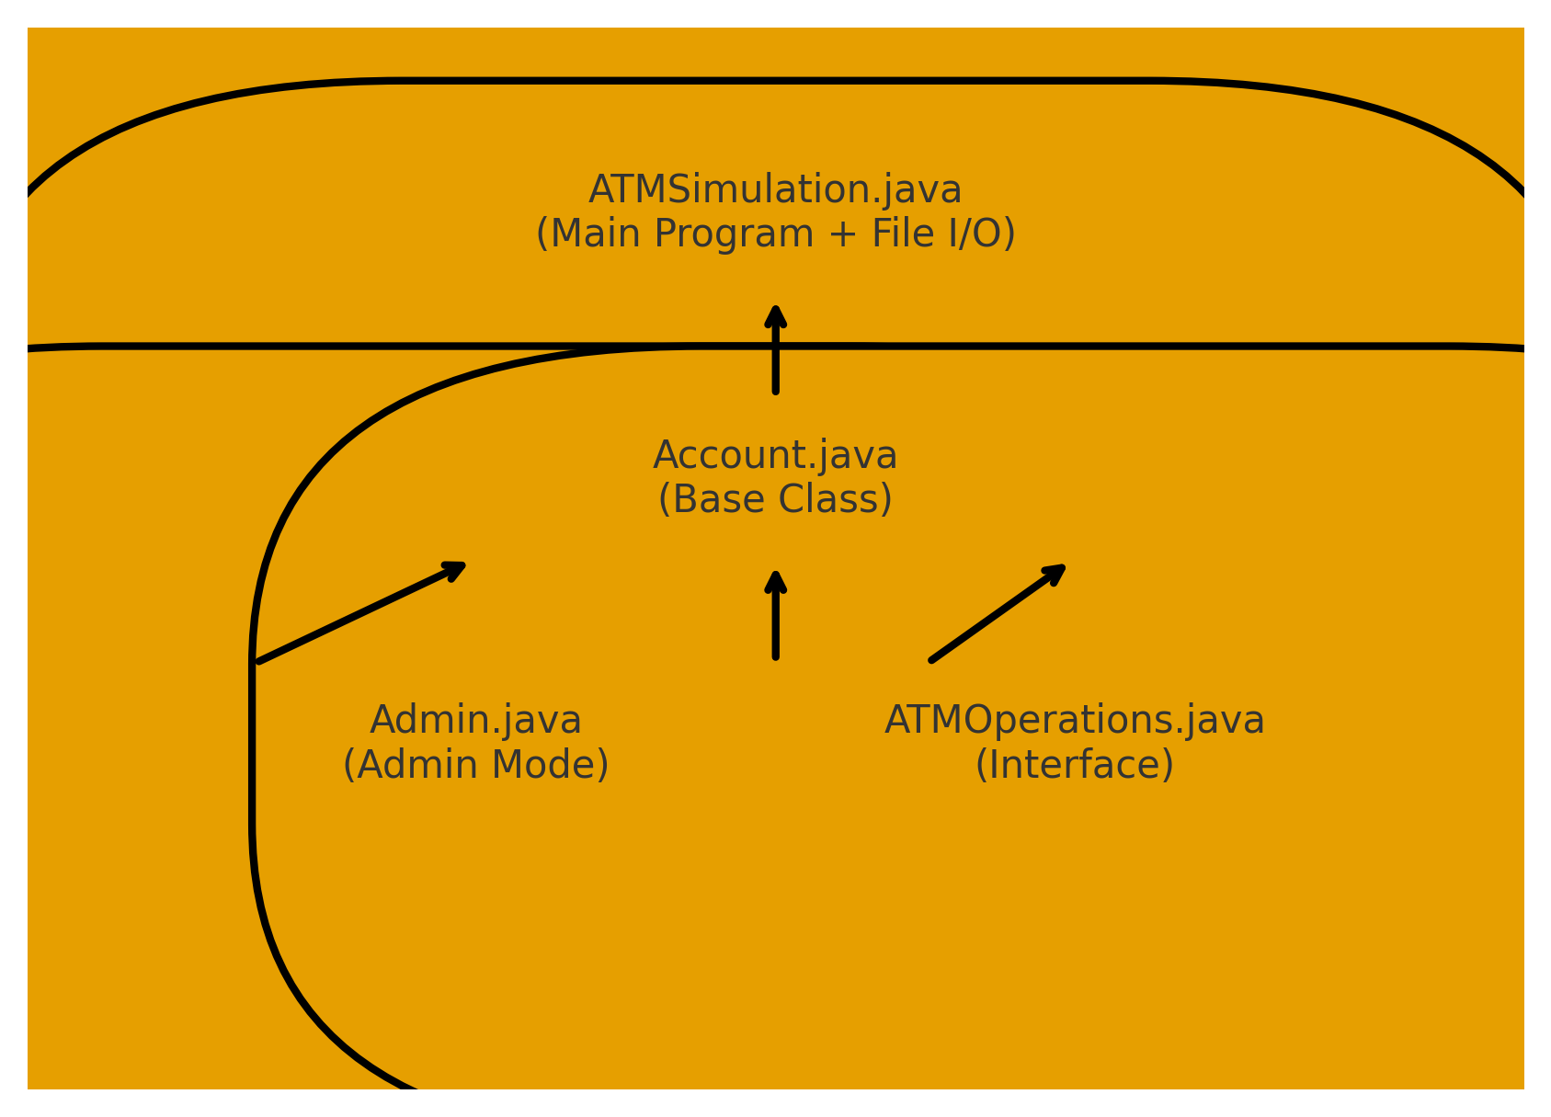
Flow Overview
- System loads account details from accounts.txt
- User selects:
  - Admin Mode
  - User Mode
- Admin can manage account records.
- User can perform ATM transactions.
- All changes are saved back to accounts.tx
7.VS code Screenshots (Without GUI)
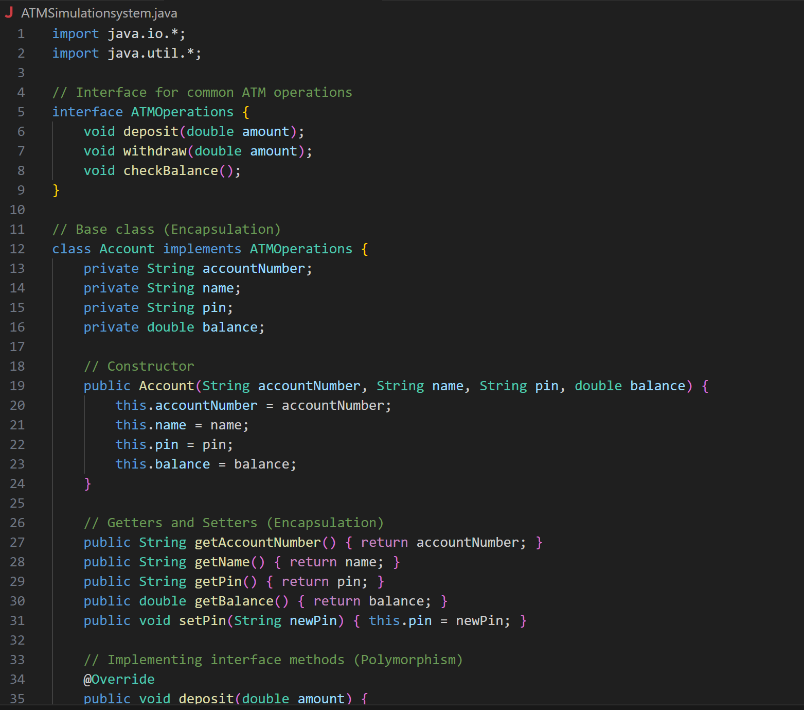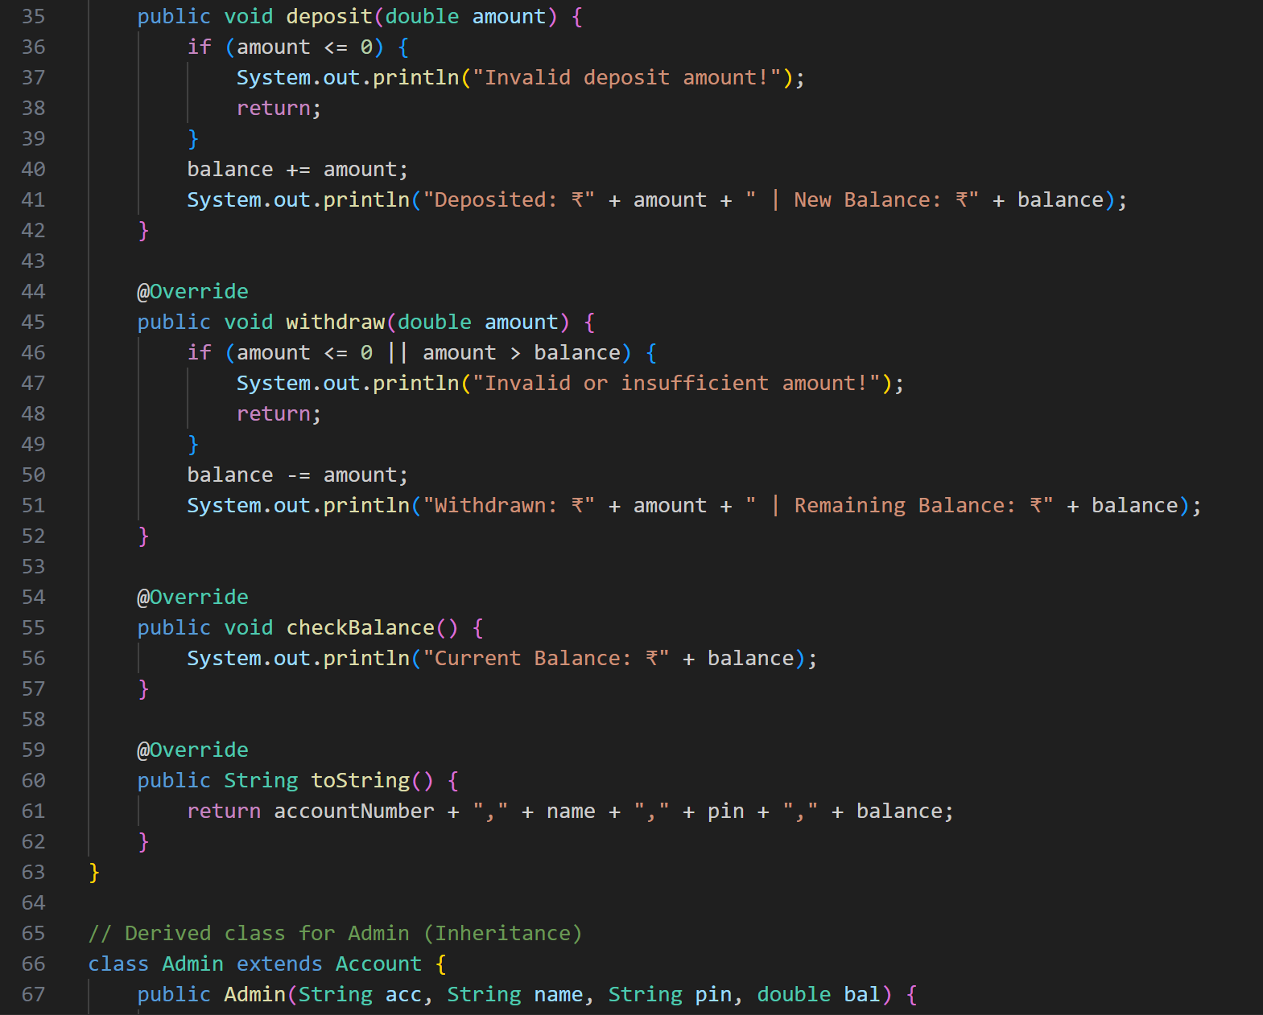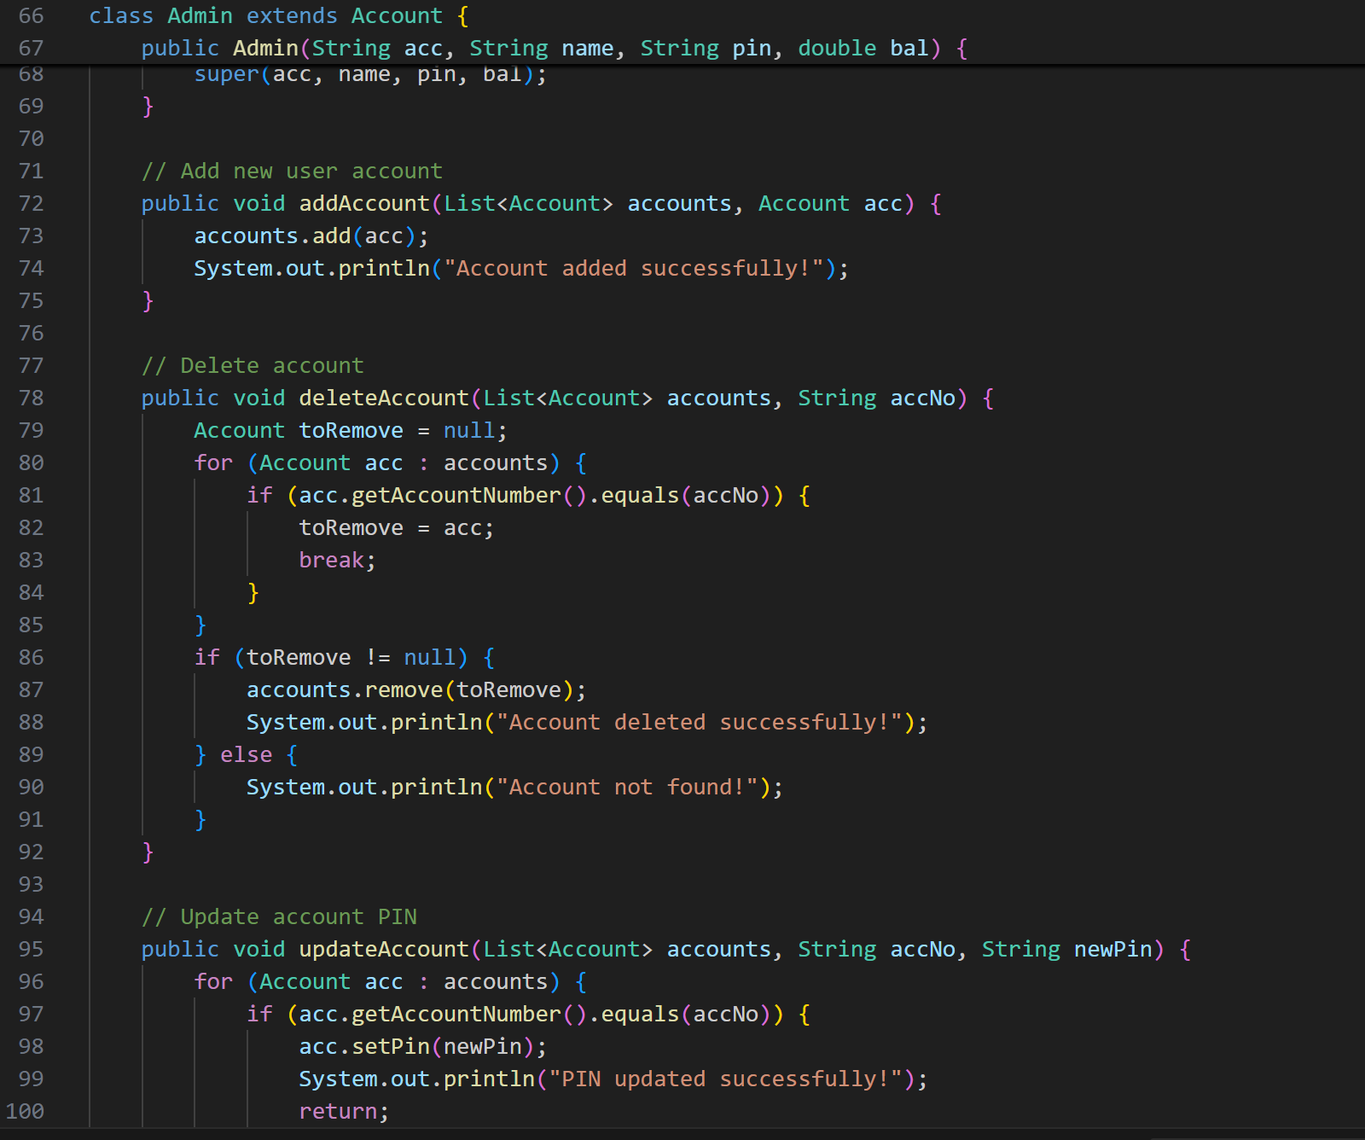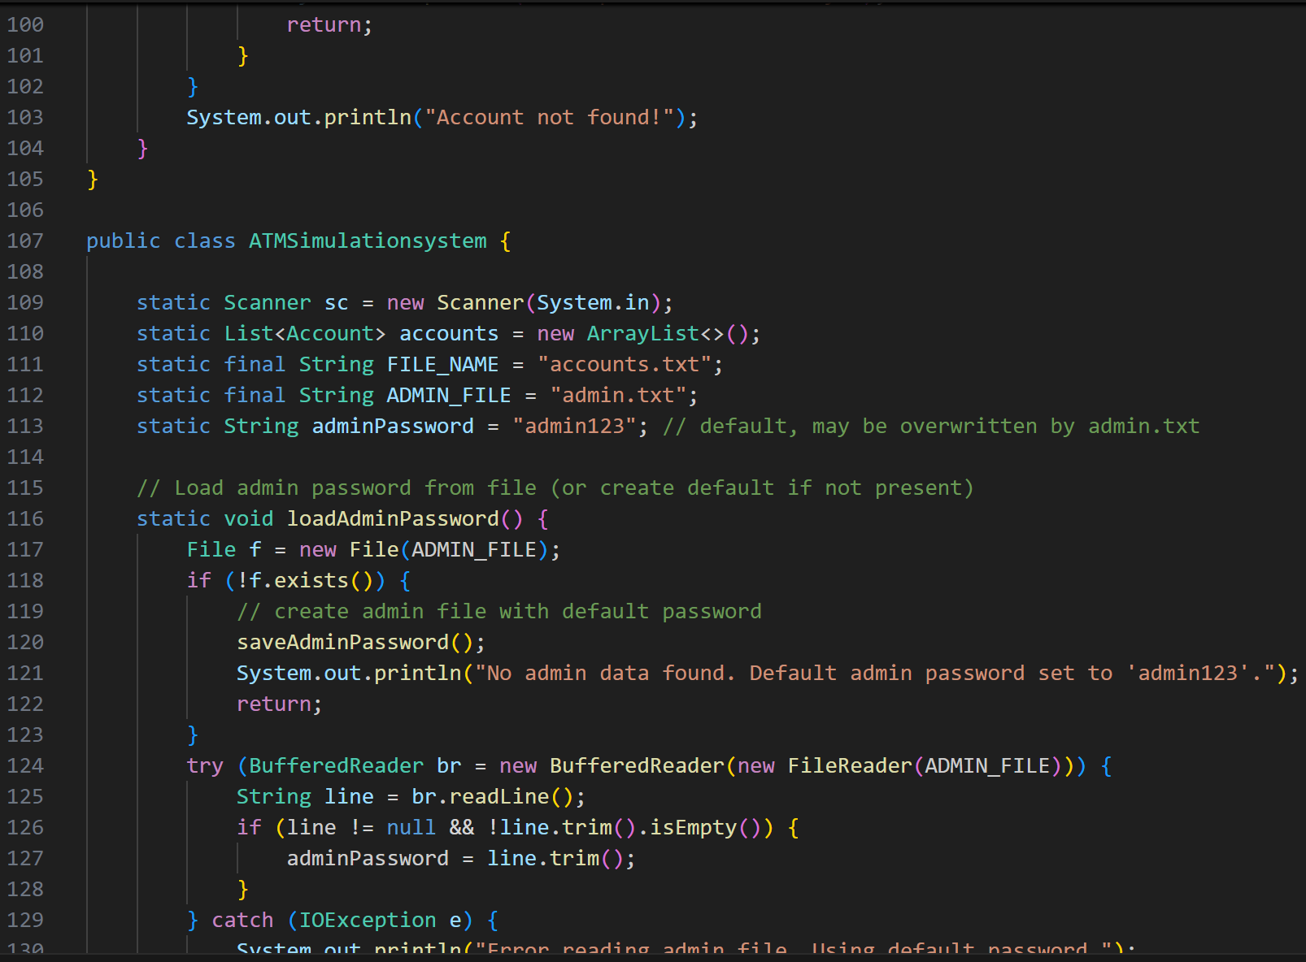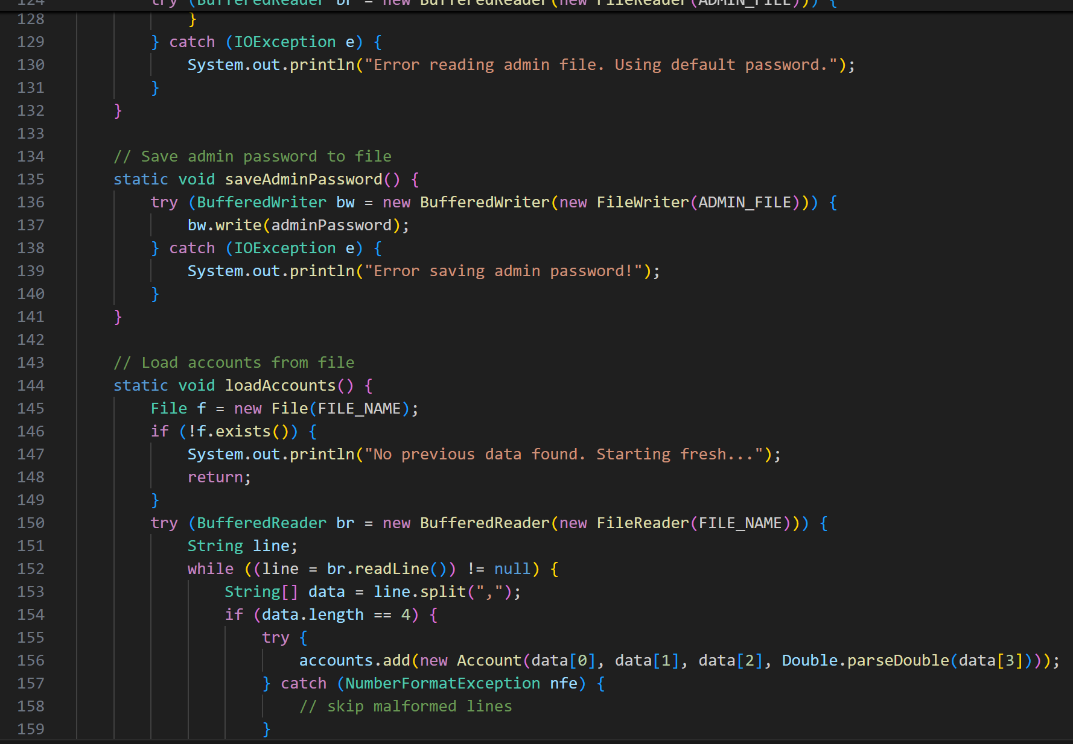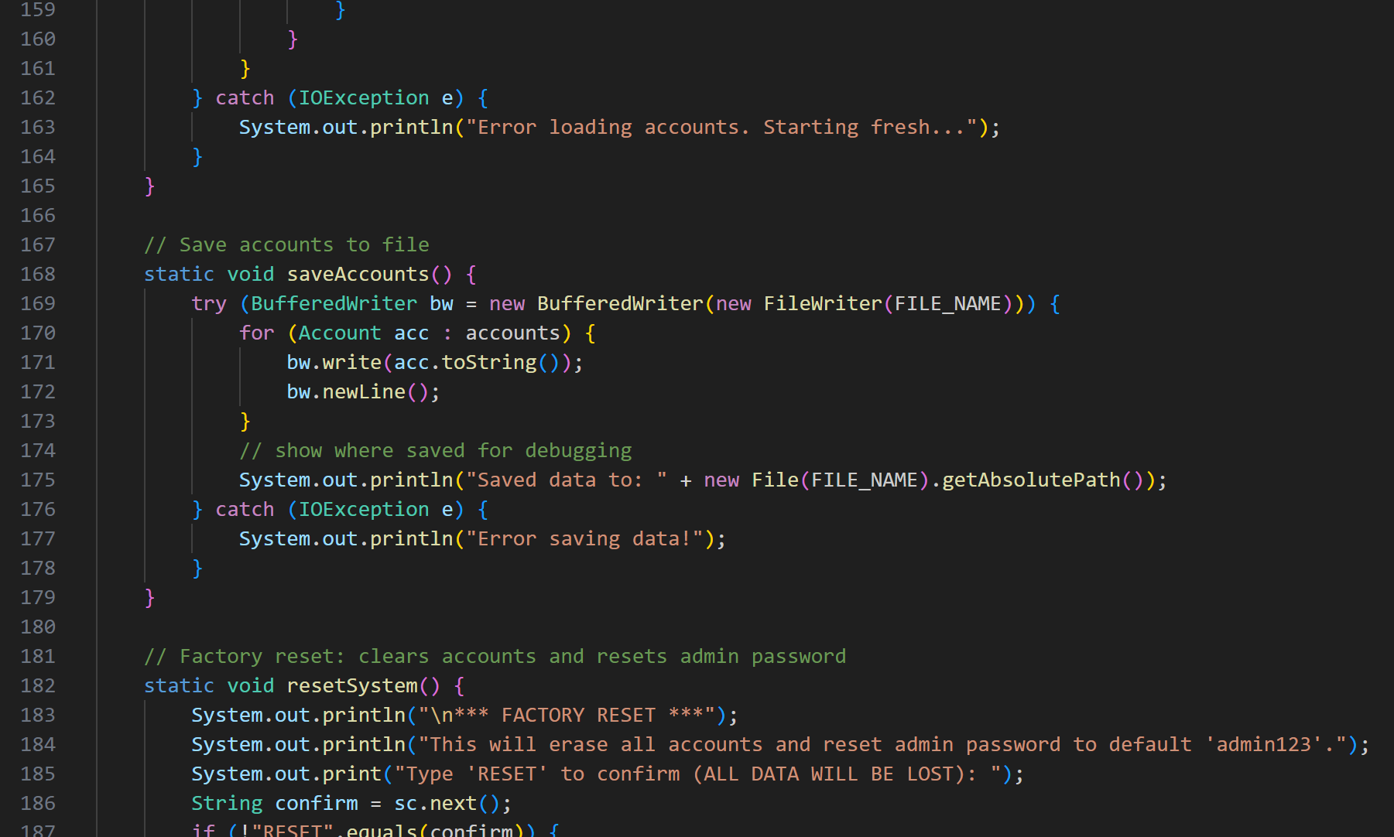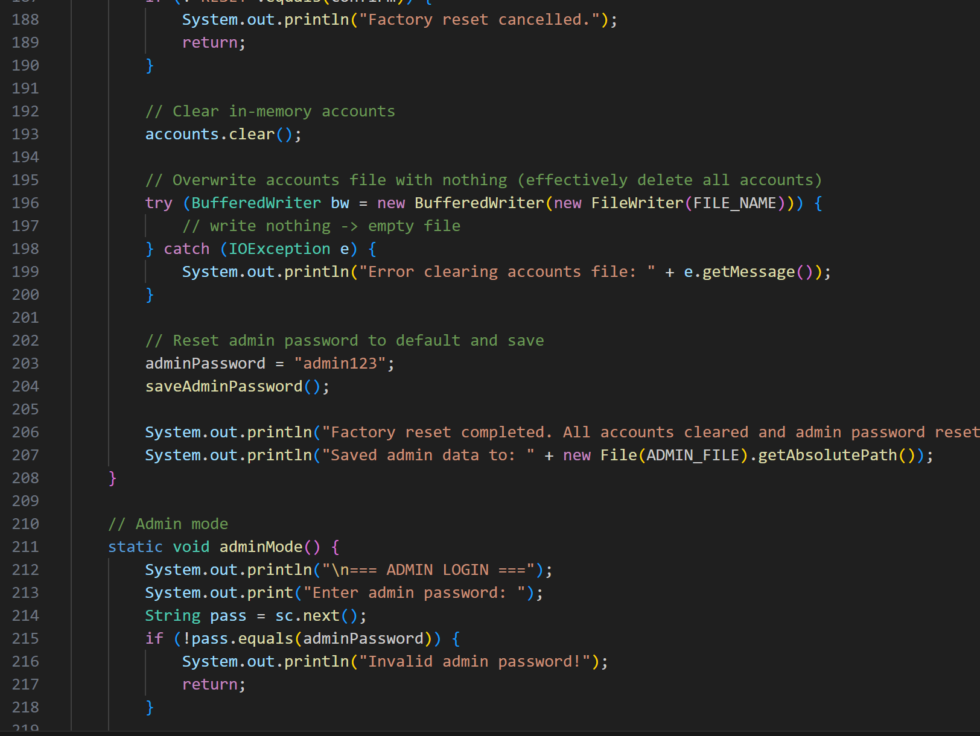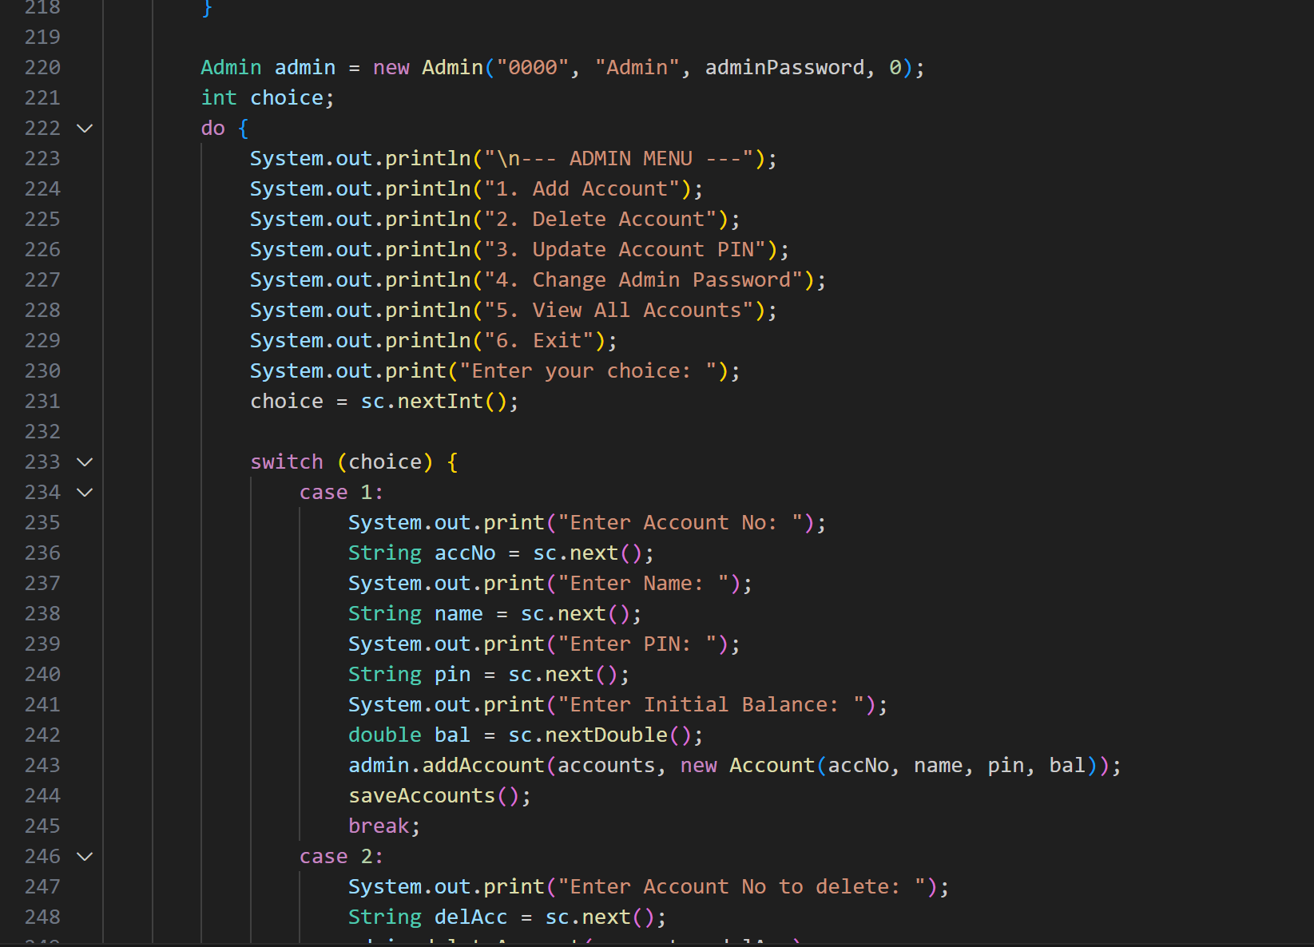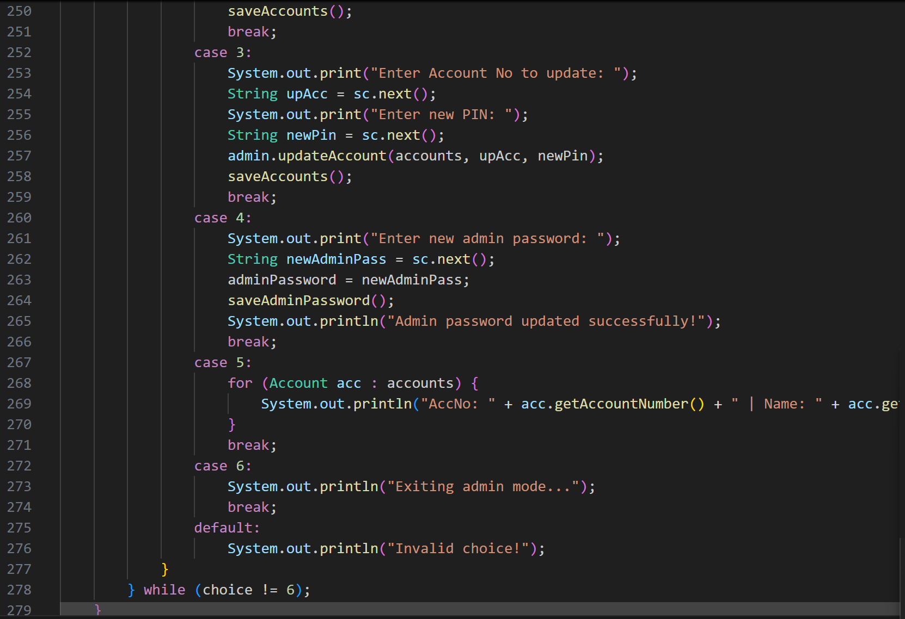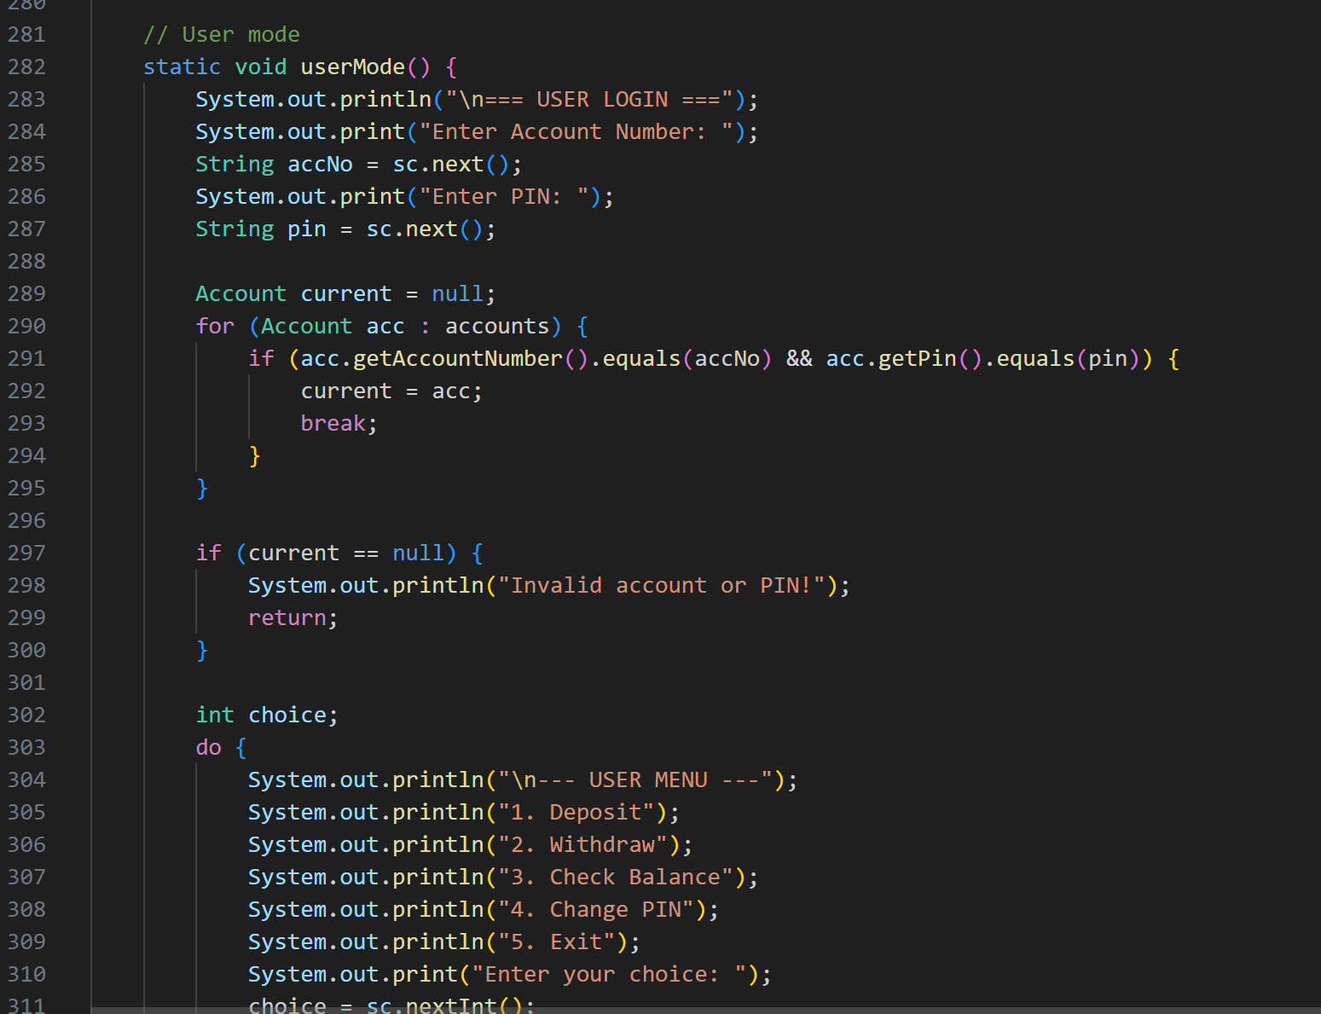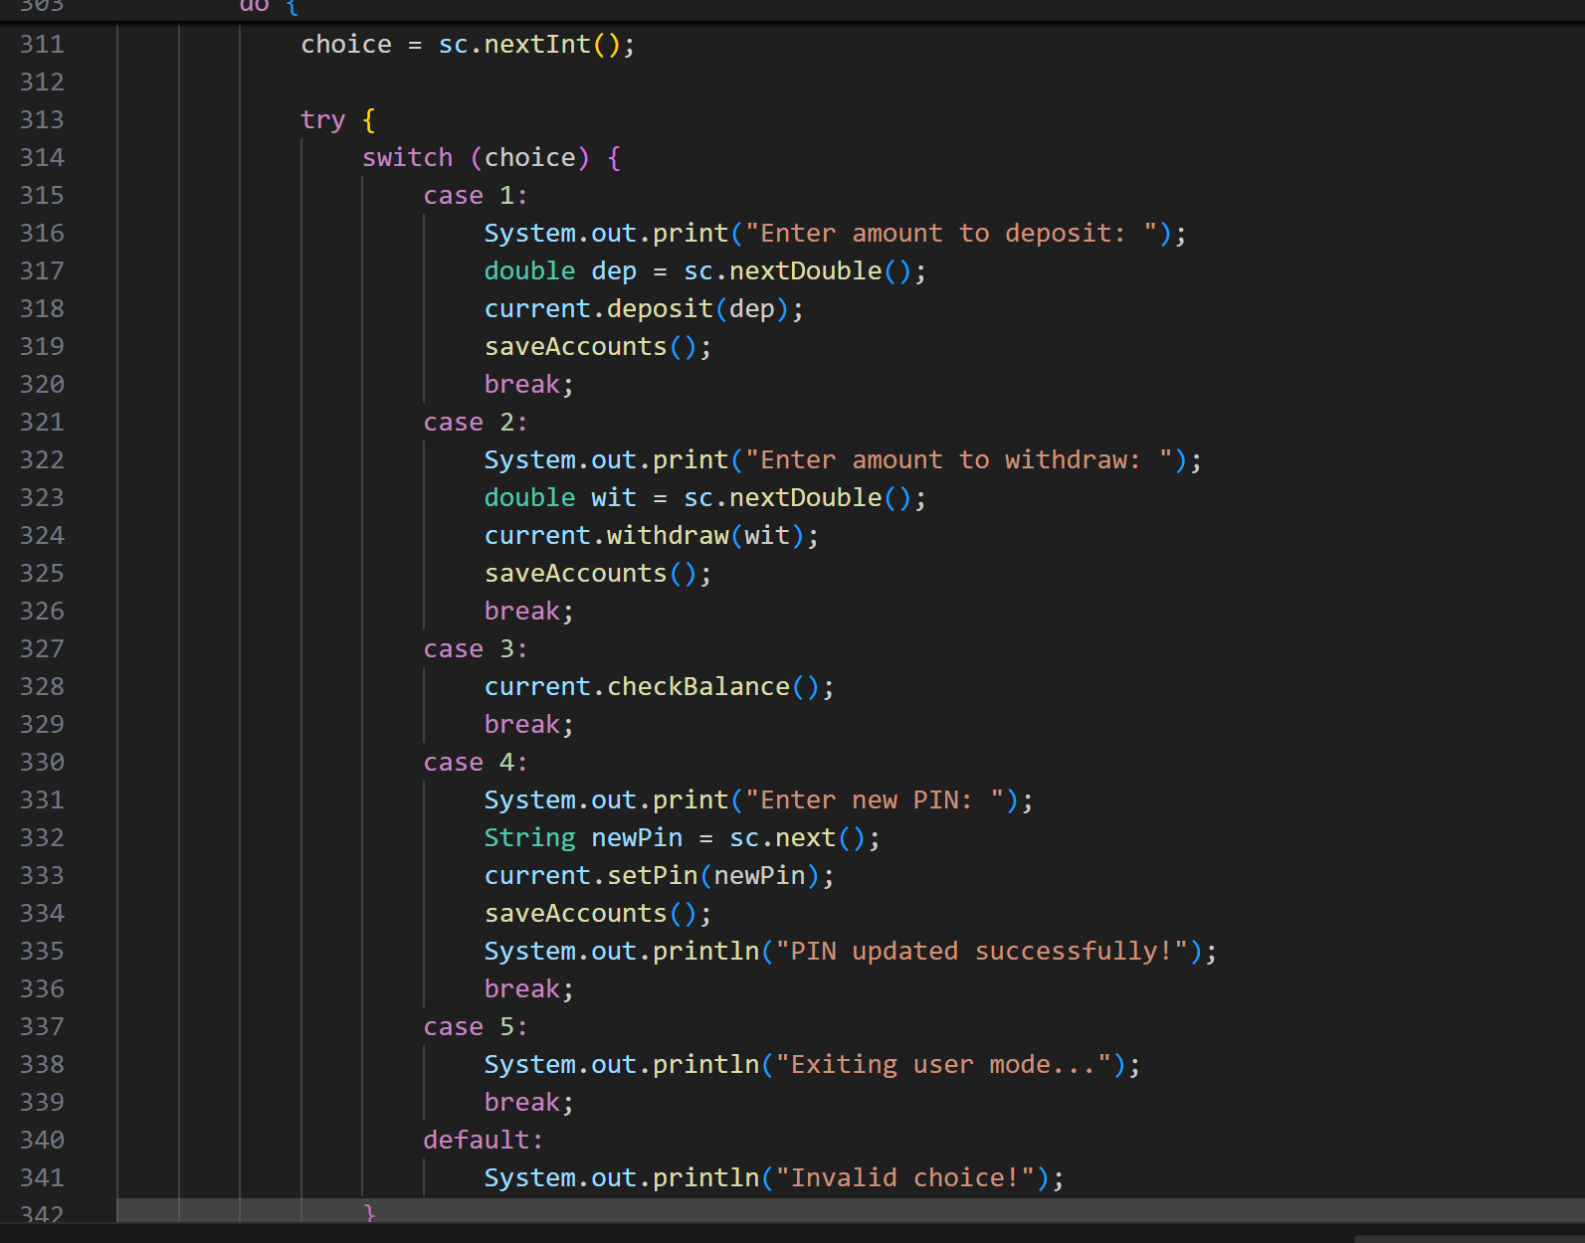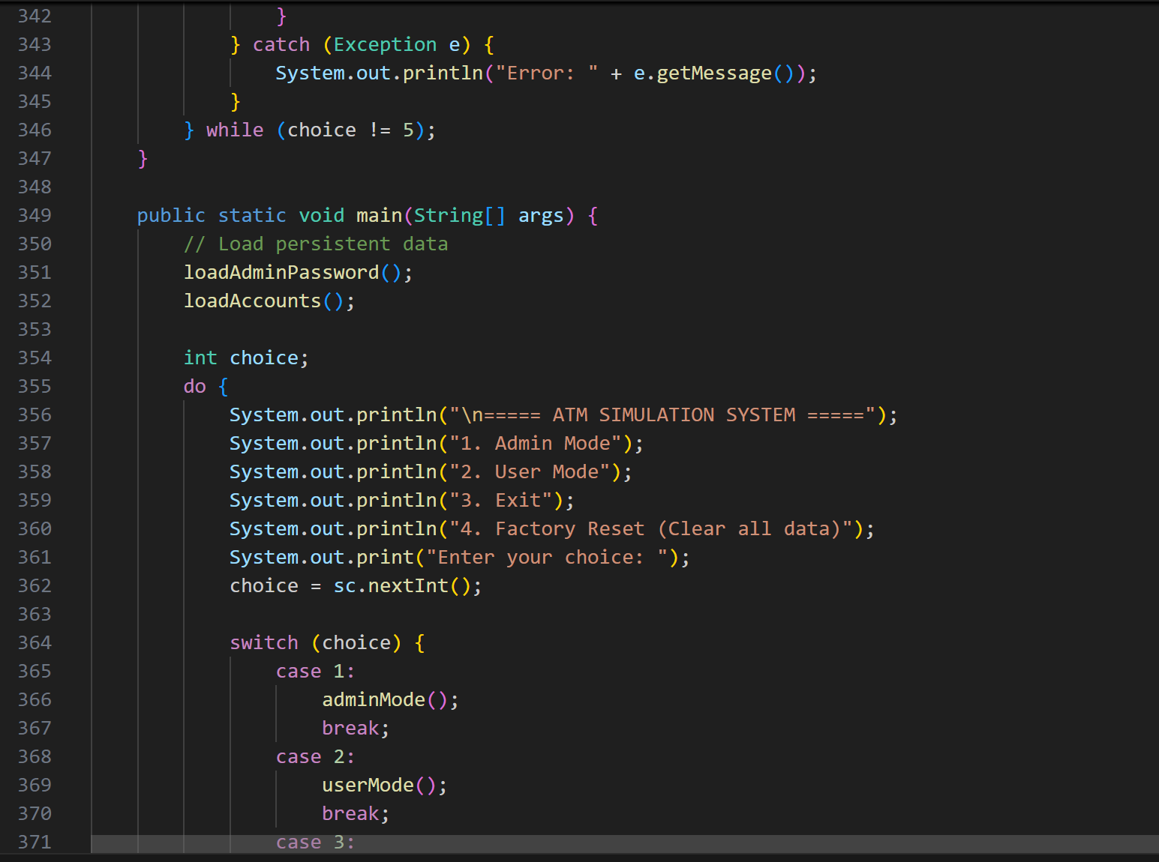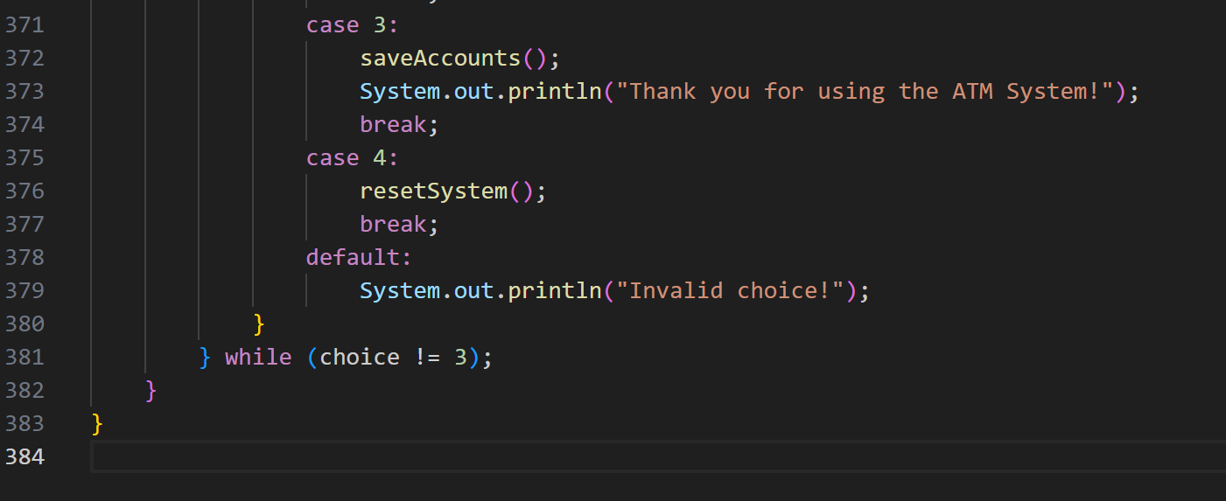

8. Sample Output (Screenshot below)
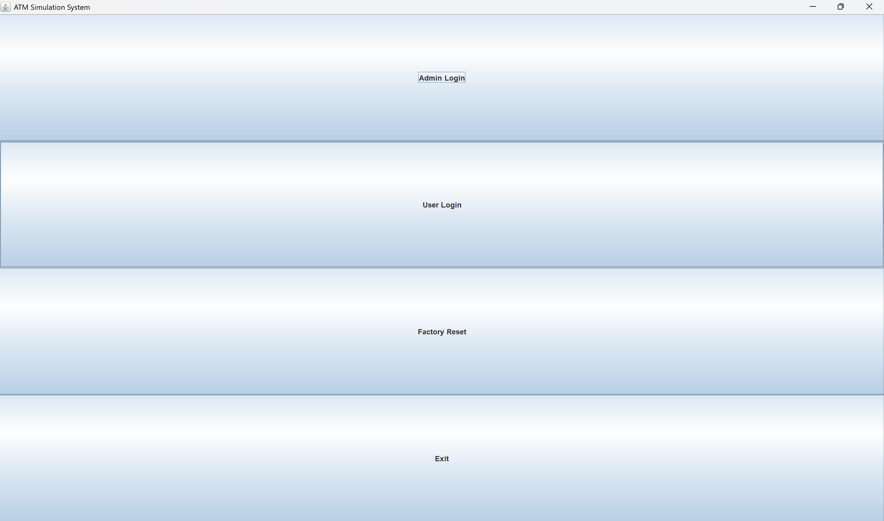

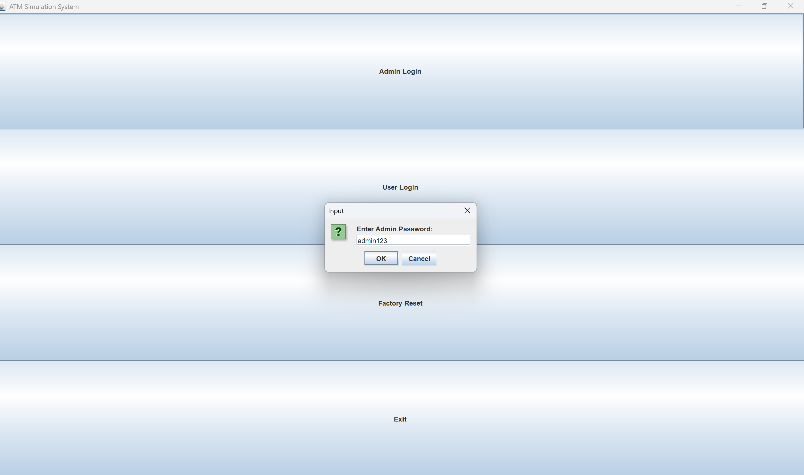

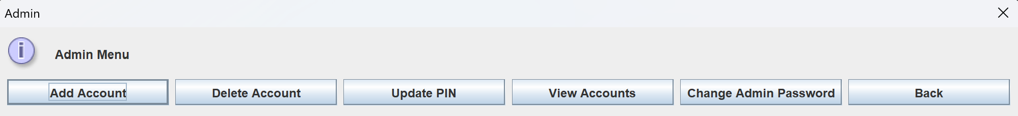
Name | Roll No. | Responsibility
Shubham | 24CSU197 | Designed and implemented the GUI using Java Swing, integrated user/admin menus, implemented file handling for accounts, and managed ATM operations (deposit, withdraw, balance).
Yajur | 24CSU361 | Developed the account and admin logic (OOP, inheritance, interface implementation), handled factory reset and password security features, and assisted in debugging/testing the full ATM system.
9. Advantages
- Simple and user-friendly interface
- Permanent file-based storage
- Proper OOP structure
- Admin & User Mode
- Handles invalid inputs gracefully
10. Limitations
- Console-based interface
- No database
- PIN stored in plain text
11. Conclusion
This ATM Simulation System demonstrates OOP, file handling, interfaces, and inheritance.
It can be further expanded with GUI and database integration.

