The **Milky Chain** is a web application for Milk Supply Chain Management. The main objective of this application is to automate the complete operations of the Suppliers office and bring ease between supplier and the system admin. Supplier was finding difficulties while maintaining the track of transaction activities and faces many challenges to maintain huge number of customer records.

**Project Write-UP**

This web application is based on concept of managing milk distribution and order management. It has a user friendly interface and is easy to use. It can be accessed by suppliers and customers at any time on any Platform. It helps to keep the track of transaction, reduces manual work, reduces time consumption and provides data security. This application has following modules to manage requirements of supplier, customer and admin:-

* Profile Management
* Product Management
* Billing management
* Monthly order Data Management
* Delivery on Demand Management
* Complaint Management

Software used:-

Mysql, Node js, Spring Framework, Vs Code, Eclipse, Lucid Chart.

**Use Case Diagram:-**

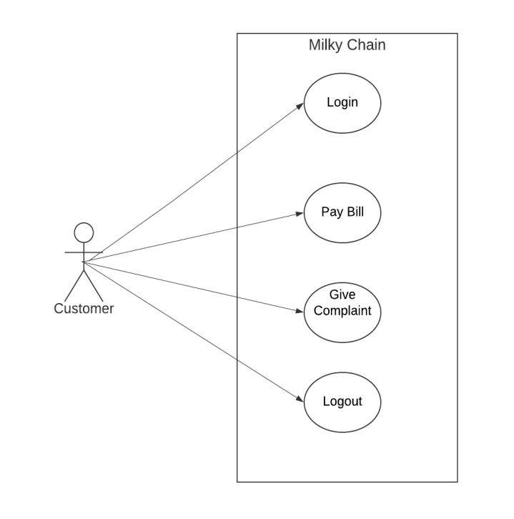

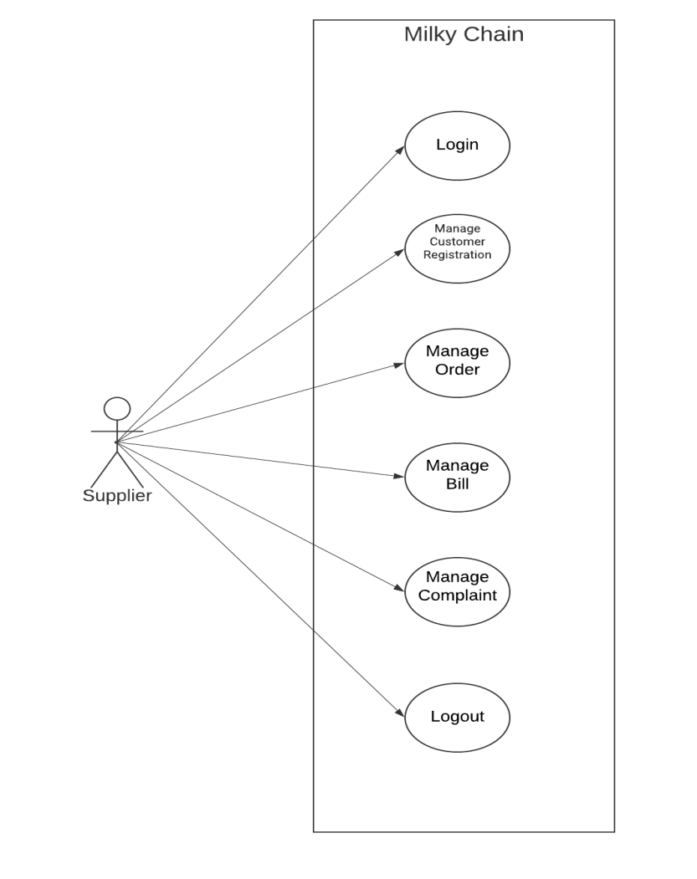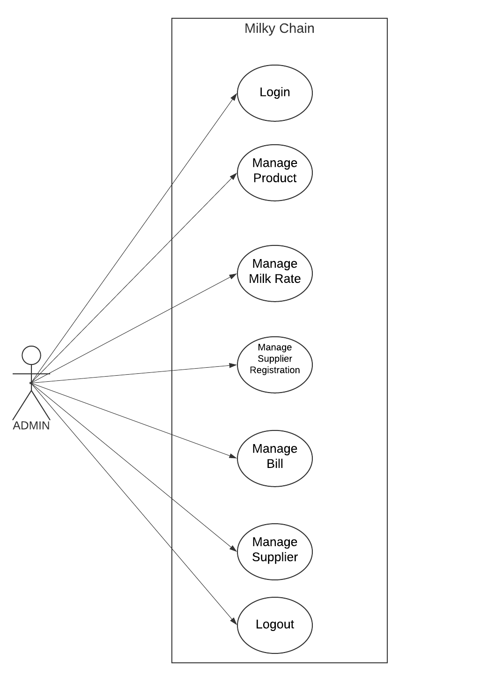

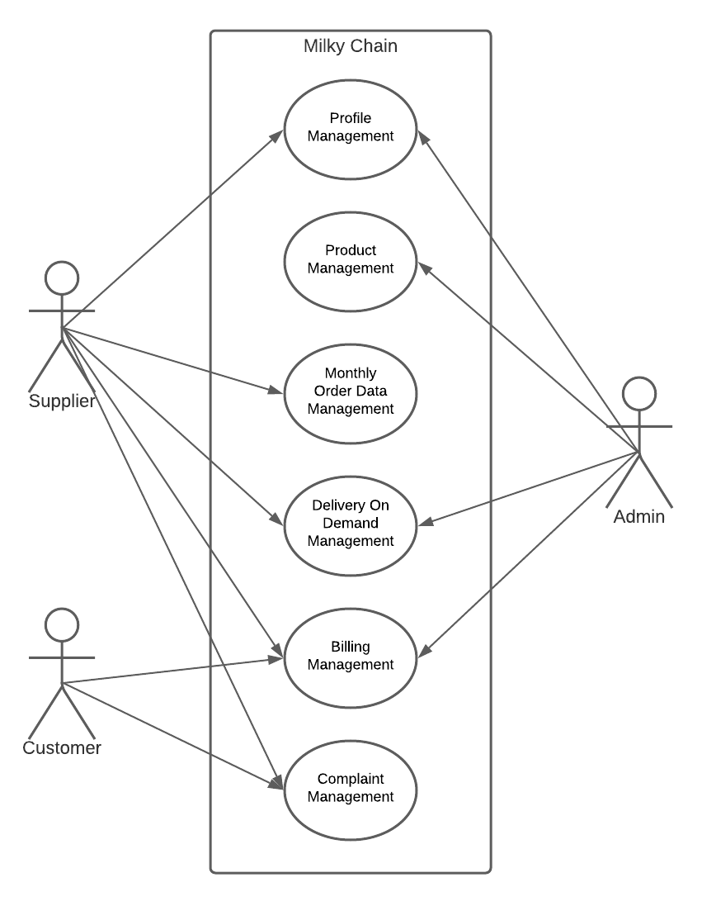**Use Case Diagram (Module wise):-**

|  |  |  |  |
| --- | --- | --- | --- |
|  |  |  |  |
|  | **SR.No** | **Software** | **Version** |
|  | 1 | My-Sql | 8.0.27 |
|  | 2 | Eclipse | Oxygen.3(March-2018) |
|  | 3 | Spring Framework | 5.3.8 |
|  | 4 | Lucidchart | Virtual Platform |
|  |  |  |  |

**Software:-**