*Coronavirus Prediction*

Coronavirus disease 2019 (COVID-19) time series listing confirmed cases, reported deaths and reported recoveries. Data is disaggregated by country (and sometimes subregion). Coronavirus disease (COVID-19) is caused by the [Severe acute respiratory syndrome Coronavirus 2 (SARS-CoV-2)](https://en.wikipedia.org/wiki/Severe_acute_respiratory_syndrome_coronavirus_2) and has had a worldwide effect. On March 11 2020, the World Health Organization (WHO) declared it a pandemic, pointing to the over 118,000 cases of the coronavirus illness in over 110 countries and territories around the world at the time.

This dataset includes time series data tracking the number of people affected by COVID-19 worldwide, including:

* confirmed tested cases of Coronavirus infection
* the number of people who have reportedly died while sick with Coronavirus
* the number of people who have reportedly recovered from it.

## ****Requirements****

|  |
| --- |
|  |
|  | gunicorn==19.9.0 |
|  | Jinja2==2.10.1 |
|  | MarkupSafe==1.1.1 |
|  | Werkzeug==0.15.5 |
|  | numpy>=1.9.2 |
|  | scipy>=0.15.1 |
|  | scikit-learn>=0.18 |
|  | Flask==1.1.1 |

## ML-Model-Flask-Deployment

This is a demo project to elaborate how Machine Learn Models are deployed on production using Flask API

### Prerequisites

You must have Scikit Learn, Pandas (for Machine Leraning Model) and Flask (for API) installed.

### Project Structure

This project has four major parts :

1. model.py - This contains code that our Machine Learning model to predict Corona Patient absed on training data in 'dataset.csv' file.
2. app.py - This contains Flask APIs that receives Corona Patient details through GUI or API calls, computes the precited value based on our model and returns it.
3. request.py - This uses requests module to call APIs already defined in app.py and dispalys the returned value.
4. templates - This folder contains the HTML template to allow user to enter Patient detail and displays the predicted that is Corona Patient or not .

### Running the project

1. Ensure that you are in the project home directory. Create the machine learning model by running below command -

python model.py

This would create a serialized version of our model into a file covid.pkl

1. Run app.py using below command to start Flask API

python app.py

By default, flask will run on port 5000.

1. Navigate to URL [http://localhost:5000](http://localhost:5000/)

You should be able to view the homepage as below :

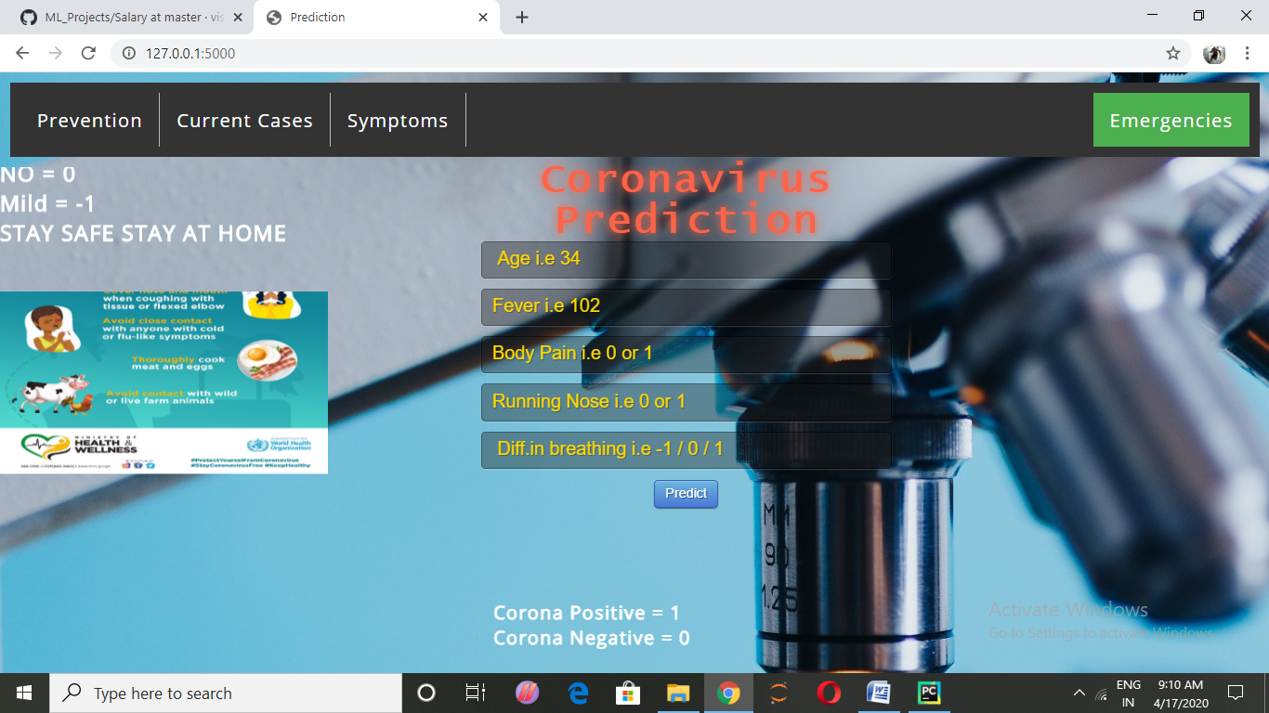

Enter valid numerical values in all 5 input boxes and hit Predict.

If everything goes well, you should be able to see the predcited Corona Patient is positive or not on the HTML page!