DAA Lab Assignment 8

Name – Shubham Konar

Roll – 1928320

Section – CSSE 4

Group 2

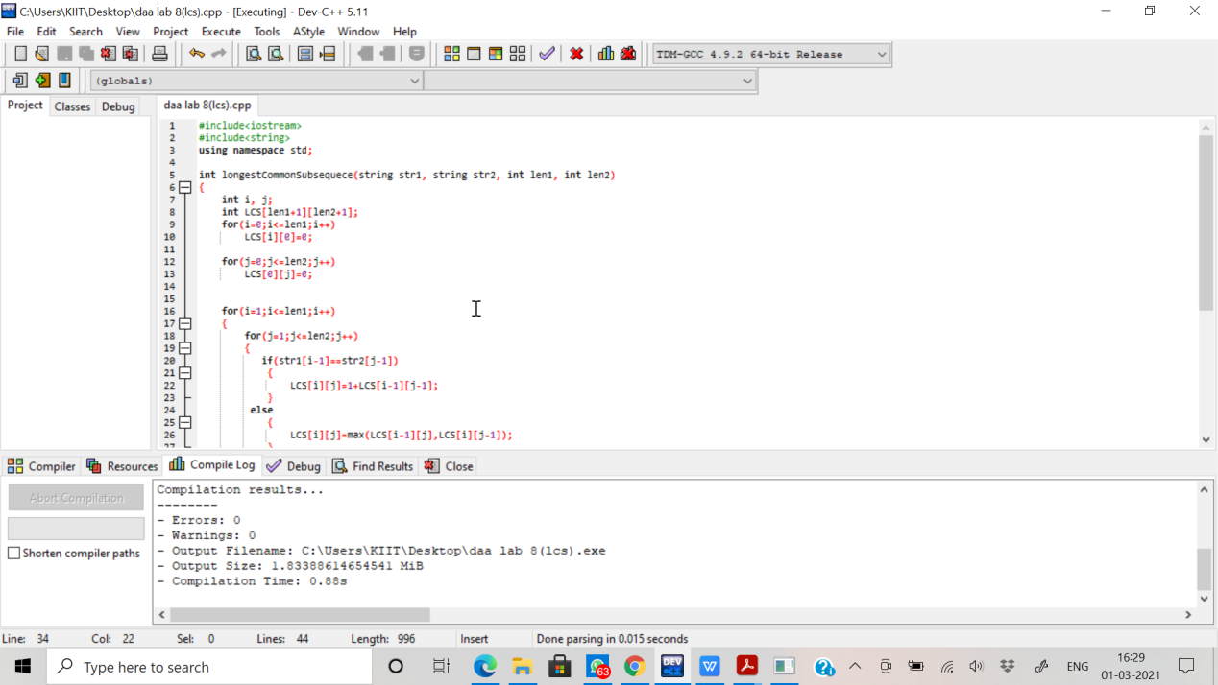

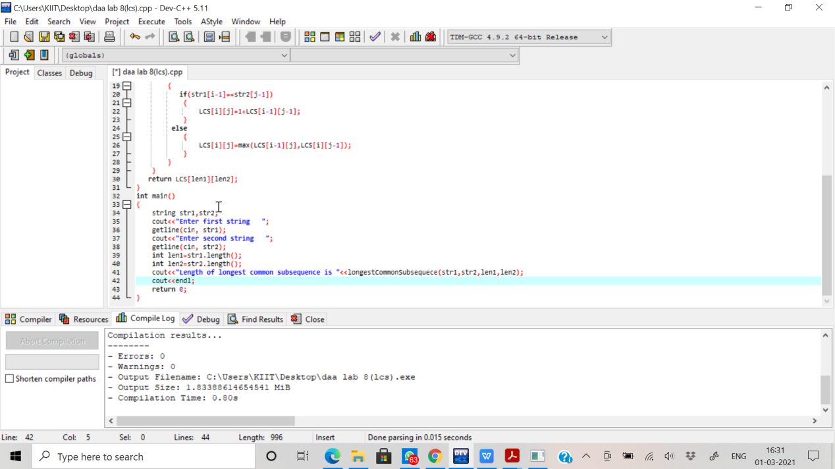

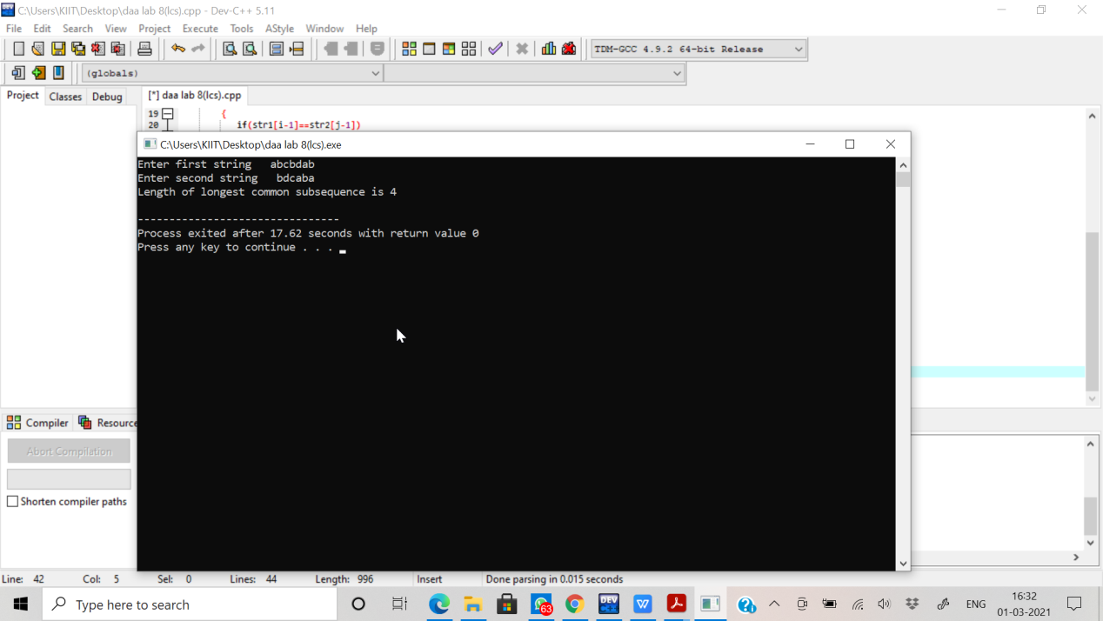Output: