**PROJECT REPORT**

**Computational Linguistics CSE 567**

Authors

Akshay Chopra 50248989

Shubham Pandey 50245725

**Project Description**

* We have created a Natural Language understanding System that interfaces with a ‘smart’ refrigerator and allows users to text queries or instructions to the fridge.
* For the system, we have created a vocabulary with lemmas from different part of speech (like nouns, pronouns, determiners, intransitive verbs, transitive verbs, adjectives etc).
* Grammar has been defined and is used by the parser.
* Parser has been created for parsing the sentence given to the system and annotating the lexical items with the corresponding syntactic and semantic representations. Parser output is fed to the model checker.
* Finally, a model checker has been created which takes the output of the parser as the input and performs an evaluation on it and responds accordingly to the user.

**NOTE**: The parser does not parse annotations like fullstop (.) , comma (,) or question mark (?) etc. Please enter the text in the chat without any annotations

Like : 1. who ate the chicken

2. The fridge contains fruits

**Modules of the Project.pl file**

**Parser:** Modified Shift Reduce Parser.

**Lemmas:** Over 70+ Lemmas have been created for the project from 14 different part of speech.

**Lexicons:** Lexicons have been defined for various lemmas.

**Rules:** Different grammar rules have been added.

**WordNet:** Hand-built WordNet fragment has been created. Hypernyms have been added for various nouns like “**apple, orange, banana** is a **type** of **fruit”**, **“chicken, ham, sausage** is a **type** of **meat”** etc. “**isa”** predicate has been used for achieving this task.

**Model Checker:** We have used the base code from sat.txt provided by the Professor. Model has been created containing values relevant to the examples given in the pdf plus the examples that we have added by ourselves. Model checker, sat, f and other predicates have been modified according to the project requirement.

**Running the Examples given in the Project PDF**

1. Every blue container on the top shelf contains a sandwich that has no meat
2. Every white container on the bottom shelf contains a banana
3. Are there two watermelons in the fridge
4. Is there milk
5. Who drank the almond milk
6. Is there a sandwich that does not contain meat
7. Is there an empty box of popsicles in the freezer
8. A blue box contains some ham
9. A blue box contains ham
10. The white box that the freezer contains belongs to sue
11. Is there an egg inside the blue box
12. Are there two eggs inside the blue box
13. What does the green box contain

**Parser Output for the above examples**

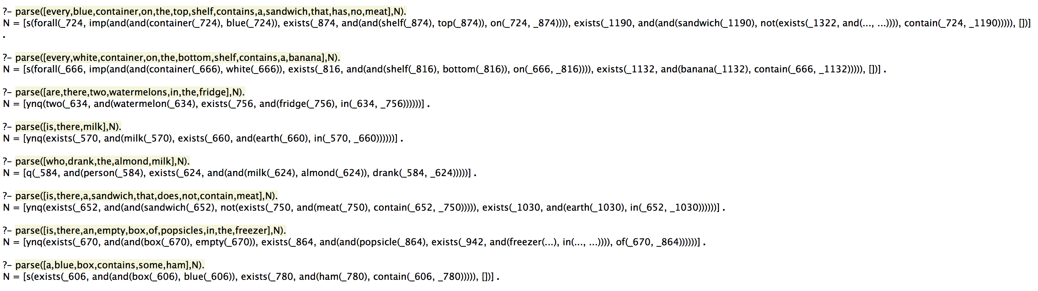

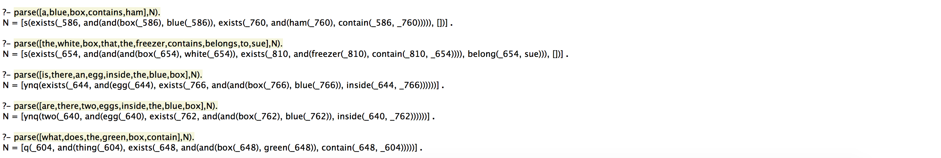

**Chat result for the above examples**

**Running the Self Made Examples**

1. Who ate the chicken
2. Are there any fruits in the fridge
3. The bottom shelf contains four vegetables
4. What does the bottom shelf contain
5. What does the freezer contain
6. The fridge contains a red apple
7. Are there vegetables inside the bottom shelf

**Parser output for the above examples**

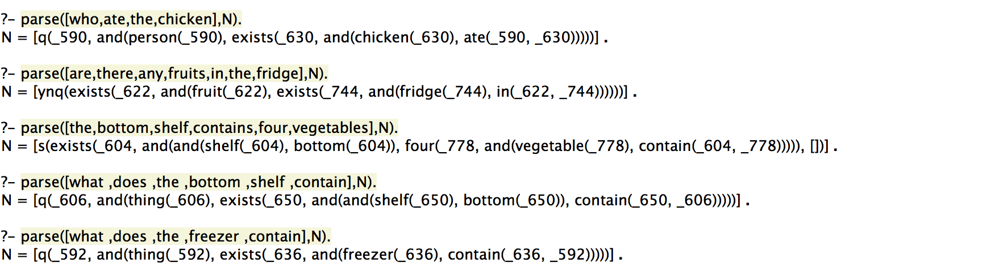

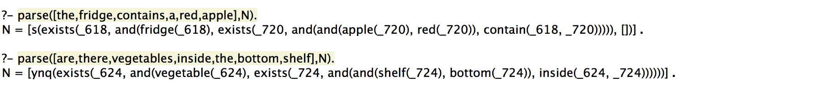

**Chat Result for the above examples**