**CHANDIGARD UNIVERSITY**

**FINAL-PRACTICAL-IOT-PROJECT**

**NAME- SHUBHAM BAWANKAR**

**CLASS- CSE10 B**

**UID- 20BCS7409**

**DATE- 13/05/2021**

**SUBJECT- IOT LAB**

**AIM -**

**IOT BASED SMART AGRICULTURE SYSTEM.**

**APPARATUS -**

1. **AUDRINO MINI/MACRO/NANO**
2. **SOIL MOISTURE SENSOR**
3. **BLUTETOOTH HC05**
4. **1 RELAY MODULE**
5. **SOLENOID VALVE**
6. **PIPE AND HOSE**
7. **WIRES**

**CODE-**

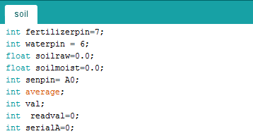

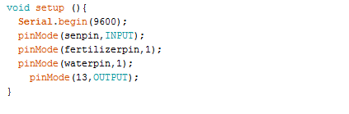

**After that, we create a loop function where we create several ‘if’ conditions. Then, we have to create a ‘for’ function that will read the soil sensor data upto 160 times. Out of that, an average reading will be obtained which we can map (i.e. convert) in the range of 100 to get the moisture level output of soil in the range from 0 to 100 per cent.**

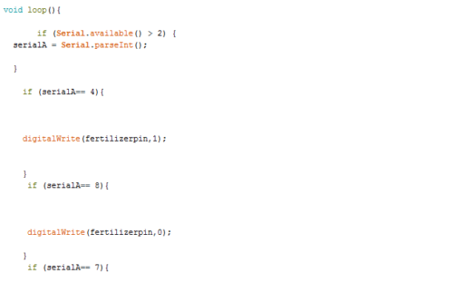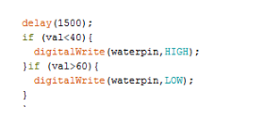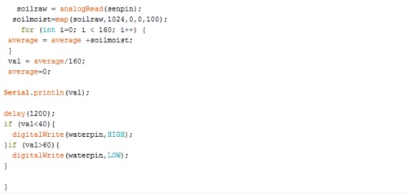

**APP CREATION SCREENSHOT:**

**First, we create a layout of the app. This app uses an extension plugin that visualises the soil data in the form of a circular ring.**

**Components**

* **Circular bar extension**
* **Bluetooth Client**
* **List picker**
* **4 Buttons**
* **2 Text View**

**SCREEN SHOT:**

