# chandigarh-university-seal

# WORKSHEET-2.3

# Student’s Name : SHUBHAM BAWANKAR

# UID: 20BCS7409

# SECTION/GROUP: 20CSE10/B

**SUBJECT - IOT LAB**

**AIM:** Develop a smart phone application for close range wireless robot motion control.

**APPARATUS:** PC with Arduino

Connecting Wires

Breadboard

DOIT ESP32 DEVKIT V1

10uF Electrolytic Capacitor

Wire Clipper

USB Type A to Micro USB Cable

DC 5V Power Supply

DC 3.3V Power Supply

L293D Motor Driver

2 piece - DC Motors

**CODE:**

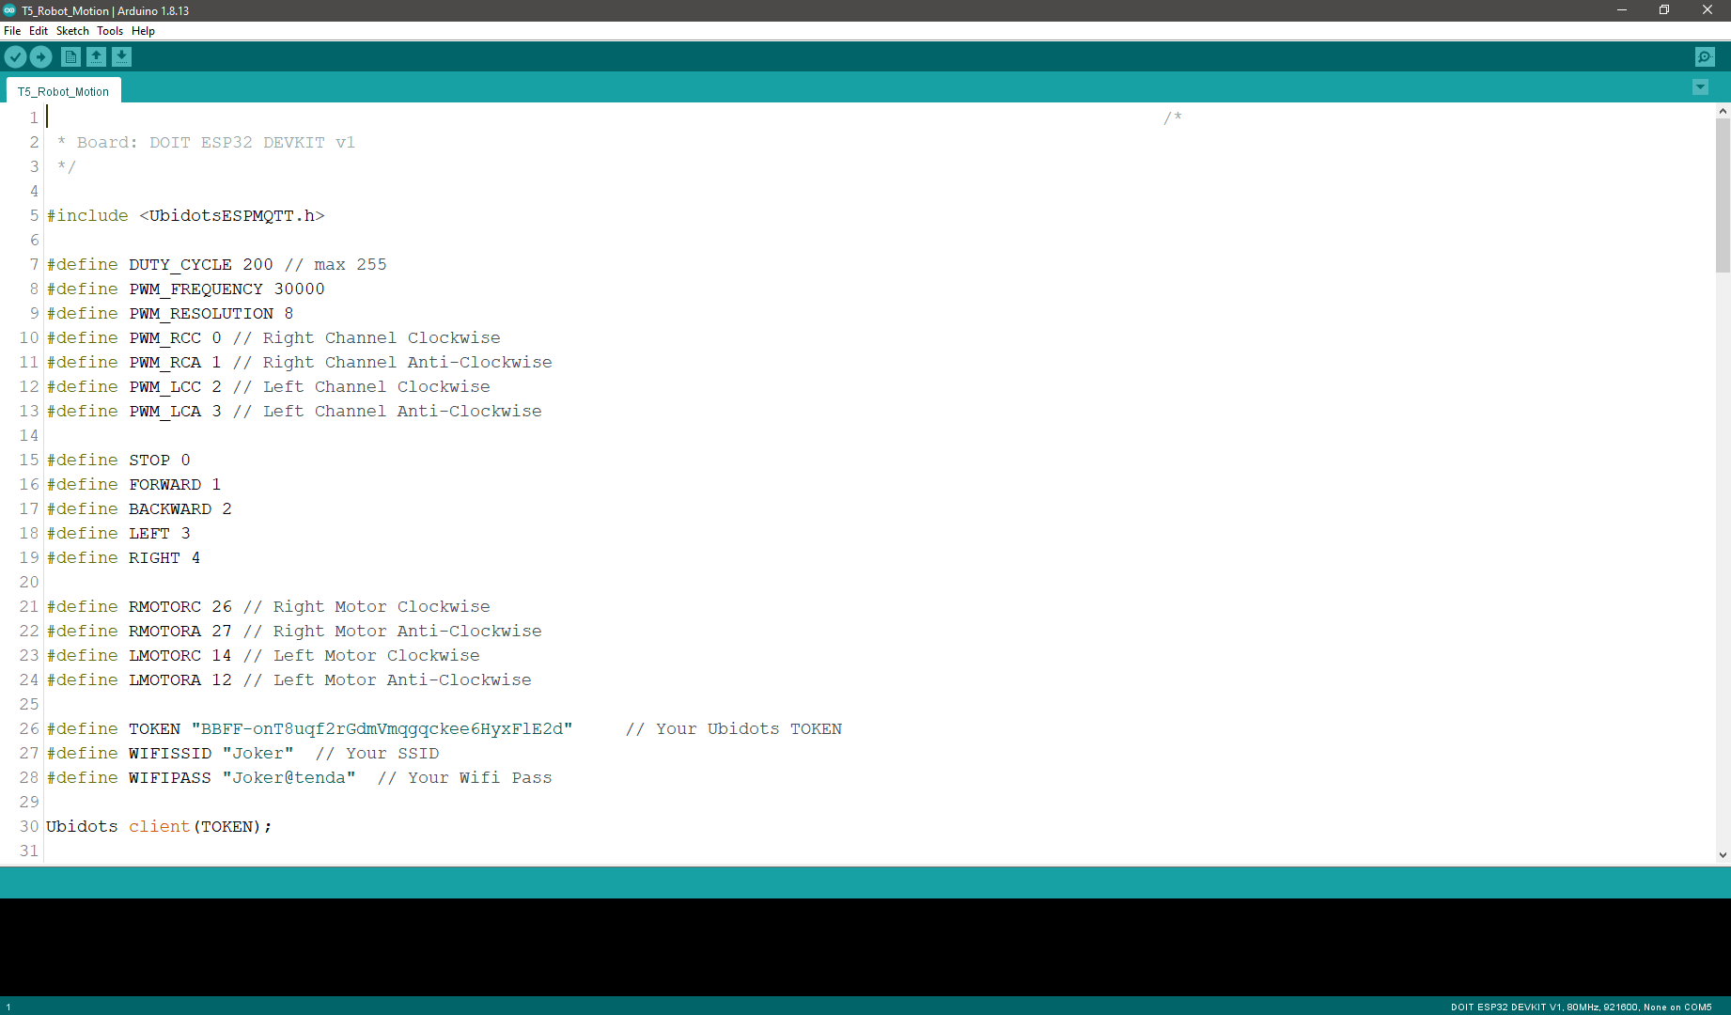

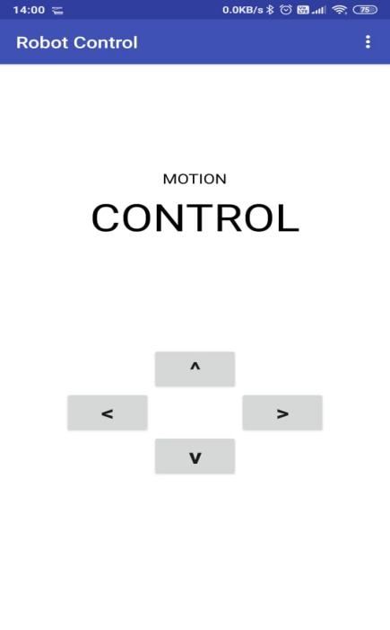

## Screenshot 1-

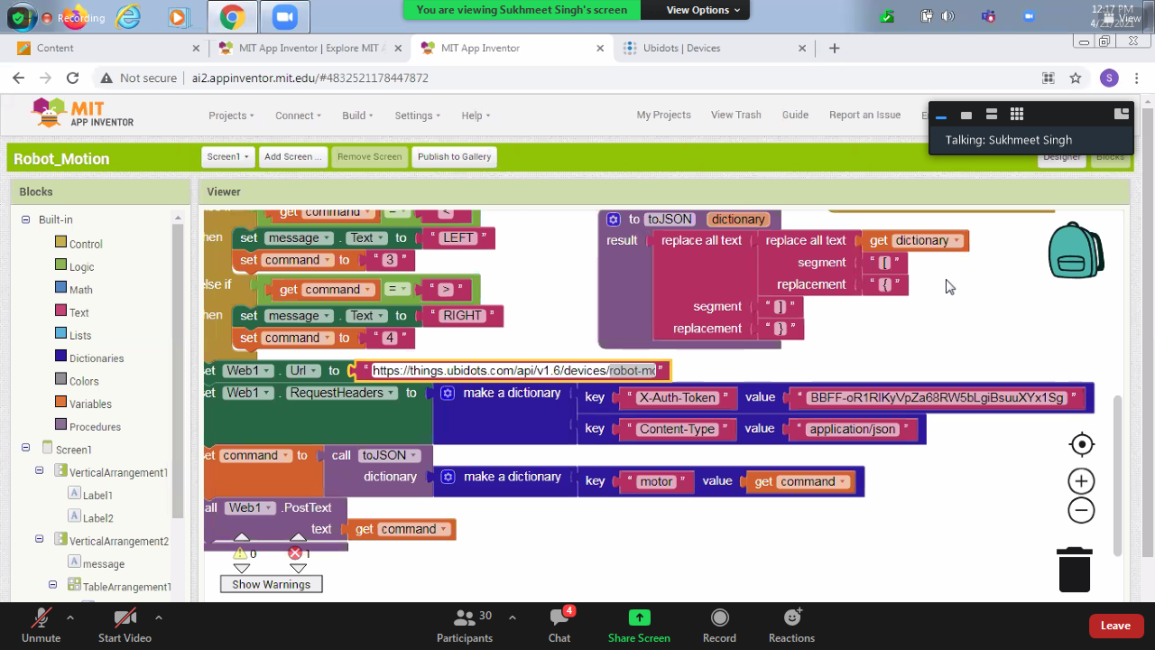

## Screenshot 2-



 