***WORKSHEET 2.4***

|  |
| --- |
| ***Student name = SHUBHAM BAWANKAR***  ***Student UID = 20BCS7409***  ***Class & group = CSE 10 & B***  ***Semester = 2***  ***SUBJECT - IOT LAB*** |

***Task:***

*Develop a human vitals monitoring and alert system using IoT analytics platform.*

***APPARATUS***

* *PC with Arduino*
* *Connecting Wires*
* *Breadboard*
* *DOIT ESP32 DEVKIT V1*
* *10uF Electrolytic Capacitor*
* *Wire Clipper*
* *USB Type A to Micro USB Cable*
* *DC 5V Power Supply*
* *DC 3.3V Power Supply*
* *DS18B20*

**Screenshot-1:**

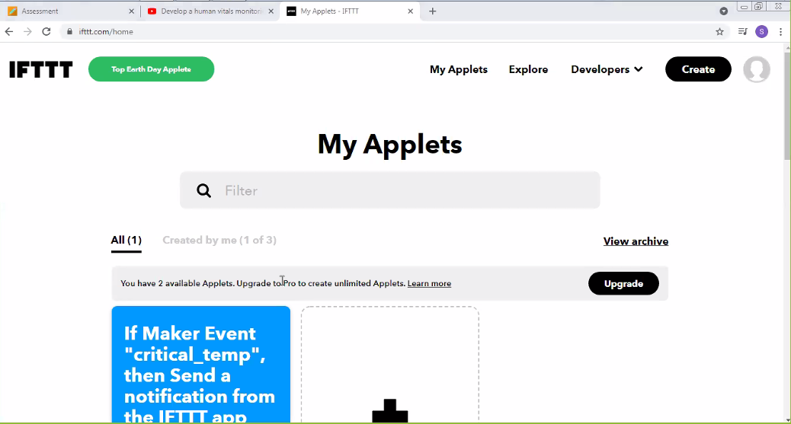

**Screenshot-2:**

