**WORKSHEET 3.2**

**NAME- SHUBHAM BAWANKAR**

**CLASS - CSE10 B**

**UID - 20BCS7409**

**SEMESTER -2**

**SUBJECT - IOT LAB 3.2 PRACTICAL**

**Task:**

**Develop an IoT based intruder detection and alert system.**

**Requirements:**

* PC with Arduino
* Connecting Wires
* Breadboard
* DOIT ESP32 DEVKIT V1
* 10uF Electrolytic Capacitor
* Wire Clipper
* USB Type A to Micro USB Cable
* DC 5V Power Supply
* DC 3.3V Power Supply

.

**Circuit Diagram:**

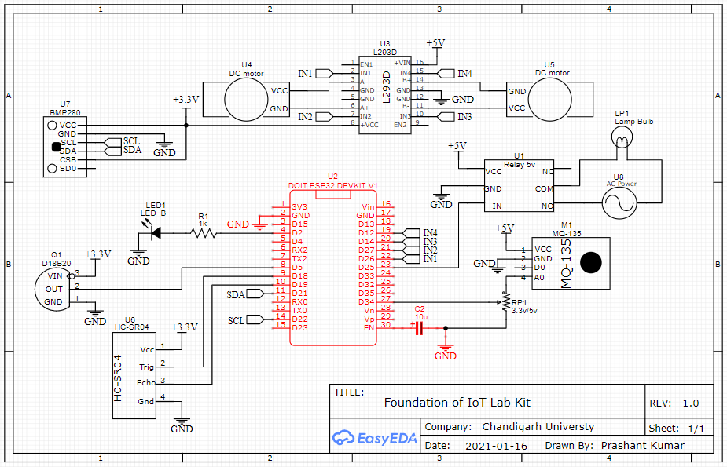

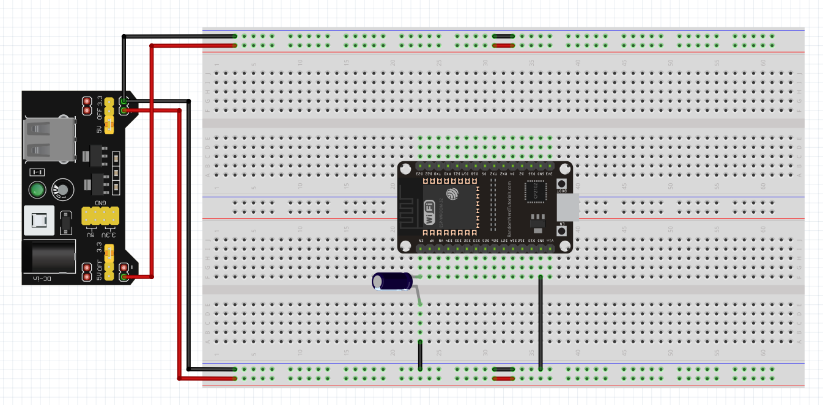

**Code (if any):**

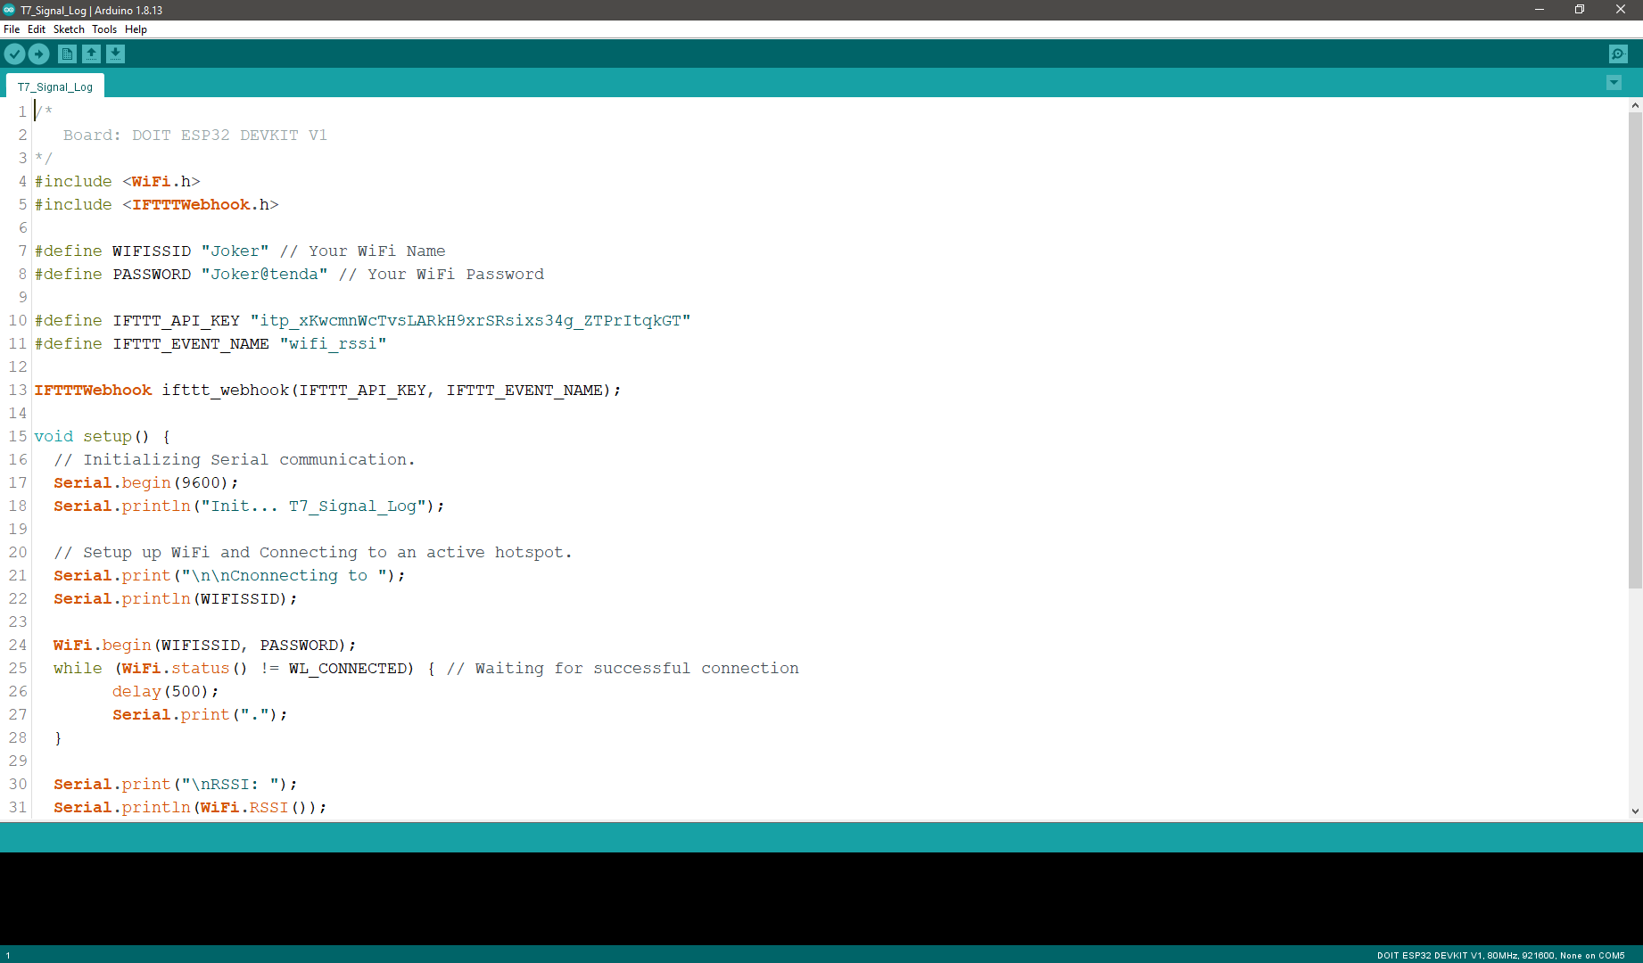

**Dashboard Snippet (if any):**

**Screenshot 1:**

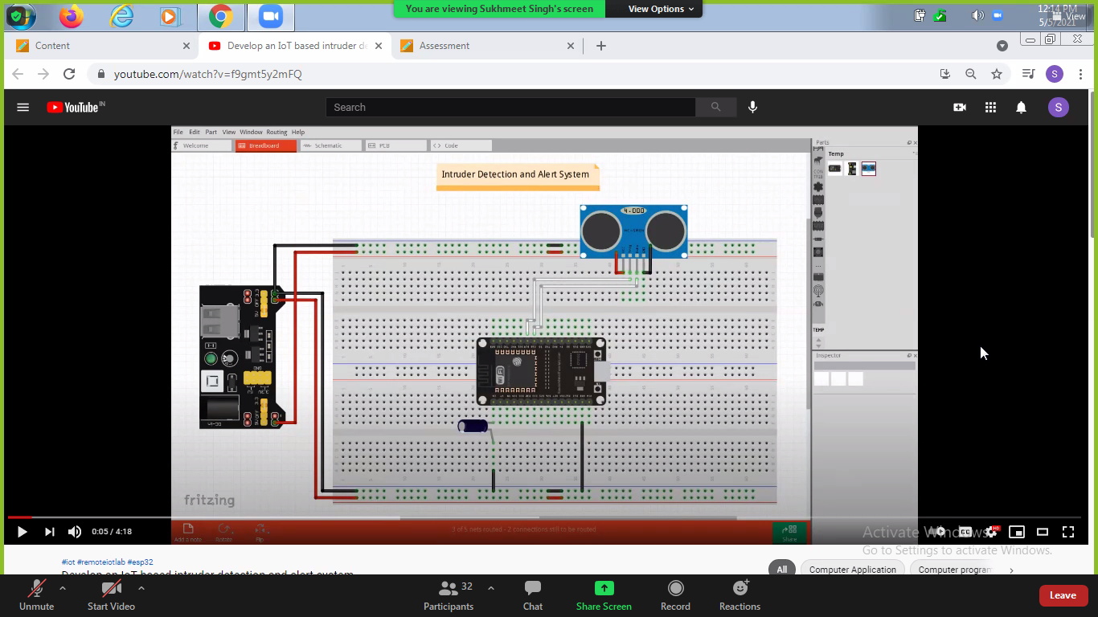

**Screenshot 2:**

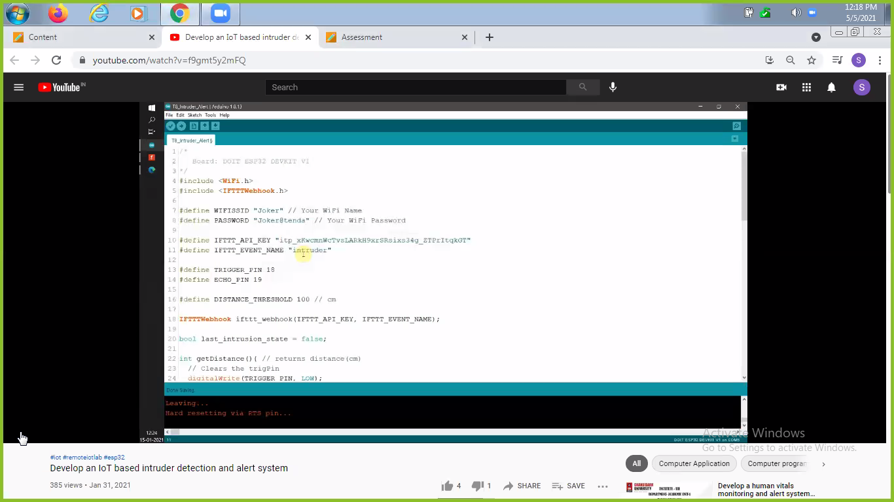

**Screenshot 3:**

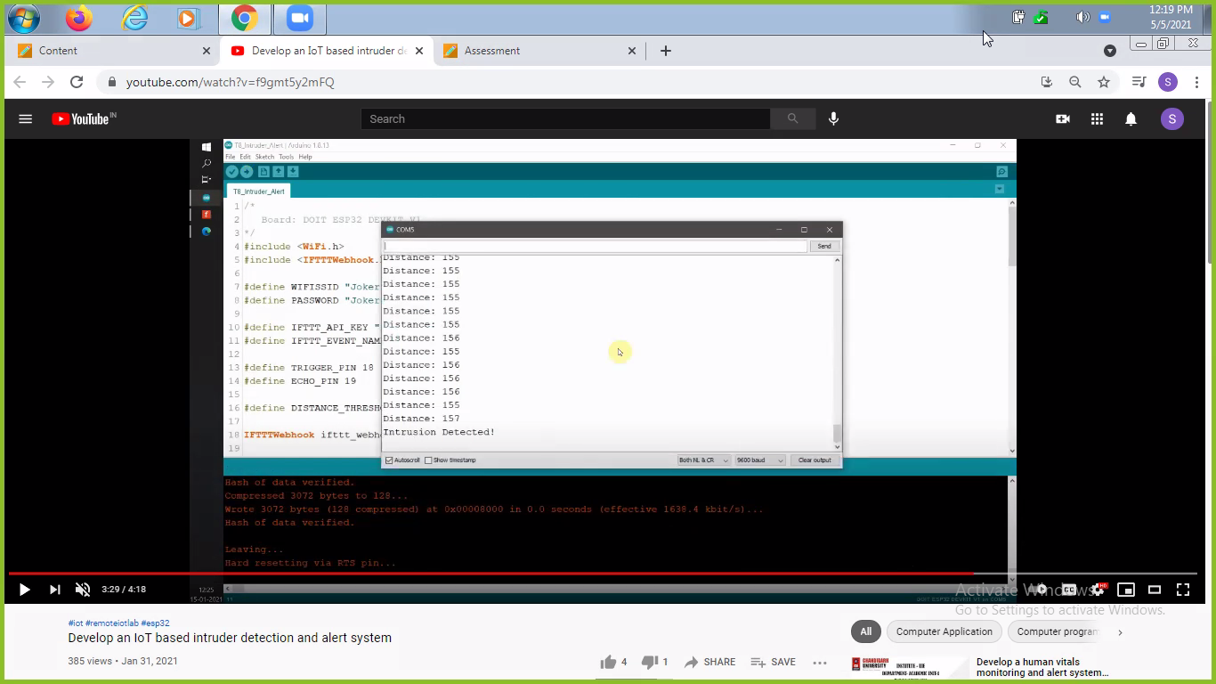

**Outcome:**

On completion of the experiment, the students will be able to:

* Establish an interface between embedded IoT system and the physical world through sensors, to read the state of the world, and actuators, to change the state of the world.
* Establish connectivity of IoT modules with cloud for sensor data collection and management.