WORKSHEET 3.3
NAME- SHUBHAM BAWANKAR
CLASS - CSE10 B
UID - 20BCS7409
SEMESTER -2
SUBJECT - IOT LAB 3.3 PRACTICAL

Task:
Design an IoT based real-time video surveillance system.
Requirements:
PC with Arduino
Connecting Wires
Breadboard
DOIT ESP32 DEVKIT V1
10uF Electrolytic Capacitor
Wire Clipper
USB Type A to Micro USB Cable
DC 5V Power Supply
DC 3.3V Power Supply
FTDI Connector

.Circuit Diagram:
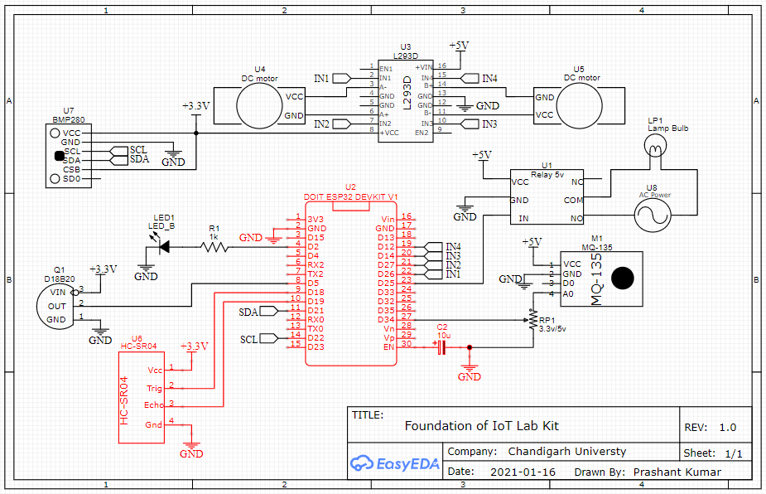
DEVICES:
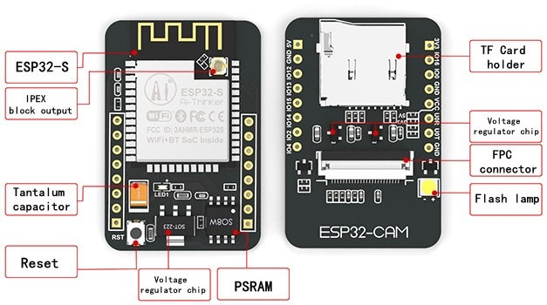
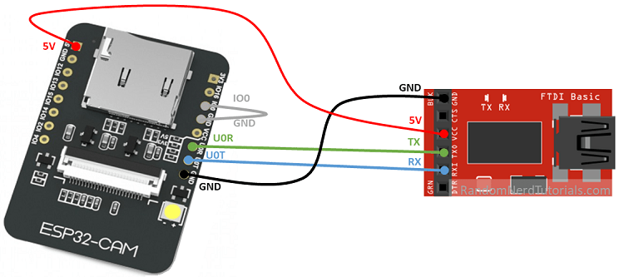

CODE:
SEREENSHOT 1:
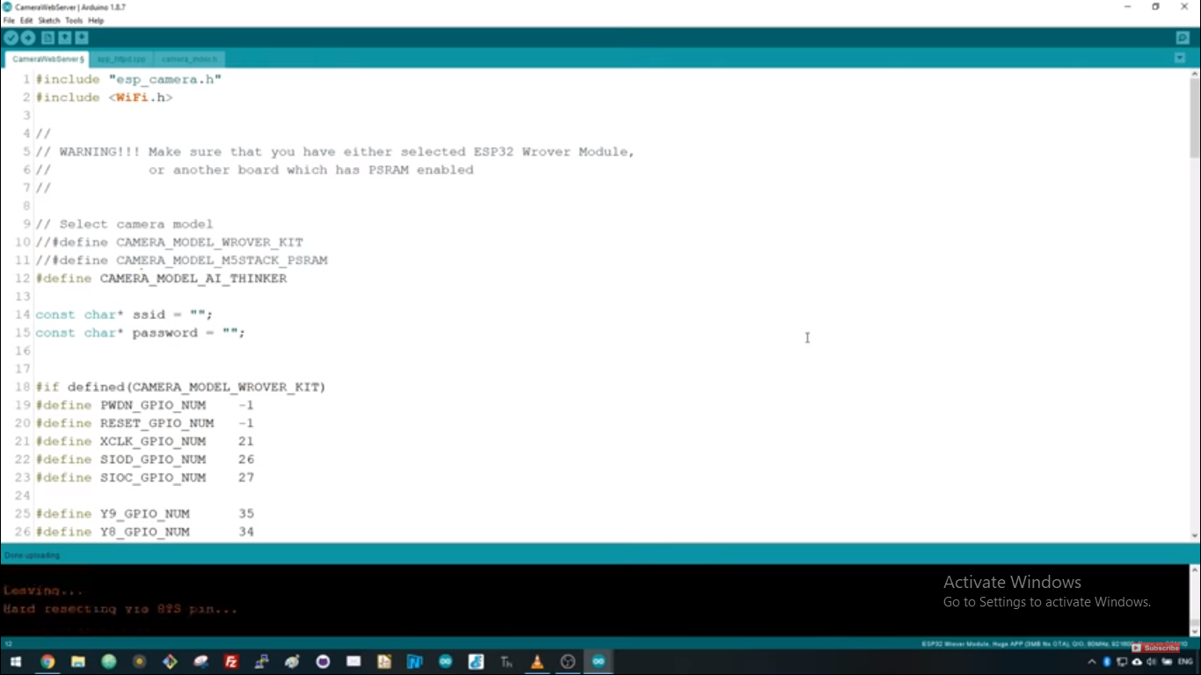

SCREENSHOT 2:
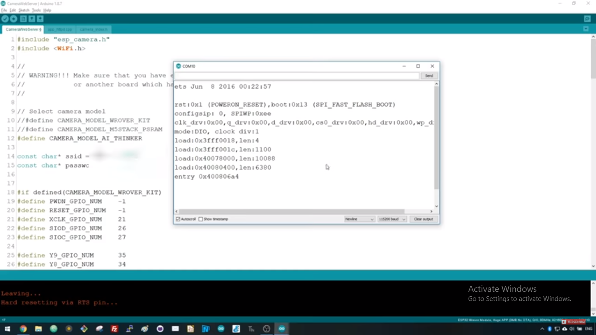

SCREENSHOT 3:
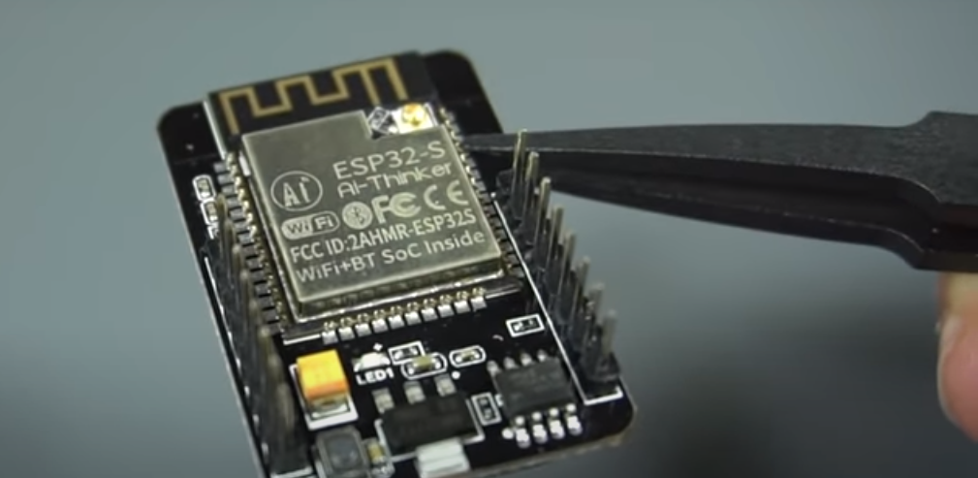

OUTCOME:
On completion of the experiment, the students will be able to:
- Establish an interface between embedded IoT system and the physical world through sensors, to read the state of the world, and actuators, to change the state of the world.
- Design an appcessory with Bluetooth/Wi-Fi connectivity using standard mobile application development tools.

