**Synopsis**

**On**

**Comparative Study and Implementation of Algorithms in**

**Machine Learning**

**By**

**Shreya Patle(CT18123)**

**Rutuja Kale(CT18037)**

**Shubham Chambhare(CT18125)**

**Prachi Patel(CT18031)**

**Raghav Shukla(CT18121)**

Under guidance of

**Shri. V. P. MAHATME**

Associate Professor



**2020-2021**

**DEPARTMENT OF COMPUTER TECHNOLOGY KAVIKULGURU INSTITITE OF TECHNOLOGY AND SCIENCE**

**RAMTEK – 441 106**

**Problem Statement**

Comparative Study and Implementation of Algorithms in Machine Learning.

**Objectives**

* To study theory and concepts of Python.
* To study Python.
* To study various machine learning algorithms.
* To implement machine learning algorithms using Python.
* To validate machine learning K-NN algorithm on different data sets.
* To implement handwritten digit classifier using K-NN algorithm.

**Introduction**

We have seen Machine Learning as a buzzword for the past few years, the reason for this might be the high amount of data production by applications, the increase of computation power in the past few years and the development of better algorithms. Machine Learning is used anywhere from automating mundane tasks to offering intelligent insights, industries in every sector try to benefit from it. You may already be using a device that utilizes it. For example, a wearable fitness tracker like Fitbit, or an intelligent home assistant like Google Home. But there are much more examples of ML in use. Machine Learning is a system of automated data processing algorithms that help to make decision making more natural and enhance performance based on the results. The “learning” implies that the algorithm can glean new information and insights without being explicitly programmed. There are several models of machine learning:

Supervised ML

This algorithm consists of a target / outcome variable (or dependent variable) which is to be predicted from a given set of predictors (independent variables). Using these set of variables, we generate a function that map inputs to desired outputs. The training process continues until the model achieves a desired level of accuracy on the training data. Examples of Supervised Learning: Regression, [Decision Tree](https://www.analyticsvidhya.com/blog/2015/01/decision-tree-simplified/), [Random Forest](https://www.analyticsvidhya.com/blog/2014/06/introduction-random-forest-simplified/), KNN, Logistic Regression etc.

Unsupervised ML

In this algorithm, we do not have any target or outcome variable to predict / estimate. It is used for clustering population in different groups, which is widely used for segmenting customers in different groups for specific intervention. Examples of Unsupervised Learning: Apriorist algorithm, K-means.

**Literature Survey**

Machine learning is an application of artificial intelligence (AI) that provides systems the ability to automatically learn and improve from experience without being explicitly programmed. Machine learning focuses on the development of computer programs that can access data and use it learn for themselves. The process of learning begins with observations or data, such as examples, direct experience, or instruction, in order to look for patterns in data and make better decisions in the future based on the examples that we provide. The primary aim is to allow the computers learn automatically without human intervention or assistance and adjust actions accordingly.

Python offers concise and readable code. While complex algorithms and versatile workflows stand behind machine learning and AI, Python’s simplicity allows developers to write reliable systems. Developers get to put all their effort into solving an ML problem instead of focusing on the technical nuances of the language. Additionally, Python is appealing to many developers as it’s easy to learn. Python code is understandable by humans, which makes it easier to build models for machine learning. Many programmers say that Python is more intuitive than other programming languages. Others point out the many frameworks, libraries, and extensions that simplify the implementation of different functionalities. It’s generally accepted that Python is suitable for collaborative implementation when multiple developers are involved. Since Python is a general-purpose language, it can do a set of complex machine learning tasks and enable you to build prototypes quickly that allow you to test your product for machine learning purposes.

**Proposed approach and system architecture**

In a K-Nearest Neighbors Algorithm, the proposed method uses k-nearest neighbor (knn) classification algorithm for classifying the MNIST digit images in test set using the feature vector of training database. The k-nearest neighbor algorithm (k-NN) is a classification technique which classify the objects base on training features space. The functionality of k-NN algorithm is to define the computations until classification is done irrespective of the learning techniques. Generally, k-NN has two learning techniques. They are Instance-based and Lazy learning techniques. K-nearest neighbor algorithm is simplest classification technique because of computations are simple. The classification of objects based on votes of its neighbors which represented by k. In K-nn object is classified to a particular class which has majority of votes.

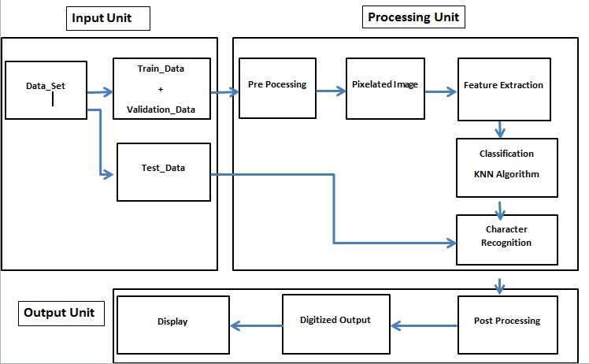

**Fig: Architecture Diagram**

**Plan of Implementation:**

|  |  |
| --- | --- |
| **Weeks** | **Activities** |
| Week 1 | Project discussion and selection of domain. |
| Week 2 | Study of Python. |
| Week 3 | Study of Machine learning algorithm. |
| Week 4 | Implementation of Algorithm. |
| Week 5 | Validation of result on different data set. |
| Week 6 | Report writing. |

**Tools and Libraries used**

1. Python-3.9
2. Jupyter Notebook

**References**

1. <https://www.analyticsvidhya.com/blog/2017/09/common-machine-learning-algorithms/> Accessed on: 1st April 2021 at 2.15 p.m.
2. <http://ijariie.com/AdminUploadPdf/Handwriting_Recognition_using_KNN_classificatiob_algorithm_ijariie6729.pdf> Accessed on: 2nd April 2021 at 1.30 p.m.
3. <https://www.tutorialspoint.com/python>. Accessed on: 2nd April 2021 at 3.00 p.m.
4. <https://www.expertsystem.com/machine-learning-definition>. Accessed on: 3rd April 2021 at 11.30 a.m.
5. <https://www.youtube.com/watch?v=rroGKLqbncs&list=PLyzHIYrZBplo3K0dNUqppd2ynnoZPD6N1&index=9> Accessed on: 3rd April 2021 at 11.30 a.m.
6. <https://cutt.ly/GcvOsA8> Accessed on: 4th April 2021 at 10.05 a.m.