Digit recognition using deep learning
This project report is submitted to
Rashtrasant Tukadoji Maharaj Nagpur University
in the partial fulfilment of the requirement for the award of the degree
of
Bachelor of Engineering in Computer Technology
by
Ms. Shreya Patle (CT18123)
Ms. Rutuja Kale (CT18037)
Mr. Shubham Chambhare (CT18125)
Ms. Prachi Patel (CT18031)
Mr. Raghav Shukla (CT18121)

Under the guidance of
Dr. Vilas P. Mahatme
Professor

2021-2022

DEPARTMENT OF COMPUTER ENGINEERING
KAVIKULGURU INSTITUTE OF TECHNOLOGY AND SCIENCE
RAMTEK – 441 106

DEPARTMENT OF COMPUTER TECHNOLOGY
KAVIKULGURU INSTITUTE OF TECHNOLOGY AND SCIENCE
RAMTEK – 441 106

CERTIFICATE

This is to certify that the project report entitled Digit recognition using deep learning carried out by Ms. Shreya Patle (CT18123), Ms. Rutuja Kale (CT18037), Mr. Shubham Chambhare (CT18125), Ms. Prachi Patel (CT18031), Mr. Raghav Shukla (CT18121) of the B.E. fourth year of Computer Technology, during the academic year 2021-2022, in the partial fulfilment of the requirement for the award of the degree of Bachelor of Engineering (Computer Technology) offered by the Rashtrasant Tukadoji Maharaj Nagpur University, Nagpur.

Dr. Vilas P. Mahatme
Guide

Dr. Vilas P. Mahatme Dr. Avinash N. Shrikhande
Professor Principal

Date:
Place: Ramtek

DECLARATION

We declare that

- The work contained in this dissertation has been done by us under the supervision of our guide.
- The work has not been submitted to any other Institute for any degree or diploma.
- We have followed the guidelines provided by the Institute in preparing the dissertation report.
- We have confirmed to the norms and guidelines given in the Ethical Code of Conduct of the Institute.
- Whenever we have used material (data, theoretical analysis, figures and text) from other sources, we have given due credit to them by citing them in the text of the report and giving their details in the references. Further, we have taken permission from the copyright owners of the sources, whenever necessary.

Project-mates

ACKNOWLEDGEMENT
We are grateful to my respected guide and Head of the Department Dr. Vilas P. Mahatme for his kind, disciplined and invaluable guidance allowing us to use all facilities that are available in the Department which inspired us to solve all the difficulties that came across during completion of project.

Our sincere thanks to Dr. Avinash N Shrikhande, Principal, for extending all the possible help and allowing us to use all resources that are available in the Institute.

We are also thankful to our Family members and Friends for their valuable corporation and standing with us in all difficult conditions.

Project-mates

ABSTRACT
The task for handwritten digit recognition has been troublesome due to various variations in writing styles. Therefore, we have tried to create a base for future researches in the area so that the researchers can overcome the existing problems. The existing methods and techniques for handwritten digit recognition were reviewed and understood to analyze the most suitable and best method for digit recognition. Here, we introduce a convolutional neural network, which is a specific type of deep neural network having wide applications in image classification, object recognition, natural language processing, computer vision, and face recognition.
A number of 60,000 images were used as training sets of images with pixel size of 28×28. The images/training sets were matched with original image. It was found out after complete analysis and review that classifier ensemble system has the least error rate of just 0.32%. In this paper, review of different methods handwritten digit recognition were observed and analyzed.

KEYWORDS: Handwritten digit recognition, Convolutional neural network, Deep Learning ,Image recognition, Training sets, Original image, Neural networks, etc.

CONTENTS

Acknowledgement |  |  | i
Abstract |  |  | ii
Contents |  |  | iii
Notations |  |  | iv
Abbreviations |  |  | v
List of Figures |  |  | vi
CHAPTER 1 | INTRODUCTION |  | 1-4
 | 1.1 | Basic Information | 1
 | 1.2 | Overview
 | 1.3 | Recent Scenario
 | 1.4 | Organization of Report
CHAPTER 2 | LITERATURE REVIEW |  | 16-20
 | 2.1 | Related work
 | 2.2 | Programming Languages  2.2.1 Python Programming Language
 |  | 2.2.2 R Programming Language
 | 2.3 | Deep Learning
 | 2.4 | Aim and Objectives
CHAPTER 3 | DEEP LEARNING AND ITS ALGORITHM |  | 21-35
 | 3.1 | What is deep learning?  3.1.1 How does deep learning works?  3.1.2 History of deep learning  3.1.3 Classification of deep learning
 | 3.2 | Convolutional Neural Network
CHAPTER 4 | TOOLS AND TECHNOLOGIES |  | 36-41
 | 4.1 | What is python?  4.1.1 Introduction  4.1.2 IDLE  4.1.3 Features of Python
 | 4.2 | Jupyter Notebook  4.2.1 Components of Jupyter Notebook  4.2.2 Application of Jupyter Notebook
 | 4.3 | Pandas
 | 4.4 | Scikit-learn
 | 4.5 | Keras
 | 4.6 | HTML
 | 4.7 | Cascading Style Sheet
 | 4.8 | JavaScript
 | 4.9 | OpenCV
CHAPTER 5 | DESIGN AND IMPLEMENTATION |  | 42-50
 | 5.1 | Data Collection
 | 5.2 | Dataset Creation
 | 5.3 | Data analysis
 | 5.4 | Data pre-processing
 | 5.5 | Block Diagram
 | 5.6 | Convolutional Neural Network (CNN)
 | 5.7 | External Interface Requirements  5.7.1 Hardware Requirement  5.7.2 Software Requirement
CHAPTER 6 | RESULTS AND DISCUSSION
 | 6.1 Dataset
 | 6.2 Execution
CHAPTER 7 | CONCLUSION |  | 51
 | 7.1 | Limitations of the Study
 | 7.2 | Future Scope of Work
References |  |  | 52
Publications |  |  | 53

NOTATIONS

P | Unknown Probability Distribution
b^{k} | Bias
W^{k} | Weight
K | Kernels

ABBREVIATIONS

Abbreviations | Meaning
ML | Machine Learning
DL | Deep Learning
RL | Representation Learning
HPC | High Performance Computing
NLP | Natural Language Processing
CNN | Convolutional Neural Networks
MLP | Multilayer Perceptron
SVM | Support Vector Machine
EDA | Exploratory Data Analysis
RNN | Recurrent Neural Networks
GAN | Generative Adversarial Networks
FC | Fully Connected
Lists of Figures

Figure No. | Caption | Page No.
2.1 | Evolution of Deep Learning | 18
2.2 | Difference between Deep Learning and traditional Machine Learning | 19
3.1 | Convolutional Neural Network Architecture | 26
3.2 | Convolutional layer | 28
3.3 | Pooling Layer | 30
3.4 | Activation functions | 31
3.5 | Fully Connected Layer | 32
3.6 | Under-fitting and Over-fitting issues | 34
5.1 | Graphical representation of Dataset | 43
5.2 | Dataflow Diagram of the system model | 44
6.1 | Exploring Mnist Dataset | 47
6.2 | Different layer of model | 48
6.3 | Plotting the accuracy and loss of model | 49
6.4 | Prediction of Digits | 50
6.5 | Screenshot 1
6.6 | Screenshot 2
6.7 | Screenshot 3
6.8 | Screenshot 4
6.9 | Screenshot 5

CHAPTER 1
INTRODUCTION

  - Basic Information
Recently, machine learning (ML) has become very widespread in research and has been incorporated in a variety of applications, including text mining, spam detection, video recommendation, image classification, and multimedia concept retrieval .Among the different ML algorithms, deep learning (DL) is very commonly employed in these applications . Another name for DL is representation learning (RL).The continuing appearance of novel studies in the fields of deep and distributed learning is due to both the unpredictable growth in the ability to obtain data and the amazing progress made in the hardware technologies, e.g. High Performance Computing (HPC) .
DL is derived from the conventional neural network but considerably outperforms its predecessors. Moreover, DL employs transformations and graph technologies simultaneously in order to build up multi-layer learning models. The most recently developed DL techniques have obtained good outstanding performance across a variety of applications, including audio and speech processing, visual data processing, natural language processing (NLP), among others.

1.2 Overview
Recently Convolutional Neural Networks (CNN) becomes one of the most appealing approaches and has been an ultimate factor in a variety of recent success and challenging machine learning applications such as challenge ImageNet object detection image segmentation and face recognition. Therefore, we choose CNN for our challenging tasks of image classification. We can use it for handwriting digits recognition which is one of high academic and business transactions. There are many applications of handwriting digit recognition in our real life purposes. Precisely, we can use it in banks for reading checks, post offices for sorting letter, and many other related works.
Machine Learning (ML) is a subfield of artificial intelligence (AI). The goal of machine learning generally is to understand the structure of data and fit that data into models that can be understood and utilized by people. Although machine learning is a field within computer science, it differs from traditional computational approaches. In traditional computing, algorithms are sets of explicitly programmed instructions used by computers to calculate or problem solve. Machine learning algorithms instead allow for computers to train on data inputs and use statistical analysis in order to output values that 2 fall within a specific range. Because of this,
machine learning facilitates computers in building models from sample data in order to automate decision-making processes based on data inputs.
Machine learning develops algorithms and builds models from data, and uses them to predict on new data. The main difference with traditional algorithm is that a model is built from inputs data rather than just execute a series of instructions. Supervised learning uses data with result labelled, while unsupervised learning using unlabelled data. There are a few common machine learning algorithms, such as regression, classification, neural network and deep learning. Reinforcement learning and representation learning are heavily used for deep learning.
In the current age of digitization, handwriting recognition plays an important role in information processing. A lot of information is available on paper, and processing of digital files is cheaper than processing traditional paper files. The aim of a handwriting recognition system is to convert handwritten characters into machine readable formats. The main applications are vehicle license-plate recognition, postal letter-sorting services, Cheque truncation system scanning and historical document preservation in archaeology departments, old documents automation in libraries and banks, etc. All these areas deal with large databases and hence demand high recognition accuracy, lesser computational complexity and consistent performance of the recognition system.
The deep learning field is ever evolving, and some of its variants are autoencoders, CNNs, recurrent neural networks (RNNs), recursive neural networks, deep belief networks and deep Boltzmann machines. Here, we introduce a convolutional neural network, which is a specific type of deep neural network having wide applications in image classification, object recognition, recommendation systems, signal processing, natural language processing, computer vision, and face recognition. The ability to automatically detect the important features of an object (here an object can be an image, a handwritten character, a face, etc.) without any human supervision or intervention makes them (CNNs) more efficient than their predecessors (Multilayer perceptron (MLP), etc.). The high capability of hierarchical feature learning results in a highly efficient CNN.

1.3 Recent Scenario
In the past few years, the CNN model has been extensively employed for handwritten digit recognition from the MNIST benchmark database. Some researchers have reported accuracy as good as 98% or 99% for handwritten digit recognition . An ensemble model has been designed using a combination of multiple CNN models. The recognition experiment was carried out for MNIST . digits, and an accuracy of 99.73% was reported . Later, this “7-net committee” was extended to the “35-net committee” experiment, and the improved recognition accuracy was reported as 99.77% for the same MNIST dataset . An extraordinary recognition accuracy of 99.81% was reported by Niu and Suen by integrating the SVM (support vector machine) capability of minimizing the structural risk and the capability of a CNN model for extracting the deep features for the MNIST digit recognition experiment . The bend directional feature maps were investigated using CNN for in-air handwritten Chinese character recognition .
Recently, the work of Alvear-Sandoval et al. achieved a 0.19% error rate for MNIST by building diverse ensembles of deep neural networks (DNN) . However, on careful investigation, it has been observed that the high recognition accuracy of MNIST dataset images is achieved through ensemble methods only. Ensemble methods help in improving the classification accuracy but at the cost of high testing complexity and increased computational cost for real-world application .

1.4 Organization of Report
Chapter one contains the introduction of the project work. It includes general introduction of the project i.e., overview of project, purpose and explanation about the system. This chapter also includes organization of report and the basic knowledge of Deep Learning.
Chapter two is the literature review which includes brief description of the algorithms used in the project. It also describes about Aim and Objective of the project.
Chapter three contains the introduction to Deep Learning and its Algorithms . In this, how Deep Learning works ,about deep learning history and classification of deep learning algorithms are explained.
Chapter four contains the tools and technologies used. In this, installation and working of tools used are explained the brief tools and technology used.
Chapter five contains the design and implementation used. In this, data set and the implemented algorithm used is briefly explained .
Chapter six provides the result and discussions about the implemented work using Deep Learning Concepts.
Chapter seven deals with the conclusive remark on the conclusion derived from the system with its limitation and future scope.

CHAPTER 2
LITERATURE REVIEW
2.1 Reviews
A literature review discusses published information in a particular subject area, and sometimes information in a particular subject area within a certain time period. It can be just a simple summary of the sources, but it usually has an organizational pattern and combines both summary and synthesis. A summary is a recap of the important information of the source, but a synthesis is a re-organization, or a reshuffling, of that information.

    - Related work
K. Gaurav, Bhatia P. K. “Analytical Review of Preprocessing Techniques for Offline Handwritten Character Recognition” , this paper deals with the various pre-processing techniques involved in the character recognition with different kind of images ranges from a simple handwritten form based documents and documents containing colored and complex background and varied intensities. In this, different preprocessing techniques like skew detection and correction, image enhancement techniques of contrast stretching, binarization, noise removal techniques, normalization and segmentation, morphological processing techniques are discussed. It was concluded that using a single technique for preprocessing, we can’t completely process the image. However, even after applying all the said techniques might not possible to achieve the full accuracy in a preprocessing system.

Walid, R. and A. Lasfar. Handwritten digit recognition using sparse deep architectures. in Intelligent Systems: Theories and Applications (SITA-14), 2014 9th International Conference on. 2014. IEEE This paper proposed that “A lot of research has been lately focusing on deep neural networks as an alternative to shallow ones. The added advantage among many, is the automated feature extraction of pattern from data. These models have been applied successfully to many tasks, including handwritten digit recognition, where they lead the state of the art performance. In this paper we apply a sparse deep belief network and a denoising autoencoder to a new dataset proposed in the ICDAR 2013 handwritten digit competition, which is a challenging alternative in multiple aspects to many popular digit datasets. Additionally we raise some difficulties met during modelling. We finally put the spot on some elements that could improve the performance for subsequent attempts in improving models' accuracy. ”

Bouchain, D., Character recognition using convolutional neural networks. Institute for Neural Information Processing, 2006. 2007. This paper proposed that
Pattern recognition is one of the traditional uses of neural networks. When trained with gradient-based learning methods, these networks can learn the classification of input data by example. An introduction to classifiers and gradient-based learning is given. It is shown how several perceptrons can be combined and trained gradient-based. Furthermore, an overview of convolutional neural networks, as well as a real-world example, are discussed.

2.2 Programming Languages
When choosing a language to specialize in with machine learning. Python is the most sought for programming language in the machine learning professional field. It has several machine learning packages and advanced implementations for the top machine learning algorithms which every data scientist must be familiar with, to explore, model and prototype the given data.

2.2.1 Python Programming Languages
Python’s popularity may be due to the increased development of deep learning frameworks available for this language recently, including Tensor Flow, Torch, and Keras. As a language that has readable syntax and the ability to be used as a scripting language, Python proves to be powerful and straightforward both for pre-processing data and working with data directly. The scikit-learn machine learning library is built on top 10 of several existing Python packages that Python developers may already be familiar with, namely NumPy, SciPy, and Matplotlib.

2.2.2 R Programming Language
R is the preeminent choice among data professionals who want to understand and explore data, using statistical methods and graphs. It has several machine learning packages and advanced implementations for the top machine learning algorithms which every data scientist must be familiar with, to explore, model and prototype the given data. R is an open source language to which people have contributed, from around the world. Starting from data collection and cleaning to reproducible research that will find a Black Box written by someone else, which can directly be used in the program. This Black Box is known as Package in R. A Package in R is but collection of pre-written codes which can be reused.

2.3 Deep Learning
Deep Learning, a subset of Machine Learning , is inspired by the information processing patterns found in the human brain. DL does not require any human-designed rules to operate; rather, it uses a large amount of data to map the given input to specific labels. DL is designed using numerous layers of algorithms (artificial neural networks, or ANNs), each of which provides a different interpretation of the data that has been fed to them . Achieving the classification task using conventional,

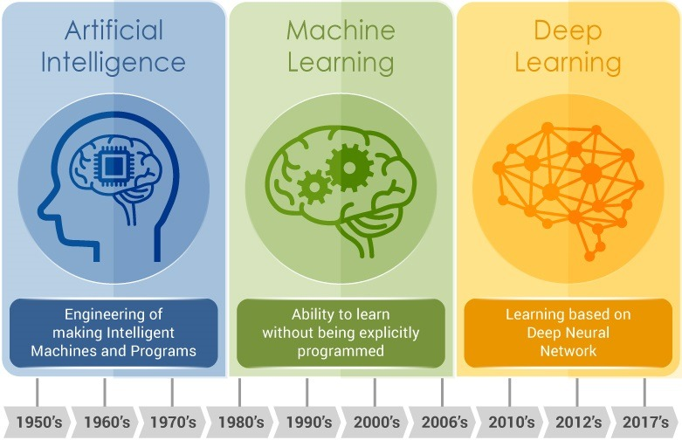
Fig 2.1 Evolution of Deep Learning

ML techniques requires several sequential steps, specifically pre-processing, feature extraction, wise feature selection, learning, and classification. Furthermore, feature selection has a great impact on the performance of ML techniques. Biased feature selection may lead to incorrect discrimination between classes. Conversely, DL has the ability to automate the learning of feature sets for several tasks, unlike conventional ML methods. DL enables learning and classification to be achieved in a single shot . DL has become an incredibly popular type of ML algorithm in recent years due to the huge growth and evolution of the field of big data . It is still in continuous development regarding novel performance for several ML tasks and has simplified the improvement of many learning fields , such as image super-resolution , object detection, and image recognition. Recently, DL performance has come to exceed human performance on tasks such as image classification.
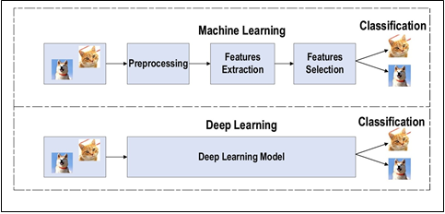
Fig. 2.2 Difference between Deep Learning and traditional Machine Learning
Deep learning Life cycle
Deep learning has given the computer systems the abilities to automatically learn without being explicitly programmed. But how does a deep learning system work? So, it can be described using the life cycle of deep learning. Machine learning life cycle is a cyclic process to build an efficient deep learning project. The main purpose of the life cycle is to find a solution to the problem or project. Deep learning life cycle involves seven major steps, which are given below:
• Gathering Data
• Data preparation
• Data Wrangling
• Analyse Data
• Train the model
• Test the model
• Deployment
The most important thing in the complete process is to understand the problem and to know the purpose of the problem. Therefore, before starting the life cycle, there is a need to understand the problem because the good result depends on the better understanding of the problem. In the complete life cycle process, to solve a problem, create a deep learning system called "model", and this model is created by providing "training". But to train a model, we need data, hence, life cycle starts by collecting data.

a) MNIST database
The MNIST database (Modified National Institute of Standards and Technology database) is a handwritten digits dataset. We can use it for training various image processing systems . The database is also widely used for training and testing in the field of machine learning. It has 60,000 training and 10,000 testing examples.

Each image has fixed size. The images are of size 28*28 pixels. It is a database for people who want to try learning techniques and pattern recognition methods on real-world data while spending minimal efforts on preprocessing and formatting. We will use this database in this project.

b) Convolutional Neural Networks
Convolutional neural networks are deep artificial neural networks. We can use it to classify images (e.g., name what they see), cluster them by similarity (photo search) and perform object recognition within scenes. It can be used to identify faces, individuals, street signs, tumors, platypuses and many other aspects of visual data. The convolutional layer is the core building block of a CNN. The layer’s parameters consist of a set of learnable filters (or kernels) which have a small receptive field but extend through the full depth of the input volume. During the forward pass, each filter is convolved across the width and height of the input volume, computing the dot product, and producing a 2- dimensional activation map of that filter. As a result, the network learns when they see some specific type of feature at some spatial position in the input. Then the activation maps are fed into a down sampling layer, and like convolutions, this method is applied one patch at a time. CNN has also fully connected layer that classifies output with one label per node.

2.4 Aim and Objectives
Given below are the aim and objectives of the project.
Aim
To recognize handwritten digits using Convolutional Neural Network (CNN) model of deep learning and comparing it with kNN algorithm.
Objectives
- To study theory and concepts of Python.
- To study various Deep learning algorithms.
- Exploratory data analysis (EDA) of mnist data.
- To validate kNN algorithm and deep learning CNN algorithm on mnist data set.
- To compare the accuracy of both the algorithms.

CHAPTER 3
Deep Learning and it’s Algorithms
  - What is deep learning?
Deep learning (deep structured learning, hierarchical learning or deep machine learning) is a branch of machine learning based on a set of algorithms that attempt to model high-level abstractions in data by using multiple processing layers with complex structures, or otherwise composed of multiple non-linear transformations . Deep learning is part of a broader family of machine learning methods based on learning representations of data. An observation (e.g., an image) can be represented in many ways such as a vector of intensity values per pixel, or in a more abstract way as a set of edges, regions of particular shape, etc. Some representations make it easier to learn tasks (e.g., face recognition or facial expression recognition ) from examples. One of the potentials of deep learning is replacing handcrafted features with efficient algorithms for unsupervised or semi-supervised feature learning and hierarchical feature extraction.
Various deep learning architectures such as deep neural networks, convolutional deep neural networks, deep belief networks and recurrent neural networks have been applied to fields like computer vision, automatic speech recognition, natural language processing, audio recognition and bioinformatics where they have been shown to produce state-of-the-art results on various tasks. Alternatively, deep learning has been characterized as a buzzword, or a rebranding of neural networks . Deep learning could be characterized as a class of machine learning algorithms that Use a cascade of many layers of nonlinear processing units for feature extraction and transformation. Each successive layer uses the output from the previous layer as input. The algorithms may be supervised or unsupervised and applications include pattern analysis (unsupervised) and classification (supervised).

3.1.1 How does Deep Learning work ?
Neural Networks are layers of nodes, much like the human brain is made up of neurons. Nodes within individual layers are connected to adjacent layers. The network is said to be deeper based on the number of layers it has. A single neuron in the human brain receives thousands of signals from other neurons. In an artificial neural network, signals travel between nodes and assign corresponding weights. A heavier weighted node will exert more effect on the next layer of nodes. The final layer compiles the weighted inputs to produce an output. Deep learning systems require powerful hardware because they have a large amount of data being processed and involves several complex mathematical calculations. Even with such advanced hardware, however, deep learning training computations can take weeks.
Deep learning systems require large amounts of data to return accurate results; accordingly, information is fed as huge data sets. When processing the data, artificial neural networks are able to classify data with the answers received from a series of binary true or false questions involving highly complex mathematical calculations. For example, a facial recognition program works by learning to detect and recognize edges and lines of faces, then more significant parts of the faces, and, finally, the overall representations of faces. Over time, the program trains itself, and the probability of correct answers increases. In this case, the facial recognition program will accurately identify faces with time.

3.1.2 History of Deep Learning
The history of deep learning dates back to 1943 when Warren McCulloch and Walter Pitts created a computer model based on the neural networks of the human brain. Warren McCulloch and Walter Pitts used a combination of mathematics and algorithms they called threshold logic to mimic the thought process. Since then, deep learning has evolved steadily, over the years with two significant breaks in its development. The development of the basics of a continuous Back Propagation Model is credited to Henry J. Kelley in 1960. Stuart Dreyfus came up with a simpler version based only on the chain rule in 1962. The concept of back propagation existed in the early 1960s but only became useful until 1985.
The earliest efforts in developing deep learning algorithms date to 1965, when Alexey Grigoryevich Ivakhnenko and Valentin Grigorʹevich Lapa used models with polynomial (complicated equations) activation functions, which were subsequently analysed statistically.During the 1970’s a brief setback was felt into the development of AI, lack of funding limited both deep learning and artificial intelligence research. However, individuals carried on the research without funding through those difficult years.
Convolutional neural networks were first used by Kunihiko Fukushima who designed the neural networks with multiple pooling and convolutional layers. Kunihiko Fukushima developed an artificial neural network, called Neocognitron in 1979, which used a multi-layered and hierarchical design. The multi-layered and hierarchical design allowed the computer to learn to recognize visual patterns. The networks resembled modern versions and were trained with a reinforcement strategy of recurring activation in multiple layers, gaining strength over time.
3.1.3 Classification of Deep Learning
DL techniques are classified into three major categories: unsupervised, partially super- vised (semi-supervised) and supervised. Furthermore, deep reinforcement learning (DRL), also known as RL, is another type of learning technique, which is mostly considered to fall into the category of partially supervised (and occasionally unsupervised) learning techniques.

1. Deep Supervised Learning
This technique deals with labeled data. When considering such a technique, the environs have a collection of inputs and resultant outputs (xt , yt ) ∼ ρ. For instance, the smart agent guesses if the input is xt and will obtain as a loss value. Next, the network parameters are repeatedly updated by the agent to obtain an improved estimate for the preferred outputs. Following a positive training outcome, the agent acquires the ability to obtain the right solutions to the queries from the environs. For DL, there are several supervised learning techniques, such as recurrent neural networks (RNNs), convolutional neural networks (CNNs), and deep neural networks (DNNs). In addition, the RNN category includes gated recurrent units (GRUs) and long short-term memory (LSTM) approaches. The main advantage of this technique is the ability to collect data or generate a data output from the prior knowledge. However, the disadvantage of this technique is that decision boundary might be overstrained when training set doesn’t own samples that should be in a class. Overall, this technique is simpler than other techniques in the way of learning with high performance.

2. Deep Semi-supervised Learning
In this technique, the learning process is based on semi-labeled datasets. Occasionally, generative adversarial networks (GANs) and DRL are employed in the same way as this technique. In addition, RNNs, which include GRUs and LSTMs, are also employed for partially supervised learning. One of the advantages of this technique is to minimize the amount of labeled data needed. On other the hand, One of the disadvantages of this technique is irrelevant input feature present training data could furnish incorrect decisions. Text document classifier is one of the most popular example of an application of semi-supervised learning. Due to difficulty of obtaining a large amount of labeled text documents, semi-supervised learning is ideal for text document classification task.

3. Deep Unsupervised Learning
This technique makes it possible to implement the learning process in the absence of available labeled data (i.e. no labels are required). Here, the agent learns the significant features or interior representation required to discover the unidentified structure or relationships in the input data. Techniques of generative networks, dimensionality reduction and clustering are frequently counted within the category of unsupervised learning. Several members of the DL family have performed well on non-linear dimensionality reduction and clustering tasks; these include restricted Boltzmann machines, auto-encoders and GANs as the most recently developed techniques . Moreover, RNNs, which include GRUs and LSTM approaches, have also been employed for unsupervised learning in a wide range of applications. The main disadvantages of unsupervised learning are unable to provide accurate information concerning data sorting and computationally complex. One of the most popular unsupervised learning approaches is clustering .

4. Deep Reinforcement Learning
Reinforcement Learning operates on interacting with the environment, while super- vised learning operates on provided sample data. This technique was developed in 2013 with Google Deep Mind . Subsequently, many enhanced techniques dependent on reinforcement learning were constructed. For example, if the input environment samples: xt ∼ ρ, agent predict and the received cost of the agent , P here is the unknown probability distribution, then the environment asks a question to the agent. The answer it gives is a noisy score. This method is sometimes referred to as semi-supervised learning. Based on this concept, several supervised and unsupervised techniques were developed. In comparison with traditional supervised techniques, performing this learning is much more difficult, as no straightforward loss function is available in the reinforcement learning technique. In addition, there are two essential differences between supervised learning and reinforcement learning: first, there is no complete access to the function, which requires optimization, meaning that it should be queried via interaction; second, the state being interacted with is founded on an environment, where the input xt is based on the preceding actions.
For solving a task, the selection of the type of reinforcement learning that needs to be performed is based on the space or the scope of the problem. For example, DRL is the best way for problems involving many parameters to be optimized. By contrast, derivative-free reinforcement learning is a technique that performs well for problems with limited parameters. Some of the applications of reinforcement learning are business strategy planning and robotics for industrial automation.

  - Convolutional Neural Network
In the field of DL, the CNN is the most famous and commonly employed algorithm . The main benefit of CNN compared to its predecessors is that it automatically identifies the relevant features without any human supervision . CNNs have been extensively applied in a range of different fields, including computer vision , speech processing , Face Recognition , etc. The structure of CNNs was inspired by neurons in human and animal brains, similar to a conventional neural network. More specifically, in a cat’s brain, a complex sequence of cells forms the visual cortex; this sequence is simulated by the CNN . Goodfellow identified three key benefits of the CNN: equivalent representations, sparse interactions, and parameter sharing. Unlike conventional fully connected (FC) networks, shared weights and local connections in the CNN are employed to make full use of 2D input-data structures like image signals. This operation utilizes an extremely small number of parameters, which both simplifies the training process and speeds up the network. This is the same as in the visual cortex cells. Notably, only small regions of a scene are sensed by these cells rather than the whole scene (i.e., these cells spatially extract the local correlation available in the input, like local filters over the input).
Deep Learning has emerged as a central tool for self-perception problems like understanding images, a voice from humans, robots exploring the world. We aim to implement the concept of Convolutional Neural Network for digit recognition. Understanding CNN and applying it to the handwritten digit recognition system is the target of the proposed model. Convolutional Neural Network extracts the features maps from the 2D images. Then it can classify the images using the features maps. The convolutional neural network considers the mapping of image pixels with the neighborhood space rather than having a fully connected layer of neurons. The convolutional neural network is a powerful tool in signal and image processing. Even in the fields of computer vision such as handwriting recognition, natural object classification, and segmentation, CNN has been a much better tool compared to all other previously implemented tools. The broader aim may be to develop a machine learning model that could recognize people’s handwriting.
a) The Architecture of the Proposed Model
When one starts learning deep learning with a neural network, he realizes that CNN is an important tool for image classification. Convolutional Neural Networks are a special kind of multi-layer neural networks designed to recognize visual patterns directly from pixel images with minimal preprocessing. Almost all CNN architectures follow the same general design principles of successively applying convolutional layers to the input, periodically downsampling (Max pooling) the spatial dimensions while increasing the number of feature maps. Moreover, there are also fully connected layers, activation functions and loss function (e.g., cross entropy or softmax). However, among all the operations of CNN, convolutional layers, pooling layers, and fully connected layers are the most important ones. Therefore, we will quickly introduce these layers before presenting our proposed model.
The convolutional layer is the first layer which can extract features from the images. Because pixels are only related to the adjacent and close pixels, convolution allows us to preserve the relationship between different parts of an image. Convolution is filtering the image with a smaller pixel filter to decrease the size of the image without losing the relationship between pixels. When we apply convolution to the 5x5 image by using a 3x3 filter with 1x1 stride (1-pixel shift at each step), we will end up having a 3x3 output (64% decrease in complexity).
When constructing CNN, it is common to insert pooling layers after each convolution layer to reduce the spatial size of the features maps. Pooling layers also help with the overfitting problem. We select a pooling size to reduce the amount of the parameters by selecting the maximum, average, or sum values inside these pixels. Max Pooling, one of the most common pooling techniques.
A fully connected network is in any architecture where each parameter is linked to one another to determine the relation and effect of each parameter on the labels. Since convolution and pooling layers reduce time-space complexity, we can construct a fully connected network in the end to classify the images.
Convolutional Neural Networks (CNN) are the current state-of-art architecture for the image classification task. Our proposed 2-D Convolutional Neural Network (CNN) model is designed using MatConvNet backened for the well known MNIST digit recognition task. The whole workflow can be to preparing the data, building and compiling of the model, training and evaluating the model and saving the model to disk to reuse. Preparing the data is the first step of our approach. Before we build the network, we need to set up our training and testing data, combine data, combine labels and reshape into the appropriate size. We save the dataset of normalized data (single precision and zero mean), labels, and miscellaneous (meta) information. Building and compiling of the model is the second step. To create the CNN, we must initialize MatConvNets DagNN (Directed acyclic graph neural network) network and then define important initialization parameters.
Batch size determines the number of samples for the training phase of the CNN. The CNN will process the third step is the training and evaluating the model. Training a CNN requires computing the derivatives of the loss concerning the network parameters. We use back propagation algorithm for computing derivatives. It is a memory-efficient implementation of the chain rule for derivatives. We have use Stochastic Gradient Descent (SGD) training algorithm to adjust the weight of the connection between neurons so that the loss reaches a minimum value or stops after several epochs. Only log loss is used to adjust weights. We have used CPU training. It is important to note that GPU training will dramatically help training time for CNN. Lastly, we can begin the training of CNN by supplying the training data, the constructed model and the current ‘batch’ of data.
When training the CNN, only the data specified for training plays a role in minimizing error in the CNN. The algorithm uses training data for the forward and backward pass. The algorithm uses all the training data, but only in increments of the specified batch size. We use batch size for computational efficiency, and its value will be dependent on the user’s available hardware. An epoch is a successful forward pass and a backward pass through the network. It’s usually beneficial to set its value high. Then we can reduce the value once if one is satisfied with the convergence at a particular state (chosen epoch) in the network. Learning rate is a very sensitive parameter that pushes the model towards convergence. Finding its best value will be an empirical process unless one invokes more powerful techniques such as batch normalization. In our this project, we use batch size 40, a number of epochs 8 and learning rate 0.001 for maximum accuracy.
A commonly used type of CNN, which is similar to the multi-layer perceptron (MLP), consists of numerous convolution layers preceding sub-sampling (pooling) layers, while the ending layers are FC layers. An example of CNN architecture for classification is illustrated in Fig.
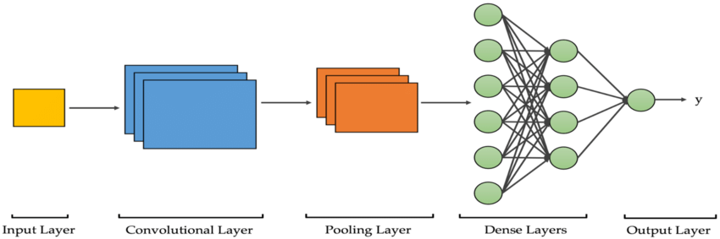
Fig 3.1 Convolutional Neural Network Architecture
The input x of each layer in a CNN model is organized in three dimensions: height, width, and depth, or , where the height (m) is equal to the width. The depth is also referred to as the channel number. For example, in an RGB image, the depth (r) is equal to three. Several kernels (filters) available in each convolutional layer are denoted by k and also have three dimensions (n × n × q), similar to the input image; here, however, n must be smaller than m, while q is either equal to or smaller than r. In addition, the kernels are the basis of the local connections, which share similar parameters (bias b^{k} and weight W^{k} ) for generating k feature maps h^{k} with a size of (m − n − 1) each and are convolved with input, as mentioned above. The convolution layer calculates a dot product between its input and the weights , similar to NLP, but the inputs are undersized areas of the initial image size. Next, by applying the nonlinearity or an activation function to the convolution-layer output, we obtain the following:
hk = f (W k ∗ x + bk )
The next step is down-sampling every feature map in the sub-sampling layers. This leads to a reduction in the network parameters, which accelerates the training process and in turn enables handling of the overfitting issue. For all feature maps, the pooling function (e.g. max or average) is applied to an adjacent area of size p × p, where p is the kernel size. Finally, the FC layers receive the mid- and low-level features and create the high-level abstraction, which represents the last-stage layers as in a typical neural net- work. The classification scores are generated using the ending layer [e.g. support vector machines (SVMs) or softmax]. For a given instance, every score represents the probability of a specific class.
Benefits of employing CNNs
The benefits of using CNNs over other traditional neural networks in the computer vision environment are listed as follows:
1. The main reason to consider CNN is the weight sharing feature, which reduces the number of trainable network parameters and in turn helps the network to enhance generalization and to avoid overfitting.
2. Concurrently learning the feature extraction layers and the classification layer causes the model output to be both highly organized and highly reliant on the extracted features.
3. Large-scale network implementation is much easier with CNN than with other neural networks.
CNN layers
The CNN architecture consists of a number of layers (or so-called multi-building blocks). Each layer in the CNN architecture, including its function, is described in detail below.
1. Convolutional Layer
In CNN architecture, the most significant component is the convolutional layer. It consists of a collection of convolutional filters (so-called ker- nels). The input image, expressed as N-dimensional metrics, is convolved with these filters to generate the output feature map.
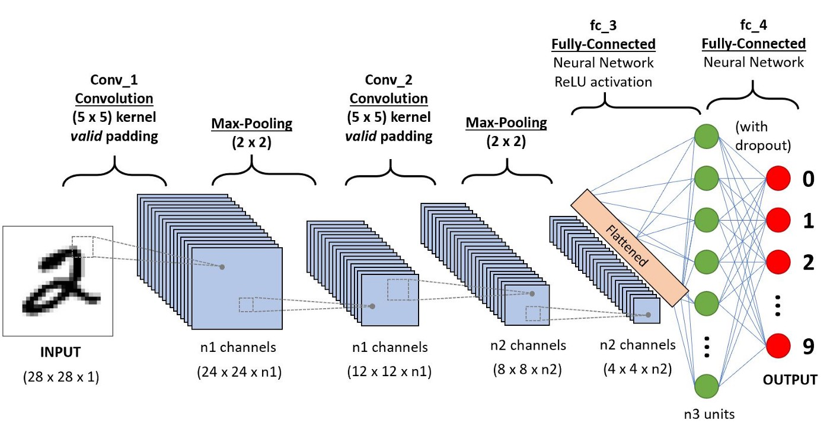
Fig 3.2 Convolutional layer
- Kernel definition: A grid of discrete numbers or values describes the kernel. Each value is called the kernel weight. Random numbers are assigned to act as the weights of the kernel at the beginning of the CNN training process. In addition, there are several different methods used to initialize the weights. Next, these weights are adjusted at each training era; thus, the kernel learns to extract significant features.
- Convolutional Operation: Initially, the CNN input format is described. The vector format is the input of the traditional neural network, while the multi- channeled image is the input of the CNN. For instance, single-channel is the format of the gray-scale image, while the RGB image format is three-channeled. To understand the convolutional operation, let us take an example of a 4 × 4gray-scale image with a 2 × 2 random weight-initialized kernel. First, the kernel slides over the whole image horizontally and vertically. In addition, the dot product between the input image and the kernel is determined, where their corresponding values are multiplied and then summed up to create a single scalar value, calculated concurrently. The whole process is then repeated until no further sliding is possible. Note that the calculated dot product values represent the feature map of the output. Figure 8 graphically illustrates the primary calculations executed at each step. In this figure, the light green color represents the 2 × 2 kernel, while the light blue color represents the similar size area of the input image. Both are multiplied; the end result after summing up the resulting product values (marked in a light orange color) represents an entry value to the output feature map.
However, padding to the input image is not applied in the previous example, while a stride of one (denoted for the selected step-size over all vertical or horizontal locations) is applied to the kernel. Note that it is also possible to use another stride value. In addition, a feature map of lower dimensions is obtained as a result of increasing the stride value.
On the other hand, padding is highly significant to determining border size information related to the input image. By contrast, the border side-features moves carried away very fast. By applying padding, the size of the input image will increase, and in turn, the size of the output feature map will also increase. Core Benefits of Convolutional Layers.
- Sparse Connectivity: Each neuron of a layer in FC neural networks links with all neurons in the following layer. By contrast, in CNNs, only a few weights are available between two adjacent layers. Thus, the number of required weights or connections is small, while the memory required to store these weights is also small; hence, this approach is memory-effective. In addition, matrix operation is computationally much more costly than the dot (.) operation in CNN.
- Weight Sharing: There are no allocated weights between any two neurons of neighboring layers in CNN, as the whole weights operate with one and all pixels of the input matrix. Learning a single group of weights for the whole input will significantly decrease the required training time and various costs, as it is not necessary to learn additional weights for each neuron.
2. Pooling Layer
The main task of the pooling layer is the sub-sampling of the feature maps. These maps are generated by following the convolutional operations. In other words, this approach shrinks large-size feature maps to create smaller feature maps. Concurrently, it maintains the majority of the dominant information (or features) in every step of the pooling stage. In a similar manner to the convolutional operation, both the stride and the kernel are initially size-assigned before the pooling operation is executed. Several types of pooling methods are available for utilization in various pooling layers. These methods include tree pooling, gated pooling, average pooling, min pooling, max pooling, global average pooling (GAP), and global max pooling. The most familiar and frequently utilized pooling methods are the max, min, and GAP pooling. Figure 3.3 illustrates these three pooling operations.
Sometimes, the overall CNN performance is decreased as a result; this represents the main shortfall of the pooling layer, as this layer helps the CNN to determine whether or not a certain feature is available in the particular input image, but focuses exclusively on ascertaining the correct location of that feature. Thus, the CNN model misses the relevant information.
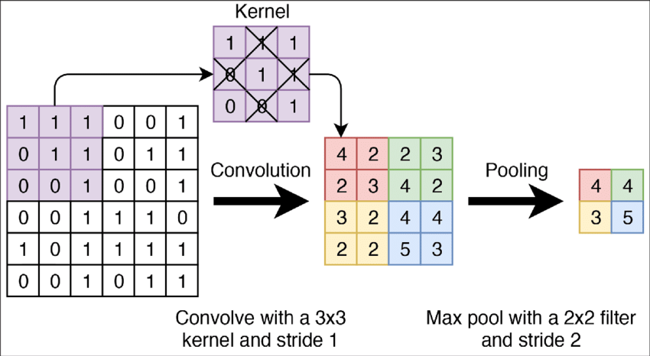
Fig. 3.3 Pooling Layer
3.Activation Function (non-linearity)
Mapping the input to the output is the core function of all types of activation function in all types of neural network. The input value is determined by computing the weighted summation of the neuron input along with its bias (if present). This means that the activation function makes the decision as to whether or not to fire a neuron with reference to a particular input by creating the corresponding output.
Non-linear activation layers are employed after all layers with weights (so-called learnable layers, such as FC layers and convolutional layers) in CNN architecture. This non-linear performance of the activation layers means that the mapping of input to output will be non-linear; moreover, these layers give the CNN the ability to learn extra-complicated things. The activation function must also have the ability to differentiate, which is an extremely significant feature, as it allows error back-propagation to be used to train the network. The following types of activation functions are most commonly used in CNN and other deep neural networks.
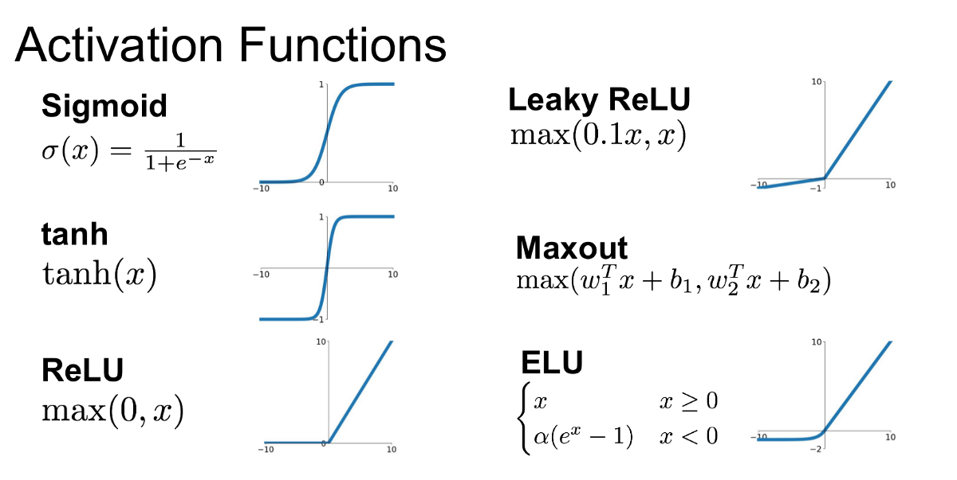
Fig. 3.4 Activation functions
• Sigmoid: The input of this activation function is real numbers, while the output is restricted to between zero and one. The sigmoid function curve is S-shaped .
• Tanh: It is similar to the sigmoid function, as its input is real numbers, but the out- put is restricted to between − 1 and 1.
• ReLU: The mostly commonly used function in the CNN context. It converts the whole values of the input to positive numbers. Lower computational load is the main benefit of ReLU over the others.
Occasionally, a few significant issues may occur during the use of ReLU. For instance, consider an error back-propagation algorithm with a larger gradient flowing through it. Passing this gradient within the ReLU function will update the weights in a way that makes the neuron certainly not activated once more. This issue is referred to as “Dying ReLU”.
4. Fully Connected Layer
Commonly, this layer is located at the end of each CNN architecture. Inside this layer, each neuron is connected to all neurons of the previous layer, the so-called Fully Connected (FC) approach. It is utilized as the CNN classifier. It follows the basic method of the conventional multiple-layer perceptron neural network, as it is a type of feed-forward ANN. The input of the FC layer comes from the last pooling or convolutional layer. This input is in the form of a vector, which is created from the feature maps after flattening. The output of the FC layer represents the final CNN output, as illustrated in Fig.
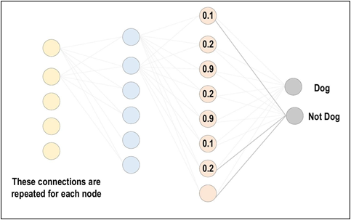
Fig. 3.5 Fully Connected Layer
5. Loss Functions
The previous section has presented various layer-types of CNN architecture. In addition, the final classification is achieved from the output layer, which represents the last layer of the CNN architecture. Some loss functions are utilized in the output layer to calculate the predicted error created across the training samples in the CNN model. This error reveals the difference between the actual out- put and the predicted one. Next, it will be optimized through the CNN learning process.
However, two parameters are used by the loss function to calculate the error. The CNN estimated output (referred to as the prediction) is the first parameter. The actual output (referred to as the label) is the second parameter. Several types of loss function are employed in various problem types. The following concisely explains some of the loss function types.
(a) Cross-Entropy or Softmax Loss Function: This function is commonly employed for measuring the CNN model performance. It is also referred to as the log loss function. Its output is the probability p ∈ {0, 1}. In addition, it is usually employed as a substitution of the square error loss function in multi-class classification problems. In the output layer, it employs the softmax activations to generate the output within a probability distribution.
(b) Euclidean Loss Function: This function is widely used in regression problems. In addition, it is also the so-called mean square error.
(c) Hinge Loss Function: This function is commonly employed in problems related to binary classification. This problem relates to maximum-margin-based classification; this is mostly important for SVMs, which use the hinge loss function, wherein the optimizer attempts to maximize the margin around dual objective classes.The margin m is commonly set to 1.
Regularization to CNN
For CNN models, over-fitting represents the central issue associated with obtaining well-behaved generalization. The model is entitled over-fitted in cases where the model executes especially well on training data and does not succeed on test data (unseen data) which is more explained in the latter section. An under-fitted model is the opposite; this case occurs when the model does not learn a sufficient amount from the training data. The model is referred to as “just-fitted” if it executes well on both training and testing data. These three types are illustrated in Fig. 3.6
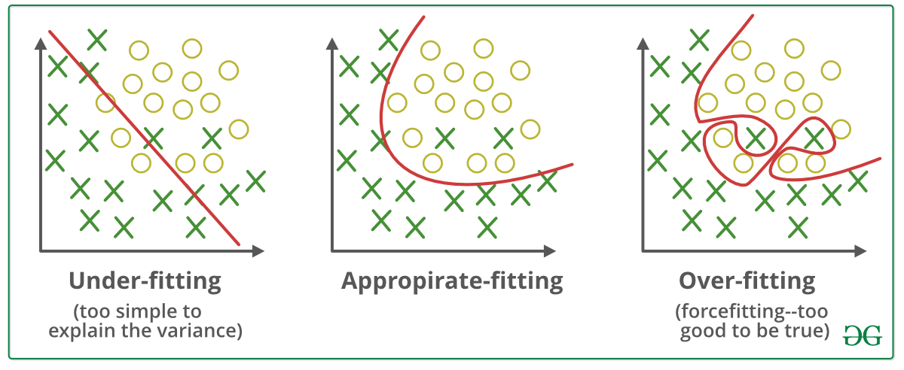Fig. 3.6 Under-fitting and Over-fitting issues
1. Dropout: This is a widely utilized technique for generalization. During each training epoch, neurons are randomly dropped. In doing this, the feature selection power is distributed equally across the whole group of neurons, as well as forcing the model to learn different independent features. During the training process, the dropped neuron will not be a part of back-propagation or forward-propagation. By contrast, the full-scale network is utilized to perform prediction during the testing process.
2. Drop-Weights: This method is highly similar to dropout. In each training epoch, the connections between neurons (weights) are dropped rather than dropping the neurons; this represents the only difference between drop-weights and dropout.
3. Data Augmentation: Training the model on a sizeable amount of data is the easiest way to avoid over-fitting. To achieve this, data augmentation is used. Several techniques are utilized to artificially expand the size of the training dataset. More details can be found in the latter section, which describes the data augmentation techniques.
4. Batch Normalization: This method ensures the performance of the output activations . This performance follows a unit Gaussian distribution. Subtracting the mean and dividing by the standard deviation will normalize the output at each layer. While it is possible to consider this as a pre-processing task at each layer in the network, it is also possible to differentiate and to integrate it with other networks. In addition, it is employed to reduce the “internal covariance shift” of the activation layers. In each layer, the variation in the activation distribution defines the internal covariance shift. This shift becomes very high due to the continuous weight updating through training, which may occur if the samples of the training data are gathered from numerous dissimilar sources (for example, day and night images). Thus, the model will consume extra time for convergence, and in turn, the time required for training will also increase. To resolve this issue, a layer representing the operation of batch normalization is applied in the CNN architecture.
The advantages of utilizing batch normalization are as follows:
• It prevents the problem of vanishing gradient from arising.
• It can effectively control the poor weight initialization.
• It significantly reduces the time required for network convergence (for large-scale datasets, this will be extremely useful).
• It struggles to decrease training dependency across hyper-parameters.
• Chances of over-fitting are reduced, since it has a minor influence on regularization.

CHAPTER 4
TOOLS AND TECHNOLOGIES

4.1 What is Python?
4.1.1 Introduction
Python is a general purpose, dynamic, high-level, and interpreted programming language. It supports Object Oriented programming approach to develop applications. It is simple and easy to learn and provides lots of high-level data structures. Python is easy to learn yet powerful and versatile scripting language, which makes it attractive for Application Development.
Python's syntax and dynamic typing with its interpreted nature make it an ideal language for scripting and rapid application development. Python supports multiple programming pattern, including object-oriented, imperative, and functional or procedural programming styles. Python's syntax and dynamic typing with its interpreted nature make it an ideal language for scripting and rapid application development. Python is not intended to work in a particular area, such as web programming. That is why it is known as multipurpose programming language because it can be used with web, enterprise, 3D CAD, etc. They don't need to use data types to declare variable because it is dynamically typed so can be written as a=10 to assign an integer value in an integer variable.
Python makes the development and debugging fast because there is no compilation step included in Python development, and edit-test-debug cycle is very fast.

Applications of Python
There are so many applications of Python, here are some of the them.
- Web development : Web framework like Django and Flask are based on Python. They help us to write server side code which helps us to manage database, write backend programming logic, mapping urls etc.
- Machine learning : There are many machine learning applications written in Python. Machine learning is a way to write a logic so that a machine can learn and solve a particular problem on its own.
- Data Analysis : Data analysis and data visualisation in form of charts can also be developed using Python.
- Scripting : Scripting is writing small programs to automate simple tasks such as sending automated response emails etc. Such type of applications can also be written in Python programming language.
- Game development : Games can be develop using Python.
- Embedded applications can be develop in Python.
- Desktop applications : Desktop application can be develop in Python using library like TKinter or QT.

4.1.2 Python Idle
IDLE (short for integrated development environment or integrated development and learning environment) is an integrated development environment for Python. It is packaged as an optional part of the Python packaging with many Linux distributions. It is completely written in Python and the Tkinter GUI toolkit (wrapper functions for Tcl/Tk). IDLE allows user to create, read, edit and execute the programs under the same roof without touching the command line. It can also access Python Shell from IDLE.
Its main features are:
- Multi-window text editor with syntax highlighting, auto completion, smart indent and other.
- Python shell with syntax highlighting.
- Integrated debugger with stepping, persistent breakpoints, and call stack visibility.
IDLE has been criticized for various usability issues, including losing focus, lack of copying to clipboard feature, lack of line numbering options, and general user interface design; it has been called a "disposable" IDE, because users frequently move on to a more advanced IDE as they gain experience.

4.1.3 Python Features
- Readable : Python is a very readable language.
- Easy to Learn : Learning python is easy as this is a expressive and high level programming language, which means it is easy to understand the language and thus easy to learn.
- Cross platform : Python is available and can run on various operating systems such as Mac, Windows, Linux, Unix etc. This makes it a cross platform and portable language.
- Open Source : Python is a open source programming language.
- Large standard library : Python comes with a large standard library that has some handy codes and functions which can use while writing code in Python.
- Free: Python is free to download and use. Python is an example of a FLOSS (Free/Libre Open Source Software), which means it can be freely distribute copies of this software, read its source code and modify it.
- Supports exception handling : If someone are new, it may wonder what is an exception? An exception is an event that can occur during program exception and can disrupt the normal flow of program. Python supports exception handling which means can write less error prone code and can test various scenarios that can cause an exception later on.
- Advanced features : Supports generators and list comprehensions.
- Automatic memory management : Python supports automatic memory management which means the memory is cleared and freed automatically. Do not have to bother clearing the memory.

4.2 Jupyter Notebook
The Jupyter Notebook is an open source web application that can use to create and share documents that contain live code, equations, visualizations, and text. Jupyter Notebook is maintained by the people at Project Jupyter. Jupyter Notebooks are a spin-off project from the IPython project, which used to have an IPython Notebook project itself. The name, Jupyter, comes from the core supported programming languages that it supports: Julia, Python, and R. Jupyter ships with the IPython kernel, which allows us to write programs in Python, but there are currently over 100 other kernels that can also use.

4.2.1 Components
The Jupyter Notebook combines three components:
- The notebook web application: An interactive web application for writing and running code interactively and authoring notebook documents.
- Kernels: Separate processes started by the notebook web application that runs users‟ code in a given language and returns output back to the notebook web application. The kernel also handles things like computations for interactive widgets, tab completion and introspection.
- Notebook documents: Self-contained documents that contain a representation of all content visible in the notebook web application, including inputs and outputs of the computations, narrative text, equations, images, and rich media representations of objects. Each notebook document has its own kernel.
4.2.2 Advantages of Jupyter Notebook
There are the following advantages of Jupyter Notebook
1. All in one place: As you know, Jupyter Notebook is an open-source webbased interactive environment that combines code, text, images, videos, mathematical equations, plots, maps, graphical user interface and widgets to a single document.
2. Easy to convert: Jupyter Notebook allows users to convert the notebooks into other formats such as HTML and PDF. It also uses online tools and nbviewer which allows you to render a publicly available notebook in the browser directly.
3. Easy to share: Jupyter Notebooks are saved in the structured text files (JSON format), which makes them easily shareable.
4. Language independent: Jupyter Notebook is platform-independent because it is represented as JSON (JavaScript Object Notation) format, which is a languageindependent, text-based file format. Another reason is that the notebook can be processed by any programing language, and can be converted to any file formats such as Markdown, HTML, PDF, and others.
5. Interactive code: Jupyter notebook uses ipywidgets packages, which provide many common user interfaces for exploring code and data interactivity.
4.3 Pandas
Pandas is an open-source Python Library providing high-performance data manipulation and analysis tool using its powerful data structures. The name Pandas is derived from the word Panel Data – an Econometrics from Multidimensional data. In 2008, developer Wes McKinney started developing pandas when in need of high performance, flexible tool for analysis of data.
Prior to Pandas, Python was majorly used for data munging and preparation. It had very little contribution towards data analysis. Pandas solved this problem. Using Pandas, there are five typical steps in the processing and analysis of data, regardless of the origin of data load, prepare, manipulate, model, and analyze.
Python with Pandas is used in a wide range of fields including academic and commercial domains including finance, economics, Statistics, analytics, etc.

4.3.1 Features of Pandas
- Fast and efficient DataFrame object with default and customized indexing.
- Tools for loading data into in-memory data objects from different file formats.
- Data alignment and integrated handling of missing data.
- Reshaping and pivoting of date sets.
- Label-based slicing, indexing and subsetting of large data sets.
- Columns from a data structure can be deleted or inserted.
- Group by data for aggregation and transformations.
- High performance merging and joining of data.
- Time Series functionality.

4.4 Scikit-learn
Scikit-learn is an open source Python library that implements a range of machine learning, pre-processing, cross-validation and visualization algorithms using a unified interface.
Important features of scikit-learn:
- Simple and efficient tools for data mining and data analysis. It features various classification, regression and clustering algorithms including support vector machines, random forests, gradient boosting, k-means, etc.
- Accessible to everybody and reusable in various contexts.
- Built on the top of NumPy, SciPy, and matplotlib.
- Open source, commercially usable – BSD license.

4.5 Keras
Keras is a deep learning API written in Python, running on top of the machine learning platform TensorFlow. It was developed with a focus on enabling fast experimentation. .
Keras is:
- Simple -- but not simplistic. Keras reduces developer cognitive load to free you to focus on the parts of the problem that really matter.
- Flexible -- Keras adopts the principle of progressive disclosure of complexity: simple workflows should be quick and easy, while arbitrarily advanced workflows should be possible via a clear path that builds upon what you've already learned.
- Powerful -- Keras provides industry-strength performance and scalability: it is used by organizations and companies including NASA, YouTube, or Waymo.
Keras combines four key abilities:
- Efficiently executing low-level tensor operations on CPU, GPU, or TPU.
- Computing the gradient of arbitrary differentiable expressions.
- Scaling computation to many devices, such as clusters of hundreds of GPUs.
- Exporting programs ("graphs") to external runtimes such as servers, browsers, mobile and embedded devices.
Keras is the high-level API of TensorFlow 2: an approachable, highly-productive interface for solving machine learning problems, with a focus on modern deep learning. It provides essential abstractions and building blocks for developing and shipping machine learning solutions with high iteration velocity.
4.6 HTML
HTML is an acronym which stands for Hyper Text Markup Language which is used for creating web pages and web applications. Let's see what is meant by Hypertext Markup Language, and Web page.
Hyper Text: HyperText simply means "Text within Text." A text has a link within it, is a hypertext. Whenever you click on a link which brings you to a new webpage, you have clicked on a hypertext. HyperText is a way to link two or more web pages (HTML documents) with each other.
Markup language: A markup language is a computer language that is used to apply layout and formatting conventions to a text document. Markup language makes text more interactive and dynamic. It can turn text into images, tables, links, etc.
Web Page: A web page is a document which is commonly written in HTML and translated by a web browser. A web page can be identified by entering an URL. A Web page can be of the static or dynamic type. With the help of HTML only, we can create static web pages.
Hence, HTML is a markup language which is used for creating attractive web pages with the help of styling, and which looks in a nice format on a web browser. An HTML document is made of many HTML tags and each HTML tag contains different content.
<!DOCTYPE>: It defines the document type or it instruct the browser about the version of HTML.
<html > :This tag informs the browser that it is an HTML document. Text between html tag describes the web document. It is a container for all other elements of HTML except <!DOCTYPE>
<head>: It should be the first element inside the <html> element, which contains the metadata(information about the document). It must be closed before the body tag opens.
<title>: As its name suggested, it is used to add title of that HTML page which appears at the top of the browser window. It must be placed inside the head tag and should close immediately. (Optional)
<body> : Text between body tag describes the body content of the page that is visible to the end user. This tag contains the main content of the HTML document.
<h1> : Text between <h1> tag describes the first level heading of the webpage
<p> : Text between <p> tag describes the paragraph of the webpage.
HTML5 is the newest version of HyperText Markup language. The first draft of this version was announced in January 2008. There are two major organizations one is W3C (World Wide Web Consortium), and another one is WHATWG( Web Hypertext Application Technology Working Group) which are involved in the development of HTML 5 version, and still, it is under development.
4.7 Cascading Style Sheet
Cascading Style Sheet is a style sheet language which is used to describe the look and formatting of a document written in markup language. It provides an additional feature to HTML. It is generally used with HTML to change the style of web pages and user interfaces. It can also be used with any kind of XML documents including plain XML, SVG and XUL. CSS is used along with HTML and JavaScript in most websites to create user interfaces for web applications and user interfaces for many mobile applications.
A CSS rule set contains a selector and a declaration block.
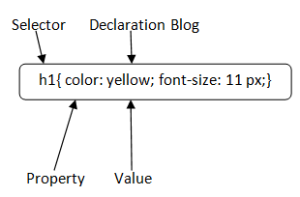
Selector: Selector indicates the HTML element you want to style. It could be any tag like <h1>, <title> etc.
Declaration Block: The declaration block can contain one or more declarations separated by a semicolon. For the above example, there are two declarations:
- color: yellow;
- font-size: 11 px;
Each declaration contains a property name and value, separated by a colon.
Property: A Property is a type of attribute of HTML element. It could be color, border etc.
Value: Values are assigned to CSS properties. In the above example, value "yellow" is assigned to color property.
Selector{Property1: value1; Property2: value2; ..........;}
CSS is added to HTML pages to format the document according to information in the style sheet. There are three ways to insert CSS in HTML documents.
- Inline CSS
- Internal CSS
- External CSS
4.8 JavaScript
JavaScript (js) is a light-weight object-oriented programming language which is used by several websites for scripting the webpages. It is an interpreted, full-fledged programming language that enables dynamic interactivity on websites when applied to an HTML document. It was introduced in the year 1995 for adding programs to the webpages in the Netscape Navigator browser. Since then, it has been adopted by all other graphical web browsers. With JavaScript, users can build modern web applications to interact directly without reloading the page every time. The traditional website uses js to provide several forms of interactivity and simplicity.
Although, JavaScript has no connectivity with Java programming language. The name was suggested and provided in the times when Java was gaining popularity in the market. In addition to web browsers, databases such as CouchDB and MongoDB uses JavaScript as their scripting and query language.
Features of JavaScript
- All popular web browsers support JavaScript as they provide built-in execution environments.
- JavaScript follows the syntax and structure of the C programming language. Thus, it is a structured programming language.
- JavaScript is a weakly typed language, where certain types are implicitly cast (depending on the operation).
- JavaScript is an object-oriented programming language that uses prototypes rather than using classes for inheritance.
- It is a light-weighted and interpreted language.
- It is a case-sensitive language.
- JavaScript is supportable in several operating systems including, Windows, macOS, etc.
- It provides good control to the users over the web browsers.

Parallax Effect
Parallax scrolling is a web site trend where the background content (i.e. an image) is moved at a different speed than the foreground content while scrolling. Parallax scrolling is a web design technique in which the website background moves at a slower pace than the foreground. This results in a 3D effect as visitors scroll down the site, adding a sense of depth and creating a more immersive browsing experience. Parallax is based on optical illusion. Since the human eye perceives objects that are close to us as larger than things farther away, we perceive distant objects as if they were moving more slowly.
4.9 Open CV
Computer vision is a process by which we can understand the images and videos how they are stored and how we can manipulate and retrieve data from them. Computer Vision is the base or mostly used for Artificial Intelligence. Computer-Vision is playing a major role in self-driving cars, robotics as well as in photo correction apps.
OpenCV
OpenCV is the huge open-source library for the computer vision, machine learning, and image processing and now it plays a major role in real-time operation which is very important in today’s systems. By using it, one can process images and videos to identify objects, faces, or even handwriting of a human. When it integrated with various libraries, such as NumPy, python is capable of processing the OpenCV array structure for analysis. To Identify image pattern and its various features we use vector space and perform mathematical operations on these features.
Applications of OpenCV: There are lots of applications which are solved using OpenCV, some of them are listed below
- Digit and face recognition
- Automated inspection and surveillance
- number of people – count (foot traffic in a mall, etc)
- Vehicle counting on highways along with their speeds
- Interactive art installations
- Anamoly (defect) detection in the manufacturing process (the odd defective products)
- Street view image stitching
- Video/image search and retrieval
- Robot and driver-less car navigation and control
- object recognition
- Medical image analysis
- Movies – 3D structure from motion
- TV Channels advertisement recognition

CHAPTER 5
DESIGN AND IMPLEMENTATION

It represents a description about the machine learning algorithm that is undertaken. It consists of various milestones that need to be achieved in order to fulfil the objective. This project undertaken different classification methods and machine learning algorithms.

5.1 Data collection
The MNIST database contains 60,000 training images and 10,000 testing images. Half of the training set and half of the test set were taken from NIST's training dataset, while the other half of the training set and the other half of the test set were taken from NIST's testing dataset. The original creators of the database keep a list of some of the methods tested on it. In their original paper, they use a support-vector machine to get an error rate of 0.8%. An extended dataset similar to MNIST called EMNIST has been published in 2017, which contains 240,000 training images, and 40,000 testing images of handwritten digits and characters.
5.2 Dataset creation
The MNIST database was constructed from NIST's Special Database 3 and Special Database 1 which contain binary images of handwritten digits. NIST originally designated SD-3 as their training set and SD-1 as their test set. However, SD-3 is much cleaner and easier to recognize than SD-1. The reason for this can be found on the fact that SD-3 was collected among Census Bureau employees, while SD-1 was collected among high-school students. Drawing sensible conclusions from learning experiments requires that the result be independent of the choice of training set and test among the complete set of samples. Therefore it was necessary to build a new database by mixing NIST's datasets.
5.3 Data analysis
Before applying any model to our dataset, we need to find out characteristics of our dataset. Thus, we need to analyse our dataset and study the different parameters and relationship between these parameters. The datasets are shown in Fig. 5.3.1 below.
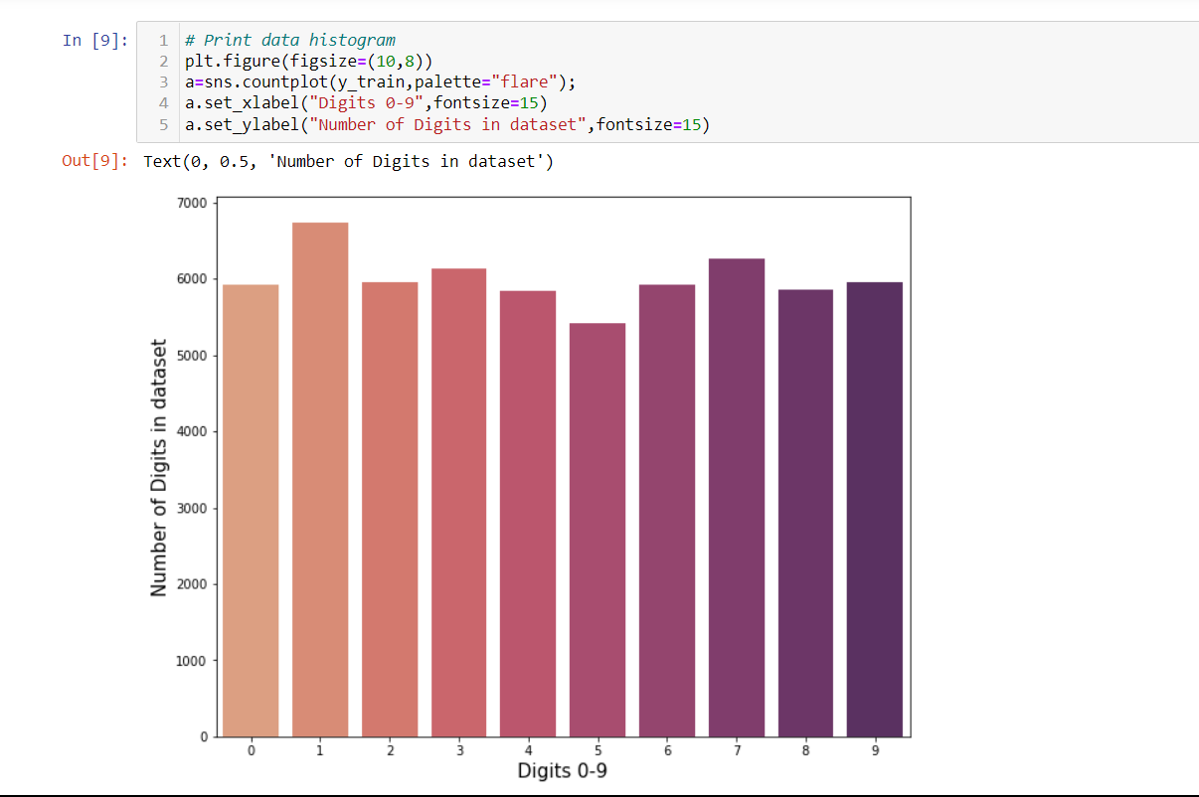
Fig 5.3.1 Graphical representation of Dataset
5.4 Data pre-processing
The available data was divided into training set and test data. 63% of the data was used for the training set. The data is cleaned as all the NA are replaced by 0.0. Different graphs are plotted to study the distribution of data. The rating is important in order make the better classification. The study of the plots is done in order to choose better approach.
5.5 Dataflow Diagram
The following Fig. describes the Data flow diagram of the proposed system model. There are two ways to provide input to the system. The user can either upload the image of the digit he wants to detect or the data from the MNIST dataset. The input images are pre-processed. Using the different classifiers the recognized digits’ accuracy is compared and the result is obtained. The results obtained are displayed along with the accuracy.
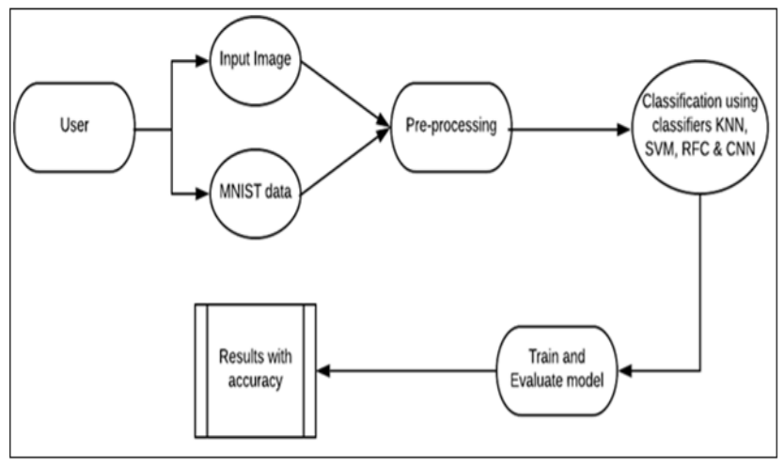

Fig. 5.2 Dataflow Diagram of the system model

5.6 Convolutional Neural Networks (CNN)
- Applications of CNN
Simple applications of CNNs which we can see in everyday life are obvious choices, like facial recognition software, image classification, speech recognition programs, etc. These are terms which we, as laymen, are familiar with, and comprise a major part of our everyday life, especially with image-savvy social media networks like Instagram. Some of the key applications of CNN are listed here -
- Decoding Facial Recognition
Facial recognition is broken down by a convolutional neural network into the following major components -
  - Identifying every face in the picture
  - Focusing on each face despite external factors, such as light, angle, pose, etc.
  - Identifying unique features
  - Comparing all the collected data with already existing data in the database to match a face with a name.
A similar process is followed for scene labeling as well.
- Analyzing Documents
Convolutional neural networks can also be used for document analysis. This is not just useful for handwriting analysis, but also has a major stake in recognizers. For a machine to be able to scan an individual's writing, and then compare that to the wide database it has, it must execute almost a million commands a minute. It is said with the use of CNNs and newer models and algorithms, the error rate has been brought down to a minimum of 0.4% at a character level, though it's complete testing is yet to be widely seen.
- Historic and Environmental Collections
CNNs are also used for more complex purposes such as natural history collections. These collections act as key players in documenting major parts of history such as biodiversity, evolution, habitat loss, biological invasion, and climate change.
- Understanding Climate
CNNs can be used to play a major role in the fight against climate change, especially in understanding the reasons why we see such drastic changes and how we could experiment in curbing the effect. It is said that the data in such natural history collections can also provide greater social and scientific insights, but this would require skilled human resources such as researchers who can physically visit these types of repositories. There is a need for more manpower to carry out deeper experiments in this field.
- Grey Areas
Introduction of the grey area into CNNs is posed to provide a much more realistic picture of the real world. Currently, CNNs largely function exactly like a machine, seeing a true and false value for every question. However, as humans, we understand that the real world plays out in a thousand shades of grey. Allowing the machine to understand and process fuzzier logic will help it understand the grey area us humans live in and strive to work against. This will help CNNs get a more holistic view of what human sees.
- Advertising
CNNs have already brought in a world of difference to advertising with the introduction of programmatic buying and data-driven personalized advertising.
- Other Interesting Fields
CNNs are poised to be the future with their introduction into driverless cars, robots that can mimic human behaviour, aides to human genome mapping projects, predicting earthquakes and natural disasters, and maybe even self-diagnoses of medical problems. So, you wouldn't even have to drive down to a clinic or schedule an appointment with a doctor to ensure your sneezing attack or high fever is just the simple flu and not symptoms of some rare disease. One problem that researchers are working on with CNNs is brain cancer detection. The earlier detection of brain cancer can prove to be a big step in saving more lives affected by this illness.
5.7 External Interface Requirements
The external interface requirements are classified into two categories such as
5.8.1 Hardware Requirements
1. Pentium-IV (Processor).
2. 256 MB Ram
3. 512 KB Cache Memory
4. Hard disk 10 GB
5. Microsoft Compatible 101 or more Key Board

5.8.2 Software Requirements
1. Operating System : Windows

CHAPTER 6
RESULTS AND DISCUSSIONS
In this chapter, the various results of execution are shown. When the system runs
the program, the following screens are displayed. All the preparation had been done and the testing was performed according to the various types of input provided and got outputs. Various inputs lead to the unique outputs.

6.1 Data Set
To recognize the handwritten digits, a seven-layered convolutional neural network with one input layer followed by five hidden layers and one output layer is designed and illustrated.
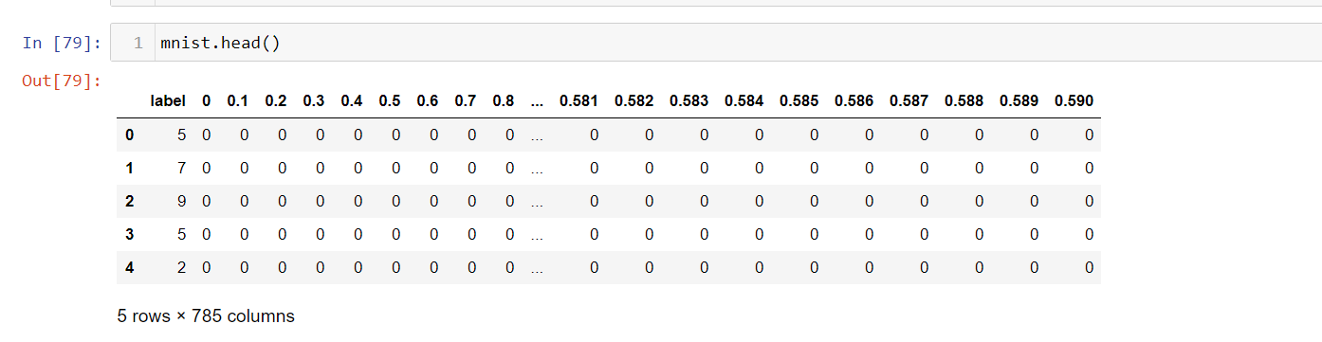
The input layer consists of 28 by 28-pixel images which mean that the network contains 784 neurons as input data. The first hidden layer is the convolution layer 1 which is responsible for feature extraction from an input data. The next hidden layer is the pooling layer 1. A fully connected layer is another hidden layer also known as the dense layer. The output layer of the network consists of ten neurons and determines the digits numbered from 0 to 9.

Fig 6.1 Exploring Mnist Dataset

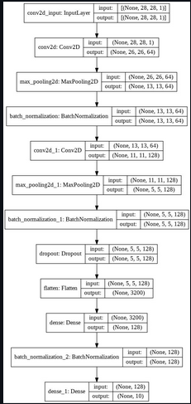
Fig 6.2 Different layer of model
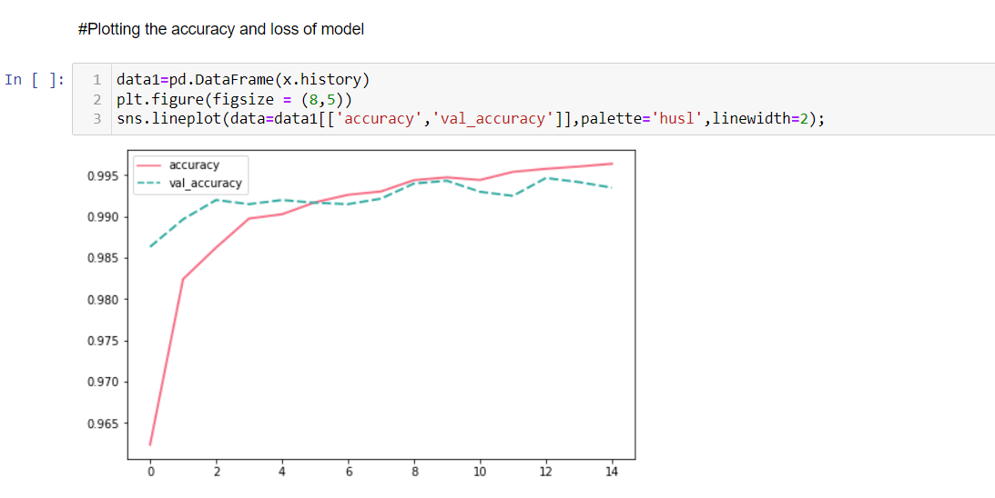
Fig. 6.3 Plotting the accuracy and loss of model

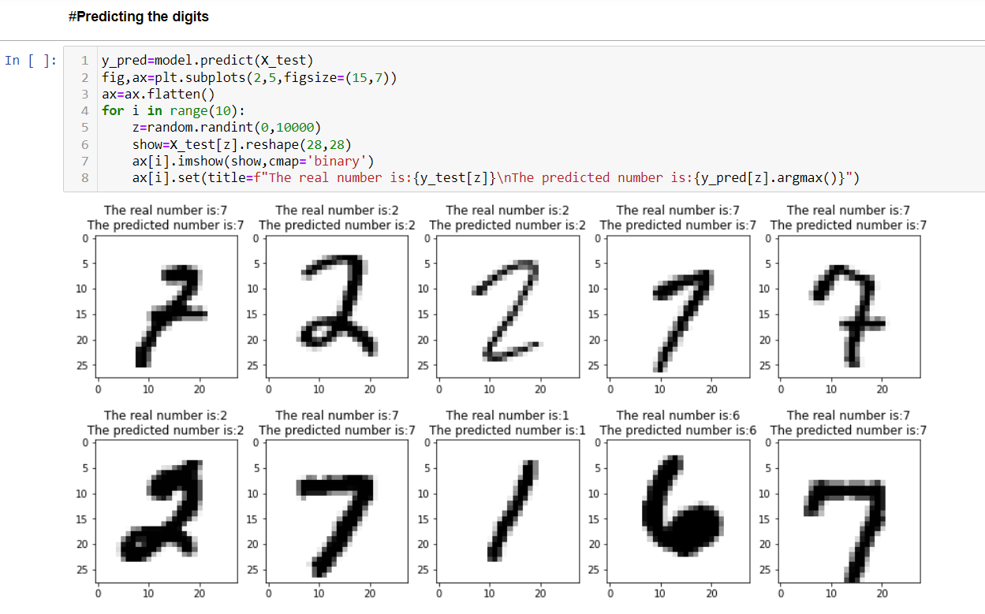
Fig 6.4 Prediction of Digits
6.2 Execution
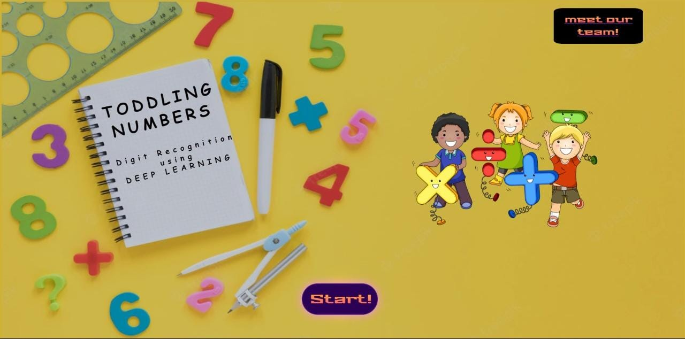
On deploying the project at Github ,the homescreen of the project will be seen as follows in Fig 6.5 which comprises of two buttons . on clicking “start” button , the page will be redirected to main page of project and clicking “ meet our team” button ,then will be redirected to another page that will show details of project guide and team members.

Fig. 6.5 Screenshot 1

Fig. 6.6 illustarates the main page of the project.

Fig 6.6 Screenshot 2

User will have to draw the answer digit of the given equation which is demonstrated in fig. 6.7


Fig. 6.7 Screenshot 3

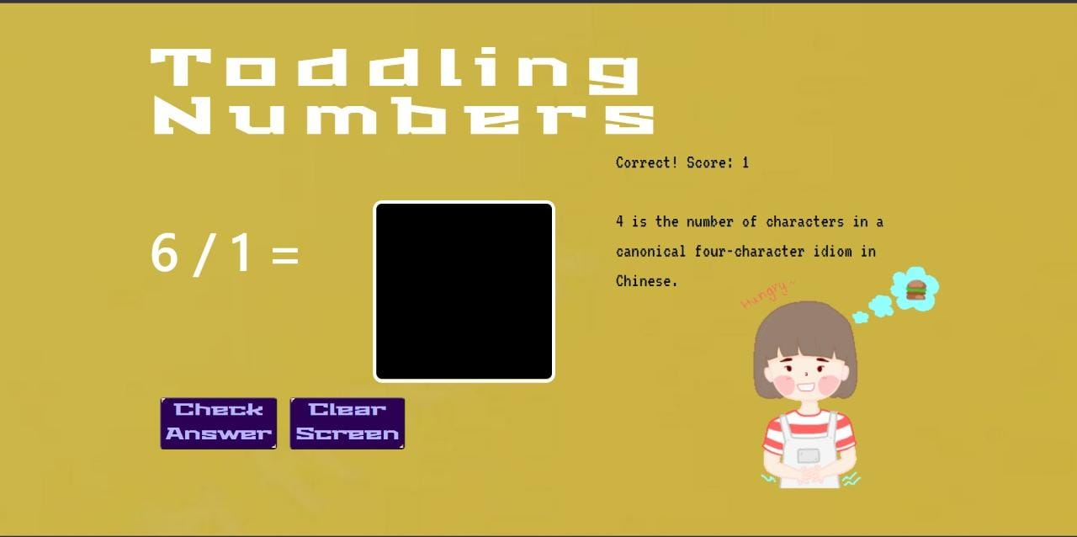
On drawing the answer digit ,deep learning model will also predicts the answer for the equation ,if both the answers are same then the user will credited one score which is shown in fig 6.8

Fig. 6.8 Screenshot 4

On each correct answer the score will be updated by one which is shown in fig 6.9
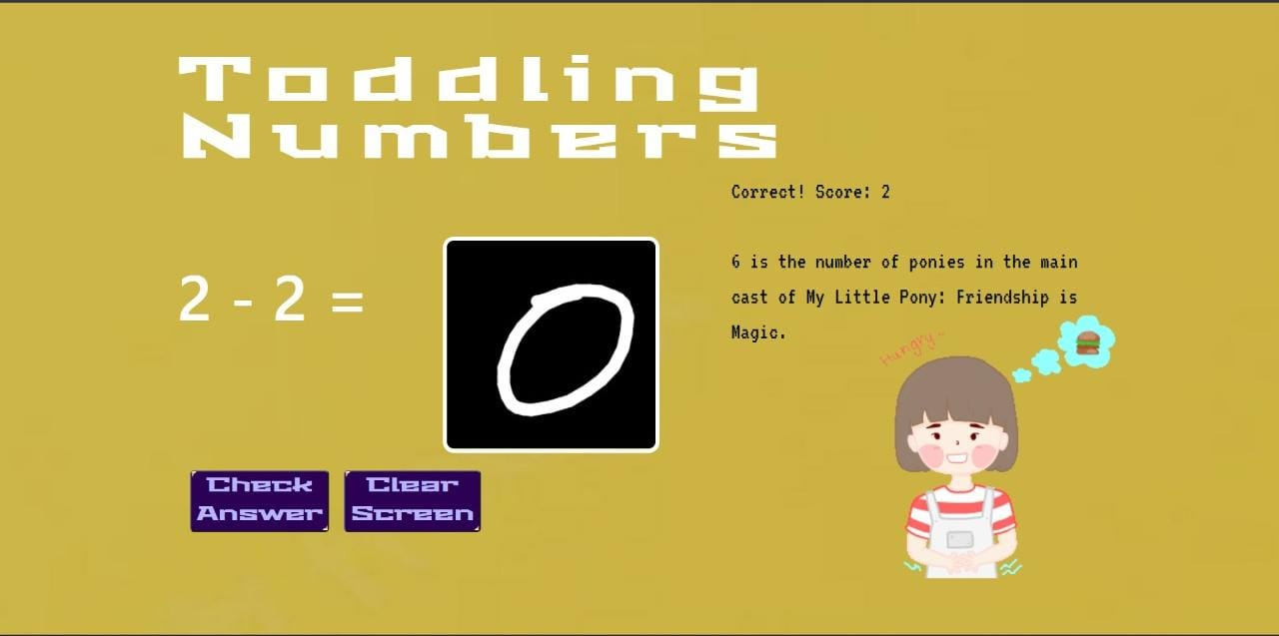
Fig. 6.9 Screenshot 5
If the user draw wrong answer then the pop-up will display which is shown in fig. 6.10
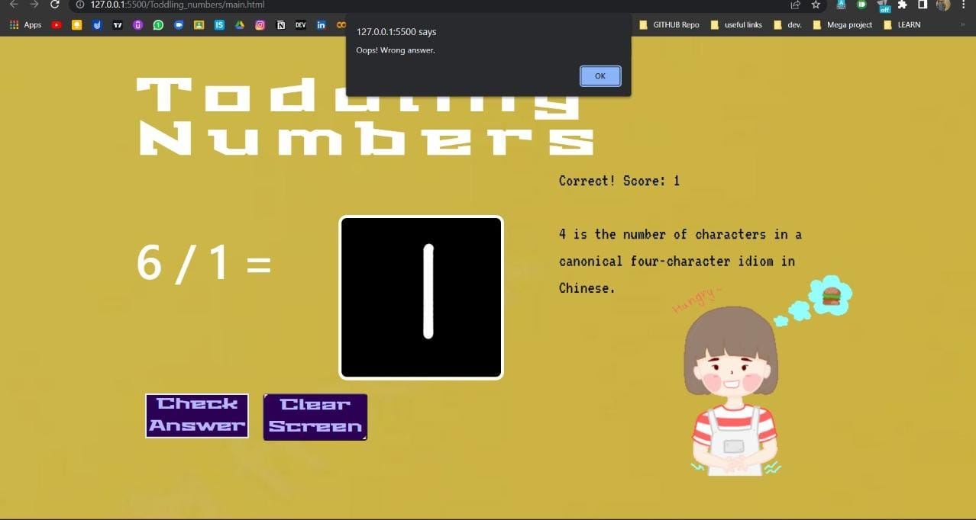
Fig. 6.10 Screenshot 6

CHAPTER 7
CONCLUSION
Here we demonstrate a model which can recognize handwritten digit. Later it can be extended for character recognition and real-time person’s handwriting. Handwritten digit recognition is the first step to the vast field of Artificial Intelligence and Computer Vision. As seen from the results of the experiment, CNN proves to be far better than other classifiers. The results can be made more accurate with more convolution layers and more number of hidden neurons. It can completely abolish the need for typing. Digit recognition is an excellent prototype problem for learning about neural networks and it gives a great way to develop more advanced techniques of deep learning. In future, we are planning to develop a real-time handwritten digit recognition system.
In result we tend to aim to match the potency of the classifiers. The results are shown in the table below
Algorithm Name | Trained Data Accuracy (%) | Testing Data Accuracy (%)
KNN | 97.1 | 96.8
CNN | 99.4 | 98.33
Table 1. Comparison of different machine learning models

7.1 Limitations of the Study
- CNN do not encode the position and orientation of object.
- Lack of ability to be spatially invariant to the input data.
- Lots of training data is required.

7.2 Future scope of work
This model proved to be CNN with the accuracy the highest training and testing accuracy of 99.4% and 98.33% We have shown a version of CNN that can identify handwritten digits. Further convolution and secret layers can make the results further reliable. Handwritten digit recognition is an excellent experimental problem for learning about neural networks and it provides an excellent way to improve more sophisticated deep learning techniques. It can be expanded in the future to character recognition, handwriting in real time, reading computerized bank check numbers, signature authentication, interpretation of postal addresses, etc.

Reference
- K. Gaurav and Bhatia P. K., “Analytical Review of Preprocessing Techniques for Offline Handwritten Character Recognition”, 2nd International Conference on Emerging Trends in Engineering & Management, ICETEM, 2013
- Walid, R. and A. Lasfar. Handwritten digit recognition using sparse deep architectures. in Intelligent Systems: Theories and Applications (SITA-14), 2014 9th International Conference on. 2014. IEEE.
- Laith Alzubaidi, Review of deep learning: concepts, CNN architectures, challenges, applications, future directions, 2021.
- Bouchain, D., Character recognition using convolutional neural networks. Institute for Neural Information Processing, 2006. 2007.
- Saabni R., Recognizing handwritten single digits and digit strings using deep architecture of neural networks in Artificial Intelligence and Pattern Recognition (AIPR), International Conference on. 2016. IEEE.
- Nimisha Jain, Kumar Rahul, Ipshita Khamaru. AnishKumar Jha, Anupam Ghosh (2017). “Hand Written Digit Recognition using Convolutional Neural Network (CNN)”, International Journal of Innovations & Advancement in Computer Science, IJIACS,ISSN 2347 – 8616,Volume 6, Issue 5.
- Haider A. Alwzwazy1, Hayder M. Albehadili2, Younes S. Alwan3, Naz E. Islam4, "Handwritten Digit Recognition using Convolutional Neural Networks", International Journal of Innovative Research in Computer and Communication Engineering, vol. 4, no. 2, pp. 1101-1106, 2016

PUBLICATIONS

International Journals:

- Andreas C. Müller,Sarah Guido.‘‘Introduction to Machine Learning with Python-A Guide for Data Scientists’’. O’Reilly Media, Inc., 1005 Gravenstein Highway North, Sebastopol, CA 95472 (2016). Accessed on: 19th April 2021 at 10.00 a.m.

