**Pizza Delivery App**

For Mentorship Project

By: -

Shubham (46002223)

**Table of Contents**

**1. Abstract**

**2. Technology Used**

**3. Scope**

3.1. Abstract Level Use Case Diagram

**4. Project Design**

**5. Entity Relation Diagram**

**Abstract**

This project is aimed to develop an application for Pizza delivery management. This is an integrated web-based application that contains customer and admin as users. This lets new customer to register or existing customers to sign in and proceed with ordering pizzas. The application ensures that customer can take book as per their choice of crust type, topping or veg/non-veg. Further, he can modify his order before finalizing the order. Total charges will be displayed to the customer before placing the order also.

Admin is able to add new pizzas, retrieve details of the existing pizzas and remove a pizza. Further, he can see summary of all the orders.

**Technology Used**

* Java 8(base programming language)
* Jdk1.8.0_65
* Jre1.8.0_65
* Log4j-api-2.11.2.jar
* Junit 4.12
* Spring Web 5.1.10.RELEASE
* Spring Boot 2.1.9
* Spring Data 2.1.9
* My SQL 5.5.43(database storage)
* GIT 2.23.0(GIT Bash version)
* Postman 7.11.0(for testing RESTful service)
* Node JS 10.11.0(Javascript Runtime Environment)
* Angular CLI 6.2.9(Framework to develop web apps)
* VsCode 1.39.1

**Scope**

There are two categories of people who would access the system viz. customer and admin. Each one of them would have some exclusive privileges.

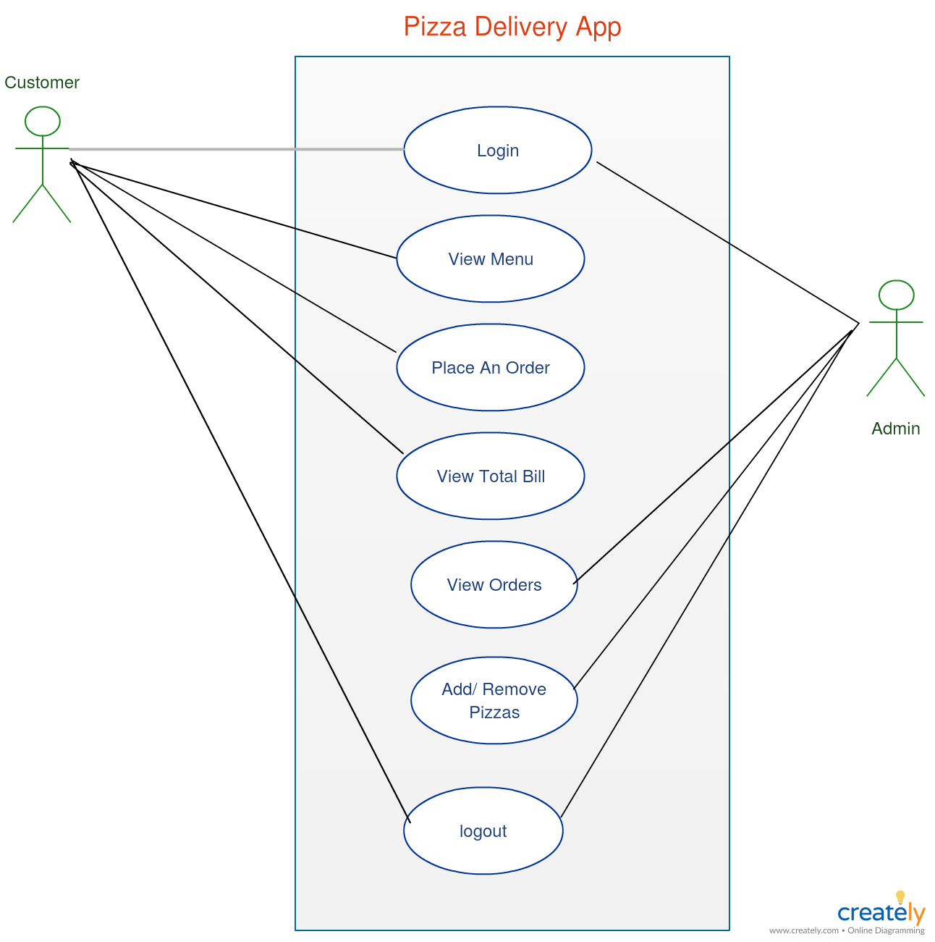

**Admin:**

1. Login to the system using his/her credentials.
2. Sign up by using valid details.
3. Manage pizzas which include adding, retrieving and removing a pizza.
4. View all the past orders.

**Customer:**

1. Login into the system using his/her credentials.
2. Sign up by using valid details.
3. Search for a pizza based on crust type, veg/non-veg or topping.
4. See total bill before confirming order.
5. Can view his/her past orders.

**Project Design**

In this project, there are three microservices which specialize in handling three different activities/functions:

1. **Managing Registrations Module**: The operations defined in this module are login and signup for customers and admin.

**Sign Up:** User details are added on signup page and these details are injected into the corresponding tables into the database. Only valid data are added to the tables else appropriate error messages are displayed. For customers, personal details like name, date-of-birth, gender, contact number, email-ID will be added to the database.

**Login:** Customers can login into their account by giving correct username and password. Both customers and admin with valid credentials can login into their account.

1. **Managing Inventory Module (For Admin):** In this module, admin can add new pizzas along with the details like veg/non-veg, crust type, topping, extra cheese, cost, etc. Further, he/she can view past orders.
2. **Managing Orders Module:** The functionality of this module is to manage all the orders. An order can contain one or more pizza. An order is placed when the customer clicks on the confirm button. Final cost is calculated and shown to the customer.

Entity relationship diagram

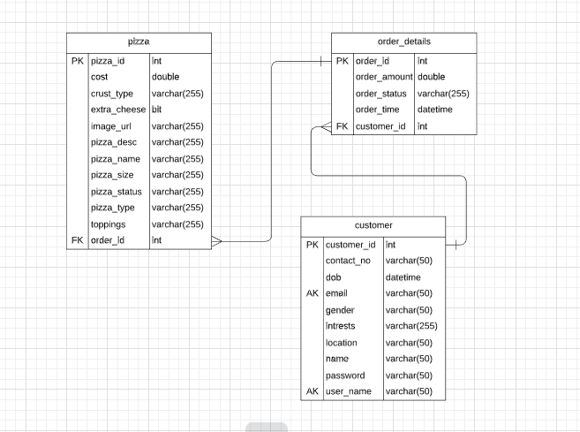

Key points:

* An order can have multiple pizzas.
* A customer can have multiple orders.