PeerDocs: Blockchain based document administration system.



# *Abstract--*Blockchain technology has been widely recognized for its potential to revolutionize industries, including document verification and administration, by providing a secure and decentralized platform for recording and sharing data. In this research paper, we propose a blockchain-based administration system using Hyperledger Sawtooth and Arweave, which utilizes Elasticsearch for efficient data search and NextJS for web development. The system's primary objective is to provide a secure and transparent platform for managing data in a decentralized manner. Our proposed system aims to tackle the scalability challenges of blockchain technology by utilizing off-chain storage for documents while ensuring granular access control for users. The system also provides a user-friendly interface, built using ReactJS and NodeJS, allowing users to interact with the platform easily. The proposed system provides a secure, scalable, and efficient blockchain-based solution for document administration, ensuring the integrity and confidentiality of data.

# Keywords: Blockchain, Healthcare, Hyperledger Sawtooth, Arweave, Elasticsearch, NextJS.

I.INTRODUCTION

With the rapid digitization of businesses and organizations, document administration has become a critical task that requires efficiency and security. Traditional document management systems are being replaced by digital ones that can better cope with the demands of modern document handling. Blockchain technology has emerged as a powerful solution to address the trust, security, and transparency issues that arise with digital document management. In this research paper, we introduce "PeerDocs," a blockchain-based document administration system that aims to provide a secure and reliable platform for managing documents. PeerDocs utilizes the decentralized and distributed nature of blockchain to ensure the authenticity, privacy, and security of documents, while also providing a user-friendly interface for document management. Our research delves into the architecture, design, and implementation of PeerDocs, including a performance evaluation and comparative analysis with other existing document management systems. PeerDocs offers a promising solution for organizations seeking to streamline their

document administration and security processes.

II. LITERATURE REVIEW

"Using Blockchain for Electronic Health Records" provides a detailed and comprehensive overview of blockchain technology and its potential application in healthcare, specifically in the context of electronic health records (EHRs). Different types of blockchains, such as public, private, and hybrid, and their respective benefits and limitations have been discussed. Increased security, privacy, and transparency of data, as well as improved interoperability among different healthcare providers and systems are some of the benefits of using blockchain in healthcare. Technical challenges, such as scalability, performance, and interoperability with existing systems, are highlighted as potential barriers to the widespread adoption of blockchain in healthcare. [4]

The paper "Comparison of Smart Contract Blockchains for Healthcare Applications" by Yu et al. (2020) reviews the potential use of smart contract blockchains in healthcare applications. The authors compare several popular blockchain platforms such as Ethereum, Hyperledger Fabric, and Corda, analyzing their strengths and limitations in terms of performance, security, privacy, and regulatory compliance. They highlight the importance of choosing a suitable blockchain platform based on the specific healthcare application and data management requirements. The paper concludes by providing recommendations for selecting a blockchain platform for healthcare applications, including the importance of interoperability and the need for a strong governance framework. Overall, the paper provides valuable insights into the potential use of blockchain technology in the healthcare sector and offers guidance for researchers and practitioners interested in implementing blockchain-based solutions in this field. [5]

The paper "Electronic Healthcare Data Record Security Using Blockchain and Smart Contract" proposes an EHR system using blockchain technology which provides a secure and efficient way for storing the patient data. The proposed system provides

privacy, confidentiality and tamper-resistance. The authors have first introduced the basic concepts and terminologies of blockchain technology along with its applications in healthcare. They have proposed the blockchain system which provides a scalable, secure, efficient way of handling large volumes of real time data. The paper has also given the benefits of blockchain technology and how it can help in overcoming the challenges like data security, interoperability and transparency which were faced by the existing healthcare record management system. Also, it gives an insight of the challenges associated with this technology. [6]

Several studies have proposed the use of blockchain technology in healthcare, including the use of Ethereum blockchain for secure and efficient storage of EHRs. A study by (Jiang et al., 2021) proposed a permissioned Ethereum blockchain-based EHR system to provide secure and selective access to medical records. The study used a combination of symmetric and asymmetric key cryptography to ensure secure storage and selective access to records. The use of IPFS to store EHRs has also been proposed in several studies. IPFS is a distributed storage system that provides immutable and decentralized storage of data. A study by (Kaur et al., 2021) proposed the use of IPFS to store EHRs to ensure data privacy and security. The study highlighted the advantages of using IPFS, such as the ability to distribute and replicate data across multiple nodes, ensuring high availability and fault tolerance. The proposed EHR model also maintains the statistics of diseases without violating the privacy of any patient. This is achieved by using techniques such as differential privacy, which ensures that no individual's data can be identified from the statistics. A study by (Shah et al., 2021) proposed the use of differential privacy to ensure the privacy of patients while maintaining the accuracy of the disease statistics. [7]

IV. PRELIMINARIES

# Block Chain

Blockchain is a new technology that is gradually emerging with the increasing popularity of digital currencies such as Bitcoin. It is essentially a distributed ledger database. Blockchain records transactions that have occurred by establishing a database maintained by all network nodes and the entire process is open, transparent, and irreversible. According to the participants, it can be divided into the public blockchain, consortium blockchain, and private blockchain, and the consortium blockchain and the private blockchain are collectively referred to as the permissioned blockchain. The public blockchain is completely decentralized in the real sense. At any time, any node will join or leave the decision to build a new block. In the permissioned blockchain, though, the decision to build a new block is made by certain trusted nodes. It has been applied to copyright management, identity authentication, and data storage services.

# Hyperledger Sawtooth

# Hyperledger Fabric Sawtooth is a distributed ledger technology that is gaining popularity with the increasing demand for secure and efficient blockchain solutions. It is a permissioned blockchain network that allows trusted nodes to build new blocks, making it ideal for enterprise-level applications. Unlike public blockchains, the Hyperledger Fabric Sawtooth network is managed by a select group of nodes, making it more efficient and secure for sensitive data and transactions.

# Hyperledger Fabric Sawtooth has been applied to various industries, including copyright management, identity authentication, and data storage services. Its features, including permissioned access and smart contract capabilities, make it a promising technology for businesses seeking to streamline their operations and secure their data. Hyperledger Fabric Sawtooth is designed for use in enterprise environments, providing a flexible and customizable platform for businesses to build their blockchain-based applications.

# Arweave

Arweave is a decentralized blockchain-based storage platform that offers a secure and cost-effective solution for archiving valuable data and information. It uses its unique "blockweave" technology and its cryptocurrency AR to ensure data integrity and incentivize users to store data. Arweave has applications in digital archiving, content distribution, and decentralized applications, providing a permanent and reliable storage platform..

# Web3

In order to communicate with the chain's modules, transactions need be verified in the chain. The peer-to-peer (p2p) connection, which is an actual network, must receive a transaction from a participant in the network of another offline framework in order to construct and authenticate it. Additionally, a library collection that facilitates communication between Ethereum nodes and in- chain components is included. It is used by Node.js on the server side.

Web3 connects to the Ethereum network by means of an Ethereum node using the Hypertext Transfer Protocol (HTTP) connection. This might be a node for local system ETH wallets. With the help of the in-browser extension MetaMask, you may access your Ethereum accounts and use the platform on the website. The Ethereum wallet MetaMask is a browser-based application that links the browser to a Web3 provider class. A data structure known as a Web3 provider offers access to publicly accessible Ethereum nodes. With the help of MetaMask, a user can use, save, and manage public and private keys that are specific to their account. Back-end-front-end communication is made possible by the combination of Ethereum, MetaMask, and web3.js, as well as a web interface.

# Elasticsearch

# Elasticsearch is a distributed search and analytics engine that enables users to search, analyze, and visualize large amounts of data in real-time. It is built on top of the Apache Lucene library and provides a powerful and flexible platform for data exploration and analysis. Elasticsearch is commonly used in enterprise applications for log analysis, security analysis, and business intelligence, and it is known for its scalability and high availability.

# VS Code

Windows, Linux, and macOS users can use the editor Visual Studio Code from Microsoft. There are options for troubleshooting, Git management, GitHub, syntax underlining, intelligent code completion, samples, and bug fixes.

1. PROPOSED METHODOLOGY

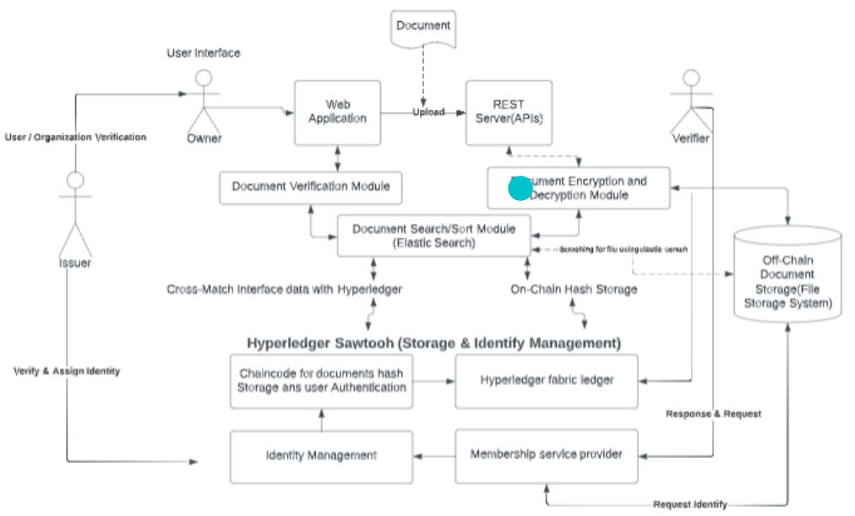

Fig. 1

The proposed system aims to enable doctors from different medical institutions to access patient records securely and efficiently. To achieve this goal, a combination of technologies is being used. Ethereum, the decentralized blockchain platform, is utilized for secure and efficient data sharing across organizations. In addition, the InterPlanetary File System (IPFS) is used to store and retrieve large files related to patient records. Smart contracts, the self-executing agreements that enforce the rules of the system, are built, and deployed on the Ethereum blockchain using tools such as Ganache and Truffle. To interact with the Ethereum network, developers use Web3.js, a JavaScript library that provides an interface for deploying smart contracts and reading data from them. Finally, Metamask, a browser extension, is used to interact with Ethereum-based applications in a user-friendly manner, such as signing transactions and managing wallet addresses. Overall, this combination of technologies enables secure, decentralized, and efficient data sharing, while also providing a user-friendly interface for interacting with the system.

1. EXPERIMENTAL SETUP

As shown in Fig. 2, the proposed system uses smart contracts written in Solidity to manage the access to patient records. When a doctor or patient registers for the system, the contract checks whether they are already signed up for the blockchain. If they are not, then their name and ID are recorded, and the registration process consumes some gas for a successful transaction to take place. After successful registration, the patient can add a doctor's

ID to allow them to access their reports. The reports and files uploaded by the patient are stored with the help of IPFS, which also consumes some gas as a transaction is happening here.

Once a doctor logs in through their ID, they will be able to view the patient's reports. This approach ensures that issues related to portability, authorization, and harm from malicious attacks are solved. The use of a decentralized blockchain system ensures secure and efficient data sharing across organizations, while IPFS provides a reliable and efficient way to store and retrieve large files related to patient records.

By leveraging these technologies, the proposed system ensures that patient records are accessible only to authorized individuals, and that the data remains secure and tamper-proof. Overall, this system offers a decentralized and secure approach to managing patient records, which can benefit the healthcare industry in several ways, including reduced costs, improved data sharing, and enhanced patient care.

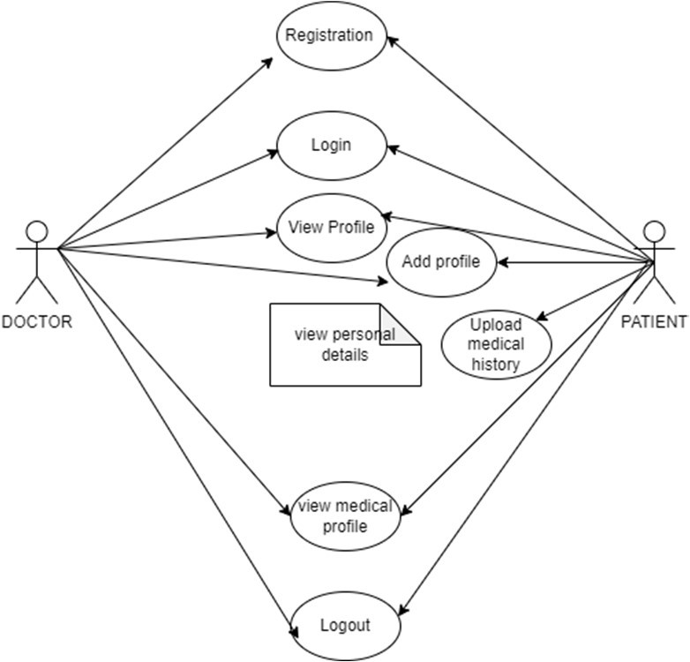

Fig. 2

1. RESULT

The record creation and viewing interface for this study was developed using React js, with pure Javascript used for the backend. To simulate a blockchain network, we utilized the ganache GUI interface as our testing blockchain and Web3 js to interact with it. To test the IPFS network, we employed INFURA, which offers a secure, reliable, and scalable access to the IPFS gateway. The use of INFURA enables TLS-enabled IPFS gateways to be utilized, providing access to up-and-running IPFS nodes.

For our testing, we employed a Dell laptop Inspiron 14 5000, equipped with a 64-bit operating system with an x64-based processor. The processor used is an 11th Gen Intel(R) Core (TM) i5-1135G7 @ 2.40GHz, with a base clock speed of 1.38 GHz. It has 8.00 GB of installed RAM, with 7.73 GB of usable memory. Our network connection was a standard 4G connection.

While IPFS fetch speed may vary depending on factors such as the number of systems storing the records and the location of the closest system containing the record, it is worth noting that our simulation cannot provide an accurate analysis of IPFS fetch time on an actual system. Despite this, we still consider IPFS the preferred choice for our model because of its immutability of records and decentralization, even if its fetch speed is slightly slower than that of a traditional cloud service.

1. DISCUSSION AND LIMITATIONS

Confidentiality is a critical requirement in e-Health. However, it poses a significant challenge. Although the proposed system prevents the hospital from accessing a patient's record without consent, there is a possibility of hospitals taking photographs or copying record contents during the record upload or when accessing the record.

In developing countries, the enforcement of a digital system is difficult due to limited internet access and lack of knowledge on the system's usage. However, blockchain technology offers a solution to this problem by providing a decentralized and immutable logging system. All participants in the blockchain can view who gave permission to a particular hospital, who revoked access, and who created or accessed which record, making data and records secure, and misuse easily identifiable.

To achieve a completely decentralized system that doesn't require any organization for data logging or storage, IPFS is used alongside blockchain. The combination of these technologies ensures immutability of patient records and logged transactions, respectively.

1. CONCLUSION AND FUTURE SCOPE

In this paper, we discussed how our blockchain-based patient- doctor connection system provides a secure and efficient way of managing electronic health records. With the implementation of smart contracts, patients and doctors have complete control over their data, ensuring its authenticity and integrity. The use of IPFS for data storage eliminates the risk of data breaches and tampering. The platform has potential to significantly improve patient care by allowing doctors to have quick and easy access to a patient's medical history. In future, we plan to implement a payment module with consideration for healthcare sector policies, and exploring the possibility of using machine learning to analyze patient documents for improved diagnosis. Telemedicine capabilities can also be added for improved access to healthcare. The system can be scaled to support a larger user base and extended to include medical billing and insurance claims, providing a foundation for further innovation and improvements in electronic health records management.

1. REFERENCES
2. G. Jetley and H. Zhang, "Electronic health records in IS research: Quality issues essential thresholds and remedial actions", Decis. Support Syst., vol. 126, pp. 113-137, Nov. 2019.
3. K. Wisner, A. Lyndon and C. A. Chesla, "The electronic health record’s impact on nurses’ cognitive work: An integrative review", Int. J. Nursing Stud., vol. 94, pp. 74-84, Jun. 2019.
4. M. Hochman, "Electronic health records: A “Quadruple win” a “quadruple failure", J. Gen. Int. Med., vol. 33, pp. 397-399, Apr. 2018.
5. A. Shahnaz, U. Qamar and A. Khalid, "Using Blockchain for Electronic Health Records," in IEEE Access, vol. 7, pp. 147782- 147795, 2019, doi: 10.1109/ACCESS.2019.2946373.
6. Yu H, Sun H, Wu D, Kuo TT. Comparison of Smart Contract Blockchains for Healthcare Applications. AMIA Annu Symp Proc. 2020 Mar 4;2019:1266-1275. PMID: 32308924; PMCID: PMC7153130.
7. Farjana Khanam Nishi, Mahizebin Shams-E-Mofiz, Mohammad Monirujjaman Khan, Abdulmajeed Alsufyani, Sami Bourouis, Punit Gupta, Dinesh Kumar Saini, "Electronic Healthcare Data Record Security Using Blockchain and Smart Contract", Journal of Sensors, vol. 2022, Article ID 7299185, 22 pages, 2022. https://doi.org/10.1155/2022/7299185
8. G. S. Reen, M. Mohandas and S. Venkatesan, "Decentralized Patient Centric e- Health Record Management System using Blockchain and IPFS," 2019 IEEE Conference on Information and Communication Technology, Allahabad, India, 2019, pp. 1- 7, doi: 10.1109/CICT48419.2019.9066212.