**Name:** Shubham Golwal

**Roll No.:** 20203000**15**

**Batch:** TE COMPS - **E**

**Class:** TE

**Experiment No.:** 07

**Name of the Experiment:** Icons - Design appropriate icons pertaining to a given domain. (Considered scenario: **Sanitation**)

**Problem Statement:**

Create a user-friendly interface for a sanitation application that enables users to access and use different sanitation services. One of the essential features of the application is its use of icons to make it easy for users to navigate and use different features of the app. Design appropriate icons that are easily recognizable, visually appealing, and effectively communicate the different sanitation services offered by the application. Additionally, the icons should be consistent with the overall design language. Create a UI prototype that showcases the appropriate icons and demonstrates how users can use the application to access different sanitation services.

**Implementation:**

1. 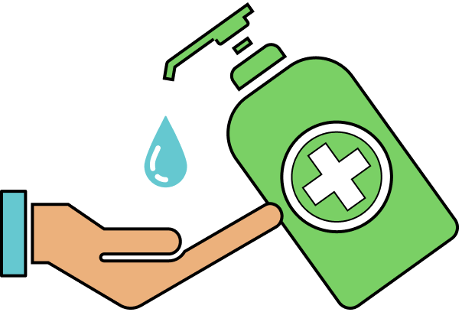 **hand sanitization**
2. **hygienic washroom**
3. **food safety**
4. ** housekeeping**
5. ** mask**

**Conclusion:**

We created icons for sanitation in this experiment. These icons were created with respect for the viewpoint and comprehension of users.

|  |  |  |  |  |  |
| --- | --- | --- | --- | --- | --- |
| Sr.No. | Principles | Poor | Average Good | Very  good | Excellent |
| 1 | Aesthetically pleasing |  |  | Yes |  |
| 2 | Compatibility |  |  | Yes |  |
| 3 | Comprehensibility |  | Yes |  |  |
| 4 | Consistency |  |  | Yes |  |
| 5 | Control |  | Yes |  |  |
| 6 | Efficiency |  | Yes |  |  |
| 7 | Flexibility |  |  | Yes |  |
| 8  9  10 | Forgiveness  Recovery  Responsiveness |  |  | Yes |  |